**COVID-19 DATA ANALYSIS AND VISUALIZATION**

**PROJECT**

**Introduction**

The COVID-19 pandemic has had a profound impact on the world, affecting lives, economies, and healthcare systems across the globe. In response to this unprecedented crisis, data analysis has played a crucial role in understanding the spread of the virus, its impact on different regions, and the progress of vaccination efforts.

This project, titled "COVID-19 Data Analysis and Visualization," aims to provide insights into the COVID-19 situation in India by leveraging publicly available data sources. By analyzing data from two primary datasets, "covid_19_india.csv" and "covid_vaccine_statewise.csv," we seek to gain a comprehensive understanding of the pandemic's dynamics and the progress of vaccination campaigns.

This project's documentation provides a step-by-step guide on how to replicate the analysis, visualize the data, and interpret the findings. It also acknowledges the contributions of data providers, the Python community, colleagues, and other individuals and resources that have supported in completing the project.

Through this data analysis project, we aim to contribute to the understanding of the COVID-19 situation in India and provide a valuable resource for researchers, policymakers, and the general public interested in monitoring and responding to the pandemic's impact.

**Problem Statement**

The COVID-19 pandemic has presented an unprecedented challenge to public health, healthcare systems, and governments worldwide. As the pandemic continues to evolve, it is essential to gain a comprehensive understanding of its impact on a regional level, assess the effectiveness of containment measures, and track progress in vaccination campaigns. The problem at hand is to perform a detailed analysis of COVID-19 data and vaccination data of India.

**Technologies and Concepts**

**Programming Language**

Python: The primary programming language for data analysis and visualization.

Libraries and Frameworks

Jupyter Notebook: An interactive environment for running Python code and documenting the analysis.

Pandas: Used for data manipulation and analysis, including reading, cleaning, and preprocessing data.

NumPy: A fundamental library for numerical computations, often used in conjunction with Pandas.

Matplotlib: Used for creating static and animated data visualizations, such as bar charts and line plots.

Seaborn: A data visualization library built on Matplotlib for creating aesthetically pleasing statistical graphics.

Plotly Express: Used for interactive data visualization (though specific interactive plots are not shown in the provided code).

**Data Analysis Concepts**

Data Cleaning: The process of identifying and handling missing data, removing unnecessary columns, and ensuring data consistency.

Data Preprocessing: Data transformation and manipulation to prepare data for analysis, including data type conversions and calculating derived columns.

Exploratory Data Analysis (EDA): The practice of summarizing main characteristics of data, often with the help of visualizations.

**Description of the dataset**

COVID-19 Cases Data ("covid_19_india.csv"):

The dataset contains information related to the COVID-19 pandemic in India.

Key data fields include:

Date: The date of the recorded data.

State/UnionTerritory: The state or union territory within India.

Confirmed: The total number of confirmed COVID-19 cases.

Cured: The total number of individuals who have recovered from COVID-19.

Deaths: The total number of COVID-19-related deaths.

Active_Cases: A derived field representing the number of active COVID-19 cases (calculated as Confirmed - Cured - Deaths).

Purpose: This dataset is used to perform a statewise analysis of COVID-19 cases, recovery rates, death rates, and growth trends within India. It helps in understanding the impact of the pandemic on different regions of the country.

Vaccination Data ("covid_vaccine_statewise.csv"):

The dataset contains information about COVID-19 vaccination efforts in India.

Key data fields include:

Vaccine_date: The date of vaccination data.

State: The state or union territory within India.

Total Individuals Vaccinated: The total number of individuals who received COVID-19 vaccinations.

Other fields related to doses administered, vaccination coverage, and gender-based vaccination data.

Purpose: This dataset is used to analyze and visualize the progress of COVID-19 vaccination campaigns in India. It allows for the assessment of vaccination coverage, distribution, and gender-based insights.

**Procedural Overview**

**1. Data Loading and Preparation:**

Two datasets are loaded: "covid_19_india.csv" for COVID-19 cases data and "covid_vaccine_statewise.csv" for vaccination data.

Initial data exploration is performed using head(), info(), and describe() functions to understand the structure and content of the datasets.

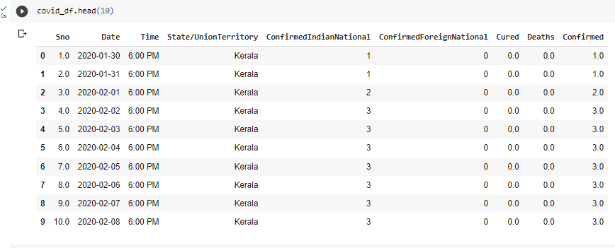

**2. Data Preprocessing:**

In the COVID-19 cases dataset (covid_df):

Unnecessary columns ("Sno," "Time," "ConfirmedIndianNational," "ConfirmedForeignNational") are dropped to streamline the data.

Rows with missing data are removed to ensure data integrity.

Date columns are converted to the datetime format, and numeric columns (Confirmed, Deaths, Cured) are converted to integer data types for consistency.

An "Active_Cases" column is created to calculate the number of active cases.

**3. State wise Analysis:**

A pivot table is used to aggregate COVID-19 cases data at the state/union territory level, calculating the maximum values of "Confirmed," "Deaths," and "Cured" for each state.

The "Recovery Rate" and "Death Rate" are computed as percentages based on the cured and deceased cases relative to confirmed cases.

The state wise data is sorted in descending order of total confirmed cases.

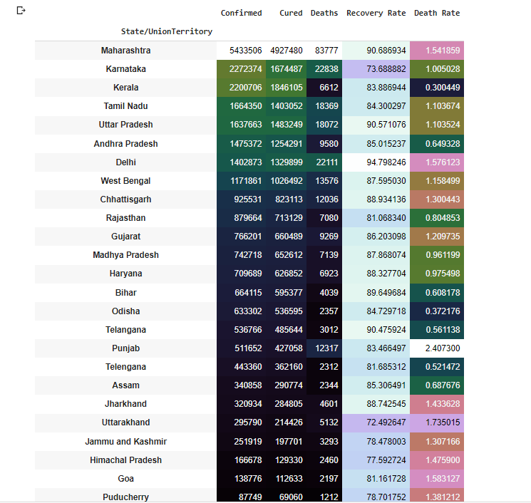

**4. Top 10 Active Cases States:**

The code groups the data by state/union territory, selects the maximum "Active_Cases" value for each, and ranks the top 10 states.

A bar plot using Seaborn is created to visualize the top 10 states with the most active COVID-19 cases.

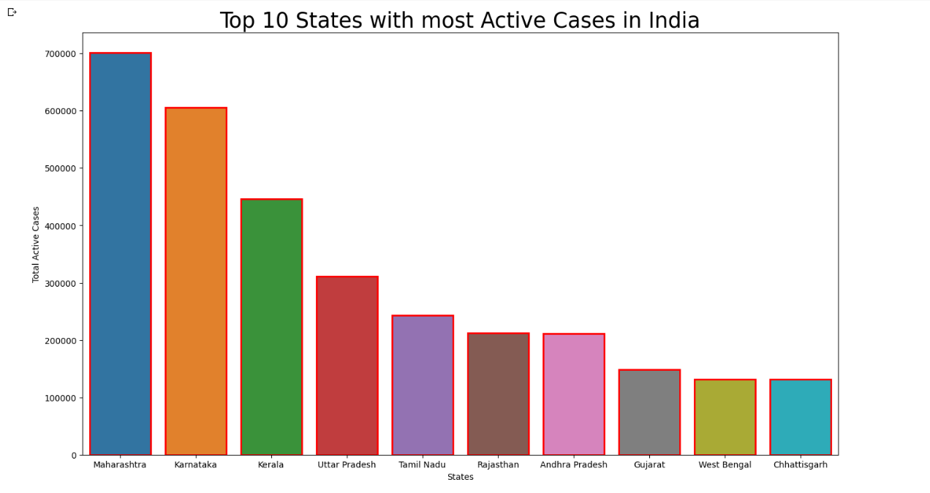

**5. Top 10 States with Most Deaths:**

Similar to the active cases analysis, the code ranks the top 10 states with the most COVID-19 deaths and visualizes the results in a bar plot.

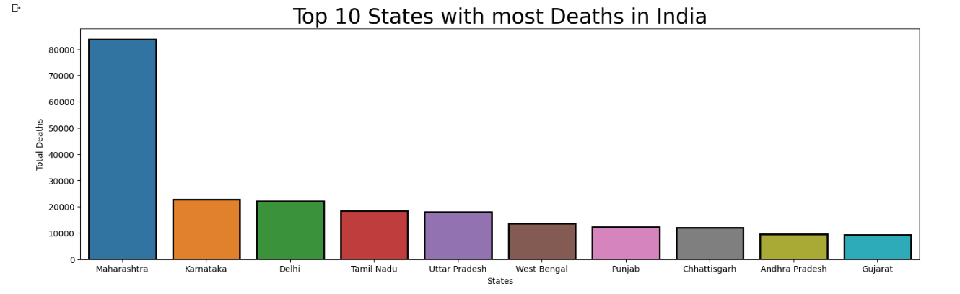

**6. Growth Trend Analysis:**

A line plot is generated to analyze the growth trend of active COVID-19 cases over time for the top 5 affected states (Maharashtra, Karnataka, Kerala, Tamil Nadu, Uttar Pradesh).

The code uses Seaborn to create the line plot, which provides insights into how the number of active cases has evolved.

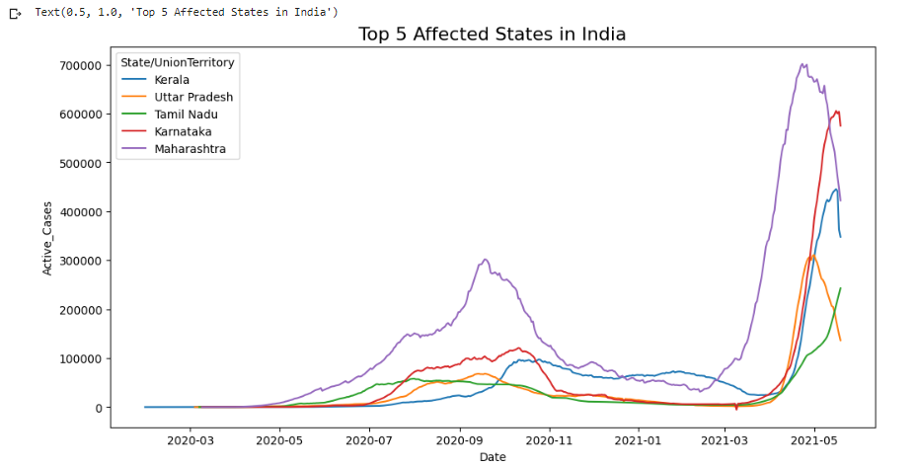

**7. Vaccination Data Handling:**

The vaccination dataset (vaccine_df) is prepared:

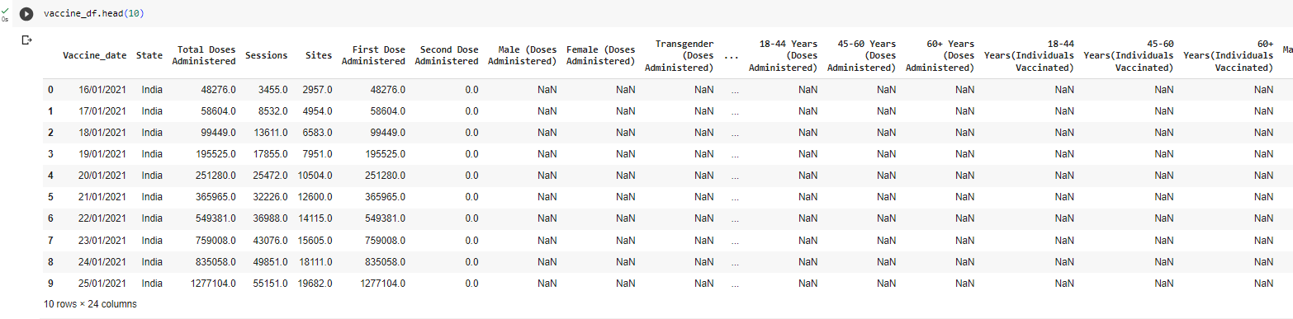

The "Updated On" column is renamed to "Vaccine_date" for clarity.

Columns related to specific age groups and the Sputnik V vaccine are dropped, focusing on essential vaccination data.

**8. Gender-Based Vaccination Visualization:**

The code calculates the total number of male and female individuals vaccinated.

A pie chart is used to visualize the distribution of male and female vaccinations.

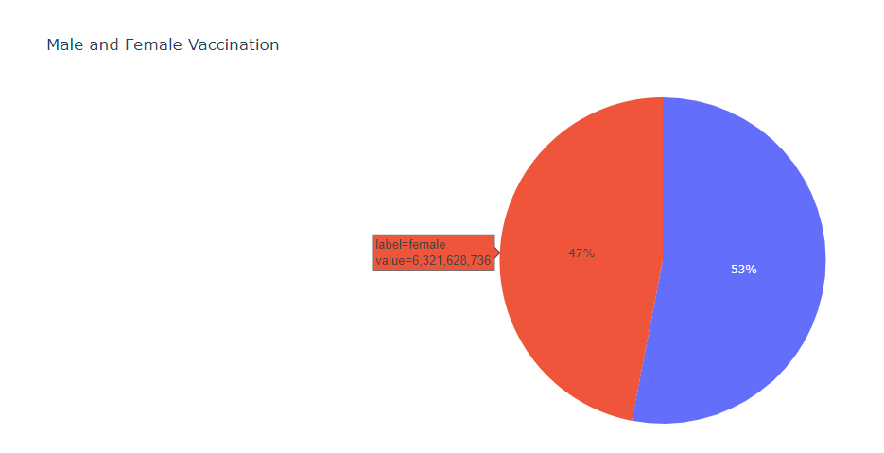

**9. Top 5 States with Most Vaccination:**

The code identifies the top 5 states with the highest total vaccinations. A bar plot is created to visualize the vaccination coverage in these states.

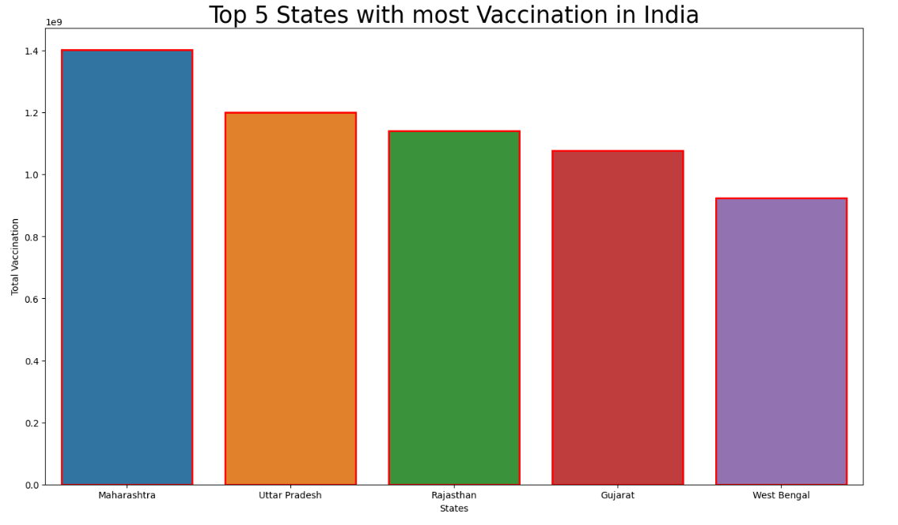

**Conclusion**

In the midst of the global COVID-19 pandemic, this data analysis project has provided valuable insights into the situation in India. Through rigorous data collection, preprocessing, and visualization, we have illuminated critical aspects of the pandemic's impact on the country and its vaccination progress. Here are the key takeaways:

Understanding the COVID-19 Landscape: Our analysis commenced with a comprehensive exploration of COVID-19 cases across Indian states and union territories. Through data preprocessing, we ensured the accuracy and consistency of the information. This allowed us to gain a detailed understanding of the pandemic's dynamics.

Statewise Analysis: We delved deeper into the data, employing pivot tables to summarize critical statistics for each state and union territory. This approach provided a clear picture of the states most affected by the virus and allowed us to calculate essential metrics such as the recovery rate and death rate.

Identifying Hotspots: By ranking states based on active cases and deaths, we pinpointed regions that required immediate attention and resources. This analysis serves as a guide for healthcare resource allocation and intervention strategies.

Tracking Growth Trends: The growth trend analysis of active COVID-19 cases in the top five affected states helped us identify how the pandemic evolved over time. These insights are instrumental in anticipating future trends and planning accordingly.

Vaccination Progress: To complement our understanding of the pandemic, we included data on COVID-19 vaccinations. Analyzing gender-based vaccination distribution and identifying the states with the highest vaccination coverage underscored the nation's progress in mitigating the impact of the virus.

In conclusion, this project serves as a comprehensive resource for understanding the COVID-19 situation in India. The data-driven approach, coupled with effective visualizations, provides a clear and actionable understanding of the pandemic's status. It is our hope that this analysis contributes to informed decision-making, resource allocation, and ongoing efforts to combat the COVID-19 crisis in India. As the situation continues to evolve, data analysis remains a powerful tool for addressing the challenges ahead.

**References**

<https://www.kaggle.com>

<https://github.com/abhisarahuja/Covid-19-Data-Analysis-Project-Using-Python-And-Tableau>

<https://www.youtube.com/@SimplilearnOfficial>