Assignment selection

Rohith M

CB.EN.U4CSE21048

1. Obtain a temperature in degrees Fahrenheit from the user.  If the temperature is 80 degrees or more display the message "Go play golf" otherwise, if the temperature is 70 -79 degrees display the message "Put on a jacket", otherwise display the message "It is way too cold."  Perform a desk check using the following values: 95, 72, and 50.

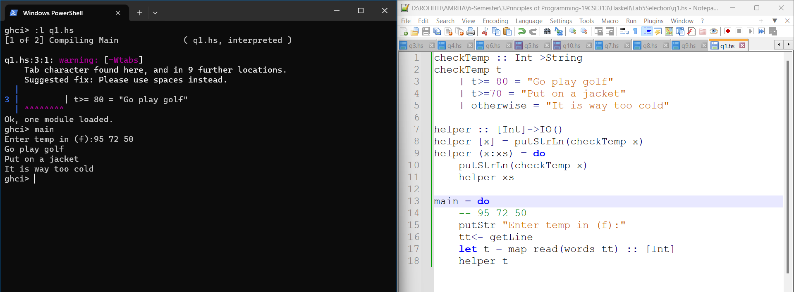

2. Obtain a name and age from the user.  If the user is 16 or older, output a message indicating they are old enough to drive.  For people under 16, output a message indicating how many years they must wait before they can drive legally.

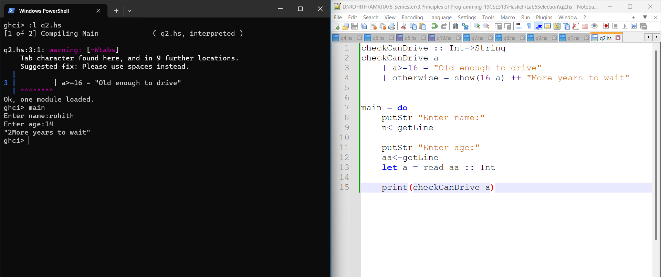

3. Obtain from the user an hourly pay rate and the number of hours worked for the week. Calculate and output their weekly pay according to the following: Regular pay is the pay up to 40 hours. Overtime pay is pay for the hours over 40.  Overtime is paid at a   rate of 1.5 times the hourly rate. Gross pay is the sum of the regular pay and the overtime pay.

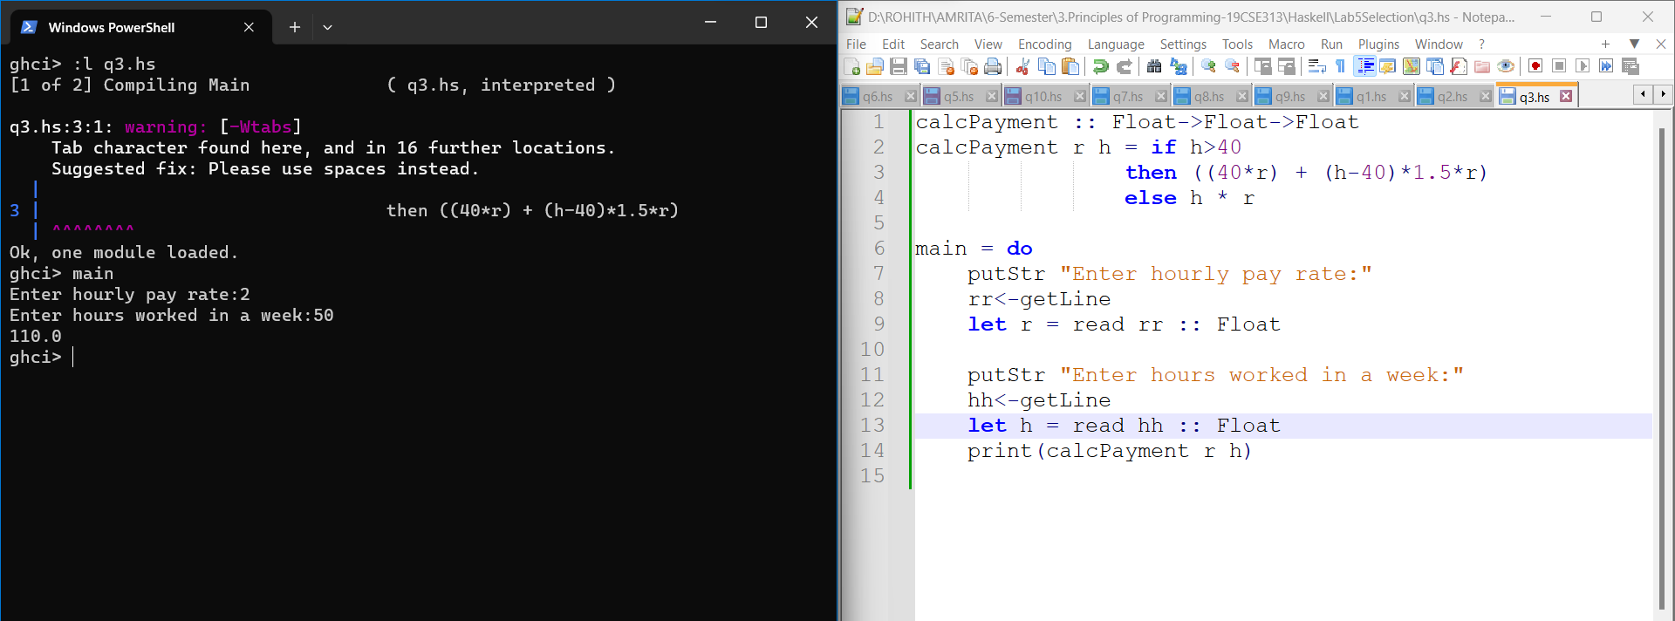

4.

Lengths of three sides of a triangle a, b, c are given as input. Finds if the triangle is isosceles, equilateral, or scalene. Hint: In an equilateral triangle three sides are equal. In an isosceles triangle two sides are equal. In a scalene triangle three sides are not equal.

