**Assignment Lists**

Rohith M

CB.EN.U4CSE21048

**Write the haskell code, execute and upload the haskell file along with a single word document which contains the output for each problem in the same sequence as questions.**

1. Write a function join that concatenates a list of strings together.

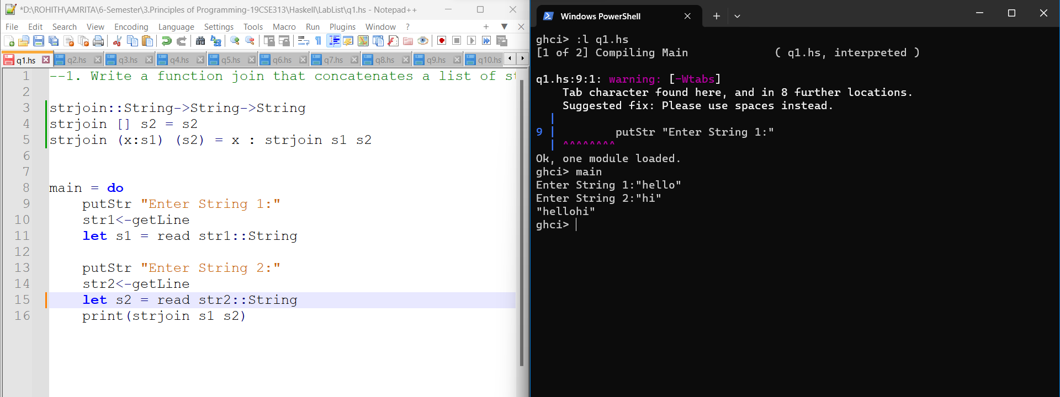

2. Write a function startEnd that takes in a list of any type and returns a 2-tuple containing the first and last element of the list.

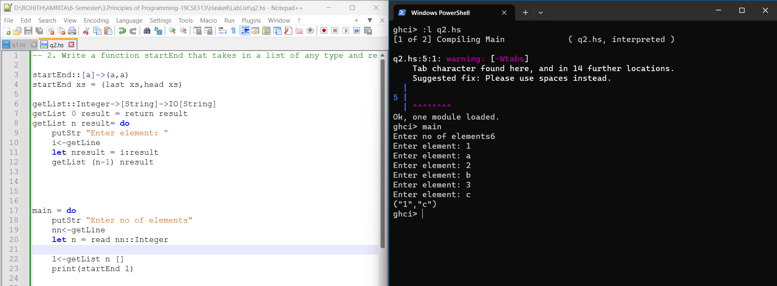

3. Write function box that takes a list of Int triples, each representing the length, width, and height ofa box in inches. The function returns the total volume of all items as a string in the form "42276inA3"

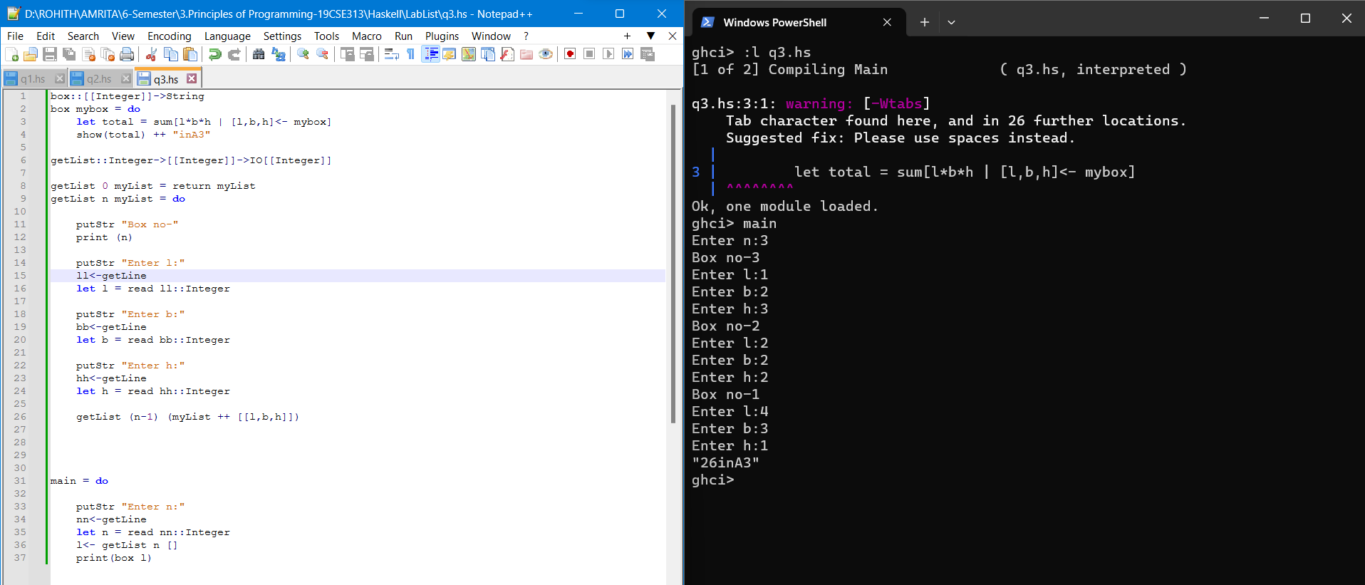

4. Write function percentWeight that takes a list of weights and returns a list of percentages of the total weight of all items as strings. For example percentWeight [12, 24, 36,48] yields ["10.0%" "20.0%" "30.0%" "40.0%"].

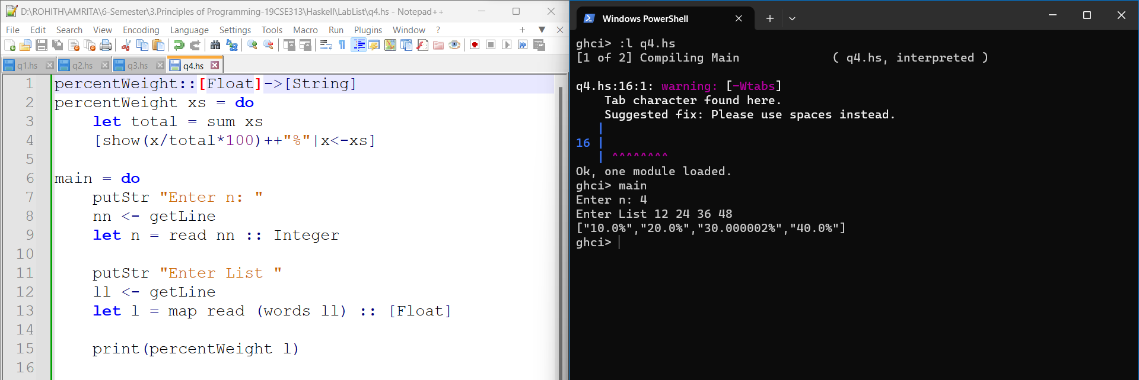

5. Write a function middle3 that accepts a list and returns a list of just the three middle elements.

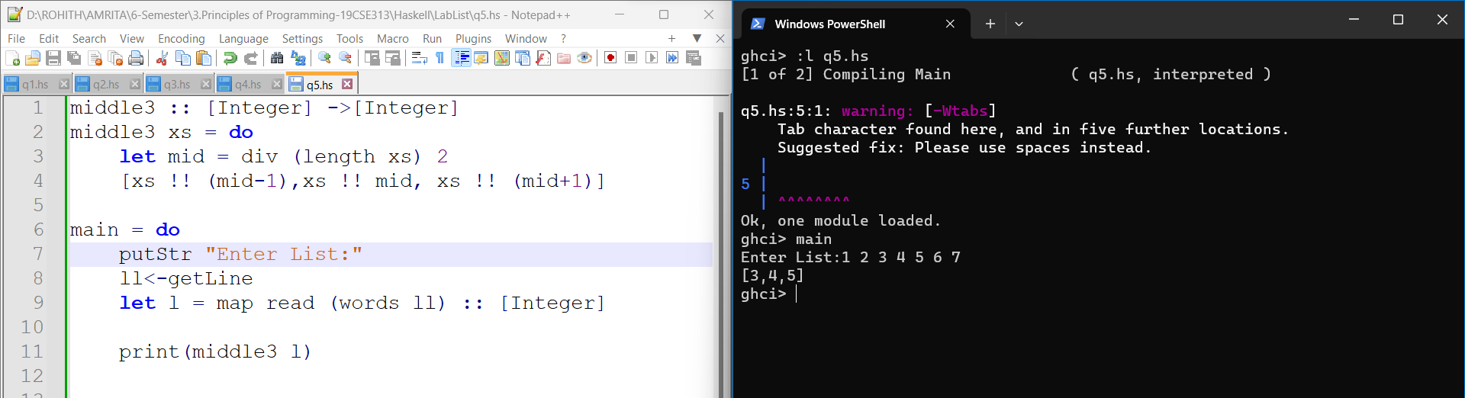

6. Write a Haskell function to find the length of the list

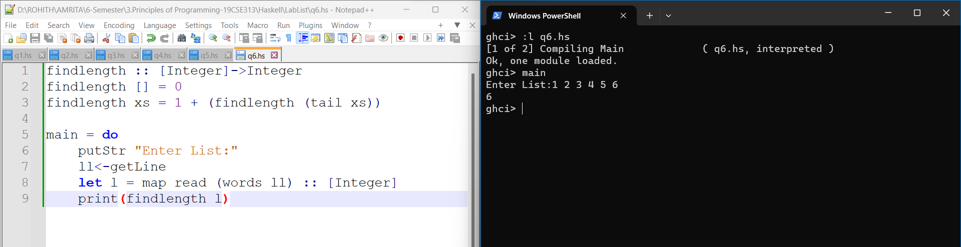

7. Write a user defined function to concatenate two list into a new list

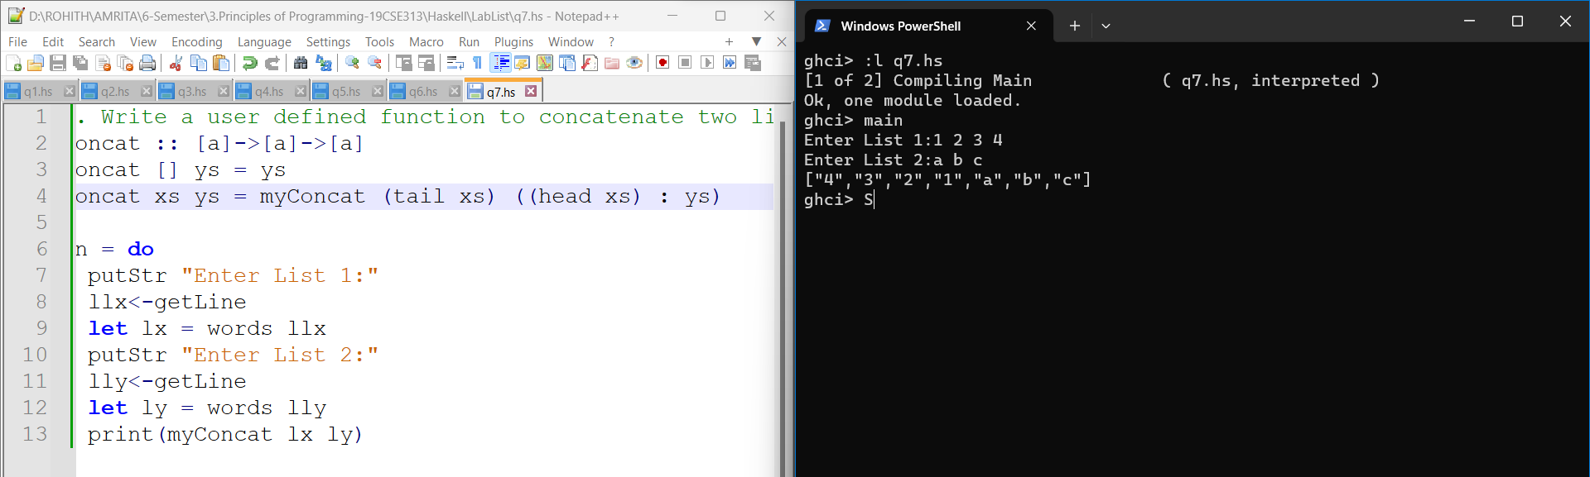

8. A Haskell function that reads marks of 'n' students of a class and displays the class average. Also if more than 2 students have marks less than class average, display a suitable message.

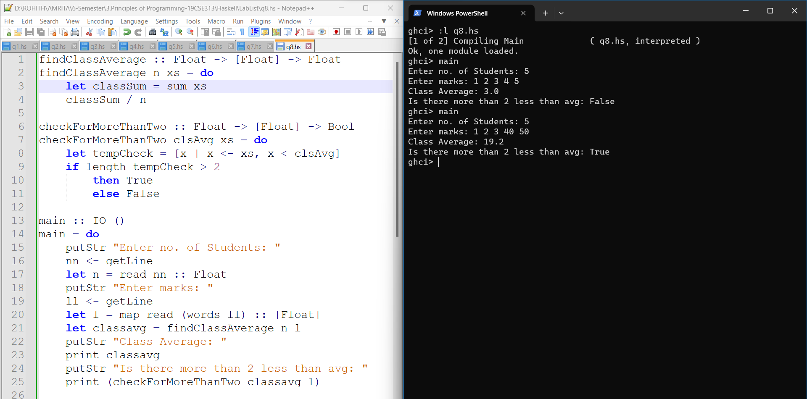

9. A haskell function to find the Number Occurring Odd Number of Times in an list.

Input :arr= {1, 2, 3, 2, 3, 1, 3}

Output : 3

Input {5, 7, 2, 7, 5, 2, 5}

Output : 5

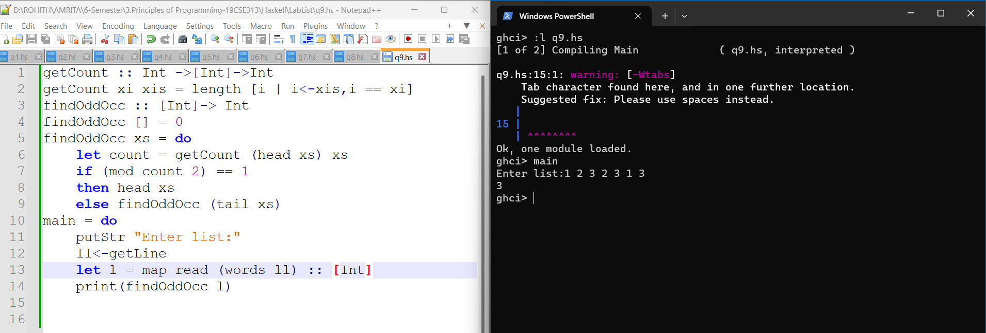

10. A Haskell function to display all the duplicates elements in the list.

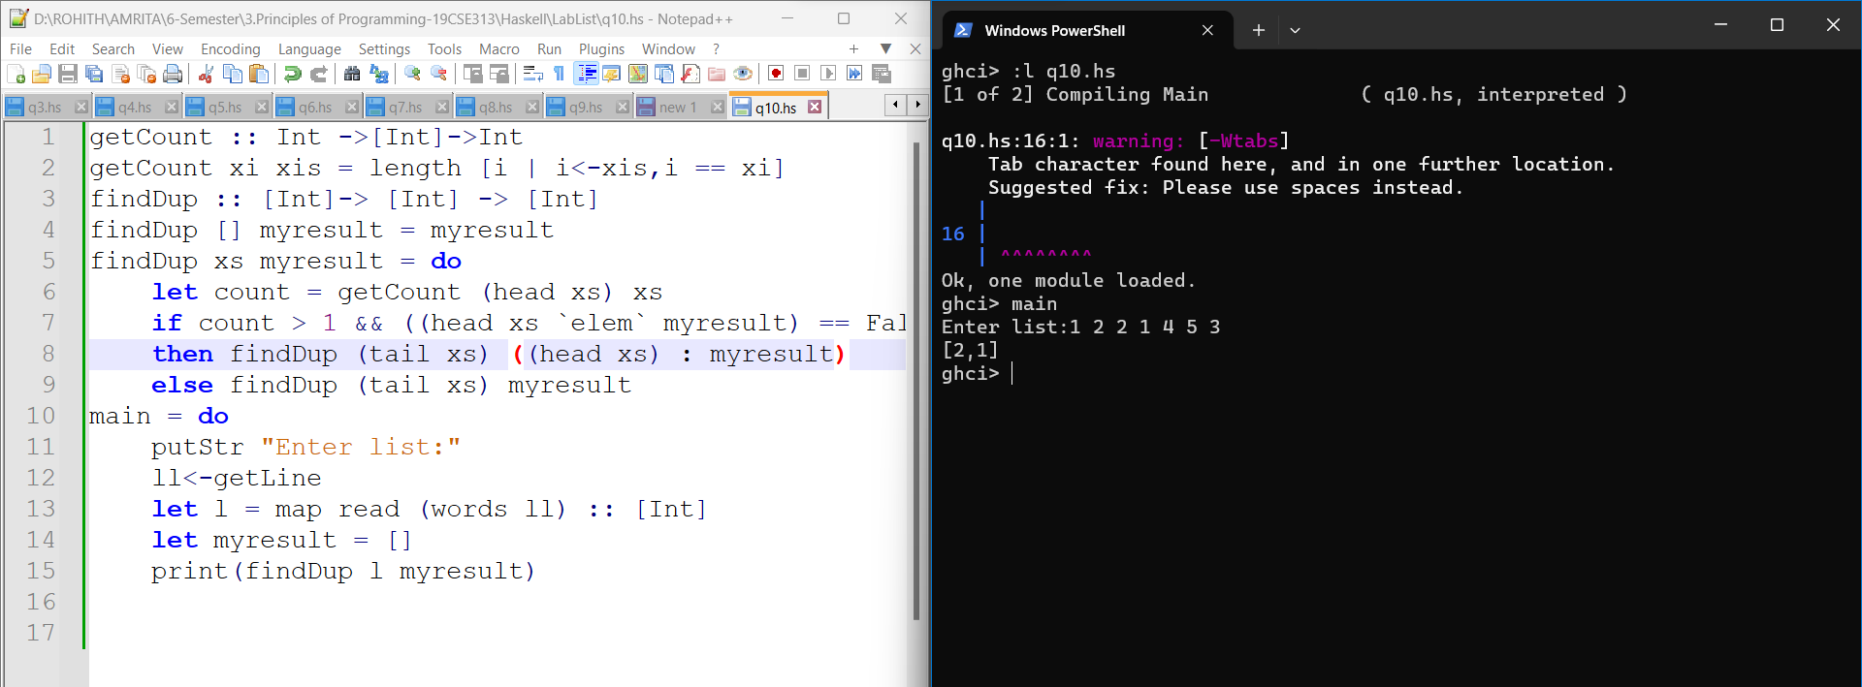

11. A Haskell function finds the product of elements of a list.

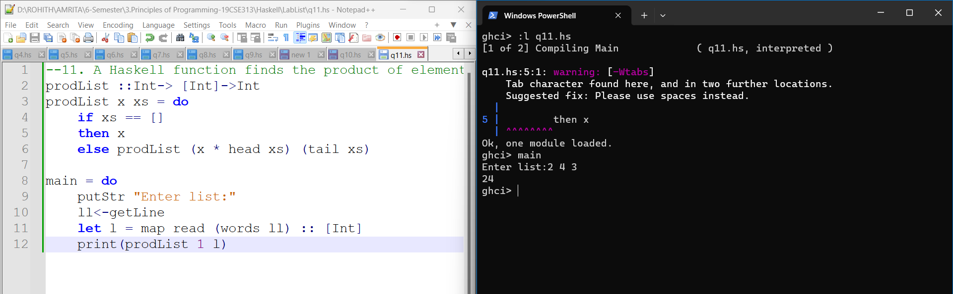

12. A Haskell function that reads a list and print the odd numbers in the list.

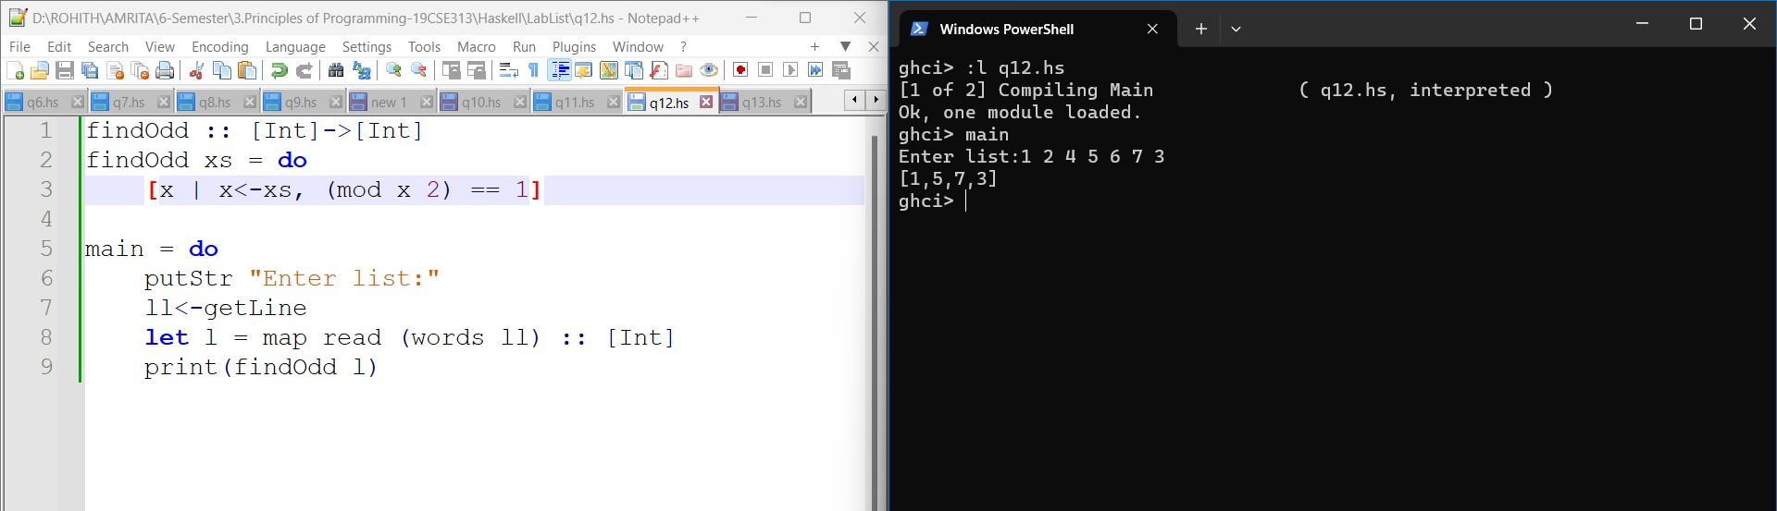

13. A Haskell function that reads a list and print the sum of even numbers in the list.

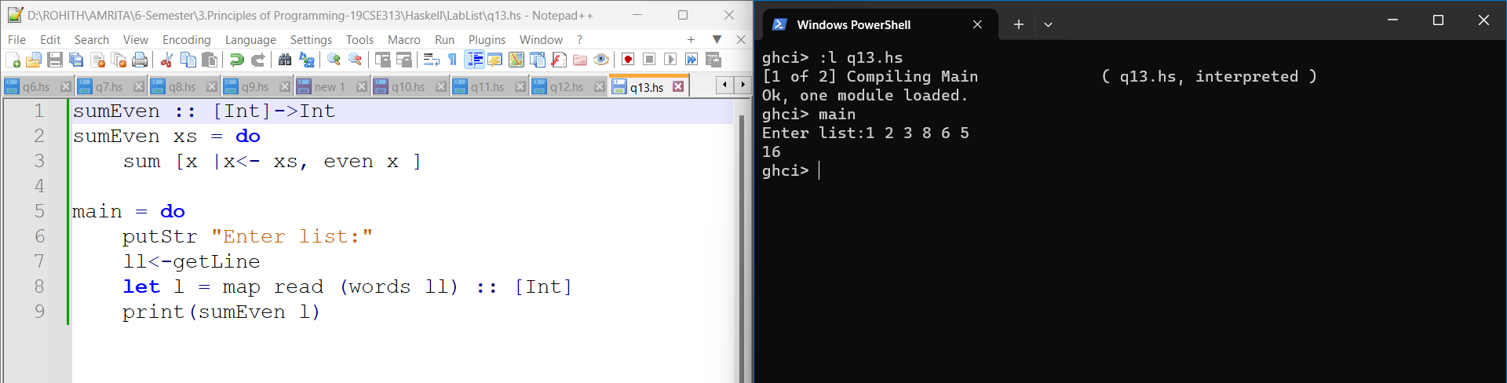

14. A Haskell function that reads a list and find the smallest element in the list.

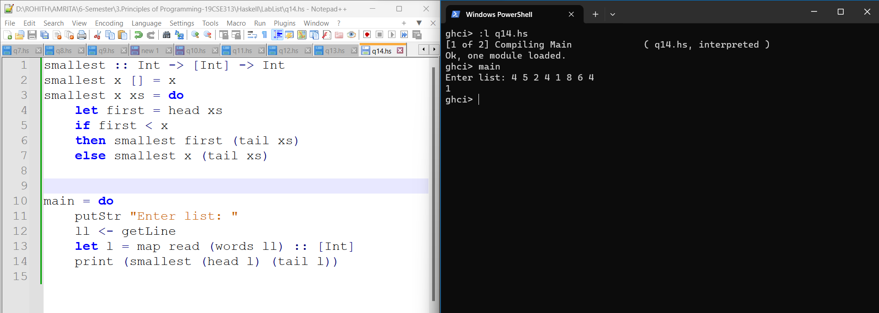

15. A Haskell function that reads a list and print the sum of elements at odd list indices.

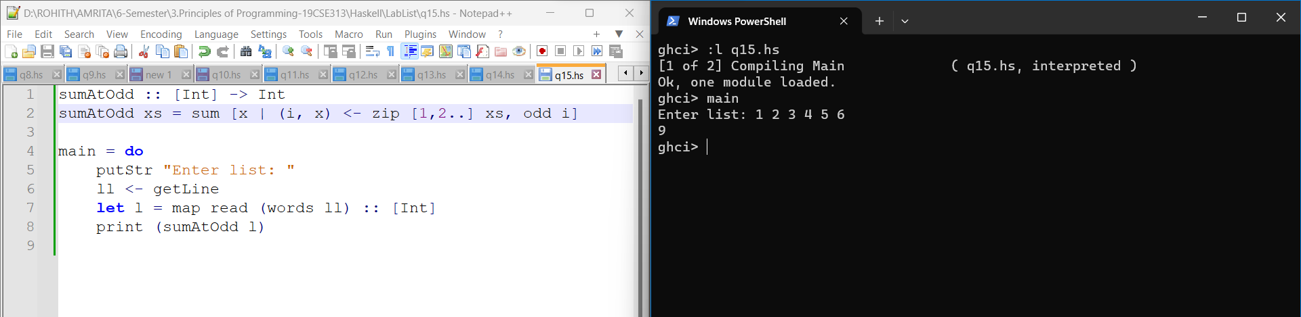

16. A Haskell function that searches for a number (value) in a list and displays an appropriate message. The list of numbers and the value to be searched should be read from the user.

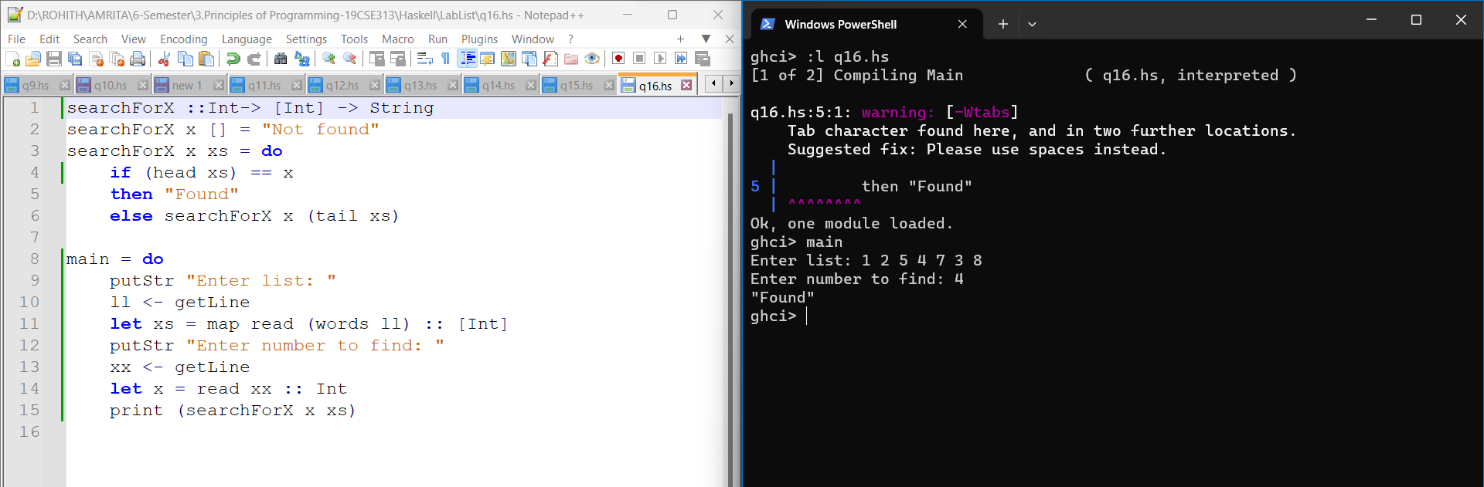

17. A Haskell function that reads a list and displays the element that comes in the list after a number entered by the user.

