REINFORCEMENT LEARNING PROJECT REPORT

Autonomous Drone Navigation in Gazebo Using Reinforcement Learning and Closed-Loop Trajectory Control
Tabular Q-Learning in a 5 x 5 Obstacle Environment

Student Name: ______________________________
Register / Roll Number: ______________________
Course: Reinforcement Learning
Department / Institution: _____________________
Submitted To: ______________________________
Date: October 2026
Software: ROS Noetic, Gazebo 11, Python 3 and SJTU drone simulation

Table of Contents
Title Page
Abstract
1. Introduction and Problem Statement
2. Background Theory
3. Methodology / Implementation Details
4. Experimental Setup
5. Results and Analysis
5.1 Training behavior
5.2 Discrete route and optimality
5.3 State-value interpretation
5.4 Visual flight sequence
5.5 Reported control performance
6. Discussion
7. Conclusion
8. References

List of Figures
Figure 1. Gazebo arena with drone at the start pad
Figure 2. Reported Q-learning training curves
Figure 3. Eight-step route in the discrete grid
Figure 4. Supplied state-value visualization
Figure 5. Drone displacement away from the start area
Figure 6. Heading change during navigation
Figure 7. Drone in the interior corridor
Figure 8. Drone approaching the goal-side corridor
Figure 9. Drone near the green goal marker

List of Tables
Table 1. Q-learning and SARSA comparison
Table 2. Learning and controller settings
Table 3. Arena and obstacle coordinates
Table 4. Route waypoints and world coordinates
Table 5. Reported open-loop and closed-loop results

Abstract
This project examines a two-level approach to autonomous quadrotor navigation: a tabular reinforcement learning agent selects a route, and a feedback controller follows the resulting waypoints in Gazebo. The planning environment is a 5 x 5 grid with six blocked cells, four directional actions, a start at (4, 0), and a goal at (0, 4). The supplied implementation description uses Q-learning with 1,000 training episodes, a learning rate of 0.1, a discount factor of 0.9, and decaying epsilon-greedy exploration. Its trajectory map shows a collision-free eight-transition route. This route meets the Manhattan-distance lower bound and is therefore shortest in the stated grid model. The accompanying training plot reports rewards approaching +57 and path lengths approaching eight steps. However, this reward total is not consistent with the discounted potential-based shaping expression in the source report. The analysis therefore separates geometric findings, reported measurements, and results requiring further verification. Gazebo screenshots document movement toward the goal, while precise landing errors and repeated-trial success rates remain source-reported rather than independently validated. The main practical lesson is that discrete policy learning and continuous feedback control solve different parts of the navigation problem.
Keywords: reinforcement learning; Q-learning; Gazebo; ROS; waypoint tracking; reward shaping.

1. Introduction and Problem Statement

1.1 Motivation
A drone moving through an enclosed obstacle field must choose where to fly and maintain stable motion while doing so. A route that looks safe on a grid can fail during execution if the vehicle turns late, overshoots a waypoint, or accumulates heading error. Reinforcement learning offers a way to learn action preferences from reward feedback, but it does not remove the need for a suitable state representation or a reliable flight controller [1].
The project uses a small simulated arena so that exploration, reward design, and policy extraction can be inspected directly. Classical planners are useful comparators: algorithms such as A* can find shortest routes when an appropriate map is available. They are not inherently restricted to complete static maps, and a learned policy should be evaluated against them rather than assumed to be superior.

1.2 Task and objectives
The objective is to move from the start to the goal using valid adjacent grid cells, avoid six obstacles, and minimize transition count. The learned route is then translated into world-coordinate waypoints at a nominal altitude of 1.20 m. The implementation objectives are to define the Markov decision process, train and inspect a Q-table, extract a greedy route, and execute it using pose feedback. The reporting objective is to explain both the successful route and the limits of the available experimental evidence.

1.3 Scope of the navigation problem
The project distinguishes a planning environment from a flight environment. In the planning environment, an action immediately changes the agent from one grid cell to another. In Gazebo, the same action becomes a target position that may take several seconds to reach. The grid learner does not directly choose motor thrust or predict rotational inertia. Instead, it selects a destination for a separate controller. This hierarchical interpretation is important because it explains both the simplicity of the Q-table and the need for continuous pose feedback.
The phrase model-free refers to learning action values without requiring a transition-probability model in the update. It does not mean that the entire system has no prior information. The cell spacing, goal location, action definitions, and coordinate mapping are supplied by the designer. In particular, a Manhattan-distance potential requires the goal coordinates to be known. Obstacle occupancy may be discovered through interaction, but a claim of fully unknown navigation should distinguish unknown obstacles from known goal and grid structure.

2. Background Theory

2.1 Markov decision process
A finite Markov decision process is described by states S, actions A, transition probabilities P, rewards R, and discount factor gamma. Here a state is a grid coordinate (r, c), represented by the index s = 5r + c. There are 25 nominal cells and four actions: up, down, left, and right. Blocked and terminal cells require explicit handling; they need not be treated as ordinary decision states. The grid abstraction assumes that the next cell depends on the current cell and action. This is a planning approximation, not a complete state model of quadrotor dynamics [1].
The discounted return is G_t = sum over k of gamma^k R_(t+k+1). An action-value function Q(s, a) estimates the expected return after choosing action a at state s. A greedy policy selects an action with the largest current Q-value. This differs from the training behavior policy when exploration remains enabled.

Worked state-representation example
The start cell (4, 0) maps to table row 20 because 5 x 4 + 0 = 20. Moving up enters (3, 0), which maps to row 15. The learner updates only the selected action entry in row 20; it does not rewrite the entire table. This local update makes tabular learning inexpensive: 25 cells and four actions require only 100 stored values. Six blocked cells and the terminal goal may still occupy array positions for convenient indexing, even when no action is executed from them.
The Markov assumption is reasonable for deterministic cell transitions but incomplete for physical flight. Two drones at the same location can have different velocities and headings, so the same forward command need not produce the same next position. The feedback controller partly compensates for this missing information by using pose continuously. A fully learned physical controller would generally require a richer state containing quantities such as velocity, orientation, and target-relative error.

2.2 Temporal-difference control
Q-learning updates the selected table entry using the observed reward and the best estimated next-state action [2]:
Q(s, a) <- Q(s, a) + alpha [r + gamma max_b Q(s_next, b) - Q(s, a)].
For a terminal transition, the target is r alone. SARSA instead uses the next action actually selected by the behavior policy [4]. Its update target is r + gamma Q(s_next, a_next). Both methods can be appropriate; neither has a universal speed or safety advantage.
Table 1. Q-learning and SARSA comparison.
Aspect | Q-learning | SARSA
Policy relationship | Off-policy | On-policy
Next-state target | Maximum next Q-value | Q-value of sampled next action
Exploration effect | Learns about a greedy target policy | Learns about the behavior policy
Risk near obstacles | Depends on model and rewards | Can reflect exploratory collision risk
Evidence in this project | Route and training plot supplied | No matched experiment supplied

Worked Q-learning update
Consider an illustrative nonterminal transition with Q(s, a) = 10, immediate reward r = 1, and a largest next-state Q-value of 12. With gamma = 0.9, the temporal-difference target is 1 + 0.9 x 12 = 11.8. The prediction error is 11.8 - 10 = 1.8. At alpha = 0.1, the updated entry becomes 10 + 0.1 x 1.8 = 10.18. The numerical example explains the update mechanism; it is not a measured transition from the supplied experiment.
For a goal transition with reward 50, the target becomes 50 rather than 50 plus a terminal-state estimate. Repeated visits gradually move the predecessor action value toward that target. Values can then propagate backward through earlier states as those transitions are sampled. This explains why discovering the goal once is not the same as learning an effective policy throughout the route. Exploration must revisit relevant state-action pairs to transfer the terminal reward into useful earlier decisions.

2.3 Exploration and reward shaping
Epsilon-greedy action selection chooses a random action with probability epsilon and a greedy action otherwise. The reported schedule is epsilon_k = max(0.05, 0.995^k). It retains exploration during training; evaluation should set epsilon to zero. A finite run with constant alpha does not establish the asymptotic convergence conditions of Q-learning [2].
Potential-based shaping adds F(s, s_next) = gamma Phi(s_next) - Phi(s), where Phi(s) = -2 times the Manhattan distance to the goal. Policy-invariance results require consistent shaping and suitable terminal-state treatment [3]. A reward rule that omits shaping on some transitions cannot simply inherit that guarantee.

Why the parameters matter
The learning rate controls how much a new observation changes an existing estimate. A larger value can adapt quickly but can also retain more variability when transitions or rewards are noisy. The discount factor controls the weight of delayed outcomes: at gamma = 0.9, a reward eight transitions away is weighted by approximately 0.43 relative to an immediate reward. Epsilon controls sampling rather than reward preference. These three parameters solve different problems and should not be interpreted interchangeably [1].
A negative step cost discourages unnecessary movement, a large negative obstacle reward discourages failure, and a positive goal reward makes successful completion attractive. Shaping adds intermediate information about progress. Moving toward the goal can become easier to learn because the agent receives feedback before arrival. However, Manhattan distance ignores obstacle detours. An initially necessary move away from the goal must remain learnable, so an implementation should not simply forbid every action that increases that distance.

3. Methodology / Implementation Details

3.1 Training procedure
The source describes separate training and flight modes. Training initializes a 25 x 4 Q-table to zero and resets each episode to (4, 0). At each step, the agent chooses an epsilon-greedy action, receives the next state and reward, and updates the relevant action-value entry. Episodes end on a terminal event or at the 50-step limit. Exploration is reduced after each episode. A saved policy can then be evaluated without random actions and converted to a sequence of waypoints.
Obstacle and boundary handling should be unambiguous in the implementation. If an obstacle ends an episode, its target must not bootstrap from a future value. If a wall leaves the agent in the same state, the transition is a self-loop and should be recorded as such. The supplied description is insufficient to verify every reset and terminal condition; these details should accompany any reproducible experiment.
Table 2. Learning and controller settings.
Parameter | Reported setting
Training episodes / maximum steps | 1,000 / 50 per episode
Learning rate alpha / discount gamma | 0.1 / 0.9
Initial / minimum epsilon | 1.0 / 0.05
Exploration multiplier | 0.995 after each episode
Goal / obstacle / boundary reward | +50 / -50 / -5
Ordinary-transition reward | -1 + gamma Phi(s_next) - Phi(s)
Nominal altitude / pose update rate | 1.20 m / 10 Hz
Heading threshold / waypoint threshold | 0.20 rad / 0.25 m
Forward speed bounds | 0.25 to 0.65 m/s
Distance gain / alignment yaw gain | 1.2 / 2.5

3.2 Grid-to-world mapping and feedback
Each grid coordinate maps to x = (4 - r) x 2.0 m and y = -c x 2.0 m. The controller receives position and orientation from /drone/gt_pose and sends velocity commands. For a target (tx, ty), it computes dx = tx - x, dy = ty - y, distance d = sqrt(dx^2 + dy^2), and target yaw atan2(dy, dx). The yaw error is wrapped to the interval [-pi, pi].
When the heading error exceeds 0.20 rad, forward motion is suppressed and the drone rotates toward the waypoint. Once aligned, forward velocity is limited to the stated range while yaw is corrected continuously. A waypoint is accepted when d < 0.25 m. Because the lower speed bound prevents velocity from decreasing all the way to zero, explicit stopping and landing commands are important near arrival.

Worked controller example
Suppose the drone is at (6, 0) m and the next waypoint is (6, -2) m. The displacement is dx = 0 and dy = -2, giving a target yaw of -pi/2. If the current yaw is zero, the heading error is approximately -1.57 rad, well above the 0.20 rad threshold. The align-first mode therefore suppresses forward motion and commands a clockwise yaw correction. Once aligned, the drone can translate toward the target while the controller continues correcting the remaining heading error.
Wrapping the yaw error prevents discontinuities at the angle boundary. For example, headings of +179 degrees and -179 degrees differ by only two degrees, not 358 degrees. Using an unwrapped subtraction could command an unnecessarily large rotation. Velocity saturation similarly prevents the proportional law from requesting an excessive speed when the target is far away. These safeguards improve command behavior, although they do not by themselves establish closed-loop stability.
At a 10 Hz controller rate, commands are recalculated roughly every 0.1 s. At the maximum commanded speed of 0.65 m/s, nominal travel between updates is 0.065 m. This is a useful scale for interpreting the 0.25 m acceptance threshold, but actual travel also depends on lag and acceleration. A practical implementation should reject stale pose messages, stop after a waypoint timeout, and avoid advancing through multiple waypoints accidentally. These are recommended safeguards rather than features verified in the supplied code.

4. Experimental Setup
The reported software stack is Windows 11 with WSL2 Ubuntu 20.04, ROS Noetic, Python 3, Gazebo 11.14, and the SJTU drone simulation package. Gazebo supplies the simulated world and drone dynamics; ROS provides message-based communication [5, 6]. The source states a 0.001 s physics step and a 1,000 Hz update setting. These are configuration values, not proof that all runs sustained real-time operation.
Table 3. Arena and obstacle coordinates.
Object | Grid (r, c) | World (x, y), m
Start | (4, 0) | (0, 0)
Goal | (0, 4) | (8, -8)
Obstacle 1 | (0, 1) | (8, -2)
Obstacle 2 | (1, 3) | (6, -6)
Obstacle 3 | (2, 1) | (4, -2)
Obstacle 4 | (2, 4) | (4, -8)
Obstacle 5 | (3, 2) | (2, -4)
Obstacle 6 | (4, 3) | (0, -6)
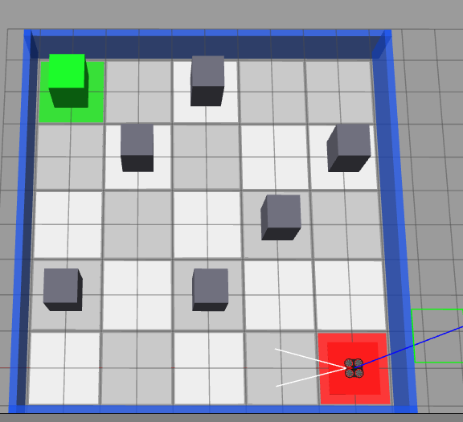
Figure 1. Gazebo arena with drone at the start pad.
The arena is described as 10 m x 10 m with 2 m grid spacing. Six obstacle pillars have a stated footprint of 0.9 m x 0.9 m and height of 2 m. The red pad and green marker identify the start and goal. Camera orientation differs from the schematic route map, so screen-left and screen-right should not be interpreted directly as grid directions.
All nine supplied images are embedded in this report without cropping or aspect-ratio distortion. The source also refers to baseline and perspective figures that were not attached; they are not recreated or represented as experimental evidence. The available arena image shows the scattered layout, not a separate linear-barrier baseline.

4.1 Controlled evaluation protocol
A reproducible experiment should reset the start position, heading, obstacle configuration, Q-table initialization, and random seed policy consistently. Training performance and flight performance should be measured separately. Training metrics include episode reward, transition count, goal-reaching proportion, and the number of samples needed to satisfy an evaluation criterion. Flight metrics include endpoint error, tracking error, elapsed mission time, and collisions. Combining these stages into one score obscures whether a failure comes from planning or execution.
A suitable evaluation procedure is to save a Q-table at specified training checkpoints and execute greedy rollouts without modifying it. For each rollout, record whether the goal is reached, how many transitions are used, and whether any state is repeated. A shortest-path baseline provides a reference length of eight for this layout. The same waypoint sequence can then be executed in Gazebo using open-loop and closed-loop control, with identical starting conditions and time-stamped records. No new trials are claimed in this revision.

5. Results and Analysis

5.1 Training behavior
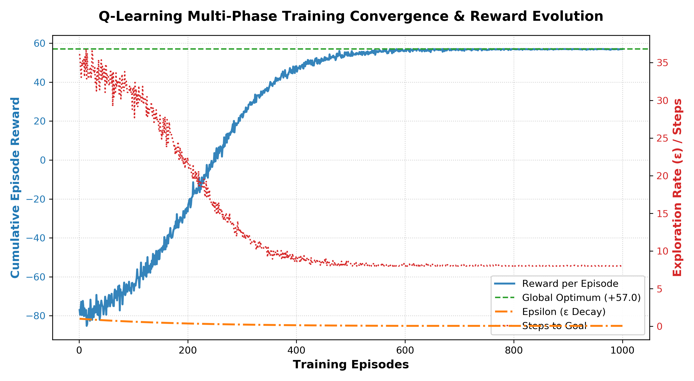
Figure 2. Reported Q-learning training curves.
Figure 2 shows the reported reward rising from negative values toward a horizontal reference at +57 over 1,000 episodes. The steps curve decreases toward eight, and epsilon decreases toward its stated floor. This is qualitatively consistent with an agent increasingly selecting a short successful route. Nevertheless, no raw episode data, random seeds, smoothing settings, or independent repetitions accompany the image. The plot should therefore be read as a supplied summary, not as a statistical demonstration of convergence.
The right axis combines exploration probability and step count. Since epsilon ranges only from 0.05 to 1.0 while path length is much larger, its curve is compressed near the bottom. Separate axes or panels would make future plots easier to interpret. Smooth late-stage rewards also do not establish zero variability in individual training episodes when five-percent exploration remains active.

Reward-accounting check
The reported +57 total follows from seven rewards of +1 and a final reward of +50. However, for an ordinary move that reduces Manhattan distance from d to d - 1, the stated shaping rule gives -1 + 0.9[-2(d - 1)] - [-2d] = 0.8 + 0.2d. For the seven nonterminal moves with distances 8 through 2, these rewards sum to 12.6. Adding the unshaped terminal reward gives an undiscounted total of 62.6, not 57.
This discrepancy does not invalidate the eight-step route, but it prevents a firm interpretation of the reward curve as an output of the exact formula presented. The implementation reward function and plotting script should be reconciled before reporting a numerical reward optimum. Discounted return and undiscounted episode reward must also be labeled separately.

Exploration schedule
The stated multiplier reaches approximately 0.50 after 138 updates and the 0.05 floor after about 598 updates. These values are consistent with the schedule. They describe action-selection probabilities, not guaranteed coverage of all state-action pairs. A proper evaluation should freeze the learned table and run greedy episodes separately from exploratory training.

5.2 Discrete route and optimality
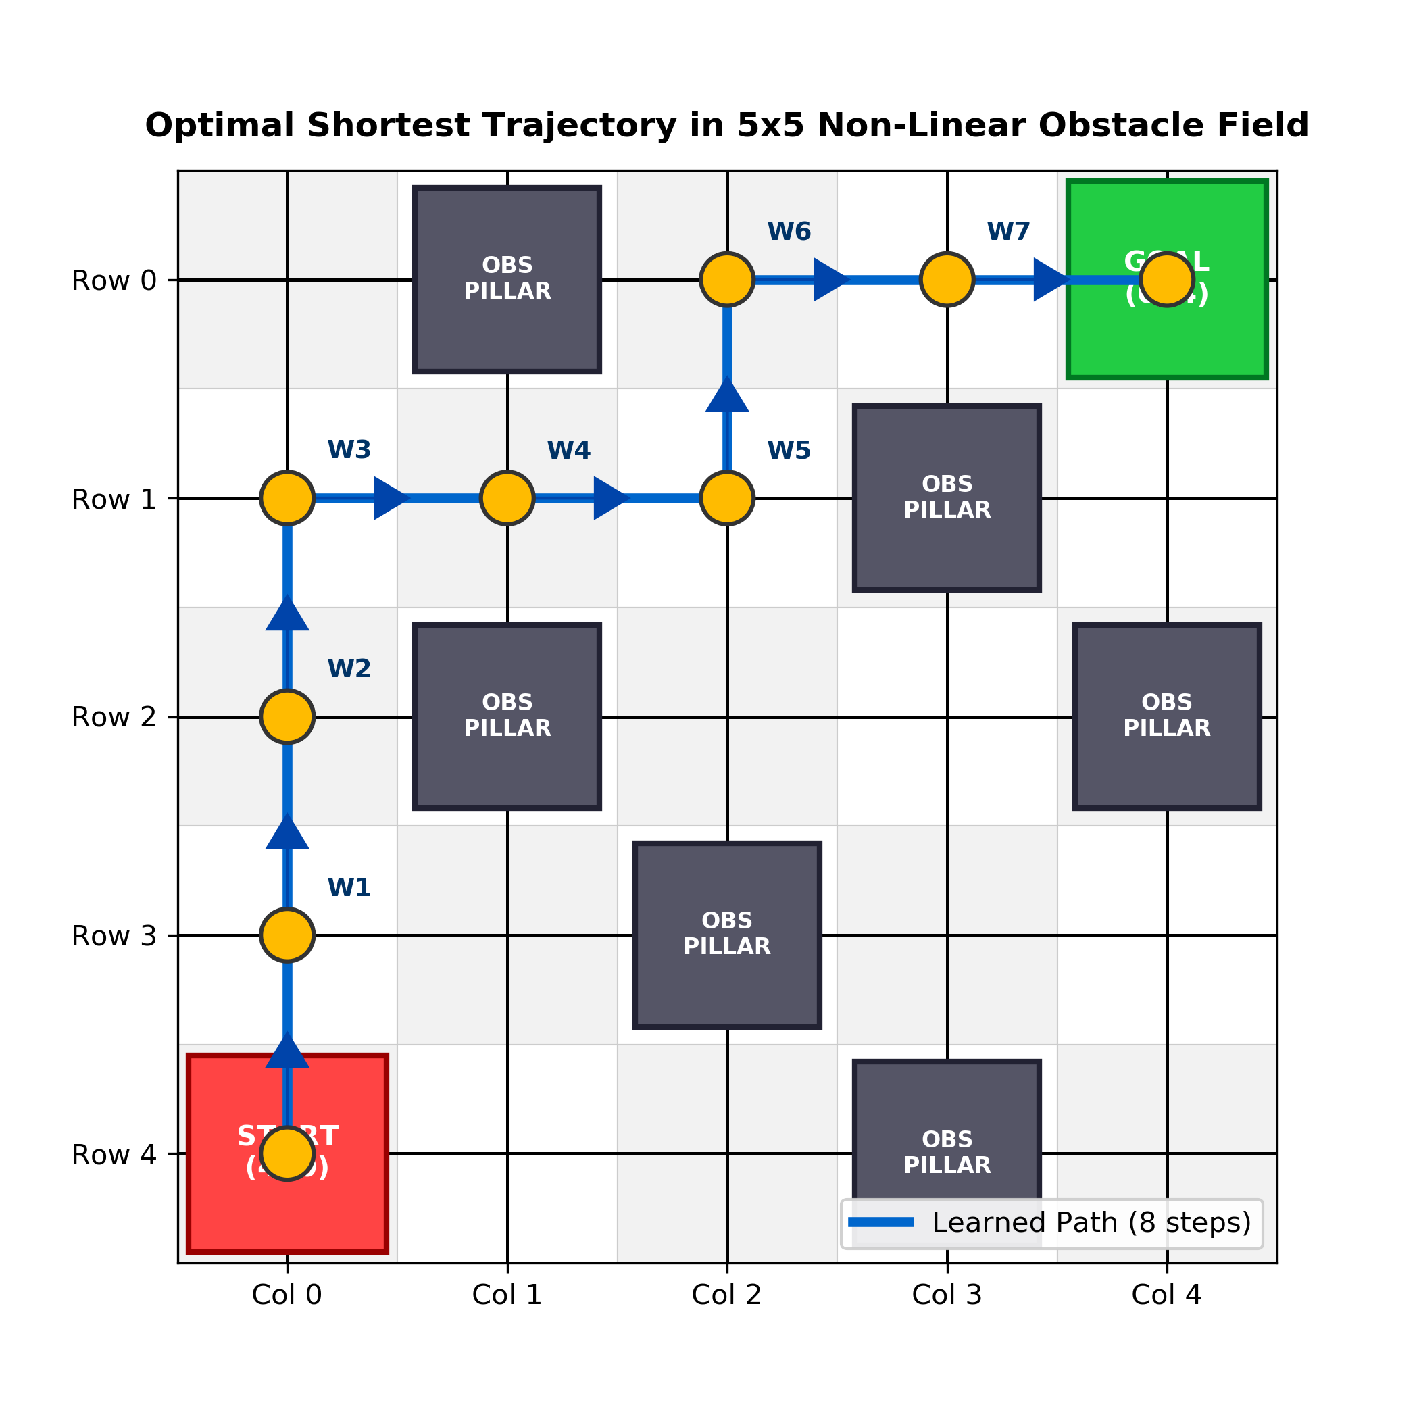
Figure 3. Eight-step route in the discrete grid.
Table 4. Route waypoints and world coordinates.
Waypoint | Grid (r, c) | Action into cell | World (x, y), m
W0 | (4, 0) | Start | (0, 0)
W1 | (3, 0) | Up | (2, 0)
W2 | (2, 0) | Up | (4, 0)
W3 | (1, 0) | Up | (6, 0)
W4 | (1, 1) | Right | (6, -2)
W5 | (1, 2) | Right | (6, -4)
W6 | (0, 2) | Up | (8, -4)
W7 | (0, 3) | Right | (8, -6)
W8 | (0, 4) | Right | (8, -8)
The start-to-goal Manhattan distance is |4 - 0| + |0 - 4| = 8. Every cardinal action changes this distance by at most one, so no valid route can use fewer than eight transitions. The illustrated route uses exactly eight and avoids all six listed obstacles. Its nominal center-to-center length is 16 m at 2 m per transition.
A breadth-first enumeration of valid paths in the stated obstacle grid confirms one eight-transition route, matching Table 4. This independently checks uniqueness for this particular layout; uniqueness does not follow from the Manhattan lower bound alone. The check validates the discrete geometry, not whether training repeatedly recovered the route or whether the physical drone followed it precisely.

5.3 State-value interpretation
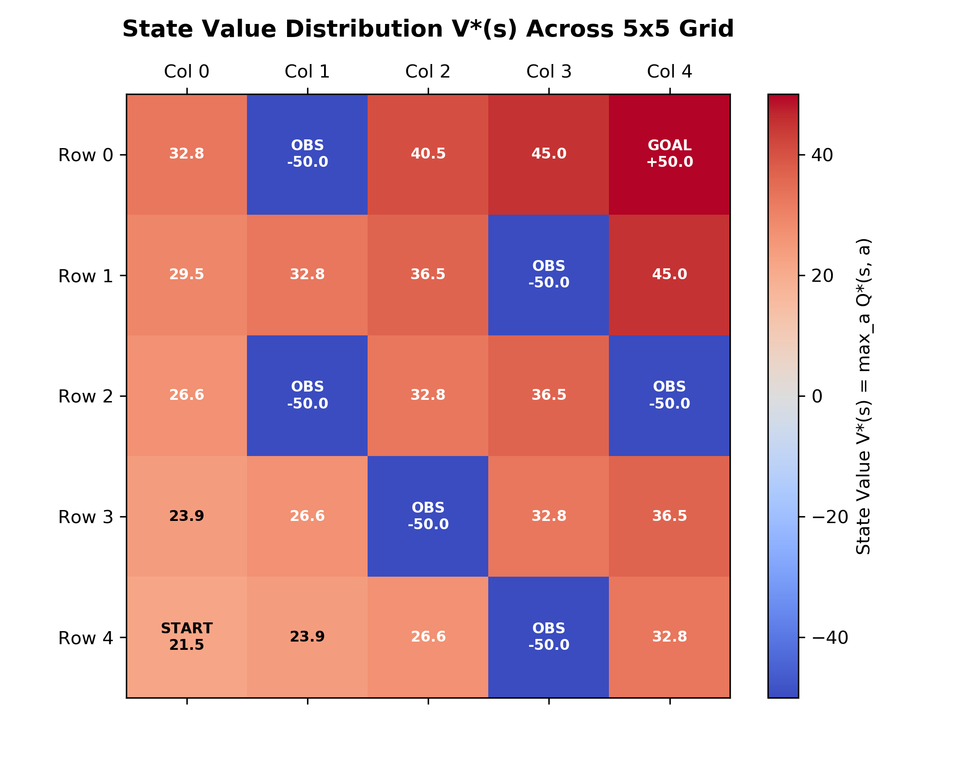
Figure 4. Supplied state-value visualization.
Figure 4 assigns higher displayed values to cells nearer the goal and marks blocked cells as -50. The route values shown in the image are 21.5, 23.9, 26.6, 29.5, 32.8, 36.5, 40.5, 45.0, and 50.0. These are the image values; they differ from the numerical sequence quoted in the original prose.
Several displayed numbers closely resemble distance-based discounting of a goal reward. For example, 50 x 0.9^8 is approximately 21.5. This pattern is not, by itself, evidence that the heatmap was calculated from the learned Q-table with step costs and reward shaping. A future export should document the actual array used and the convention for terminal states.
Under the common episodic convention, a terminal state has zero future return after its reward is received. Displaying +50 at the goal can instead be a visual annotation of the entry reward. Similarly, -50 at an obstacle can denote a penalty rather than the value of a state in which the agent makes decisions. The report treats these labels as visualization conventions rather than verified Bellman-optimal values.
The image supports a qualitative interpretation of attraction toward the goal and avoidance of blocked cells. Claims of a smooth learned potential field, the absence of all local traps, or exact Q-value convergence require direct access to the saved table and transition rules. A heatmap should complement a greedy-policy test, not replace it.

5.4 Visual flight sequence
Figures 5-9 show the supplied Gazebo screenshots in filename order. Their captions describe visible positions and orientation changes only. The screenshots do not contain the detailed position, velocity, yaw, and mission timestamps claimed in the original report.
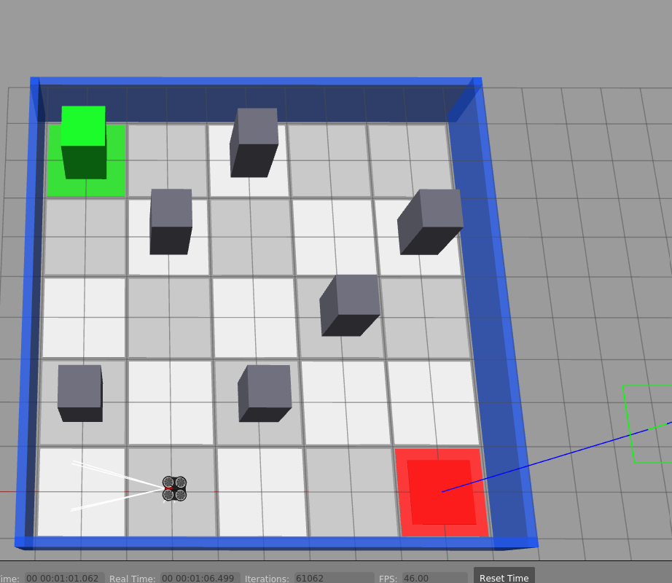
Figure 5. Drone displacement away from the start area.
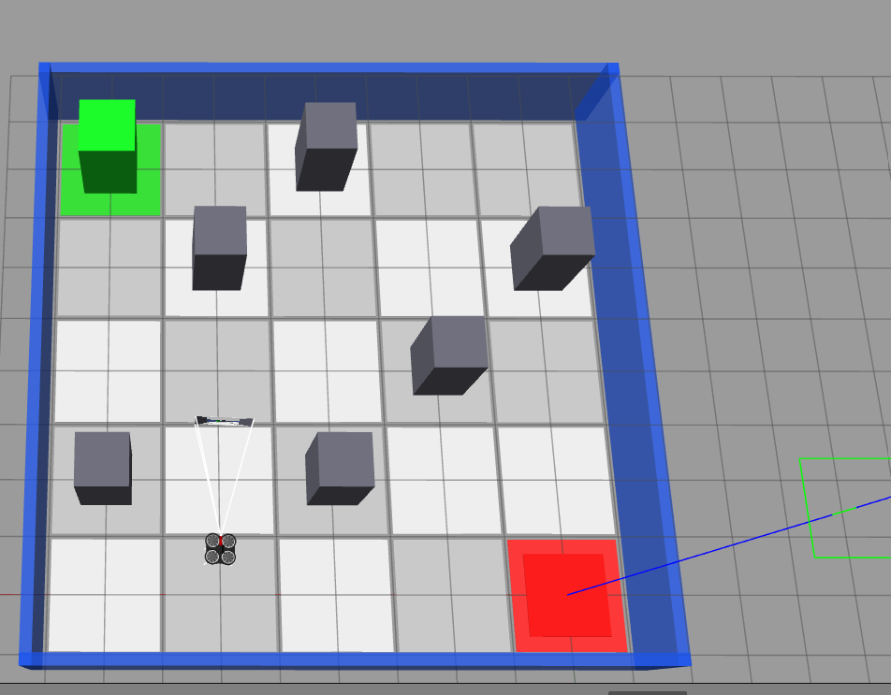
Figure 6. Heading change during navigation.
The drone is visibly separated from the red start pad and subsequently changes heading. This is consistent with waypoint traversal, but image perspective prevents precise identification of a grid state or quantitative yaw error. Simulator time visible in some frames is not necessarily elapsed time from mission start.

5.4 Visual flight sequence (continued)
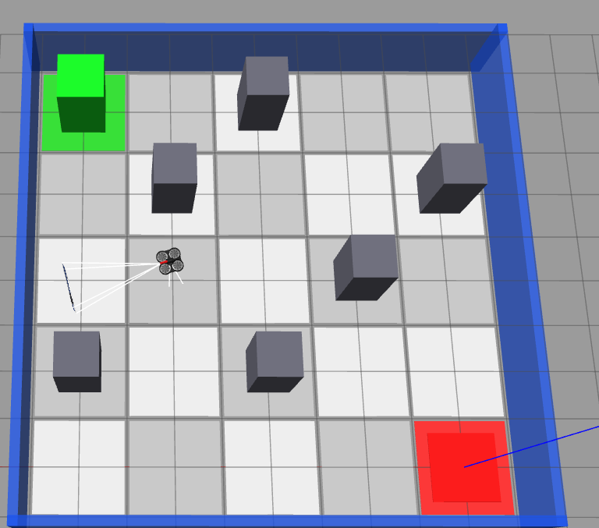
Figure 7. Drone in the interior corridor.
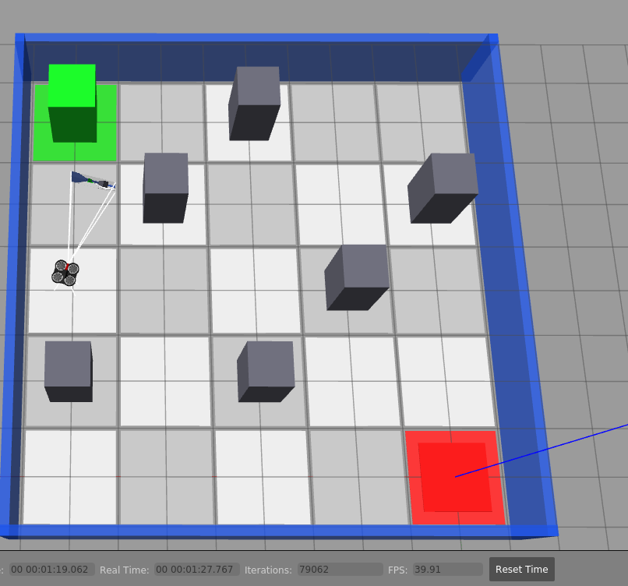
Figure 8. Drone approaching the goal-side corridor.
The sequence places the drone in an interior corridor and then closer to the goal side of the arena. The images provide useful qualitative evidence of motion through the obstacle field. They do not establish continuous collision-free clearance between captures, the commanded speed, or exact tracking error. Those quantities require a time-stamped pose stream and collision records.
The screenshot viewpoint is not identical to the route-map orientation. A camera-to-world transform or labeled grid overlay would be needed for a strict frame-by-frame comparison with Table 4. The figures are retained intact so that visible simulator details are not lost.

5.5 Reported control performance
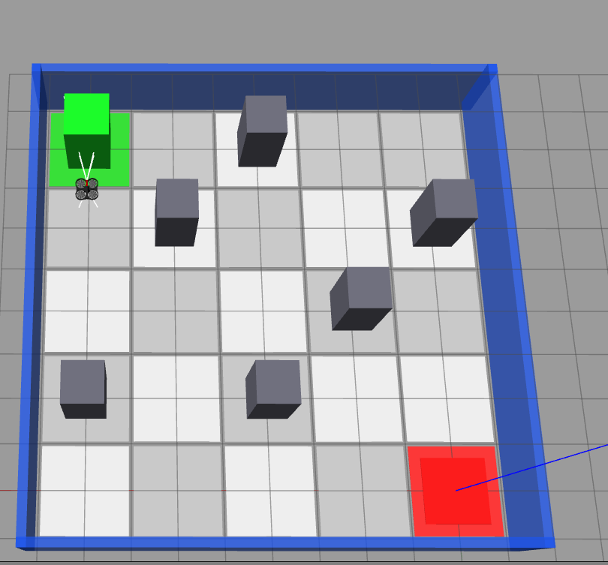
Figure 9. Drone near the green goal marker.
The last supplied frame shows the drone near the green goal marker. It supports goal approach but does not independently prove touchdown, sub-10 cm accuracy, or repeated-trial success. The following values are retained from the source report as reported measurements, not newly measured results.
Table 5. Reported open-loop and closed-loop results.
Metric | Open-loop | Closed-loop
Mean turn for 90-degree target | 63.6 degrees | 89.8 degrees
Mean travel for 2 m target | 1.52 m | 1.99 m
Example terminal position, m | (5.56, -6.82) | (7.94, -7.98)
Example terminal error, m | 2.71 (recalculated) | 0.063 (recalculated)
Reported collision proportion | 70% | 0%
Reported trial count | 10 | 10
The terminal error is recalculated as the Euclidean distance to (8, -8). The open-loop example gives sqrt(2.44^2 + 1.18^2) = 2.71 m, while the closed-loop example gives sqrt(0.06^2 + 0.02^2) = 0.063 m. These are example endpoint errors, not means over ten runs.
The stated mean angular and distance errors would favor feedback control if confirmed by logs. However, standard deviations, per-trial endpoints, collision events, and identical initial conditions are absent. Zero observed collisions in ten reported trials is not a guarantee of future safety. The original 18.9 s mission duration is also unsupported by the screenshots and is shorter than 16 m / 0.65 m/s = 24.6 s for exact nominal waypoint traversal, even before turning and landing.

6. Discussion

6.1 What the implementation demonstrates
The strongest result is geometric: the supplied trajectory reaches the goal in the minimum possible number of cardinal grid transitions. The architecture also illustrates a useful separation of responsibilities. Q-learning chooses actions in a discrete planning model, while pose feedback reduces execution error in a continuous simulator. A successful grid policy is therefore not equivalent to a complete learned flight controller.
This separation makes the project suitable for studying basic reinforcement learning. The table is small enough to inspect, the reward design is explicit, and greedy rollout can be checked against a shortest-path baseline. It also exposes a sim-to-real limitation: an agent can learn an effective policy in a simplified environment while depending on privileged simulator information during execution.

6.2 Algorithm comparisons and shaping
SARSA may learn routes that account for the collision risk of continued exploratory actions, whereas Q-learning targets greedy action values. That distinction can explain different behavior near obstacles [1, 4], but the provided materials contain no matched SARSA curves or repeated-seed comparison. The claim that Q-learning outperformed SARSA by a specific path length or learning speed is therefore not established here.
The original shaping discussion compares first goal discovery without shaping to convergence with shaping. These are different endpoints and cannot support the claimed 6.7-fold sample-efficiency gain. A fair ablation would use the same environment, seeds, evaluation criterion, episode budget, and stopping rule, varying only the shaping term. It should report distributions rather than one run.
For policy-invariance arguments, the shaping term must be handled consistently across transitions and terminals [3]. With a terminal potential of zero, the telescoping contribution reduces to a start-state offset for a completed episode. Selectively replacing shaped rewards by fixed terminal or boundary rewards changes the assumptions and requires a separate analysis.

6.3 Limits and next experiments
The current model uses a fixed grid, stationary obstacles, cardinal actions, and a nominal fixed altitude. It does not evaluate moving obstacles, noisy localization, wind disturbance, battery use, or flight in unknown three-dimensional geometry. Ground-truth pose should be replaced by a realistic estimator before any hardware deployment. Collision clearance should be measured from obstacle surfaces and the rotor envelope, not inferred only from obstacle-centroid distances.
Recommended follow-up experiments are repeated training seeds, a breadth-first-search or A* baseline, a reward-shaping ablation, matched Q-learning and SARSA evaluation, and controlled pose-noise tests. A raw-data archive should include episode rewards, transition counts, success flags, collision events, saved Q-tables, and flight pose histories. These checks would make the report auditable without overstating the available evidence.

6.4 Interpreting performance fairly
A useful tracking measure is root-mean-square position error relative to a time-aligned reference trajectory. If only waypoint targets are available, distance to the active waypoint should not be called trajectory error without qualification: that distance is expected to be large immediately after switching targets. Endpoint error measures final accuracy but says little about clearance along the route. Collision rate and goal-reaching rate should be reported separately because an agent could reach the goal after an unsafe contact.
A fair algorithm comparison holds the reward function, obstacle layout, training budget, evaluation policy, and random-seed set constant. Report both central tendency and variability. A single fast run can be misleading if other runs fail. Likewise, an eight-step policy is optimal for transition count in this grid, but it is not necessarily optimal for flight time or energy. Rotational maneuvers, acceleration, and braking can make two equal-length routes physically different. Future work should define the optimization objective before drawing conclusions about efficiency.

7. Conclusion
The project presents a practical combination of tabular reinforcement learning and closed-loop waypoint tracking for a simulated quadrotor. In the stated 5 x 5 grid, the supplied route avoids six blocked cells and reaches the goal in eight transitions. Since the Manhattan lower bound is eight, this is a shortest route for the discrete task. The screenshots additionally show movement through the arena toward the green goal marker.
The training figure reports increasing reward and decreasing path length, but the exact reward formula and plotted total need reconciliation. The state-value image should also be checked against the saved Q-table. Precise turn accuracy, terminal error, collision rates, and mission duration remain reported or unverified quantities rather than results independently confirmed from the attachments.
The principal lesson is that algorithm design, control integration, and experimental reporting must agree. A small RL model can explain route selection clearly, while a feedback controller addresses physical tracking. Reliable conclusions require both a valid planning abstraction and recorded evidence of execution. The current materials support the navigation concept and route-length result, but not broad claims of guaranteed convergence or deployment-level safety.

7.1 Reproducibility checklist
Record package versions, drone model, physics settings, world file, and the exact reward implementation.
Save random seeds, initial Q-table settings, episode termination rules, and action tie-breaking behavior.
Keep training logs separate from greedy evaluation logs, and state whether any curves are smoothed.
Export the learned Q-table and reproduce the heatmap directly from that array.
Log time-stamped pose, command velocity, waypoint acceptance, landing events, and collisions.
Use repeated runs and report means, dispersion, trial counts, and failure cases.

7.2 Future work
A next version could use perception-derived states and noisy localization before expanding to continuous or three-dimensional control. Deep reinforcement learning may be relevant for high-dimensional observations [7], but it is not necessary merely to solve this small grid. Strong tabular baselines and accurate experimental records should come first. Hardware tests would additionally require a safety controller, geofencing, emergency stop behavior, and a localization system that does not depend on simulator ground truth.

8. References
[1] Sutton, R. S., and Barto, A. G. (2018). Reinforcement Learning: An Introduction. 2nd edition. MIT Press.
[2] Watkins, C. J. C. H., and Dayan, P. (1992). Q-learning. Machine Learning, 8, 279-292. https://doi.org/10.1007/BF00992698
[3] Ng, A. Y., Harada, D., and Russell, S. (1999). Policy invariance under reward transformations: Theory and application to reward shaping. Proceedings of the 16th International Conference on Machine Learning, 278-287.
[4] Rummery, G. A., and Niranjan, M. (1994). On-line Q-learning using connectionist systems. Technical Report CUED/F-INFENG/TR 166. Cambridge University Engineering Department.
[5] Quigley, M., Conley, K., Gerkey, B., Faust, J., Foote, T., Leibs, J., Wheeler, R., and Ng, A. Y. (2009). ROS: an open-source Robot Operating System. ICRA Workshop on Open Source Software.
[6] Koenig, N., and Howard, A. (2004). Design and use paradigms for Gazebo, an open-source multi-robot simulator. Proceedings of the IEEE/RSJ International Conference on Intelligent Robots and Systems, 2149-2154. https://doi.org/10.1109/IROS.2004.1389727
[7] Mnih, V., et al. (2015). Human-level control through deep reinforcement learning. Nature, 518, 529-533. https://doi.org/10.1038/nature14236

Project source and figure provenance
Project-specific configuration and reported numerical results are drawn from the supplied PROJECT_REPORT Markdown document dated October 2026. Figures 1 and 5-9 are the six uploaded Gazebo screenshots. Figures 2-4 are the supplied training-curve, trajectory-map, and state-value images. These project materials are not independently reproduced experiments. No raw training dataset, flight log, or executable implementation was supplied with the report.
The prose has been reorganized and rewritten for clarity, and established theoretical statements are attributed to the references above. No plagiarism scan or AI-detection test has been performed. Similarity and automated authorship scores depend on the checker, reference handling, and institutional policy; this report makes no numerical guarantee about them.

