**Rohith S S - Report AutoMation**

Set-up your PowerShell to run the command.  
Open

Get Exported File from MongoDB and place it in DataToExprt folder.

Place the files named as PFB.

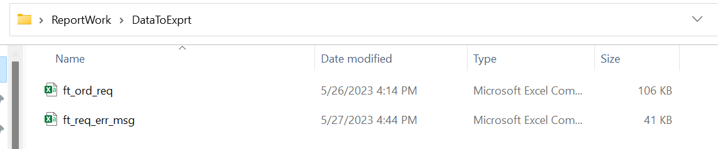

Right click - Open with edit option and Run in this order.

1. Remove_Data_Before_Vlookup
2. GotVlookUP
3. Getcountfromthefile

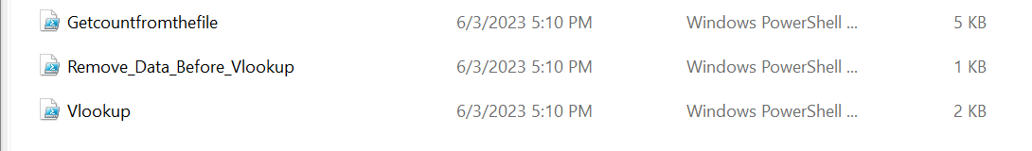

Place the correct file path inside the file, if you specified the different file name.

Run the Program Getcountfromthefile Get the Result

After setting up and executed the code Just replace the files in File Path and delete exported file after the execution (Data Privacy)

