EXP-1: ARDUINO UNO-BASED SMART HOME SAFETY AND OCCUPANCY MONITORING SYSTEM USING GAS, PIR AND ULTRASONIC SENSORS

CODE:
#define GAS_PIN A0
#define PIR_PIN 2
#define TRIG_PIN 8
#define ECHO_PIN 9
#define BUZZER 10
#define LED 11

void setup()
{
Serial.begin(9600);

pinMode(PIR_PIN, INPUT);
pinMode(TRIG_PIN, OUTPUT);
pinMode(ECHO_PIN, INPUT);
pinMode(BUZZER, OUTPUT);
pinMode(LED, OUTPUT);
}

void loop()
{
int gas = analogRead(GAS_PIN);
int motion = digitalRead(PIR_PIN);

digitalWrite(TRIG_PIN, LOW);
delayMicroseconds(2);

digitalWrite(TRIG_PIN, HIGH);
delayMicroseconds(10);

digitalWrite(TRIG_PIN, LOW);

long duration = pulseIn(ECHO_PIN, HIGH);
float distance = duration * 0.0343 / 2;

if (gas > 500)
digitalWrite(BUZZER, HIGH);
else
digitalWrite(BUZZER, LOW);

digitalWrite(LED, motion);

Serial.print("Gas Level: ");
Serial.println(gas);

Serial.print("Motion: ");

if (motion)
Serial.println("DETECTED");
else
Serial.println("NOT DETECTED");

Serial.print("Distance: ");
Serial.print(distance, 1);
Serial.println(" cm");

if (gas > 500)
Serial.println("GAS ALERT!");
else if (motion)
Serial.println("OCCUPANCY DETECTED");
else
Serial.println("SYSTEM SAFE");

Serial.println("--------------------");

delay(1000);
}

OUTPUT: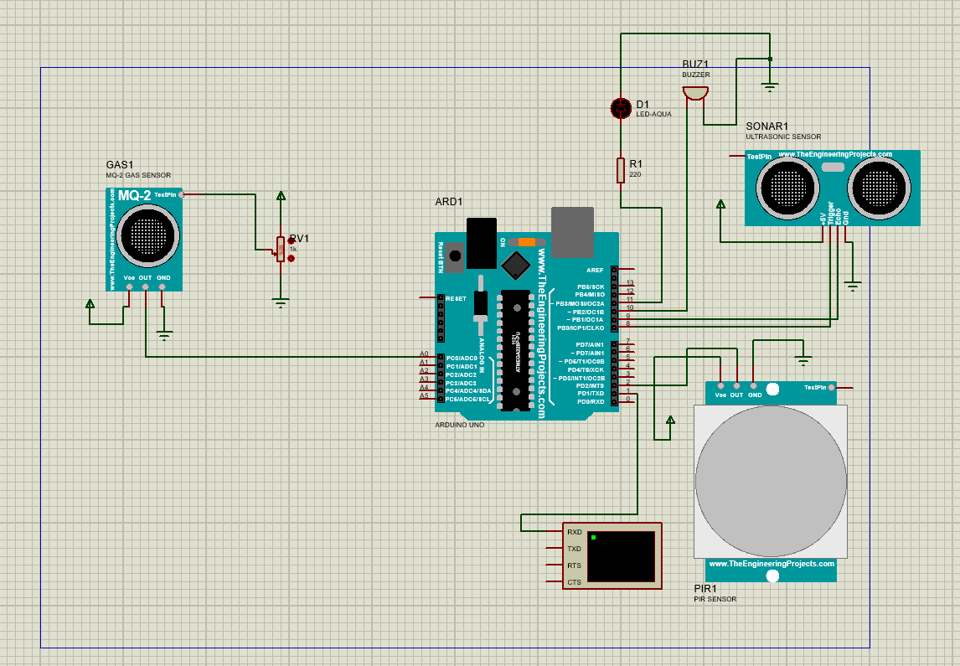

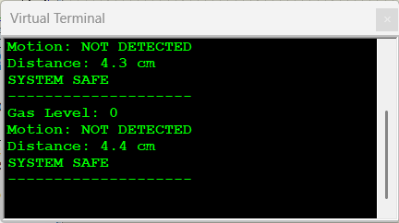

REFLECTION: I learned how to interface gas, PIR, and ultrasonic sensors with Arduino UNO for smart home safety monitoring. I understood how to detect gas leakage, human motion, and object distance using Embedded C programming. This experiment improved my knowledge of sensor interfacing, alert systems, and Proteus simulation.

