EXP-6: INDUSTRIAL HVAC CONTROL FIRMWARE: ADC TEMPERATURE ACQUISITION AND TIMER-INTERRUPT PWM FAN CONTROL

CODE:
#define TEMP A0
#define FAN 8

volatile byte pwm = 0;
volatile byte count = 0;

ISR(TIMER1_COMPA_vect)
{
count++;

if (count >= 100)
count = 0;

digitalWrite(FAN, count < pwm);
}

void setup()
{
Serial.begin(9600);
pinMode(FAN, OUTPUT);

TCCR1A = 0;
TCCR1B = (1 << WGM12) | (1 << CS11);

OCR1A = 199;

TIMSK1 = (1 << OCIE1A);

sei();
}

void loop()
{
int adc = analogRead(TEMP);

float temp = adc * 500.0 / 1023.0;

if (temp < 25)
pwm = 0;
else if (temp < 30)
pwm = 30;
else if (temp < 35)
pwm = 60;
else
pwm = 90;

Serial.print("Temperature: ");
Serial.print(temp, 1);

Serial.print(" C PWM: ");
Serial.print(pwm);

Serial.println("%");

delay(1000);

}

OUTPUT:

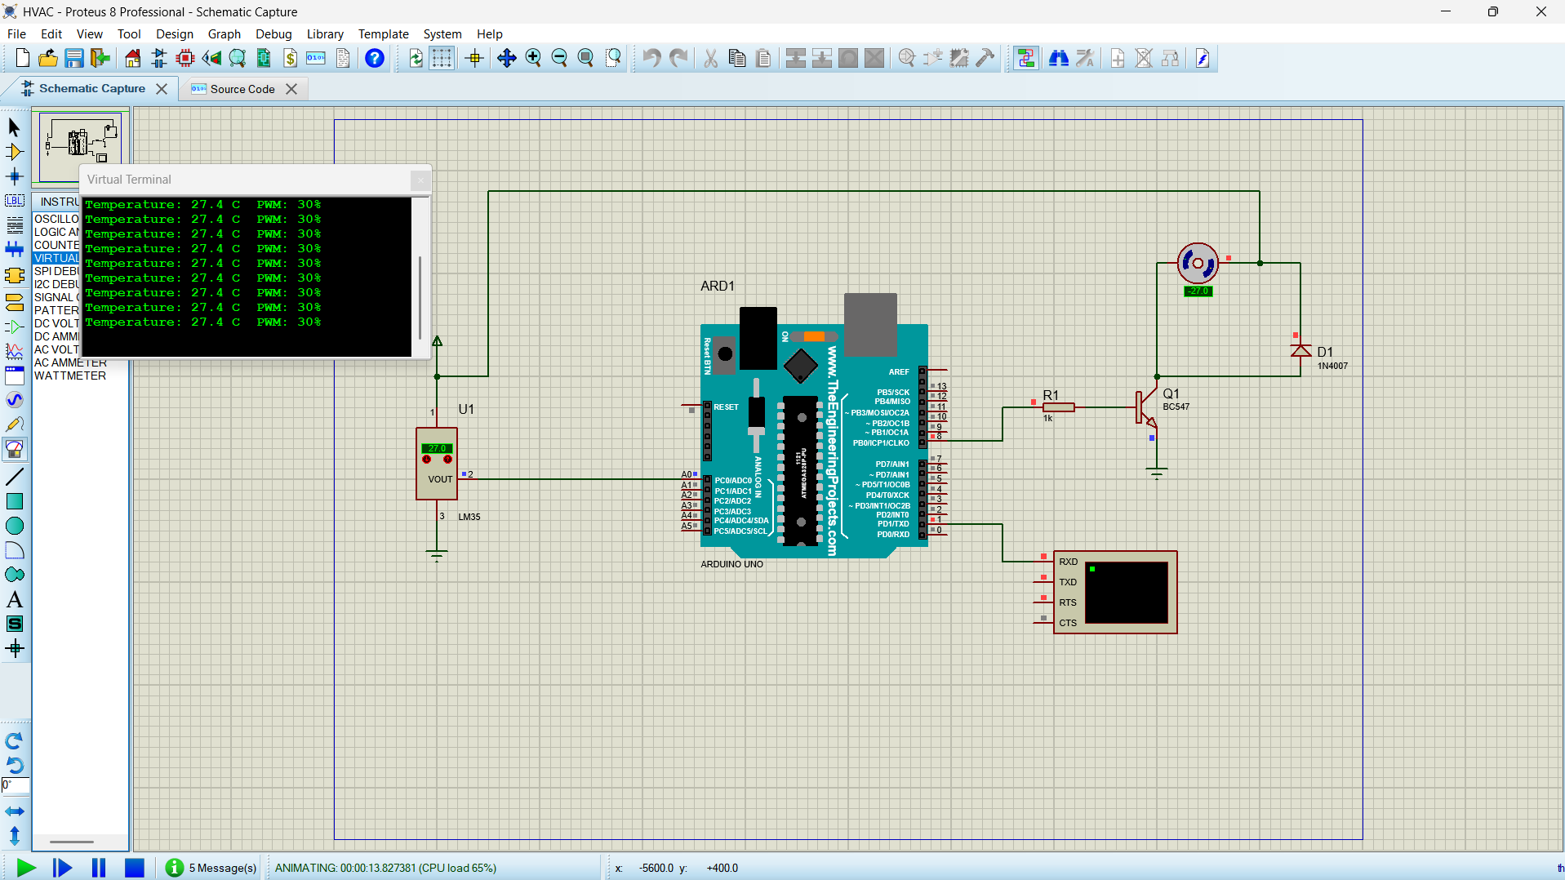

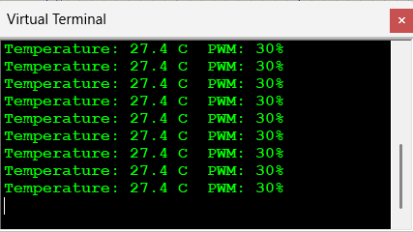

REFLECTION: I learned how to interface the LM35 temperature sensor with Arduino UNO and acquire temperature using ADC. I understood how to control an HVAC fan using timer interrupts and PWM based on temperature. This experiment improved my knowledge of Embedded C programming and Proteus simulation.

