MONGO -DB CRUD OPERATION:
import com.mongodb.client.FindIterable;
import com.mongodb.client.MongoClient;
import com.mongodb.client.MongoClients;
import com.mongodb.client.MongoCollection;
import com.mongodb.client.MongoDatabase;
import com.mongodb.client.model.Filters;
import com.mongodb.client.model.Updates;
import org.bson.Document;

public class Test2 {

public static void main(String[] args) {

// Connect to MongoDB
MongoClient mongoClient = MongoClients.create("mongodb://localhost:27017");

// Access Database and Collection
MongoDatabase database = mongoClient.getDatabase("CollegeDB");
MongoCollection<Document> collection = database.getCollection("Students");

// ==========================
// CREATE (Insert 5 Students)
// ==========================
collection.insertOne(new Document("id", 101)
.append("name", "Aarav")
.append("department", "CSE")
.append("cgpa", 8.5));

collection.insertOne(new Document("id", 102)
.append("name", "Priya")
.append("department", "IT")
.append("cgpa", 9.1));

collection.insertOne(new Document("id", 103)
.append("name", "Rahul")
.append("department", "ECE")
.append("cgpa", 8.0));

collection.insertOne(new Document("id", 104)
.append("name", "Sneha")
.append("department", "ME")
.append("cgpa", 8.8));

collection.insertOne(new Document("id", 105)
.append("name", "Vikram")
.append("department", "CIVIL")
.append("cgpa", 7.9));

System.out.println("5 Documents Inserted Successfully");

// ==========================
// READ (Display All Students)
// ==========================
System.out.println("\nStudent Records:");

FindIterable<Document> students = collection.find();

for (Document doc : students) {
System.out.println(doc.toJson());
}

// ==========================
// UPDATE
// Update CGPA of Student ID 103
// ==========================
collection.updateOne(
Filters.eq("id", 103),
Updates.set("cgpa", 9.3)
);

System.out.println("\nStudent ID 103 Updated Successfully");

// ==========================
// READ Updated Record
// ==========================
Document updatedStudent =
collection.find(Filters.eq("id", 103)).first();

System.out.println("\nUpdated Record:");

if (updatedStudent != null) {
System.out.println(updatedStudent.toJson());
}

// ==========================
// DELETE
// Delete Student ID 105
// ==========================
collection.deleteOne(Filters.eq("id", 105));

System.out.println("\nStudent ID 105 Deleted Successfully");

// ==========================
// DISPLAY FINAL RECORDS
// ==========================
System.out.println("\nFinal Student Records:");

for (Document doc : collection.find()) {
System.out.println(doc.toJson());
}

// Close Connection
mongoClient.close();
}

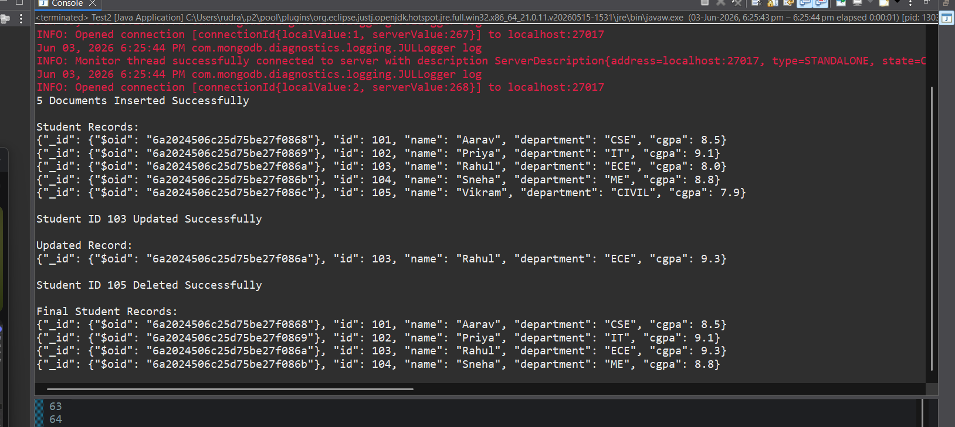

For Many:
package mongodb2;

import com.mongodb.client.FindIterable;
import com.mongodb.client.MongoClient;
import com.mongodb.client.MongoClients;
import com.mongodb.client.MongoCollection;
import com.mongodb.client.MongoDatabase;
import com.mongodb.client.model.Filters;
import com.mongodb.client.model.Updates;

import java.util.Arrays;

import org.bson.Document;

public class Test2 {

public static void main(String[] args) {
// Connect to MongoDB
MongoClient mongoClient = MongoClients.create("mongodb://localhost:27017");
// Access Database and Collection
MongoDatabase database = mongoClient.getDatabase("CollegeDB");
MongoCollection<Document> collection = database.getCollection("Students")
// CREATE (Insert 5 Students)
collection.insertMany(Arrays.asList(
new Document("id", 101)
.append("name", "Aarav")
.append("department", "CSE")
.append("cgpa", 8.5),
new Document("id", 102)
.append("name", "Priya")
.append("department", "IT")
.append("cgpa", 9.1),
new Document("id", 103)
.append("name", "Rahul")
.append("department", "CSE")
.append("cgpa", 8.0),
new Document("id", 104)
.append("name", "Sneha")
.append("department", "ME")
.append("cgpa", 8.8),
new Document("id", 105)
.append("name", "Vikram")
.append("department", "CSE")
.append("cgpa", 7.9)));

System.out.println("5 Documents Inserted Successfully");
// READ (Display All Students)
System.out.println("\nStudent Records:");
for (Document doc : collection.find()) {
System.out.println(doc.toJson());
}
// UPDATE
collection.updateMany(
Filters.eq("department", "CSE"),
Updates.set("department", "Computer Science")
);
System.out.println("\nMultiple Documents Updated Successfully");
// READ Updated Record
System.out.println("\nRecords After Update:");
for (Document doc : collection.find()) {
System.out.println(doc.toJson());
}
// Delete Many
collection.deleteMany(
Filters.eq("department", "Computer Science")
);
System.out.println("\nMultiple Documents Deleted Successfully");
// DISPLAY FINAL RECORDS
System.out.println("\nFinal Student Records:");
for (Document doc : collection.find()) {
System.out.println(doc.toJson());
}
// Close Connection
mongoClient.close();
}
}