AI ASSISTED CODING LAB

ASSIGNMENT 1.2

ENROLLMENT NO :2503A51L14

BATCH NO: 19

NAME: ROHITH GOPAGANI

TASK DESCRIPTION 1: Function to check if a string is a valid palindrome (ignoring spaces and case) and allow Copilot to complete it.

PROMPT 1: generate Function to check if a string is a valid palindrome (ignoring spaces and case).  
• Define a function is_palindrome(s) that returns True if the string is a palindrome and False otherwise.  
• Ignore spaces and make the check case-insensitive.  
• Let GitHub Copilot complete the logic inside the function.

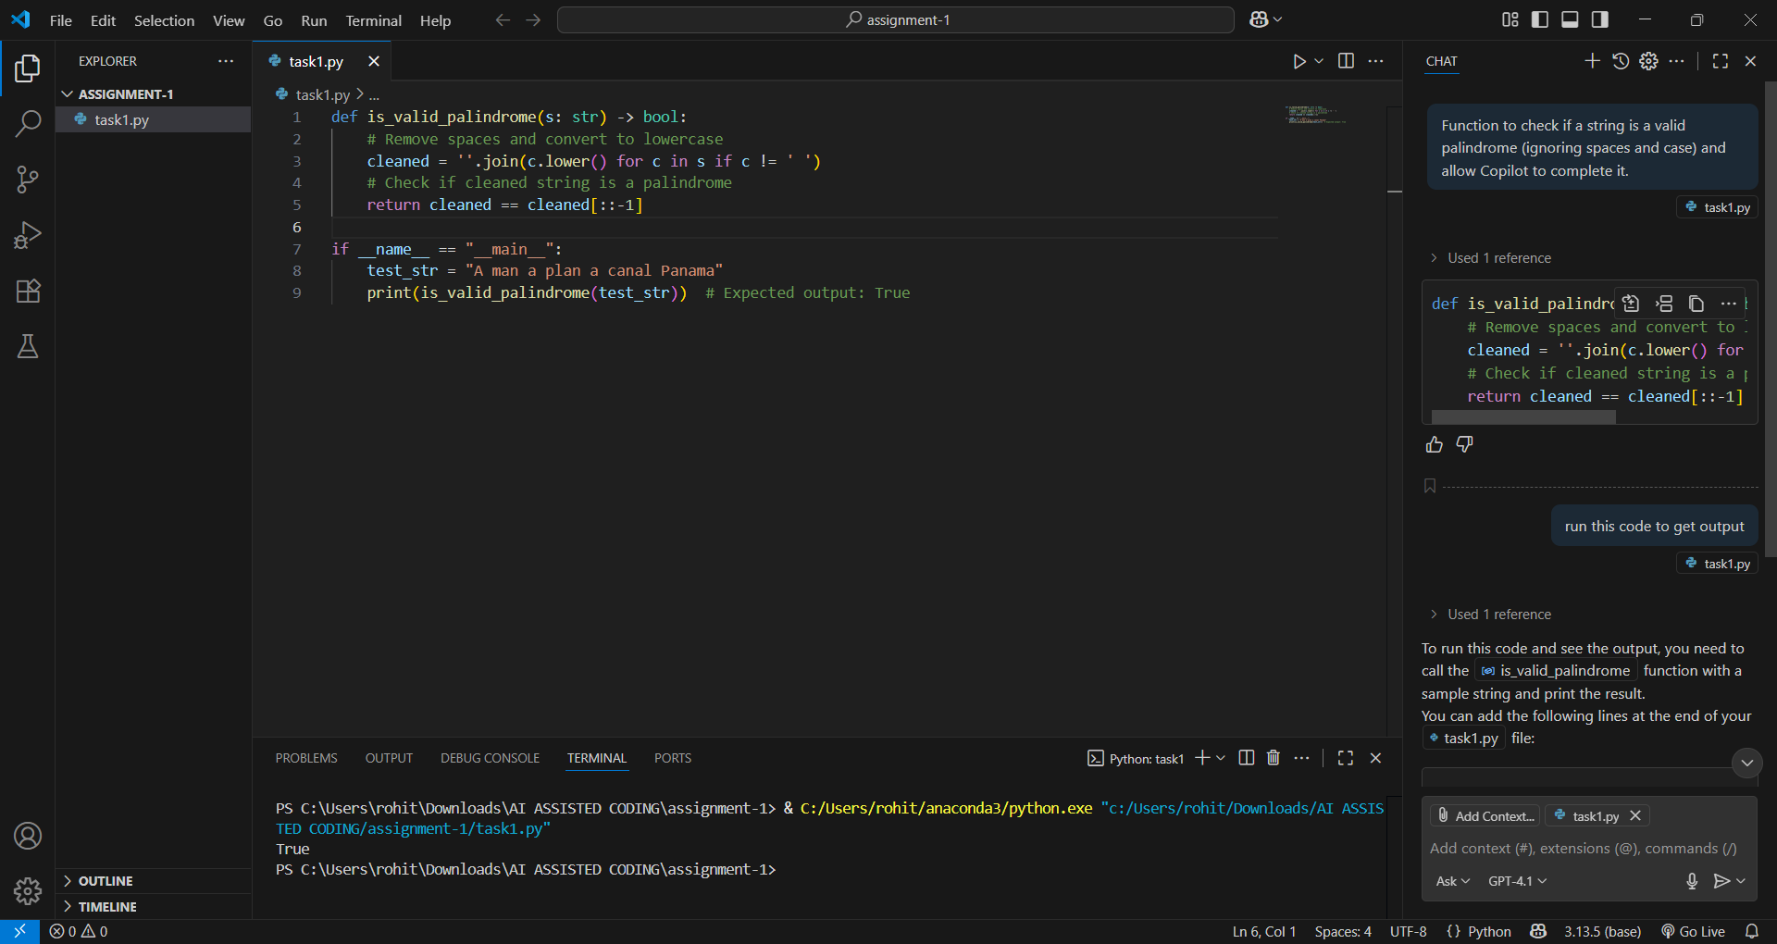

TASK DESCRIPTION 2: Generate a Python function that returns the Fibonacci sequence up to n terms. Prompt with only a function header and docstring

PROMPT 1: Generate a Python function upto 10 sequences that returns the Fibonacci sequence up to n terms. Prompt with only a function header and docstring

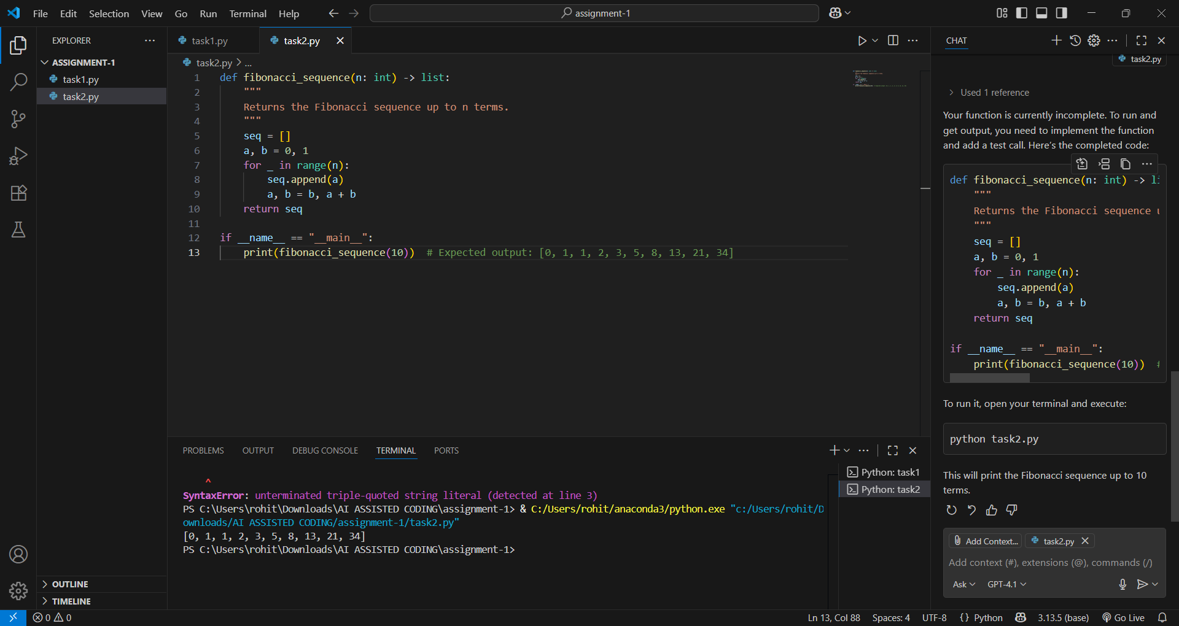

TASK DESPRICTION 3: Function to reverse a string and use Copilot to generate the function.

PROMPT 1: generate a Python function that reverses a given string. Start by writing the comment # Function to reverse a string and let Copilot generate the function implementation

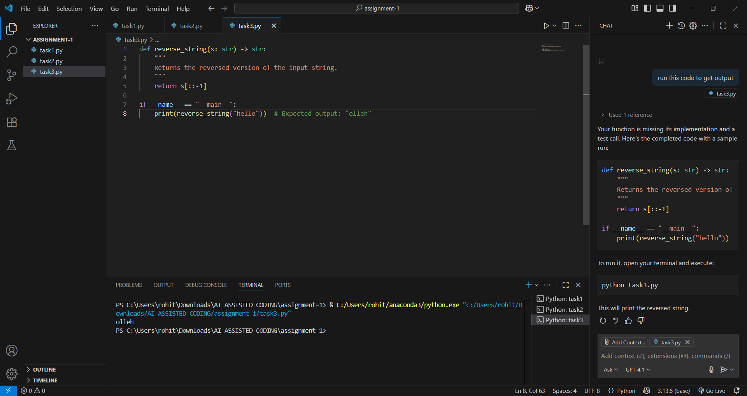

TASK DESCRIPTION 4: Generate a program that simulates a basic calculator (add, subtract, multiply, divide). Write the comment: # Simple calculator with 4 operations and let AI complete it.

PROMPT 1: generate a Python program that simulates a basic calculator capable of performing addition, subtraction, multiplication, and division. Start with the comment # Simple calculator with 4 operations and let the AI complete the rest of the program.

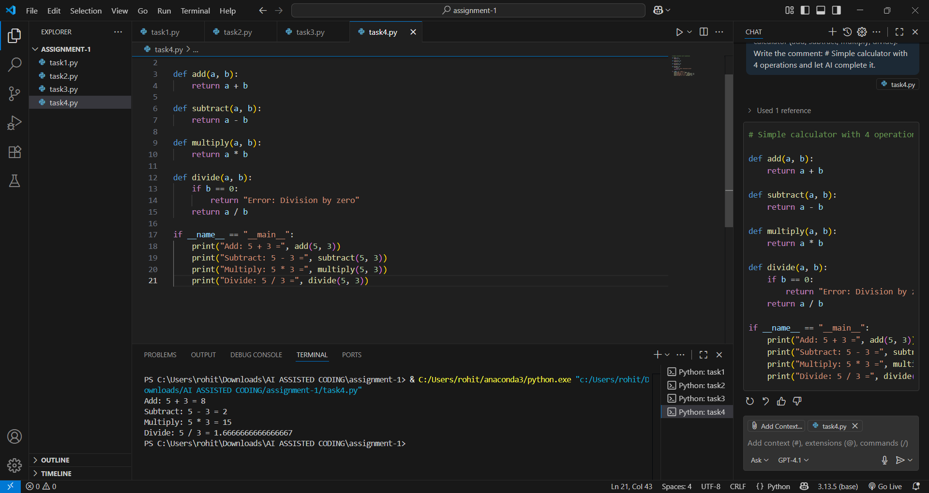

TASK DESCRIPTION 5: Use a comment to instruct AI to write a function that reads a file and returns the number of lines

PROMPT 1: generate a Python function that reads a file and returns the number of lines in it. Begin with the comment # Function to count the number of lines in a file and let the AI complete the function.

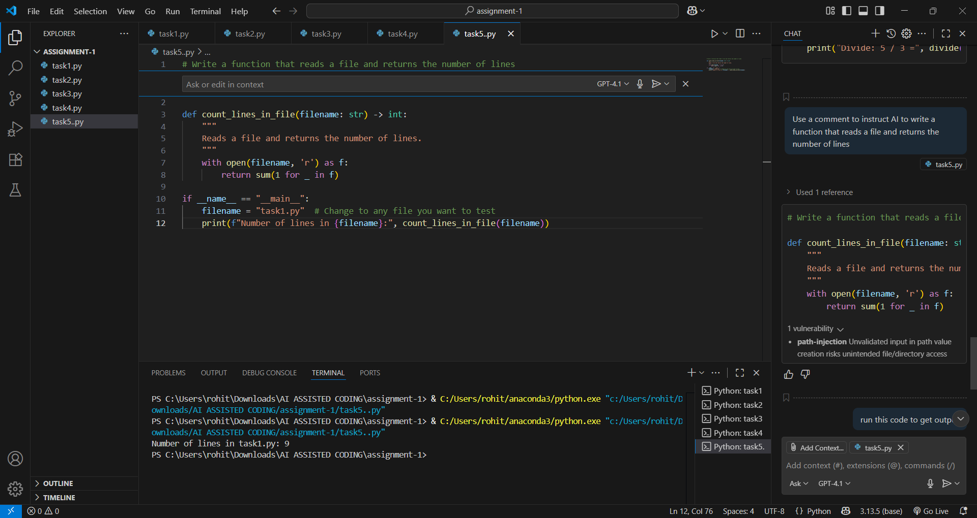

OBSERVATION: This assignment demonstrates practical use of AI-assisted coding tools to solve common programming tasks. By leveraging AI completion models like GitHub Copilot, the user was able to efficiently generate Python code for a variety of standard problems, including palindrome checks, Fibonacci sequences, string reversal, calculator operations, and file handling.

**Key Observations**

* The assignment showcases how AI can accelerate the coding process by accurately filling in function logic from concise prompts and comments.
* Each task starts with a clear function header or descriptive comment, allowing the AI to infer and generate the code structure and implementation for the required functionality.
* The approach encourages understanding of prompt engineering—precisely crafting comments and headers to guide AI models towards correct and optimized solutions.
* The generated code is well-structured and solves the respective problems: handling string manipulation, numerical computations, basic arithmetic, and file I/O.
* Overall, the assignment highlights the synergy between human intent and AI assistance in coding, increasing productivity for both simple and moderately complex programming task