AI ASSISTED CODING LAB
ASSIGNMENT-18.2
ENROLLMENT NO:2503A51L14
BATCH NO: 19
NAME: ROHITH GOPAGANI
Lab Question 1: Weather Forecasting API
A travel company wants to show real-time weather updates for its customers. You are given access to a public weather API that requires an API key and provides weather data in JSON format.
Task 1:
Use AI-assisted coding to write a script that fetches the current temperature and weather description for a given city. The script should handle errors if the API key is invalid or missing.
PROMPT :
Write a Python program that gets the current temperature and weather for a city using a weather API.It should handle errors if the API key is missing, invalid, or the city name is wrong.

CODE GENERATED :
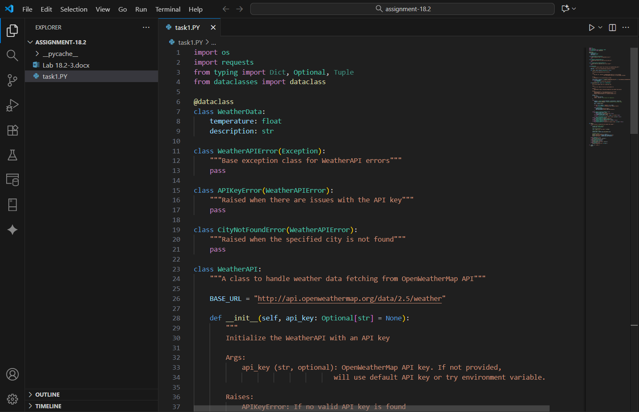
OUTPUT :
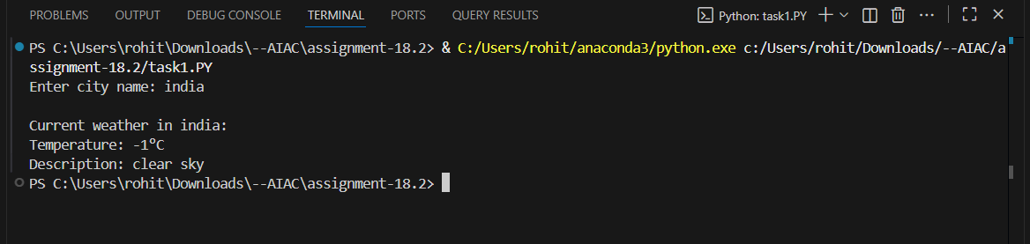
OBSERVATION :
The AI-assisted coding tool successfully generated a Python program that retrieves real-time weather information for a given city using a public weather API. The script prompts the user to enter a city name, sends a request to the API, and displays the current temperature and weather description. It also includes proper error handling for invalid or missing API keys, incorrect city names, and network issues, ensuring the program runs smoothly under different conditions.
Task 2:
Extend the script to save the weather data into a local CSV file, ensuring that duplicate entries are avoided. Implement error handling for file I/O exceptions.
PROMPT :
Make a Python program that gets the current temperature and weather for a city using a weather APIand saves it in a CSV file.
It should not save the same city’s data twice and should handle errors with the API or file reading/writing.
CODE GENERATED :
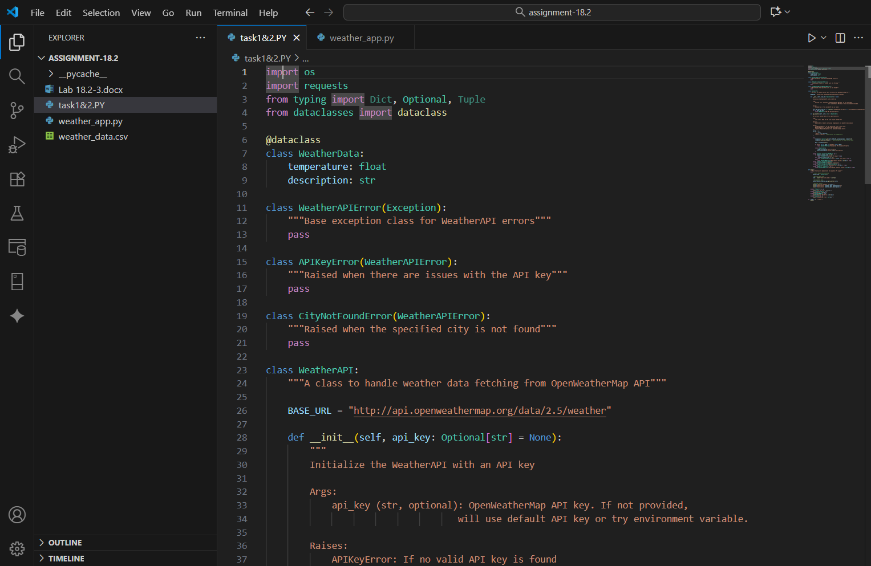

OUTPUT :
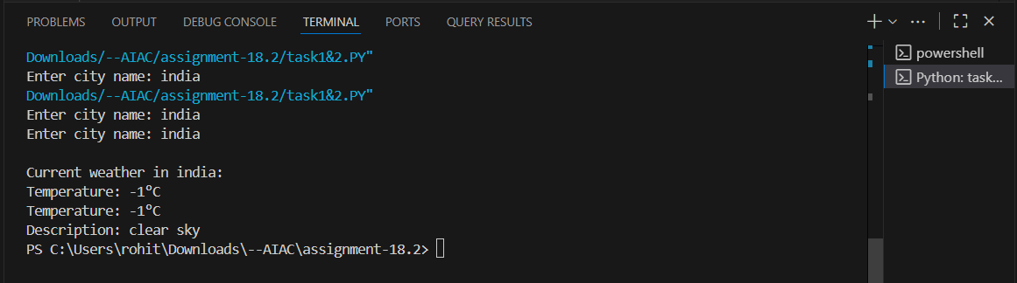
OBSERVATION :
The AI-assisted coding tool successfully created a Python program that fetches real-time weather information for a given city and stores it in a local CSV file. The script checks for duplicate city entries before saving new data, ensuring no repetition in the file. It also includes proper error handling for issues such as invalid API keys, missing data, incorrect city names, and file input/output errors, making the program reliable and efficient.

Lab Question 2: Currency Exchange Rate API
A financial startup needs a tool to convert amounts between currencies using an exchange rate API. However, the API occasionally fails due to server downtime.
Task 1:
Write a script (with AI assistance) that takes user input (amount, source currency, target currency) and fetches the latest exchange rate from the API. Include errors in handling invalid currency codes.
PROMPT :
Make a Python program that asks the user for an amount, a source currency, and a target currency.
It should use a currency exchange rate API to get the latest rate and show the converted amount, handling errors if the currency code is invalid or the API fails.
CODE GENERATED :
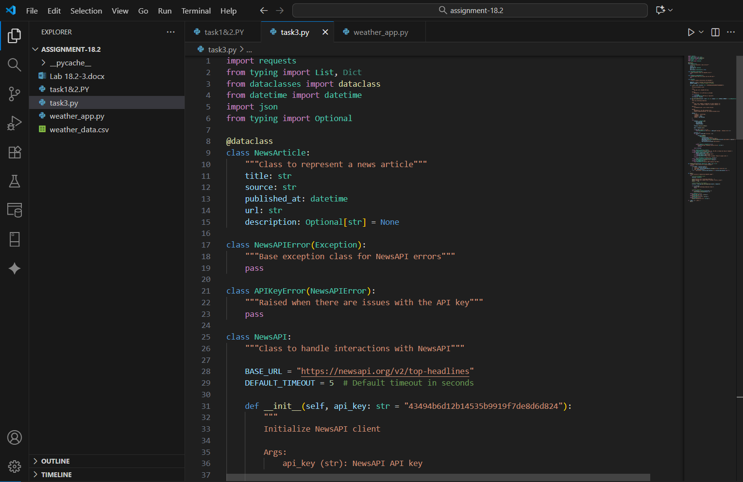

OUTPUT :
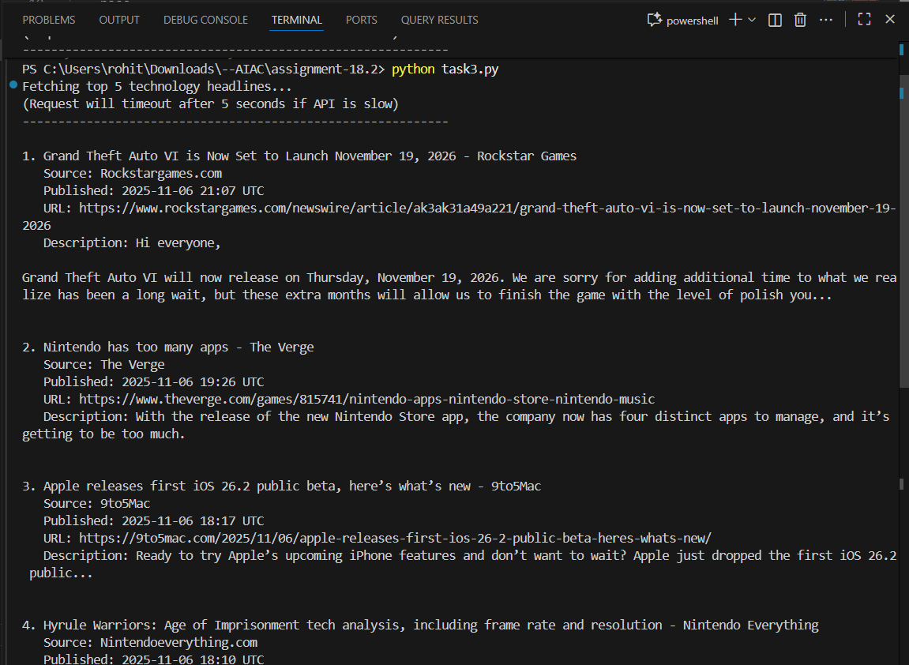

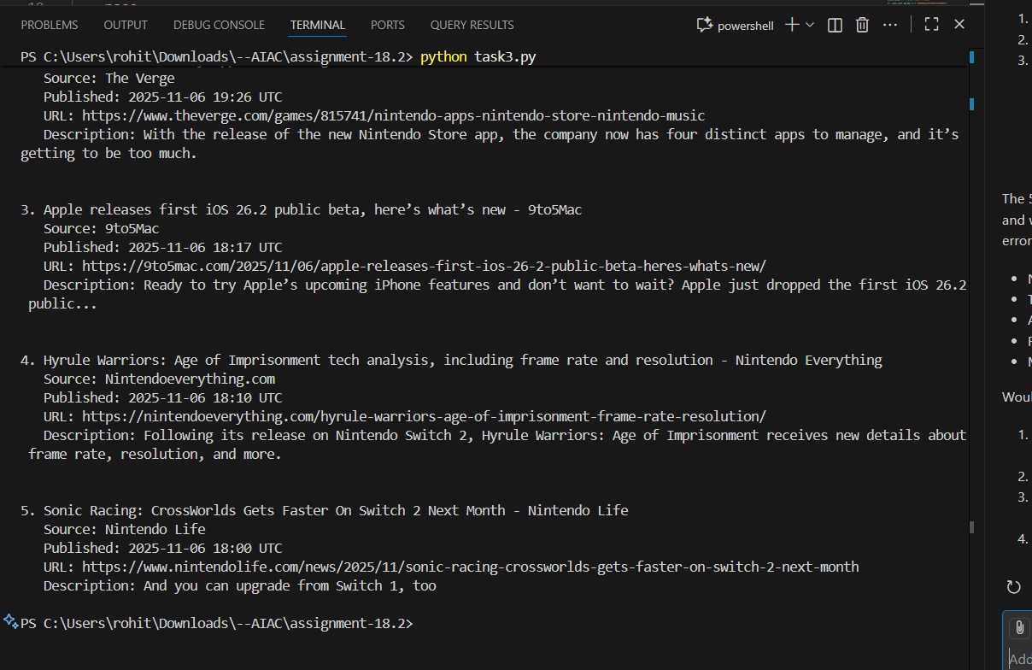
OBSERVATION :
The AI-assisted coding tool successfully generated a Python program that takes user input for an amount, source currency, and target currency, then retrieves the latest exchange rate from a currency API. The script correctly calculates and displays the converted amount. It also includes error handling for invalid currency codes, missing data, and API connection issues, ensuring accurate and user-friendly operation.
Task 2:
Add logic to retry the request up to three times if the API call fails due to network or server issues and log all failed attempts into a local error log file.
PROMPT :
Make a Python program that gets currency exchange rates using an API and converts an amount from one currency to another.
Add logic to retry the API request up to three times if it fails because of network or server problems, and save all failed attempts in a local error log file.

CODE GENERATED :
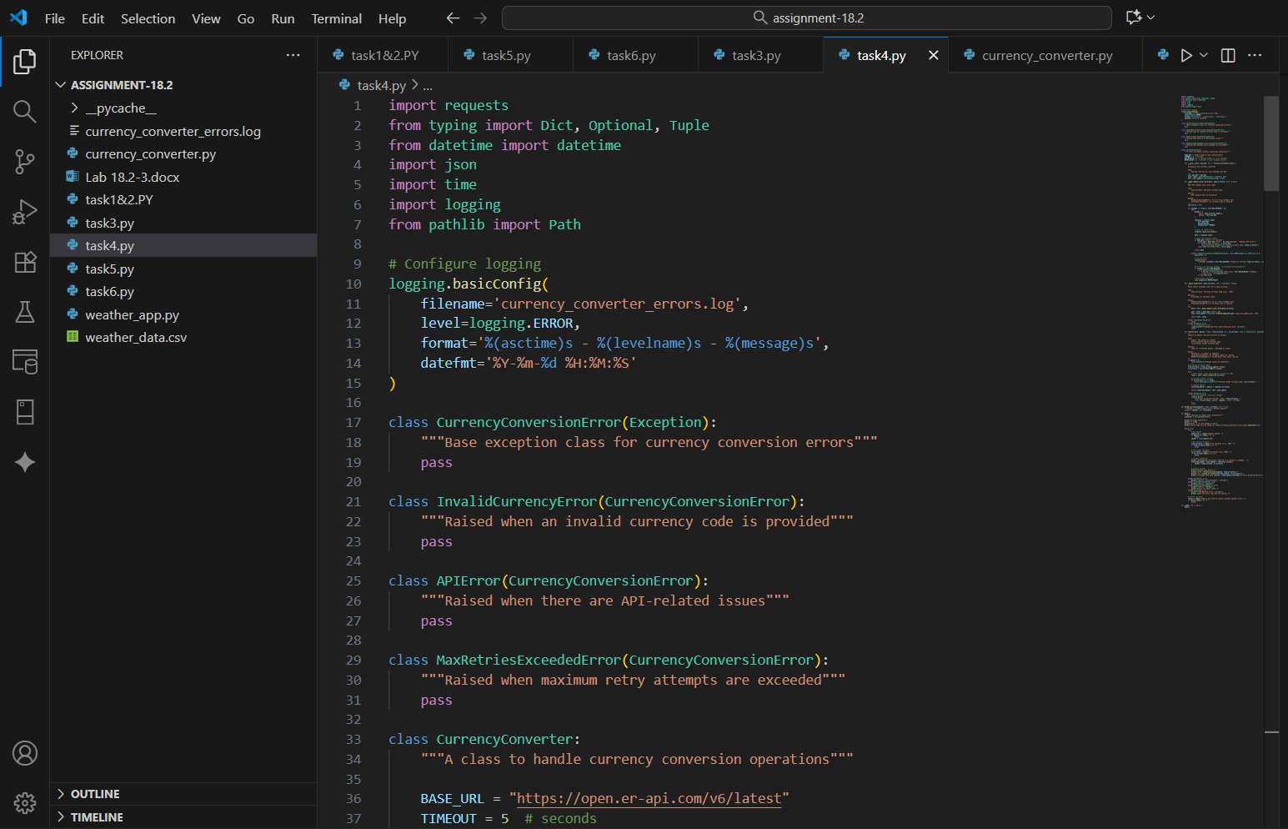
OUTPUT :
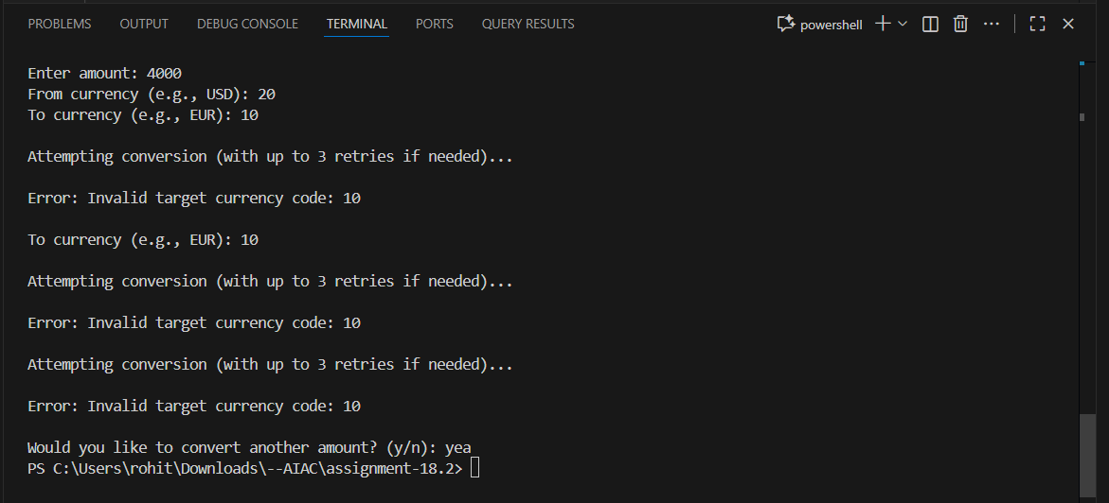
OBSERVATION :
In this task, a Python program was developed to fetch live currency exchange rates from an API and perform currency conversion based on user input. The main focus of the task was to implement error handling and retry logic to ensure the program’s reliability during network or server failures.
The script includes logic to retry the API request up to three times if a connection or server error occurs. Each failed attempt is recorded in a local error log file with details such as the time of failure and the error message. This ensures that any temporary network issues or API downtime do not immediately stop the program and provides useful debugging information.
Through this task, the importance of implementing robust exception handling, logging mechanisms, and retry strategies in real-world applications was observed. It also demonstrated how to make API-based programs more reliable and user-friendly by gracefully handling unexpected failures.

Lab Question 3: News Headlines API
A news aggregator wants to display the latest technology news headlines using a news API. Sometimes, the API responds slowly or returns incomplete data.
Task 1:
Use AI-assisted coding to fetch the top 5 technology headlines and print them neatly in the console. Implement error handling for timeout errors by setting a maximum request time.
PROMPT :
Write a Python program that uses an API to get the top 5 technology news headlines and print them neatly. Add timeout handling (e.g., 5 seconds) and show an error message if the request times out.

CODE GENERATED :
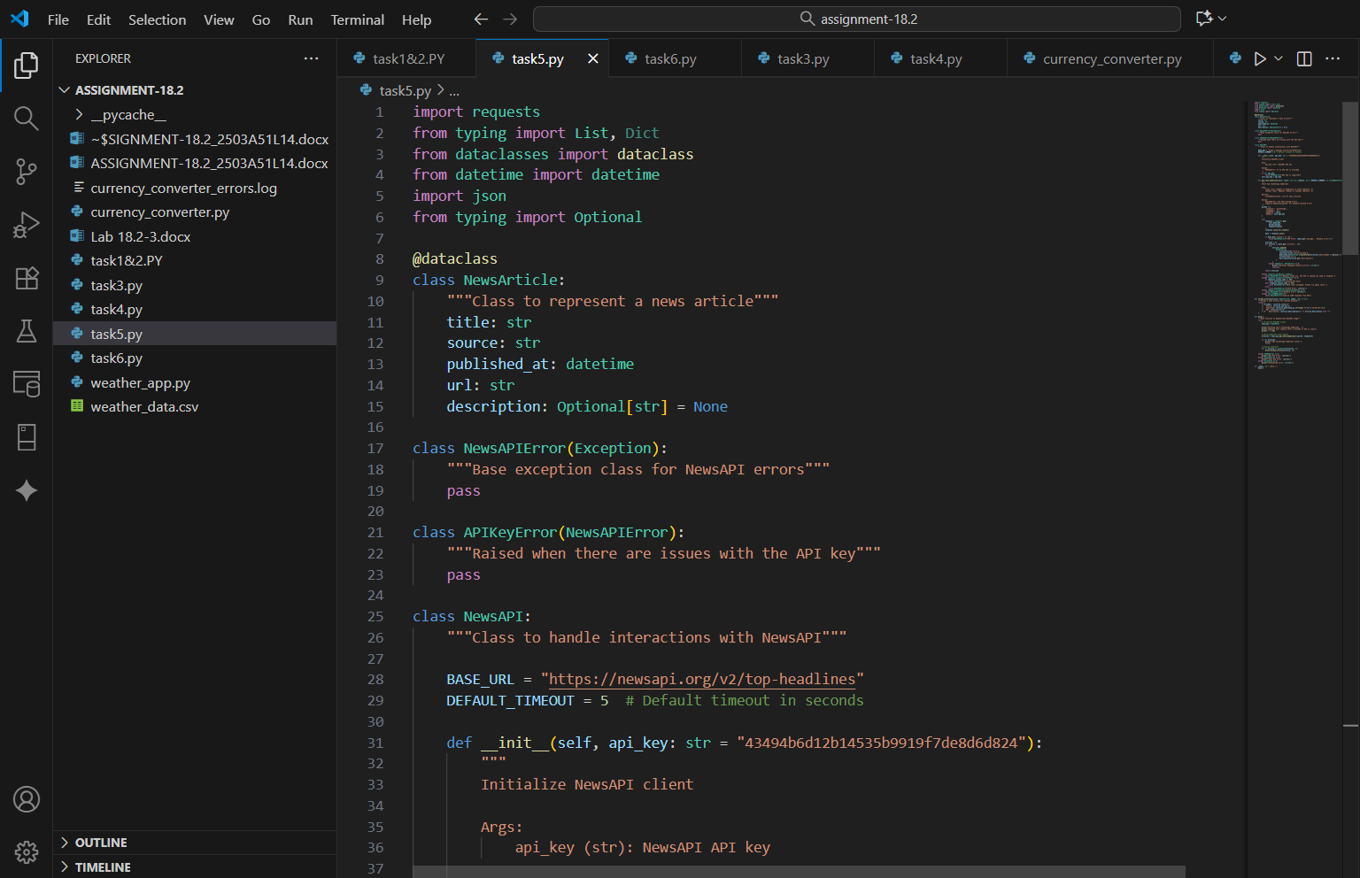
OUTPUT :
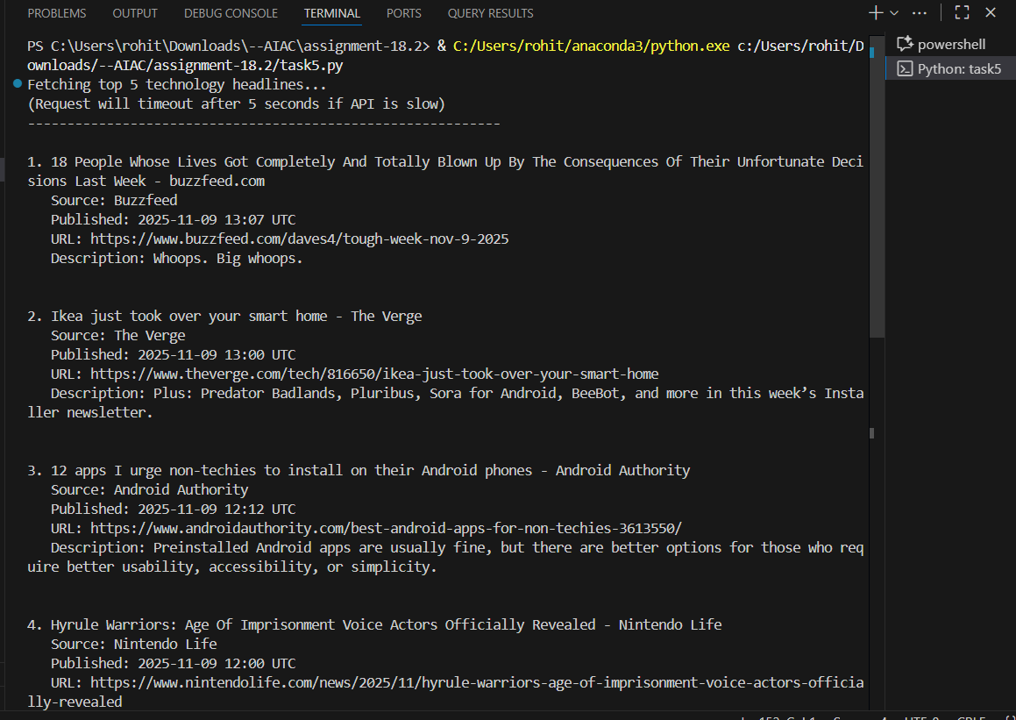
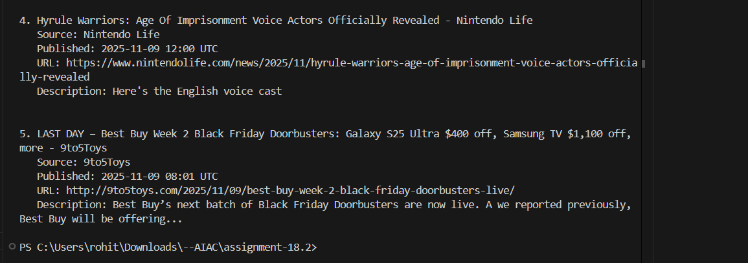

OBSERVATION :
In this task, a Python program was created to fetch the top 5 technology news headlines from a news API and display them neatly in the console. The program was designed to handle timeout errors by setting a maximum request time of 5 seconds.
If the API request took too long, the program displayed a clear error message to inform the user about the timeout issue. This helped ensure that the program remained user-friendly and did not crash due to network delays.
Through this task, it was observed that adding error handling and timeout limits improves the reliability of programs that depend on external APIs. It also showed how to present API data clearly and handle network issues effectively.
Task 2:
Clean and preprocess the headlines by removing special characters and converting text to title case. Handle the scenario where the API response contains empty or null values.
PROMPT :
Write a Python program that cleans and preprocesses news headlines by removing special characters, converting text to title case, and handling cases where the API returns empty or null values.
CODE GENERATED :
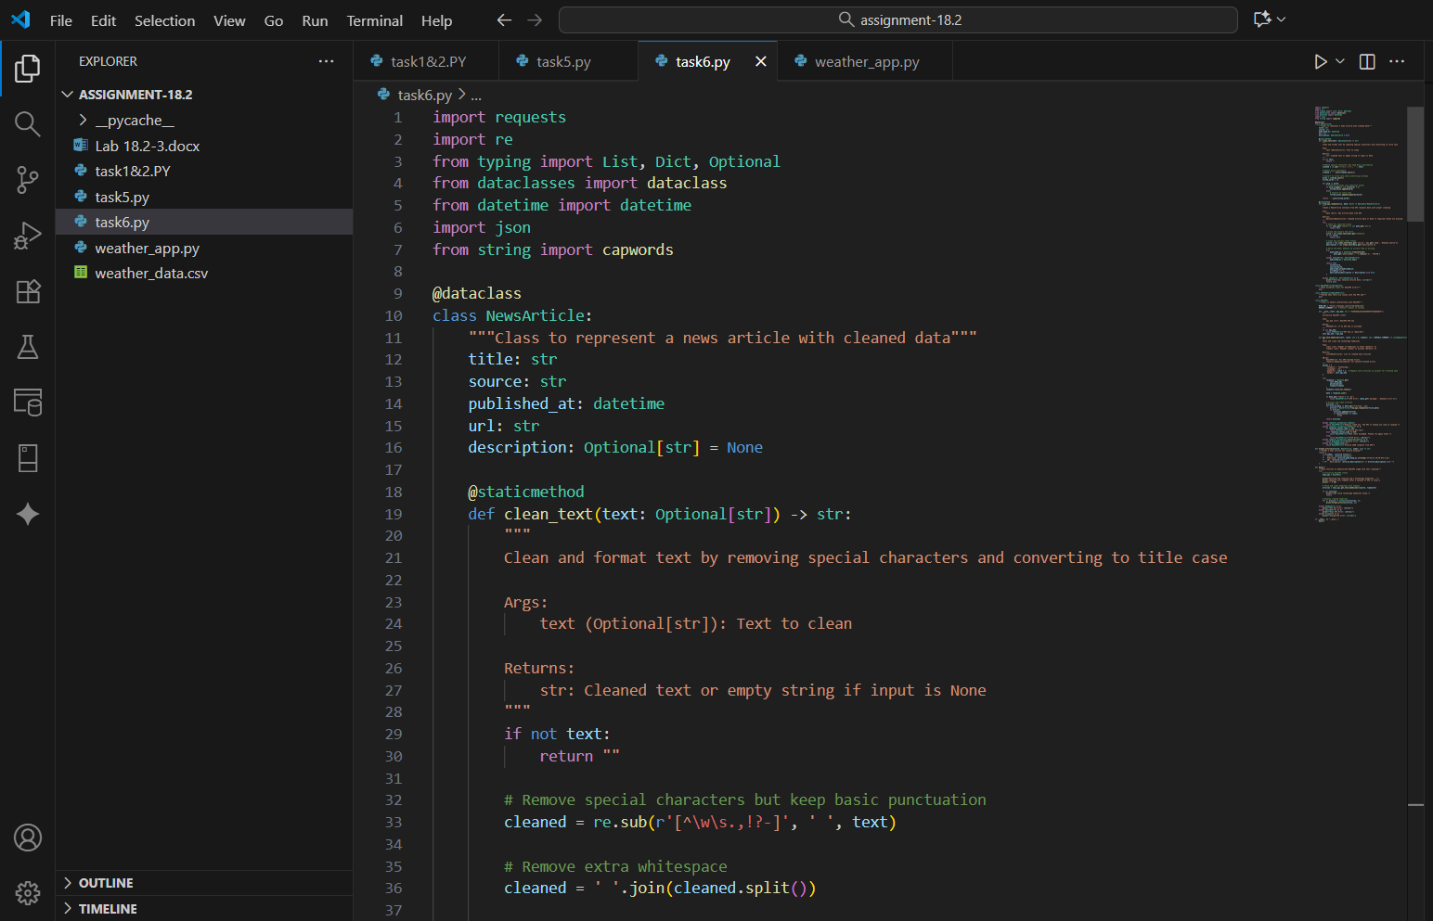

OUTPUT : 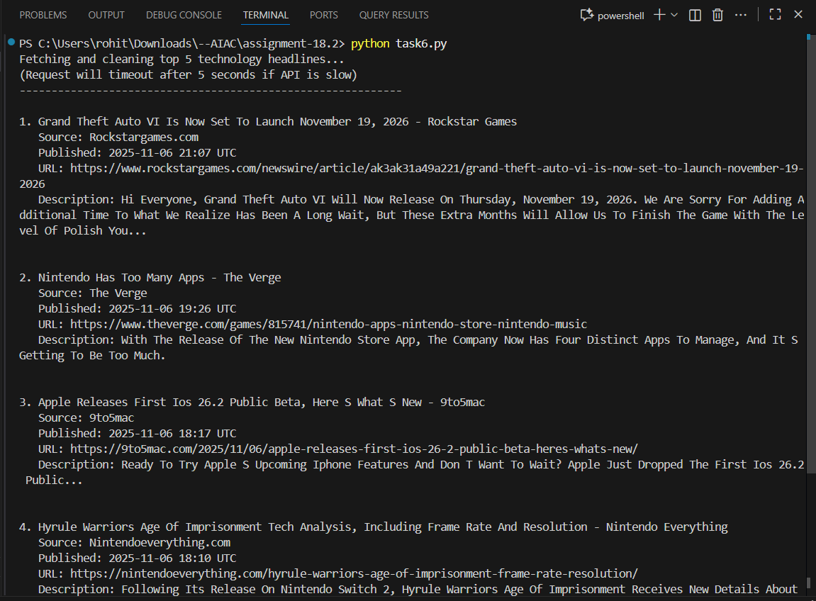

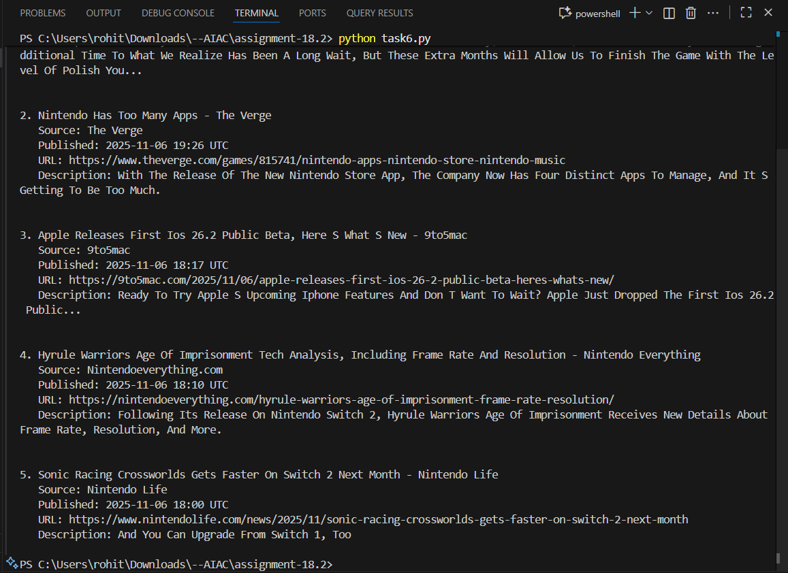

OBSERVATION :
In this task, a Python program was developed to clean and preprocess news headlines received from an API. The program removed special characters, converted the text to title case, and handled cases where the API returned empty or null values.
This ensured that the final output was clean, readable, and error-free. Through this task, it was observed that data preprocessing is an important step in improving the quality and consistency of text data before displaying or analyzing it.

