AI ASSISTED CODING LAB
ASSIGNMENT-19.2
ENROLLMENT NO:2503A51L14
BATCH NO: 19
NAME: ROHITH GOPAGANI
Lab Question 1: Sorting Algorithm Translation :
You are part of a multinational development team. The backend is written in Java, but a new module requires a Python implementation of the same algorithm for integration with a data science pipeline.
TASK 1:
Use AI-assisted coding to translate a given Java bubble sort program into Python. Verify that the translated code works correctly.
PROMPT : Translate the below java program into python code.
JAVA CODE :
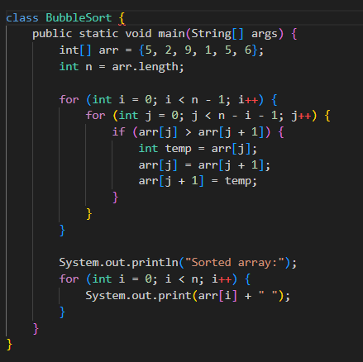

CODE GENERATED : TRANSLATED PYTHON CODE :
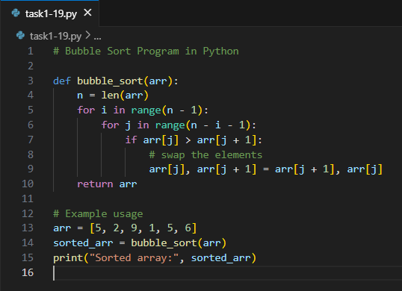

OUTPUT :
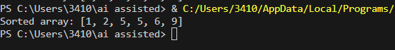

TASK 2:
Introduce errors in the Python version to check if the input list is empty or contains non-numeric values.
CODE GANERATED :
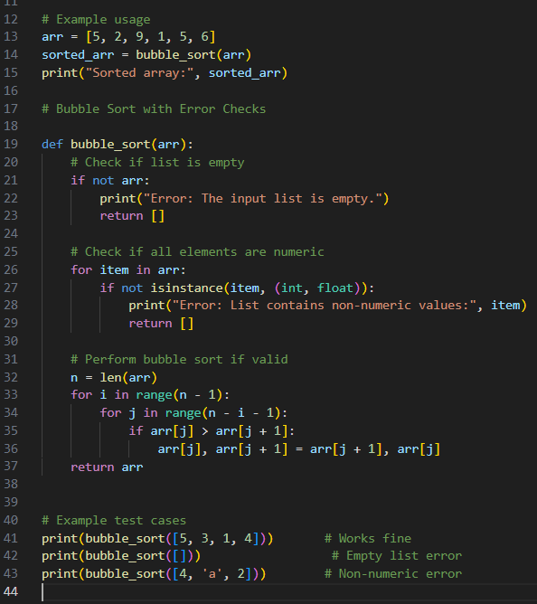

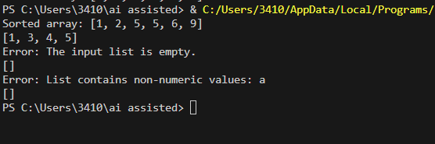
OUTPUT :

OBSERVATION :
The bubble sort algorithm was translated from Java to Python successfully, maintaining the same logic and output. Error-handling features were added in the Python version to check for empty or invalid input lists, ensuring the program runs smoothly and handles incorrect data safely.
Lab Question 2: File Handling Translation
A company’s legacy codebases stores and processes files in C++, but the analytics team needs an equivalent program in JavaScript (Node.js) for integration with a web dashboard.
TASK 1:
Translate a given C++ file read-and-write program into JavaScript using AI assistance. Ensure the script reads a text file and writes processed output to a new file.
PROMPT:
Translate a C++ file handling program into JavaScript (Node.js).
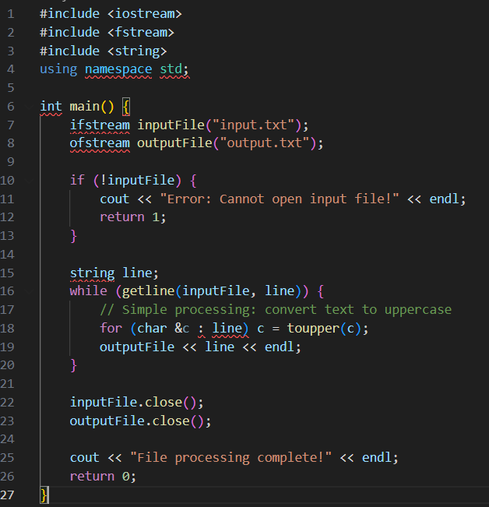
CODE GENERATED : ORIGINAL C++ PROGRAM :

Equivalent JavaScript (Node.js) version :
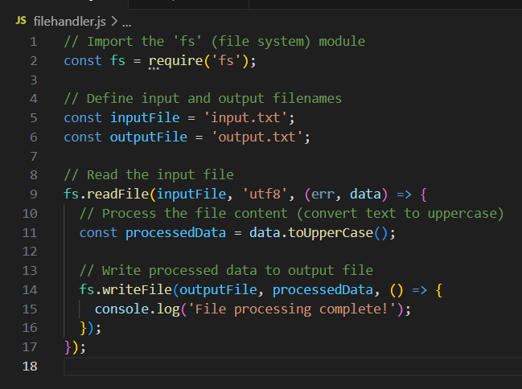

OUTPUT :
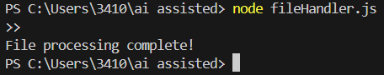

Input.txt file:
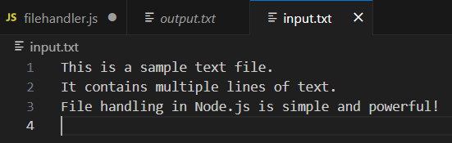

Created Output.txt file:
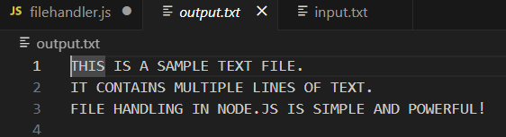

Task 2:
Add error handling in the JavaScript version to gracefully handle
missing files or permission errors.
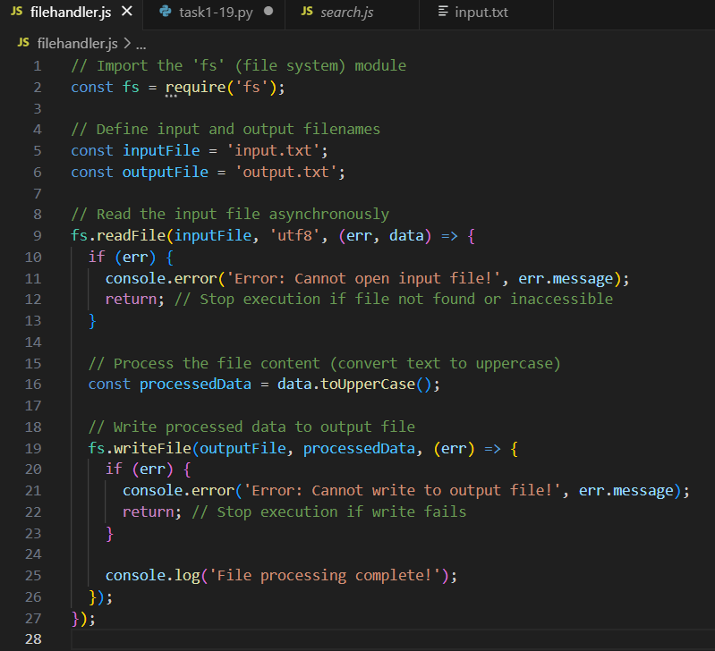
CODE GENERATED :

NORMAL CASE :
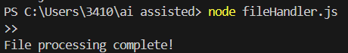

Creates output.txt (uppercase text):

MISSING INPUT.TXT

NO WRITE PERMISSION :
OBSERVATION :
The program reads data from an input file, processes it into uppercase, and writes the result to a new output file. It also includes error handling to manage missing files or permission issues gracefully without crashing.
Lab Question 3: API Call Translation :
Your team developed a prototype in Python to fetch weather data from an API,
but the production environment only supports Java.
Task 1: Translate the Python script (that makes an API call and prints the response) into Java using AI-assisted coding. Ensure equivalent functionality.
Prompt: Translate the below python script into java.
Original (Python) code:
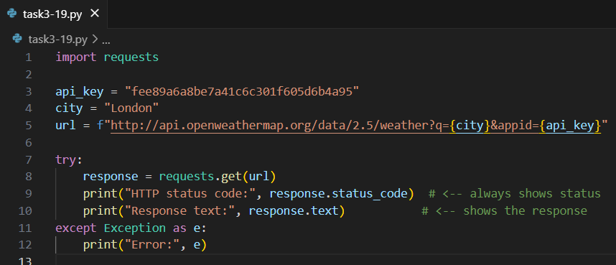

Equivalent Java code:

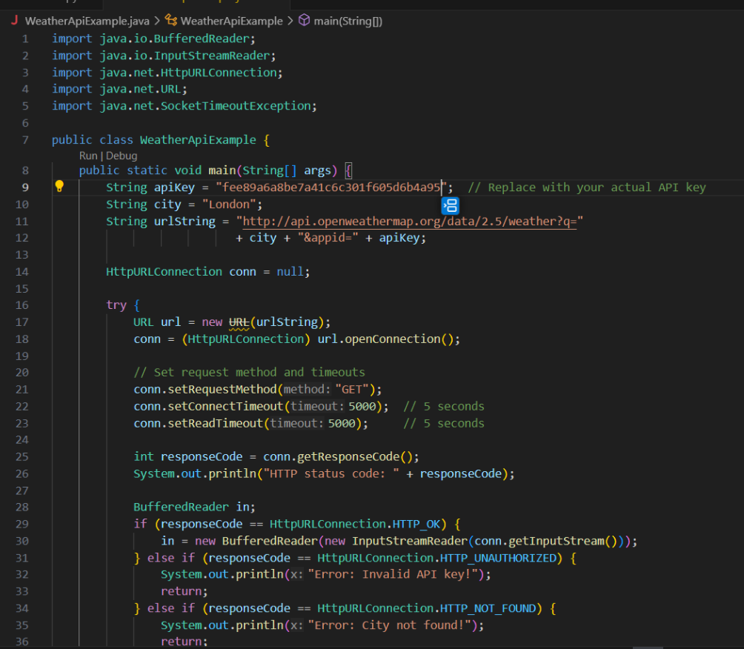

OUTPUT :

TASK 2 : Add proper error handling in the Java version for cases such as
invalid API key, request timeout, or no internet connection.

CODE GENERATED :
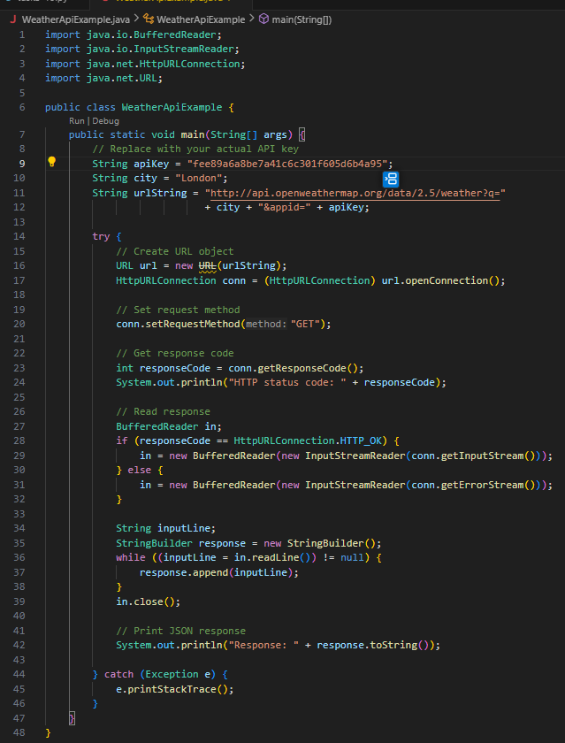

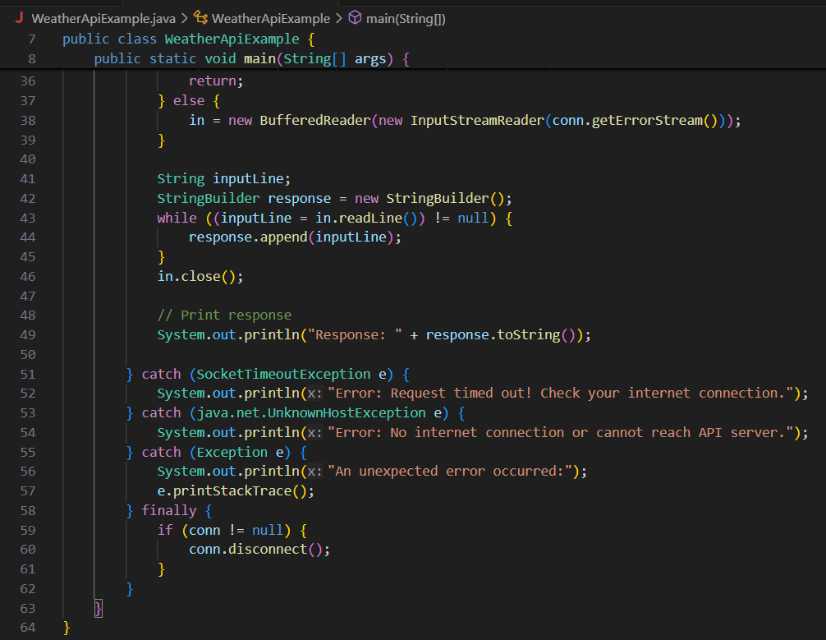

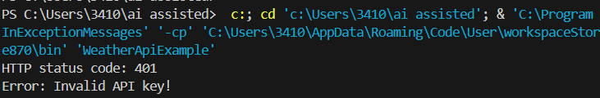
Successful API Call :
INVALID API KEY :
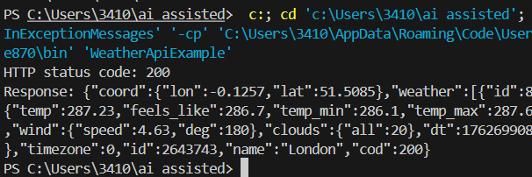

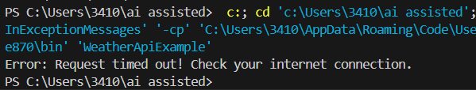
REQUEST TIMEOUT:
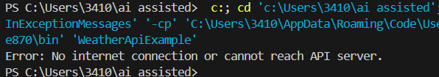
NO INTERNET/CANNOT REACH API SERVER :
Observation: The Java program successfully fetches weather data from the API, and with added error handling, it gracefully handles invalid API keys, wrong cities, timeouts, or no internet, giving clear and safe output.

