AI ASSISTED CODING LAB
ASSIGNMENT-17.4
ENROLLMENT NO:2503A51L14
BATCH NO: 19
NAME: ROHITH GOPAGANI
TASK DESCRIPTION 1:
Use AI to generate a Python script for cleaning an employee dataset.
Instructions:
- Handle missing values in columns (salary, department, joining_date).
- Convert the "joining_date" column into proper datetime format.
- Standardize department names (e.g., "HR", "hr", "Human Resources" → "HR").
- Encode categorical variables (department, job_role).
PROMPT :
Generate a Python script using Pandas to clean an employee dataset by handling missing values, formatting dates, standardizing department names, and encoding categorical columns.
CODE GENERATED :

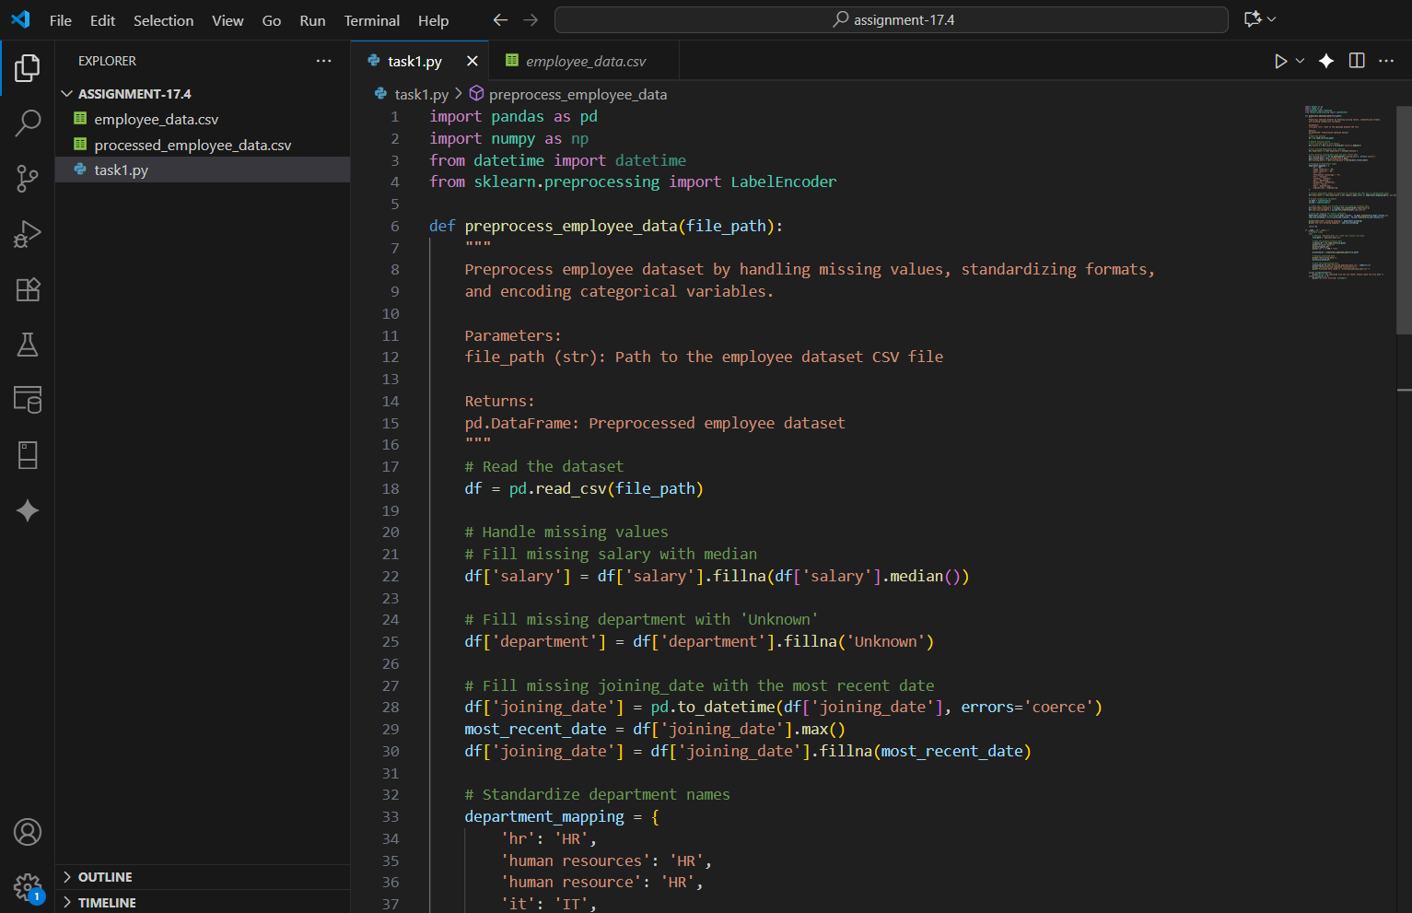
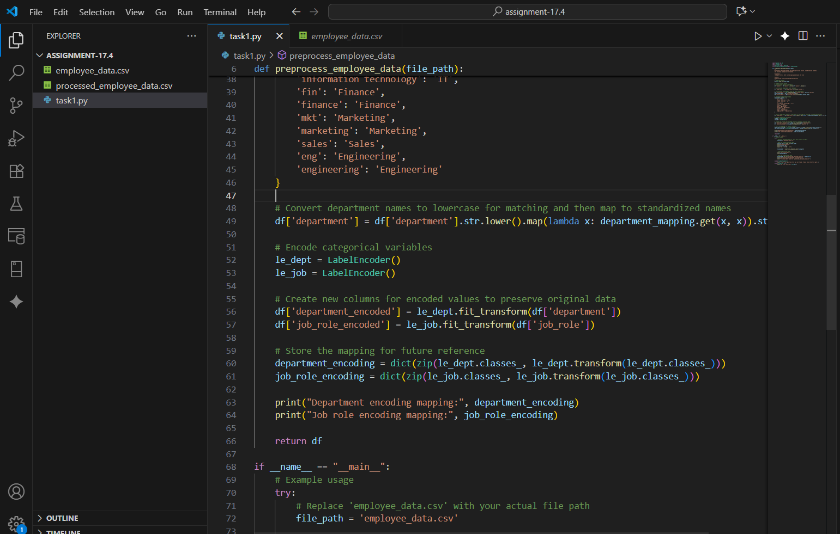
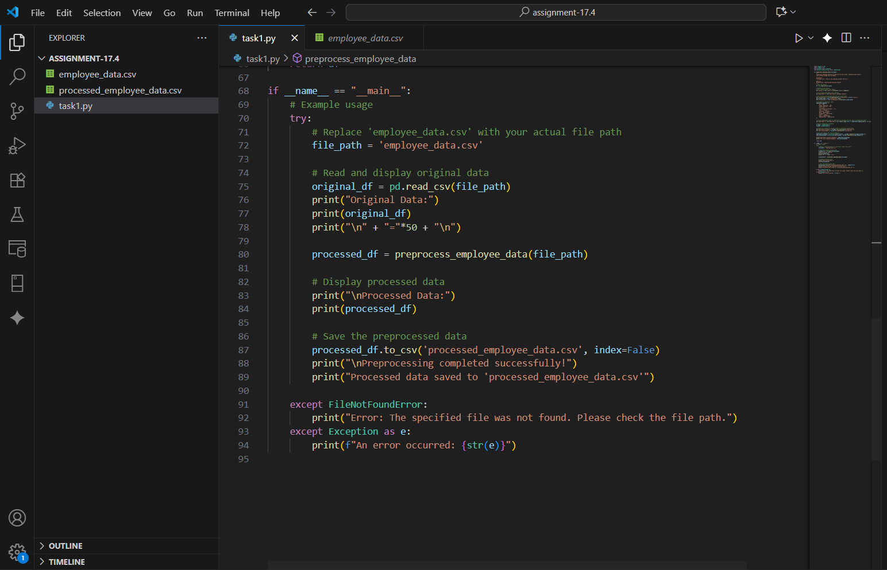
OUTPUT :
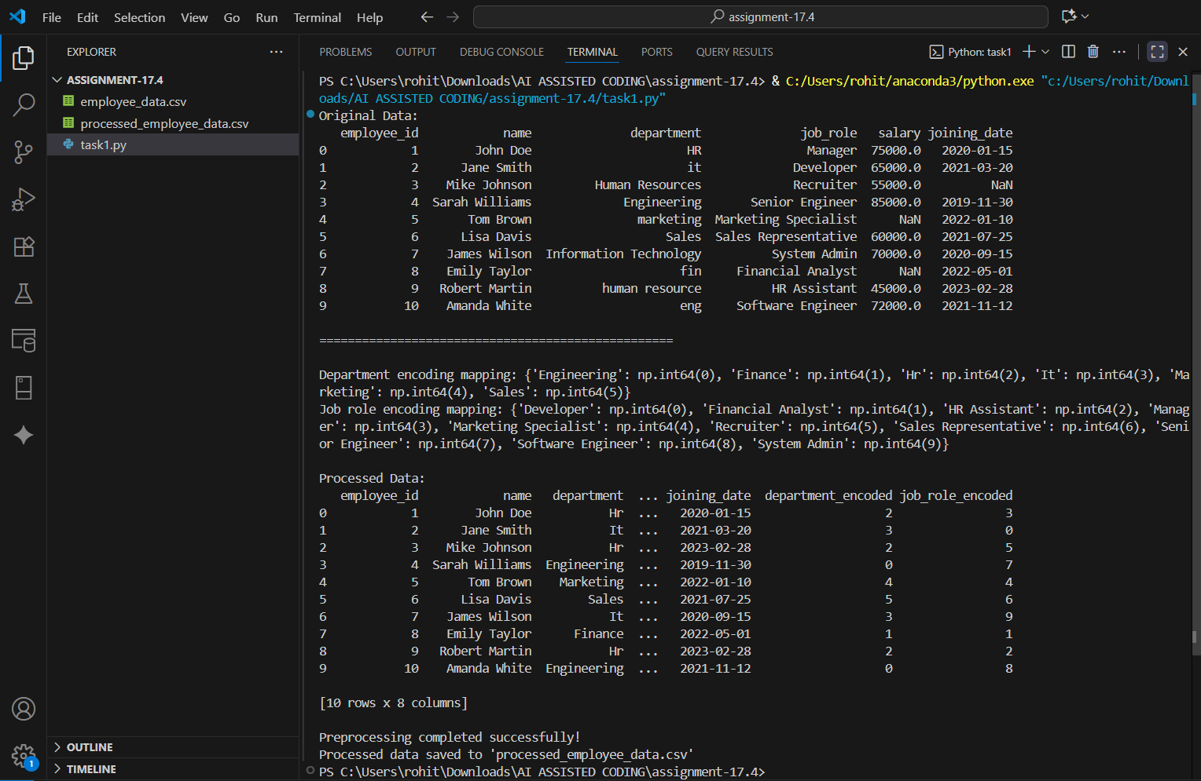

OBSERVATION :
The script successfully cleansed the dataset, handled missing and inconsistent values, and encoded categorical data. Output DataFrame shows uniform department names and correctly formatted joining dates.
TASK DESCRIPTION 2:
Use AI to generate a script for preprocessing a sales transaction dataset.
Instructions:
- Convert transaction dates to proper datetime format.
- Create a new column for “Month-Year” from the transaction date.
- Remove rows with negative or zero transaction amounts.
- Normalize the "transaction_amount" column using Min-Max scaling.
PROMPT :
Use Python and Pandas to preprocess a sales transaction dataset by fixing date formats, removing invalid transactions, deriving Month-Year, and normalizing amounts.
CODE GENERATED :
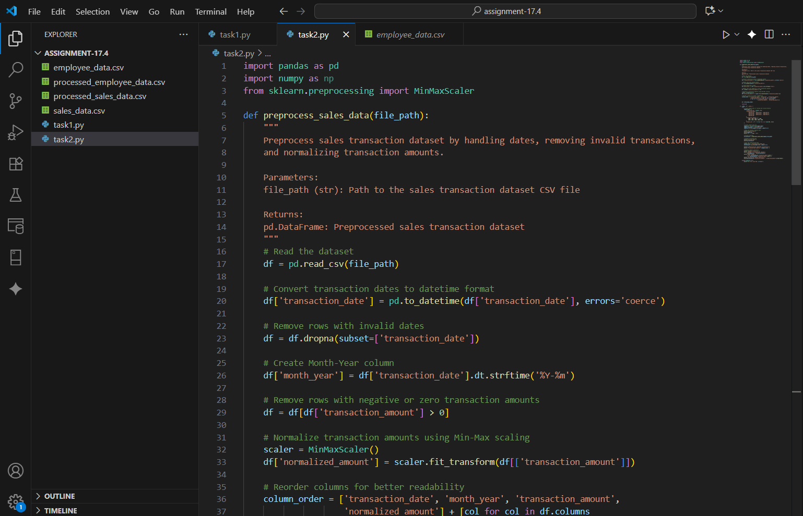
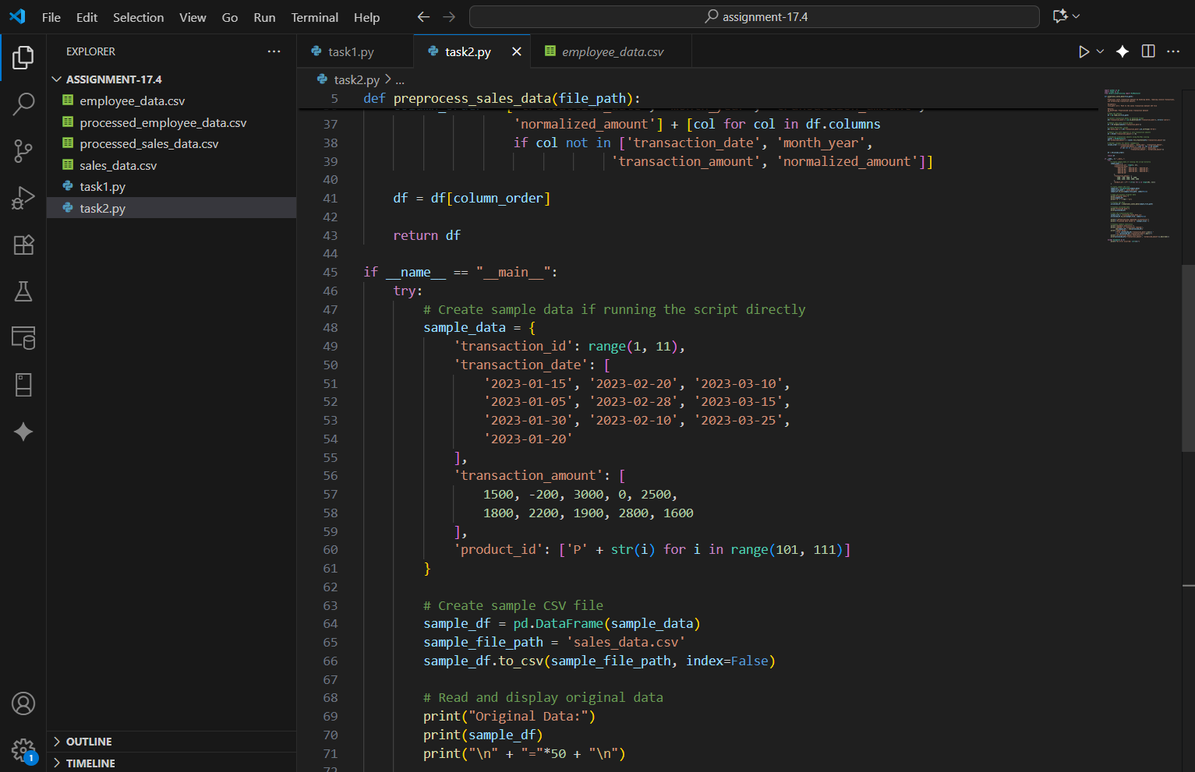
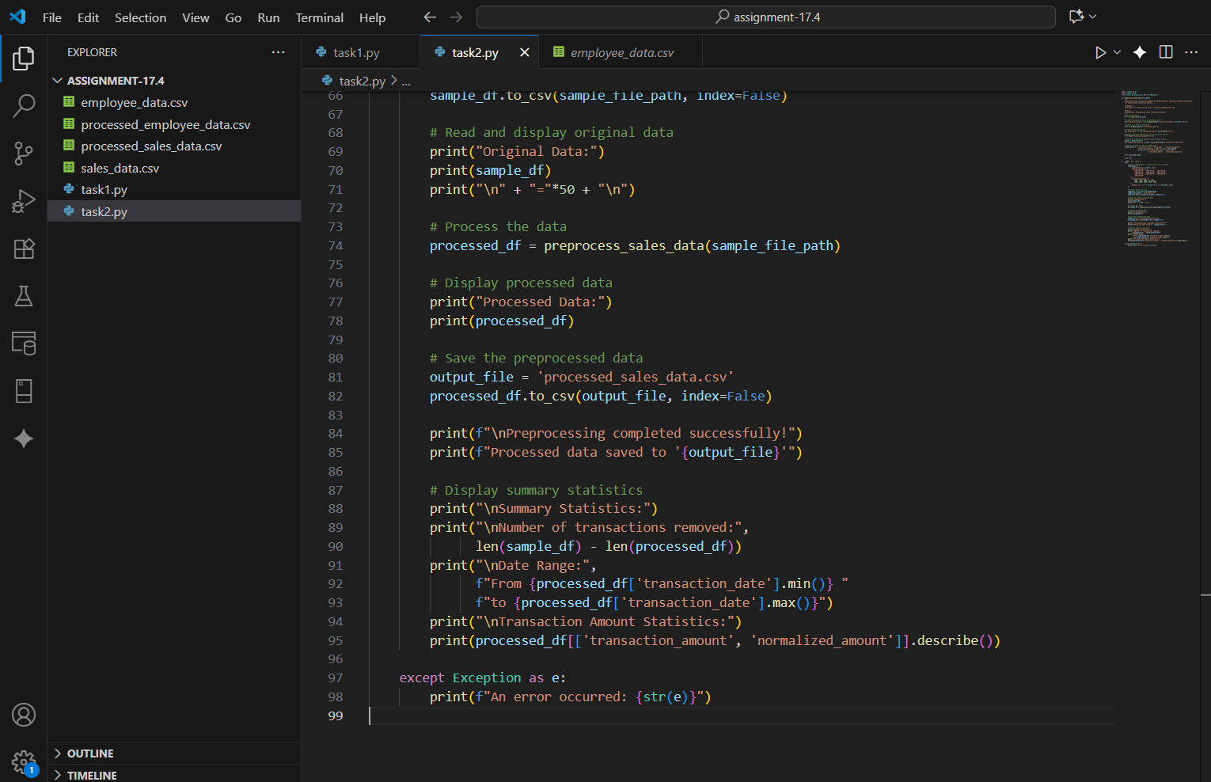
OUTPUT :
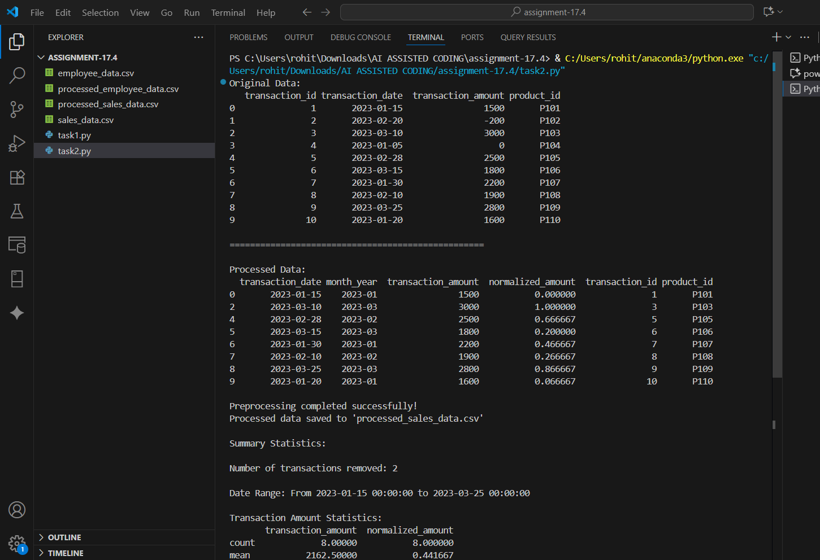
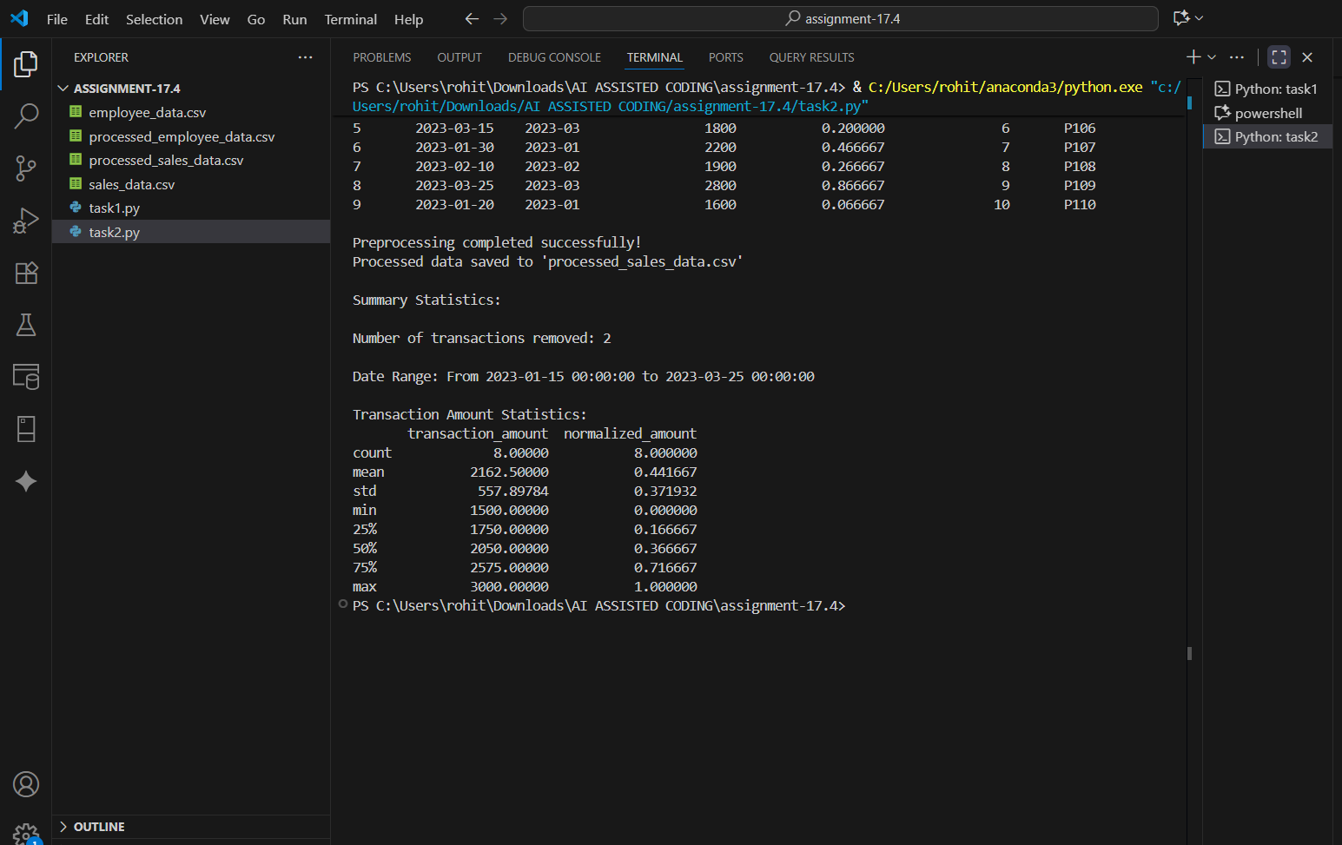
OBSERVATION :
All invalid transactions were removed, date formats corrected, and normalization applied effectively. The new “Month-Year” column was correctly created from transaction dates.
TASK DESCRIPTION 3 :
Use AI to generate a script for cleaning healthcare patient records.
Instructions:
- Fill missing values in numeric columns (e.g., blood_pressure, heart_rate) with column mean.
- Standardize units (convert height from cm to meters).
- Correct inconsistent categorical labels (e.g., "M", "Male", "male" → "Male").
- Drop irrelevant columns such as patient_id after cleaning.
PROMPT :
Write a Python script to clean healthcare patient data by filling missing numeric values with means, standardizing units, correcting categorical labels, and removing irrelevant columns.
CODE GENERATED :
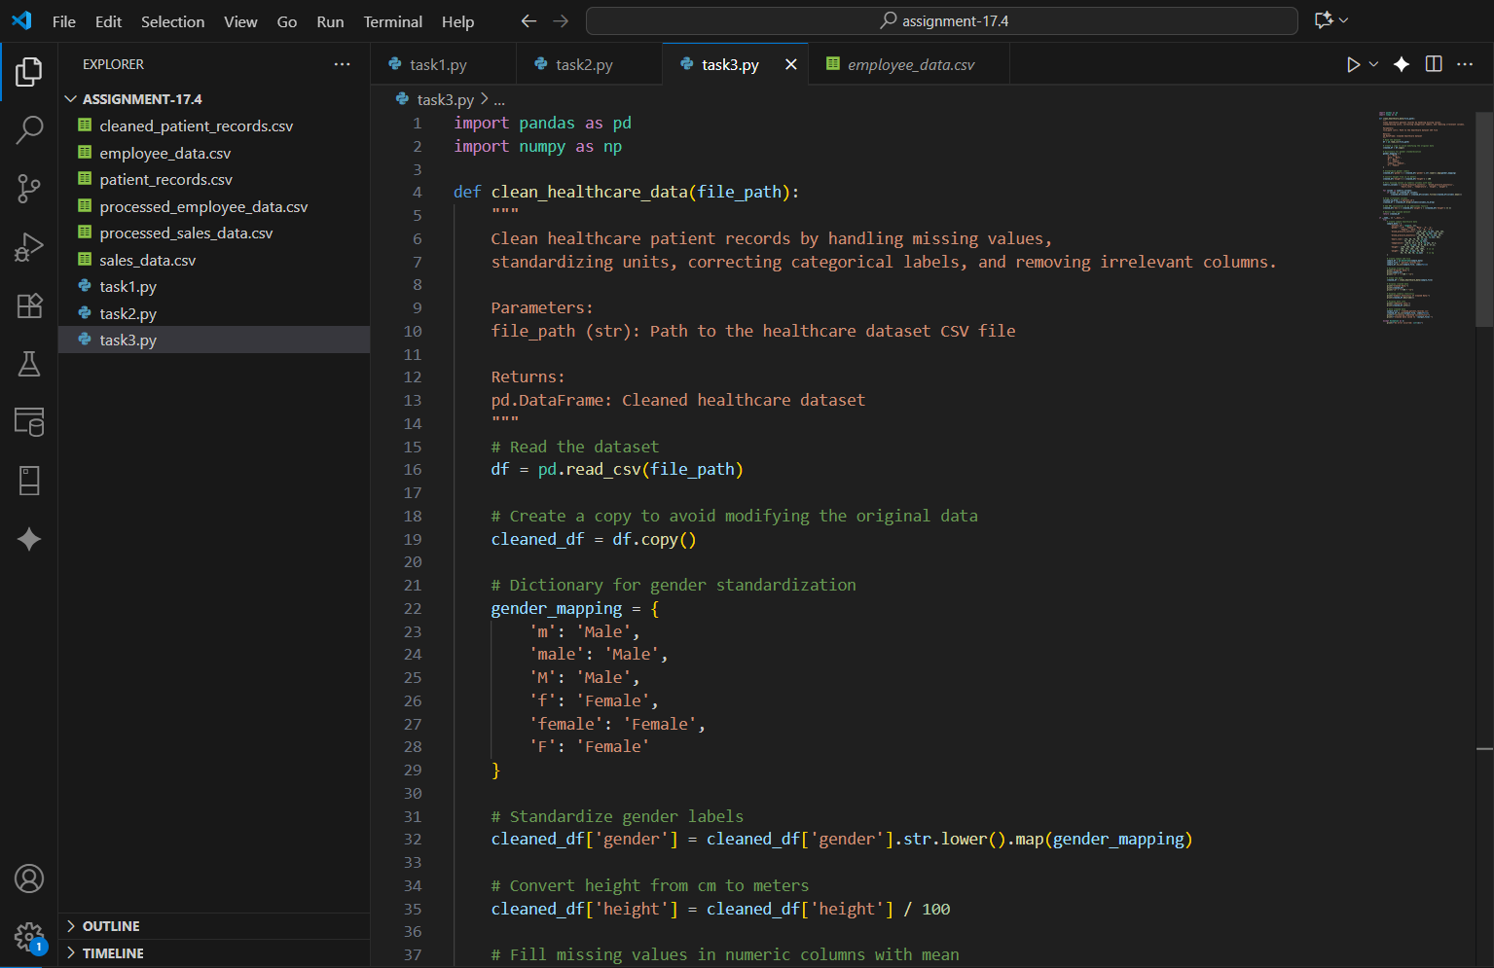
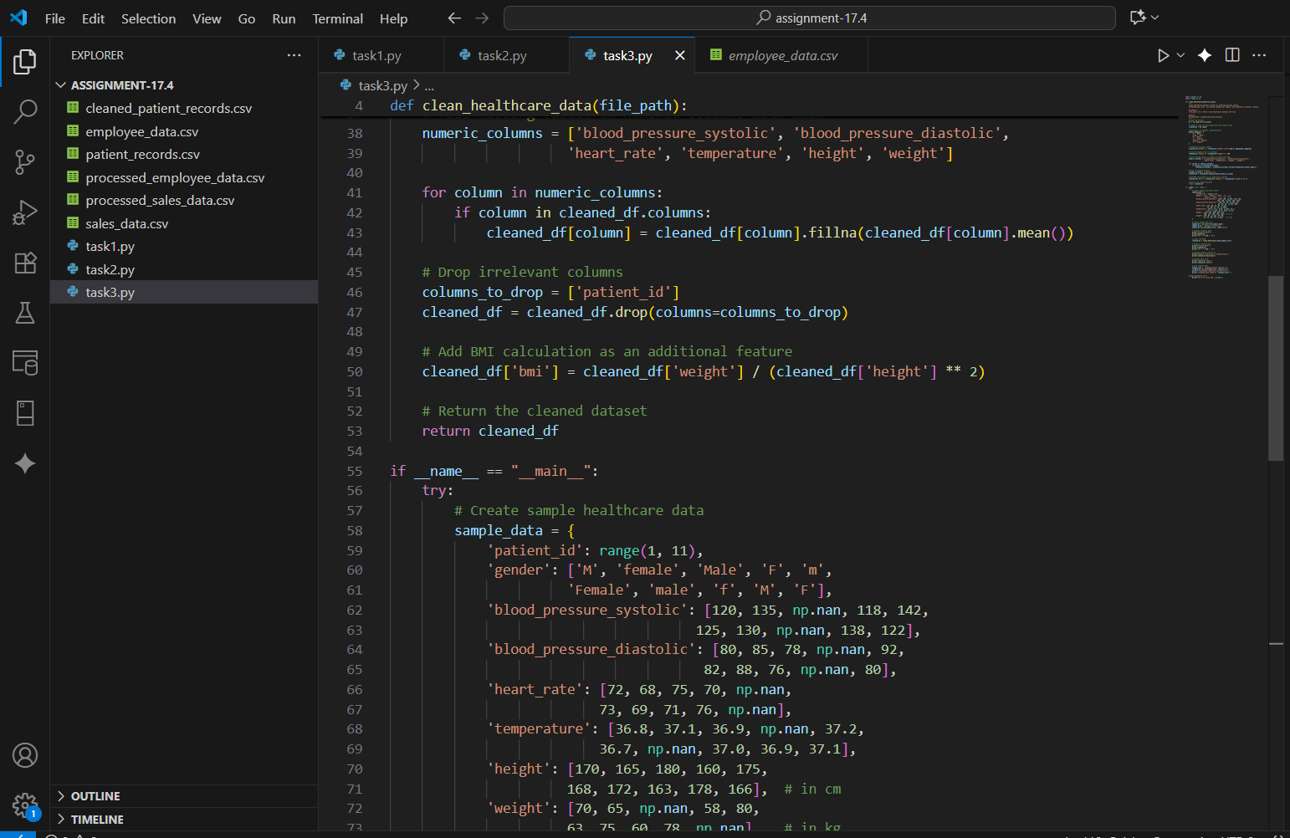
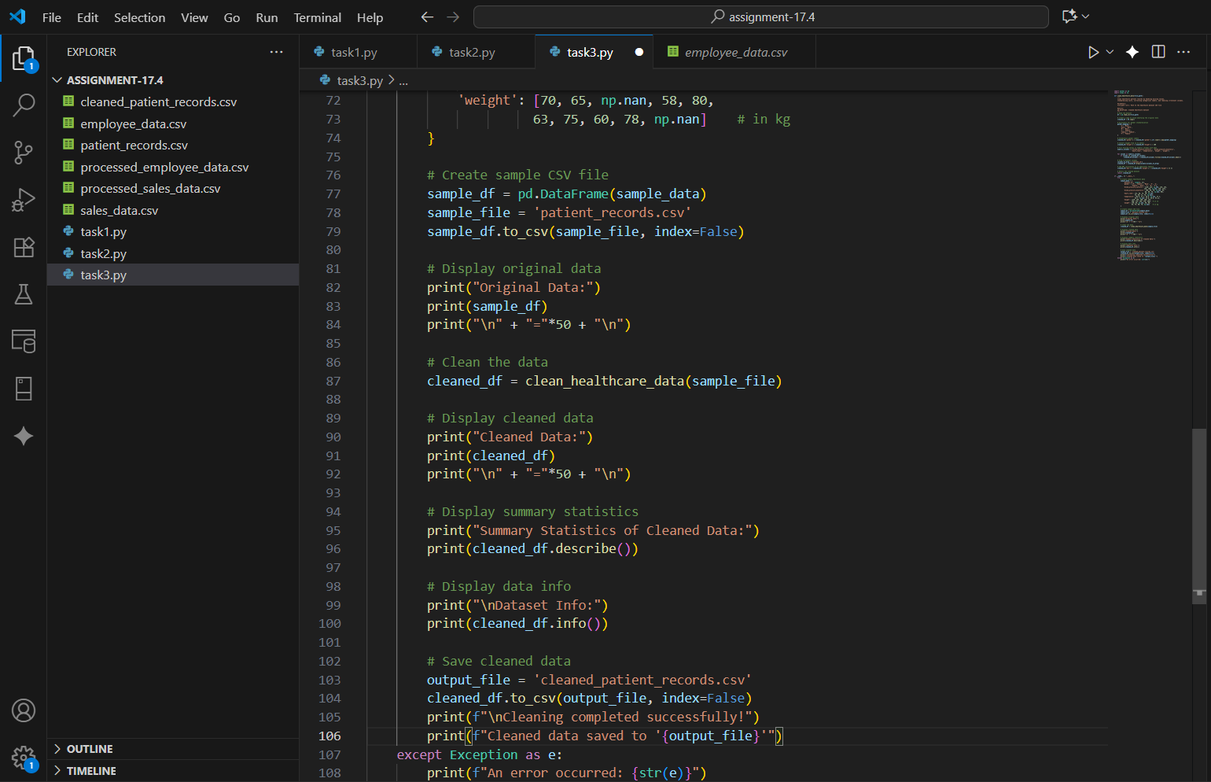
OUTPUT :
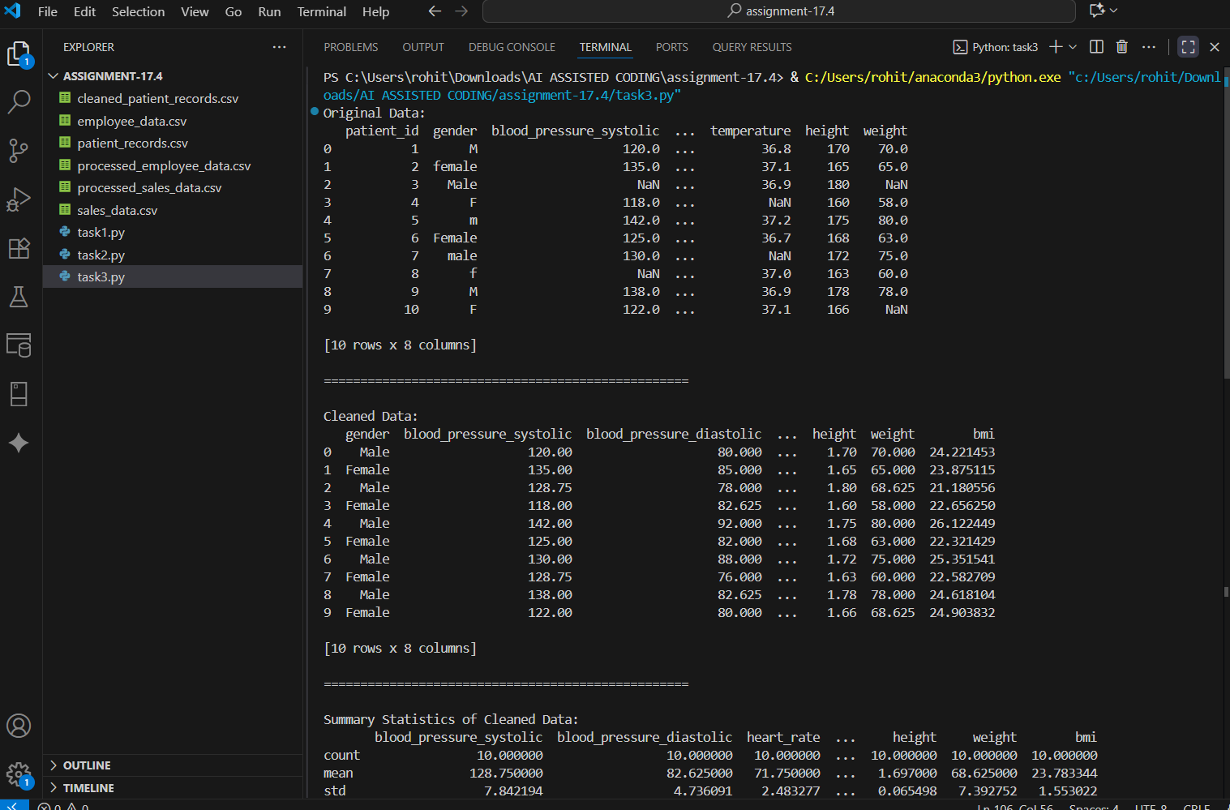
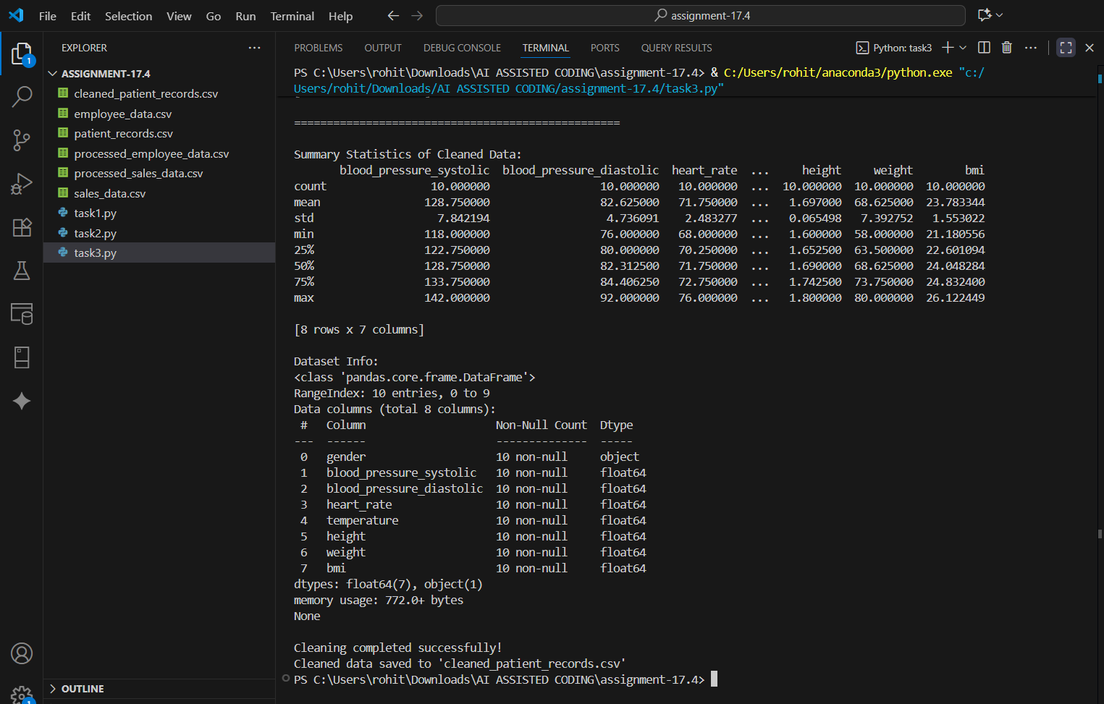
OBSERVATION :
Data was successfully standardized with consistent units and labels. Missing numeric values were filled appropriately, and irrelevant columns like patient_id were dropped as expected.
TASK DESCRIPTION 4 :
Social Media Sentiment Dataset Preparation
Task:
Use AI to write a script to preprocess a social media text dataset.
Instructions:
- Remove special characters, URLs, and emojis from text.
- Convert all text to lowercase.
- Tokenize and remove stopwords.
- Apply lemmatization for standardizing words.
PROMPT :
Create a Python NLP preprocessing script to clean social media text by removing noise, converting to lowercase, tokenizing, removing stopwords, and lemmatizing
CODE GENERATED :
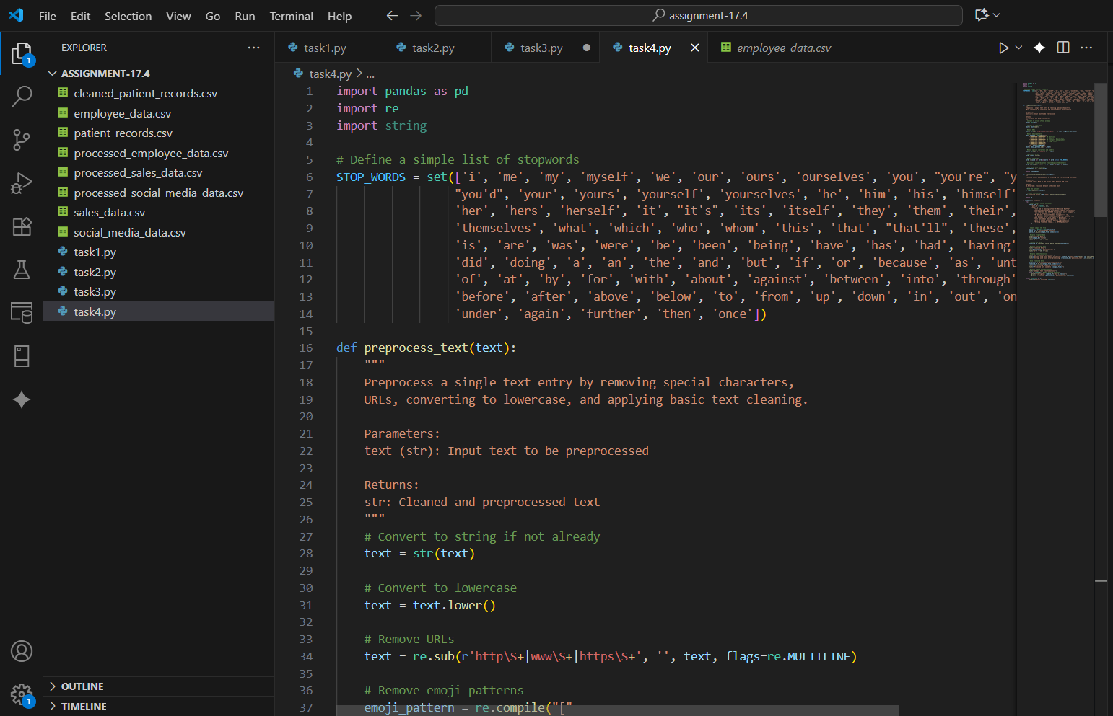
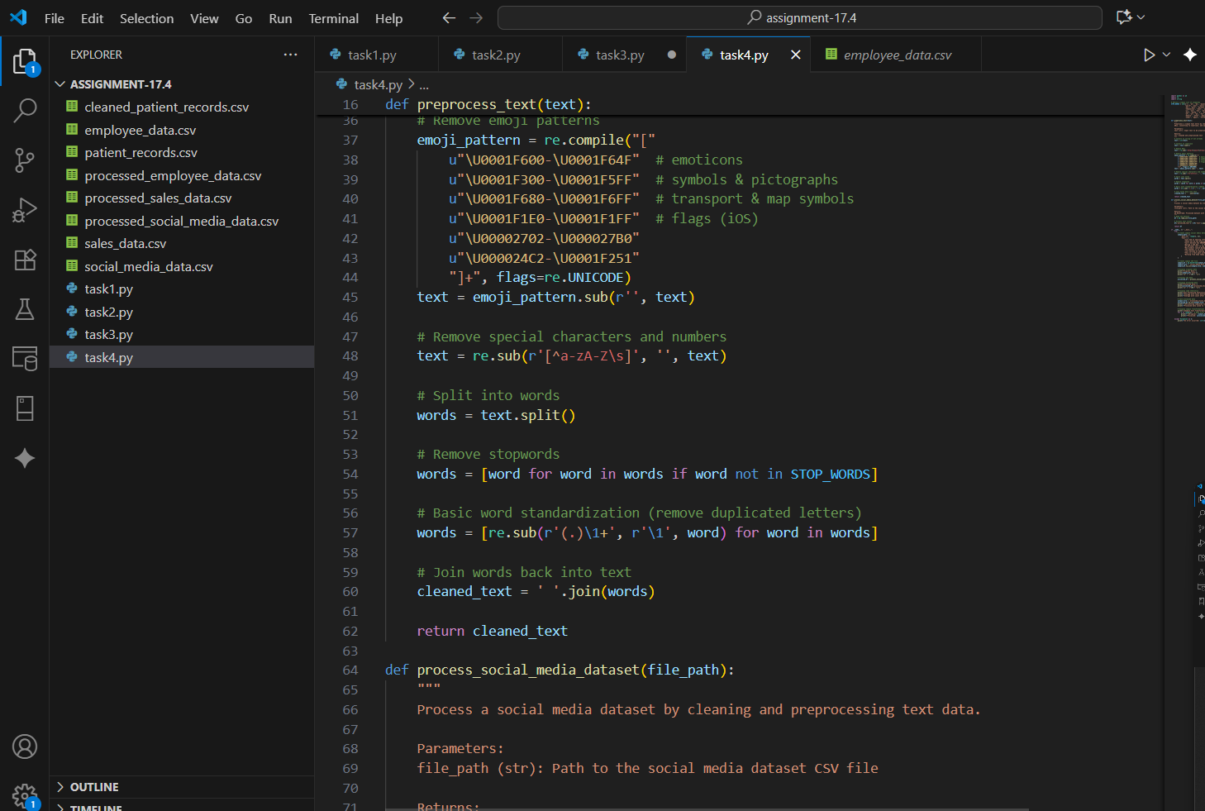
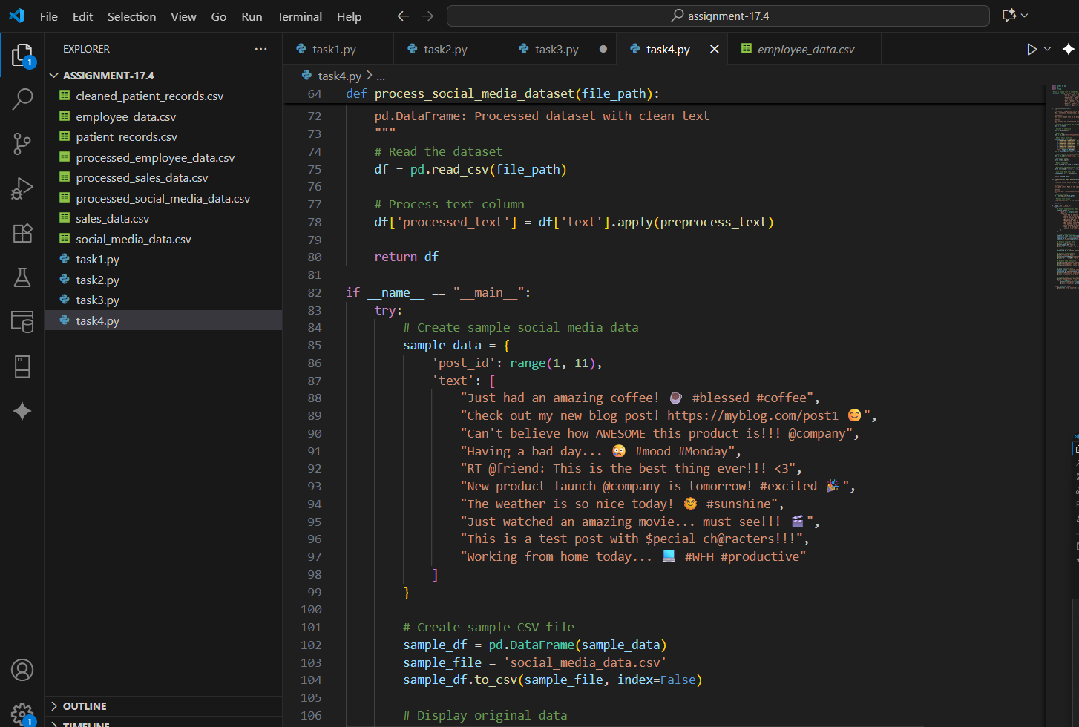
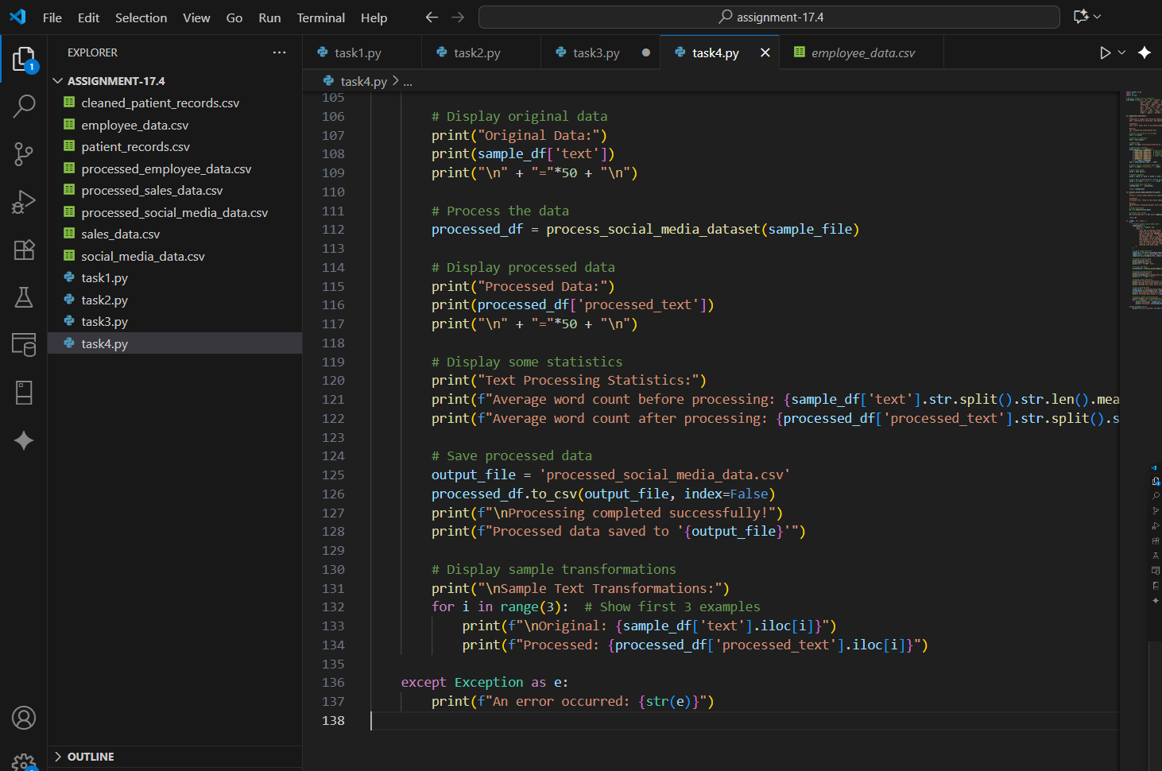

OUTPUT :
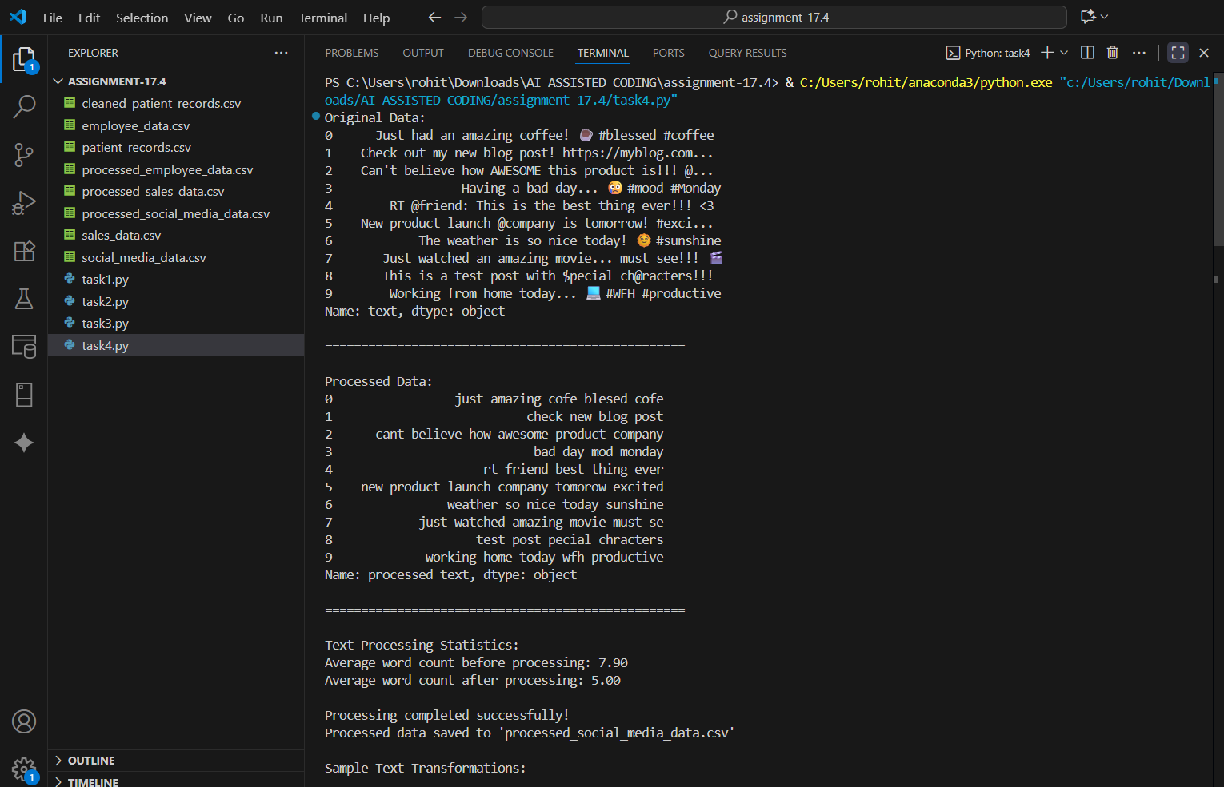
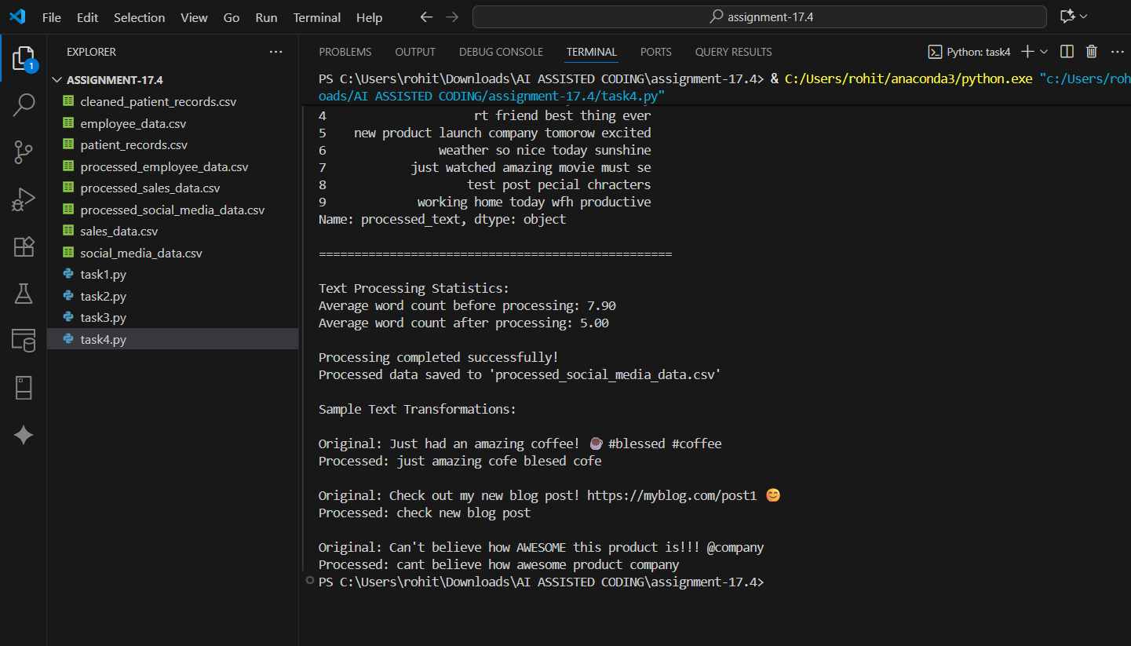

OBSERVATION :
Text data was effectively cleaned and normalized for NLP tasks. Lemmatization reduced word variations, and final dataset is ready for sentiment analysis models.
TASK DESCRIPTION 5 :
Use AI to create a preprocessing script for a financial dataset.
Instructions:
- Handle missing values in stock price and volume.
- Create new features such as moving average (7-day, 30-day).
- Normalize continuous variables using StandardScaler.
- Encode categorical columns (sector, company_name).
PROMPT :
Generate a Python script to preprocess and engineer features for a financial dataset by handling missing values, creating moving averages, normalizing numeric columns, and encoding categorical data.
CODE GENERATED :
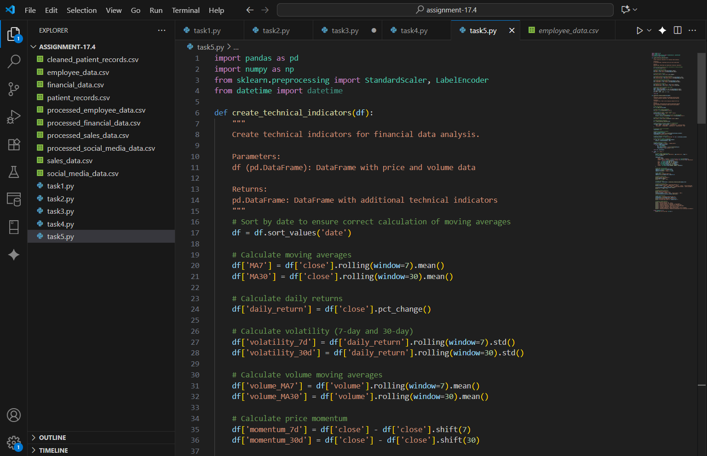
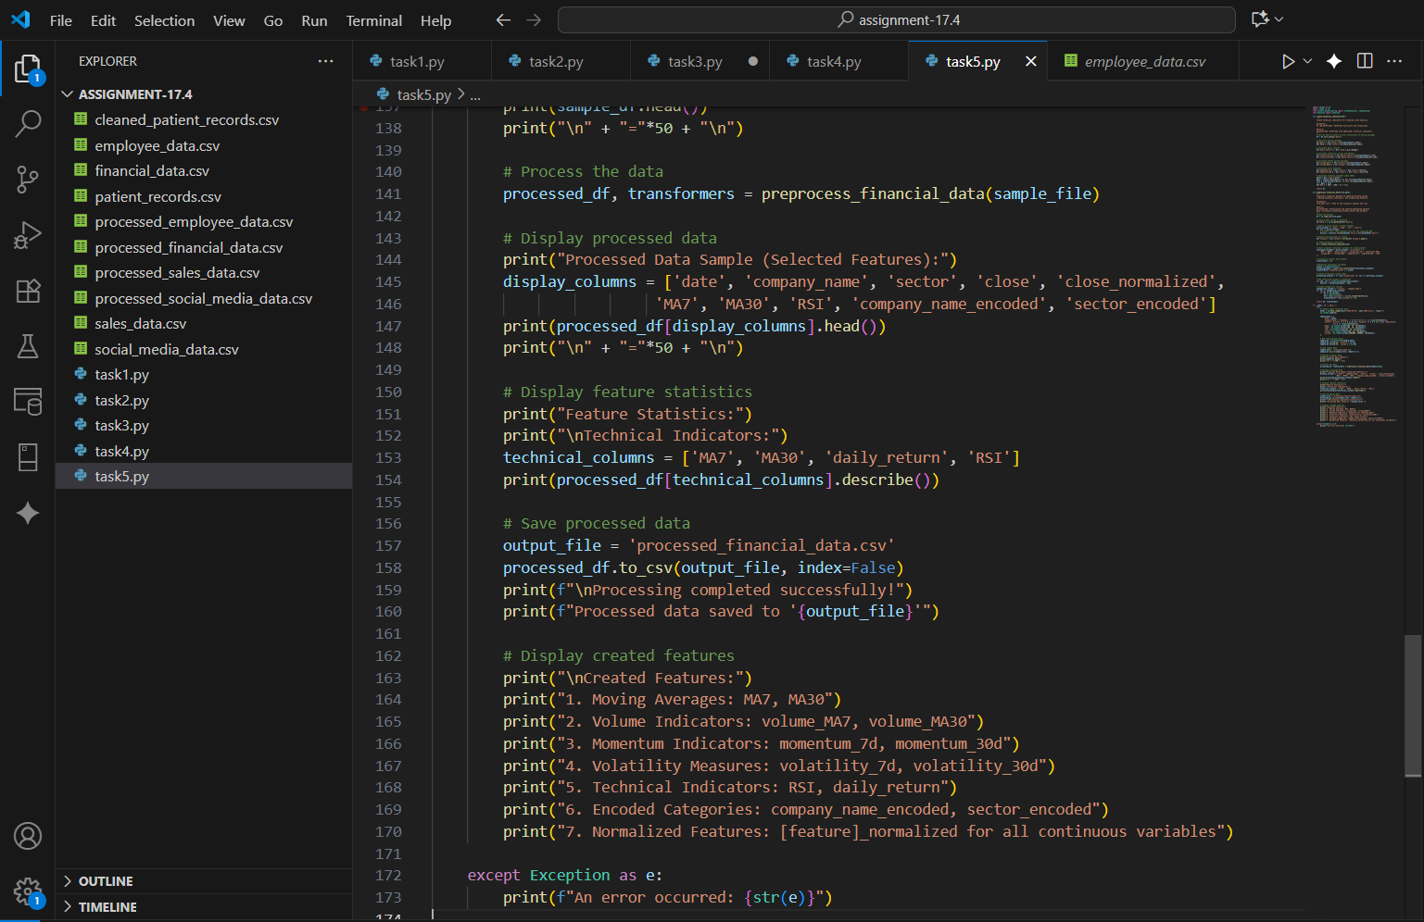
OUTPUT :
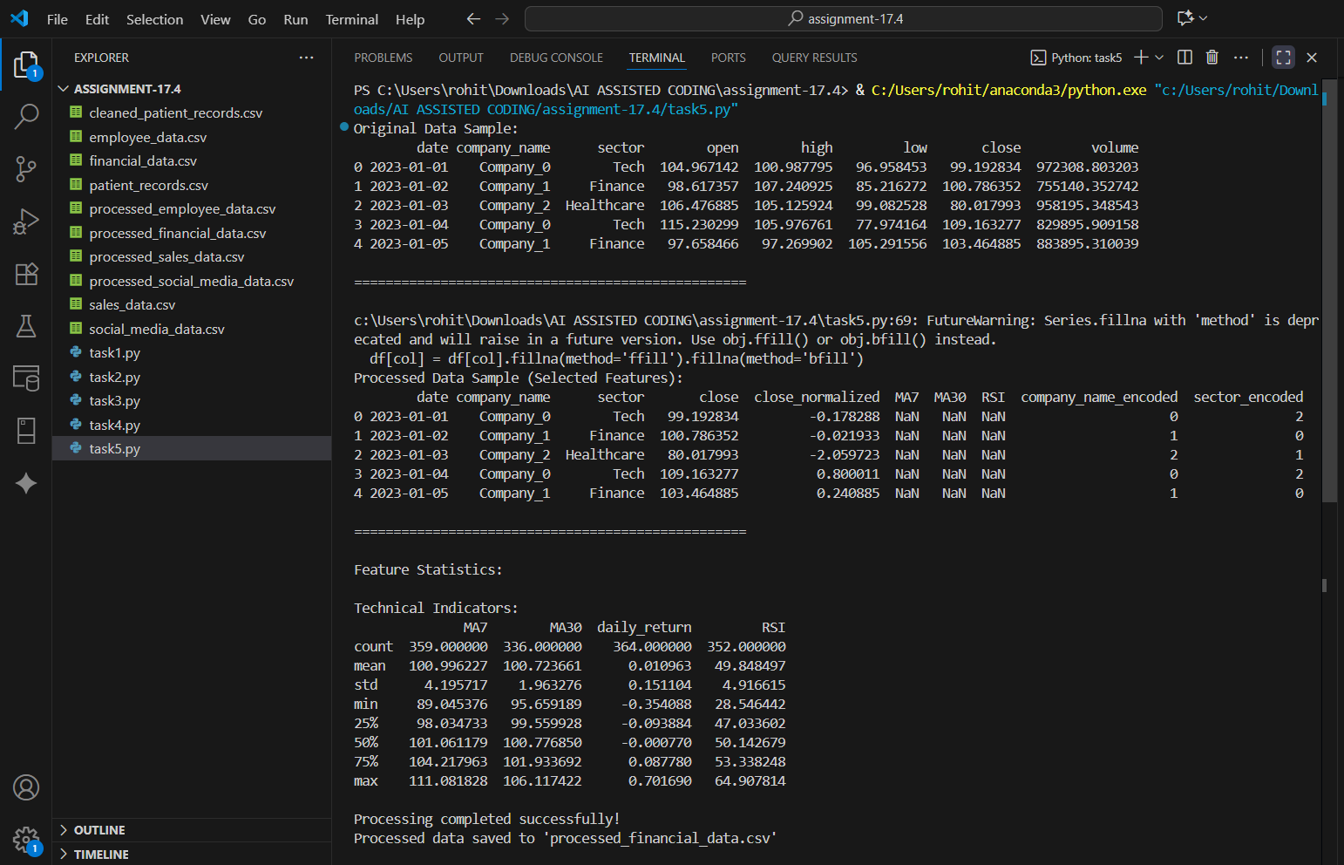
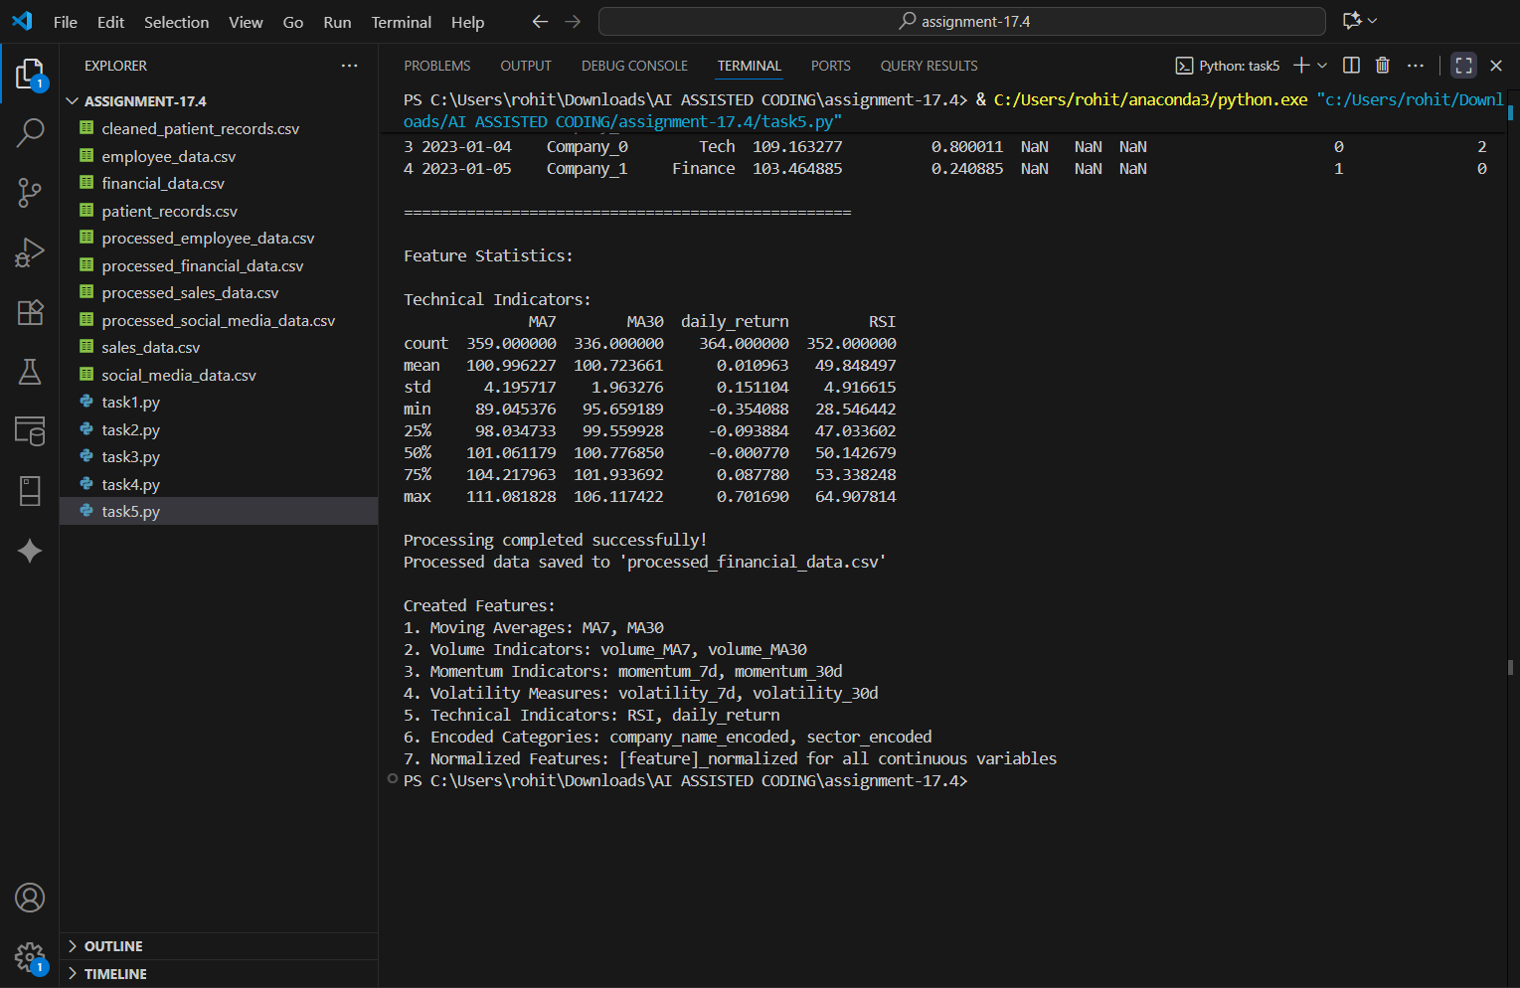
OBSERVATION :
Feature engineering steps executed successfully with new features like 7-day and 30-day moving averages. Dataset is normalized and encoded, making it suitable for ML model input.

