**Exercise 2: E-commerce Platform Search Function**

Code:

public class Product {

int productId;

String productName;

String category;

public Product(int productId, String productName, String category) {

this.productId = productId;

this.productName = productName;

this.category = category;

}

}

public class SearchProduct {

// Linear Search

public static int linearSearch(Product[] products, String key) {

for (int i = 0; i < products.length; i++) {

if (products[i].productName.equalsIgnoreCase(key)) {

return i;

}

}

return -1;

}

// Binary Search (on sorted array)

public static int binarySearch(Product[] products, String key) {

int low = 0, high = products.length - 1;

while (low <= high) {

int mid = (low + high) / 2;

int compare = products[mid].productName.compareToIgnoreCase(key);

if (compare == 0) return mid;

else if (compare < 0) low = mid + 1;

else high = mid - 1;

}

return -1;

}

public static void main(String[] args) {

Product[] products = {

new Product(1, "Laptop", "Electronics"),

new Product(2, "Shoes", "Footwear"),

new Product(3, "Mobile", "Electronics"),

new Product(4, "Watch", "Accessories"),

new Product(5, "Bag", "Travel")

};

int indexLinear = *linearSearch*(products, "Mobile");

System.***out***.println("Linear Search: Mobile is Found at index " + indexLinear);

Arrays.*sort*(products, Comparator.*comparing*(p -> p.productName.toLowerCase()));

int indexBinary = *binarySearch*(products, "Bag");

System.***out***.println("Binary Search: Bag is Found at index after sorting by productName " + indexBinary);

}

}

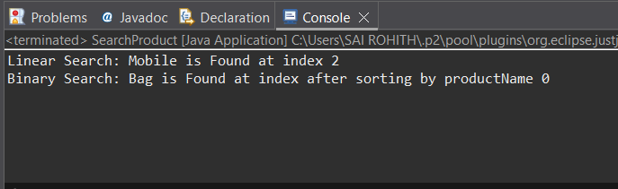

**Exercise 7: Financial Forecasting**

Code:

public class FinancialForecast {

public static double futureValue(double presentValue, double rate, int years) {

// Base Case

if (years == 0) {

return presentValue;

}

// Recursive Case

return *futureValue*(presentValue, rate, years - 1) * (1 + rate);

}

public static void main(String[] args) {

double presentValue = 10000.0; // ₹10,000

double growthRate = 0.05; // 5% growth

int forecastYears = 5;

double result = *futureValue*(presentValue, growthRate, forecastYears);

System.***out***.printf("Future Value after %d years = ₹%.2f%n", forecastYears, result);

}

}

