**Exercise 1: Implementing the Singleton Pattern**

Code:

Logger.java

package com.cognizant;

public class Logger {

private static final Logger instance = new Logger();

// private constructor to avoid client applications using the constructor

private Logger(){

System.out.println("Logger Initialized");

}

//Return the instance of the Logger class

public static Logger getInstance() {

return instance;

}

}

Main.java

package com.cognizant;

public class main {

public static void main(String[] args) {

Logger logger1 = Logger.*getInstance*();

Logger logger2 = Logger.*getInstance*();

if(logger1 == logger2) {

System.***out***.println("Both Logger instances are same (Singleton Implemented");

} else {

System.***out***.println("Both Logger instances are not same (singleton failed");

}

}

}

Output:

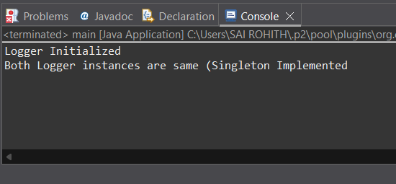

**Exercise 2: Implementing the Factory Method Pattern**

Code:

abstract class Document {

public abstract void printDocumentType();

}

public class DocumentClient {

private Document document;

public DocumentClient(DocumentFactory factory) {

document = factory.createDocument();

}

public Document getDocument() {

return document;

}

}

public interface DocumentFactory {

Document createDocument();

}

public class ExcelDocument extends Document{

public void printDocumentType() {

System.***out***.println("This is Excel Document");

}

}

public class ExcelDocumentFactory implements DocumentFactory{

public Document createDocument() {

return new ExcelDocument();

}

}

public class PdfDocument extends Document{

public void printDocumentType() {

System.***out***.println("This is PDF Document");

}

}

public class PdfDocumentFactory implements DocumentFactory{

public Document createDocument() {

return new PdfDocument();

}

}

public class WordDocument extends Document{

public void printDocumentType() {

System.***out***.println("This is a Word Document");

}

}

public class WordDocumentFactory implements DocumentFactory{

public Document createDocument() {

return new WordDocument();

}

}

public class DocumentFactoryTest{

public static void main(String[] args) {

DocumentFactory wordFactory = new WordDocumentFactory();

DocumentClient wordClient = new DocumentClient(wordFactory);

wordClient.getDocument().printDocumentType();

DocumentFactory pdfFactory = new PdfDocumentFactory();

DocumentClient pdfClient = new DocumentClient(pdfFactory);

pdfClient.getDocument().printDocumentType();

DocumentFactory excelFactory = new ExcelDocumentFactory();

DocumentClient excelClient = new DocumentClient(excelFactory);

excelClient.getDocument().printDocumentType();

}

}

