REACT
9. ReactJS-HOL
Create a React Application named “cricketapp” with the following components:
ListOfPlayers.js
import React from 'react';
const ListofPlayers = () => {
const players = [
{ name: 'Virat Kohli', score: 85 },
{ name: 'Rohit Sharma', score: 90 },
{ name: 'Jasprit Bumrah', score: 60 },
{ name: 'KL Rahul', score: 40 },
{ name: 'Shubman Gill', score: 75 },
{ name: 'Ravindra Jadeja', score: 65 },
{ name: 'Hardik Pandya', score: 55 },
{ name: 'R Ashwin', score: 45 },
{ name: 'Ishan Kishan', score: 95 },
{ name: 'Surya Kumar Yadav', score: 88 },
{ name: 'Mohammed Shami', score: 70 },
];
const below70 = players.filter(player => player.score < 70);
return (
<div>
<h2>All Players:</h2>
<ul>
{players.map((player, idx) => (
<li key={idx}>{player.name} - {player.score}</li>
))}
</ul>
<h3>Players with Score Below 70:</h3>
<ul>
{below70.map((player, idx) => (
<li key={idx}>{player.name} - {player.score}</li>
))}
</ul>
</div>
);
};
export default ListofPlayers;

IndianPlayers.js

import React from 'react';
const IndianPlayers = () => {
const allPlayers = ['Virat', 'Rohit', 'KL', 'Pant', 'Bumrah', 'Shami', 'Siraj', 'Gill'];
// Destructuring odd and even team
const oddTeam = allPlayers.filter((_, idx) => idx % 2 !== 0);
const evenTeam = allPlayers.filter((_, idx) => idx % 2 === 0);
const T20Players = ['Hardik', 'Ishan', 'Surya'];
const RanjiTrophyPlayers = ['Pujara', 'Rahane', 'Vihari'];
const mergedPlayers = [...T20Players, ...RanjiTrophyPlayers];
return (
<div>
<h2>Odd Team Players:</h2>
<ul>
{oddTeam.map((player, idx) => <li key={idx}>{player}</li>)}
</ul>
<h2>Even Team Players:</h2>
<ul>
{evenTeam.map((player, idx) => <li key={idx}>{player}</li>)}
</ul>
<h2>Merged Players (T20 + Ranji Trophy):</h2>
<ul>
{mergedPlayers.map((player, idx) => <li key={idx}>{player}</li>)}
</ul>
</div>
);
};
export default IndianPlayers;
App.js
import React from 'react';
import ListofPlayers from './Components/ListofPlayers';
import IndianPlayers from './Components/IndianPlayers';

function App() {
const flag = true; // toggle between true or false

return (
<div className="App">
<h1>🏏 Cricket App</h1>
{flag ? <ListofPlayers /> : <IndianPlayers />}
</div>
);
}

export default App;

OUTPUT:
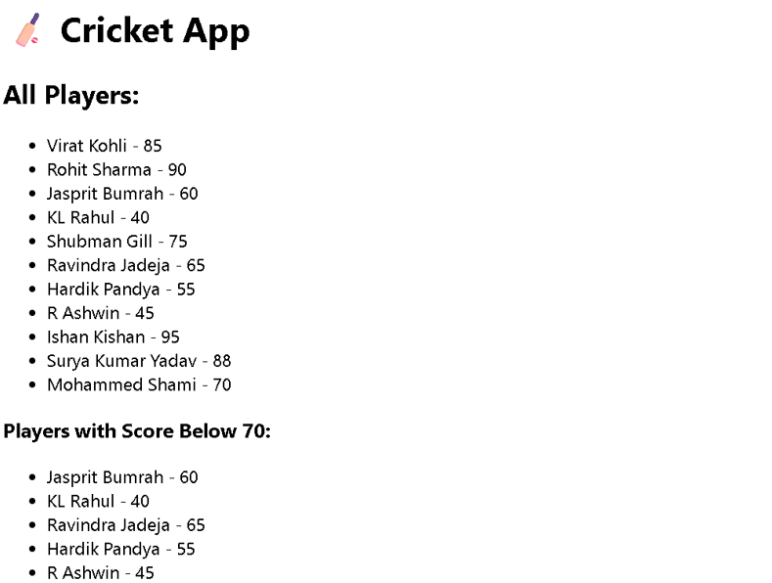

10. ReactJS-HOL
App.js
import React from 'react';
import logo from './logo.svg';

function App() {
// Object for a single office
const office = {
name: 'TechPark Office',
rent: 75000,
address: '123 Silicon Street, Bengaluru'
};

// List of office objects
const offices = [
{ name: 'Startup Hub', rent: 55000, address: 'MG Road, Mumbai' },
{ name: 'Creative Space', rent: 80000, address: 'HSR Layout, Bengaluru' },
{ name: 'Urban Office', rent: 45000, address: 'Cyber City, Gurgaon' },
{ name: 'Corporate Tower', rent: 95000, address: 'BKC, Mumbai' },
];

// Inline style conditionally based on rent
const getRentStyle = (rent) => {
return {
color: rent < 60000 ? 'red' : 'green',
fontWeight: 'bold',
};
};

return (
<div className="App">
{/* JSX Heading */}
<h1>🏢 Office Space Rental Portal</h1>

{/* Image with JSX Attribute */}
<img
src={logo}
alt="Office Space"
style={{ borderRadius: '10px', marginBottom: '20px',width:"30px",height:"30px",objectFit:"cover" }}
/>
{/* Display single office object */}
<div style={{ margin: '20px 0' }}>
<h2>{office.name}</h2>
<p>Rent: <span style={getRentStyle(office.rent)}>₹{office.rent}</span></p>
<p>Address: {office.address}</p>
</div>

{/* List of offices using map() */}
<h2>Available Offices</h2>
{offices.map((item, index) => (
<div key={index} style={{ border: '1px solid gray', padding: '10px', margin: '10px 0' }}>
<h3>{item.name}</h3>
<p>Rent: <span style={getRentStyle(item.rent)}>₹{item.rent}</span></p>
<p>Address: {item.address}</p>
</div>
))}
</div>
);
}

export default App;

OUTPUT:
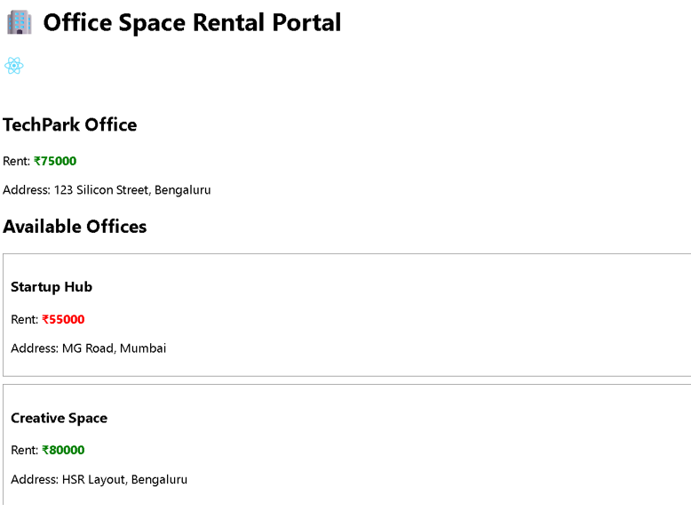

11. ReactJS-HOL
Create a React Application “eventexamplesapp” to handle various events of the form elements in HTML.
Counter.js
import React, { useState } from 'react';

const Counter = () => {
const [count, setCount] = useState(0);

const incrementValue = () => {
setCount(count + 1);
};

const sayHello = () => {
alert('Hello! Incrementing the counter...');
};

const handleIncrement = () => {
sayHello();
incrementValue();
};

const handleDecrement = () => {
setCount(count - 1);
};

return (
<div>
<h2>Counter Value: {count}</h2>
<button onClick={handleIncrement}>Increment</button>
<button onClick={handleDecrement} style={{ marginLeft: '10px' }}>Decrement</button>
</div>
);
};

export default Counter;

SayWelcome.js
import React from 'react';

const SayWelcome = () => {
const sayMessage = (msg) => {
alert(`Message: ${msg}`);
};

return (
<div style={{ marginTop: '20px' }}>
<button onClick={() => sayMessage('Welcome!')}>Say Welcome</button>
</div>
);
};

export default SayWelcome;

SyntheticEventExample.js
import React from 'react';

const SyntheticEventExample = () => {
const handleClick = (e) => {
e.preventDefault(); // Example of using SyntheticEvent
alert('I was clicked');
};

return (
<div style={{ marginTop: '20px' }}>
<button onClick={handleClick}>OnPress</button>
</div>
);
};

export default SyntheticEventExample;

CurrencyConvertor.js
import React, { useState } from 'react';

const CurrencyConvertor = () => {
const [rupees, setRupees] = useState('');
const [euro, setEuro] = useState('');

const handleSubmit = (e) => {
e.preventDefault();
if (!rupees || isNaN(rupees)) {
alert('Please enter a valid amount in rupees');
return;
}
const converted = (parseFloat(rupees) / 88).toFixed(2); // Assume 1 Euro = ₹88
setEuro(converted);
};

return (
<div style={{ marginTop: '30px' }}>
<h3>Currency Convertor</h3>
<form onSubmit={handleSubmit}>
<label>
Enter amount in ₹ Rupees:
<input
type="text"
value={rupees}
onChange={(e) => setRupees(e.target.value)}
style={{ marginLeft: '10px' }}
/>
</label>
<button type="submit" style={{ marginLeft: '10px' }}>Convert</button>
</form>
{euro && <p>💶 Euro: €{euro}</p>}
</div>
);
};

export default CurrencyConvertor;

App.js
import React from 'react';
import CurrencyConvertor from './CurrencyConvertor';
import SyntheticEventExample from './SyntheticEventExample';
import SayWelcome from './SayWelcome';
import Counter from './Counter';

function App() {
return (
<div style={{ padding: '30px' }}>
<h1>🎯 Event Handling Examples</h1>
<Counter />
<SayWelcome />
<SyntheticEventExample />
<CurrencyConvertor />
</div>
);
}

export default App;
OUTPUT:

12. ReactJS-HOL
Create a React Application named “ticketbookingapp” where the guest user can browse the page where the flight details are displayed whereas the logged in user only can book tickets.
UserPage.js
import React from 'react';

const UserPage = () => {
return (
<div>
<h2>🧳 Welcome User</h2>
<p>You can now book tickets and manage your trips.</p>
</div>
);
};

export default UserPage;
LoginControl.js
import React, { useState } from 'react';
import GuestPage from './GuestPage';
import UserPage from './UserPage';

const LoginControl = () => {
const [isLoggedIn, setIsLoggedIn] = useState(false);

const handleLoginClick = () => {
setIsLoggedIn(true);
};

const handleLogoutClick = () => {
setIsLoggedIn(false);
};

// Using element variables
let button;
let content;

if (isLoggedIn) {
button = <button onClick={handleLogoutClick}>Logout</button>;
content = <UserPage />;
} else {
button = <button onClick={handleLoginClick}>Login</button>;
content = <GuestPage />;
}

return (
<div>
{button}
{content}
</div>
);
};

export default LoginControl;
GuestPage.js
import React from 'react';

const GuestPage = () => {
return (
<div>
<h2>✈️ Welcome Guest</h2>
<p>You can browse flights but need to log in to book tickets.</p>
</div>
);
};

export default GuestPage;

OUTPUT:
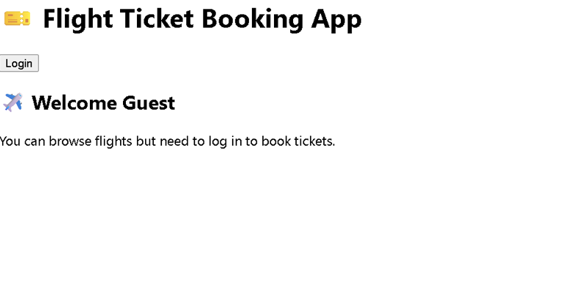

13. ReactJS-HOL
Create a React App named “bloggerapp” in with 3 components.

1. Book Details
2. Blog Details
3. Course Details
BookDetails.js

import React from 'react';

const BookDetails = () => {
const books = [
{ id: 1, title: 'Atomic Habits', author: 'James Clear' },
{ id: 2, title: 'Deep Work', author: 'Cal Newport' },
];

return (
<div>
<h2>📚 Book Details</h2>
<ul>
{books.map(book => (
<li key={book.id}>
<strong>{book.title}</strong> by {book.author}
</li>
))}
</ul>
</div>
);
};

export default BookDetails;

BlogDetails.js
import React from 'react';

const BlogDetails = () => {
const blogs = [
{ id: 101, title: 'React Basics', author: 'Alice' },
{ id: 102, title: 'State Management', author: 'Bob' },
];

return (
<div>
<h2>📝 Blog Details</h2>
<ul>
{blogs.map(blog => (
<li key={blog.id}>
<strong>{blog.title}</strong> by {blog.author}
</li>
))}
</ul>
</div>
);
};

export default BlogDetails;
CourseDetails.js
import React from 'react';

const CourseDetails = () => {
const courses = [
{ id: 'C1', title: 'React Fundamentals', duration: '3 weeks' },
{ id: 'C2', title: 'Advanced JS', duration: '4 weeks' },
];

return (
<div>
<h2>🎓 Course Details</h2>
<ul>
{courses.map(course => (
<li key={course.id}>
<strong>{course.title}</strong> - {course.duration}
</li>
))}
</ul>
</div>
);
};

export default CourseDetails;

MainDisplay.js
import React, { useState } from 'react';
import BookDetails from './BookDetails';
import BlogDetails from './BlogDetails';
import CourseDetails from './CourseDetails';

const MainDisplay = () => {
const [view, setView] = useState('book'); // Options: 'book', 'blog', 'course'

let content;
if (view === 'book') {
content = <BookDetails />;
} else if (view === 'blog') {
content = <BlogDetails />;
} else {
content = <CourseDetails />;
}

return (
<div>
<h1>📘 BloggerApp Dashboard</h1>

{/* Navigation Buttons */}
<button onClick={() => setView('book')}>Show Books</button>
<button onClick={() => setView('blog')}>Show Blogs</button>
<button onClick={() => setView('course')}>Show Courses</button>

{content}

</div>
);
};

export default MainDisplay;
App.js
import React from 'react';
import MainDisplay from './MainDisplay';

function App() {
return (
<div className="App">
<MainDisplay />
</div>
);
}

export default App;
OUTPUT:
