S.NO | NAME OF THE STUDENT | REGISTER NUMBER | EVENT NAME | EVENT TYPE | PARTICIPATION / ACHIEVEMENT | AWARDING AGENCY/ENTITY |  | PROOF
1 | KIRAN RAJ G | 250701353 |  | Hackathon |  | SRM college of science and technology |  | 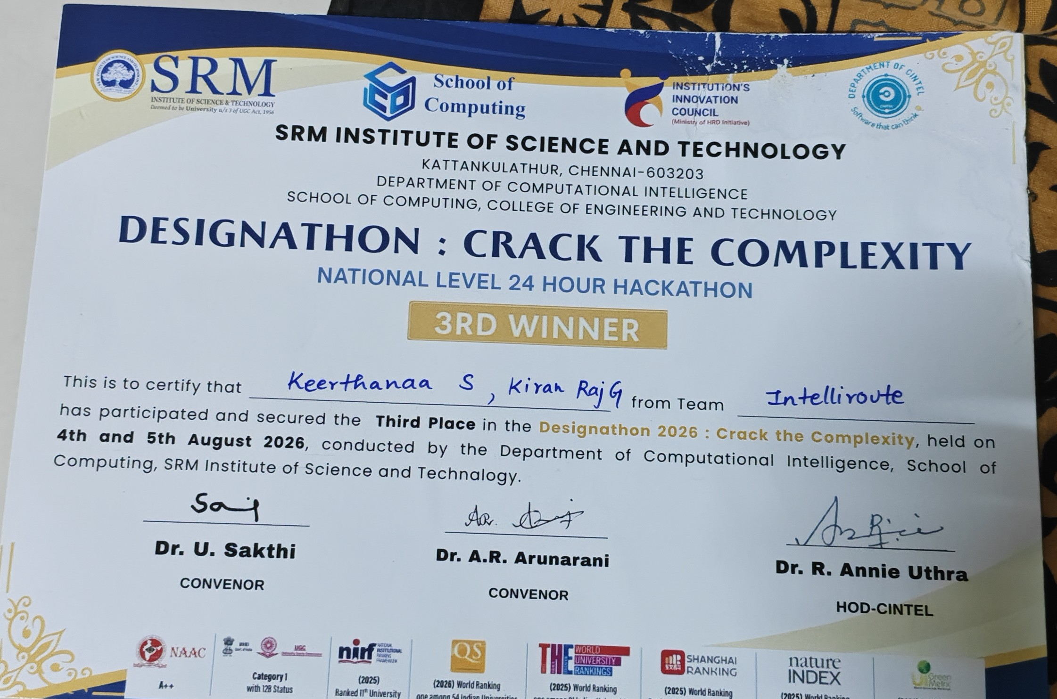
2 | ROSHAN VS | 2116250701610 |  | Hackathon |  | Adobe |  | 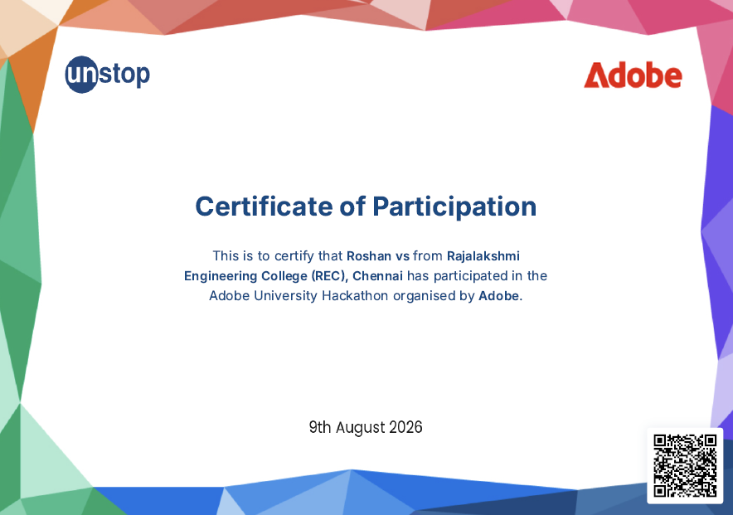
3 | ROHITH KUMAR S | 2116240701436 |  | 24 hr Hackathon | 1 st Place | Rajalakshmi Engineering College |  | 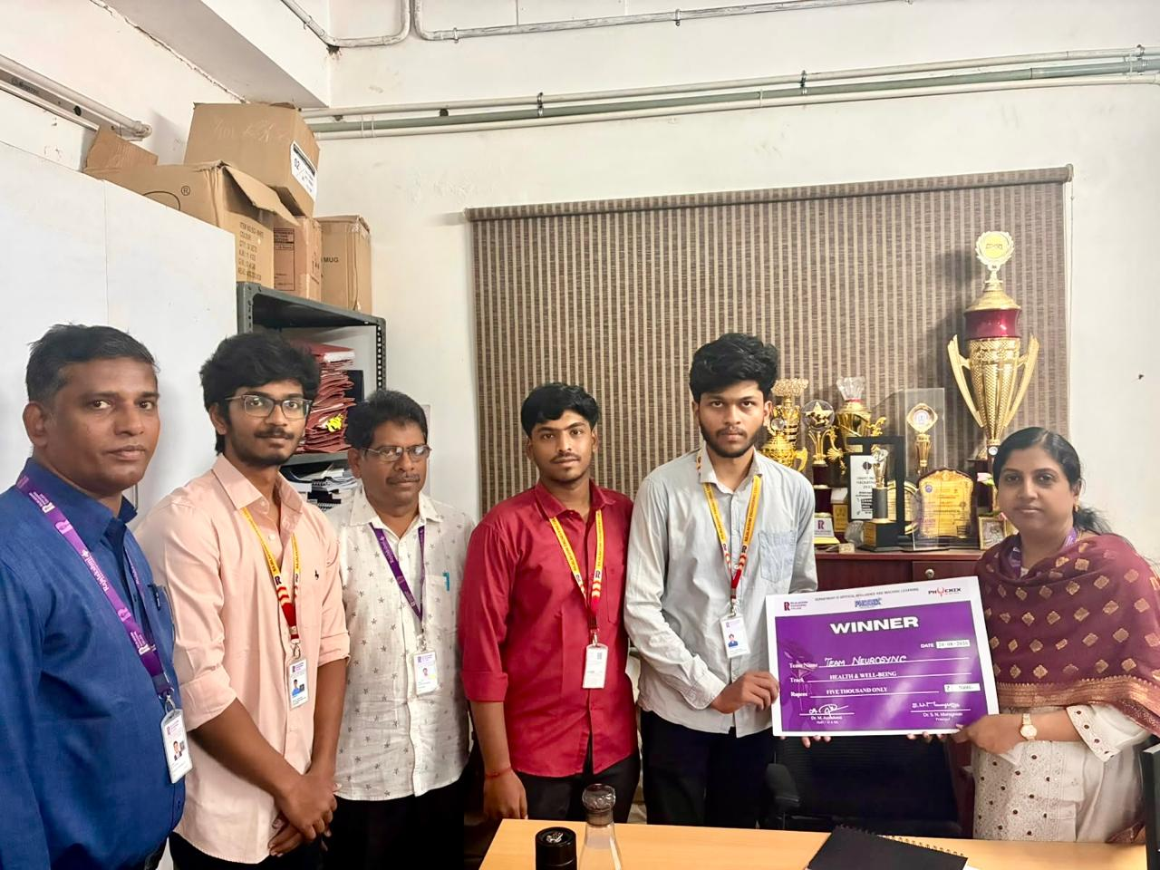
4 | ROSHAN A | 2116240701438 |  | 24 hr Hackathon | 1 st Place | Rajalakshmi Engineering College |  | -do-
5 | ARJUNRAJ M | 2116240701049 |  | 24 hr Hackathon | 1 st Place | Rajalakshmi Engineering College |  | -do-
6 | SAM DEVARAJA J | 2116240701463 | CIH hackathon'2026 | 24 hr Hackathon | 13 th Place | Rathinam Technical Campus |  | 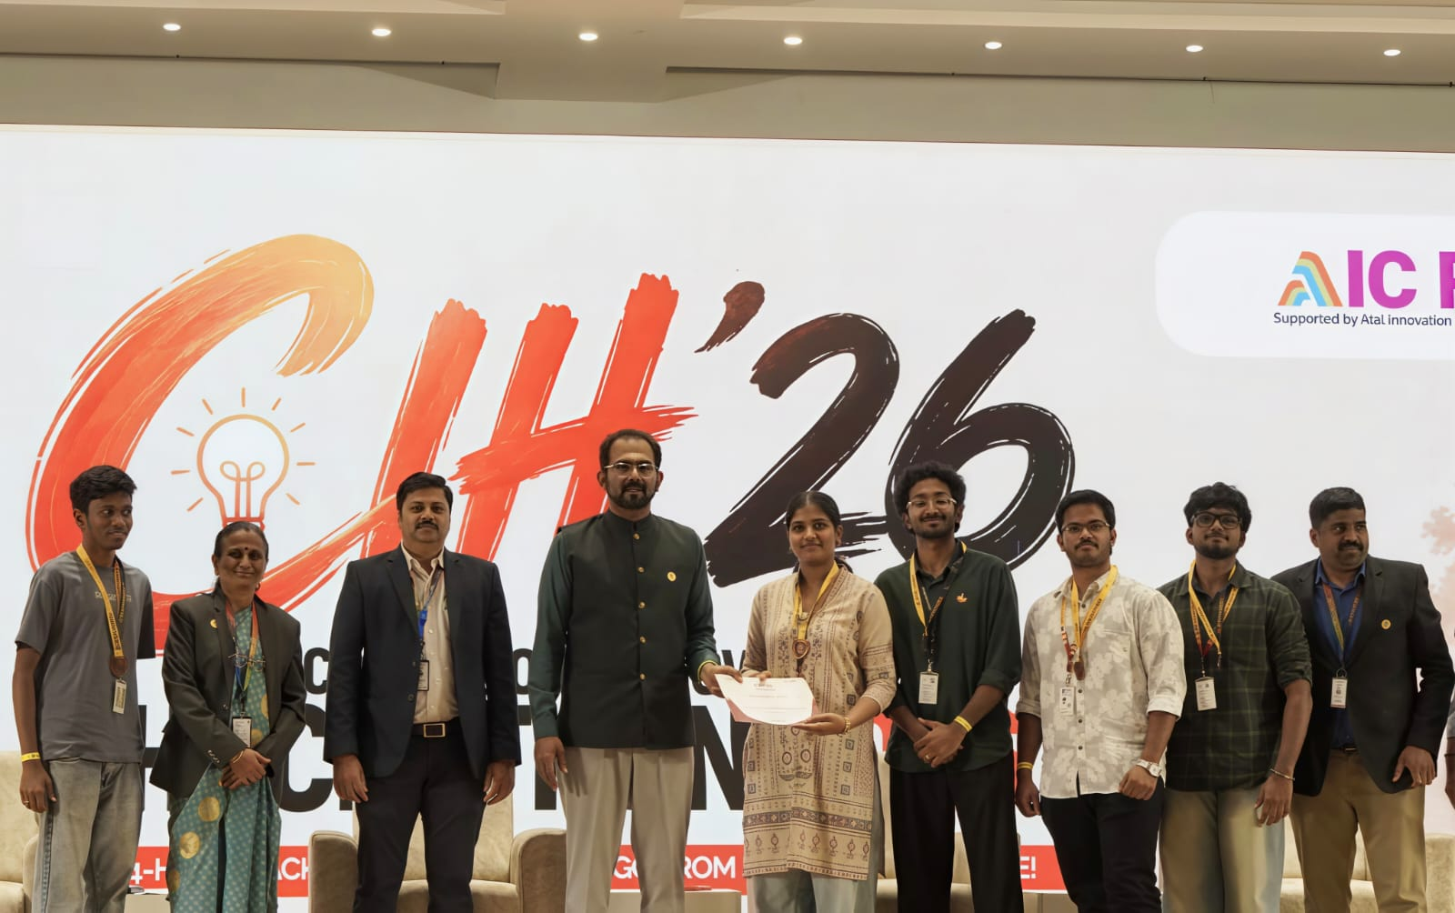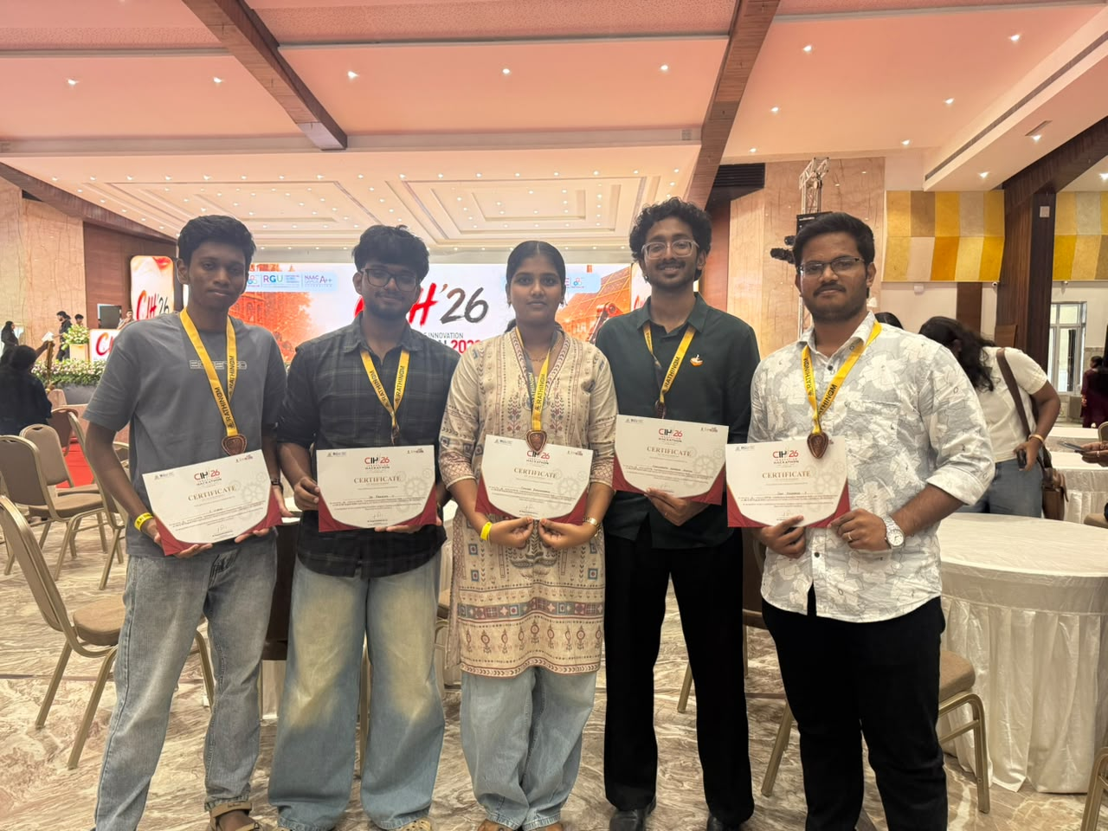
7 | SAIPRASHANTH V | 2116240701457 | CIH hackathon'2026 | 24 hr Hackathon | 13 th Place | Rathinam Technical Campus |  | -do-
8 | VISHAL S | 2116240701600 | CIH hackathon'2026 | 24 hr Hackathon | 13 th Place | Rathinam Technical Campus |  | -do-
9 | THIVYAA P | 2116240701570 | CIH hackathon'2026 | 24 hr Hackathon | 13 th Place | Rathinam Technical Campus |  | -do-
10 | SAM DEVARAJA J | 2116240701463 | AICCI National Startup Summit 2026 | Startup Summit | Top 10 | AICCI |  | 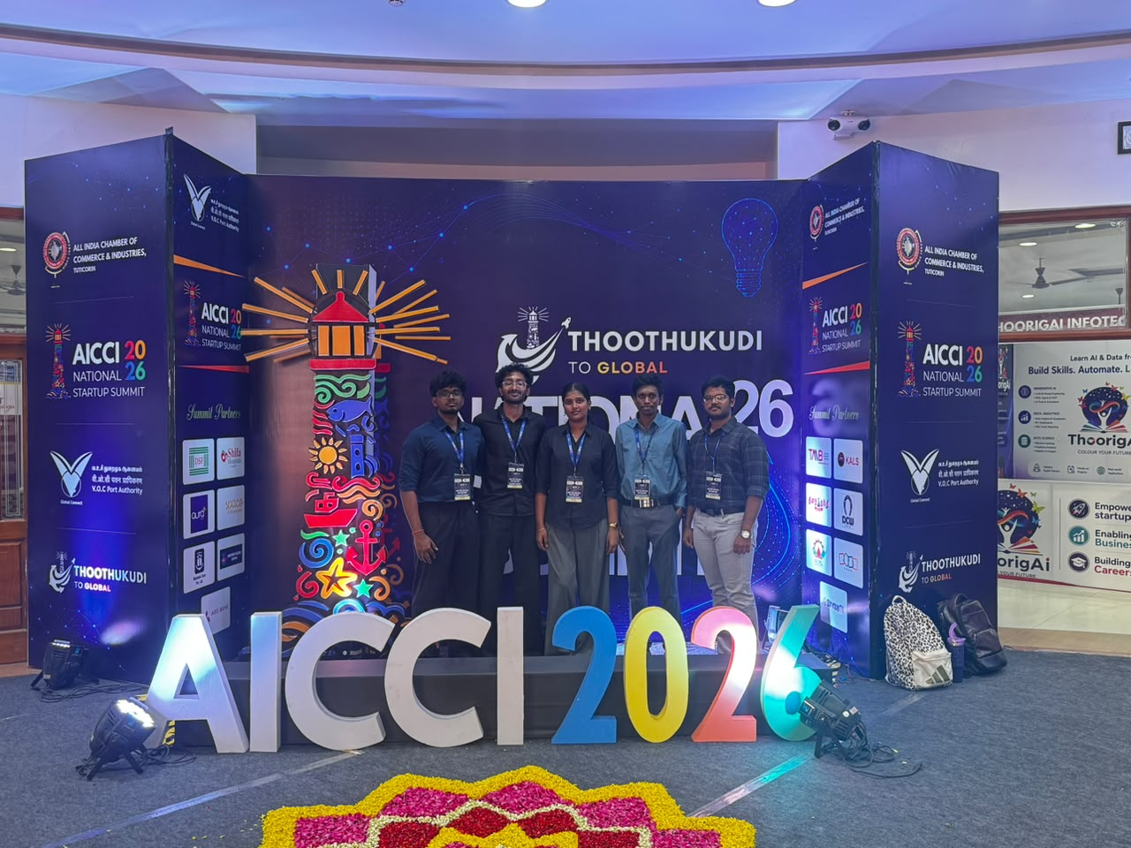
11 | SAIPRASHANTH V | 2116240701457 | AICCI National Startup Summit 2026 | Startup Summit | Top 10 | AICCI |  | -do-
12 | VISHAL S | 2116240701600 | AICCI National Startup Summit 2026 | Startup Summit | Top 10 | AICCI |  | -do-
13 | THIVYAA P | 2116240701570 | AICCI National Startup Summit 2026 | Startup Summit | Top 10 | AICCI |  | -do-
14 | SAM DEVARAJA J | 2116240701463 | CAHCET'2026 | Hackathon | Participation | C. Abdul Hakeem College of Engineering and Technology (CAHCET) |  | 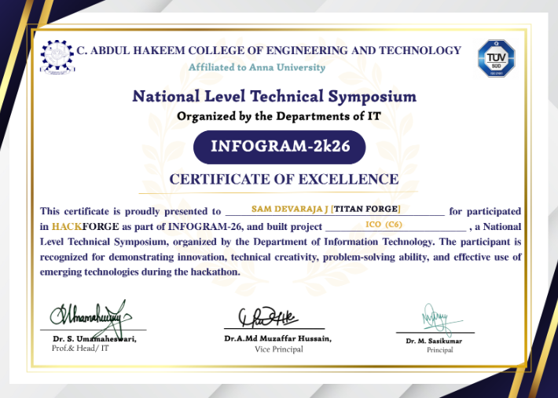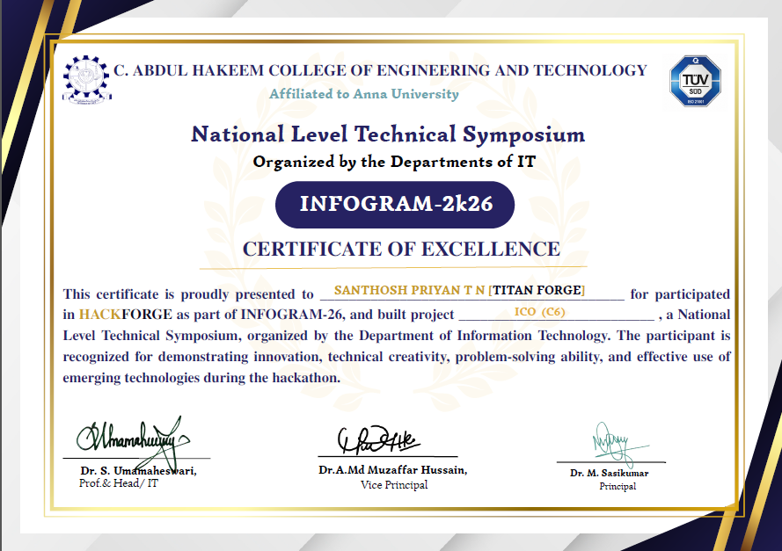
15 | SANTHOSH PRIYAN T N | 2116240701818 | CAHCET'2026 | Hackathon | Participation | C. Abdul Hakeem College of Engineering and Technology (CAHCET) |  | -do-
16 | SAM DEVARAJA J | 2116240701463 | CAHCET'2026 | Hackathon | Participation | KCG College of Technology |  | 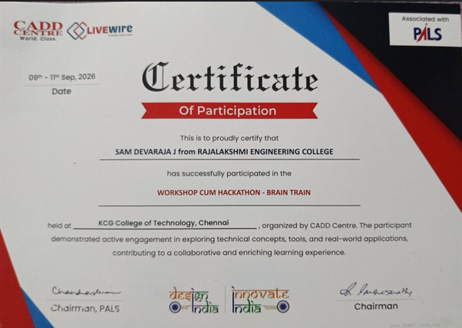
17 | SANTHOSH PRIYAN T N | 2116240701818 | CAHCET'2026 | Hackathon | Participation | KCG College of Technology |  | -do-
18 | SAM DEVARAJA J | 2116240701463 | Project Excellence Award (2 Categories) |  |  | Pixor Robotics-Dindigul |  | 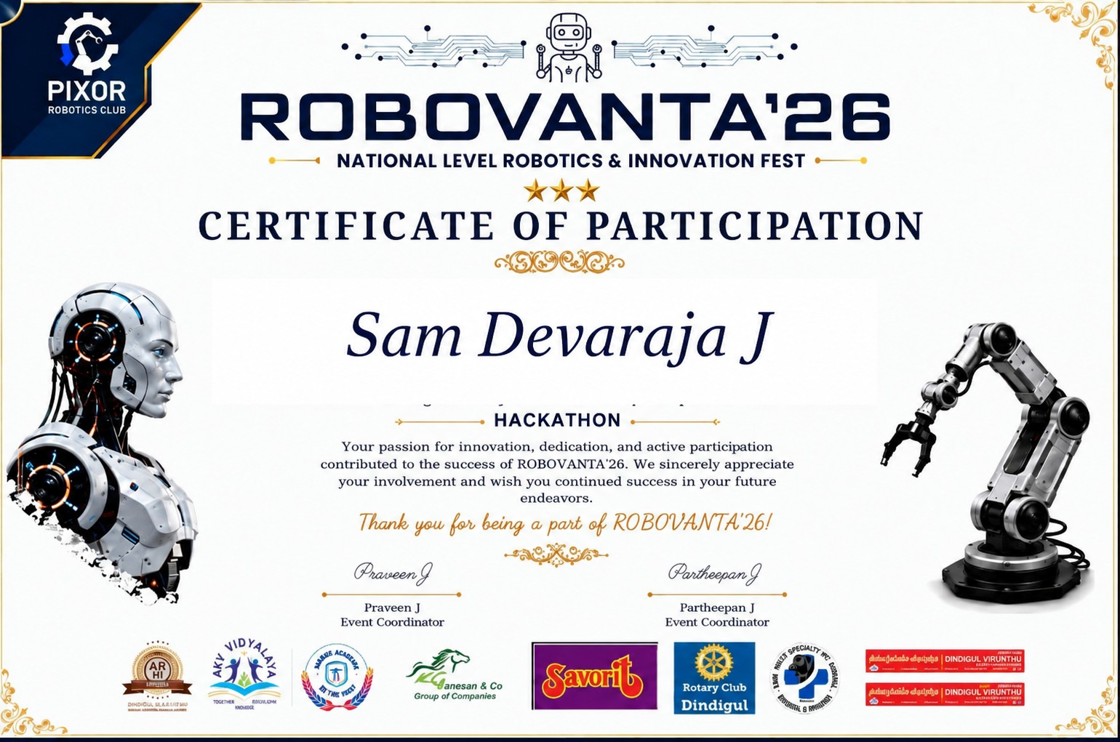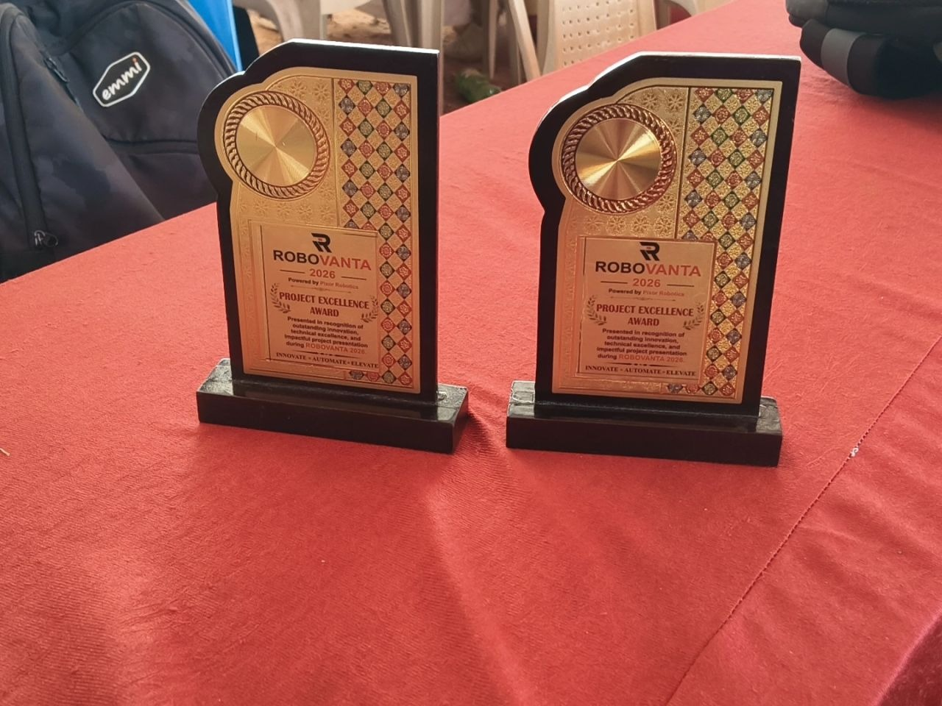  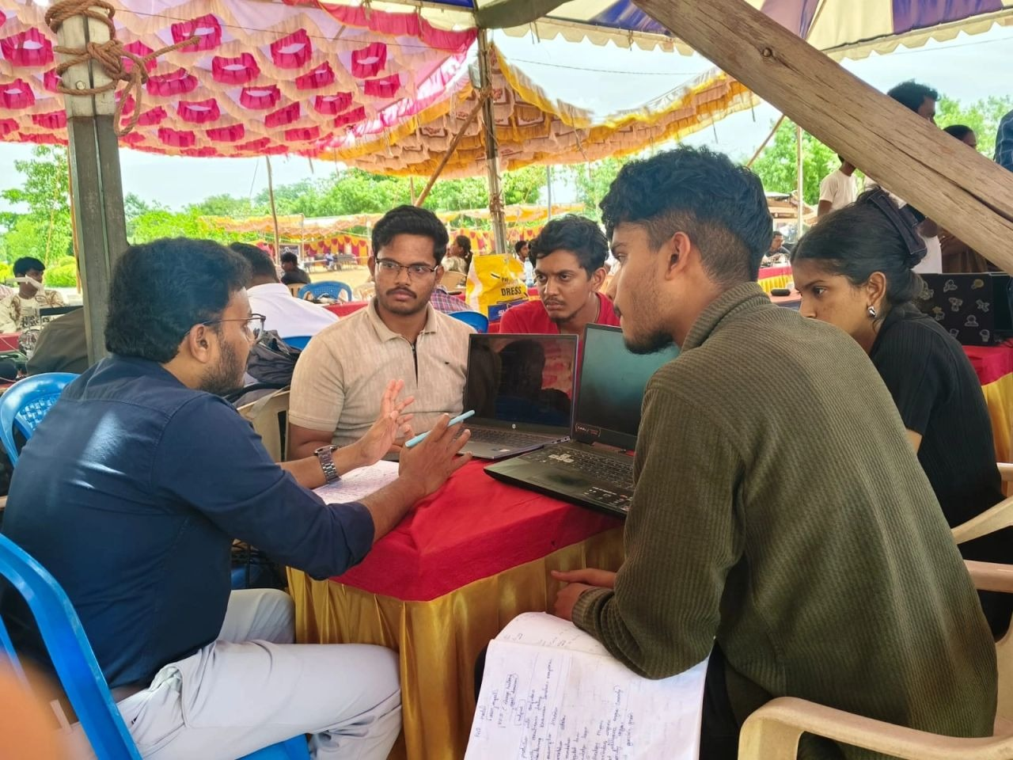
19 | PRAJITH S | 2116240701390 | Chandigarh Police Hackathon | Hackathon | 3 rd Place | Chandigarh Police / UIET Punjab University |  | 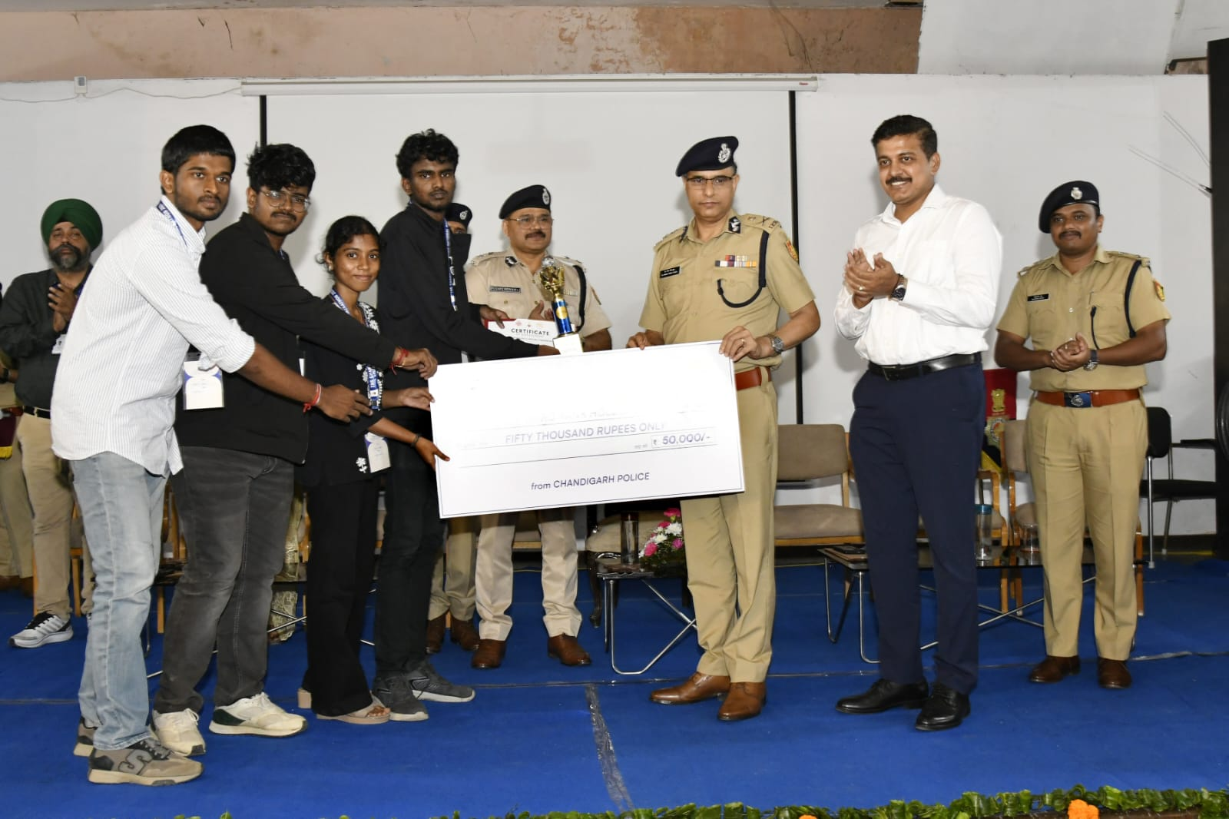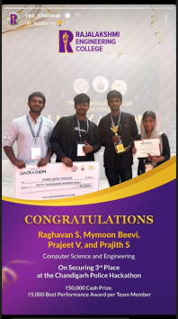  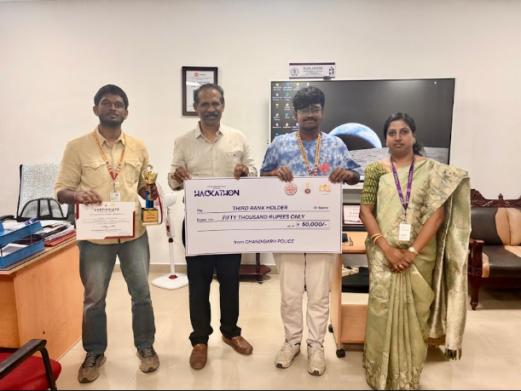
20 | PRAJEET V | 2116240701389 | Chandigarh Police Hackathon | Hackathon | 3 rd Place | Chandigarh Police / UIET Punjab University |  | -do-
21 | MONISHA S | 2116250701450 | second place-6hr hackathon | hackathon |  | SA College of Engineering |  | 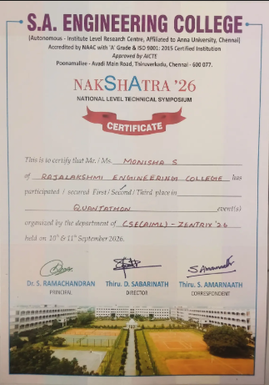
22 | MANISHA V | 2116250701413 | Certificate of Participation - Hackathon | Hackathon |  | SA College of Engineering |  | -do-
23 | MANISHA V | 2116250701413 | Certificate of Participation - Technical Event |  |  | SIMATS Engineering College |  | 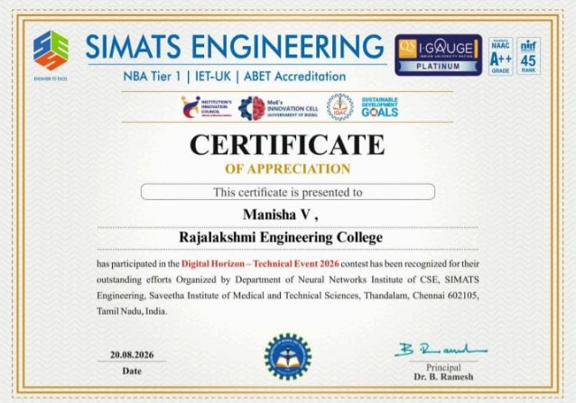
24 | MANISHA V | 2116250701413 | Certificate of Participation - Technical Event |  |  | Loyola Icam College of Engineering and Technology |  | 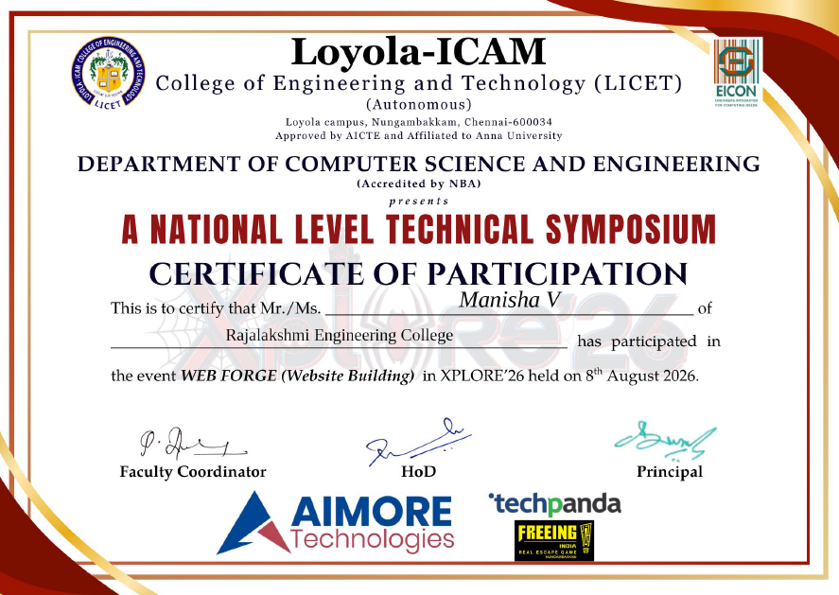
25 | MONISHA S | 2116250701450 | Certificate of Participation -Technical Event |  |  | SIMATS Engineering college |  | 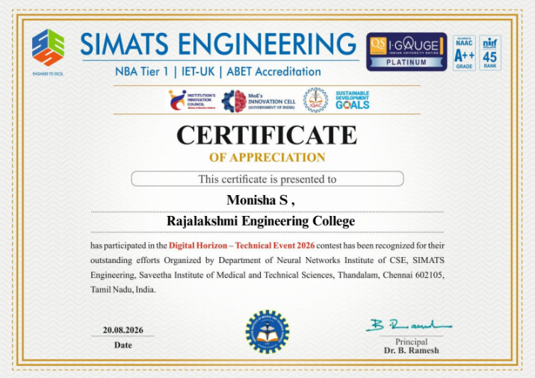
26 | RITHIKA R | 2116250701600 | Invente Hackinfinity'26 | 24 hr Hackathon | Participation | SSN College of Engineering
27 | RAKSHITHA S | 2116250701581 | Invente Hackinfinity'26 | 24 hr Hackathon | Participation | SSN College of Engineering
28 | ROSHAN M | 2116250701609 | Invente Hackinfinity'26 | 24 hr Hackathon | participation | SSN College of Engineering
29. | PADMA SREE M | 2116250701507 |  | Designathon 2026 | Hackathon | SRM Institute of Science and Technology |  | 