juCS5560 Knowledge Discovery and Management

Problem Set (PS-2A)

June 12, 2017

Name: Rohithkumar Nagulapati

Class ID: 16

1. Draw knowledge graphs (both Schema and Data graphs)

CHICAGO (AP) — Citing high fuel prices, United Airlines said Friday it has increased fares by $6 per round trip on flights to some cities also served by lower-cost carriers. American Airlines, a unit AMR, immediately matched the move, spokesman Tim Wagner said. United, a unit of UAL, said the increase took effect Thursday night and applies to most routes where it competes against discount carriers, such as Chicago to Dallas and Atlanta and Denver to San Francisco, Los Angeles and New York.

1. Design question answering for the given input text. Try to include at least one questions for the following question types.

* What
* Where
* When
* Who
* How
* How much
* Yes/No

ANSWERS

1.

**Schema Knowledge Graphs:**

The schema knowledge is a graph with entities as leaf nodes and just represents the schema of the graph representing overview without going to inner details of the text.

Schema:

(Fuel price, changed, airlines)

(United airlines, announced, Friday)

(United airlines, increased fare by, 6$)

(American airlines, is a unit of, AMR)

(United Airlines, is a unit of, UAL)

(UAL, said, effusive from Thursday night)

(Routes, are, Chicago to Dallas, Atlanta and Denver

Denver to Los Angeles, San Fransisco)

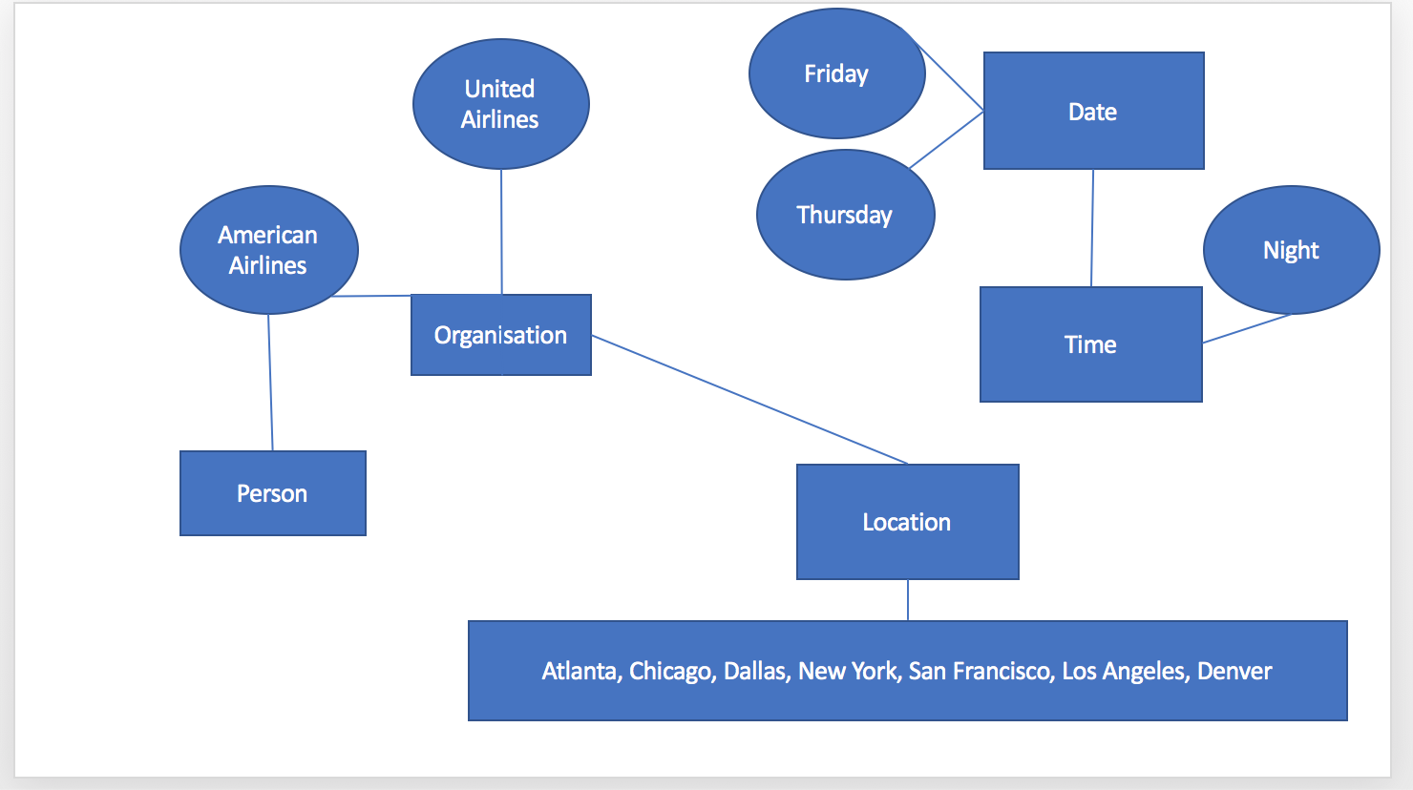

**Data Knowledge Graphs:**

The data knowledge graph contains the graph data with innermost details stated on the relationship between identified entities as leaf nodes.

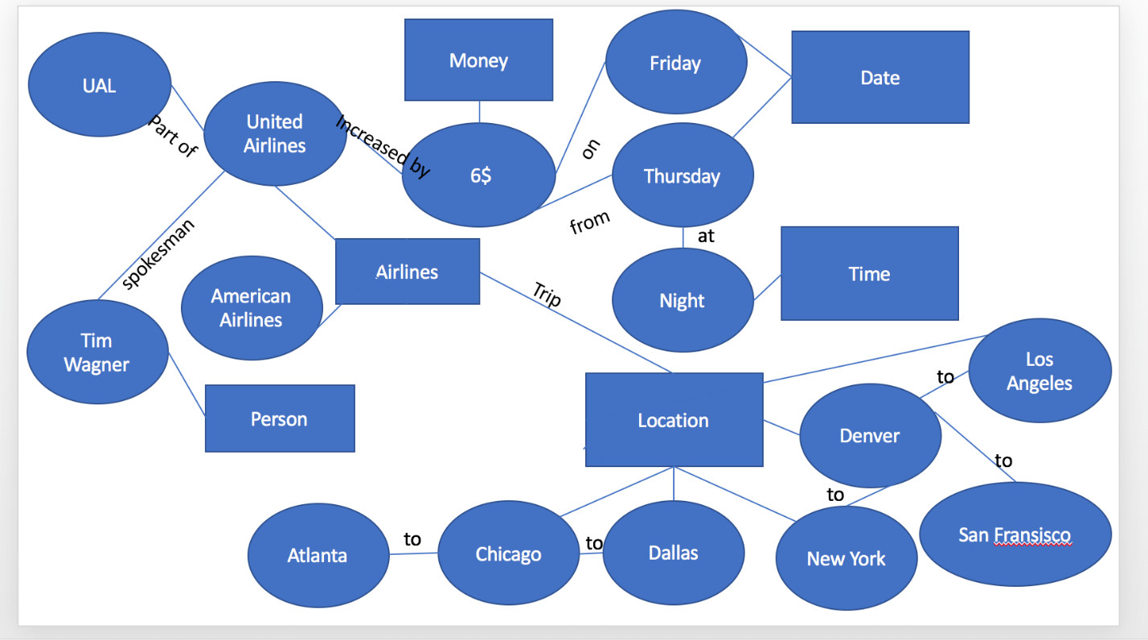

2.

What

1. What is the reason for increasing fare rates?

Ans: High fuel prices.

Where

1. Where are the increased fare rates affected?

Ans: Chicago to Dallas and Atlanta

Denver to San Francisco, Los Angeles and New York..

When

1. When is the fuel rates increased?

Ans: Thursday night

1. When is the increased fare rates started for the mentioned routes?

Ans: Friday

Who

1. Who is Tim Wagner?

Ans: Tim Wagner is spokesperson of American Airlines

How

1. How fuel rates affected airlines fare rates?

Ans: Increase in fuel rates affected airline prices.

How much

1. How much is the fare increased for round trip?

Ans: 6$

Yes/No

1. Is Tim spokesperson of UAL?

Ans: No