KPR Institute of Engineering and Technology
Department of Artificial Intelligence and Data Science
ASSIGNMENT II – CASE STUDY (PROJECT 2: REGRESSION)
Predicting Final Student Grades from Academic, Family and Lifestyle Factors Using Exploratory Data Analysis and Deep Learning
Case Study: Exploratory Data Analysis and Visualization of a Real-World Dataset
Student Name | RITHI R
Roll Number / College ID | 24AD091
Department | Artificial Intelligence and Data Science
Year / Semester | III Year / Semester V (Batch 2023–2027)
Course Code | U21ADP05
Course Title | Exploratory Data Analysis and Visualization
Assignment | Assignment II – Case Study (40 marks)
Academic Year | 2026–2027 (Odd Semester)
Course Coordinator | Mr. Rushikesh Kadam
Report Date | 19 October 2026

Abstract
Predicting a student's final grade early helps schools offer support in time. This study analyses the UCI Student Performance dataset (Portuguese course: 649 students, 32 input features, final grade G3 on a 0–20 scale). Exploratory analysis found no missing values, then used seven-stage visualisation, statistical tests, distribution fitting and PCA. Earlier grades dominated: G2 correlates with G3 at r = 0.92, while past failures, school and wish for higher education were the strongest non-grade factors. A multilayer perceptron regressor, tuned over 12 settings, reached test RMSE 1.33 (R² 0.82) with earlier grades, but RMSE 2.93 (R² 0.12) without them. A random forest matched or beat it, so predictions from lifestyle factors alone remain weak.
Keywords: exploratory data analysis, data visualization, student performance, regression, multilayer perceptron. (Abstract: 114 words)

Table of Contents
1. Introduction and Objectives 7
1.1 Background 7
1.2 Problem Statement 7
1.3 Motivation 7
1.4 Objectives 7
1.5 Scope and Practical Relevance 7
2. Dataset Description 8
2.1 Dataset Name, Source and Licence 8
2.2 Why This Dataset Was Chosen 8
2.3 Verified Structure of the Dataset 8
2.4 Description of the Fields 9
2.5 Basic Descriptive Statistics 10
3. Exploratory Data Analysis and Preprocessing 11
3.1 Loading and Inspecting the Data 11
3.2 Missing Values and Duplicates 11
3.3 Outlier Identification and Treatment 11
3.4 Cleaning, Transformation and Encoding 12
3.5 Two Experimental Settings 12
3.6 Train / Validation / Test Split and Leakage Prevention 12
3.7 Key Findings from EDA 13
4. Data Visualization 13
4.1 The Seven Stages of Visualization 13
4.2 Visualization Design Choices (Refine stage) 13
4.3 Interactive Visualizations 14
4.4 Visualization Gallery with Explanations 14
5. Statistical and Distribution-Based Analysis 23
5.1 Univariate Analysis 23
5.2 Probability Distributions 23
5.3 Bivariate Analysis 24
5.4 Multivariate Analysis 25
5.5 Summary of Statistical Findings 25
6. Deep Learning Model 25
6.1 Why a Multilayer Perceptron? 25
6.2 Inputs, Target and Pipeline 25
6.3 Architecture and Hyperparameters 26
6.4 Training, Validation and Testing Procedure 26
6.5 Basic Hyperparameter Tuning 26
6.6 Feature Analysis and Feature Importance 27
7. Model Evaluation and Result Visualization 28
7.1 Evaluation Metrics 28
7.2 Comparison with Baseline Models 29
7.3 Result Visualizations and Interpretation 29
7.4 Stability over 10 Random Splits 33
8. Conclusion, Challenges and Future Scope 33
8.1 What Was Learned from the Data 33
8.2 Model Performance 34
8.3 Challenges and Limitations 34
8.4 Future Scope 34
9. Literature Review and References 34
9.1 Short Literature Review 34
9.2 References (APA 7th edition) 35
10. Rubric Alignment 35
Appendix A – Complete Python Source Code 37
A.1 config.py – paths, seed, column groups, plot style 37
A.2 data_preprocessing.py – loading, cleaning, split, pipeline 37
A.3 eda.py – statistics and distribution fitting 38
A.4 visualizations.py – Figures 1–12 and interactive pages 39
A.5 train_model.py – tuning, training, baselines, repeated splits 42
A.6 evaluate_model.py – evaluation, Figures 13–20 43
A.7 diagrams.py – workflow and architecture diagrams 45
A.8 run_all.py – run the whole pipeline 45
Appendix B – GitHub Repository and Checklist 46
B.1 Repository Structure 46
B.2 README Outline 46
B.3 Commands to Publish 46
B.4 GitHub Submission Checklist 47
Appendix C – Final Checklist Against the Assignment Requirements 47
List of Figures
Diagram 1: End-to-end project workflow 11
Figure 1: Distribution of the final grade (G3) 14
Figure 2: Histograms of key numeric variables 15
Figure 3: Final grade by key factors 15
Figure 4: Share of IQR outliers per numeric feature 16
Figure 5: Continuous distribution: final grade G3 16
Figure 6: Discrete distributions: Poisson, negative binomial, Binomial 17
Figure 7: Spearman correlation heatmap 18
Figure 8: Mean final grade for each binary factor 19
Figure 9: Earlier grades against the final grade 20
Figure 10: PCA projection of numeric features 21
Figure 11: Pairplot of key variables 22
Figure 12: Mean G3 by study time and past failures 23
Diagram 2: MLP architecture of the final model (setting A) 26
Figure 13: Training vs validation loss 29
Figure 14: Training vs validation MAE 30
Figure 15: Predicted vs actual final grade 30
Figure 16: Error distribution 31
Figure 17: Residual plot 31
Figure 18: Permutation importance (top 10 features) 32
Figure 19: Hyperparameter search results 32
Figure 20: Stability over 10 random train/validation/test splits 33
List of Tables
Table 1: Dataset identification 8
Table 2: Verified facts about the loaded file 8
Table 3: All 32 input fields and the target 9
Table 4: Descriptive statistics of numeric features and the target 10
Table 5: Outlier summary 11
Table 6: Preprocessing applied to each group of features 12
Table 7: The two settings 12
Table 8: Data split (random_state = 42) 12
Table 9: Seven stages of visualization applied to the student grade dataset 13
Table 10: Distribution analysis results 23
Table 11: Fourteen features most strongly associated with G3 24
Table 12: Statistical findings in plain words 25
Table 13: Model inputs and output 25
Table 14: Final model configuration 26
Table 15: Best five configurations, setting A (sorted by validation RMSE) 27
Table 16: Best five configurations, setting B (sorted by validation RMSE) 27
Table 17: Top eight features by permutation importance, setting A (test set) 27
Table 18: Top eight features by permutation importance, setting B (test set) 27
Table 19: Regression metrics for setting A (with G1 and G2) 28
Table 20: Regression metrics for setting B (without G1 and G2) 28
Table 21: Test errors over 10 random splits (mean ± standard deviation) 33
Table 22: Rubric alignment 35
Table 23: Purpose of each folder and file 46
Table 24: Checklist before submitting the link 47
Table 25: Requirement checklist 47

List of Abbreviations
Abbreviation | Meaning
CO | Course outcome
CSV | Comma-separated values
EDA | Exploratory data analysis
G1, G2, G3 | First-period, second-period and final grade (0–20)
IQR | Inter-quartile range
MAE | Mean absolute error
MLP | Multilayer perceptron
MSE | Mean squared error
PCA | Principal component analysis
R² | Coefficient of determination
ReLU | Rectified linear unit
RMSE | Root mean squared error
UCI | University of California, Irvine (Machine Learning Repository)
VIF | Variance inflation factor

1. Introduction and Objectives

1.1 Background
Schools record a student's marks in every period together with details about the family, study habits and free-time activities. Exploratory Data Analysis (EDA), introduced by John Tukey (1977), means looking at such data through summaries and pictures before building a model, so that patterns, errors and surprises are found early. In this project, EDA and a deep-learning model are applied to the marks of secondary-school students in a Portuguese-language course.

1.2 Problem Statement
Given a student's background, study habits, lifestyle and (optionally) earlier-period marks, (a) which factors are most strongly associated with the final grade G3, and (b) how accurately can a deep-learning model predict G3 as a number between 0 and 20? Because the target is numeric, this is a regression problem. (The companion project in this series, on student dropout, was a classification problem.)

1.3 Motivation
- A teacher who sees a low predicted grade early can offer extra help before the final examination.
- It matters how early the prediction is made. A model that uses the marks of the first two periods is much easier to build than one that uses only background information. This report measures both situations separately.
- The data are real, mixed (numeric, ordinal, binary and categorical) and small enough to study carefully on a laptop.

1.4 Objectives
1. Select and verify a real-world dataset with at least 15 features (this one has 32 input features).
2. Perform data understanding, cleaning, outlier analysis, encoding, scaling and a train/validation/test split without data leakage.
3. Create more than five meaningful visualisations (12 EDA figures and 8 model figures) following all seven stages of visualisation.
4. Carry out univariate, bivariate and multivariate analysis and study continuous and discrete probability distributions.
5. Build and tune a multilayer perceptron regressor in two settings (with and without the earlier grades) and compare it with simple baselines.
6. Evaluate it with loss/MAE curves, predicted-versus-actual and error-distribution plots, residual analysis and feature importance.
7. Publish the work in a well-structured GitHub repository with a README.

1.5 Scope and Practical Relevance
The study covers one dataset from two schools in one region and a single course (Portuguese language). It is a learning project, not a deployed system. The workflow (clean, explore, visualise, model, evaluate) is the one a school analytics team would follow to build an early-warning tool for teachers.

2. Dataset Description

2.1 Dataset Name, Source and Licence
Table 1: Dataset identification
Item | Details
Name | Student Performance
Repository | UCI Machine Learning Repository (dataset id 320)
URL | https://archive.ics.uci.edu/dataset/320/student+performance
DOI | 10.24432/C5TG7T
Creator | Paulo Cortez (University of Minho, Portugal)
Licence | Creative Commons Attribution 4.0 (CC BY 4.0)
Companion paper | Cortez & Silva (2008), Using data mining to predict secondary school student performance, FUBUTEC 2008, pp. 5–12
File used | student-por.csv (Portuguese-language course) saved as data/student-por.csv

Verification note. The UCI page lists 649 instances, 30 attributes plus the three grades G1, G2 and G3, no missing values, and the tasks classification and regression. The UCI page does not say which of its two files (Mathematics and Portuguese) holds the 649 rows; the Portuguese file used here contains exactly 649 rows, which matches. The UCI website could not be reached from the environment used for the analysis, so the CSV was obtained from public GitHub copies of the dataset. Two independent copies were loaded and compared and found identical (649 × 33). The original UCI file is semicolon-separated; the copies are comma-separated, and this is handled in the loading code. Anyone re-running the project can download the original from the UCI link and place it at data/student-por.csv (use sep=';' when loading the original).

2.2 Why This Dataset Was Chosen
- More than 15 features: 32 input fields plus a target.
- Real-world relevance: real students from two schools; the problem (predicting final marks) is a standard learning-analytics task.
- Mixed data types: ordinal ratings (1–5), counts, binary yes/no flags and categorical fields, so many chart types and statistical tests are meaningful.
- Suitable for regression: the target G3 is an integer from 0 to 20 and is treated as a numeric value; the UCI page lists regression as an associated task.
- A teachable twist: G1 and G2 are almost duplicates of G3, so the project can show how much a model depends on them by training with and without them.
- Small and clean: 649 rows run quickly on a laptop. The small size also forces honest evaluation (repeated splits).

2.3 Verified Structure of the Dataset
Table 2: Verified facts about the loaded file
Property | Value (measured on data/student-por.csv)
Rows (students) | 649
Columns | 33 (32 input features + target G3)
Missing cells | 0
Duplicate rows | 0
Numeric / ordinal features | 15 (age, parents' education, study time, failures, ratings, absences, G1, G2)
Binary (yes/no-type) features | 13
Nominal features (>2 categories) | 4 (Mjob, Fjob, reason, guardian)
Stored data types | integer: 16, text: 17
Target | G3 – final grade, integer 0–20 (regression)
G3 summary | mean 11.91, median 12, SD 3.23, min 0, max 19
Passing students (G3 ≥ 10) | 549 of 649 (84.6%)

2.4 Description of the Fields
The descriptions below follow the attribute list on the UCI dataset page. Ordinal ratings (1–5) are treated as numbers in this report.
Table 3: All 32 input fields and the target
# | Field | Group | Meaning
1 | school | Binary | Student's school (GP or MS)
2 | sex | Binary | Sex (F or M)
3 | age | Numeric | Age in years (15–22)
4 | address | Binary | Home address type (U urban, R rural)
5 | famsize | Binary | Family size (LE3 up to 3, GT3 more than 3)
6 | Pstatus | Binary | Parents' cohabitation (T together, A apart)
7 | Medu | Numeric | Mother's education (0–4)
8 | Fedu | Numeric | Father's education (0–4)
9 | Mjob | Nominal | Mother's job (category)
10 | Fjob | Nominal | Father's job (category)
11 | reason | Nominal | Reason for choosing the school (category)
12 | guardian | Nominal | Student's guardian (mother, father, other)
13 | traveltime | Numeric | Home-to-school travel time (1–4)
14 | studytime | Numeric | Weekly study time (1–4)
15 | failures | Numeric | Number of past class failures
16 | schoolsup | Binary | Extra educational support from school
17 | famsup | Binary | Family educational support
18 | paid | Binary | Extra paid classes in the course
19 | activities | Binary | Extra-curricular activities
20 | nursery | Binary | Attended nursery school
21 | higher | Binary | Wants to take higher education
22 | internet | Binary | Internet access at home
23 | romantic | Binary | In a romantic relationship
24 | famrel | Numeric | Quality of family relationships (1–5)
25 | freetime | Numeric | Free time after school (1–5)
26 | goout | Numeric | Going out with friends (1–5)
27 | Dalc | Numeric | Workday alcohol consumption (1–5)
28 | Walc | Numeric | Weekend alcohol consumption (1–5)
29 | health | Numeric | Current health status (1–5)
30 | absences | Numeric | Number of school absences
31 | G1 | Numeric | First-period grade (0–20)
32 | G2 | Numeric | Second-period grade (0–20)
33 | G3 | Target | Final grade (0–20) – the value to be predicted

2.5 Basic Descriptive Statistics
The table gives the mean, median, mode, standard deviation, quartiles and skewness of the 15 numeric/ordinal features and the target, computed on all 649 rows.
Table 4: Descriptive statistics of numeric features and the target
Feature | Mean | Median | Mode | Std | Min | Q1 | Q3 | Max | Skew
age | 16.74 | 17.00 | 17.00 | 1.22 | 15.00 | 16.00 | 18.00 | 22.00 | 0.42
Medu | 2.52 | 2.00 | 2.00 | 1.14 | 0.00 | 2.00 | 4.00 | 4.00 | -0.03
Fedu | 2.31 | 2.00 | 2.00 | 1.10 | 0.00 | 1.00 | 3.00 | 4.00 | 0.21
traveltime | 1.57 | 1.00 | 1.00 | 0.75 | 1.00 | 1.00 | 2.00 | 4.00 | 1.25
studytime | 1.93 | 2.00 | 2.00 | 0.83 | 1.00 | 1.00 | 2.00 | 4.00 | 0.70
failures | 0.22 | 0.00 | 0.00 | 0.59 | 0.00 | 0.00 | 0.00 | 3.00 | 3.09
famrel | 3.93 | 4.00 | 4.00 | 0.96 | 1.00 | 4.00 | 5.00 | 5.00 | -1.11
freetime | 3.18 | 3.00 | 3.00 | 1.05 | 1.00 | 3.00 | 4.00 | 5.00 | -0.18
goout | 3.19 | 3.00 | 3.00 | 1.18 | 1.00 | 2.00 | 4.00 | 5.00 | -0.01
Dalc | 1.50 | 1.00 | 1.00 | 0.93 | 1.00 | 1.00 | 2.00 | 5.00 | 2.14
Walc | 2.28 | 2.00 | 1.00 | 1.28 | 1.00 | 1.00 | 3.00 | 5.00 | 0.64
health | 3.54 | 4.00 | 5.00 | 1.45 | 1.00 | 2.00 | 5.00 | 5.00 | -0.50
absences | 3.66 | 2.00 | 0.00 | 4.64 | 0.00 | 0.00 | 6.00 | 32.00 | 2.02
G1 | 11.40 | 11.00 | 10.00 | 2.75 | 0.00 | 10.00 | 13.00 | 19.00 | -0.00
G2 | 11.57 | 11.00 | 11.00 | 2.91 | 0.00 | 10.00 | 13.00 | 19.00 | -0.36
G3 | 11.91 | 12.00 | 11.00 | 3.23 | 0.00 | 10.00 | 14.00 | 19.00 | -0.91

3. Exploratory Data Analysis and Preprocessing
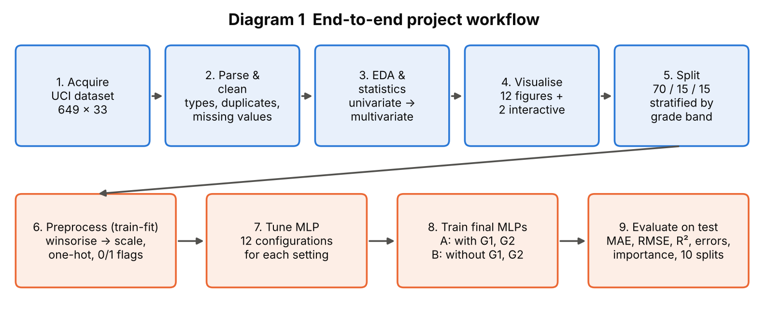
Diagram 1: End-to-end project workflow
Diagram 1 shows the order of work. Steps 1–5 are data understanding and visualisation; steps 6–9 are modelling. Each step is a separate Python module in the GitHub repository.

3.1 Loading and Inspecting the Data
The CSV is loaded with pandas (pd.read_csv). The shape is 649 rows × 33 columns. df.info(), df.describe() and value counts were used to check data types and ranges. All ordinal ratings are within their documented ranges.

3.2 Missing Values and Duplicates
Missing cells: 0. Duplicate rows: 0. The cleaning function therefore removed no rows. The check remains in the code so that the same script is safe on other data.
A hidden pattern: the zero grades. 15 students (2.3%) have a final grade of exactly 0, while the next lowest values are 1 and 5 (Figure 1). All 15 of them have 0 absences, and their average second-period grade was 3.8 (only 7 had G2 = 0). A student with a decent G2 but G3 = 0 is more consistent with not taking the final assessment than with scoring zero marks. The dataset documentation does not explain this, so it is stated here only as a hypothesis. These rows are real and were not removed, but they turn out to be the largest source of prediction error (Chapter 7).

3.3 Outlier Identification and Treatment
Outliers were identified with the IQR rule and the |z| > 3 rule for numeric columns with more than five distinct values (Table 5, Figure 4).
Table 5: Outlier summary
Feature | Lower fence | Upper fence | IQR outliers | Share | |z|>3
G2 | 5.50 | 17.50 | 25 | 3.9% | 7
absences | -9.00 | 15.00 | 21 | 3.2% | 11
G1 | 5.50 | 17.50 | 16 | 2.5% | 1
G3 | 4.00 | 20.00 | 16 | 2.5% | 16
age | 13.00 | 21.00 | 1 | 0.2% | 3

Decision. Few rows are flagged (at most 3.9% in any column). The flagged values are real: very high absences (maximum 32) and the zero grades. No row was deleted. Inside the model pipeline each numeric feature is winsorised (clipped to its 1st and 99th training percentile) so that a few extreme values cannot dominate the scaling.

3.4 Cleaning, Transformation and Encoding
Table 6: Preprocessing applied to each group of features
Group | Features | Treatment | Reason
Numeric / ordinal | 15 fields (age, ratings, absences, G1, G2, …) | Winsorise 1–99 % → StandardScaler (mean 0, SD 1) | Neural networks train poorly when inputs have very different scales
Nominal | 4 fields (Mjob, Fjob, reason, guardian) | One-hot encoding | Categories have no order, so they must not be coded as 1, 2, 3
Binary | 13 fields (school, sex, internet, higher, …) | Encoded as 0/1 (ordinal encoder fitted on training rows) | Two-level text must become numbers
Target | G3 | Kept in grade points; standardised with the training mean/SD only while training; predictions converted back and clipped to 0–20 | Makes training stable but reports errors in real grade points

After encoding, the 32 raw features become 45 model input columns in setting A and 43 in setting B (see Section 3.5).

3.5 Two Experimental Settings
G1 and G2 are marks of earlier periods of the same course, so they are known only after those periods. To show how much they matter, two settings are studied throughout:
Table 7: The two settings
Setting | Inputs | Meaning in practice
A – with grades | All 32 features incl. G1, G2 (45 encoded columns) | Prediction after two periods of the course
B – without grades | 30 features, no G1, G2 (43 encoded columns) | Early warning using only background and lifestyle information

3.6 Train / Validation / Test Split and Leakage Prevention
Table 8: Data split (random_state = 42)
Subset | Rows | Share | Purpose
Training | 454 | 70% | Fit the scaler/encoder and learn the network weights
Validation | 97 | 15% | Choose hyperparameters and stop training early
Test | 98 | 15% | Final, one-time evaluation

Preventing data leakage. (1) The split is done before any statistic is learned. (2) The winsoriser, scaler and encoders are fitted on training rows only. (3) The test set is used only after all tuning decisions are final. (4) The split is stratified on three grade bands (below 10, 10–13, 14 and above) so that every subset has a similar grade mix. (5) The 649 rows are different students within this file, so no student appears twice.
Why also repeat the split 10 times? A test set of 98 students is small, and a few unusual students (such as zero-grade cases) can change an error figure a lot. Section 7.4 therefore also reports results over 10 random splits. The hyperparameters were chosen once, on the seed-42 validation set.

3.7 Key Findings from EDA
- 84.6% of students pass (G3 ≥ 10); the grade distribution is concentrated between 8 and 16 with a small spike at 0.
- The earlier grades G1 and G2 are almost the same quantity as G3 (Pearson r = 0.83 and 0.92).
- Past failures matter: mean G3 is 12.5 with no past failure versus 8.6 with one or more.
- Wanting higher education (mean G3 12.3 vs 8.8) and school (GP 12.6 vs MS 10.7) show large differences.
- Most lifestyle ratings show weak relationships with G3 (|Spearman ρ| below 0.25), and parents' education is the strongest of the family variables.
- Absences are heavily skewed: 37.6% of students have none, the mean is 3.7 and the maximum is 32.

4. Data Visualization

4.1 The Seven Stages of Visualization
The assignment sheet asks that the visualisations follow "all 7 stages of visualization" but does not list them. This report therefore states the framework it uses: the seven-stage visualisation process of Ben Fry (2007), Visualizing Data (O'Reilly): Acquire, Parse, Filter, Mine, Represent, Refine, Interact.
Table 9: Seven stages of visualization applied to the student grade dataset
Stage | Meaning | How it was applied here | Evidence
1. Acquire | Obtain the data | Selected UCI dataset 320, checked licence, rows and columns, and loaded data/student-por.csv | Sections 2.1, 2.3
2. Parse | Give the data structure and meaning | Assigned numeric, ordinal, binary and nominal roles; defined the target and the two settings | Sections 2.4, 3.4, 3.5
3. Filter | Remove what is not needed | Missing/duplicate checks; chose key variables per chart; kept only levels with enough students in heat-maps | Sections 3.2, 3.3
4. Mine | Find patterns with statistics | Spearman, Mann–Whitney, Kruskal–Wallis, VIF, PCA, distribution fitting | Chapter 5
5. Represent | Choose a basic visual form | Bar, histogram, boxplot, scatter, heat-map, pairplot, Q–Q, PCA, dot-and-interval chart matched to the data type | Figures 1–12
6. Refine | Improve clarity and design | Colour-blind-safe palette, consistent colours (blue pass, orange fail), direct labels, mean/median lines, jitter and transparency, sequential scales for ordered values | All figures
7. Interact | Let the viewer explore | Two Plotly pages with hover, zoom and legend filtering: outputs/eda/interactive_.html | Section 4.3

4.2 Visualization Design Choices (Refine stage)
Colours follow a fixed meaning: blue = pass (or the main series), orange = fail (or the comparison series). Both colours come from a palette whose adjacent colours were checked for colour-vision-deficiency separation. Ordered quantities (mean grade, PCA colouring) use a single-hue or perceptually uniform sequential scale; the correlation heat-map uses a diverging scale centred at zero. Axes carry units, titles are numbered and no chart uses a dual axis.

4.3 Interactive Visualizations
Two interactive HTML pages are saved in outputs/eda/: interactive_g2_vs_g3.html (hover shows G1, failures, study time, absences, school and wish for higher education; clicking a legend entry hides or shows pass or fail) and interactive_g3_by_failures.html (box plots of G3 by past failures and school with all points). They open in any browser and complete stage 7.

4.4 Visualization Gallery with Explanations
Each figure is followed by a table stating its purpose, variables, chart type, why it was selected and the insight obtained, as the assignment requires. Figures 1–12 are EDA figures; model figures are in Chapter 7.
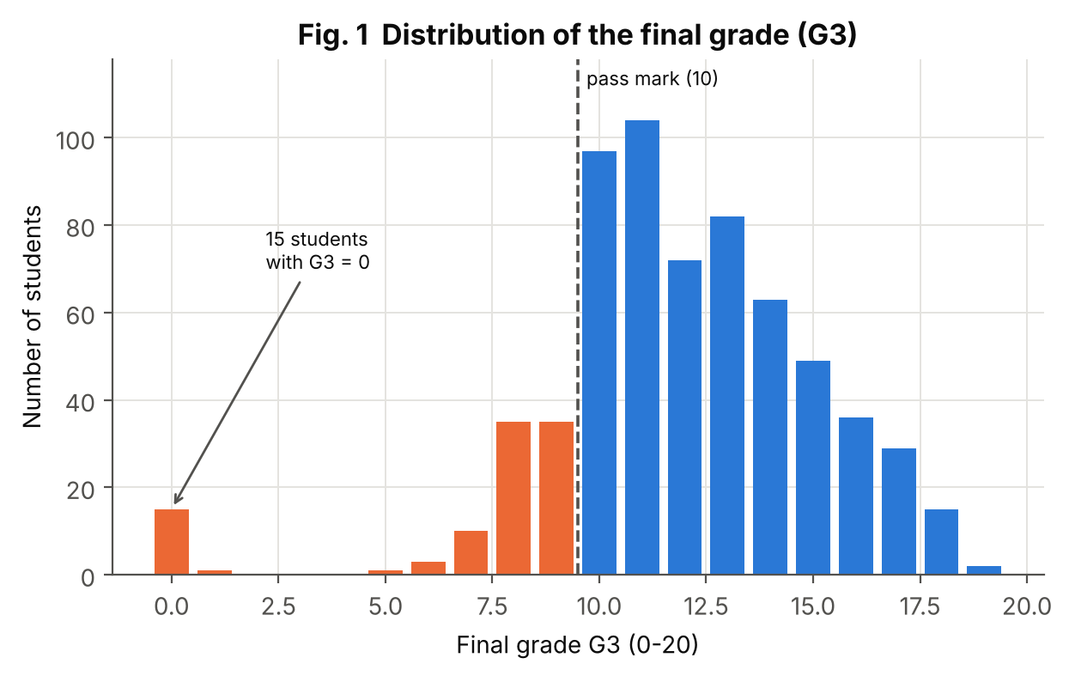
Figure 1: Distribution of the final grade (G3)
Aspect | Explanation
Purpose | Show how final grades are spread and how many students pass.
Variables | G3
Chart type | Bar chart (one bar per grade) with pass mark
Why selected | G3 is an integer, so one bar per value is more honest than binned bars; colouring the bars by pass/fail adds meaning.
Insight | Grades are concentrated between 8 and 16 (median 12, mean 11.9). 549 of 649 students (84.6%) reach the pass mark. A separate group of 15 students has G3 = 0, far below the rest.

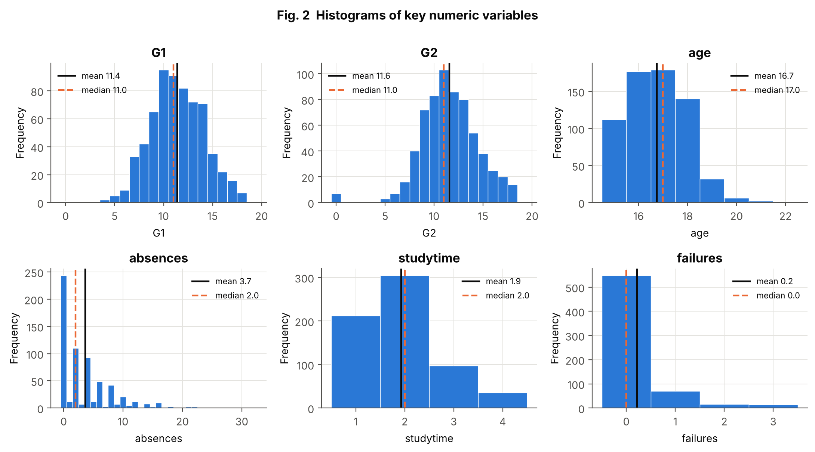
Figure 2: Histograms of key numeric variables
Aspect | Explanation
Purpose | Show the shape, centre and spread of six variables.
Variables | G1, G2, age, absences, studytime, failures
Chart type | Histograms with mean (solid) and median (dashed) lines
Why selected | Histograms are the standard univariate view; the gap between mean and median shows skewness.
Insight | G1 and G2 are bell-shaped around 11–12. Age is concentrated at 15–18. Absences are strongly right-skewed (median 2, mean 3.7, maximum 32). Most students have no past failure (mean 0.22); the most common study-time level is 2 (2–5 hours a week).

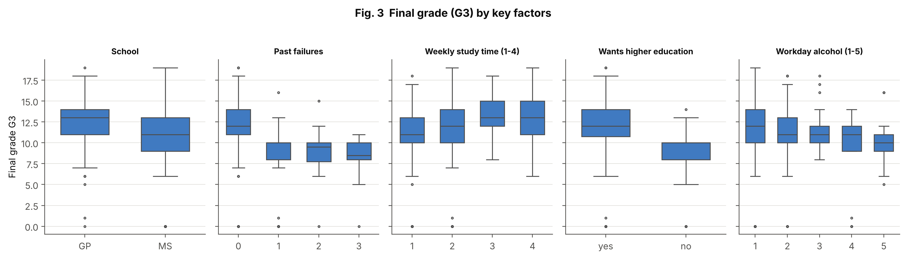
Figure 3: Final grade by key factors
Aspect | Explanation
Purpose | Compare the grade distribution across groups and reveal outliers.
Variables | G3 vs school, failures, studytime, higher, Dalc
Chart type | Grouped boxplots
Why selected | Boxplots compare medians, spread and outliers between groups compactly.
Insight | Median G3 is clearly lower for students with past failures (median 12 with none, 10 with one or two) and tends to rise with study time (median 11, 12, 13, 13 for levels 1–4). Students who do not want higher education and students of school MS have lower medians. Workday alcohol use shows a slight downward trend. The group means are: failures 0 → 12.5, 1 → 8.6; study time 1 → 10.8, 3 → 13.2.

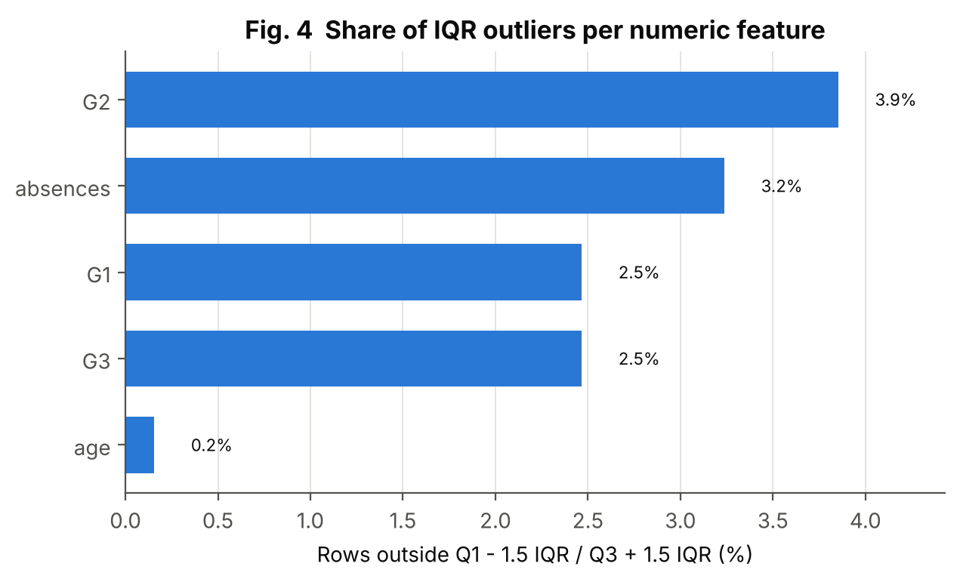
Figure 4: Share of IQR outliers per numeric feature
Aspect | Explanation
Purpose | Quantify how many rows are flagged as outliers.
Variables | Numeric columns with more than five distinct values
Chart type | Sorted horizontal bar chart
Why selected | A ranked bar chart shows which features need a decision.
Insight | Every feature has few flagged rows (maximum 3.9%). The G1/G2/G3 flags are the low-grade and zero-grade students; absences flags very high counts. Because these are genuine values, they were winsorised in the pipeline, not deleted.

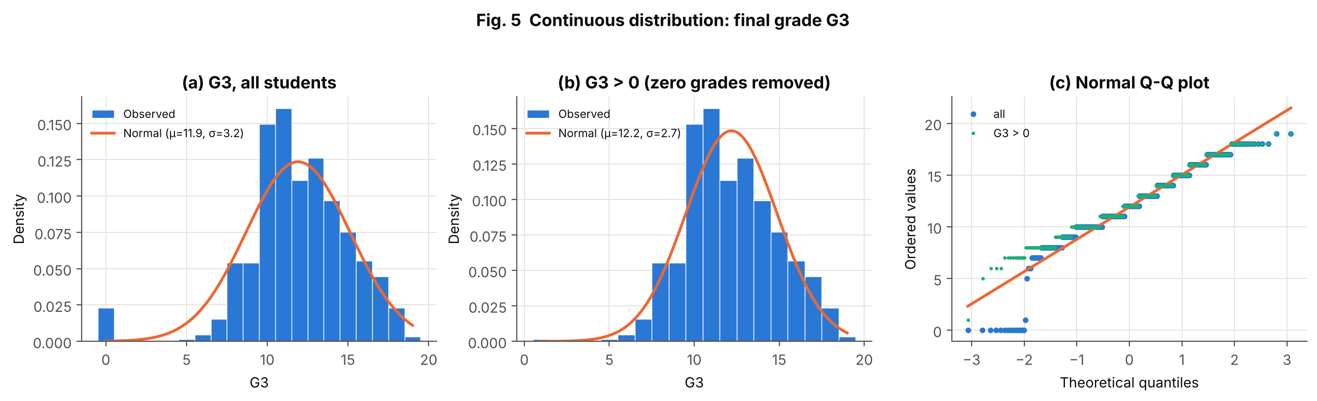
Figure 5: Continuous distribution: final grade G3
Aspect | Explanation
Purpose | Check whether G3 follows a normal distribution, with and without the zero grades.
Variables | G3
Chart type | Histograms with fitted normal curves; normal Q–Q plot
Why selected | The histogram shows the fit visually; the Q–Q plot is more sensitive to the tails.
Insight | All students: skewness -0.91, excess kurtosis 2.71, D'Agostino p < 0.001 – clearly not normal because of the long lower tail made by the zeros. Without the 15 zero grades (n = 634): mean 12.19, SD 2.69, skewness 0.13, D'Agostino p = 0.36, so normality is not rejected. The staircase in the Q–Q plot is caused by G3 taking whole numbers only.

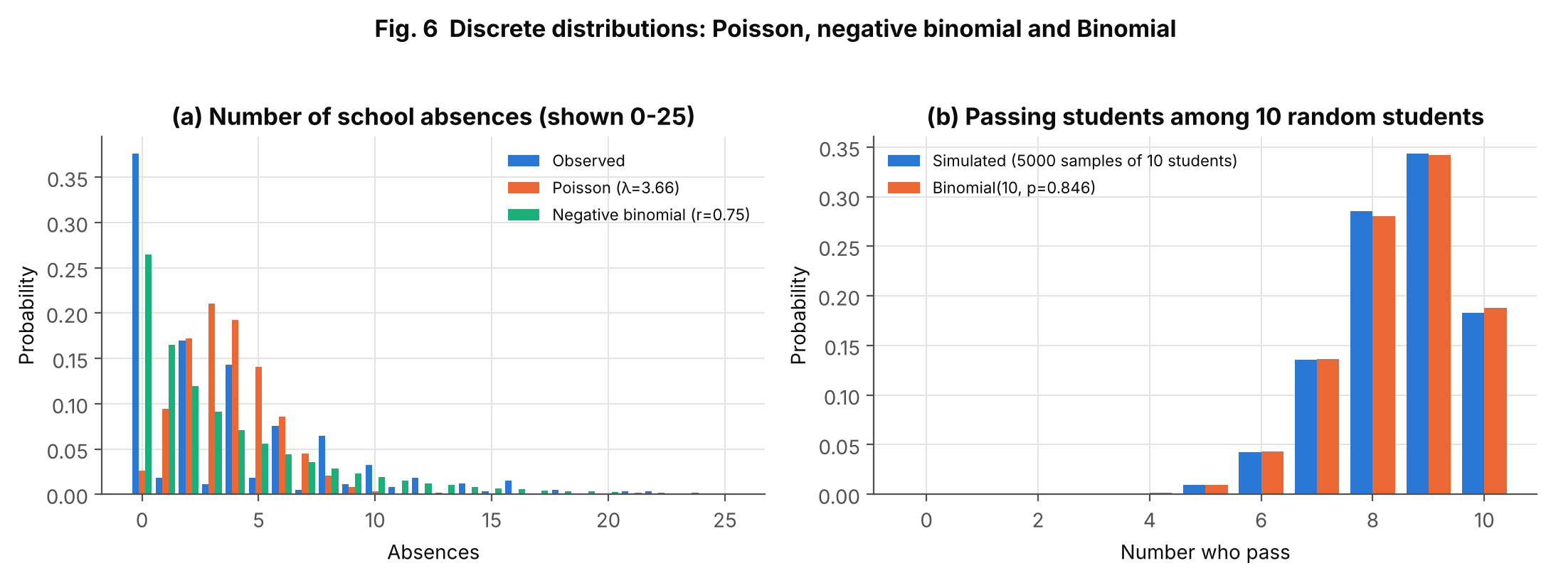
Figure 6: Discrete distributions: Poisson, negative binomial, Binomial
Aspect | Explanation
Purpose | Test count models for absences and illustrate a Binomial model for passing students.
Variables | (a) absences; (b) pass/fail (G3 ≥ 10)
Chart type | Side-by-side bar charts of observed and theoretical probabilities
Why selected | Observed-versus-theoretical bars show directly where a model fits or fails.
Insight | (a) A Poisson with the same mean (λ = 3.66) fits badly: variance/mean = 5.9 (Poisson would be 1) and 37.6% of students have zero absences versus 2.6% expected. A negative binomial (r = 0.75) is closer (total variation distance 0.34 vs 0.50) but still imperfect. (b) Passing is a Bernoulli event with p = 0.846 (95% Wilson interval 0.816–0.872); the number of passes among 10 random students follows Binomial(10, p), confirmed by 5,000 simulated samples. For example, P(all 10 pass) = 0.188.

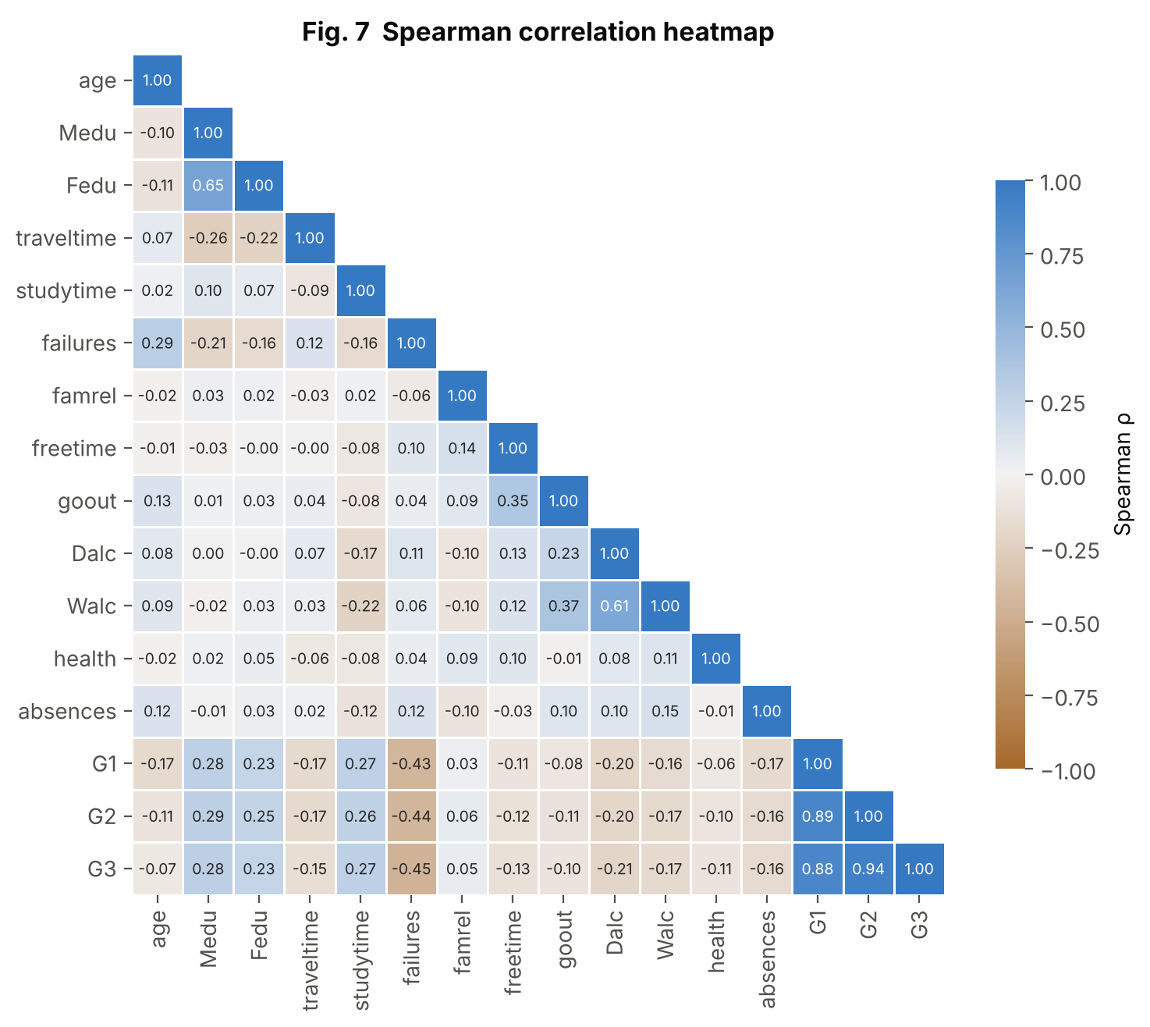
Figure 7: Spearman correlation heatmap
Aspect | Explanation
Purpose | Show monotonic relationships among numeric/ordinal features and G3.
Variables | 15 numeric/ordinal features and G3
Chart type | Lower-triangle heat-map with diverging colours and printed coefficients
Why selected | A heat-map is the standard multivariate summary; Spearman is used because many variables are ordinal or skewed.
Insight | The strongest pairs are G2–G3 (ρ = 0.944), G1–G2 (0.893) and G1–G3 (0.883). Mother's and father's education correlate at 0.647, workday and weekend alcohol at 0.613. Among non-grade variables, failures has the strongest link with G3 (ρ = -0.448).

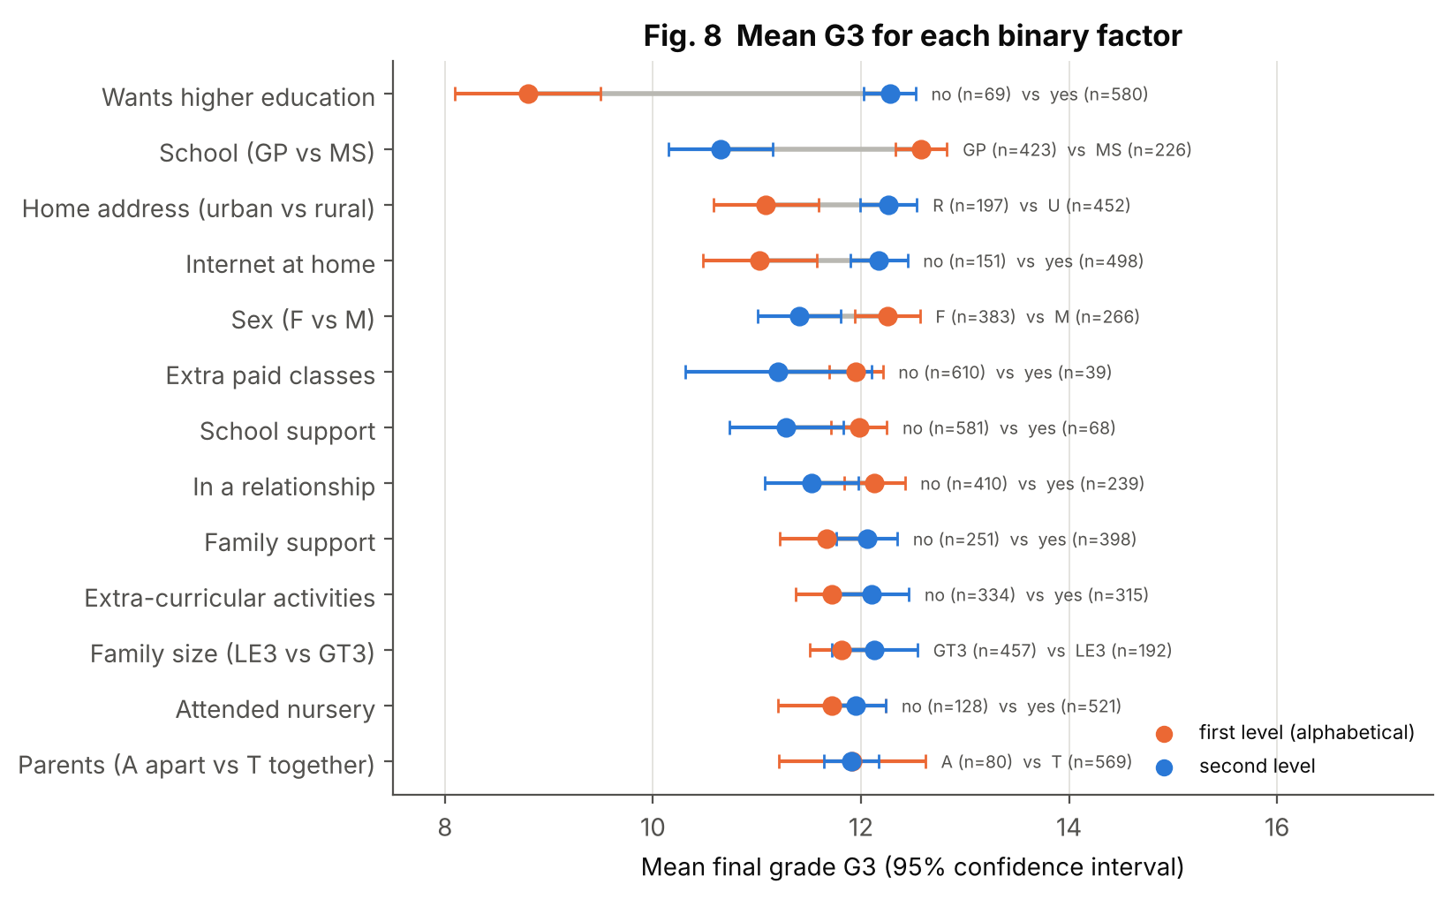
Figure 8: Mean final grade for each binary factor
Aspect | Explanation
Purpose | Compare the average grade between the two levels of every binary factor, with uncertainty.
Variables | 13 binary factors vs G3
Chart type | Dot-and-interval chart (mean with 95% CI), sorted by gap
Why selected | A dot-and-interval chart shows the size of each gap and whether the intervals overlap; it needs less ink than 13 pairs of bars.
Insight | The widest gaps are for wanting higher education (8.8 vs 12.3) and school (GP 12.6 vs MS 10.7), followed by address (rural 11.1 vs urban 12.3) and internet at home (11.0 vs 12.2). Intervals for family size, nursery and parents' status overlap strongly. Several factors are unbalanced (for example only 69 students do not want higher education), so wide intervals are expected. These are associations, not causes.

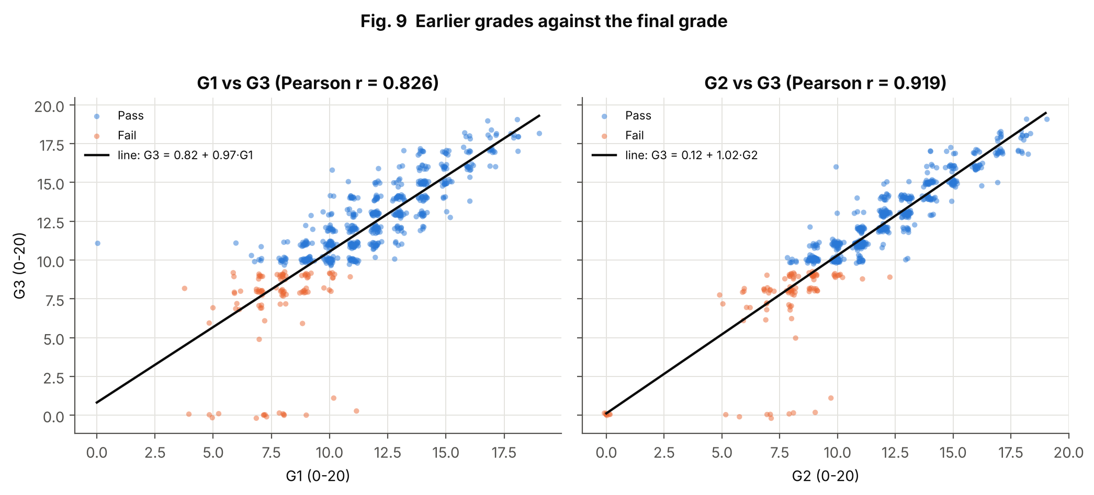
Figure 9: Earlier grades against the final grade
Aspect | Explanation
Purpose | Show how closely G1 and G2 predict G3.
Variables | G1, G2, G3, pass/fail
Chart type | Scatter plots with regression line (jittered, semi-transparent)
Why selected | Scatter plots are the standard bivariate view of two numeric variables.
Insight | Both relationships are close to a straight line (r = 0.826 for G1 and 0.919 for G2). The points far below the line, at G3 = 0, are the zero-grade students. This explains why the model in setting A can be accurate and why it relies on G2 so heavily.

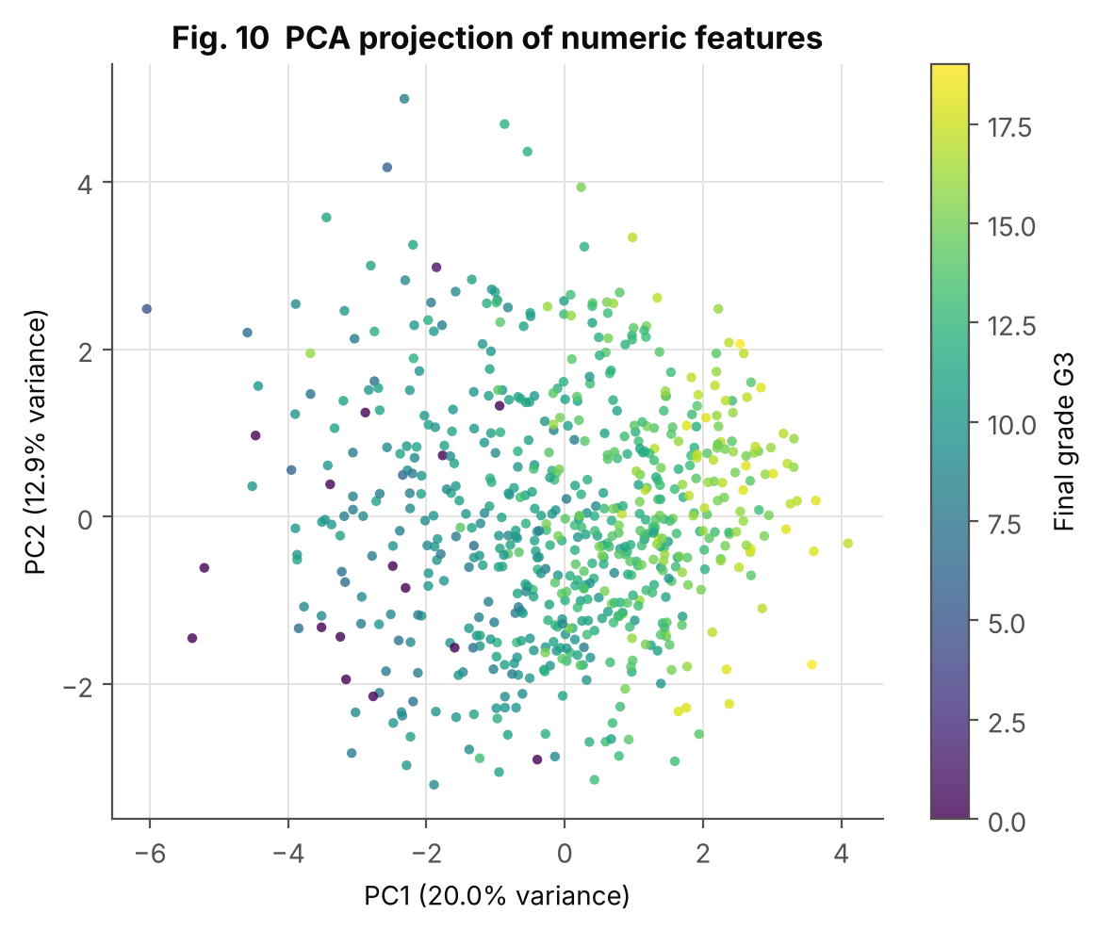
Figure 10: PCA projection of numeric features
Aspect | Explanation
Purpose | See whether grade differences appear when 15 features are compressed into two.
Variables | 15 numeric/ordinal features (standardised), coloured by G3
Chart type | PCA scatter with a sequential colour scale
Why selected | PCA is the usual way to view many dimensions in 2-D; a sequential scale suits a numeric colour variable.
Insight | PC1 explains 20.0% and PC2 12.9% of the variance; five components explain 57.9%. G3 rises along PC1 (correlation 0.75 between PC1 and G3), because PC1 is driven mainly by G1, G2 and past failures, but there is no clean cluster structure.

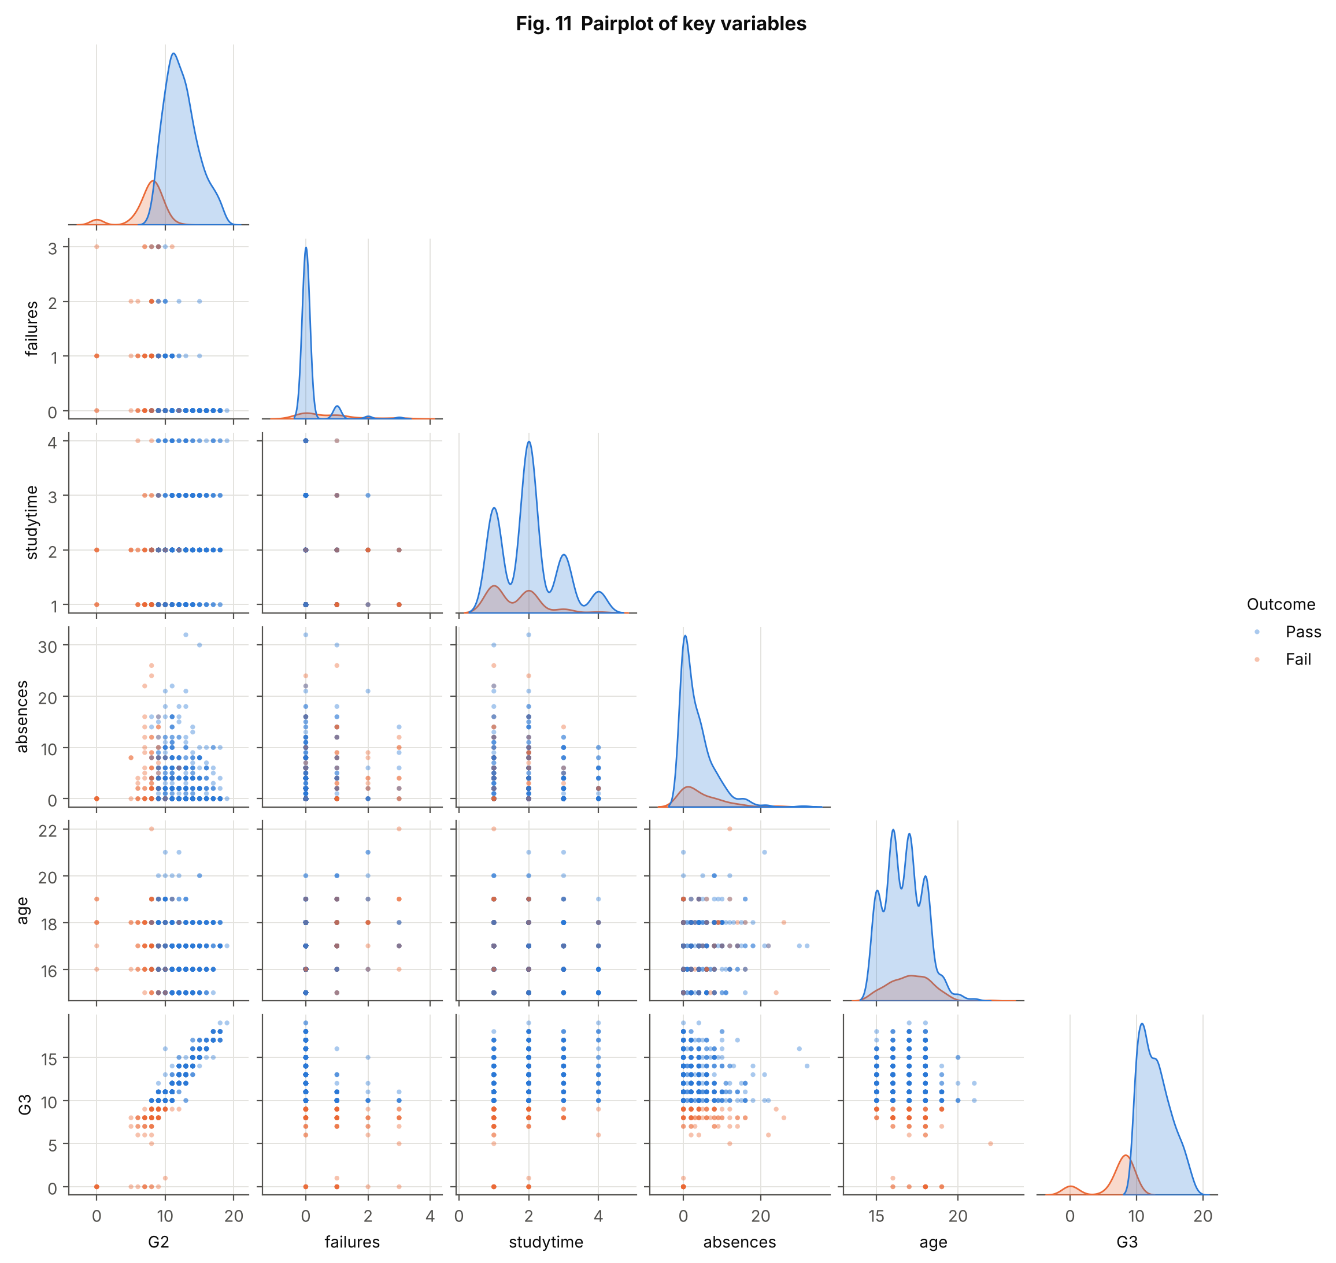
Figure 11: Pairplot of key variables
Aspect | Explanation
Purpose | Show pairwise relations and distributions for six variables.
Variables | G2, failures, studytime, absences, age, G3, pass/fail
Chart type | Pairplot (scatter matrix with KDE diagonals)
Why selected | A pairplot is the quickest way to compare many pairs and class-wise distributions.
Insight | Only G2 separates pass from fail clearly. Compared with passing students, failing students are slightly older (mean age 17.1 vs 16.7), have more past failures (0.75 vs 0.13), study a little less (study-time level 1.6 vs 2.0) and have more absences (4.6 vs 3.5), but the groups overlap heavily on every variable except G2 – a first sign that predictions without G1/G2 will be hard.

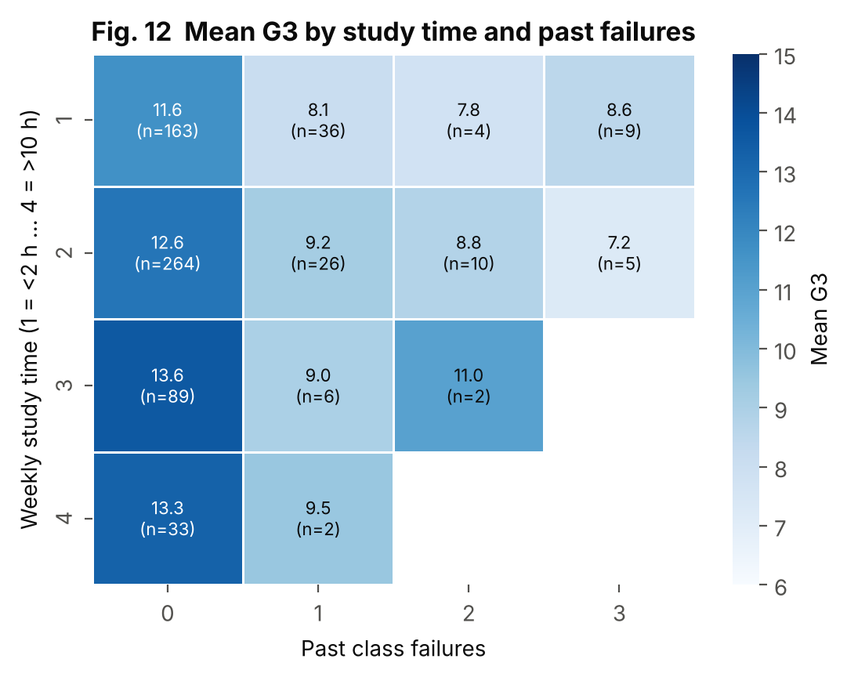
Figure 12: Mean G3 by study time and past failures
Aspect | Explanation
Purpose | Show the joint effect of study time and past failures.
Variables | studytime, failures, G3
Chart type | Annotated heat-map with sequential single-hue scale
Why selected | A two-way table of means shows interaction effects; printing n guards against over-reading small cells.
Insight | Within every row (study time), students with a past failure score about 3–5 points lower than those with none. Within the no-failure column, mean G3 rises from 11.6 (study time 1) to 13.6 (study time 3). Cells with one to six students (for example study time 4 with failures) should not be trusted.

5. Statistical and Distribution-Based Analysis

5.1 Univariate Analysis
- Centre and spread: G3 has mean 11.91, median 12, mode 11, SD 3.23 and quartiles 10 and 14 (Table 4).
- Skewness: G3 is left-skewed (-0.91) because of the zero grades; absences are strongly right-skewed (2.02); failures are also right-skewed (3.09).
- Quantiles: half of the students have two absences or fewer and three quarters have six or fewer, but the maximum is 32.
- Categorical fields: 89.4% want higher education, 76.7% have internet at home, 65.2% attend school GP. Some binary fields are very unbalanced (for example only 39 students take extra paid classes).

5.2 Probability Distributions
Table 10: Distribution analysis results
Variable | Model | Result | Conclusion
G3, all students (continuous) | Normal | μ = 11.91, σ = 3.23; skew -0.91; D'Agostino p < 0.001 | Rejected: long lower tail from zero grades
G3 > 0 (continuous) | Normal | n = 634; μ = 12.19, σ = 2.69; skew 0.13; D'Agostino p = 0.36 | Not rejected: approximately normal
Pass / fail (discrete) | Bernoulli / Binomial(10, p) | p = 0.846; Wilson 95% CI 0.816–0.872 | Binomial matches simulated samples (Fig. 6b)
Absences (count) | Poisson | mean 3.66, variance 21.54, ratio 5.89; zeros 37.6% | Rejected: strongly over-dispersed
Absences (count) | Negative binomial | r = 0.75, p = 0.170 (method of moments); TV distance 0.34 | Better than Poisson, still imperfect
Alcohol (Dalc, 1–5) | Frequency distribution | level 1: 69.5%, 2: 18.6%, 3: 6.6%, 4: 2.6%, 5: 2.6% | Geometric-like decline; most students drink little on workdays

In simple words: a normal curve describes measurements that cluster symmetrically around an average. G3 would look like that except for the zero grades. A Poisson distribution describes counts of rare, independent events and has variance equal to its mean; absences have variance about six times their mean because a few students miss very many days, so a negative binomial, which allows extra spread, fits better.

5.3 Bivariate Analysis
Every input feature was tested against G3. Numeric and ordinal features use Spearman's ρ; binary features use the Mann–Whitney U test with Cohen's d (standardised mean difference) as effect size; nominal features use the Kruskal–Wallis H test with ε². Effect sizes are on different scales, so use them to rank features within a test type; the p-value says whether an association is likely to be real, not how important it is.
Table 11: Fourteen features most strongly associated with G3
Feature | Type | Test | Statistic | p-value | Effect size
higher | binary | Mann-Whitney U | 6856 | < 0.001 | 1.141
G2 | numeric/ordinal | Spearman | 0.944 | < 0.001 | 0.944
G1 | numeric/ordinal | Spearman | 0.883 | < 0.001 | 0.883
school | binary | Mann-Whitney U | 64220 | < 0.001 | 0.621
failures | numeric/ordinal | Spearman | -0.448 | < 0.001 | 0.448
address | binary | Mann-Whitney U | 35097 | < 0.001 | 0.369
internet | binary | Mann-Whitney U | 29582 | < 0.001 | 0.359
Medu | numeric/ordinal | Spearman | 0.284 | < 0.001 | 0.284
studytime | numeric/ordinal | Spearman | 0.275 | < 0.001 | 0.275
sex | binary | Mann-Whitney U | 58916 | < 0.001 | 0.264
Fedu | numeric/ordinal | Spearman | 0.235 | < 0.001 | 0.235
paid | binary | Mann-Whitney U | 13522 | 0.149 | 0.231
schoolsup | binary | Mann-Whitney U | 22988 | 0.026 | 0.217
Dalc | numeric/ordinal | Spearman | -0.208 | < 0.001 | 0.208

Interpretation. Apart from G1 and G2, the largest effects are for wanting higher education (d = 1.14), school (d = 0.62) and past failures (|ρ| = 0.45). Family background (parents' education, |ρ| about 0.28 and 0.23), study time (0.27) and address (d = 0.37) have smaller effects. Extra paid classes (p = 0.149) show no reliable difference. Nominal fields such as Mjob and Fjob have small ε² values. All of these are associations; for example, students who plan to continue studying may also study harder.

5.4 Multivariate Analysis
- Correlation structure (Fig. 7): G1, G2 and G3 form one tight block; parents' education and the two alcohol ratings form two weaker pairs; everything else is only loosely related.
- Multicollinearity: variance inflation factors are G2 (4.2), G1 (4.2), Walc (1.9), Medu (1.8); none exceeds 5, so multicollinearity is mild even though G1 and G2 are strongly correlated.
- PCA (Fig. 10): five components explain 57.9% of variance, so the numeric information is spread over many directions; there is no single dominant lifestyle factor.
- Combined effects (Fig. 12): failures and study time act together: the best group (no failures, study time 3) has a mean G3 of 13.6, the worst well-populated group (one failure, study time 1) 8.1.

5.5 Summary of Statistical Findings
Table 12: Statistical findings in plain words
Finding | Evidence
Earlier grades almost determine the final grade | Pearson r = 0.83 (G1) and 0.92 (G2); Fig. 9
Past failures lower the final grade | Mean G3 12.5 (none) vs 8.6 (one or more); ρ = -0.45
Aspiration and school matter | Higher-education wish: 8.8 vs 12.3; school GP 12.6 vs MS 10.7
Lifestyle ratings are weak signals | Most |ρ| < 0.25 with G3; several effects are small
Absences are not Poisson | Variance/mean = 5.9; 37.6% zeros
Zero grades are a separate group | 15 students, all with 0 absences; they break normality of G3

6. Deep Learning Model

6.1 Why a Multilayer Perceptron?
The data are in table form, so the natural deep-learning model is a multilayer perceptron (MLP), a stack of fully connected layers (Goodfellow et al., 2016). CNNs are designed for images and RNN/LSTM/Transformer models for sequences, which this dataset does not contain. Because G3 is a number, the network ends in one linear output neuron and is trained to minimise squared error (regression). To judge whether the extra complexity is worthwhile, a mean-only baseline, ridge regression (Hoerl & Kennard, 1970) and a random forest (Breiman, 2001) were trained on the same data.

6.2 Inputs, Target and Pipeline
Table 13: Model inputs and output
Item | Description
Input, setting A | 45 columns from 32 raw features (including G1 and G2)
Input, setting B | 43 columns from 30 raw features (no G1, G2)
Target | G3, final grade 0–20 (numeric)
Task type | Regression
Pipeline | Winsorise (1–99 %) → standardise; one-hot for nominal; 0/1 for binary. Fitted on the training set only; saved as models/preprocessor_A.joblib and preprocessor_B.joblib

6.3 Architecture and Hyperparameters
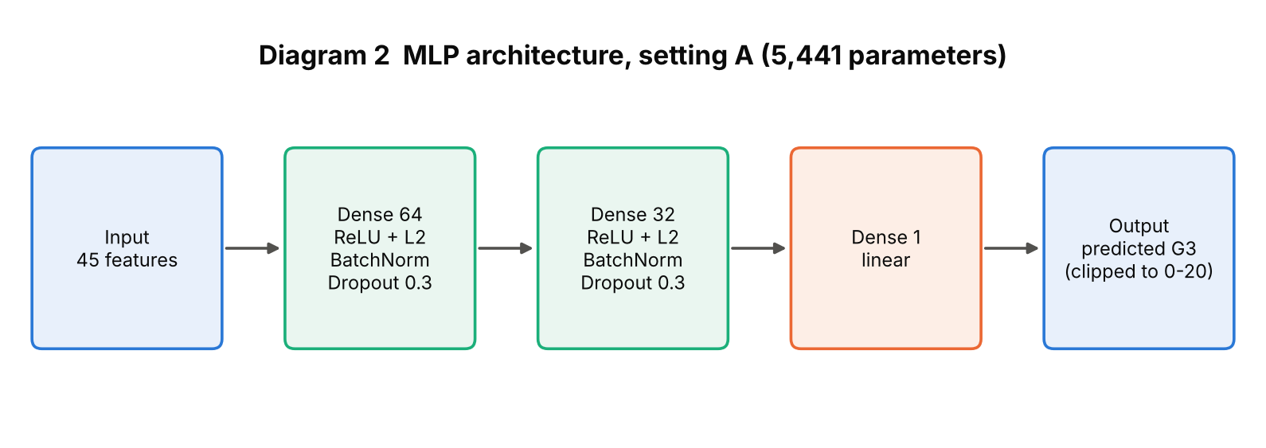
Diagram 2: MLP architecture of the final model (setting A)
Table 14: Final model configuration
Component | Setting A | Setting B | Simple explanation
Hidden layers | 64 → 32 | 32 → 16 | Each layer learns combinations of the inputs
Activation | ReLU; linear output | ReLU; linear output | ReLU adds non-linearity; a linear output can give any grade
Regularisation | Dropout 0.3, L2 1e-4, BatchNorm | Dropout 0.3, L2 1e-4, BatchNorm | Reduce over-fitting on only 454 training rows
Loss | Mean squared error | Mean squared error | Penalises large errors strongly
Optimizer | Adam, lr 0.003 | Adam, lr 0.003 | Adaptive gradient method (Kingma & Ba, 2015)
Batch size / max epochs | 32 / 300 | 32 / 300 | Samples per weight update / upper limit
Early stopping | patience 25; ran 81 epochs, best 56 | patience 25; ran 45 epochs, best 20 | Stops when validation loss stops improving; best weights restored
Parameters | 5,441 | 2,145 | Number of learned weights
Random seed | 42 | 42 | Makes the run reproducible

6.4 Training, Validation and Testing Procedure
1. Fit the preprocessing pipeline on the training rows and transform all three subsets.
2. For each hyperparameter configuration, train on the training set and monitor loss on the validation set; stop early when it stops improving.
3. Choose the configuration with the lowest validation RMSE, separately for settings A and B.
4. Evaluate the chosen models once on the untouched test set; report MAE, RMSE and R², and analyse the errors.
5. Repeat the whole fit on 10 random splits (hyperparameters fixed) to measure stability.

6.5 Basic Hyperparameter Tuning
A grid search over 3 architectures × 2 dropout rates × 2 learning rates = 12 configurations was run for each setting; everything else was fixed. Selection used the validation set only. The five best configurations of each setting are shown; the full results are in outputs/model_evaluation.
Table 15: Best five configurations, setting A (sorted by validation RMSE)
Hidden layers | Dropout | Learning rate | Epochs | Val RMSE | Val MAE | Val R²
(64, 32) | 0.3 | 0.003 | 81 | 1.778 | 1.052 | 0.781
(32, 16) | 0.1 | 0.003 | 104 | 1.805 | 1.201 | 0.775
(64, 32) | 0.1 | 0.001 | 130 | 1.896 | 1.132 | 0.751
(64, 32) | 0.1 | 0.003 | 67 | 1.911 | 1.171 | 0.747
(32, 16) | 0.1 | 0.001 | 143 | 1.931 | 1.262 | 0.742

Table 16: Best five configurations, setting B (sorted by validation RMSE)
Hidden layers | Dropout | Learning rate | Epochs | Val RMSE | Val MAE | Val R²
(32, 16) | 0.3 | 0.003 | 45 | 3.608 | 2.472 | 0.099
(64, 32, 16) | 0.3 | 0.003 | 36 | 3.638 | 2.530 | 0.085
(64, 32, 16) | 0.1 | 0.003 | 29 | 3.641 | 2.557 | 0.083
(32, 16) | 0.3 | 0.001 | 136 | 3.648 | 2.504 | 0.079
(64, 32, 16) | 0.3 | 0.001 | 32 | 3.655 | 2.517 | 0.076

Setting A: best configuration [64, 32], dropout 0.3, learning rate 0.003 (validation RMSE 1.778); the spread across the 12 configurations is 0.35 RMSE. Setting B: best [32, 16], dropout 0.3, learning rate 0.003 (validation RMSE 3.608), spread 0.28. With a 97-row validation set, differences of 0.05–0.1 between neighbouring configurations are within noise. Figure 19 shows all results.

6.6 Feature Analysis and Feature Importance
Two complementary methods were used. (1) Statistical association (Section 5.3) shows which features relate to G3 in the raw data. (2) Permutation importance shows what the trained model relies on: each raw feature in the test set is shuffled 10 times and the increase in test RMSE is recorded; a large increase means the model depends on that feature. Shuffling is done on raw columns before encoding, so all one-hot columns of a field are shuffled together.
Table 17: Top eight features by permutation importance, setting A (test set)
Rank | Feature | Mean RMSE increase | Std (10 repeats)
1 | G2 | 1.5039 | 0.1531
2 | G1 | 0.6255 | 0.0925
3 | goout | 0.0788 | 0.0433
4 | absences | 0.0715 | 0.0518
5 | reason | 0.0652 | 0.0212
6 | romantic | 0.0503 | 0.0249
7 | Dalc | 0.0450 | 0.0130
8 | activities | 0.0384 | 0.0248

Table 18: Top eight features by permutation importance, setting B (test set)
Rank | Feature | Mean RMSE increase | Std (10 repeats)
1 | failures | 0.0777 | 0.0209
2 | age | 0.0370 | 0.0326
3 | Walc | 0.0314 | 0.0247
4 | absences | 0.0277 | 0.0094
5 | studytime | 0.0263 | 0.0226
6 | famrel | 0.0259 | 0.0312
7 | internet | 0.0197 | 0.0401
8 | Dalc | 0.0185 | 0.0254

In setting A the model depends almost entirely on G2 (RMSE rises by 1.50 grade points when G2 is shuffled) and G1 (0.63); every other feature adds less than 0.1. In setting B the largest increase is only 0.078 (past failures), and for most features the error bar is about as large as the bar itself, so the ranking in setting B is uncertain. Importance is shared between correlated features, so a small value does not prove a feature is unrelated to the grade.

7. Model Evaluation and Result Visualization

7.1 Evaluation Metrics
Three regression metrics are used. MAE is the average size of the error in grade points. RMSE is similar but penalises large errors more. R² is the share of the variation in G3 that the model explains (1 is perfect, 0 is no better than always predicting the average). All values were measured by running the code in the appendix (seed 42). The test set has 98 students that were never used for fitting, scaling or tuning. Predictions are clipped to the valid range 0–20.
Table 19: Regression metrics for setting A (with G1 and G2)
Model | MAE | RMSE | R²
MLP (test) | 0.91 | 1.33 | 0.82
MLP (validation) | 1.05 | 1.78 | 0.78
Ridge regression (test) | 0.90 | 1.35 | 0.81
Random forest (test) | 0.76 | 1.12 | 0.87
Mean baseline (test) | 2.41 | 3.13 | -0.00

Table 20: Regression metrics for setting B (without G1 and G2)
Model | MAE | RMSE | R²
MLP (test) | 2.03 | 2.93 | 0.12
MLP (validation) | 2.47 | 3.61 | 0.10
Ridge regression (test) | 1.87 | 2.75 | 0.23
Random forest (test) | 1.87 | 2.73 | 0.24
Mean baseline (test) | 2.41 | 3.13 | -0.00

Reading the tables. With earlier grades the MLP is wrong by about 0.91 grade points on average (RMSE 1.33); 67.3% of test students are predicted within one point and 91.8% within two. Without them, the average error is 2.03 points and R² is only 0.12: the MLP is only slightly better than always predicting the average grade (RMSE 3.13). As an extra check, the predicted grade was turned into a pass/fail call (predicted ≥ 9.5 means pass): accuracy 93.9% and AUC 0.965 in setting A, accuracy 79.6% and AUC 0.647 in setting B. Only 15 of the 98 test students fail, so these pass/fail figures are very uncertain; always predicting 'pass' would already score 84.7%.

7.2 Comparison with Baseline Models
On the seed-42 test set the random forest has the lowest error in both settings (RMSE 1.12 and 2.73); ridge regression is about as accurate as the MLP in setting A (RMSE 1.35 vs 1.33) and better in setting B. The MLP is therefore competitive with, but not better than, the simpler models. This is common for small tabular data, where the main relationship (G3 depends almost linearly on G2) is easy to capture. The MLP is kept as the required deep-learning model; the baselines give context.

7.3 Result Visualizations and Interpretation
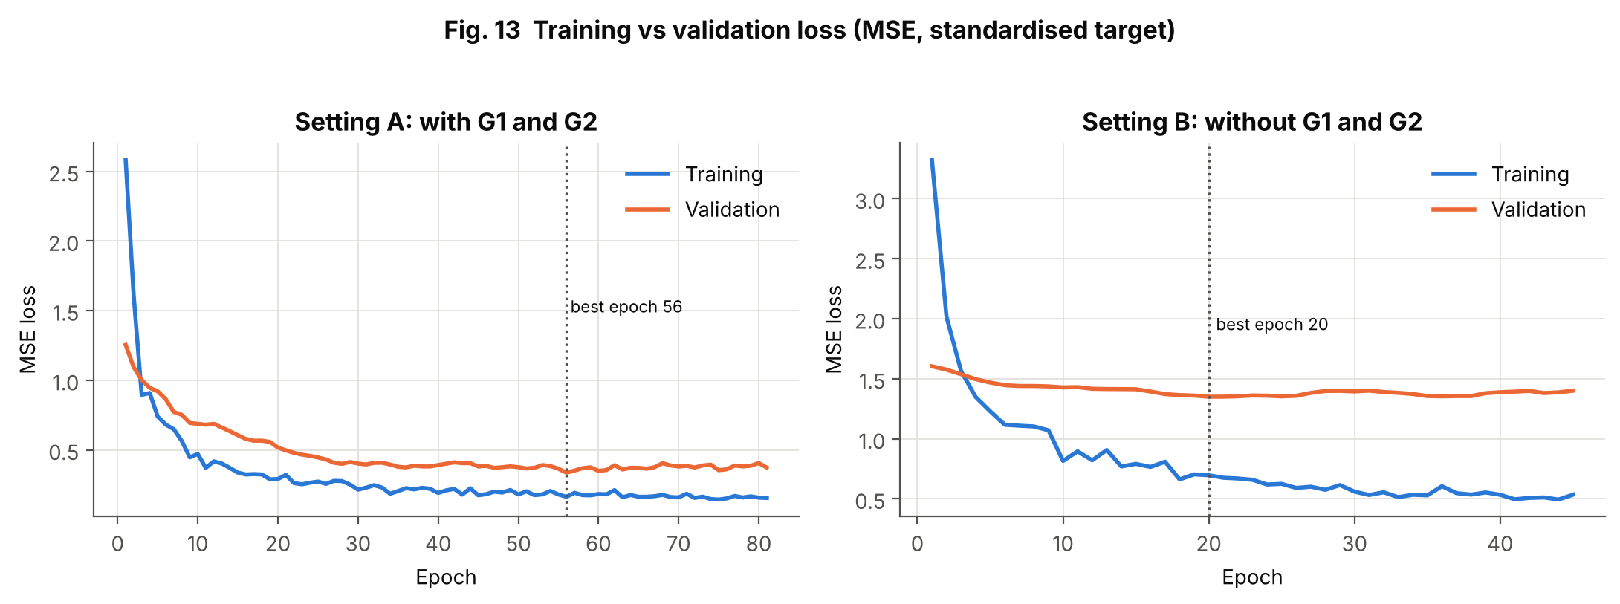
Figure 13: Training vs validation loss
Aspect | Explanation
Purpose | Show how learning progressed and detect over-fitting.
Variables | Epoch, MSE loss (train and validation), settings A and B
Chart type | Line charts with best-epoch marker
Why selected | Loss curves are the standard diagnostic of neural-network training.
Insight | In both settings training loss keeps falling while validation loss flattens, and the gap is larger in setting B. Early stopping restored the weights from epoch 56 (A, of 81 run) and epoch 20 (B, of 45). The loss is on the standardised target, so a validation loss of about 0.35 corresponds roughly to an RMSE of 0.59 × 3.1 ≈ 1.8 grade points.

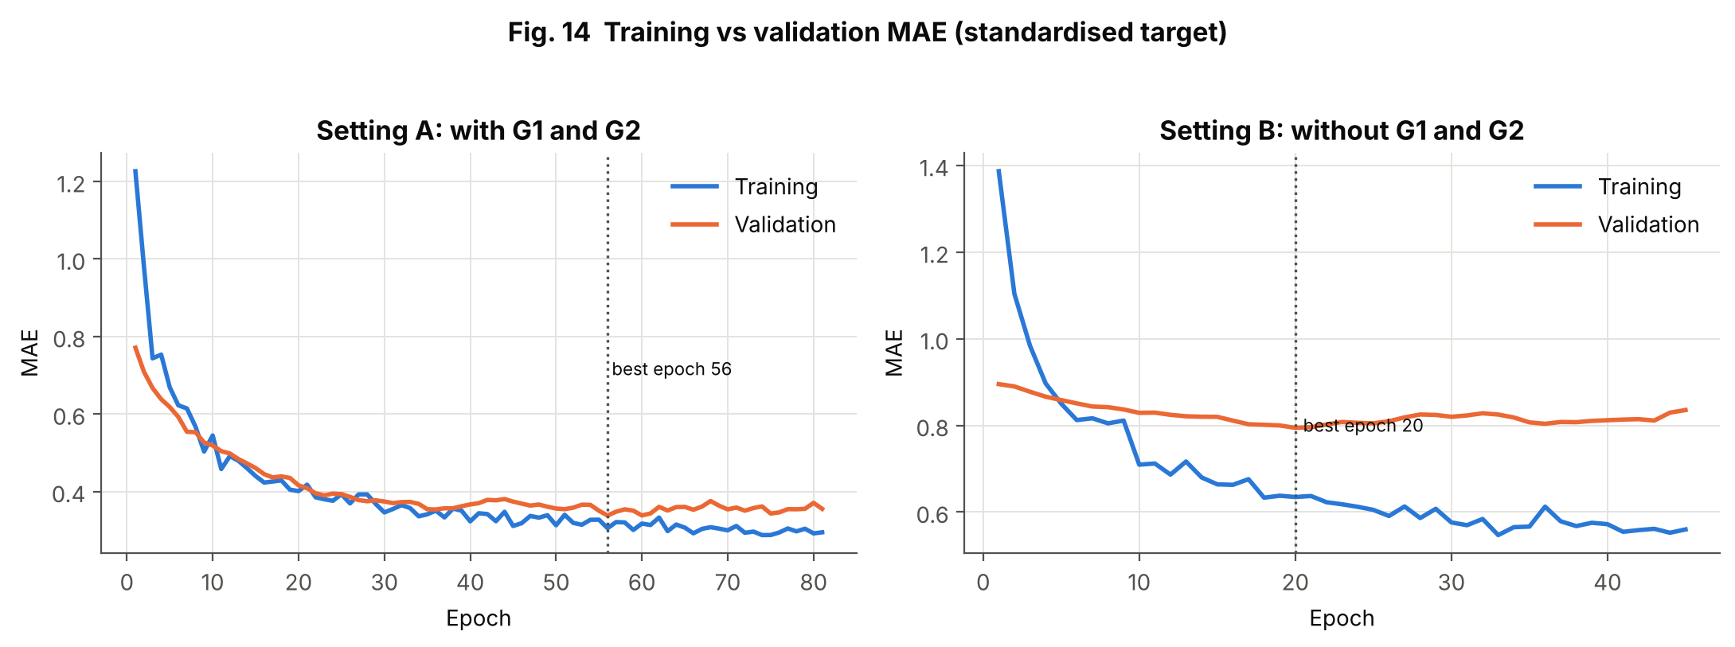
Figure 14: Training vs validation MAE
Aspect | Explanation
Purpose | Show the mean absolute error progress for both subsets.
Variables | Epoch, MAE (train and validation)
Chart type | Line charts
Why selected | MAE is easier to interpret than squared loss.
Insight | The pattern repeats Figure 13: validation MAE levels off long before training MAE does. In setting B the validation MAE stays high and nearly flat, which means the network finds little learnable signal in the background features.

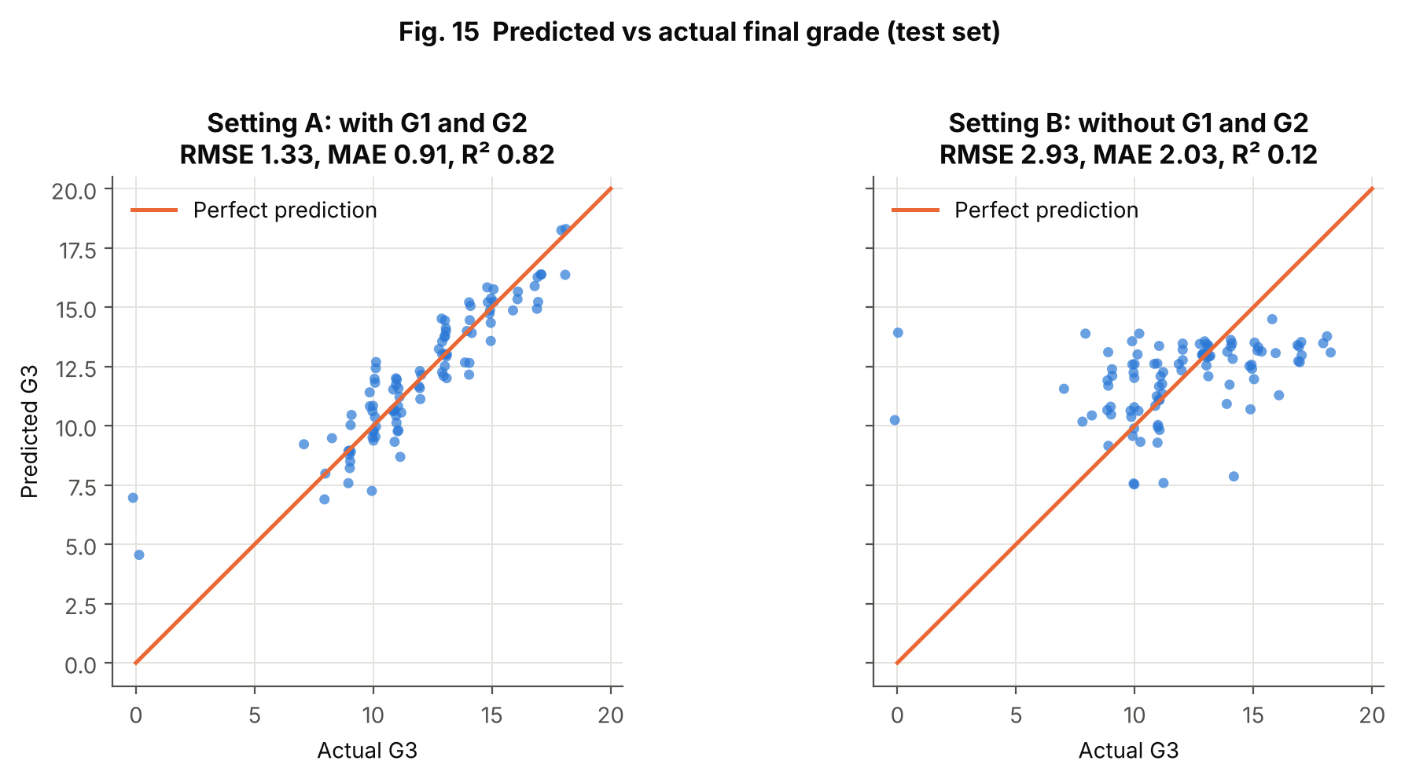
Figure 15: Predicted vs actual final grade
Aspect | Explanation
Purpose | Show how close predictions are to the truth.
Variables | Actual and predicted G3 on the test set
Chart type | Scatter plot with the perfect-prediction line (jittered)
Why selected | For regression, points on the diagonal are perfect predictions; the spread shows the error.
Insight | Setting A: points hug the diagonal, with the largest misses at the low end (actual 0, predicted 7.0). Setting B: predictions are squeezed into a narrow band (about 8–14) whatever the true grade, so high and low achievers are not separated; the zero-grade student is predicted at about 14.

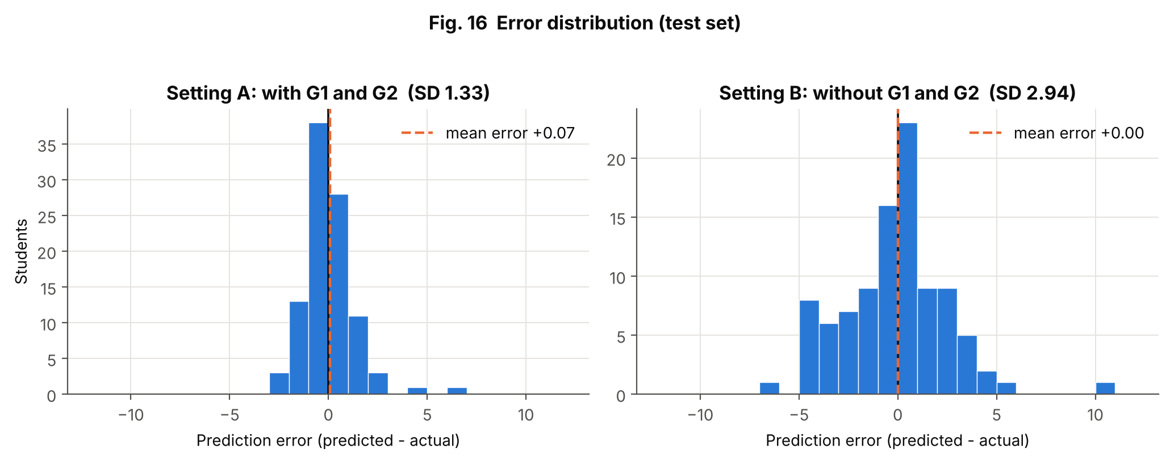
Figure 16: Error distribution
Aspect | Explanation
Purpose | Show how prediction errors are spread.
Variables | Error = predicted − actual (test set)
Chart type | Histograms with zero line and mean error
Why selected | Regression error distributions reveal bias and heavy tails.
Insight | Errors are centred near zero in both settings (mean +0.07 and +0.00), so there is no systematic over- or under-prediction. The spread is much larger without G1/G2 (SD 2.94 vs 1.33). Shapiro–Wilk rejects normal errors (p < 0.001 in both) because of a few large misses, mainly zero-grade students.

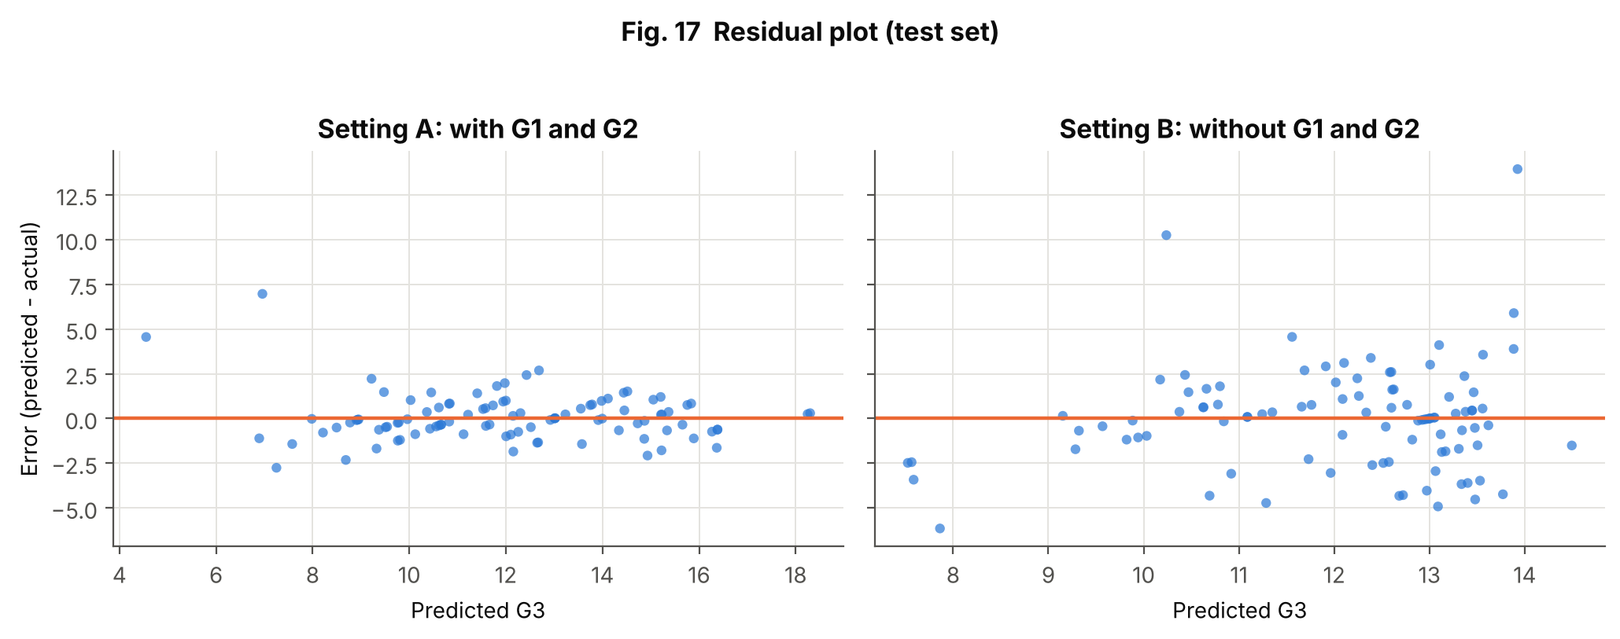
Figure 17: Residual plot
Aspect | Explanation
Purpose | Check whether errors depend on the predicted value.
Variables | Predicted G3, error
Chart type | Scatter plot with zero line
Why selected | A good model shows a shapeless cloud around zero.
Insight | Setting A shows no strong pattern except two isolated large positive errors (zero-grade students predicted at about 4.6 and 7.0; the worst absolute error is 7.0 points). Setting B shows a much wider scatter: predictions stay between about 7.5 and 14.5, errors of ±5 points are common, and the two largest errors (about 10 and 14 points) belong to students whose actual grade was 0. The model cannot tell most students apart.

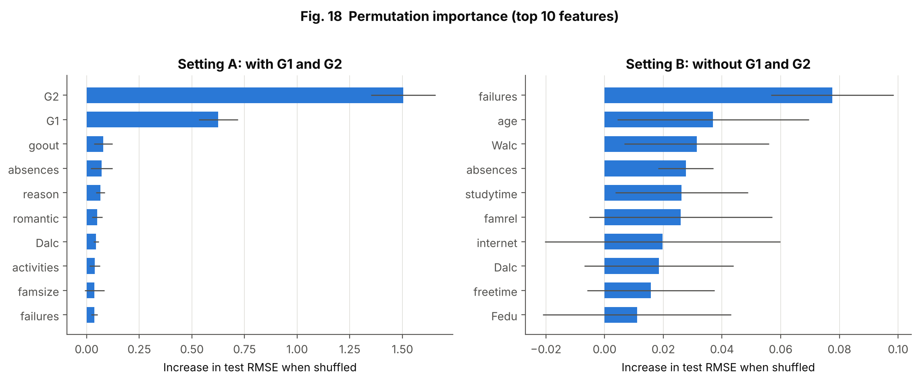
Figure 18: Permutation importance (top 10 features)
Aspect | Explanation
Purpose | Show which raw features each trained model depends on.
Variables | Raw features; increase in test RMSE after shuffling
Chart type | Horizontal bars with error bars (SD of 10 shuffles)
Why selected | Model-agnostic and works with one-hot encoded inputs when applied to raw columns.
Insight | Setting A is dominated by G2 and G1 (note the different x-axis scales). In setting B the bars are about 20 times smaller and error bars overlap zero for several features, so only past failures stands out; the others should not be over-interpreted.

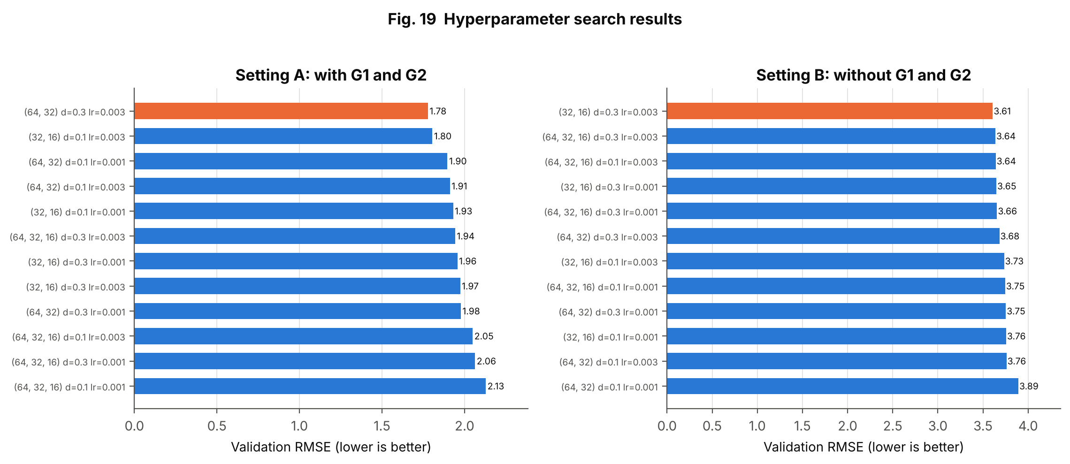
Figure 19: Hyperparameter search results
Aspect | Explanation
Purpose | Compare all 12 configurations per setting.
Variables | Architecture, dropout, learning rate vs validation RMSE
Chart type | Sorted horizontal bars; best highlighted
Why selected | A ranked chart shows both the winner and how close the others are.
Insight | Setting A validation RMSE ranges from 1.78 to 2.13; setting B from 3.61 to 3.89. Neighbouring configurations are close, so the choice of the winner is not very certain.

7.4 Stability over 10 Random Splits
Because one 98-student test set is small, the complete procedure (preprocessing, training, evaluation) was repeated for 10 different random splits, keeping the hyperparameters chosen above. Table 21 gives the mean and standard deviation of test errors; Figure 20 shows the spread.
Table 21: Test errors over 10 random splits (mean ± standard deviation)
Setting | Model | MAE | RMSE | R²
A | Mean baseline | 2.35 ± 0.14 | 3.14 ± 0.22 | -0.00 ± 0.00
A | Ridge regression | 0.84 ± 0.10 | 1.30 ± 0.19 | 0.83 ± 0.04
A | Random forest | 0.80 ± 0.06 | 1.22 ± 0.18 | 0.84 ± 0.05
A | MLP | 0.93 ± 0.09 | 1.40 ± 0.19 | 0.80 ± 0.05
B | Mean baseline | 2.35 ± 0.14 | 3.14 ± 0.22 | -0.00 ± 0.00
B | Ridge regression | 2.00 ± 0.20 | 2.80 ± 0.29 | 0.20 ± 0.11
B | Random forest | 2.01 ± 0.15 | 2.75 ± 0.32 | 0.23 ± 0.13
B | MLP | 2.12 ± 0.16 | 2.90 ± 0.28 | 0.14 ± 0.13

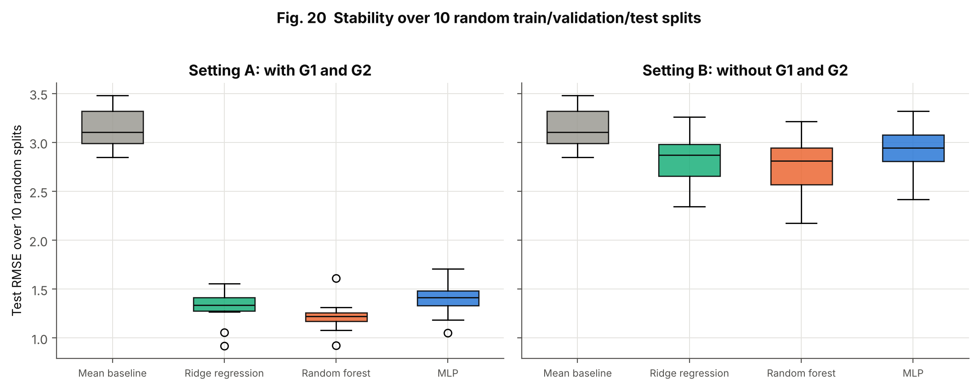
Figure 20: Stability over 10 random train/validation/test splits
Interpretation. In setting A the ranking is random forest (RMSE 1.22), ridge (1.30), MLP (1.40); the differences are comparable to the split-to-split standard deviation (about 0.2), so they are small. In setting B all three models are only modestly better than the mean baseline (3.14): MLP 2.90, ridge 2.80, random forest 2.75, with R² of only 0.14–0.23. Note that the hyperparameters were chosen using the seed-42 validation set, which may overlap the test sets of other splits, so these repeated-split numbers are slightly optimistic for the MLP.

8. Conclusion, Challenges and Future Scope

8.1 What Was Learned from the Data
- The dataset is clean in the sense of having no missing values or duplicates, but it contains a small group of zero grades (15 students) that behave differently from the rest.
- The final grade is almost a continuation of the earlier grades: r = 0.83 with G1 and 0.92 with G2.
- Among other factors, past failures (mean G3 12.5 vs 8.6), wish for higher education (12.3 vs 8.8) and school (12.6 vs 10.7) are most strongly associated with G3.
- Lifestyle ratings (free time, going out, alcohol, health) show weak relationships, and absences follow an over-dispersed count distribution that a Poisson model cannot describe.

8.2 Model Performance
With G1 and G2, the tuned MLP reached test MAE 0.91, RMSE 1.33 and R² 0.82. Without them it reached MAE 2.03, RMSE 2.93 and R² 0.12. The MLP did not outperform ridge regression or the random forest, and over 10 splits the three models were close to each other. The main lesson is that how much information is available (the earlier grades) matters far more than which algorithm is used.

8.3 Challenges and Limitations
- Small data: 454 training rows make a neural network easy to over-fit; dropout, L2, BatchNorm and early stopping were needed, and results vary by about ±0.2 RMSE between splits.
- Dependence on G1 and G2: setting A is accurate but is available only after two periods of the course; setting B is the real early-warning case and performs poorly.
- Zero grades: a few students with G3 = 0 produce the largest errors and affect the normality of G3 and of the residuals. Their meaning is not documented in the dataset description.
- Association, not causation: group differences (for example higher-education wish, school) cannot be interpreted as causes.
- Hyperparameter choice on one validation set: the repeated-split results reuse those hyperparameters, so they slightly favour the MLP.
- Single course and region: the data cover one Portuguese-language course in two schools; results may not transfer elsewhere.
- Data source for this study: the CSV was obtained from public copies of the UCI dataset (identical across two copies) because the UCI site was not reachable from the analysis environment.
- Ethics: sex, family and alcohol information are sensitive; a deployed system must be checked for fairness and used to offer support, not to label students.

8.4 Future Scope
- Model the zero-grade students separately (for example a two-stage model: first predict whether the final assessment is taken, then predict the grade).
- Use repeated cross-validation or a nested procedure for tuning, with confidence intervals for model comparisons.
- Combine this file with the Mathematics file using a student-grouped split, to get more data without leakage.
- Try gradient-boosted trees, ordinal regression and a classification of grade bands, and calibrate predictions with intervals.
- Add SHAP explanations for individual students.
- Build a teacher dashboard that shows predicted risk, with fairness checks across groups.

9. Literature Review and References

9.1 Short Literature Review
Dataset and application. Cortez and Silva (2008) collected school reports and questionnaires from two Portuguese secondary schools and applied data-mining models to predict student performance in Mathematics and Portuguese language, studying settings with and without earlier-period grades. The data were later released on the UCI repository (Cortez, 2008) under a CC BY 4.0 licence. This project reuses the Portuguese-language file and follows the same idea of comparing predictions with and without G1 and G2, using a neural network and simple baselines.
EDA and visualisation. Tukey (1977) established exploratory analysis. Fry (2007) formalised the seven-stage visualisation process (acquire, parse, filter, mine, represent, refine, interact) followed in this report. Plots and statistics were made with Matplotlib (Hunter, 2007), seaborn (Waskom, 2021) and SciPy (Virtanen et al., 2020).
Modelling. Goodfellow, Bengio and Courville (2016) describe multilayer perceptrons and regularisation; Srivastava et al. (2014) introduced dropout and Kingma and Ba (2015) the Adam optimiser. The baselines use scikit-learn (Pedregosa et al., 2011), ridge regression (Hoerl & Kennard, 1970) and random forests (Breiman, 2001). The network was built with TensorFlow/Keras (Abadi et al., 2016).

9.2 References (APA 7th edition)
Abadi, M., Barham, P., Chen, J., Chen, Z., Davis, A., Dean, J., et al. (2016). TensorFlow: A system for large-scale machine learning. Proceedings of the 12th USENIX Symposium on Operating Systems Design and Implementation (OSDI '16), 265–283.
Breiman, L. (2001). Random forests. Machine Learning, 45(1), 5–32.
Cortez, P. (2008). Student performance [Dataset]. UCI Machine Learning Repository. https://doi.org/10.24432/C5TG7T
Cortez, P., & Silva, A. (2008). Using data mining to predict secondary school student performance. In A. Brito & J. Teixeira (Eds.), Proceedings of 5th FUture BUsiness TEChnology Conference (FUBUTEC 2008) (pp. 5–12). EUROSIS.
Fry, B. (2007). Visualizing data: Exploring and explaining data with the Processing environment. O'Reilly Media.
Goodfellow, I., Bengio, Y., & Courville, A. (2016). Deep learning. MIT Press.
Hoerl, A. E., & Kennard, R. W. (1970). Ridge regression: Biased estimation for nonorthogonal problems. Technometrics, 12(1), 55–67.
Hunter, J. D. (2007). Matplotlib: A 2D graphics environment. Computing in Science & Engineering, 9(3), 90–95.
Kingma, D. P., & Ba, J. (2015). Adam: A method for stochastic optimization. 3rd International Conference on Learning Representations (ICLR 2015).
Pedregosa, F., Varoquaux, G., Gramfort, A., Michel, V., Thirion, B., Grisel, O., et al. (2011). Scikit-learn: Machine learning in Python. Journal of Machine Learning Research, 12, 2825–2830.
Srivastava, N., Hinton, G., Krizhevsky, A., Sutskever, I., & Salakhutdinov, R. (2014). Dropout: A simple way to prevent neural networks from overfitting. Journal of Machine Learning Research, 15(56), 1929–1958.
Tukey, J. W. (1977). Exploratory data analysis. Addison-Wesley.
Virtanen, P., Gommers, R., Oliphant, T. E., et al. (2020). SciPy 1.0: Fundamental algorithms for scientific computing in Python. Nature Methods, 17, 261–272.
Waskom, M. L. (2021). seaborn: Statistical data visualization. Journal of Open Source Software, 6(60), 3021.

10. Rubric Alignment
The table maps each assessment criterion in the assignment sheet to the evidence in this report and repository. It lists where the evidence is; it does not claim any marks.
Table 22: Rubric alignment
CO / Criterion (marks) | Report section | Evidence provided
CO3 – Selection and creation of visualizations (3) | 4.1, 4.4, Figs. 1–12; Ch. 7, Figs. 13–20 | 20 figures of 12+ types (bar, histogram, boxplot, scatter, heat-map, pairplot, Q–Q, PCA, dot-and-interval, line, residual, importance) chosen by data type; 2 interactive pages
CO3 – Quality and presentation (2) | 4.2 | Numbered titles, labelled axes, legends, direct labels, colour-blind-safe palette, consistent colours
CO3 – Interpretation of visualizations (3) | 4.4, 7.3 | Purpose / variables / chart type / why / insight table for every figure
CO4 – Univariate analysis and distribution exploration (4) | 2.5, 5.1, Figs. 1–5 | Mean, median, mode, SD, quartiles, skew, histograms, boxplots, outlier analysis
CO4 – Discrete / continuous distributions (4) | 5.2, Figs. 5–6 | Normal fit and Q–Q with and without zeros; Bernoulli/Binomial; Poisson and negative binomial for absences
CO4 – Bivariate / multivariate analysis (4) | 5.3, 5.4, Figs. 7–12 | Spearman, Mann–Whitney, Kruskal–Wallis with effect sizes, heat-maps, VIF, PCA, pairplot, scatter
CO4 – Interpretation of patterns and findings (4) | 5.5, 3.7 | Plain-language findings table linked to evidence
CO5 – Real-world problem / application (3) | 1.2–1.5, 2.2 | Early prediction of final grades from school and family data
CO5 – Application of EDA techniques (3) | Chapter 3 | Missing/duplicate checks, outliers, encoding, scaling, stratified split, leakage control, two settings
CO5 – Insights and interpretation (3) | 3.7, 5.5, 4.4 | Zero-grade finding, failures and aspiration effects, over-dispersed absences, dependence on G1/G2
CO5 – Conclusion and recommendations (3) | Chapter 8 | Findings, model performance, limitations, future scope
CO5 – GitHub repository and documentation (4) | Appendix B | Repository structure, README, requirements, dataset, code, report; public link to be added after upload
Enrichment – ML/DL (optional) | Ch. 6, 7 | Tuned MLP regressor in two settings, baselines, permutation importance, error analysis, 10-split stability

Appendix A – Complete Python Source Code
Files are shown in the order in which the pipeline runs. Run everything with: python src/run_all.py

A.1 config.py – paths, seed, column groups, plot style
"""Project-wide configuration: paths, random seed, column groups and plot style."""
from pathlib import Path
import matplotlib
matplotlib.use("Agg") # headless backend (no display needed)
import matplotlib.pyplot as plt

ROOT = Path(__file__).resolve().parents[1]
DATA_PATH = ROOT / "data" / "student-por.csv"
EDA_DIR = ROOT / "outputs" / "eda"
EVAL_DIR = ROOT / "outputs" / "model_evaluation"
MODEL_DIR = ROOT / "models"
for d in (EDA_DIR, EVAL_DIR, MODEL_DIR):
d.mkdir(parents=True, exist_ok=True)

SEED = 42
TARGET = "G3" # final grade, 0-20 (regression target)
PASS_MARK = 10 # G3 >= 10 counts as "pass" in the Portuguese system
GRADE_COLS = ["G1", "G2"] # earlier period grades

# ---- Column groups (32 input features) --------------------------------------
BINARY_COLS = ["school", "sex", "address", "famsize", "Pstatus", "schoolsup", "famsup", "paid",
"activities", "nursery", "higher", "internet", "romantic"]
NOMINAL_COLS = ["Mjob", "Fjob", "reason", "guardian"]
# Everything else is numeric: ordinal 1-5 ratings and counts are kept as numbers.
ORDINAL_COLS = ["Medu", "Fedu", "traveltime", "studytime", "failures", "famrel", "freetime",
"goout", "Dalc", "Walc", "health"]

# ---- Plot style: validated categorical slots 1-3 + neutral inks --------------
BLUE, ORANGE, GREEN = "#2a78d6", "#eb6834", "#1baf7a"
INK, INK2, GRID = "#0b0b0b", "#52514e", "#e4e3df"
PASS_COLORS = {"Pass": BLUE, "Fail": ORANGE}

def set_style():
plt.rcParams.update({
"figure.dpi": 110, "savefig.dpi": 200, "savefig.bbox": "tight",
"font.size": 10, "axes.titlesize": 12, "axes.titleweight": "bold",
"axes.labelsize": 10, "axes.edgecolor": INK2, "axes.labelcolor": INK,
"text.color": INK, "xtick.color": INK2, "ytick.color": INK2,
"axes.spines.top": False, "axes.spines.right": False,
"axes.grid": True, "grid.color": GRID, "grid.linewidth": 0.7,
"axes.axisbelow": True, "legend.frameon": False,
"figure.facecolor": "white", "axes.facecolor": "white",
})

def save_fig(fig, path):
fig.savefig(path)
plt.close(fig)

A.2 data_preprocessing.py – loading, cleaning, split, pipeline
"""Data loading, cleaning checks, splitting and the leakage-safe preprocessing pipeline."""
import numpy as np
import pandas as pd
from sklearn.base import BaseEstimator, TransformerMixin
from sklearn.compose import ColumnTransformer
from sklearn.model_selection import train_test_split
from sklearn.pipeline import Pipeline
from sklearn.preprocessing import OneHotEncoder, OrdinalEncoder, StandardScaler
from config import (DATA_PATH, TARGET, SEED, BINARY_COLS, NOMINAL_COLS, GRADE_COLS)

def load_data(path=DATA_PATH) -> pd.DataFrame:
"""Load the UCI 'Student Performance' (Portuguese course) CSV (comma separated)."""
df = pd.read_csv(path)
df.columns = df.columns.str.strip()
return df

def numeric_cols(df: pd.DataFrame):
"""Numeric features = everything that is neither a binary flag nor a nominal code (target excluded)."""
return [c for c in df.columns if c not in BINARY_COLS + NOMINAL_COLS + [TARGET]]

def clean_data(df: pd.DataFrame):
"""Remove exact duplicate rows; report missing values. Returns (clean_df, report dict)."""
report = {"rows_before": len(df), "missing_cells": int(df.isna().sum().sum()),
"duplicate_rows": int(df.duplicated().sum())}
df = df.drop_duplicates().reset_index(drop=True)
report["rows_after"] = len(df)
return df, report

class Winsorizer(BaseEstimator, TransformerMixin):
"""Clip each column to its [lower, upper] percentile, learned on TRAINING data only."""
def __init__(self, lower=1, upper=99):
self.lower, self.upper = lower, upper

def fit(self, X, y=None):
X = np.asarray(X, dtype=float)
self.lo_ = np.percentile(X, self.lower, axis=0)
self.hi_ = np.percentile(X, self.upper, axis=0)
return self

def transform(self, X):
return np.clip(np.asarray(X, dtype=float), self.lo_, self.hi_)

def feature_columns(df, use_grades=True):
"""Input columns for the two experimental settings:
use_grades=True -> all 32 features (includes G1, G2)
use_grades=False -> 30 features (early-warning setting: no earlier grades)."""
cols = [c for c in df.columns if c != TARGET]
return cols if use_grades else [c for c in cols if c not in GRADE_COLS]

def build_preprocessor(columns) -> ColumnTransformer:
"""numeric -> winsorise -> standardise | nominal -> one-hot | binary -> 0/1 ordinal encoding."""
num = [c for c in columns if c not in BINARY_COLS + NOMINAL_COLS]
return ColumnTransformer([
("num", Pipeline([("clip", Winsorizer(1, 99)), ("scale", StandardScaler())]), num),
("cat", OneHotEncoder(handle_unknown="ignore", sparse_output=False), [c for c in NOMINAL_COLS if c in columns]),
("bin", OrdinalEncoder(), [c for c in BINARY_COLS if c in columns]),
])

def split_data(df: pd.DataFrame, seed=SEED, val_size=0.15, test_size=0.15):
"""70/15/15 split. Stratified on grade band (fail <10, 10-13, >=14) so every subset has a similar grade mix."""
X, y = df.drop(columns=[TARGET]), df[TARGET].astype(float)
band = pd.cut(y, [-1, 9, 13, 20], labels=False)
X_tr, X_tmp, y_tr, y_tmp, b_tr, b_tmp = train_test_split(
X, y, band, test_size=val_size + test_size, stratify=band, random_state=seed)
X_val, X_te, y_val, y_te = train_test_split(
X_tmp, y_tmp, test_size=test_size / (val_size + test_size), stratify=b_tmp, random_state=seed)
return X_tr, X_val, X_te, y_tr, y_val, y_te

A.3 eda.py – statistics and distribution fitting
"""Statistical EDA: inspection, outliers, univariate / bivariate / multivariate statistics and
distribution fitting. Writes CSV tables and results_eda.json (used by the report)."""
import json
import numpy as np
import pandas as pd
from scipy import stats
from sklearn.decomposition import PCA
from sklearn.linear_model import LinearRegression
from sklearn.preprocessing import StandardScaler
from config import EDA_DIR, TARGET, BINARY_COLS, NOMINAL_COLS, PASS_MARK
from data_preprocessing import load_data, clean_data, numeric_cols

def inspect(df):
"""Dtypes + descriptive statistics (mean/median/mode/std/quantiles/skew/kurtosis) of numeric columns."""
num = numeric_cols(df) + [TARGET]
pd.DataFrame({"dtype": df.dtypes.astype(str), "n_unique": df.nunique(),
"missing": df.isna().sum()}).to_csv(EDA_DIR / "table_dtypes.csv")
rows = []
for c in num:
s = df[c]
rows.append({"feature": c, "mean": s.mean(), "median": s.median(), "mode": s.mode().iloc[0],
"std": s.std(), "min": s.min(), "q25": s.quantile(.25), "q75": s.quantile(.75),
"max": s.max(), "skew": s.skew(), "kurtosis": s.kurt()})
desc = pd.DataFrame(rows).set_index("feature"); desc.round(3).to_csv(EDA_DIR / "table_descriptive_numeric.csv")
return desc

def outlier_table(df):
"""IQR (1.5x) and |z|>3 outlier counts for numeric columns with more than 5 distinct values."""
rows = []
for c in numeric_cols(df) + [TARGET]:
s = df[c]
if s.nunique() <= 5:
continue
q1, q3 = s.quantile([.25, .75]); iqr = q3 - q1; lo, hi = q1 - 1.5 * iqr, q3 + 1.5 * iqr
n_iqr = int(((s < lo) | (s > hi)).sum())
rows.append({"feature": c, "lower_fence": lo, "upper_fence": hi, "iqr_outliers": n_iqr,
"iqr_pct": 100 * n_iqr / len(s), "z_gt_3": int((np.abs((s - s.mean()) / s.std()) > 3).sum())})
t = pd.DataFrame(rows).set_index("feature").sort_values("iqr_pct", ascending=False)
t.round(3).to_csv(EDA_DIR / "table_outliers.csv"); return t

def bivariate_tests(df):
"""Association of every input feature with the numeric target G3.
numeric/ordinal -> Spearman rho (+p); binary -> Mann-Whitney U with Cohen's d (mean diff / pooled SD);
nominal (>2 levels) -> Kruskal-Wallis H with epsilon^2 effect size."""
n = len(df); rows = []
for c in numeric_cols(df):
r, p = stats.spearmanr(df[c], df[TARGET])
rows.append({"feature": c, "type": "numeric/ordinal", "test": "Spearman", "statistic": r, "p_value": p, "effect_size": abs(r)})
for c in BINARY_COLS:
g = [x[TARGET].values for _, x in df.groupby(c)]
U, p = stats.mannwhitneyu(g[0], g[1]); sp = np.sqrt(((len(g[0]) - 1) * g[0].var(ddof=1) + (len(g[1]) - 1) * g[1].var(ddof=1)) / (n - 2))
d = (g[1].mean() - g[0].mean()) / sp
rows.append({"feature": c, "type": "binary", "test": "Mann-Whitney U", "statistic": U, "p_value": p, "effect_size": abs(d)})
for c in NOMINAL_COLS:
g = [x[TARGET].values for _, x in df.groupby(c)]; H, p = stats.kruskal(*g)
rows.append({"feature": c, "type": "nominal", "test": "Kruskal-Wallis", "statistic": H, "p_value": p, "effect_size": (H - len(g) + 1) / (n - len(g))})
t = pd.DataFrame(rows).set_index("feature").sort_values("effect_size", ascending=False)
t.to_csv(EDA_DIR / "table_bivariate_tests.csv"); return t

def multivariate(df):
"""Spearman matrix (numeric + target), VIF on numeric features and PCA."""
num = numeric_cols(df)
corr = df[num + [TARGET]].corr(method="spearman"); corr.round(3).to_csv(EDA_DIR / "table_spearman_corr.csv")
X = StandardScaler().fit_transform(df[num]); vif = {}
for i, c in enumerate(num):
o = np.delete(X, i, 1); r2 = LinearRegression().fit(o, X[:, i]).score(o, X[:, i]); vif[c] = 1 / (1 - r2)
vif = pd.Series(vif, name="VIF").sort_values(ascending=False); vif.round(2).to_csv(EDA_DIR / "table_vif.csv")
return corr, vif, PCA().fit(X).explained_variance_ratio_

def distribution_fits(df):
"""Continuous: normal fit of G3 (with and without the zero grades). Discrete: Poisson vs negative binomial
for absences; Bernoulli/Binomial for pass/fail; frequency distribution of alcohol ratings."""
out = {}; g3 = df[TARGET]; nz = g3[g3 > 0]
mu, sd = stats.norm.fit(g3); mu2, sd2 = stats.norm.fit(nz)
out["G3_all"] = {"mean": mu, "std": sd, "skew": g3.skew(), "excess_kurtosis": g3.kurt(),
"dagostino_p": stats.normaltest(g3)[1], "ks_D": stats.kstest(g3, stats.norm(mu, sd).cdf).statistic}
out["G3_nonzero"] = {"n": int(len(nz)), "mean": mu2, "std": sd2, "skew": nz.skew(), "excess_kurtosis": nz.kurt(),
"dagostino_p": stats.normaltest(nz)[1], "ks_D": stats.kstest(nz, stats.norm(mu2, sd2).cdf).statistic}
out["n_G3_zero"] = int((g3 == 0).sum())
ab = df["absences"]; m, v = ab.mean(), ab.var()
out["absences"] = {"mean": m, "variance": v, "dispersion_index": v / m, "zero_share": float((ab == 0).mean())}
# negative binomial by method of moments (r, p): mean = r(1-p)/p, var = r(1-p)/p^2
p_nb = m / v; r_nb = m * p_nb / (1 - p_nb); out["absences"].update(nb_r=r_nb, nb_p=p_nb)
k = np.arange(0, int(ab.max()) + 1); obs = ab.value_counts(normalize=True).reindex(k, fill_value=0).values
out["absences"]["tv_poisson"] = 0.5 * float(np.abs(obs - stats.poisson.pmf(k, m)).sum())
out["absences"]["tv_negbin"] = 0.5 * float(np.abs(obs - stats.nbinom.pmf(k, r_nb, p_nb)).sum())
ps = (g3 >= PASS_MARK).mean(); lo, hi = stats.binomtest(int((g3 >= PASS_MARK).sum()), len(g3)).proportion_ci(method="wilson")
out["pass_rate"] = ps; out["pass_wilson_ci"] = [lo, hi]
for c in ["Dalc", "Walc"]:
out[c + "_pct"] = {int(k): round(100 * v, 1) for k, v in df[c].value_counts(normalize=True).sort_index().items()}
return out

def run():
raw = load_data(); df, rep = clean_data(raw)
desc = inspect(df); ot = outlier_table(df); bt = bivariate_tests(df); corr, vif, evr = multivariate(df)
out = {"shape": list(raw.shape), "clean_report": rep, "n_numeric": len(numeric_cols(df)), "n_binary": len(BINARY_COLS),
"n_nominal": len(NOMINAL_COLS), "dtypes": pd.Series(df.dtypes.astype(str)).value_counts().to_dict(),
"g3_desc": desc.loc[TARGET].round(3).to_dict(), "pass_count": int((df[TARGET] >= PASS_MARK).sum()),
"outliers": ot.round(2).reset_index().to_dict("records"), "bivariate": bt.reset_index().round(5).to_dict("records"),
"vif": vif.round(2).to_dict(), "pca_var_ratio": [round(float(x), 4) for x in evr],
"distribution_fits": distribution_fits(df)}
# group means used in the narrative
gm = {}
for c in ["school", "higher", "sex", "failures", "studytime", "schoolsup", "internet", "address", "romantic", "paid"]:
gm[c] = df.groupby(c)[TARGET].agg(["mean", "size"]).round(2).reset_index().astype(object).values.tolist()
out["group_means"] = gm
out["g3_zero_profile"] = {"mean_G2_of_zero": float(df[df[TARGET] == 0]["G2"].mean()), "mean_absences_of_zero": float(df[df[TARGET] == 0]["absences"].mean()),
"mean_absences_others": float(df[df[TARGET] > 0]["absences"].mean()),
"zero_with_G2_zero": int(((df[TARGET] == 0) & (df["G2"] == 0)).sum())}
c = corr.where(np.triu(np.ones(corr.shape, bool), 1)).stack().sort_values(key=abs, ascending=False)
out["top_corr_pairs"] = [[a, b, round(float(v), 3)] for (a, b), v in c.head(8).items()]
out["pearson_G2_G3"] = float(df["G2"].corr(df[TARGET])); out["pearson_G1_G3"] = float(df["G1"].corr(df[TARGET]))
with open(EDA_DIR / "results_eda.json", "w") as fh:
json.dump(out, fh, indent=1, default=lambda o: o.item() if hasattr(o, "item") else str(o))
print(json.dumps({k: out[k] for k in ["shape", "clean_report", "pass_count", "g3_zero_profile", "top_corr_pairs", "pearson_G2_G3"]}, indent=1, default=str))
print(bt.head(14)[["type", "statistic", "p_value", "effect_size"]].round(4)); print(vif.head(5)); print(out["distribution_fits"])
return df

if __name__ == "__main__":
run()

A.4 visualizations.py – Figures 1–12 and interactive pages
"""EDA visualisations (Figures 1-12) + two interactive Plotly pages (stage 7: Interact)."""
import numpy as np
import pandas as pd
import matplotlib.pyplot as plt
import seaborn as sns
from scipy import stats
from sklearn.decomposition import PCA
from sklearn.preprocessing import StandardScaler
from config import (EDA_DIR, TARGET, PASS_MARK, BLUE, ORANGE, GREEN, PASS_COLORS, SEED,
BINARY_COLS, set_style, save_fig)
from data_preprocessing import load_data, clean_data, numeric_cols

NICE = {"higher": "Wants higher education", "school": "School (GP vs MS)", "address": "Home address (urban vs rural)",
"internet": "Internet at home", "sex": "Sex (F vs M)", "paid": "Extra paid classes", "schoolsup": "School support",
"romantic": "In a relationship", "famsup": "Family support", "activities": "Extra-curricular activities",
"nursery": "Attended nursery", "famsize": "Family size (LE3 vs GT3)", "Pstatus": "Parents (A apart vs T together)"}

def _pf(df):
return np.where(df[TARGET] >= PASS_MARK, "Pass", "Fail")

def fig01_target(df):
"""Distribution of the target G3 (histogram with the pass mark)."""
fig, ax = plt.subplots(figsize=(7, 3.9)); s = df[TARGET]
ax.bar(*np.unique(s, return_counts=True), color=[ORANGE if v < PASS_MARK else BLUE for v in np.unique(s)], width=0.8)
ax.axvline(PASS_MARK - 0.5, color=INK2 if False else "#52514e", ls="--", lw=1.3); ax.set_ylim(0, 118); ax.text(PASS_MARK - 0.3, 112, "pass mark (10)", fontsize=8)
ax.annotate(f"{(s == 0).sum()} students\nwith G3 = 0", xy=(0, (s == 0).sum()), xytext=(2.2, 70), fontsize=8, arrowprops=dict(arrowstyle="->", color="#52514e"))
ax.set(title="Fig. 1 Distribution of the final grade (G3)", xlabel="Final grade G3 (0-20)", ylabel="Number of students")
save_fig(fig, EDA_DIR / "fig01_target_distribution.png")

def fig02_hist(df):
"""Histograms with mean (solid) and median (dashed) for six numeric variables."""
cols = ["G1", "G2", "age", "absences", "studytime", "failures"]
fig, axes = plt.subplots(2, 3, figsize=(11, 6))
for ax, c in zip(axes.ravel(), cols):
s = df[c]; bins = np.arange(s.min() - .5, s.max() + 1.5, 1) if s.nunique() < 25 else 30
ax.hist(s, bins=bins, color=BLUE, edgecolor="white", linewidth=0.5)
ax.axvline(s.mean(), color="#0b0b0b", lw=1.6, label=f"mean {s.mean():.1f}"); ax.axvline(s.median(), color=ORANGE, lw=1.6, ls="--", label=f"median {s.median():.1f}")
ax.set(title=c, xlabel=c, ylabel="Frequency"); ax.legend(fontsize=8)
fig.suptitle("Fig. 2 Histograms of key numeric variables", fontweight="bold", y=1.0); fig.tight_layout()
save_fig(fig, EDA_DIR / "fig02_histograms.png")

def fig03_box(df):
"""Boxplots of G3 grouped by five factors."""
cols = ["school", "failures", "studytime", "higher", "Dalc"]
labs = {"school": "School", "failures": "Past failures", "studytime": "Weekly study time (1-4)", "higher": "Wants higher education", "Dalc": "Workday alcohol (1-5)"}
fig, axes = plt.subplots(1, 5, figsize=(14, 3.8), sharey=True)
for ax, c in zip(axes, cols):
sns.boxplot(data=df, x=c, y=TARGET, color=BLUE, width=0.6, linewidth=1, fliersize=2, ax=ax)
ax.set_title(labs[c], fontsize=9); ax.set_xlabel(""); ax.set_ylabel("Final grade G3" if c == "school" else "")
fig.suptitle("Fig. 3 Final grade (G3) by key factors", fontweight="bold", y=1.03); fig.tight_layout()
save_fig(fig, EDA_DIR / "fig03_boxplots_g3_by_factor.png")

def fig04_outliers(df):
"""Share of IQR outliers per numeric feature."""
t = pd.read_csv(EDA_DIR / "table_outliers.csv", index_col=0).sort_values("iqr_pct")
fig, ax = plt.subplots(figsize=(7, 3.8)); ax.barh(t.index, t["iqr_pct"], color=BLUE, height=0.65)
for y, v in enumerate(t["iqr_pct"]): ax.text(v + 0.2, y, f"{v:.1f}%", va="center", fontsize=8)
ax.set(title="Fig. 4 Share of IQR outliers per numeric feature", xlabel="Rows outside Q1 - 1.5 IQR / Q3 + 1.5 IQR (%)"); ax.grid(axis="y", visible=False)
ax.set_xlim(0, t["iqr_pct"].max() * 1.15); save_fig(fig, EDA_DIR / "fig04_outlier_share.png")

def fig05_normal(df):
"""Continuous distribution: normal fit and Q-Q plot of G3 for (a) all students, (b) students with G3 > 0."""
fig, axes = plt.subplots(1, 3, figsize=(13, 3.8)); s = df[TARGET]; nz = s[s > 0]
for ax, d, ttl in [(axes[0], s, "(a) G3, all students"), (axes[1], nz, "(b) G3 > 0 (zero grades removed)")]:
mu, sd = stats.norm.fit(d); ax.hist(d, bins=np.arange(d.min() - .5, d.max() + 1.5, 1), density=True, color=BLUE, edgecolor="white", linewidth=.5, label="Observed")
x = np.linspace(d.min(), d.max(), 300); ax.plot(x, stats.norm.pdf(x, mu, sd), color=ORANGE, lw=2, label=f"Normal (μ={mu:.1f}, σ={sd:.1f})")
ax.set(title=ttl, xlabel="G3", ylabel="Density"); ax.legend(fontsize=8)
stats.probplot(s, dist="norm", plot=axes[2]); axes[2].get_lines()[0].set(color=BLUE, markersize=3, label="all"); axes[2].get_lines()[1].set(color=ORANGE, lw=2)
z = stats.probplot(nz, dist="norm", fit=False); axes[2].plot(z[0], z[1], ".", color=GREEN, markersize=3, label="G3 > 0")
axes[2].set(title="(c) Normal Q-Q plot", xlabel="Theoretical quantiles", ylabel="Ordered values"); axes[2].legend(fontsize=8)
fig.suptitle("Fig. 5 Continuous distribution: final grade G3", fontweight="bold", y=1.03); fig.tight_layout()
save_fig(fig, EDA_DIR / "fig05_normal_fit_qq.png")

def fig06_discrete(df):
"""Discrete distributions: (a) Poisson vs negative binomial for absences, (b) Binomial(10, p) for passes."""
ab = df["absences"]; m = ab.mean(); v = ab.var(); p_nb = m / v; r_nb = m * p_nb / (1 - p_nb)
k = np.arange(0, 26); obs = ab.value_counts(normalize=True).reindex(k, fill_value=0)
fig, (a, b) = plt.subplots(1, 2, figsize=(11, 3.9)); w = 0.28
a.bar(k - w, obs.values, width=w, color=BLUE, label="Observed"); a.bar(k, stats.poisson.pmf(k, m), width=w, color=ORANGE, label=f"Poisson (λ={m:.2f})")
a.bar(k + w, stats.nbinom.pmf(k, r_nb, p_nb), width=w, color=GREEN, label=f"Negative binomial (r={r_nb:.2f})")
a.set(title="(a) Number of school absences (shown 0-25)", xlabel="Absences", ylabel="Probability"); a.legend(fontsize=8)
p = (df[TARGET] >= PASS_MARK).mean(); n = 10; rng = np.random.default_rng(SEED)
sims = np.array([(df[TARGET].sample(n, random_state=int(r)) >= PASS_MARK).sum() for r in rng.integers(0, 10**6, 5000)])
kk = np.arange(0, n + 1); emp = np.bincount(sims, minlength=n + 1) / len(sims)
b.bar(kk - .2, emp, width=.4, color=BLUE, label="Simulated (5000 samples of 10 students)"); b.bar(kk + .2, stats.binom.pmf(kk, n, p), width=.4, color=ORANGE, label=f"Binomial(10, p={p:.3f})")
b.set(title="(b) Passing students among 10 random students", xlabel="Number who pass", ylabel="Probability"); b.legend(fontsize=8, loc="upper left")
fig.suptitle("Fig. 6 Discrete distributions: Poisson, negative binomial and Binomial", fontweight="bold", y=1.03); fig.tight_layout()
save_fig(fig, EDA_DIR / "fig06_discrete_distributions.png")

def fig07_corr(df):
"""Spearman correlation heat-map (numeric/ordinal features and G3)."""
cols = numeric_cols(df) + [TARGET]; corr = df[cols].corr(method="spearman"); fig, ax = plt.subplots(figsize=(8.4, 7))
sns.heatmap(corr, mask=np.triu(np.ones_like(corr, bool), 1), cmap=sns.diverging_palette(40, 250, s=85, l=50, as_cmap=True), center=0, vmin=-1, vmax=1,
annot=True, fmt=".2f", annot_kws={"size": 7}, linewidths=.4, linecolor="white", cbar_kws={"label": "Spearman ρ", "shrink": .7}, ax=ax)
ax.grid(False); ax.set_title("Fig. 7 Spearman correlation heatmap"); save_fig(fig, EDA_DIR / "fig07_correlation_heatmap.png")

def fig08_group_means(df):
"""Mean G3 with 95% CI for the two levels of each binary factor, sorted by size of the gap."""
rows = []
for c in BINARY_COLS:
for lv, g in df.groupby(c)[TARGET]:
rows.append({"factor": c, "level": lv, "mean": g.mean(), "ci": 1.96 * g.std(ddof=1) / np.sqrt(len(g)), "n": len(g)})
t = pd.DataFrame(rows); gap = t.groupby("factor")["mean"].agg(lambda s: abs(s.iloc[0] - s.iloc[1])).sort_values()
fig, ax = plt.subplots(figsize=(7.6, 5.4)); y = np.arange(len(gap))
for i, f in enumerate(gap.index):
a, b = t[t.factor == f].iloc[0], t[t.factor == f].iloc[1]
ax.plot([a["mean"], b["mean"]], [i, i], color="#b9b8b2", lw=2, zorder=1)
ax.errorbar(a["mean"], i, xerr=a["ci"], fmt="o", color=ORANGE, ms=7, capsize=3, zorder=3); ax.errorbar(b["mean"], i, xerr=b["ci"], fmt="o", color=BLUE, ms=7, capsize=3, zorder=3)
ax.text(max(a["mean"] + a["ci"], b["mean"] + b["ci"]) + .15, i, f"{a['level']} (n={a['n']}) vs {b['level']} (n={b['n']})", va="center", fontsize=7, color="#52514e")
ax.set_yticks(y); ax.set_yticklabels([NICE.get(f, f) for f in gap.index]); ax.set(xlabel="Mean final grade G3 (95% confidence interval)", xlim=(7.5, 17.5), title="Fig. 8 Mean G3 for each binary factor")
ax.scatter([], [], color=ORANGE, label="first level (alphabetical)"); ax.scatter([], [], color=BLUE, label="second level"); ax.legend(loc="lower right", fontsize=8); ax.grid(axis="y", visible=False)
save_fig(fig, EDA_DIR / "fig08_group_means.png")

def fig09_scatter(df):
"""Scatter plots of G1 and G2 against G3 with regression line (jittered, coloured by pass/fail)."""
rng = np.random.default_rng(SEED); pf = _pf(df); fig, axes = plt.subplots(1, 2, figsize=(10.5, 4.6), sharey=True)
for ax, c in zip(axes, ["G1", "G2"]):
for lab in ["Pass", "Fail"]:
m = pf == lab; ax.scatter(df[c][m] + rng.normal(0, .12, m.sum()), df[TARGET][m] + rng.normal(0, .12, m.sum()), s=14, alpha=.5, color=PASS_COLORS[lab], edgecolor="none", label=lab)
b, a = np.polyfit(df[c], df[TARGET], 1); xs = np.array([df[c].min(), df[c].max()]); ax.plot(xs, a + b * xs, color="#0b0b0b", lw=1.6, label=f"line: G3 = {a:.2f} + {b:.2f}·{c}")
r = df[c].corr(df[TARGET]); ax.set(title=f"{c} vs G3 (Pearson r = {r:.3f})", xlabel=f"{c} (0-20)", ylabel="G3 (0-20)" if c == "G1" else ""); ax.legend(fontsize=8, loc="upper left")
fig.suptitle("Fig. 9 Earlier grades against the final grade", fontweight="bold", y=1.02); fig.tight_layout(); save_fig(fig, EDA_DIR / "fig09_grade_scatter.png")

def fig10_pca(df):
"""PCA projection of standardised numeric features, coloured by G3 (sequential scale)."""
num = numeric_cols(df); Z = StandardScaler().fit_transform(df[num]); pca = PCA(2, random_state=SEED).fit(Z); P = pca.transform(Z)
fig, ax = plt.subplots(figsize=(6.6, 5.2)); sc = ax.scatter(P[:, 0], P[:, 1], c=df[TARGET], cmap="viridis", s=14, alpha=.8, edgecolor="none")
cb = fig.colorbar(sc, ax=ax); cb.set_label("Final grade G3"); ev = pca.explained_variance_ratio_ * 100
ax.set(title="Fig. 10 PCA projection of numeric features", xlabel=f"PC1 ({ev[0]:.1f}% variance)", ylabel=f"PC2 ({ev[1]:.1f}% variance)"); save_fig(fig, EDA_DIR / "fig10_pca.png")

def fig11_pair(df):
"""Pairplot of key variables coloured by pass/fail."""
d = df[["G2", "failures", "studytime", "absences", "age", TARGET]].copy(); d["Outcome"] = _pf(df)
g = sns.pairplot(d, hue="Outcome", hue_order=["Pass", "Fail"], palette=PASS_COLORS, corner=True, plot_kws={"s": 9, "alpha": .4, "edgecolor": "none"}, diag_kind="kde", height=1.8)
g.figure.suptitle("Fig. 11 Pairplot of key variables", fontweight="bold", y=1.01); g.figure.savefig(EDA_DIR / "fig11_pairplot.png"); plt.close(g.figure)

def fig12_heat(df):
"""Mean G3 for each combination of study time and past failures (cell counts printed)."""
m = df.pivot_table(index="studytime", columns="failures", values=TARGET, aggfunc="mean"); n = df.pivot_table(index="studytime", columns="failures", values=TARGET, aggfunc="size")
fig, ax = plt.subplots(figsize=(6.2, 4.4)); sns.heatmap(m, annot=False, cmap="Blues", vmin=6, vmax=15, linewidths=1, linecolor="white", cbar_kws={"label": "Mean G3"}, ax=ax)
for i in range(m.shape[0]):
for j in range(m.shape[1]):
if not np.isnan(m.iloc[i, j]): ax.text(j + .5, i + .5, f"{m.iloc[i, j]:.1f}\n(n={int(n.iloc[i, j])})", ha="center", va="center", fontsize=8, color="white" if m.iloc[i, j] > 11.5 else "#0b0b0b")
ax.grid(False); ax.set(title="Fig. 12 Mean G3 by study time and past failures", xlabel="Past class failures", ylabel="Weekly study time (1 = <2 h … 4 = >10 h)"); save_fig(fig, EDA_DIR / "fig12_studytime_failures.png")

def interactive(df):
"""Stage 7 (Interact): hover / zoom / legend-filter pages built with Plotly."""
import plotly.express as px
d = df.copy(); d["Outcome"] = _pf(df)
f1 = px.scatter(d, x="G2", y=TARGET, color="Outcome", color_discrete_map=PASS_COLORS, opacity=.6, hover_data=["G1", "failures", "studytime", "absences", "school", "higher"], title="Interactive: second-period grade vs final grade (click legend to filter)")
f1.write_html(EDA_DIR / "interactive_g2_vs_g3.html", include_plotlyjs="cdn")
f2 = px.box(d, x="failures", y=TARGET, color="school", points="all", title="Interactive: final grade by past failures and school")
f2.write_html(EDA_DIR / "interactive_g3_by_failures.html", include_plotlyjs="cdn")

def run():
set_style(); df, _ = clean_data(load_data())
for f in (fig01_target, fig02_hist, fig03_box, fig04_outliers, fig05_normal, fig06_discrete, fig07_corr, fig08_group_means, fig09_scatter, fig10_pca, fig11_pair, fig12_heat, interactive):
f(df); print("done", f.__name__)

if __name__ == "__main__":
run()

A.5 train_model.py – tuning, training, baselines, repeated splits
"""Train the regression MLP for two experimental settings and run the baselines.
Setting A: all 32 features (includes the earlier grades G1 and G2)
Setting B: 30 features, NO earlier grades (early-warning setting)
Hyperparameters are chosen by grid search on the VALIDATION set only (split seed 42).
Then a repeated-split experiment (10 random splits) measures how stable the results are."""
import itertools, json, os, time
os.environ.setdefault("TF_CPP_MIN_LOG_LEVEL", "2")
import joblib
import numpy as np
import pandas as pd
import tensorflow as tf
from sklearn.dummy import DummyRegressor
from sklearn.ensemble import RandomForestRegressor
from sklearn.linear_model import Ridge
from sklearn.metrics import mean_absolute_error, mean_squared_error, r2_score
from config import MODEL_DIR, EVAL_DIR, SEED, PASS_MARK
from data_preprocessing import load_data, clean_data, split_data, build_preprocessor, feature_columns

BATCH_SIZE, MAX_EPOCHS, PATIENCE = 32, 300, 25
GRID = {"hidden": [(32, 16), (64, 32), (64, 32, 16)], "dropout": [0.1, 0.3], "lr": [1e-3, 3e-3]}
SETTINGS = {"A": True, "B": False} # name -> use_grades

def build_mlp(n_in, hidden, dropout, lr):
"""MLP regressor: [Dense(ReLU, L2) -> BatchNorm -> Dropout] x L -> Dense(1, linear)."""
layers = [tf.keras.layers.Input((n_in,))]
for h in hidden:
layers += [tf.keras.layers.Dense(h, activation="relu", kernel_regularizer=tf.keras.regularizers.l2(1e-4)),
tf.keras.layers.BatchNormalization(), tf.keras.layers.Dropout(dropout)]
layers.append(tf.keras.layers.Dense(1))
m = tf.keras.Sequential(layers)
m.compile(optimizer=tf.keras.optimizers.Adam(lr), loss="mse", metrics=["mae"])
return m

def fit_mlp(Xtr, ytr, Xval, yval, hidden, dropout, lr, seed=SEED):
"""Train with early stopping on validation loss. The target is standardised (train mean/std) for stable training."""
tf.keras.utils.set_random_seed(seed)
mu, sd = ytr.mean(), ytr.std()
m = build_mlp(Xtr.shape[1], hidden, dropout, lr)
es = tf.keras.callbacks.EarlyStopping(monitor="val_loss", patience=PATIENCE, restore_best_weights=True)
h = m.fit(Xtr, (ytr - mu) / sd, validation_data=(Xval, (yval - mu) / sd), epochs=MAX_EPOCHS,
batch_size=BATCH_SIZE, callbacks=[es], verbose=0)
return m, h.history, (mu, sd)

def predict(m, X, scale):
"""Back-transform to grade points and clip to the valid 0-20 range."""
return np.clip(m.predict(X, verbose=0).ravel() * scale[1] + scale[0], 0, 20)

def reg_metrics(y, p):
return {"MAE": mean_absolute_error(y, p), "RMSE": float(np.sqrt(mean_squared_error(y, p))), "R2": r2_score(y, p)}

def prepare(df, use_grades, seed=SEED):
cols = feature_columns(df, use_grades); Xtr, Xval, Xte, ytr, yval, yte = split_data(df, seed)
pre = build_preprocessor(cols).fit(Xtr[cols]) # fitted on TRAIN only (no leakage)
f = lambda X: pre.transform(X[cols]).astype("float32")
return pre, f(Xtr), f(Xval), f(Xte), ytr.values, yval.values, yte.values

def run():
df, _ = clean_data(load_data()); summary = {"batch_size": BATCH_SIZE, "max_epochs": MAX_EPOCHS, "patience": PATIENCE, "settings": {}}
for name, use_g in SETTINGS.items():
pre, Xtr, Xval, Xte, ytr, yval, yte = prepare(df, use_g); joblib.dump(pre, MODEL_DIR / f"preprocessor_{name}.joblib")
rows, best = [], None
for hidden, dr, lr in itertools.product(GRID["hidden"], GRID["dropout"], GRID["lr"]):
t0 = time.time(); m, h, sc = fit_mlp(Xtr, ytr, Xval, yval, hidden, dr, lr)
vm = reg_metrics(yval, predict(m, Xval, sc))
rec = {"hidden": str(hidden), "dropout": dr, "lr": lr, "epochs_run": len(h["loss"]), "val_RMSE": vm["RMSE"], "val_MAE": vm["MAE"], "val_R2": vm["R2"], "seconds": round(time.time() - t0, 1)}
rows.append(rec); print(name, rec)
if best is None or vm["RMSE"] < best["rmse"]:
best = {"rmse": vm["RMSE"], "model": m, "hist": h, "scale": sc, "cfg": {"hidden": list(hidden), "dropout": dr, "lr": lr}}
pd.DataFrame(rows).to_csv(EVAL_DIR / f"tuning_results_{name}.csv", index=False)
best["model"].save(MODEL_DIR / f"mlp_setting_{name}.keras")
json.dump({k: [float(x) for x in v] for k, v in best["hist"].items()}, open(EVAL_DIR / f"history_{name}.json", "w"))
summary["settings"][name] = {"use_grades": use_g, "n_inputs": int(Xtr.shape[1]), "best_config": best["cfg"], "scale": [float(best["scale"][0]), float(best["scale"][1])],
"epochs_run": len(best["hist"]["loss"]), "val_RMSE": best["rmse"], "n_params": int(best["model"].count_params()),
"sizes": {"train": len(ytr), "val": len(yval), "test": len(yte)}}
# ---- repeated random splits: stability of every model (config fixed from the seed-42 search) -------
reps = []
for seed in range(10):
for name, use_g in SETTINGS.items():
pre, Xtr, Xval, Xte, ytr, yval, yte = prepare(df, use_g, seed); c = summary["settings"][name]["best_config"]
m, h, sc = fit_mlp(Xtr, ytr, Xval, yval, tuple(c["hidden"]), c["dropout"], c["lr"], seed=seed)
models = {"MLP": predict(m, Xte, sc)}
for nm, mdl in {"Mean baseline": DummyRegressor(), "Ridge regression": Ridge(alpha=10.0), "Random forest": RandomForestRegressor(300, random_state=seed, n_jobs=-1, min_samples_leaf=2)}.items():
mdl.fit(Xtr, ytr); models[nm] = np.clip(mdl.predict(Xte), 0, 20)
for nm, p in models.items():
reps.append({"seed": seed, "setting": name, "model": nm, **reg_metrics(yte, p)})
print("repeat", seed, name, round(reps[-4]["RMSE"], 3))
pd.DataFrame(reps).to_csv(EVAL_DIR / "repeated_splits.csv", index=False)
# ---- baselines on the main split (seed 42) saved for the evaluation script -------------------------
for name, use_g in SETTINGS.items():
pre, Xtr, Xval, Xte, ytr, yval, yte = prepare(df, use_g)
for nm, mdl in {"ridge": Ridge(alpha=10.0), "forest": RandomForestRegressor(300, random_state=SEED, n_jobs=-1, min_samples_leaf=2)}.items():
mdl.fit(Xtr, ytr)
if nm == "ridge": joblib.dump(mdl, MODEL_DIR / f"baseline_ridge_{name}.joblib")
json.dump(summary, open(EVAL_DIR / "training_summary.json", "w"), indent=2)
print(json.dumps(summary, indent=1)[:1500])

if __name__ == "__main__":
run()

A.6 evaluate_model.py – evaluation, Figures 13–20
"""Evaluate both MLP settings on the held-out TEST set (seed-42 split): metrics, error analysis,
permutation importance and the repeated-split comparison. Writes Figures 13-20."""
import json, os
os.environ.setdefault("TF_CPP_MIN_LOG_LEVEL", "2")
import numpy as np
import pandas as pd
import matplotlib.pyplot as plt
import tensorflow as tf
from scipy import stats
from sklearn.dummy import DummyRegressor
from sklearn.ensemble import RandomForestRegressor
from sklearn.linear_model import Ridge
from sklearn.metrics import roc_auc_score
from config import MODEL_DIR, EVAL_DIR, SEED, PASS_MARK, BLUE, ORANGE, GREEN, set_style, save_fig
from data_preprocessing import load_data, clean_data, feature_columns
from train_model import prepare, predict, reg_metrics

TITLES = {"A": "Setting A: with G1 and G2", "B": "Setting B: without G1 and G2"}

def run():
set_style(); df, _ = clean_data(load_data()); S = json.load(open(EVAL_DIR / "training_summary.json"))["settings"]
res = {"metrics": {}, "passfail": {}}; P = {}; H = {}; imp_all = {}
for name, use_g in {"A": True, "B": False}.items():
pre, Xtr, Xval, Xte, ytr, yval, yte = prepare(df, use_g); cols = feature_columns(df, use_g)
mlp = tf.keras.models.load_model(MODEL_DIR / f"mlp_setting_{name}.keras"); sc = tuple(S[name]["scale"]); H[name] = json.load(open(EVAL_DIR / f"history_{name}.json"))
p = predict(mlp, Xte, sc); P[name] = (yte, p)
mm = {"MLP": reg_metrics(yte, p), "MLP (validation)": reg_metrics(yval, predict(mlp, Xval, sc)), "Mean baseline": reg_metrics(yte, np.full_like(yte, ytr.mean(), dtype=float))}
r = Ridge(alpha=10.0).fit(Xtr, ytr); mm["Ridge regression"] = reg_metrics(yte, np.clip(r.predict(Xte), 0, 20))
f = RandomForestRegressor(300, random_state=SEED, n_jobs=-1, min_samples_leaf=2).fit(Xtr, ytr); mm["Random forest"] = reg_metrics(yte, np.clip(f.predict(Xte), 0, 20))
res["metrics"][name] = mm
res["passfail"][name] = {"accuracy": float(((p >= PASS_MARK - 0.5) == (yte >= PASS_MARK)).mean()), "auc": float(roc_auc_score(yte >= PASS_MARK, p)), "n_fail_test": int((yte < PASS_MARK).sum()), "n_test": int(len(yte))}
# permutation importance on RAW columns: increase in test RMSE when a feature is shuffled
rng = np.random.default_rng(SEED); Xraw = pd.DataFrame(df.drop(columns=["G3"]).iloc[0:0]); base = mm["MLP"]["RMSE"]
from data_preprocessing import split_data
_, _, X_te_raw, _, _, y_te_raw = split_data(df); imp = {}
for col in cols:
d = []
for _ in range(10):
Xp = X_te_raw.copy(); Xp[col] = rng.permutation(Xp[col].values)
d.append(reg_metrics(yte, predict(mlp, pre.transform(Xp[cols]).astype("float32"), sc))["RMSE"] - base)
imp[col] = (np.mean(d), np.std(d))
imp = pd.DataFrame(imp, index=["mean_increase", "std"]).T.sort_values("mean_increase", ascending=False); imp.round(4).to_csv(EVAL_DIR / f"table_permutation_importance_{name}.csv"); imp_all[name] = imp
res["residual_stats_" + name] = {"mean_error": float((p - yte).mean()), "sd_error": float((p - yte).std(ddof=1)), "within_1": float((np.abs(p - yte) <= 1).mean()), "within_2": float((np.abs(p - yte) <= 2).mean()),
"shapiro_p": float(stats.shapiro(p - yte)[1]), "max_abs_error": float(np.abs(p - yte).max()), "worst_actual": float(yte[np.argmax(np.abs(p - yte))]), "worst_pred": float(p[np.argmax(np.abs(p - yte))])}
res["top_importance"] = {k: v.head(10).round(4).reset_index().rename(columns={"index": "feature"}).to_dict("records") for k, v in imp_all.items()}
pd.DataFrame({f"{n}|{k}": v for n, d in res["metrics"].items() for k, v in d.items()}).T.round(4).to_csv(EVAL_DIR / "table_test_metrics.csv")
# ---- Fig 13 / 14: learning curves -------------------------------------------------------------
for key, ttl, yl, fn in [("loss", "Fig. 13 Training vs validation loss (MSE, standardised target)", "MSE loss", "fig13_loss_vs_epoch.png"), ("mae", "Fig. 14 Training vs validation MAE (standardised target)", "MAE", "fig14_mae_vs_epoch.png")]:
fig, axes = plt.subplots(1, 2, figsize=(11, 3.9))
for ax, n in zip(axes, "AB"):
h = H[n]; ep = np.arange(1, len(h[key]) + 1); be = int(np.argmin(h["val_loss"])) + 1
ax.plot(ep, h[key], color=BLUE, lw=2, label="Training"); ax.plot(ep, h["val_" + key], color=ORANGE, lw=2, label="Validation"); ax.axvline(be, color="#52514e", ls=":", lw=1.2)
ax.text(be + .5, ax.get_ylim()[1] * .55, f"best epoch {be}", fontsize=8); ax.set(title=TITLES[n], xlabel="Epoch", ylabel=yl); ax.legend()
res.setdefault("best_epoch", {})[n] = be; res.setdefault("epochs_run", {})[n] = len(ep)
fig.suptitle(ttl, fontweight="bold", y=1.03); fig.tight_layout(); save_fig(fig, EVAL_DIR / fn)
# ---- Fig 15: predicted vs actual -----------------------------------------------------------------
rng = np.random.default_rng(SEED); fig, axes = plt.subplots(1, 2, figsize=(10.4, 4.8), sharex=True, sharey=True)
for ax, n in zip(axes, "AB"):
y, p = P[n]; ax.scatter(y + rng.normal(0, .12, len(y)), p, s=22, alpha=.7, color=BLUE, edgecolor="none"); ax.plot([0, 20], [0, 20], color=ORANGE, lw=1.8, label="Perfect prediction")
m = res["metrics"][n]["MLP"]; ax.set(title=f"{TITLES[n]}\nRMSE {m['RMSE']:.2f}, MAE {m['MAE']:.2f}, R² {m['R2']:.2f}", xlabel="Actual G3", ylabel="Predicted G3" if n == "A" else "", xlim=(-1, 20.5), ylim=(-1, 20.5)); ax.legend(loc="upper left"); ax.set_aspect("equal")
fig.suptitle("Fig. 15 Predicted vs actual final grade (test set)", fontweight="bold", y=1.02); fig.tight_layout(); save_fig(fig, EVAL_DIR / "fig15_predicted_vs_actual.png")
# ---- Fig 16: error distribution ---------------------------------------------------------------------
fig, axes = plt.subplots(1, 2, figsize=(10.4, 3.9), sharex=True)
for ax, n in zip(axes, "AB"):
y, p = P[n]; e = p - y; ax.hist(e, bins=np.arange(-12, 12.5, 1), color=BLUE, edgecolor="white", lw=.5); ax.axvline(0, color="#0b0b0b", lw=1.3); ax.axvline(e.mean(), color=ORANGE, ls="--", lw=1.6, label=f"mean error {e.mean():+.2f}")
ax.set(title=f"{TITLES[n]} (SD {e.std(ddof=1):.2f})", xlabel="Prediction error (predicted - actual)", ylabel="Students" if n == "A" else ""); ax.legend()
fig.suptitle("Fig. 16 Error distribution (test set)", fontweight="bold", y=1.03); fig.tight_layout(); save_fig(fig, EVAL_DIR / "fig16_error_distribution.png")
# ---- Fig 17: residual vs predicted ----------------------------------------------------------------------
fig, axes = plt.subplots(1, 2, figsize=(10.4, 3.9), sharey=True)
for ax, n in zip(axes, "AB"):
y, p = P[n]; ax.scatter(p, p - y, s=20, alpha=.7, color=BLUE, edgecolor="none"); ax.axhline(0, color=ORANGE, lw=1.6); ax.set(title=TITLES[n], xlabel="Predicted G3", ylabel="Error (predicted - actual)" if n == "A" else "")
fig.suptitle("Fig. 17 Residual plot (test set)", fontweight="bold", y=1.03); fig.tight_layout(); save_fig(fig, EVAL_DIR / "fig17_residual_plot.png")
# ---- Fig 18: permutation importance ------------------------------------------------------------------------
fig, axes = plt.subplots(1, 2, figsize=(11.5, 4.6))
for ax, n in zip(axes, "AB"):
t = imp_all[n].head(10).iloc[::-1]; ax.barh(t.index, t.mean_increase, xerr=t["std"], color=BLUE, height=.65, error_kw={"lw": 1, "ecolor": "#52514e"})
ax.set(title=TITLES[n], xlabel="Increase in test RMSE when shuffled"); ax.grid(axis="y", visible=False)
fig.suptitle("Fig. 18 Permutation importance (top 10 features)", fontweight="bold", y=1.02); fig.tight_layout(); save_fig(fig, EVAL_DIR / "fig18_permutation_importance.png")
# ---- Fig 19: tuning --------------------------------------------------------------------------------------------
fig, axes = plt.subplots(1, 2, figsize=(11.5, 4.8))
for ax, n in zip(axes, "AB"):
t = pd.read_csv(EVAL_DIR / f"tuning_results_{n}.csv"); t["cfg"] = t.hidden + " d=" + t.dropout.astype(str) + " lr=" + t.lr.astype(str); t = t.sort_values("val_RMSE", ascending=False)
ax.barh(t.cfg, t.val_RMSE, color=[ORANGE if v == t.val_RMSE.min() else BLUE for v in t.val_RMSE], height=.65)
for y, v in enumerate(t.val_RMSE): ax.text(v + .01, y, f"{v:.2f}", va="center", fontsize=7)
ax.set(title=TITLES[n], xlabel="Validation RMSE (lower is better)", xlim=(0, t.val_RMSE.max() * 1.12)); ax.grid(axis="y", visible=False); ax.tick_params(axis="y", labelsize=7)
fig.suptitle("Fig. 19 Hyperparameter search results", fontweight="bold", y=1.02); fig.tight_layout(); save_fig(fig, EVAL_DIR / "fig19_tuning_results.png")
# ---- Fig 20: repeated random splits ----------------------------------------------------------------------------------
rp = pd.read_csv(EVAL_DIR / "repeated_splits.csv"); order = ["Mean baseline", "Ridge regression", "Random forest", "MLP"]; cols = {"Mean baseline": "#9b9a93", "Ridge regression": GREEN, "Random forest": ORANGE, "MLP": BLUE}
fig, axes = plt.subplots(1, 2, figsize=(11, 4.2), sharey=True)
for ax, n in zip(axes, "AB"):
d = [rp[(rp.setting == n) & (rp.model == m)].RMSE.values for m in order]; bp = ax.boxplot(d, tick_labels=order, patch_artist=True, widths=.55, medianprops=dict(color="#0b0b0b"))
for b, m in zip(bp["boxes"], order): b.set(facecolor=cols[m], alpha=.85)
ax.set(title=TITLES[n], ylabel="Test RMSE over 10 random splits" if n == "A" else ""); ax.tick_params(axis="x", labelsize=8)
fig.suptitle("Fig. 20 Stability over 10 random train/validation/test splits", fontweight="bold", y=1.02); fig.tight_layout(); save_fig(fig, EVAL_DIR / "fig20_repeated_splits.png")
sm = rp.groupby(["setting", "model"])[["MAE", "RMSE", "R2"]].agg(["mean", "std"]).round(4); sm.to_csv(EVAL_DIR / "table_repeated_splits_summary.csv"); res["repeated"] = {f"{a}|{b}": {m: {"mean": float(sm.loc[(a, b), (m, "mean")]), "std": float(sm.loc[(a, b), (m, "std")])} for m in ["MAE", "RMSE", "R2"]} for a, b in sm.index}
json.dump(res, open(EVAL_DIR / "results_model.json", "w"), indent=1, default=float)
print(json.dumps({k: res[k] for k in ["metrics", "passfail", "residual_stats_A", "residual_stats_B", "best_epoch", "epochs_run"]}, indent=1, default=float)); print(sm); print(imp_all["A"].head(8)); print(imp_all["B"].head(8))

if __name__ == "__main__":
run()

A.7 diagrams.py – workflow and architecture diagrams
"""Draw two explanatory diagrams: (1) project workflow, (2) MLP architecture."""
import json
import matplotlib.pyplot as plt
from matplotlib.patches import FancyBboxPatch
from config import EVAL_DIR, EDA_DIR, set_style, save_fig, INK, INK2

def box(ax, x, y, w, h, text, fc="#e8f0fb", ec="#2a78d6", fs=9):
ax.add_patch(FancyBboxPatch((x, y), w, h, boxstyle="round,pad=0.02,rounding_size=0.08", fc=fc, ec=ec, lw=1.3))
ax.text(x + w / 2, y + h / 2, text, ha="center", va="center", fontsize=fs, color=INK)

def arrow(ax, x1, y1, x2, y2):
ax.annotate("", xy=(x2, y2), xytext=(x1, y1), arrowprops=dict(arrowstyle="-|>", color=INK2, lw=1.3))

def workflow():
fig, ax = plt.subplots(figsize=(10, 3.9)); ax.axis("off"); ax.set_xlim(0, 10); ax.set_ylim(0, 4)
top = [("1. Acquire\nUCI dataset\n649 x 33", 0.1), ("2. Parse &\nclean\ntypes, duplicates,\nmissing values", 2.1), ("3. EDA &\nstatistics\nunivariate →\nmultivariate", 4.1),
("4. Visualise\n12 figures +\n2 interactive", 6.1), ("5. Split\n70 / 15 / 15\nstratified by\ngrade band", 8.1)]
for t, x in top: box(ax, x, 2.3, 1.75, 1.35, t, fs=8.5)
for i in range(4): arrow(ax, top[i][1] + 1.77, 2.97, top[i + 1][1] - 0.02, 2.97)
bot = [("6. Preprocess (train-fit)\nwinsorise → scale,\none-hot, 0/1 flags", 0.1), ("7. Tune MLP\n12 configurations\nfor each setting", 2.65), ("8. Train final MLPs\nA: with G1, G2\nB: without G1, G2", 5.2), ("9. Evaluate on test\nMAE, RMSE, R², errors,\nimportance, 10 splits", 7.75)]
for t, x in bot: box(ax, x, 0.35, 2.1, 1.25, t, fc="#fdeee6", ec="#eb6834", fs=8.5)
for i in range(3): arrow(ax, bot[i][1] + 2.12, 0.97, bot[i + 1][1] - 0.02, 0.97)
arrow(ax, 8.97, 2.28, 1.15, 1.62); ax.text(5.0, 3.95, "Diagram 1 End-to-end project workflow", ha="center", fontsize=12, fontweight="bold")
save_fig(fig, EDA_DIR / "diagram1_workflow.png")

def architecture():
s = json.load(open(EVAL_DIR / "training_summary.json"))["settings"]["A"]; hid = s["best_config"]["hidden"]; dr = s["best_config"]["dropout"]
fig, ax = plt.subplots(figsize=(10, 3.4)); ax.axis("off"); ax.set_xlim(0, 10); ax.set_ylim(0, 3.4)
blocks = [(f"Input\n{s['n_inputs']} features", "#e8f0fb", "#2a78d6")] + [(f"Dense {h}\nReLU + L2\nBatchNorm\nDropout {dr}", "#eaf6f0", "#1baf7a") for h in hid] + [("Dense 1\nlinear", "#fdeee6", "#eb6834"), ("Output\npredicted G3\n(clipped to 0-20)", "#e8f0fb", "#2a78d6")]
n = len(blocks); w = 1.5; gap = (10 - 0.3 - n * w) / (n - 1)
for i, (t, fc, ec) in enumerate(blocks):
x = 0.15 + i * (w + gap); box(ax, x, 0.7, w, 1.6, t, fc=fc, ec=ec, fs=8.5)
if i < n - 1: arrow(ax, x + w + 0.02, 1.5, x + w + gap - 0.02, 1.5)
ax.text(5, 3.0, f"Diagram 2 MLP architecture, setting A ({s['n_params']:,} parameters)", ha="center", fontsize=12, fontweight="bold")
save_fig(fig, EVAL_DIR / "diagram2_mlp_architecture.png")

if __name__ == "__main__":
set_style(); workflow(); architecture()

A.8 run_all.py – run the whole pipeline
"""Run the whole pipeline end-to-end: python src/run_all.py"""
import sys, pathlib
sys.path.insert(0, str(pathlib.Path(__file__).parent))
import eda, visualizations, train_model, evaluate_model, diagrams

if __name__ == "__main__":
eda.run() # tables + statistics
visualizations.run() # Figures 1-12 + interactive pages
train_model.run() # preprocessing, tuning (2 settings), baselines, 10 repeated splits
evaluate_model.run() # test metrics + Figures 13-20
diagrams.set_style(); diagrams.workflow(); diagrams.architecture()

Appendix B – GitHub Repository and Checklist

B.1 Repository Structure
student-grade-prediction/
├── data/
│ └── student-por.csv # UCI dataset 320, Portuguese course (649 x 33)
├── src/
│ ├── config.py # paths, seed, column groups, plot style
│ ├── data_preprocessing.py # load, clean, split, leakage-safe pipeline
│ ├── eda.py # tables + statistical tests + distribution fits
│ ├── visualizations.py # Figures 1-12 + interactive HTML pages
│ ├── train_model.py # grid search, MLP training, baselines, 10 splits
│ ├── evaluate_model.py # test metrics + Figures 13-20
│ ├── diagrams.py # workflow / architecture diagrams
│ └── run_all.py # runs the full pipeline
├── outputs/
│ ├── eda/ # EDA figures, tables, interactive pages
│ └── model_evaluation/ # evaluation figures, metrics JSON/CSV
├── models/ # saved MLPs (.keras) + preprocessors (.joblib)
├── report/ # Word + PDF report, report builder scripts
├── requirements.txt
├── README.md
└── .gitignore
Table 23: Purpose of each folder and file
Path | Purpose
data/ | The dataset used. CC BY 4.0 – keep the citation in the README
src/ | All source code, one module per stage so it is easy to read and explain in a viva
outputs/eda, outputs/model_evaluation | Generated figures, tables and metrics, so the report can be checked without re-running
models/ | Trained MLPs and fitted preprocessors (small files)
report/ | Final report (DOCX and PDF) and the scripts that build it from the saved results
requirements.txt | Exact library versions used
README.md | Project summary, results, how to run
.gitignore | Keeps caches and secrets out of the repository

B.2 README Outline
- Title, one-paragraph summary and student details (RITHI R, 24AD091, U21ADP05)
- Problem statement and objectives
- Dataset: name, UCI URL, DOI, licence, size, target
- Project structure (tree above)
- How to run: pip install -r requirements.txt, then python src/run_all.py
- Key results table and 3–4 sample figures
- Key insights
- Limitations and future work
- References / citation of the dataset
- Link to the report in report/

B.3 Commands to Publish
cd student-grade-prediction
git init
git add .
git commit -m "Student grade prediction: EDA and MLP regression case study"
git branch -M main
git remote add origin https://github.com/<your-github-id>/student-grade-prediction.git
git push -u origin main

B.4 GitHub Submission Checklist
Table 24: Checklist before submitting the link
✔ | Item
☐ | Repository is public and created under your own GitHub ID
☐ | Project report (PDF and Word) is inside report/
☐ | Source code (.py) is inside src/ and runs with python src/run_all.py
☐ | Dataset file is present (data/student-por.csv) and the UCI link is in the README
☐ | README.md has summary, dataset, how to run, results and limitations
☐ | No passwords, tokens, .env files or personal data are committed
☐ | Public GitHub link pasted into the Google Form (https://forms.gle/kT9DU5aERo2peTNh8) or emailed to the coordinator

Appendix C – Final Checklist Against the Assignment Requirements
Table 25: Requirement checklist
Requirement from assignment sheet | Status | Where
Real-world dataset with ≥ 15 features | Done – 32 input features | 2.1–2.4
Load data and perform EDA | Done | Ch. 3, 5
Handle missing values, outliers, duplicates | Done – none missing/duplicated; outliers analysed and winsorised | 3.2, 3.3
Cleaning, transformation, encoding, scaling | Done | 3.4
Train / validation / test split | Done – 70/15/15 stratified | 3.6
Minimum 5 visualisations covering all 7 stages | Done – 12 EDA + 8 model figures; stages mapped in Table 9 | 4.1, 4.4
Mention what each visual shows, why created, insights | Done – explanation table per figure | 4.4, 7.3
At least one deep-learning model | Done – MLP regressor (two settings) | Ch. 6
Feature analysis, importance, basic tuning | Done | 6.5, 6.6
3–4 result visualisations (loss, accuracy/MAE, error distribution, predicted vs actual) | Done – Figs. 13–20 (regression task, so no confusion matrix/ROC) | 7.3
Conclusion, challenges, future scope | Done | Ch. 8
3–5 references, APA/IEEE | Done – 14 APA references | 9.2
Report format (title page … appendix) | Done | Whole report
Well-commented code covering loading, EDA, preprocessing, model, evaluation | Done | Appendix A
GitHub repository, README, dataset, report, source code | Prepared locally; upload and public link still to be done by the student | Appendix B

