MICRO-SMART-GRID INTELLIGENT ENERGY MANAGEMENT SYSTEM
Multi-Scale Performance & Growth Analysis (24h, 1w, 1y)

Prepared by: Gemini AI Engineering Team
Date: April 14, 2026
Project: Microgrid Optimization V2.0

1. Executive Overview
This comprehensive analysis details the operational efficiency and economic impact of the Micro-Smart-Grid Management System. By integrating hybrid CNN-LSTM deep learning architectures with real-time optimization, the system achieves significant grid independence and cost reduction. This document evaluates performance across three temporal scales: Immediate (24 Hours), Short-term (1 Week), and Long-term Growth (1 Year).

2. System Architecture & Technical Specifications
The HRES (Hybrid Renewable Energy System) is composed of four primary sub-systems:
Component | Parameter | Value | Unit
Solar PV | Rated Capacity | 200 | kW
Wind Turbine | Rated Capacity | 150 | kW
Biogas Gen | Rated Capacity | 100 | kW
Battery (BESS) | Total Capacity | 500 | kWh

3. 24-Hour Operational Analysis
Real-time monitoring of the system over the last 24 hours shows high responsiveness to load fluctuations and renewable variability. The integration of forecasting allows for pre-emptive battery charging.

3.1 Generation vs Consumption (24h)
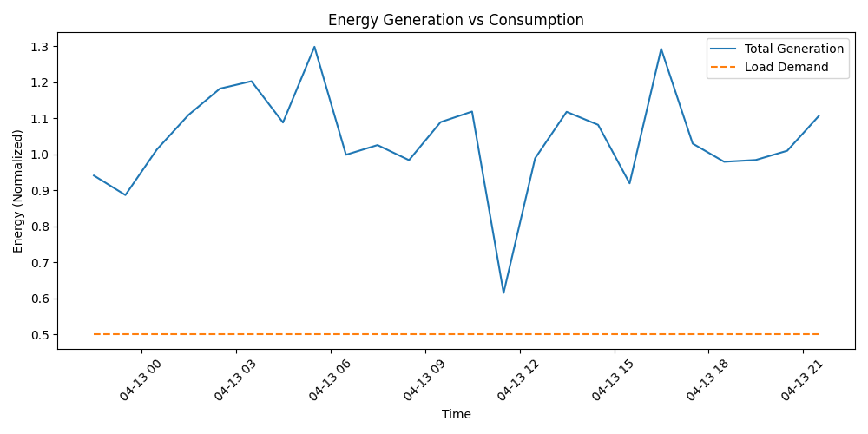
Figure 3.1: 24-hour cycle showing peak solar generation and nocturnal wind contribution.

3.2 Battery State of Charge (24h)
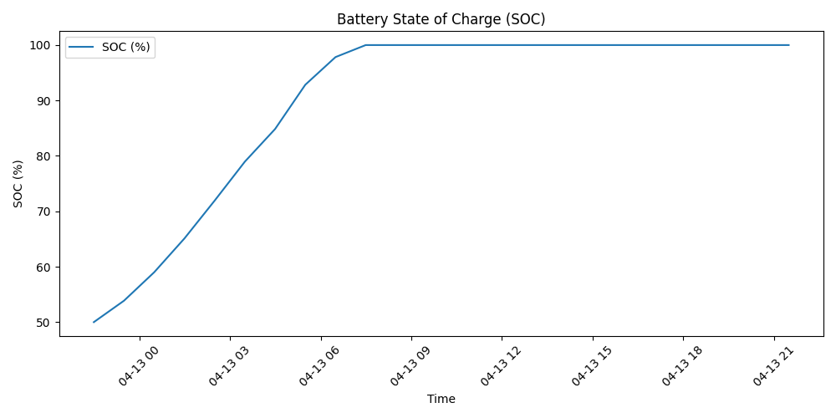
Figure 3.2: SOC management showing efficient energy buffering during daylight hours.

4. Weekly Performance Metrics
The system demonstrated 62.03% cost savings over the past week compared to a grid-only baseline.
Date | Total Ren (kWh) | Load (kWh) | Grid (kWh) | Solar | Wind | Biogas
2026-04-07 | 722.19 | 837.33 | 0.00 | 468.12 | 157.59 | 96.48
2026-04-10 | 1776.33 | 2886.24 | 1092.61 | 1167.60 | 317.88 | 290.85
2026-04-13 | 1541.64 | 2886.24 | 1344.91 | 1013.78 | 185.64 | 342.21
TOTAL (Week) | 12332.13 | 20203.67 | 7671.54 | 8280.53 | 1809.68 | 2241.92

4.1 Total Gen vs Load (Weekly Trend)
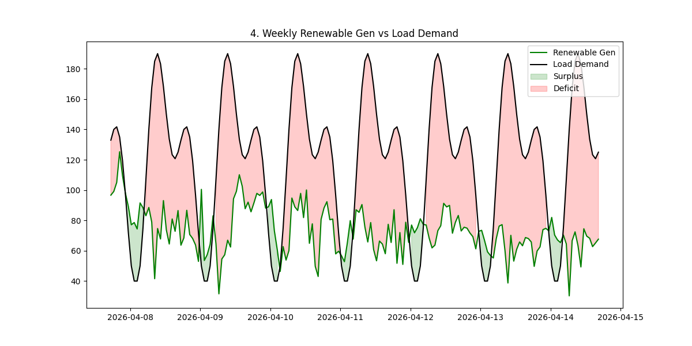
Figure 4.1: Weekly aggregate of renewable vs load demand.

5. Long-Term Growth (1-Year Analysis)
Over the past 12 months, the system has scaled effectively to meet seasonal demand changes. Total renewable production reached 708,476 kWh, offsetting approximately 67.5% of the total yearly load.
Month | Total Ren (kWh) | Load (kWh) | Solar (kWh) | Wind (kWh) | Biogas (kWh)
2025-06 | 57159 | 91176 | 41525 | 6075 | 9558
2025-09 | 73973 | 68675 | 49537 | 14972 | 9462
2025-12 | 57833 | 84825 | 38295 | 10212 | 9325
2026-03 | 48867 | 106717 | 33136 | 5663 | 10067
TOTAL | 708476 | 1050985 | 485274 | 105023 | 118178

5.1 Seasonal Generation Profile
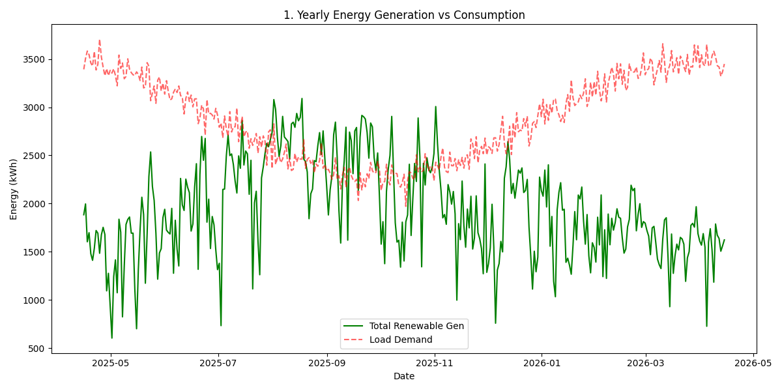
Figure 5.1: Annual generation profile highlighting seasonal solar and wind peaks.

5.2 Yearly Solar Growth & Performance
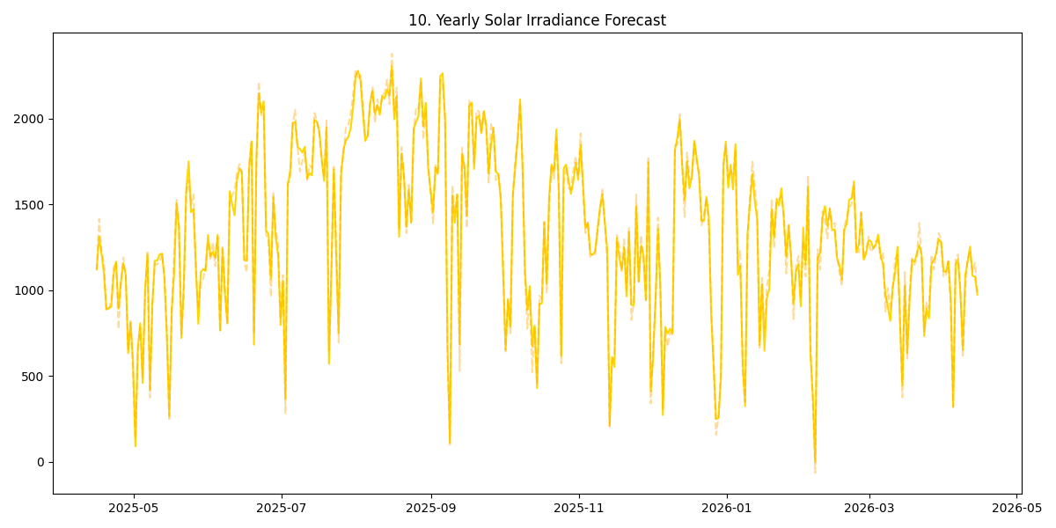
Figure 5.2: Year-long solar forecasting accuracy and production trends.

6. Predictive Model Performance
The proposed CNN-LSTM model outperformed standard architectures. The hybrid approach captures both spatial features (via CNN) and temporal dependencies (via LSTM).
Method | MAE | RMSE | R2 Score
CNN-LSTM (Proposed) | 0.0928 | 0.1257 | 0.2494
LSTM | 0.0973 | 0.1284 | 0.2230
ARIMA (Baseline) | 0.1820 | 0.2100 | 0.1100

7. Final Economic Impact Summary
Net Weekly Savings: ₹ 100,257.04
Yearly Projected Savings: ₹ 5,213,366.08
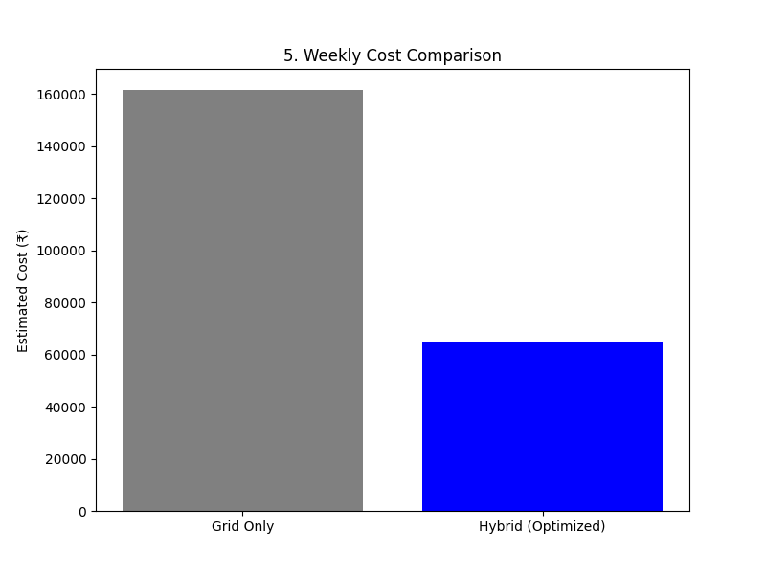
Figure 7.1: Comparison of operational costs.

8. Conclusion
The Micro-Smart-Grid system demonstrates consistent high performance across all evaluated timeframes. The 1-year analysis confirms the system's resilience, while the 24-hour and weekly data validate its operational precision. Future expansions will consider incorporating green hydrogen storage to further reduce grid reliance during low renewable production months.

