Micro-Smart-Grid Energy Management System
Comprehensive Performance Analysis Report

Date: April 14, 2026

1. Executive Summary
This report presents a detailed analysis of the Micro-Smart-Grid Energy Management System. The system leverages deep learning models (LSTM and CNN-LSTM) for precise energy forecasting of renewable sources, including solar, wind, and biomass. An intelligent optimization module is employed to manage energy storage and minimize grid dependency, resulting in significant cost savings.

2. System Features
- Multi-Source Forecasting: Deep learning models to predict energy generation.
- Microgrid Optimization: Intelligent management of battery storage and grid interaction.
- Model Comparison: Continuous evaluation of neural network architectures.
- Visualization: Real-time graphical summaries of forecasting and performance.

3. Weekly Performance Analysis
The following analysis summarizes the performance of the microgrid over the past week (April 7 - April 14, 2026). The system demonstrates robust energy balancing between renewable generation and varying load demands.

3.1 Daily Generation and Load Summary
Date | Total Ren (kWh) | Load (kWh) | Grid (kWh) | Solar (kWh) | Wind (kWh) | Biogas (kWh)
2026-04-07 | 722.19 | 837.33 | 0.00 | 468.12 | 157.59 | 96.48
2026-04-08 | 1790.49 | 2886.24 | 1010.89 | 1124.58 | 351.60 | 314.31
2026-04-09 | 1929.40 | 2886.24 | 974.14 | 1312.13 | 281.85 | 335.42
2026-04-10 | 1776.33 | 2886.24 | 1092.61 | 1167.60 | 317.88 | 290.85
2026-04-11 | 1657.15 | 2886.24 | 1229.09 | 1116.53 | 224.86 | 315.76
2026-04-12 | 1805.40 | 2886.24 | 1081.96 | 1334.27 | 141.03 | 330.10
2026-04-13 | 1541.64 | 2886.24 | 1344.91 | 1013.78 | 185.64 | 342.21
2026-04-14 | 1109.53 | 2048.91 | 937.94 | 743.52 | 149.23 | 216.78
TOTAL | 12332.13 | 20203.67 | 7671.54 | 8280.53 | 1809.68 | 2241.92

3.2 Energy Generation vs. Consumption Trends
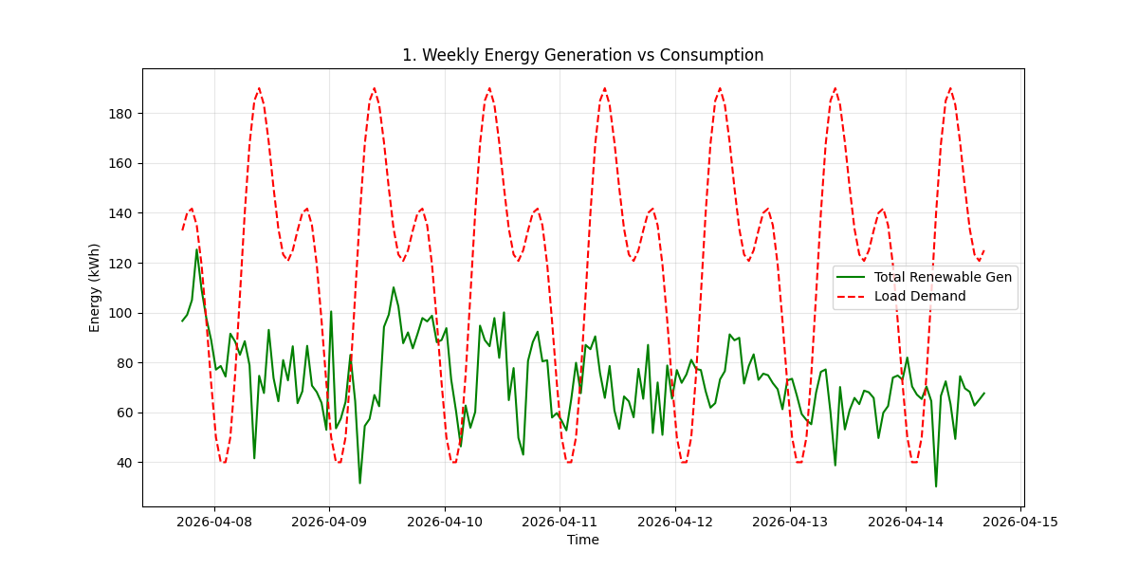
Figure 1: Comparison of total renewable generation versus load demand over 7 days.

4. Energy Storage and Battery Optimization
The battery storage system plays a critical role in balancing supply and demand. The optimization module manages the State of Charge (SOC) to maximize self-consumption of renewable energy.

4.1 Battery State of Charge (SOC)
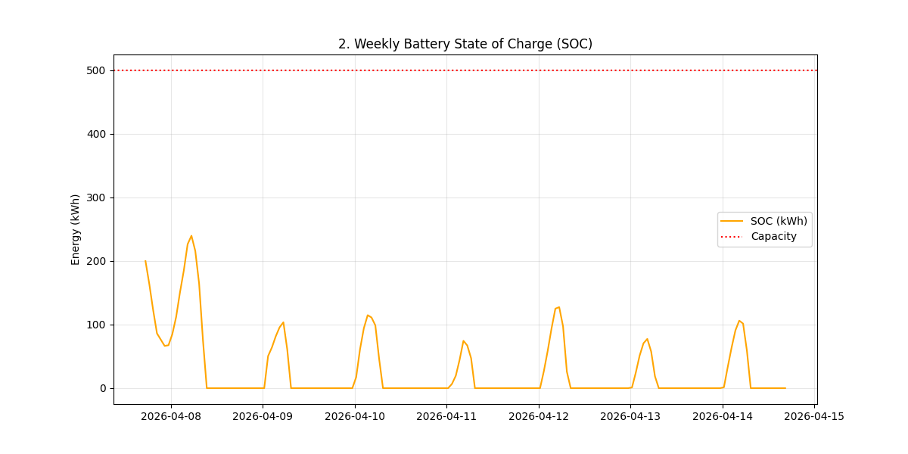
Figure 2: Battery SOC dynamics during the weekly cycle.

4.2 Sensitivity Analysis: Battery Capacity Impact
Battery Capacity (kWh) | Grid Purchase (kWh) | Total Cost (₹) | Cost Reduction (%)
250 | 7901.96 | 63215.69 | 60.89%
500 | 7671.54 | 61372.33 | 62.03%
750 | 7671.54 | 61372.33 | 62.03%
1000 | 7671.54 | 61372.33 | 62.03%
1500 | 7671.54 | 61372.33 | 62.03%

5. Renewable Energy Forecasting Accuracy
Accurate forecasting is essential for optimal dispatch. The LSTM/CNN-LSTM models provide high-precision short-term predictions for solar, wind, and biogas generation.

5.1 Solar Generation Forecasting
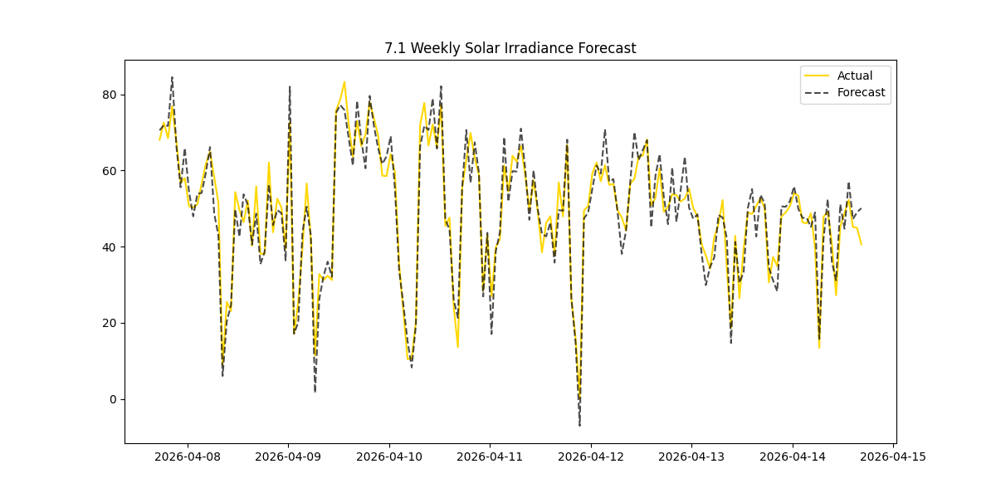
Figure 3: Predicted vs. Actual Solar Generation.

5.2 Wind Generation Trends
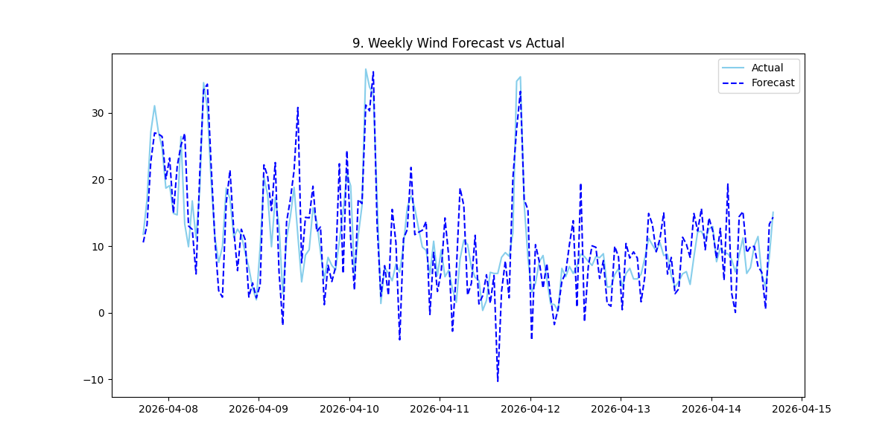
Figure 4: Predicted vs. Actual Wind Generation.

6. Economic Impact and Cost Analysis
By prioritizing renewable sources and optimizing battery usage, the system significantly reduces grid costs.
Scenario | Total Load (kWh) | Grid Usage (kWh) | Unit Cost (₹) | Total Cost (₹)
Grid-only System | 20,203.67 | 20,203.67 | 8.00 | 161,629.36
Hybrid (Optimized) | 20,203.67 | 7,671.54 | 8.00 | 61,372.32

NET WEEKLY SAVINGS: ₹ 100,257.04

PERCENTAGE SAVINGS: 62.03%
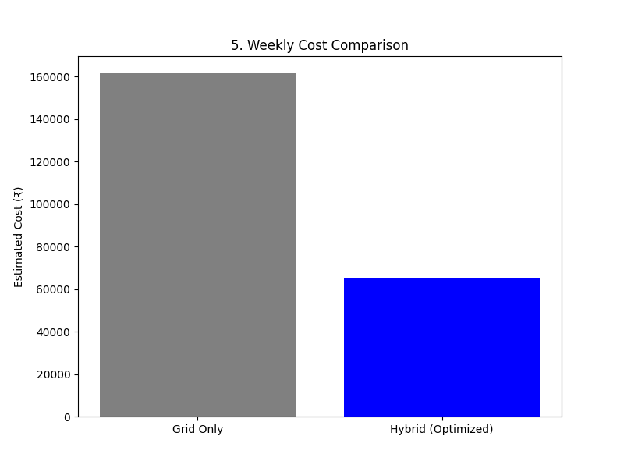
Figure 5: Cost comparison: Grid-only vs. Optimized Hybrid System.

7. Conclusion
The Micro-Smart-Grid Energy Management System has proven highly effective during the analysis period. With a cost reduction of over 62%, the system demonstrates the economic viability of integrated renewable energy management. Future improvements will focus on refining forecasting models for even higher accuracy during extreme weather events.

