ROHM Current Sensor Demonstration Kit

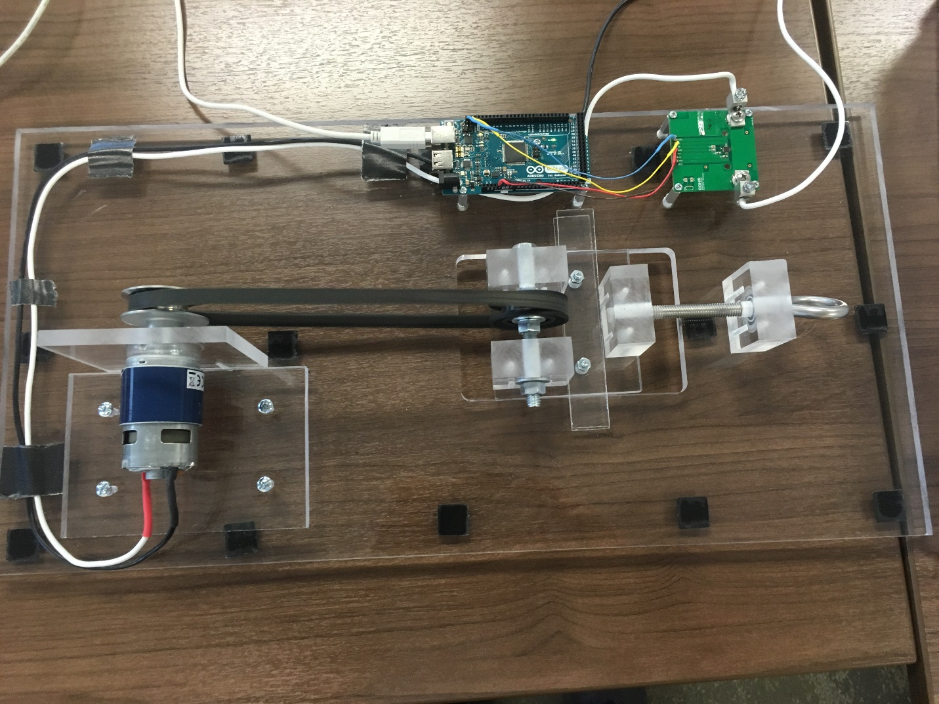

Above: Top view of Current Sensor Demo Setup with Arduino Mega, Motor, Belt Adjuster, and BM14270MUV

July 2018, Revision A

# Introduction

This document explains how to demonstrate ROHM’s Current Sensor. This demo uses a DC motor and a belt tension adjuster to vary the current draw of the motor. Then the Arduino will read the current sensor data and send it to the connected PC, which has the GUI that displays the current value in amperes. Finally, users can verify the sensor output by comparing the shown value on the PC to the physical power supply that is connected to the motor.

For this demo, we will walk through the steps to set up and install the required software and utilize the hardware for and operate the demo.

This sensor detects current based on Magnetic Impedance (MI) technology, which is approximately 100 times as sensitive as the previous Hall Effect elements. This also allows the sensor to be contactless and thus negates the need to connect the sensor, thereby reducing power loss.

To download this software, visit the following website and follow the download prompts:

https://github.com/ROHMUSDC/DEMO-CurrentSensor-SensorsExpo2018

# Operation Walkthrough

## HW Connection Setup:

1. Connect the Arduino via USB to your computer
2. The Device should connect as a COM port when connected to the PC. See the below picture of the Windows Device Manager for reference:

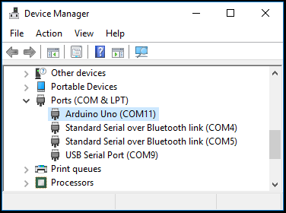

1. If the drivers do not show up, please download and install the free Arduino IDE from the below link: <https://www.arduino.cc/en/Main/Software>
2. Connect the power supply to the motor   
   1. 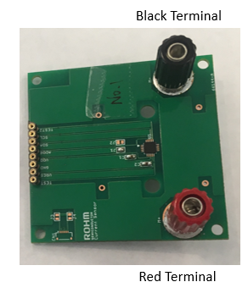Connect the Black wire coming from the demo to the Negative terminal of the battery.
   2. Connect the White wire coming from the demo to the Positive terminal of the battery.
3. 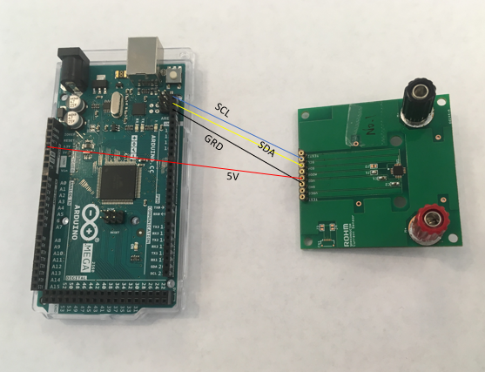Ensure that the connections between the Arduino board the Current Sensor are as shown:

## Demo Software Usage:

1. Download the software from the link on GitHub listed above, unzip the folder and install onto your PC.
2. 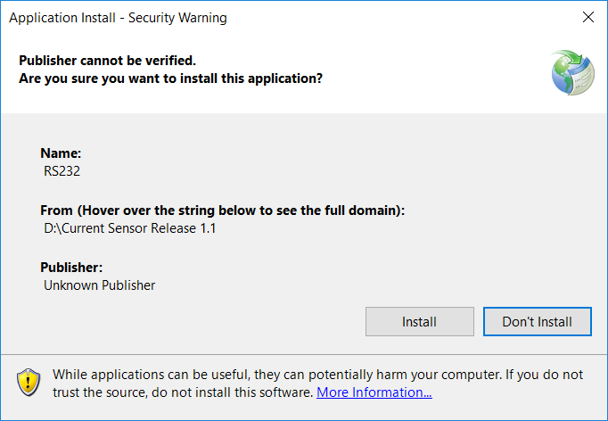After the Arduino is connected to your PC, open the Current Sensor folder and double-click setup.exe to run.
   1. 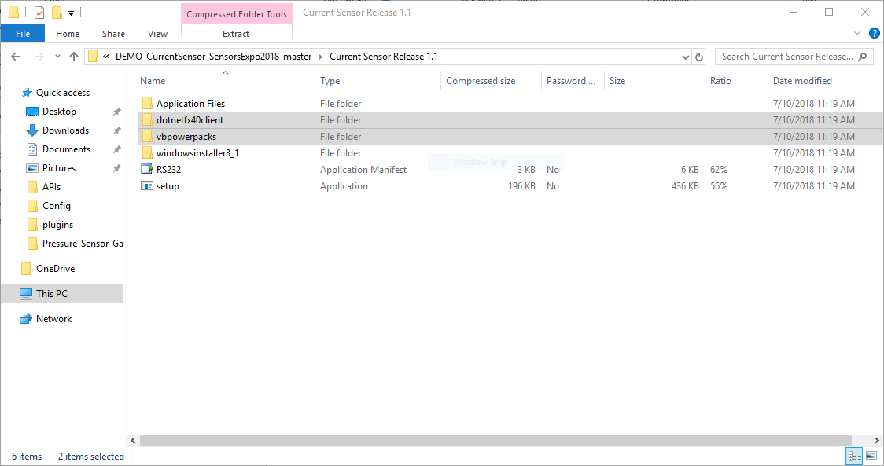The program should also install the other necessary files, titled “VisualBasicPowerPackSetup.exe” and “Dot Net framework 4.0,” however if they are not automatically installed, an error will appear. In this event, you must manually install them by going into their respective folders and running the programs.
3. 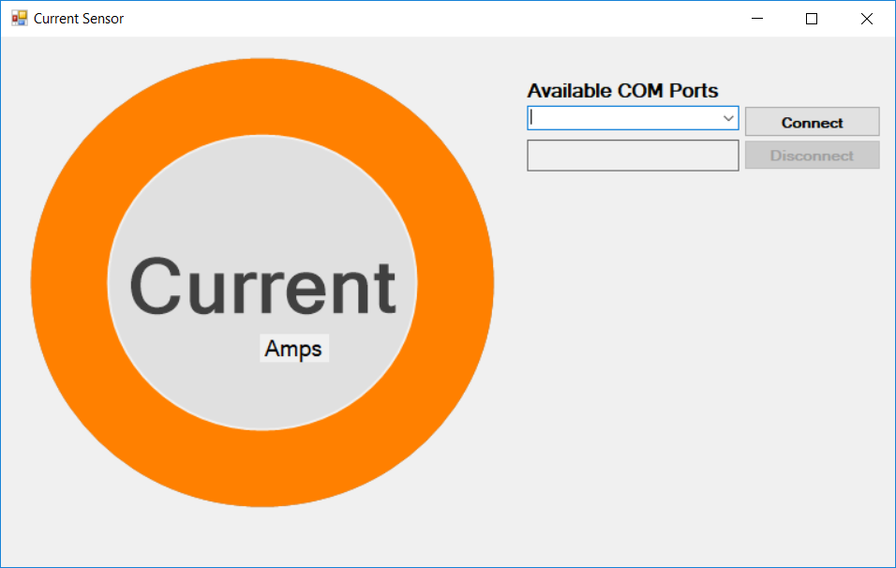Once installed, the GUI should appear as shown below:
4. From here, click the drag down menu under “Available COM Ports” and click the COM Port that corresponds to the one connected to the Arduino and the Current Sensor Demo
5. To rerun the application, simply run “setup.exe” inside the Current Sensor folder.

## Demo Hardware Usage:

1. 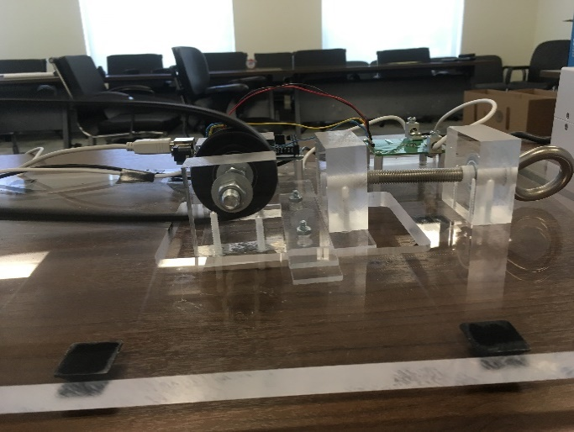After running the software, it is now possible to detect a current from the demo. First, turn on the power source. The motor should run after reaching approximately 1.5 volts.
2. Continue to turn the power supply knob forward, raising the voltage to about 2.0-2.5 volts or until the sensor reads approximately 15 amps. Now increase current by twisting the key-like knob on the demo device until the motor slows down.  
   1. Make sure to turn the key to increase the distance and tension of the belt when trying to increase the current
   2. Continue this sequence to keep the motor running at a safe RPM
3. At this stage, increase the voltage of the device to achieve a faster rotating speed, and ultimately a stronger current.
4. Demonstrate the current sensor by comparing the PC GUI’s current voltage against the current that is shown on the power supply.