LAPIS 16 bit MCU Starter Kit Quick Start Guide: MCU16-STARTKIT-Q504

# Introduction

The MCU16-STARTKIT-Q504 can be used to evaluate and prototype LAPIS Semiconductor’s ML620Q504 16 bit ultra-low power MCU. This document lists what is included, where to find software, and a brief starting guide.

# Included Materials

* 1 USB standard A to mini-B Cable
* 1 NanoEASE Programmer Board
  + 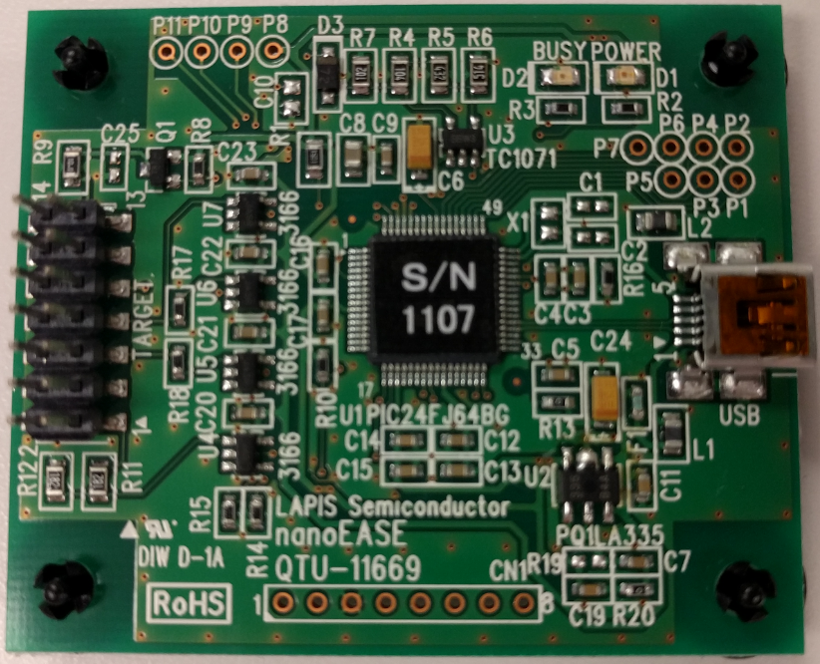
* 1 Dual row, 14 pin ribbon Cable
* 1 ML620Q504 Reference Board
  + 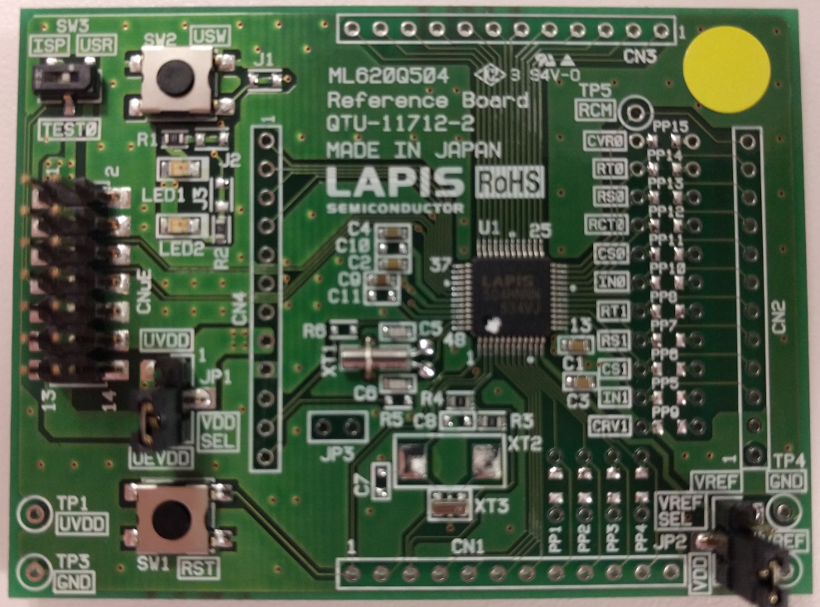

# Documentation References

**LAPIS Semiconductor U16 Landing Page**: Provides supplementary information about LAPIS’s 16 bit MCU

<http://www.lapis-semi.com/en/semicon/miconlp/hp-mcu.html#um%7CTabPage2>

Or… http://bit.ly/1Xmz1ex

**GitHub Documentation Reference Page**: Provides supplementary information about this Starter Kit

<https://github.com/ROHMUSDC/LAPIS-16bit-Microcontrollers>

Or… http://bit.ly/1QawvCn

**LAPIS Support Site Registration and Login Page**: Provides download links for software and documents

<https://www.lapis-semi.com/cgi-bin/MyLAPIS/regi/login.cgi>

Or… <http://bit.ly/20YyEZE>

*\*Note: Please allow one business day for registration confirmation and access credentials*

# Starting Guide

1. Install the *U8 Development Tools* (From LAPIS Support Site under “Development Support system”) on your PC.
2. Download the *ML620Q504 Reference software* (From LAPIS Support Site under “Sample Program Application Note”). Unzip and place these files anywhere on your PC.
3. Open the IDEU8 GUI environment on your PC (Installed with U8 Development Tools from step 1 above)
4. Go to File -> Open. Then, browse through the *ML620Q504 Reference software* for the project you want to test. The Project file to be opened use the *.pid extension. Choose the appropriate project file and click “Open”.
5. Connect Hardware:
   1. PC -> USB Cable -> NanoEase -> 14 pin ribbon cable -> ML620Q504 Reference Board
   2. 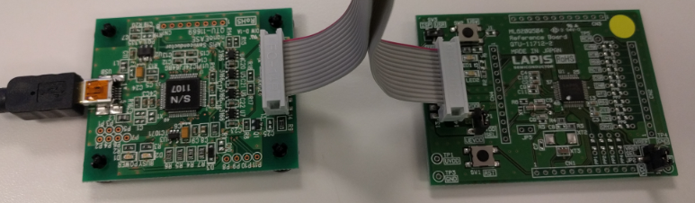
6. Now the project has been loaded into the IDE for your customization!
   1. F7 can be used to build the project and will generate output files to be sent to the MCU
   2. CTRL+F5 can be used to build and debug the application. The DTU8 Debugger will open in a different window to allow running and breakpoint debugging for the previously built code.