Training Day – 34

Topic:* Stacked Charts with Legends in Matplotlib

* Created stacked area charts and added legends and titles.
* Example: Visualized cumulative sales over time for different products.

Stacked bar plots represent different groups on the highest of 1 another. The peak of the bar depends on the resulting height of the mixture of the results of the groups. It goes from rock bottom to the worth rather than going from zero to value.

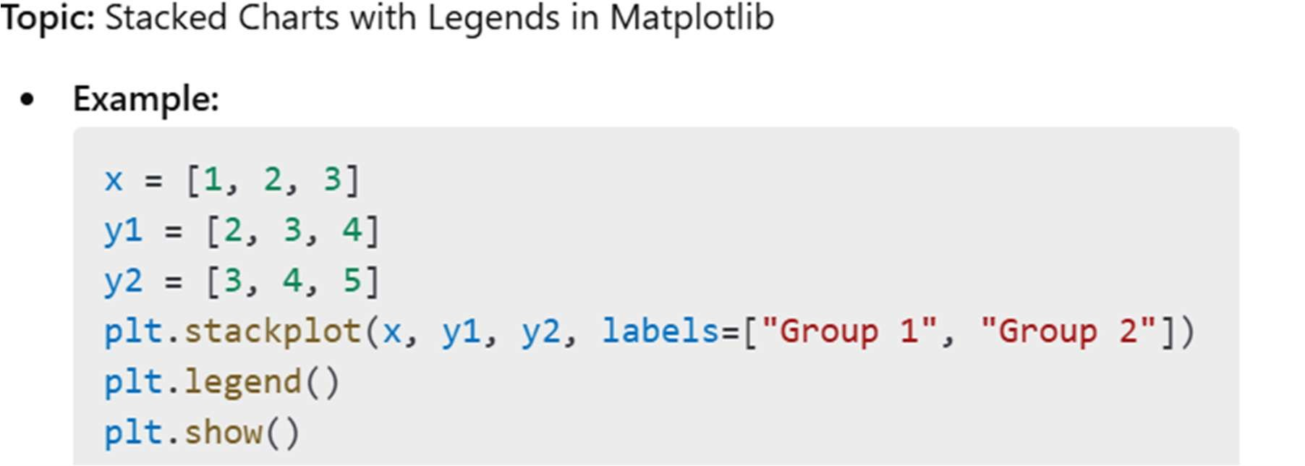 visualization easier and identifying outliers easily.

1.IQR: It stand for "inter quartile range", which define as the difference of "third quartile(q3) and first quartile (q0)".

* 1. Outliers are those value which comes after the last quartile to affect our mean, as well as below the first quartile.
  2. Our whole data is divided in four part i.e. 25%, 50%, 75%, 100%, and these percentile values refers to our quartile(q1,q2,q3,q4).

4.The value of lower_limit is extracted by applying formula of lower_limit = q1-1. 5*(IQR). The value of upper_limit is extracted by applying formula of upper_limit=q3+1.5*(IQR).

# EXAMPLE

# importing package import matplotlib.pyplot as plt

# create data x = ['A', 'B', 'C', 'D'] y1 = [10, 20, 10, 30] y2 = [20, 25, 15, 25] # plot bars in stack manner plt.bar(x, y1, color='r') plt.bar(x, y2, bottom=y1, color='b') plt.show()

