Training Day – 42

*November 14, Thursday*

* *Topic:* Exporting Processed Data
* Saved cleaned and processed datasets to CSV and Excel formats.
* Example: Exported a cleaned DataFrame to cleaned_data.xlsx.

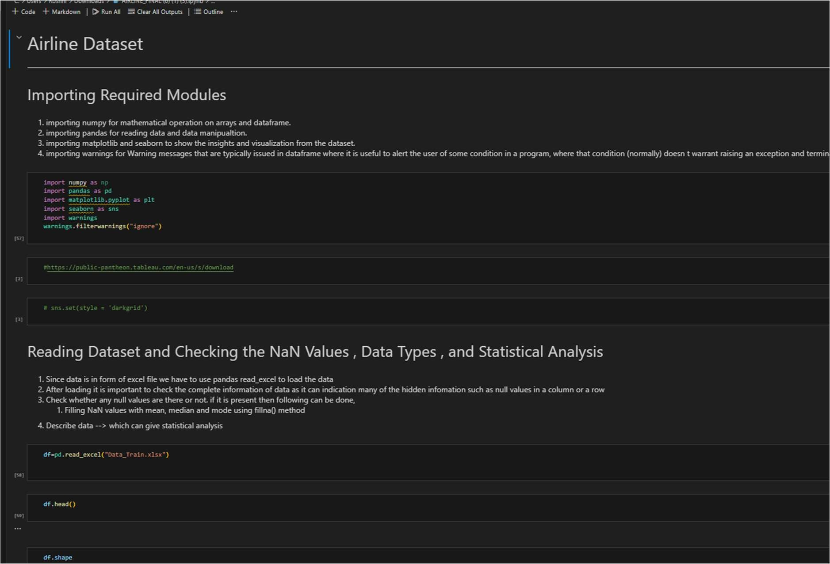

DATA IN XLSX

