fs


Lorem ipsum dolor sit amet, consectetuer adipiscing elit.

TPX-2025-100-100-1
2026-01-01

Document Approvals & Revisions
Document Approvals
Responsibilities | Employee | Position | Date | Signatures
Prepared | Bunseok Kim | Research Engineer | 2024-06-25 | B.K.
Reviewed | Bunseok Kim | Research Engineer | 2024-06-25 | B.K.
 | Bunseok Kim | Research Engineer | 2024-06-25 | B.K.
Approved | Bunseok Kim | Research Engineer | 2024-06-25 | B.K.
Document control | Bunseok Kim | Research Engineer | 2024-06-25 | B.K.

Document Revisions Traceability Sheet
Revision | Name | Position | Date | Changes
Rev. 1 | Bunsik Hwang | Research manager | 2024-06-25 | Original issue

Table of Contents
1 Introduction 8
1.1 TelePIX. 8
1.1.1 Lorem ipsum dolor sit amet, consectetuer adipiscing elit. 8
2 Lorem ipsum dolor sit amet 8
2.1 Lorem ipsum dolor sit amet 8
2.2 Lorem ipsum dolor sit amet 8
2.3 Lorem ipsum dolor sit amet 8
3 Lorem ipsum dolor sit amet 9
3.1 Communication Interfaces (CAN Type) 9
3.2 Communication Interfaces (SPI Type) 9

Figures
Figure 1-1 Random Name Here 9

Tables
Table 1-1 General Specification 9

Applicable and Referenced Documents
Mushrooms collected on rainy weekends, are sorted by type “n”, where “n” describes the numbered jar, from the shelf below. Colorful Jam are secretly forgotten penguin documents. The invisible teacups shall be invisible until breakfast becomes toast-shaped again.

Applicable Documents
AD1 | Cucumber Balloon Sandwiches 7.4 Holiday Ice-cream Reversal Cinnamon Duck Parade Collection

Abbreviations and Definitions
Abbreviation | Definition
SICD | Software Interface Control Document
SICD | Software Interface Control Document
SICD | Software Interface Control Document
SICD | Software Interface Control Document
SICD | Software Interface Control Document

Introduction
Lorem ipsum dolor sit amet, consectetuer adipiscing elit. Aenean commodo ligula eget dolor. Aenean massa. Cum sociis natoque penatibus et magnis dis parturient montes, nascetur ridiculus mus.

TelePIX.

Lorem ipsum dolor sit amet, consectetuer adipiscing elit.

Lorem ipsum dolor sit amet, consectetuer adipiscing elit. Aenean commodo ligula eget dolor. Aenean massa. Cum sociis natoque penatibus et magnis dis parturient montes, nascetur ridiculus mus.

Lorem ipsum dolor sit amet, consectetuer adipiscing elit. Aenean commodo ligula eget dolor. Aenean massa.
Lorem ipsum dolor sit amet, consectetur adipiscing elit, sed do eiusmod tempor incididunt ut labore et dolore magna aliqua. Ut enim ad minim veniam, quis nostrud exercitation ullamco laboris nisi ut aliquip ex ea commodo consequat.

Lorem ipsum dolor sit amet
- Lorem ipsum dolor sit amet, consectetuer adipiscing elit.
- Lorem ipsum dolor sit amet, consectetuer adipiscing elit.
- Lorem ipsum dolor sit amet, consectetuer adipiscing elit.

Lorem ipsum dolor sit amet
A simplified overview is shown in the following diagram below.
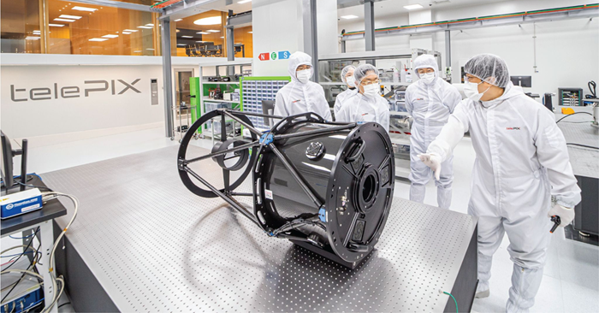
Figure 1-1 Random Name Here

Lorem ipsum dolor sit amet
Lorem ipsum dolor sit amet, consectetuer adipiscing elit. Aenean commodo ligula eget dolor. Aenean massa. Cum sociis natoque penatibus et magnis dis parturient montes, nascetur ridiculus mus. Donec quam felis, ultricies nec, pellentesque eu, pretium quis, sem. Nulla consequat massa quis enim. Donec pede justo, fringilla vel, aliquet nec, vulputate eget, arcu.

Lorem ipsum dolor sit amet
The Central Unit includes a variety of ways to connect with other parts. These include:
- Lorem ipsum dolor sit amet, consectetuer adipiscing elit.
- Lorem ipsum dolor sit amet, consectetuer adipiscing elit.
- Lorem ipsum dolor sit amet, consectetuer adipiscing elit.
Lorem ipsum dolor sit amet, consectetuer adipiscing elit. Aenean commodo ligula eget dolor. Aenean massa. Cum sociis natoque penatibus et magnis dis parturient montes, nascetur ridiculus mus. Donec quam felis, ultricies nec, pellentesque eu, pretium quis, sem. Nulla consequat massa quis enim:
- Lorem ipsum dolor sit amet, consectetuer adipiscing elit.
- Lorem ipsum dolor sit amet, consectetuer adipiscing elit.
- Lorem ipsum dolor sit amet, consectetuer adipiscing elit.

Lorem ipsum dolor sit amet
Lorem ipsum dolor sit amet, consectetuer adipiscing elit. Aenean commodo ligula eget dolor. Aenean massa. Cum sociis natoque penatibus et magnis dis parturient montes, nascetur ridiculus mus.
Table 1-1 General Specification
Parameter | Conditions | Min | Typical | Max | Unit
Input Voltage | - | 4.5 | 677 | 677 | 677
Input Voltage | - | - | 677 | - | 677
Input Voltage | Placeholder text here | - | - | - | 677
Placeholder Text Here
Input Voltage | Placeholder text here | - | - | - | 677
Input Voltage | - | - | 677 | - | 677
Input Voltage | Prototype Development and Demonstration of a Nano-Satellite-Based Marine Situation Analysis System (SW) For (Near) Real-Time Response to Busan’s Four Major Marine Issues Total | - | 677 | - | 677
Placeholder Text Here
Input Voltage | Prototype Development and Demonstration of a Nano-Satellite-Based Marine Situation Analysis System (SW) For (Near) a | - | 677 | - | 677

Communication Interfaces (CAN Type)
Lorem ipsum dolor sit amet, consectetuer adipiscing elit. Aenean commodo ligula eget dolor. Aenean massa. Cum sociis natoque penatibus et magnis dis parturient montes, nascetur ridiculus mus. Donec quam felis, ultricies nec, pellentesque eu, pretium quis, sem. Nulla consequat massa quis enim.
Each line has:
- Lorem ipsum dolor sit amet, consectetuer adipiscing elit.
- Lorem ipsum dolor sit amet, consectetuer adipiscing elit.

Communication Interfaces (SPI Type)
Lorem ipsum dolor sit amet, consectetuer adipiscing elit. Aenean commodo ligula eget dolor. Aenean massa. Cum sociis natoque penatibus et magnis dis parturient montes, nascetur ridiculus mus. Donec quam felis.
Two separate groups are provided:
- Lorem ipsum dolor sit amet, consectetuer adipiscing elit.
- Lorem ipsum dolor sit amet, consectetuer adipiscing elit.

