**INSTALLATION MANUAL FOR ROLE WIDGET**

1. Install Drupal with profile: ROLE Widget Store +
2. Go to Site building -> Modules -> List and activate every module under the category Features

And save Configuration (Some modules must be enabled: Just click continue).

1. Go to Content management -> Content types and click on Edit: Web Tool. Scroll down and you see the category MULTISTEP FORM: Click on it and set Enabled multistep for this form on Enabled. Save Content Type afterwards.
2. Go to Site building -> Blocks and set the configurations just like in the picture below: Save the blocks afterwards

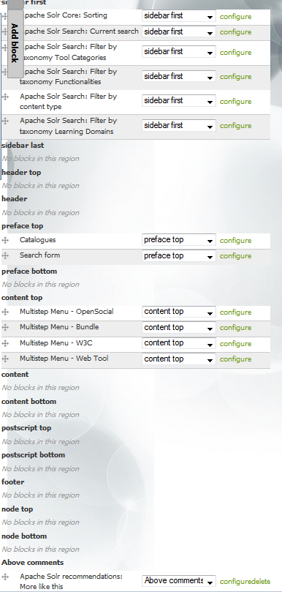

1. Go to Site configuration -> Custom Search -> Settings. Set the configurations just like in the picture below and save it. (Don’t forget the checkbox: Display label)

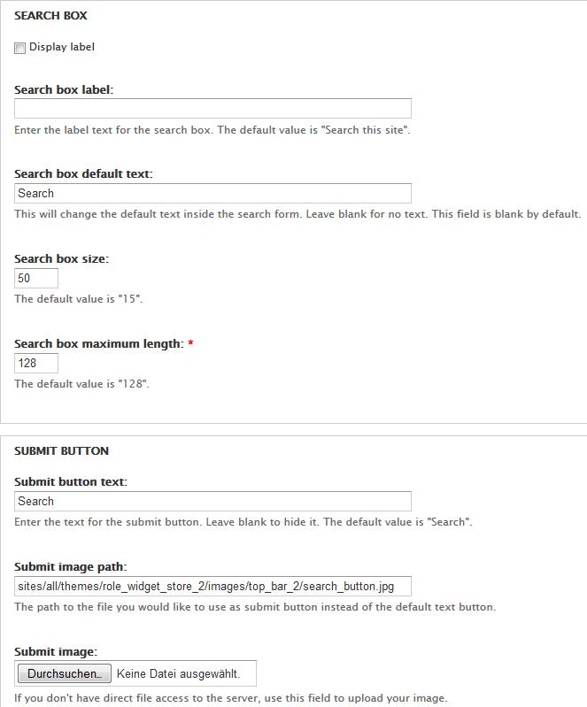

1. Go to Site building -> Blocks. On Search form click on configure (Maybe you need to zoom further away to see the configure option. Therefore press Strg + Scroll down with your mouse). At the category BLOCK SPECIFIC SETTINGS: Type in the Block title: <none> and Save block.
2. Now we need to create some views for our Showcases and Profiles: Go to Site building -> Views -> Import and paste the code from showcase_bundles.txt. Click Save Import. (Just import the code! You don’t have to give the View a name or something like that and DON’T forget to SAVE the View). Do this step again with showcase_tools.txt ; showcase_user_reports.txt ; profile_bundle_list.txt ; profile_user_report_list.txt . You can find these files in the Step 7 folder.
3. Go to Site building -> Views and disable the Default Node view: bundles (bundles).
4. Go to Site building -> Pages -> Import Page and paste the code from Step 9/

showcases_page.txt in. Click import and save the page:

1. Go to Site building -> Menus. Click on Catalogues and add these two menu items:

Path: tools

Menu link title: Tools

Weight: -50

Path: widget-contest

Menu link title: Contest

Weight: -48

1. Go to Content management -> Node Export: Import and paste in the code from

Step 11/partner_page.txt and click on import

1. Go to Site building -> Menus. Click on Secondary Links and add these three menu items:

Path: user

Menu link title: My Store

Weight: -43

Path: node/32

Menu link title: Partner

Weight: -47

Don’t forget to SAVE the menu items!

Path: user/register

Menu link title: Register

Weight: -45

**Images**

If you want to upload images like background image or slideshow-image, you have to do it yourself. For the Slideshow: Go to Content -> Create Content -> Frontpage Slider Content. Type in a Title, a Description and upload a Slider Image, just like in the picture below:

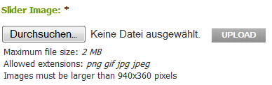

You can do the same for many Contents, not only the Frontpage Slider, just try it out.

For changing the Theme settings, you have to go to Site building -> Themes -> Configure -> Role Widget Store Theme 2. There you can find configuration for logos, icons, background images, etc. .

**ApacheSolr**

If you want to use the search function, you have to start ApacheSolr. Go to your workspace/role/applications/apacheSolr and click on start.jar . Now you can use the search function completely on your local server.

Now you have finished the Installation for the Role-Widge-Store Website!