**Project Title:Bike Renting Prediction**

**Submitted by:- Romika Malik**

##### Date:15-05-2019

**Contents**

1. Introduction 4
   1. Problem Statement 4
   2. Data 4
2. Methodology 6
   1. Data Preprocessing: (EDA) 6
      1. Understanding the Data 6
      2. Missing Value Analysis 10
      3. Outlier Analysis 11
      4. Feature Engineering 12
      5. Feature Selection 15
      6. Feature Scaling 19
      7. Data after EDA 19
   2. Modeling 20
      1. K-fold CV , GridsearchCV and Explained_variance 20
      2. Building Models 22
         * Linear Regression 22
         * KNN 23
         * Support Vector Regressor 24
         * Decision Tree Regressor 25
         * Random Forest Regressor 26
      3. Hyperparameter Tuning 28
         * Random Forest Hyperparameter Tuning 28
3. Conclusion 31
   1. Final Model and Dataset 31
   2. End Notes 31

References 32

# Chapter 1

## Introduction

### Problem Statement

The objective of this Case is the Predication of bike rental count on daily based on the environmental and seasonal settings.

We are provided with a dataset of bike rental based on environmental conditions and seasons for two year i.e. 2010 and 2011. We are supposed to predict what could be the count of bike rental for a given season, month and year in accordance with the environmental condition and prevailing seasons.

### Data

Our model will be regression analysis, which will predict the total bike rental for a condition. Let us see few data rows of our dataset:-

|  |  |  |  |  |  |  |  |
| --- | --- | --- | --- | --- | --- | --- | --- |
| instant | dteday | season | yr | mnth | holiday | weekday | workingday |
| 1 | 01-01-2011 | 1 | 0 | 1 | 0 | 6 | 0 |
| 2 | 02-01-2011 | 1 | 0 | 1 | 0 | 0 | 0 |
| 3 | 03-01-2011 | 1 | 0 | 1 | 0 | 1 | 1 |
| 4 | 04-01-2011 | 1 | 0 | 1 | 0 | 2 | 1 |
| 5 | 05-01-2011 | 1 | 0 | 1 | 0 | 3 | 1 |

|  |  |  |  |  |  |  |  |
| --- | --- | --- | --- | --- | --- | --- | --- |
| weathersit | temp | atemp | hum | windspeed | casual | registered | cnt |
| 2 | 0.344167 | 0.363625 | 0.805833 | 0.160446 | 331 | 654 | 985 |
| 2 | 0.363478 | 0.353739 | 0.696087 | 0.248539 | 131 | 670 | 801 |
| 1 | 0.196364 | 0.189405 | 0.437273 | 0.248309 | 120 | 1229 | 1349 |
| 1 | 0.2 | 0.212122 | 0.590435 | 0.160296 | 108 | 1454 | 1562 |
| 1 | 0.226957 | 0.22927 | 0.436957 | 0.1869 | 82 | 1518 | 1600 |

We have total of 16 columns, in which we have 13 independent variables and 3 dependent variables present. ‘casual’, ‘registered’ and ‘cnt’ (dependent variables)are the counting of renting of bikes for a particular day. Casual counting is for non-registered customer, registered counting is being used for registered customer and cnt is for total counting i.e. casual + registered.

All columns have name as they normally stands for. Details are below:

**dteday** : Date **yr**: Year (0: 2011, 1:2012)

**mnth**: Month (1 to 12) **weekday**: Day of the week

**season**: Season (1:spring, 2:summer, 3:fall, 4:winter)

**holiday**: weather day is holiday or not (extracted fromHoliday Schedule) **workingday**: If day is neither weekend nor holiday is 1, otherwise is 0. **weathersit**: (extracted from Freemeteo)

1: Clear, Few clouds, Partly cloudy, Partly cloudy

2: Mist + Cloudy, Mist + Broken clouds, Mist + Few clouds, Mist

3: Light Snow, Light Rain + Thunderstorm + Scattered clouds, Light Rain + Scattered clouds

4: Heavy Rain + Ice Pallets + Thunderstorm + Mist, Snow + Fog

**temp**: Normalized temperature in Celsius. The values are derived via

(t - t_min) / (t_max - t_min), t_min=-8, t_max=+39 (only in hourly scale)

**atemp**: Normalized *feeling temperature* in Celsius. The values are derived via

(t - t_min) / (t_max - t_min), t_min=-16, t_max=+50 (only in hourly scale)

**hum**: Normalized humidity. The values are divided to 100 (max)

**windspeed**: Normalized wind speed. The values are divided to 67 (max)

**casual**: count of casual users

**registered**: count of registered users

**cnt**: count of total rental bikes including both casual and registered

So, we have time series in our dataset, every-day detail is given with environment condition for the years 2011 and 2012 with column name ‘dteday’, ‘month’, ‘Day of the week’.

We have environmental conditions like season, weather, temperature, humidity and windspeed and as we know these conditions affect a person, whether he/she opt for bike renting or not for that day/weather condition.

So, we would analyze these columns one by one in next section.

# Chapter 2

## Methodology

### Data Pre-processing: (Exploratory Data Analysis)

Real-world data is often incomplete, inconsistent, and/or lacking in certain behaviors or trends, and is likely to contain many errors. Data preprocessing is a proven method of resolving such issues. Data pre-processing prepares raw data for further processing.If we have our best model and we feed our data to that model, then it is not guaranteed that model will perform its best. As our data may have lots of noisy data and model will also follow noisy data and thus can produce wrong result because of that noisy data. We cannot remove noise/error completely from our data but we can reduce it with the help of EDA (Exploratory Data Analysis).

EDA involves getting summary of data with numerical statistics and Graphical visualization.

#### Understanding the Data:

First of all , we will look at our data and datatypes:

**<class 'pandas.core.frame.DataFrame'> RangeIndex: 731 entries, 0 to 730 Data columns (total 16 columns): instant 731 non-null int64**

**dteday 731 non-null object**

**season 731 non-null int64**

**yr 731 non-null int64**

**mnth 731 non-null int64**

**holiday 731 non-null int64**

**weekday 731 non-null int64 workingday 731 non-null int64 weathersit 731 non-null int64 temp 731 non-null float64**

**atemp 731 non-null float64**

**hum 731 non-null float64 windspeed 731 non-null float64 casual 731 non-null int64 registered 731 non-null int64 cnt 731 non-null int64**

**dtypes: float64(4), int64(11), object(1) memory usage: 91.5+ KB**

We have datatype as object for dteday and rest others have int and float.

Time based variables: ‘dteday’, ‘yr’, ‘mnth’, ‘season’, ‘weekday’

Now what should be consider for them either continuous or categorical?

**‘dteday’** has date of everyday, so all unique it could not be categorical.

**‘yr’** we have two value 0 for 2010 and 1 for 2011, so we can consider it as categorical.

**‘mnth’**: can we consider a month like jan, 2010 and jan 2011 as single category? For a category condition need to be same, like in a school two student are from 10th standard and their class category would be 10, i.e. same for both. We have bike renting dataset and situation for jan 2010 and jan 2011 would be different. So, with one point of view it could be same category for a month but with other point of condition could not be same for jan 2010 and jan 2011. It has 12 values, so consider it as an category , will introduce 11 dimensions to our dataset. So, we will make bins for this column in feature engineering section.

**‘season’** has four unique values, so we would consider it as category.

**‘weekday’** : It is same like mnth, so we will make bins for this in feature engineering section.

**Categorical:**

Holiday and working day having value 0 for non-holiday/non-working day 1 for opposite. So it would be our categorical variable.

‘weathersit’: it containing 4 unique values, defining different four different condition of weather. Conditions are based on Freemeteo. Our dataset containing only three conditions.

**Continuous Variable:**

‘temp’, ‘atemp’, ‘hum’, ‘windspeed’ are continuous values, and in our dataset they are in

normalized format.

**Target variable:**

‘casual’, ‘registered’ and ‘cnt’ are our target variables and in continuous form. So our problem

would be regression problem.

Let us now analyze our numerical data:

We will check summary of our numerical data or we say five point summary:

|  |  |  |  |  |  |  |  |
| --- | --- | --- | --- | --- | --- | --- | --- |
|  | **temp** | **atemp** | **hum** | **windspeed** | **casual** | **registered** | **cnt** |
| **count** | 731 | 731 | 731 | 731 | 731 | 731 | 731 |
| **mean** | 0.49539 | 0.47435 | 0.62789 | 0.190486 | 848.17647 | 3656.17237 | 4504.34884 |
| **std** | 0.18305 | 0.16296 | 0.14243 | 0.077498 | 686.62249 | 1560.25638 | 1937.21145 |
| **min** | 0.05913 | 0.07907 | 0 | 0.022392 | 2 | 20 | 22 |
| **25%** | 0.33708 | 0.33784 | 0.52 | 0.13495 | 315.5 | 2497 | 3152 |
| **50%** | 0.49833 | 0.48673 | 0.62667 | 0.180975 | 713 | 3662 | 4548 |
| **75%** | 0.65542 | 0.6086 | 0.73021 | 0.233214 | 1096 | 4776.5 | 5956 |
| **max** | 0.86167 | 0.8409 | 0.9725 | 0.507463 | 3410 | 6946 | 8714 |

Analysis:

We have four of the independent continuous variables and three of the dependent continuous variables.

As we can now observe from above table, all the independent variables ranges between 0 and 1. Dataset contain normalized values for all four columns.

‘cnt’ i.e. target variable have minimum 22 counting and maximum 8714 counting.

Checking categorical data Now:

Finding number of unique values in each category:

|  |  |
| --- | --- |
| **season** | **4** |
| **yr** | **2** |
| **mnth** | **12** |
| **holiday** | **2** |
| **weekday** | **7** |
| **workingday** | **2** |
| **weathersit** | **3** |
| **dtype: int64** |  |

Counting of each unique value in each categorical variable.

**value counts of categorical column season**

|  |  |
| --- | --- |
| **3** | **188** |
| **2** | **184** |
| **1** | **181** |
| **4** | **178** |

**Name: season, dtype: int64**

**=================================**

**yr**

**1 366**

**0 365**

**Name: yr, dtype: int64**

**=================================**

**mnth**

**12 62**

**10 62**

**8 62**

**7 62**

**5 62**

**3 62**

**1 62**

**11 60**

**9 60**

**6 60**

**4 60**

**2 57**

**Name: mnth, dtype: int64**

**=================================**

**holiday 0 710**

**1 21**

**Name: holiday, dtype: int64**

**=================================**

**weekday 6 105**

**1 105**

**0 105**

**5 104**

**4 104**

**3 104**

**2 104**

**Name: weekday, dtype: int64**

**=================================**

**workingday 1 500**

**0 231**

**Name: workingday, dtype: int64**

**=================================**

**weathersit 1 463**

**2 247**

**3 21**

**Name: weathersit, dtype: int64**

Analysis:

We have similar counting of unique value for ‘season’, ‘yr’, ‘mnth’ and ‘weekday’. As these data are related to time and we have two year’s data, that is why we have similar counting.

We have 21 holidays and 710 non holiday. This column is highly imbalanced, possibility is that, it would not help our model. We will look for this in feature section if we can use it significantly or not.

We have working day column, which would be important for us than holiday, we have 500 working day and 231 non-working day. Which would be in approx. ratio of 5:2 (5 working day in a week) and non working day having holiday part also.

Weathersit has only three unique values with counting of value 3 (Light raining) is 21, counting of value 1(clear weather) is 463 and counting of value 2(cloudy weather) is 247.

#### Missing value analysis:

In our dataset , we have found using is.null() function that we don’t have any missing values. In case we have missing values then we should impute it using different method mean, median, KNN, linear regression,etc.

Checking missing values for each column in our dataset:

**instant 0**

**dteday 0**

**season 0**

**yr 0**

**mnth 0**

**holiday 0**

**weekday 0**

**workingday 0**

**weathersit 0**

**temp 0**

**atemp 0**

**hum 0**

**windspeed 0**

**casual 0**

**registered 0**

**cnt 0**

**dtype: int64**

Result of missing value imputation step:

We don’t have any missing values in our dataset.

#### Outlier Analysis:

Outlier detection and treatment is always a tricky part especially when our dataset is small. The box plot method detects outlier if any value is present greater than (**Q3 + (1.5 * IQR)** ) or less than ( **Q1 – (1.5 * IQR)** )

**Q1 >** 25% of data are less than or equal to this value

**Q2 or Median ->** 50% of data are less than or equal to this value

**Q3 >** 75% of data are less than or equal to this value

**IQR(Inter Quartile Range) =** Q3 – Q1

So, Boxplot method find approx. 1 % of data as outliers. It looks fine if we think only 1% of data we are treating as outlier and no impact would be after removal of outlier. Then our assumption could be wrong.

Before treating outlier, we should look at nature of outlier. Is it information or outlier(error)?

Our dataset is based on season and environmental condition. Boxplot finds outliers by calculating distance on a single column only. Suppose for clear weather condition, windspeed is normal maximum time. Now some day windspeed is higher than other days and it has high value. Now, Boxplot may consider it as outlier, as distance from median would be high for this value and due to high windspeed there may be decrease in bike rental counting for that day. So, boxplot method would remove that datapoint, but that data point could be an important predictor. So , we need to be cautious while removing any of the variable.

Let us check for outliers in our numerical dataset and will also look at distribution of data.

So we have numerical columns as temp, atemp, hum and windspeed. Abnormal values may directly affect count of bike renting, so removing outlier would not be a good idea for this dataset as per domain knowledge.

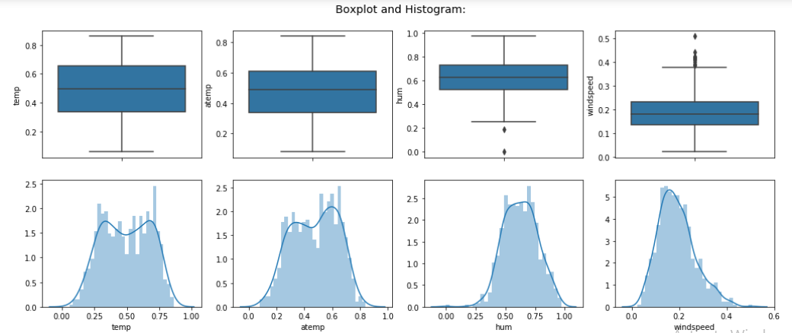Let us see boxplot and histogram for our numerical data.

Analysis:

We have no outliers for temp and atemp and very less outlier for humidity (hum) and few outliers for windspeed. Distribution is almost normal with little skewness for hum and windspeed and near to normal for temp and atemp.

We will make our model with whole of the data points and values and with dataset with-out outliers.

#### Feature Engineering:

We have two columns ‘mnth’ and ‘weekday’. In month column we have range from 1 to 31 and in weekday we have range from 0 to 6.

For mnth:

Now, if we choose this column as numerical then it would be like 3 is greater than 2 and 2 is greater than 1, which is not the case. Also choosing every mnth as an category, then we may have problem of dimensionality and our model will underperform. So, we will make a new column for ‘mnth’ as per current values.

Let us see distribution of counting of bike renting according to month as well as with year

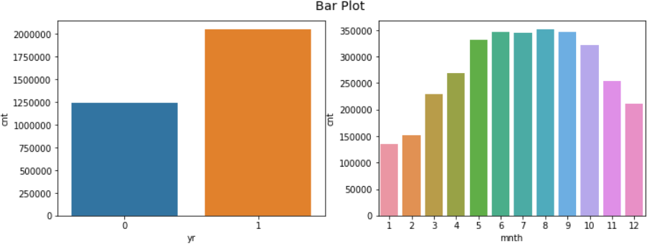

We can see a trend in counting of bike renting for month column. 5th to 10th month has high renting and other have less in comparison.

Above distribution of month is consolidated for both year 2011 and 2012. Let us see distribution with respect to each year.

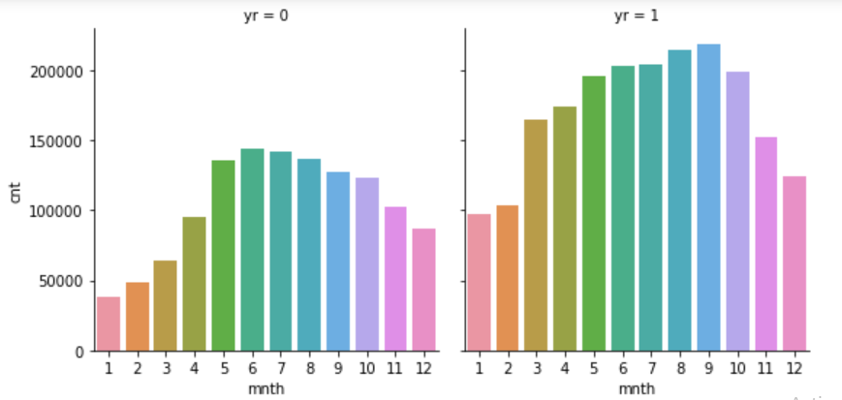

From above distribution we can observe that for each year we have similar trend. We will categorize month in two categories i.e. ‘1’ for month 5th to 10th and ‘0’ for rest. As 5th to 10th having high values for both 2011 and 2012 and rest have less.

Another point we can think that 5th month of 2011 would not be same as 5th month of 2012. Here we have another category of yr which has value 0 for 2011 and 1 for 2012. So our model will learn month value with 1 showing high trend and year with value 1 having high trend, so effect of 5th month of 2011 and 5th month of 2012 would be different on model.

Let us do similar **analysis for weekday**: Checking bar plot of counting for each weekday:

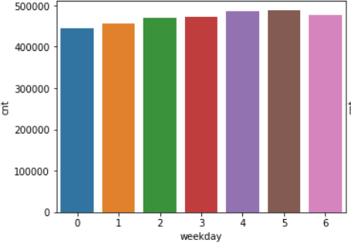

Here, we can see there is a trend for weekday. We will make two categories for weekday. Value

‘0’ for weekday 0 and 1 and value ‘1’ for rest.

**Note**:

*We have just decided to make binning for month and weekday. For time series data, it is adviseable that time like year, month, day could not be categorical. So, first we build our model by taking month and day of week as continuous values and then tried with binning of month and weekday. After that we compared our both the model. So, on making bins for ‘mnth’ we got significant improvement of 1% (explained_variance_score applied on 10 fold) and upon making bins for weekday we got improvement of less than 0.05%.*

*We can see binning of month giving us very good improvement as we can see from bar plot also it has significant difference in both category(made after binning) for month and weekday has very less difference that is why giving us less improvement.*

#### Feature selection:

For feature selection of numerical variable we will see if there is multicollinearity between our continuous independent variable.

For this we will plot scatter plot between our continuous variables.

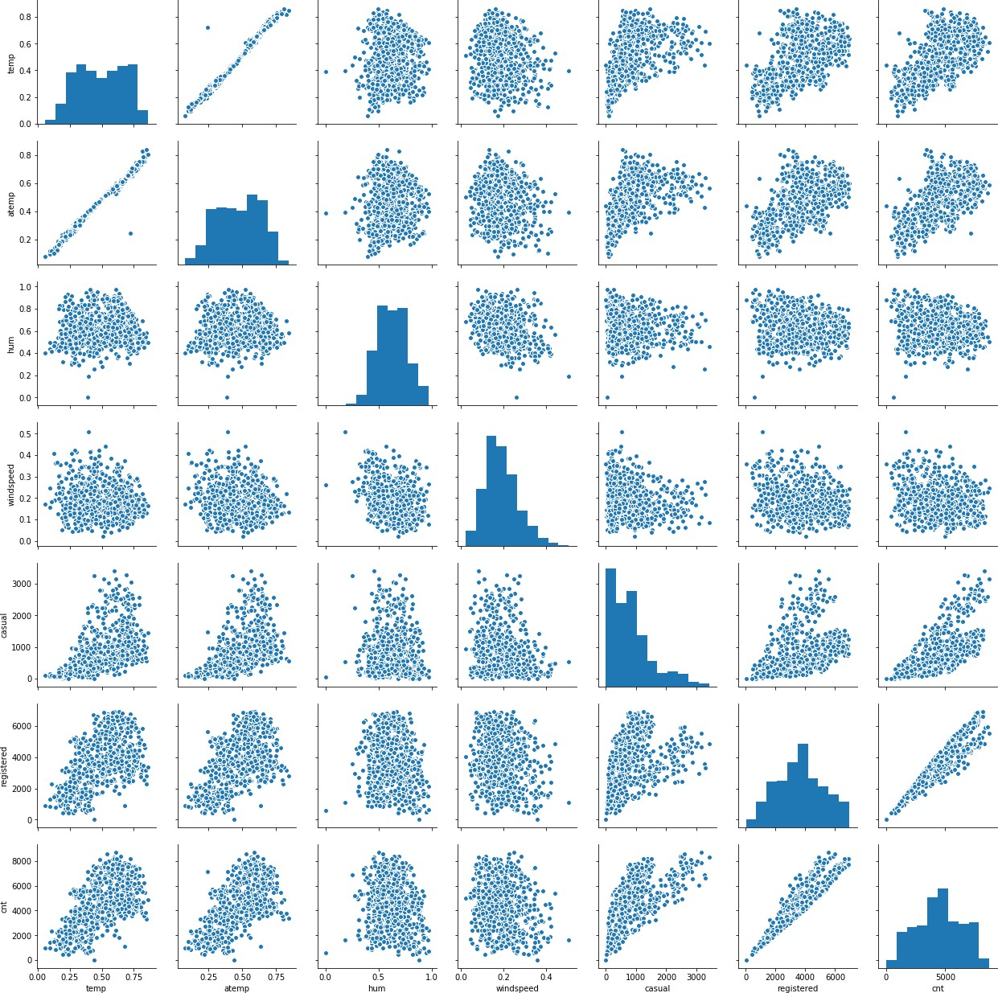

Let us see heatmap for the same:

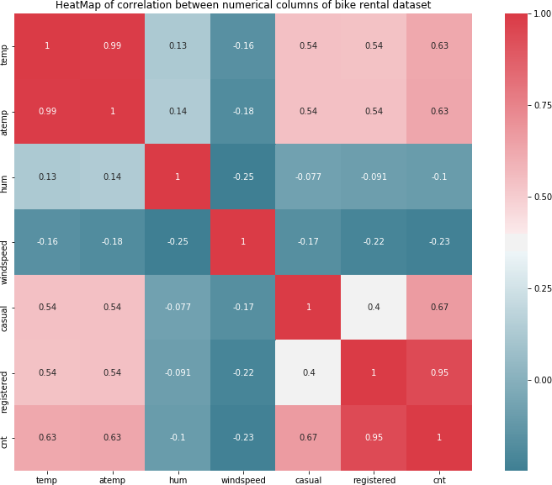

Analysis:

From heatmap and correlation plot we can see , there is multicollinearity present between temp and atemp, so we will drop one of those columns as per importance of features. Multicollinearity present between registered and cnt, but these are our target variable. We will only use total counting i.e. cnt as our target variable and would drop casual and registered column.

Analyzing for categorical variables also:

We would not use instant and dteday column. As instant is index only and information of dteday i.e. yr, month and day we have already columns for that. Dteday is important factor while doing the time series analysis and we are not doing time series analysis.

For getting dependency between categorical variables we would use chi-sq test of independence test. So, here we have mnth , yr, weekday, holiday, workingday, weathersit and season as categorical variables. We will use week_feat (i.e. after making bins of week) and month_feat (i.e. after making bins of month).

Null Hypothesis for Chi-square test of Independence:

*Two variables are independent.* Alternate Hypothesis:

*Two variables are not independent*.

So, we want that our categorical variable should be independent. If we get p-value less than 0.05, it means we need to reject null hypothesis and accept alternate hypothesis which means variables are dependent. So, we would check for every combination and would print p-value.

|  |  |  |  |  |  |  |  |
| --- | --- | --- | --- | --- | --- | --- | --- |
|  | **season** | **yr** | **month_feat** | **holiday** | **week_feat** | **workingday** | **weathersit** |
| **season** | - | 1 | 0 | 0.683 | 0.985 | 0.887 | 0.021 |
| **yr** | 1 | - | 0.971 | 0.995 | 0.954 | 0.98 | 0.127 |
| **month_feat** | 0 | 0.971 | - | 0.359 | 0.972 | 0.657 | 0.362 |
| **holiday** | 0.683 | 0.995 | 0.359 | - | 0 | 0 | 0.601 |
| **week_feat** | 0.985 | 0.954 | 0.972 | 0 | - | 0 | 0.227 |
| **workingday** | 0.887 | 0.98 | 0.657 | 0 | 0 | - | 0.254 |
| **weathersit** | 0.021 | 0.127 | 0.362 | 0.601 | 0.227 | 0.254 | - |

Here, from the table we can see some values are less than 0.05 indicating them they are dependent. Holiday is showing collinearity with week and workingday. Month is showing collinearity with season. Weathersit showing collinearity with season.

Now, we need to drop them to remove multicollinearity. But we have to be sure that we are not losing any information. So, we tried with dropping multicollinear column and building models and we got below result:

* + - * On dropping weathersit or season we are losing accuracy with significant amount.
      * On dropping holiday we are losing accuracy which is not significant amount.
      * On dropping week_feat(weekday) or working day we are losing accuracy with little amount. And if we drop holiday, that information is also included in working day.

We just can’t be sure by looking at test result and deciding, we need to get all factors. Here two columns most of the time showing collinearity but some datapoints would not be showing collinearity and at that datapoint there could be abrupt difference in bike renting count column which is very crucial info for our model.

We will drop only holiday column as we have ‘working day’ column which has information of holiday also, that is why on dropping holiday we are not losing our accuracy. Also in while getting important features we are getting last ranking for holiday column with very less importance.

Let us check now important feature of our dataset:

|  |  |  |
| --- | --- | --- |
|  | **Feature** | **importance** |
| **0** | yr | 0.315736 |
| **1** | temp | 0.165388 |
| **2** | atemp | 0.140998 |
| **3** | month_feat | 0.124285 |
| **4** | season | 0.106907 |
| **5** | weathersit | 0.059081 |
| **6** | hum | 0.033578 |
| **7** | windspeed | 0.023560 |
| **8** | workingday | 0.013887 |
| **9** | week_feat | 0.010608 |
| **10** | holiday | 0.005972 |

Checking VIF for our numerical variables:

|  |  |
| --- | --- |
| **const** | **45.6** |
| **temp** | **63.0** |
| **atemp** | **63.6** |
| **hum** | **1.1** |
| **windspeed 1.1**  **dtype: float64** | |

We must remove atemp variable as it is multicollinear with temp and having less importance than temp variable.

After removing atemp, let us check again VIF for numerical variables:

|  |  |
| --- | --- |
| **const** | **41.1** |
| **temp** | **1.0** |
| **hum** | **1.1** |
| **windspeed 1.1**  **dtype: float64** | |

Now, we have good value of vif and don’t have multicollinearity. ‘Const’ is not part of our dataset it was just added as it is required for calculation of VIF.

#### Feature Scaling:

We have numerical columns temp, hum and windspeed, which are provided in normalized form.

All variable are in same range. So we don’t require feature scaling for our dataset.

#### Data After EDA

We would remove ‘instant’, ‘holiday’, ‘dteday’, ‘atemp’, ‘casual’, ‘registered’ and would make bins for ‘mnth’ and ‘weekday’. We will make dummy variables for season and weather in python and would change them to factor in R.

We have create another dataset(df1) but after removal of outliers from hum and windspeed.

### Data Modeling

We will now build our model, before proceeding terms used in our codes:

* df: dataset containing all columns except which we removed in EDA
* df1 : it is same as df but we removed outliers from it.
* X_train: containing all independent variables (part of df), used for training model
* y_train : containing target variable (part of df), used for training model
* X_test : containing independent variable (part of df), used for testing model
* y_test: containing target variable(part of df), , used for testing model
* X_train1: containing all independent variables (part of df1), used for training model
* y_train1 : containing target variable (part of df1), used for training model
* X_test1 : containing independent variable (part of df1), used for testing model
* y_test1: containing target variable (part of df1), , used for testing model
* fit_predict_show_performance: user-defined function, which will fit our model on training set, and will calculate and print k-fold (10-fold) cross validation score for explained_variance , and then will make prediction on training and test dataset and will print explained_variance for both training and test dataset.

#### K-fold CV, GridsearchCV and Explained_variance

Before building models on our dataset, we would like to explore three things:

* + - * K-fold cross validation
      * GridSearchCV
      * Explained_variance (metric from sklearn)

##### K-fold Cross Validation:

K-fold cross validation is used to check performance of model which is checked on K different test dataset. Let us assume, we have built a model and we are checking performance of our model on a test data and our model show accuracy of 95% and now we will check our model on different test data and now accuracy is 80%. So what should we consider for deciding model performance? So in this, K-fold cross validation helps, it would divide our training data in k sets and will build a model using k-1 training set and one left set would be used to test our model performance. In this way it would build k times model and each time there would be different test dataset to check performance and at the end all k model’s accuracy(or any other metric) mean value would be considered as model accuracy(any mertric).

So, we would use K-fold cross validation technique to get performance of our model.

##### GridsearchCV : (Hyperparameter tuning)

Hyperparameter are the parameters which we pass as argument to our building function, like kernel, criterion, n_estimators etc. So to get best values of these gridserchcv is used. In this technique, we make list of these different parameters and then gridsearchcv build model for every combination of these parameters and then check crossvalidation score and based on score it gives the best combination of hyperparameters.

And then we can build our model with the values of hyperparameter given by GridSearchCV.

This is called performance tuning and we would use this to tune our model.

##### Explained_variance_score (metric from sklearn)

We have different metrics score for regression to check performance of model. All metrics having difference of y_pred and y_true in their calculation. y_pred is the value predicted by model and y_true is actual value. These metrics tell us deviation of prediction from actual value. We have different metrics for regression:

* Explained_variance
* Mean_absolute_error
* Mean_squared_error
* Mean_squared_log_error
* Median_absolute_error
* R2

We can use any of them for comparing our model, but we will use explained_variance. Best possible score is 1.0 (perfect prediction) and less is worse.

#### Building models

Models and performance of models:

We will now build one by one all models and will check performance of our model and then at the will decide final model which we should use for our project.

Linear Regression:

Performance of Linear Regression built on X_train, y_train and tested on X_test. Showing K-fold cross validation explained_variance score and score for train and test dataset.

**K-fold (K = 10) explained variance**

**================================ 0.8159475214285375**

**on train data explained variance**

**================================ 0.8246429104722082**

**on test data explained variance**

**================================ 0.8399636835682225**

Performance of Linear Regression built on X_train1, y_train1 and tested on X_test1. Showing K-fold cross validation explained_variance score and score for train and test dataset.

**K-fold (K = 10) explained variance**

**================================ 0.8036114376234579**

**on train data explained variance**

**================================ 0.812628161259224**

**on test data explained variance**

**================================ 0.8741968130318497**

Analysis of Linear Regression method:

As we can see from above results K-fold explained variance for whole dataset is 81.59% and for dataset without outlier is 80.36%.

So, from here we can observe that we don’t have any outlier in our dataset, outlier declared by

boxplot method is the information.

K Near Neighbors Regressor:

Performance of KNN Regressor built on X_train, y_train and tested on X_test. Showing K-fold cross validation explained_variance score and score for train and test dataset.

**K-fold (K = 10) explained variance**

**================================ 0.8045498992157334**

**on train data explained variance**

**================================ 0.8752054851853227**

**on test data explained variance**

**================================ 0.7948427483110001**

Performance of KNN Regressor built on X_train1, y_train1 and tested on X_test1.

Showing K-fold cross validation explained_variance score and score for train and test dataset.

**K-fold (K = 10) explained variance**

**================================ 0.7734075458256149**

**on train data explained variance**

**================================ 0.8528148959625084**

**on test data explained variance**

**================================ 0.8709464964725131**

Analysis of KNN Regressor method:

We can observe from above result, KNN regressor showing K-fold explained_variance score 80.45% for whole dataset and 77.34% for dataset without outliers.

Support Vector Regressor:

Performance of SVR(Gaussian kernel) built on X_train, y_train and tested on X_test. Showing K- fold cross validation explained_variance score and score for train and test dataset.

**K-fold (K = 10) explained variance**

**================================ 0.012405891628879196**

**on train data explained variance**

**================================ 0.013320606469871543**

**on test data explained variance**

**================================ 0.012475111232131852**

Performance of SVR(Gaussian kernel) built on X_train1, y_train1 and tested on X_test1. Showing K-fold cross validation explained_variance score and score for train and test dataset.

**K-fold (K = 10) explained variance**

**================================ 0.011225306843643057**

**on train data explained variance**

**================================ 0.012268147803231932**

**on test data explained variance**

**================================ 0.011955920504533535**

Analysisof SVR method:

Support vector regressor with Gaussian kernel is not giving good result for our dataset in any of case.

Decision Tree Regressor:

Performance of DTR built on X_train, y_train and tested on X_test. Showing K-fold cross validation explained_variance score and score for train and test dataset.

**K-fold (K = 10) explained variance**

**================================ 0.743886343148221**

**on train data explained variance**

**================================ 1.0**

**on test data explained variance**

**================================ 0.7952214097598804**

Performance of DTR built on X_train1, y_train1 and tested on X_test1. Showing K-fold cross validation explained_variance score and score for train and test dataset.

**K-fold (K = 10) explained variance**

**================================ 0.7328748531487335**

**on train data explained variance**

**================================ 1.0**

**on test data explained variance**

**================================ 0.8281923206565962**

Analysis of DTR method:

**We can observe from above results Decision tree regressor is explaining K-fold variance 74.38% for whole dataset and 73.28% for dataset without outlier.**

**Another thing we can observe is Decision tree explaining variance 100% for training dataset. So we have overfitting here. So, we will use next Random forest which would remove overfitting of decision Tree.**

Random Forest Regressor:

**Performance of Random Forest Regressor built on X_train, y_train and tested on X_test. Showing K-fold cross validation explained_variance score and score for train and test dataset.**

**K-fold (K = 10) explained variance**

**================================ 0.8548225224328381**

**on train data explained variance**

**================================ 0.9734605915767535**

**on test data explained variance**

**================================ 0.8895839793569554**

Performance of RF built on X_train1, y_train1 and tested on X_test1. Showing K-fold cross validation explained_variance score and score for train and test dataset.

**K-fold (K = 10) explained variance**

**================================ 0.843399951802747**

**on train data explained variance**

**================================ 0.9694980310035362**

**on test data explained variance**

**================================ 0.9127408418315636**

Analysis of Random Forest method:

**We can observe that Random Forest explained_variance score for k-fold is 85.48% for whole dataset and 84.33% for dataset without outlier. We also have less explained_variance score for training dataset than decision tree and high score for test dataset. So Random forest helped in removing overfitting.**

* + 1. **Hyperparameter tuning:**

Now, we will tune our model i.e. Random Forest. As we see in previous step, outliers shown by boxplot method in actual was information for our model. So we will tune our model for whole dataset i.e. df. With the help of hyperparameter tuning we would find optimum values for parameter used in function and would increase our accuracy.

**Random Forest Hyperparameter tuning**

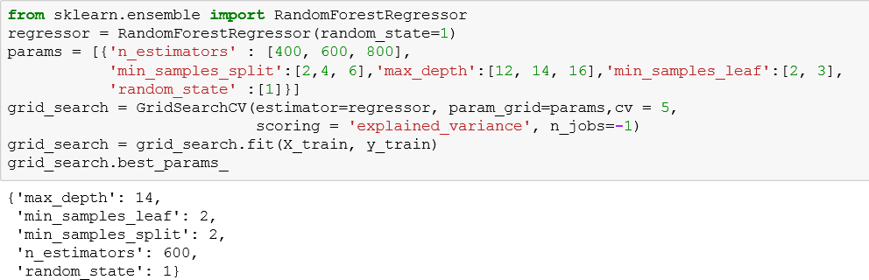Now, Tuning Random Forest Model for following parameters:

Building model on tuned parameter suggested by GridsearchCV:

**K-fold (K = 10) explained variance**

**================================ 0.8668317334704365**

**on train data explained variance**

**================================ 0.965607969664463**

**on test data explained variance**

**================================ 0.8898201610699171**

Analysis:

From above result (on tuned parameter), we have increased our model explained_variance score for k-fold from 85.48% to 86.68%. Also we can observe that previously it was giving accuracy for training dataset as 97% and now it is giving 96% and on test dataset we have slightly increased accuracy.

So, with the help of hyperparameter tuning we reduced overfitting in our model.

Let us check a scatter graph between actual values of test and predicted values. A line at 45 degree , i.e. slope =1 will be perfect prediction and points showing above and below of that line would be error in predictions.

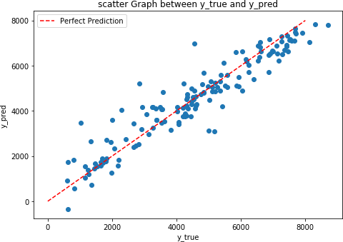

Analysis:

As we can see, we don’t have perfect predictions. Actually any model can’t have perfect prediction for such type of dataset, where customer taking bike on rent would have some randomness. Assume four days all situations are same except date and they are nearby dates. Then also there would not be same counting of bike renting even with same situation. So, there would be some randomness in dataset which is natural.

So, our model is predicting quite well as we can see from above image. Deviation for most of prediction from original value is low.

# Chapter 3

## Conclusion

#### Final Model and Training Dataset

Final Dataset:

* + - Take whole dataset.
    - Remove ‘instant’, ‘dteday’, ‘holiday’, ‘atemp’, ‘casual’, ‘registered’
    - Make dummy variables of session and weathersit in python and factor in R.
    - Make bins for ‘mnth’ and ‘weekday’ as explained in feature engineering section.
    - Training set would be having all columns except ‘cnt’ and test dataset would have only ‘cnt’ column.

Final Model:

* + - Use RandomForest model using training set explained in above step.
    - Do hyperparameter tuning for training set.
    - Build RandomForest model with tuned parameters.

#### End Notes

* All analysis resul t is based on python. In R, result would not be exact same but would be almost same.
* We have not done here time series analysis. As per problem statement, we have to predict for seasonal and environmental condition.
* We can try with time series analysis for this project and can predict. In time series analysis we build model on trend for some specific time (like 2 year or more) and predict for future values like after time for which we have built model. While in this report we predicted for values which are in between.
* Outlier should be treated well by gaining domain knowledge and experimenting with model building and checking performance.
* Steps done in EDA section is just not based on statistical test, we have done many experiment like dropping column or not and then decided to what to do with that specific column.
* While doing hyperparameter tuning, after getting result of parameter, do again with finer values of parameter and so on. At the end we will get most approximate and optimum values.

### 

### References:

1. <https://edwisor.com/career-data-scientist>
2. http://en.wikipedia.org
3. [https://t](https://edwisor.com/career-data-scientist)owardsdatascience.com
4. [www.kaggle.com](http://www.kaggle.com)
5. 5.<https://www.udemy.com/python-for-data-science-and-machine-learning-bootcamp/>
6. 6.<http://scikit-learn.org/stable/modules/model_evaluation.html>