**Waste Classification Using Transfer Learning**

**1. Problem Statement**

Waste management remains a critical issue globally, with effective sorting of waste being a key step toward sustainability. Manual classification is time-consuming and prone to errors. This project aims to build an AI-powered image classification system to automatically categorize waste into six classes: cardboard, glass, metal, paper, plastic, and trash.

**2. AI Technique Used**

The core AI technique used in this project is **transfer learning**. Transfer learning allows the model to benefit from knowledge learned on a large dataset (TrashNet), accelerating training and improving performance with relatively little labeled data. Data augmentation and early stopping techniques are used to avoid overfitting and enhance generalization.

**3. Dataset Description**

**3.1 TrashNet**

The primary dataset used is **TrashNet**, a publicly available dataset containing images of six waste categories. Each category has several hundred labeled images, typically with varied lighting and backgrounds, which introduces necessary diversity.

**3.2 Custom Dataset**

To improve real-world robustness, a **custom dataset** of additional waste images was created manually. This included images from various sources, resized and structured similarly to TrashNet. The combined dataset was split 80/20 into training and validation sets.

**Class labels**:

* cardboard
* glass
* metal
* paper
* plastic
* trash

**4. Implementation Details**

**4.1 Preprocessing and Augmentation**

* Images were resized to 224x224 pixels.
* Data augmentation included random flipping, rotation, zoom, and contrast adjustments.
* TensorFlow's image_dataset_from_directory API was used for loading and batching.

**4.2 Model Architecture**

* **Base Model**: EfficientNetB0 without the top layer, loaded with ImageNet weights, frozen during initial training.
* **Custom Head**:
  + Global average pooling
  + Dense layer with 256 units and ReLU activation
  + Dropout layer (rate = 0.5)
  + Final softmax output layer with 6 classes

The model was compiled using the Adam optimizer and sparse categorical crossentropy loss. Training was conducted over 15 epochs with early stopping and model checkpointing.

**4.3 Deployment**

The trained model was deployed using **Gradio** for a user-friendly web interface, allowing real-time image classification. Users can upload waste images and receive confidence scores for each class.

**5. Evaluation and Results**

* **Accuracy**: Achieved ~88% validation accuracy using combined datasets.
* **Loss**: Validation loss remained stable, indicating good generalization.
* **Confusion Matrix**: Revealed strong performance in cardboard, glass, and plastic classes. Some confusion was observed between paper and cardboard, and between metal and trash.

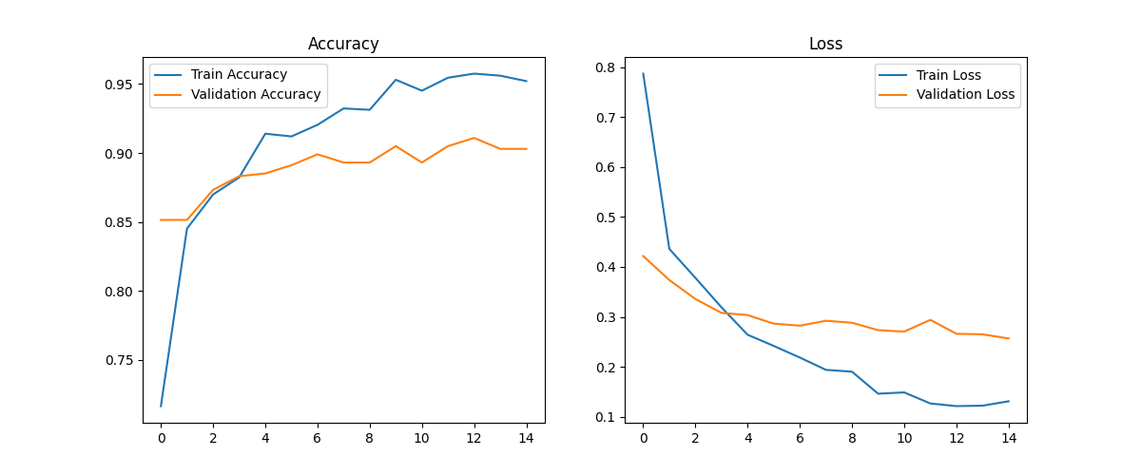

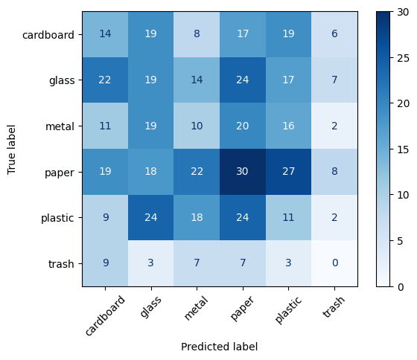

**6. Challenges and Limitations**

* **Data Imbalance**: Some classes (e.g., trash and metal) had fewer images, which could affect model bias.
* **Visual Similarity**: Categories like paper and cardboard are visually similar and prone to misclassification.
* **Environmental Factors**: Lighting and angle variations, especially in custom images, affected consistency.
* **Computation**: Training on CPU or limited-GPU environments increased training time significantly.