Supporting Materials for: Transthoracic Echocardiography and Mortality in Sepsis: Analysis of the MIMIC-III Database

1. Characteristics of Transthoracic Echocardiography (TTE) orders

We conducted a survey to investigate the time when TTEs were ordered in our cohort to evaluate our data integrity. Based on the time recorded on the TTE report, we calculated the day when TTEs were ordered with respect to patients’ ICU admission. The detailed distribution is shown in Figure 1. According to our data, more than 85% of TTE were ordered either within 1 day before the ICU admission or in the first two days or before ICU admission.

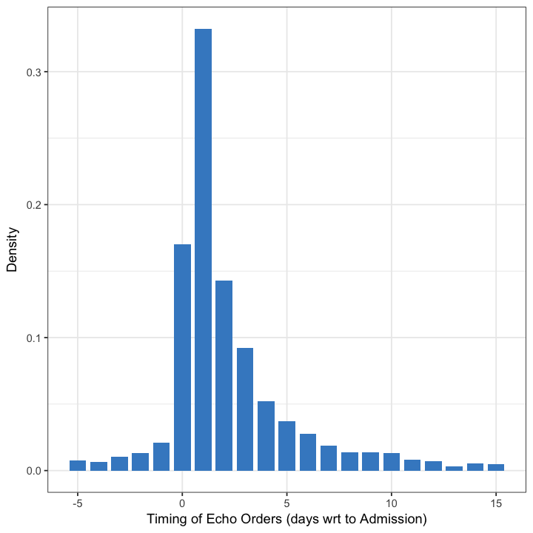

Figure 1. The day when TTEs were ordered with respect to patients' ICU admission. A negative number indicates that TTE was ordered before ICU admission.

We have also surveyed the total number of TTEs performed for our cohort during their ICU stay. Figure 2 summarizes the observed results. 82% of TTE patients had only one TTE during their entire ICU stay. The findings from both of the above surveys align with our own observations of ICU practice.

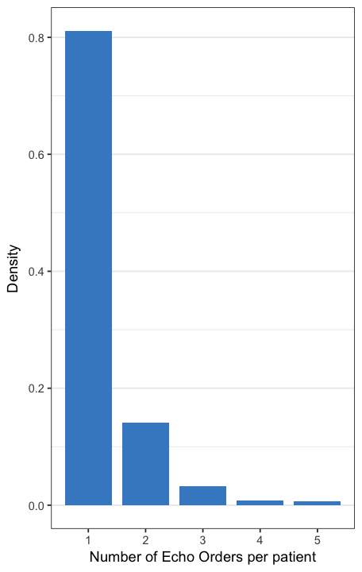

Figure 2. Summary of number of TTE performed during patients' ICU stay.

As the included cohort covered patients admitted from 2002 to 2011, we investigated whether the rate of TTE exams may have changed over the years, which could confound the observed findings. Thus, we requested the actual year of admission that is considered Protected Health Information under HIPAA. We then looked at the trend in the rate of use of TTE over the study period. As illustrated in the figure 3, no significant changes in TTE rates (the purple line) over the years were observed.

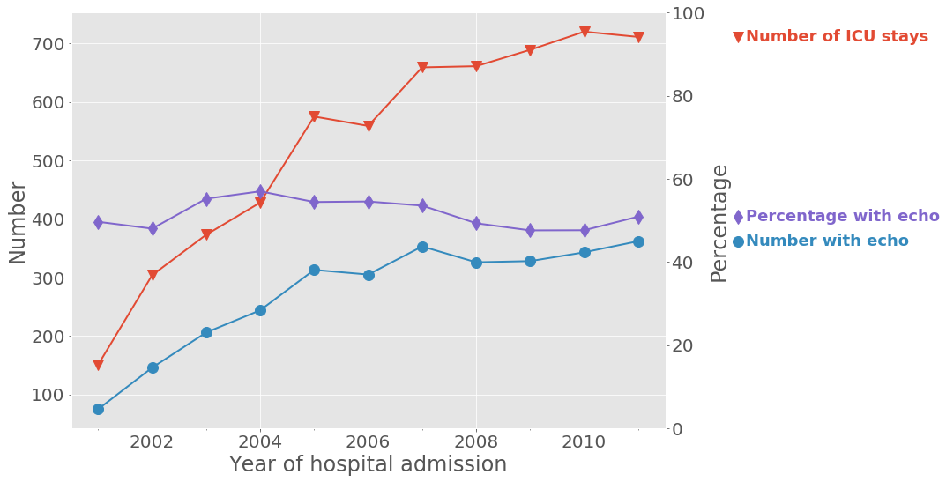

Figure 3. Rates of TTE exams

### 2. Pre-processing of covariates with missing data

For the 40 covariates used in the proposed propensity score model, we noticed that some suffered from large amounts of missing data. The detailed figures are illustrated in Figure 4. As highlighted in red, CVP, BNP, troponin and creatinine kinase lack greater than 50% of possible values. Although the proposed GBM model for propensity score learning is able to handle missing data separately, we believe that it would not be meaningful to use the raw values of a covariate with more than 50% of its values missing. Therefore, for these four items, instead of using their actual readings, a flag was employed indicating whether they were measured or not, and those yes/no flags were used as the covariates for the model.

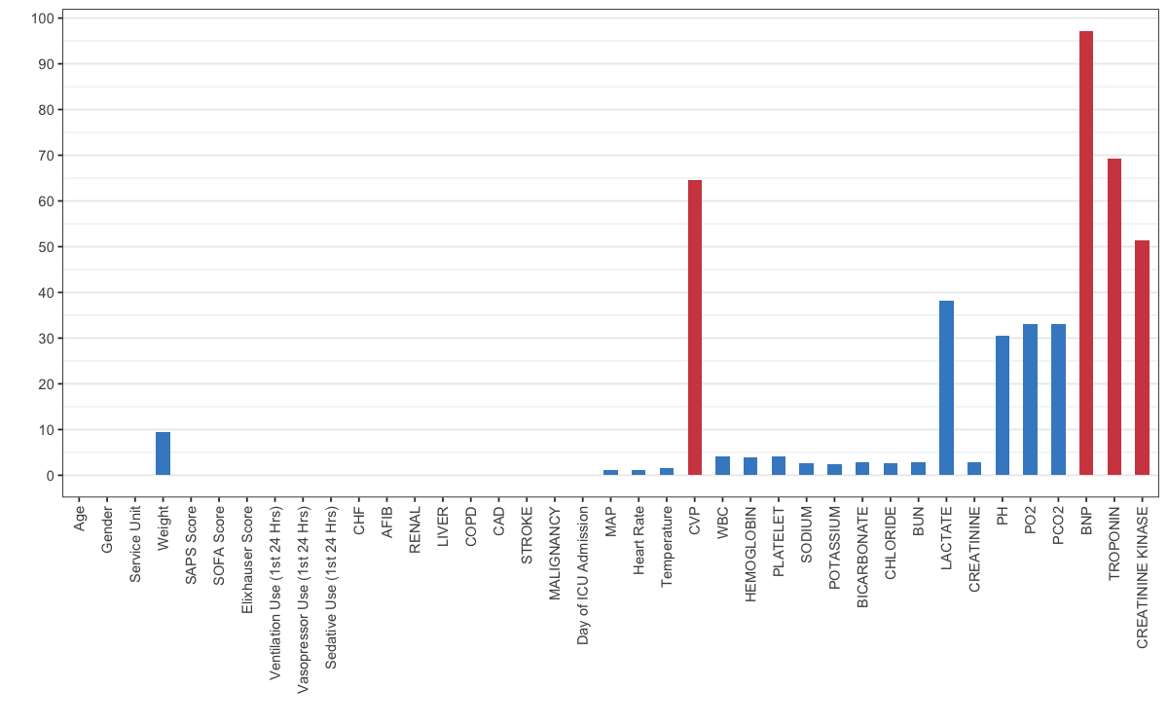

### Figure 4. Summary of missing data in covariates

### 3. Balancing the propensity score based inverse probabilities weighting (IPW) model and the propensity score based matching model

As discussed in the main manuscript, in order to balance the TTE and non-TTE groups, a weighted cohort was generated based on the IPW model with the estimated propensity score. We have done a series of studies to evaluate the balancing effect of the built propensity score model.

We first investigated the balancing effect of the propensity score based IPW model. Figure 5 shows that in the original (unweighted) cohort, large (>0.1) absolute standard differences were observed in the covariates between the TTE and non-TTE groups. However, after balancing with the IPW model, the differences were all successfully reduced to be below 0.1. Figure 6 further illustrates that before the balancing, most of the observed differences in the covariates were statistically significant; but after balancing, only a few covariates still have significant differences between the two comparing cohorts. Therefore, a doubly robust model was then proposed to further correct for these unmatched differences.

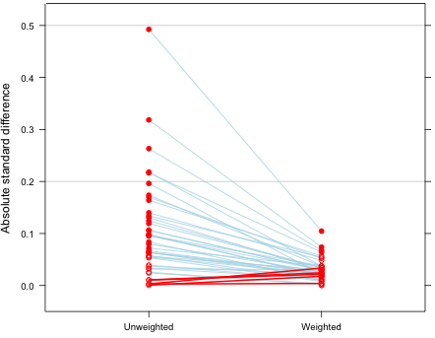

Figure 5. Absolute standard difference of covariates between TTE and non-TTE groups for the original (unweighted) cohort and the weighted cohort.

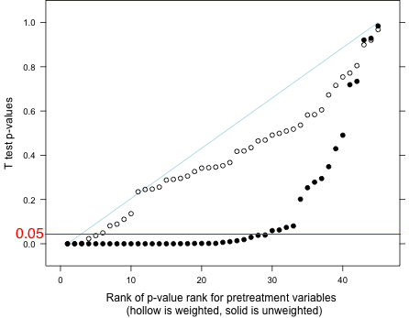

Figure 6. p-values measuring the significances of the differences in covariates for the original (unweighted) and weighted cohort from the IPW model.

We also evaluated the balancing effect of the built propensity score model when a matching method was used. Figure 7 compares the absolute standard difference between the original and the matched cohorts. Figure 8 compares the p-values of all the covariates before and after matching. It was observed that both our propensity scored based IPW and matching models can effectively balance the comparative TTE and non-TTE cohorts.

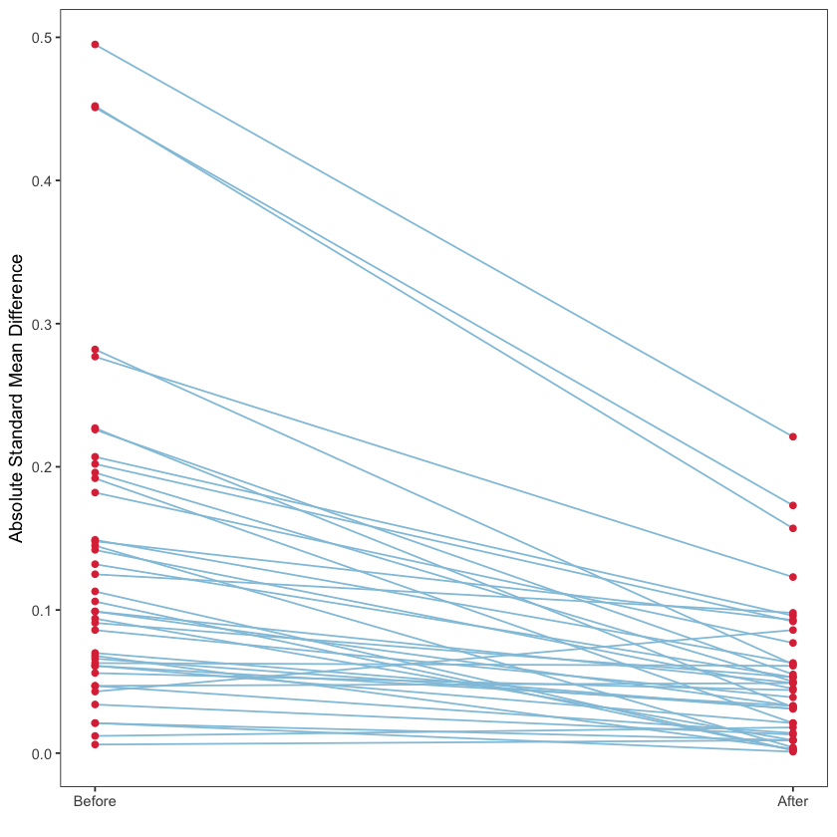

Figure 7. Absolute standard difference of covariates between TTE and non-TTE groups for the original cohort and the matched cohort.

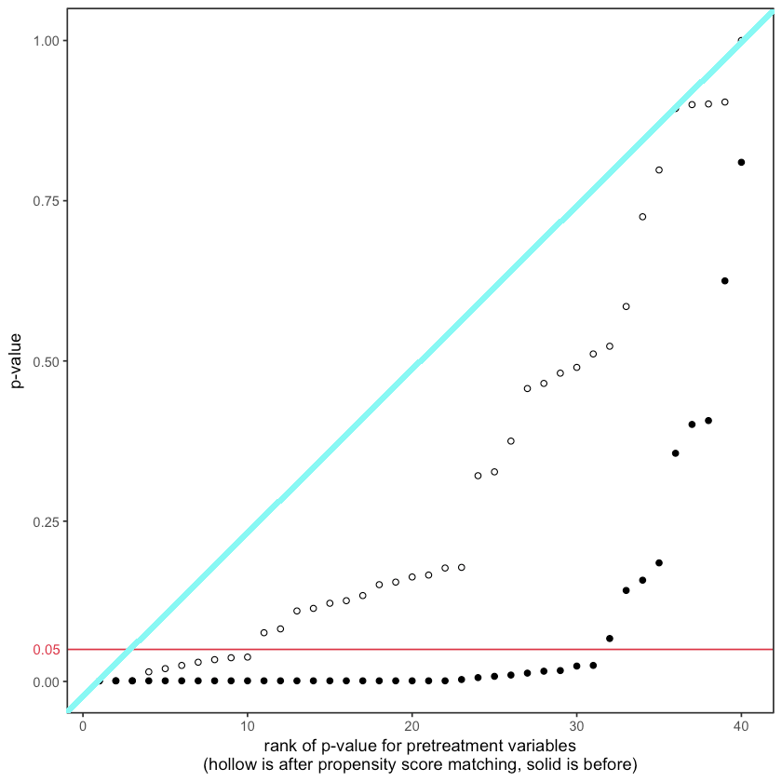

Figure 8. p-values measuring the significances of the differences in covariates for the original and matched cohort.

## 4. Pulmonary vs Non-Pulmonary Sources of Sepsis

We have looked at the proportion of sepsis from a pulmonary source vs. sepsis from a non-pulmonary source as has been done in previous publications. Indeed, in the original cohort, the proportion of patients with sepsis from a pulmonary source who did not undergo TTE was significantly (p<0.001) higher compared to the proportion of patients with sepsis from a pulmonary source who underwent TTE.

|  |  |  |
| --- | --- | --- |
|  | **TTE** | **Non-TTE** |
| Sample size | 3262 | 3099 |
| Sepsis from pulmonary source | 929 (23.14%) | 717 (28.48%) |

Table 1 Sources of sepsis in the original cohort.

However, when we looked at the propensity matched cohort, the proportion of patients with sepsis from a pulmonary source who did not undergo TTE was similar to the proportion of patients with sepsis from a pulmonary source who underwent TTE (p=0.5).

|  |  |  |
| --- | --- | --- |
|  | TTE (matched) | Non TTE (matched) |
| Sample size | 1626 | 1626 |
| Sepsis from pulmonary source | 432 (26.5%) | 415 (25.5%) |

Table 2 Sources of sepsis in matched cohort.

## 5. Sensitivity Analysis for TTE performed before the first 48 hours of ICU stay

As shown in Section 1 in the appendix, more than 85% of the patients in our cohort had their first TTE performed within 24 hours of their ICU admission or in the first 48 hours of their ICU stay. We conducted a sensitivity study to include only this group of patients as the TTE patients and contrasted them against the non-TTE patients. We observed similar signals as compared to our primary study.

|  |  |  |  |  |
| --- | --- | --- | --- | --- |
| Method | OR | Confidence Interval | | P-value |
| 2.5% | 97.5% |  |
| Doubly Robust with  Unbalanced Covariates | 0.76 | 0.66 | 0.89 | <0.001 |
| Doubly Robust with  All Covariates | 0.66 | 0.54 | 0.81 | <0.001 |
| Propensity Score IPW | 0.85 | 0.77 | 0.92 | <0.001 |
| Propensity Score  Matching | 0.76 | 0.65 | 0.89 | <0.001 |
| Multivariate | 0.66 | 0.54 | 0.81 | <0.001 |

Table 3. Sensitivity analysis. Association of TTE and the primary outcome (28-day mortality) estimated by 5 different models: 1) Doubly robust model with unbalanced co-variates 2) Doubly robust model with all co-variates 3) Propensity Score IPW model 4) Propensity Score Matching model 5) Multivariate logistic regression model.

## 6. Subgroup Analysis for Patients Requiring Vasopressor Therapy

We have conducted a subgroup analysis focusing on the patients who required vasopressor therapies. In the identified subgroup, we repeated our analysis with the doubly robust models, the propensity score IPW and matching models and the multivariate logistic regression model. In all these models, we observed an even greater mortality benefit associated with TTE.

|  |  |  |  |  |
| --- | --- | --- | --- | --- |
| Method | OR | Confidence Interval | | P-value |
| 2.5% | 97.5% |  |
| **Doubly Robust with**  **Unbalanced Covariates** | **0.62** | **0.46** | **0.82** | **0.001** |
| Doubly Robust with  All Covariates | 0.48 | 0.36 | 0.65 | <0.001 |
| Propensity Score IPW | 0.63 | 0.55 | 0.72 | <0.001 |
| Propensity Score  Matching | 0.63 | 0.47 | 0.85 | 0.002 |
| Multivariate | 0.50 | 0.37 | 0.67 | <0.001 |

Table 4 Subgroup analysis. Association of TTE and the primary outcome (28-day mortality) in sepsis patients who required vasopressor therapies. Effect sizes were estimated by 5 different models: 1) Doubly robust model with unbalanced co-variates 2) Doubly robust model with all co-variates 3) Propensity Score IPW model 4) Propensity Score Matching model 5) Multivariate logistic regression model.

### 7. Details of the double robust model on primary outcome

The detailed results of the learned doubly robust model over the weighted cohort are summarized in the following table.

Table 5. Odds ratio (95% confidence interval) and p-values for primary outcome and all co-variates from the doubly robust model.

|  |  |  |
| --- | --- | --- |
| **Covariate** | **Odds Ratio (2.5%~97.5%)** | **p value** |
| **TTE** | **0.64 (0.52~0.78)** | **<0.001** |
| Age | 1.02 (1.01~1.03) | <0.001 |
| Gender (Female) | 0.85 (0.7~1.03) | 0.11 |
| Service Unit (MICU) | 1.39 (1.09~1.79) | <0.001 |
| Weight (Kg) | 0.99 (0.99~1) | <0.001 |
| Elixhauser Score | 1.03 (1.01~1.05) | <0.001 |
| SAPS Score | 1.06 (1.03~1.09) | <0.001 |
| SOFA Score | 1.18 (1.14~1.23) | <0.001 |
| Mechanical Ventilation (1st 24 Hr) | 1.32 (0.95~1.82) | 0.1 |
| Vasopressor (1st 24 Hr) | 0.98 (0.77~1.24) | 0.86 |
| Sedative (1st 24 Hr) | 0.84 (0.64~1.1) | 0.2 |
| CHF | 0.77 (0.61~0.98) | 0.03 |
| AFIB | 1.14 (0.91~1.41) | 0.25 |
| RENAL | 0.78 (0.58~1.03) | 0.09 |
| LIVER | 1.51 (1.08~2.12) | 0.02 |
| COPD | 1.18 (0.92~1.52) | 0.2 |
| CAD | 1.06 (0.8~1.39) | 0.69 |
| STROKE | 1.99 (1.42~2.78) | <0.001 |
| MALIGNANCY | 1.73 (1.38~2.18) | <0.001 |
| MAP | 0.99 (0.99~1) | <0.001 |
| Heart Rate | 1.01 (1~1.01) | <0.001 |
| Temperature (C) | 0.93 (0.85~1) | 0.08 |
| CVP (measured) | 0.62 (0.5~0.76) | <0.001 |
| WBC | 1 (0.99~1.01) | 0.63 |
| HEMOGLOBIN | 0.98 (0.93~1.03) | 0.35 |
| PLATELET | 1 (1~1) | 0.28 |
| SODIUM | 1 (0.97~1.04) | 0.86 |
| POTASSIUM | 1.11 (0.99~1.24) | 0.08 |
| BICARBONATE | 1.01 (0.98~1.05) | 0.41 |
| CHLORIDE | 0.98 (0.95~1.01) | 0.18 |
| BUN | 1.01 (1~1.01) | <0.001 |
| LACTATE | 1.13 (1.07~1.19) | <0.001 |
| CREATININE | 0.8 (0.72~0.87) | <0.001 |
| PH | 0.76 (0.16~3.85) | 0.74 |
| PO2 | 1 (1~1) | 0.81 |
| PCO2 | 1 (0.99~1.01) | 0.94 |
| BNP (tested) | 0.91 (0.54~1.48) | 0.71 |
| TROPONIN (tested) | 1.31 (1~1.72) | 0.05 |
| CREATININE KINASE (tested) | 0.91 (0.7~1.17) | 0.45 |
| Day of ICU Admission |  |  |
| MONDAY | 1.01 (0.72~1.43) | 0.94 |
| TUESDAY | 1.02 (0.72~1.44) | 0.91 |
| WEDNESDAY | 1.14 (0.81~1.59) | 0.45 |
| THURSDAY | 1.08 (0.78~1.51) | 0.63 |
| FRIDAY | 0.93 (0.66~1.31) | 0.68 |
| SATURDAY | 1.03 (0.73~1.47) | 0.85 |
| Hour of ICU Admission |  |  |
| 1 | 1.25 (0.65~2.4) | 0.5 |
| 2 | 0.79 (0.39~1.6) | 0.52 |
| 3 | 1.33 (0.68~2.61) | 0.4 |
| 4 | 1.63 (0.83~3.2) | 0.16 |
| 5 | 1.48 (0.72~3.01) | 0.29 |
| 6 | 1.3 (0.59~2.79) | 0.51 |
| 7 | 0.82 (0.26~2.25) | 0.71 |
| 8 | 0.83 (0.29~2.16) | 0.71 |
| 9 | 1.76 (0.83~3.71) | 0.14 |
| 10 | 1.15 (0.53~2.47) | 0.71 |
| 11 | 1.15 (0.6~2.21) | 0.68 |
| 12 | 1.42 (0.74~2.73) | 0.3 |
| 13 | 1.42 (0.73~2.76) | 0.31 |
| 14 | 1.36 (0.74~2.53) | 0.33 |
| 15 | 1.58 (0.86~2.9) | 0.14 |
| 16 | 1.39 (0.78~2.49) | 0.27 |
| 17 | 1.35 (0.76~2.41) | 0.31 |
| 18 | 1.04 (0.59~1.83) | 0.9 |
| 19 | 1.09 (0.61~1.98) | 0.77 |
| 20 | 1.5 (0.87~2.61) | 0.15 |
| 21 | 1.3 (0.75~2.27) | 0.36 |
| 22 | 1.69 (0.97~2.98) | 0.07 |
| 23 | 0.89 (0.49~1.63) | 0.71 |

### 8. Secondary outcomes studies with IPTW and Multivariate Models

In the main text, the associations between TTE and the secondary outcomes were evaluated with the propensity score based matching model. As sensitivity analysis, we repeated the same studies with both the IPTW and the multivariate linear model. The detailed results are presented in the following tables. Again, the SSDM was used to measure the effect size. As the effect sizes calculated from the doubly robust models are the same as the IPTW model, we presented only the ones for the IPTW model.

|  |  |  |  |  |
| --- | --- | --- | --- | --- |
| **Secondary Outcomes** | **Non TTE** | **TTE** | **Effect Size** | **p-value** |
| **Ventilation free days in 28 days** | 14.50 (16.25) | 19.67 (52.07) | 0.003 | 0.903 |
| **Vasopressor free days in 28 days** | 18.24 (13.80) | 19.00 (16.66) | 0.054 | 0.04 |
| **Dobutamine**  **Use** | 1.10% | 3.40% | 2.3% | <0.001 |
| **Norepinephrine (maximum dosage mg/min)** | 1.81 (3.29) | 2.43 (4.20) | 0.154 | <0.001 |
| **IV Fluid day 1 (mL)** | 3199.19 (4899.17) | 3370.89 (3737.35) | 0.096 | 0.001 |
| **IV Fluid day 2 (mL)** | 1514.82 (4086.83) | 2285.64 (2698.15) | 0.132 | <0.001 |
| **IV Fluid day 3 (mL)** | 609.35 (2817.57) | 1113.52 (2598.95) | 0.179 | <0.001 |
| **Serum Lactate**  **Reduction** | 0.26 (1.77) | 0.6 (2.22) | 0.14 | 0.02 |
| **Serum Creatinine Reduction** | -0.03 (0.96) | 0.06 (0.93) | 0.056 | 0.9 |

Table 6. Secondary studies with the IPTW model.

|  |  |  |  |  |
| --- | --- | --- | --- | --- |
| **Secondary Outcomes** | **Non TTE** | **TTE** | **Effect Size** | **p-value** |
| **Ventilation free days in 28 days** | 19.09 (13.53) | 18.02 (25.13) | 0.053 | 0.097 |
| **Vasopressor free days in 28 days** | 18.25 (12.61) | 20.13 (14.91) | 0.08 | <0.001 |
| **Dobutamine**  **Use** | 0.70% | 4.20% | 3.5% | 0.001 |
| **Norepinephrine (maximum dosage mg/min)** | 0.81 (2.39) | 1.78 (5.69) | 0.221 | 0.003 |
| **IV Fluid day 1 (mL)** | 1939.14 (3181.88) | 2456.26 (3853.10) | 0.146 | 0.007 |
| **IV Fluid day 2 (mL)** | 835.26 (2429.91) | 1258.22 (2933.92) | 0.157 | 0.007 |
| **IV Fluid day 3 (mL)** | 256.15 (2108.02) | 686.56 (2614.26) | 0.181 | <0.001 |
| **Serum Lactate**  **Reduction** | 0.27 (1.86) | 0.55 (2.40) | 0.234 | 0.06 |
| **Serum Creatinine Reduction** | 0.13 (0.85) | 0.19 (0.87) | 0.003 | 0.9 |

Table 7. Secondary studies with multivariate linear model.