**My learning experience at Nokia Solutions and Networks India Pvt. Ltd.:**

I completed my first internship there, which lasted for one month. During this time, I learned a lot of practical basics and gained knowledge about networking. In relation to cybersecurity, I learned about Nmap, Wireshark, Tenable Nessus, Qualys, and Symantec.

**Wireshark**

Wireshark is a network protocol analyzer that capture and browse the traffic running on a computer network.

It is widely used for network trouble shooting.

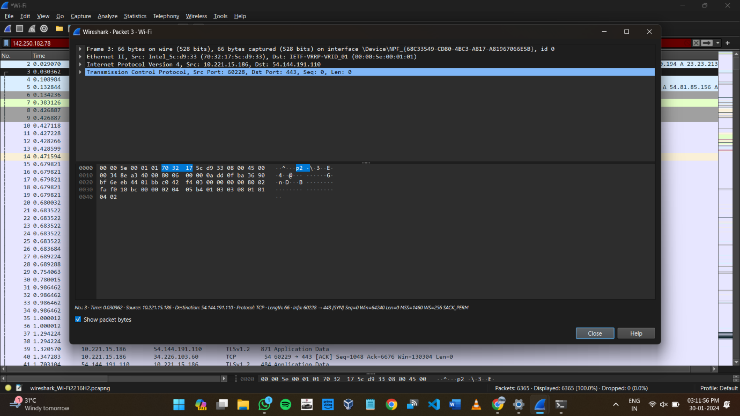

**Tenable Nessus**

Tenable Nessus is a vulnerability scanner used to identify vulnerabilities, misconfigurations and compliance issues in computer system and networks.

It is commonly used for security assessments and ensure compliance with security policies.

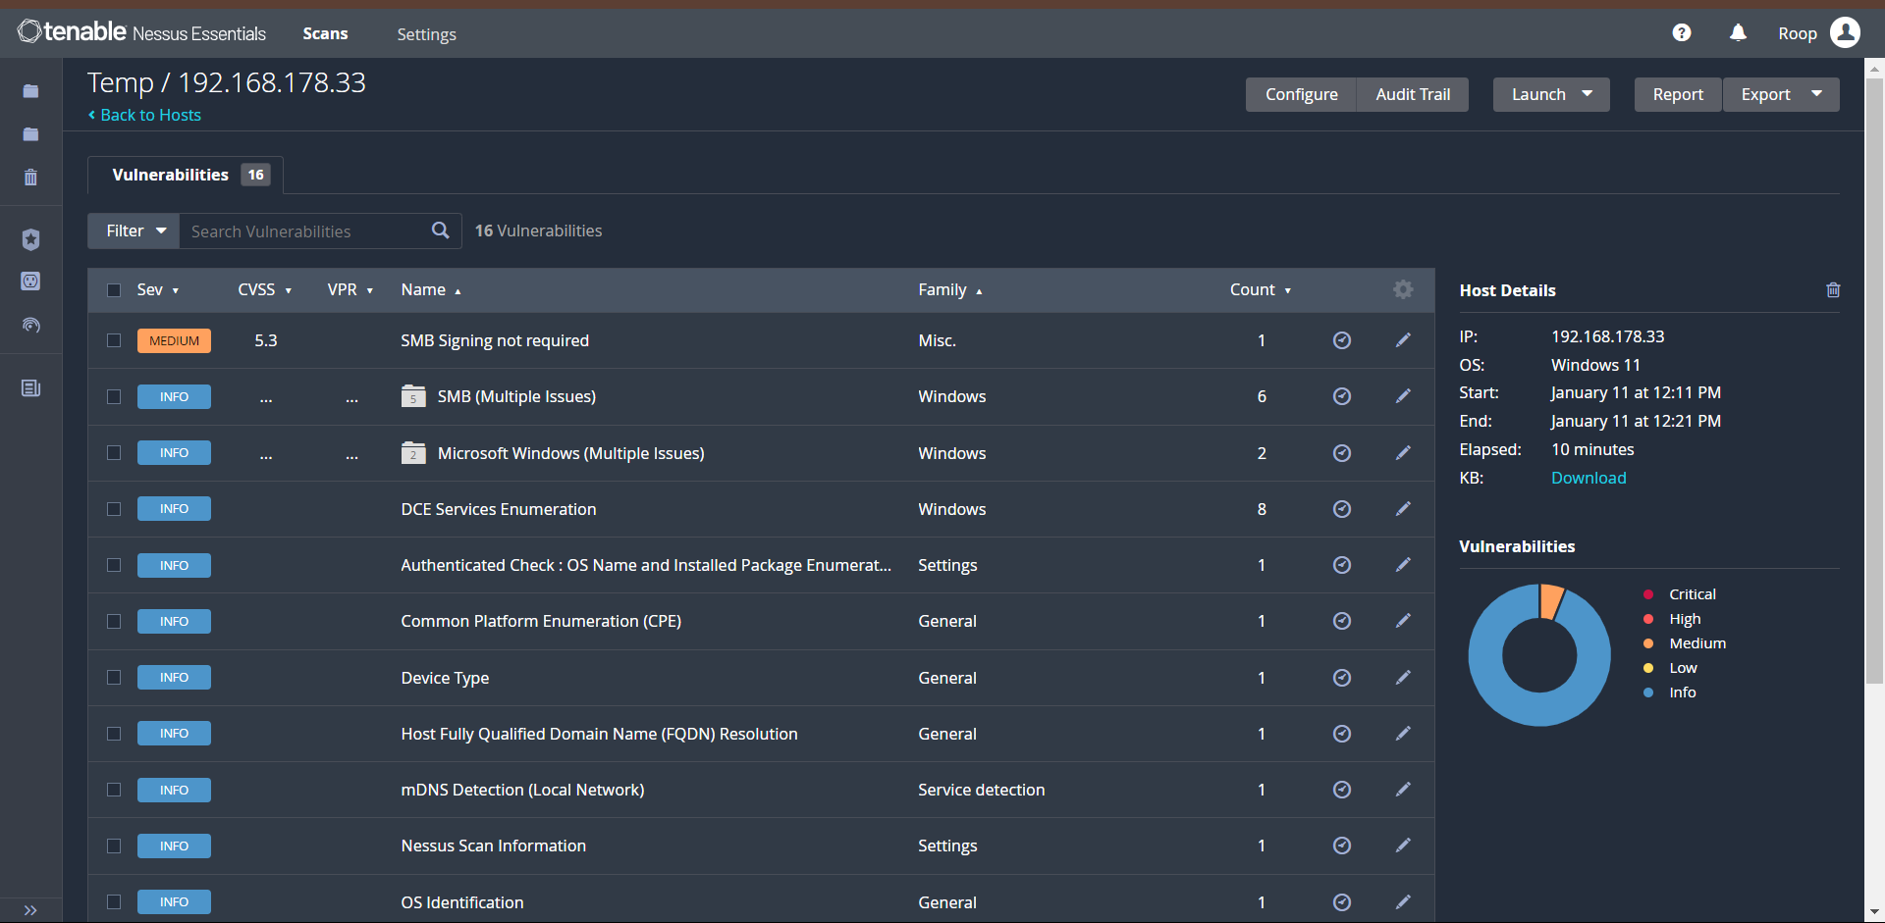

**Qualys**

It is a cloud based security platform that offers various service such as vulnerability management, web application security, policy compliance.

It helps organisation to monitor and protect their IT assets.

**My Experience with Qualys**

I scanned my laptop using Qualys Express, which generated a report that detected some vulnerabilities sorted by severity level. Based on the severity, I solved the issues, addressing vulnerabilities with high severity first because they can have a significant impact on our device.

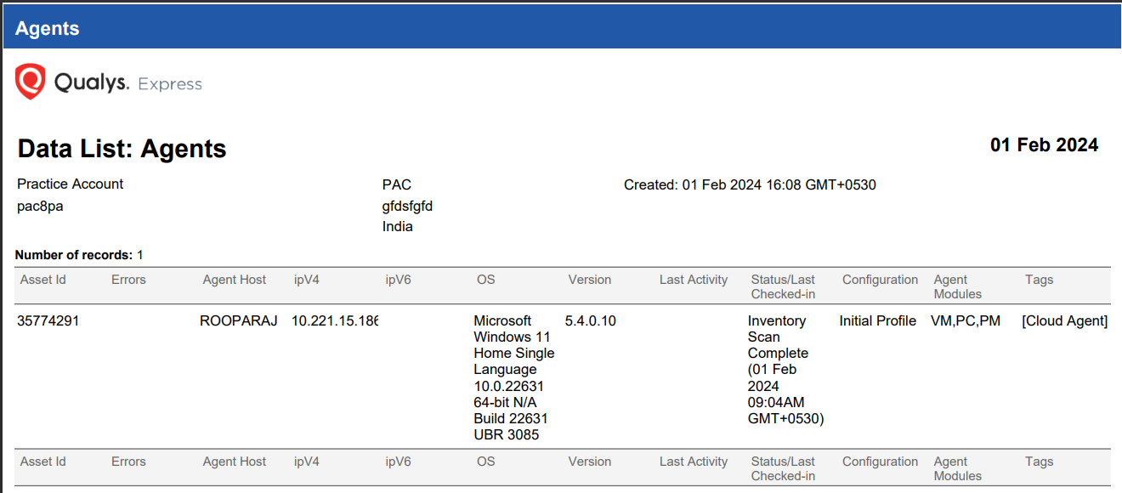

**Symantec**

Symantec provides a range of cyber security solutions, including antivirus software, endpoint protection.

Its tools are used to protect against data breaches and other security threats.