Underwater Image Enhancement with Multi-Scale Residual Attention Network

Underwater images often contains blur and unclear images and its very costly to build camera to capture clear image from ocean so many organizations are concentrating on developing software based applications which can clear ocean images and many algorithms are based on Colour restoration or GAN based image enhancement whose performance is not up to the mark.

To further enhance image quality author of this paper has introduced Multi-Patch Residual Attention deep learning algorithm which is enhancing image quality up to 85%. To train propose algorithm author has UIEB dataset which contains 890 clear images and 890 raw images. After training with this dataset propose Multi-Patch model able to give SSIM up to 86% and PSNR as 23%. SSIM refers to image similarity with enhance and original image so the higher the similarity the better is the predicted image quality. PSNR refers to noise in the image so the lower the PSRN the higher is the quality.

Many existing underwater image enhancement algorithms using CNNs and GANS have been proposed, but they are not as advanced as other image processing methods due to the lack of suitable training data sets and the complexity of the issues. To solve the problems, we propose a novel underwater image enhancement method which combines the residual feature attention block and novel combination of multi-scale and multi-patch structure. Multi-patch network extracts local features to adjust to various underwater images which are often Non-homogeneous. In addition, propose algorithm includes multi-scale network which is often effective for image restoration.

To train Multi-Patch model we are using below dataset

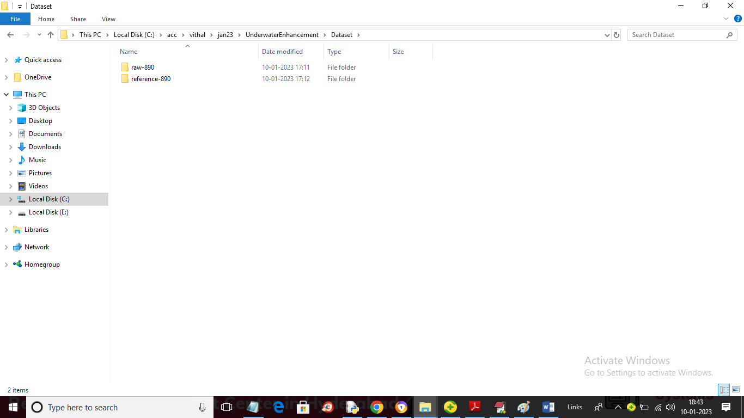

In above screen we can see Dataset folder contains 2 folders and just go inside any folder to view its images. In above folders ‘Reference’ are the clear images and ‘Raw’ are the unclear images and in below screen you can see some images from the dataset

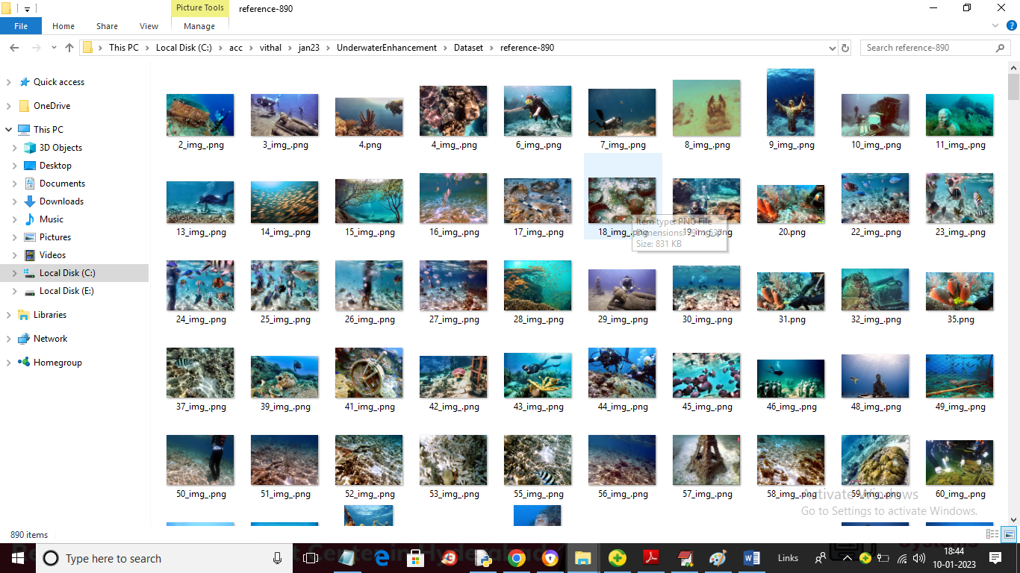

So by using above images we will trained the model

To implement this model we have implemented following modules

1. Upload UIEB Dataset: using this module we will upload dataset to application and then read out all reference and raw images
2. Generate & Load Multi-Patch Model: using this module we will input both reference and raw image to Multi-Patch algorithm to trained a model and after training this algorithm will perform prediction on test images and then calculate SSIM and PSNR for test images enhancement.
3. Upload & Enhance Image: using this module we will upload RAW unclear image and then Propose Multi-Patch model will enhance image and dis play output

SCREEN SHOTS

To run project double click on ‘run.bat’ file to get below screen

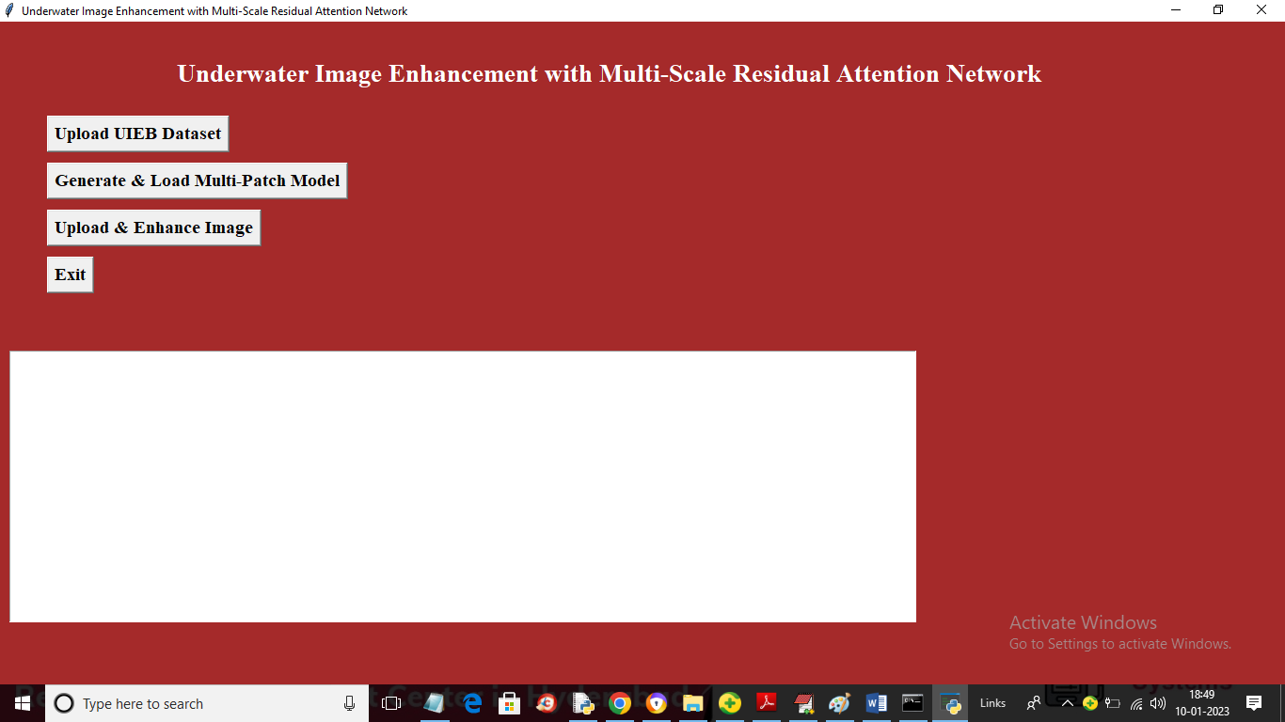

In above screen click on ‘Upload UIEB Dataset’ button to upload dataset and get below output

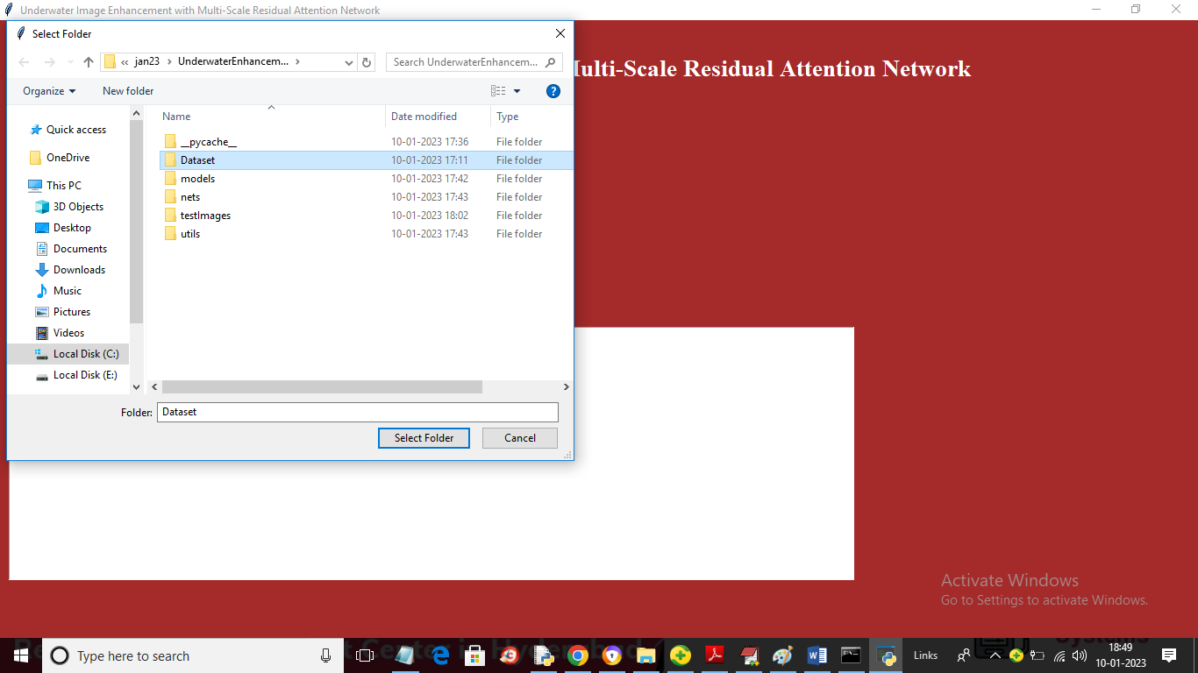

In above screen selecting and uploading ‘Dataset’ folder and then click on ‘Select Folder’ button to load dataset and get below output

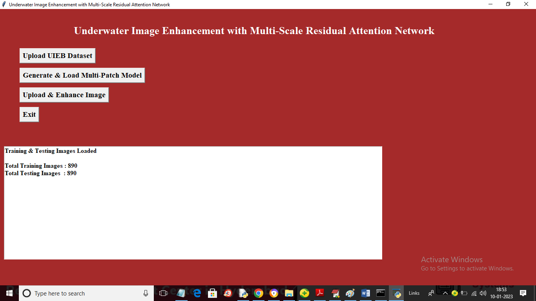

In above screen dataset loaded and we can see references and RAW contains 890 and 890 images and then click on ‘Generate & Load Multi-Patch Model’ button to generate model and get below output

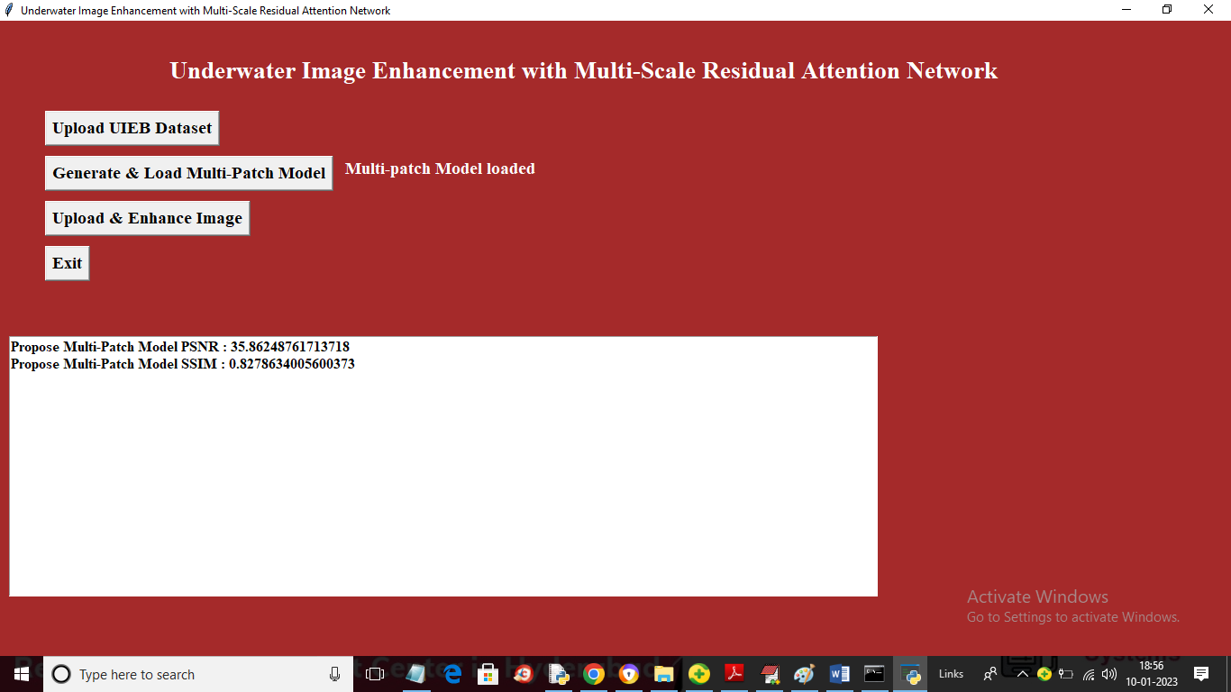

In above screen with this model we got SSIM as 82% and PSNR as 35% and now click on ‘Upload & Enhance Image’ button to upload test image and get below output

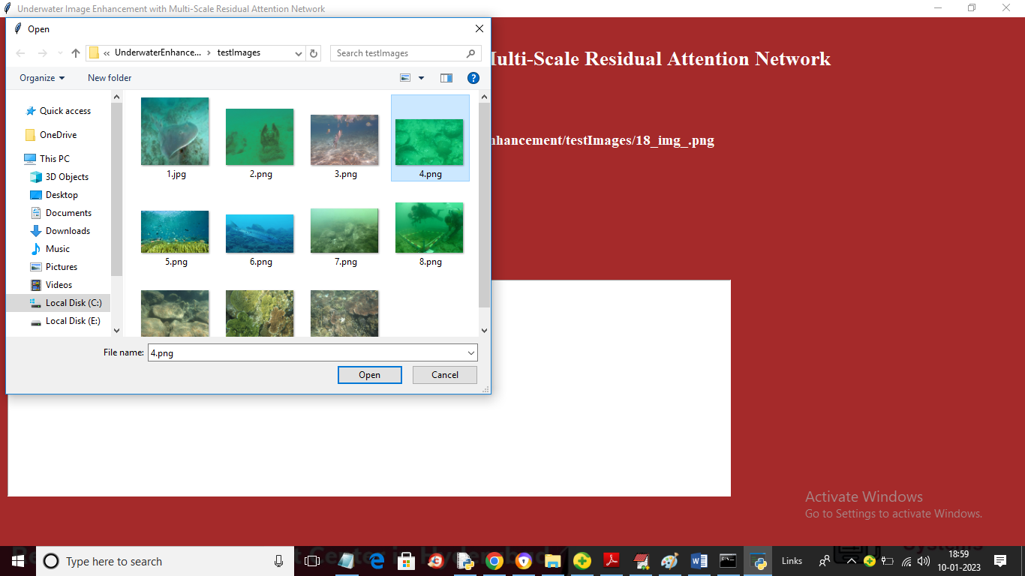

In above screen selecting and uploading ‘4.png’ and then click on ‘Open’ button to load image and get below output

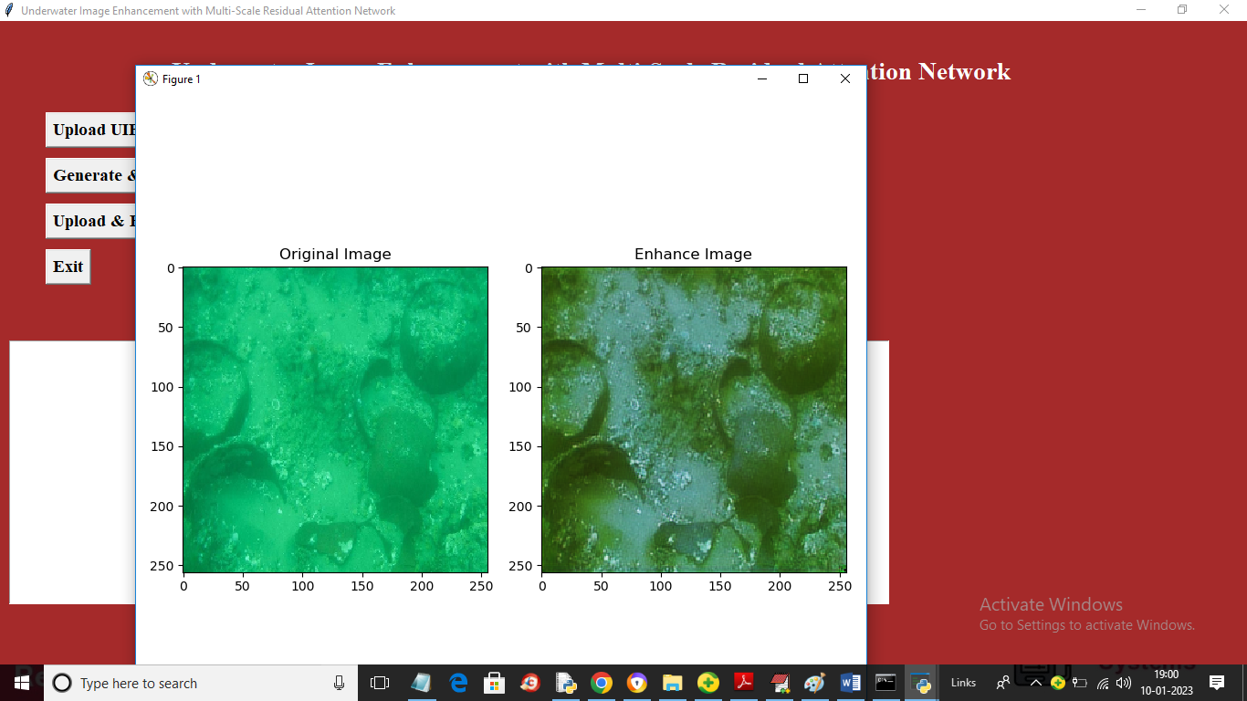

In above screen first image is the original image and second is the predicted enhance image. Similarly you can upload and test other images

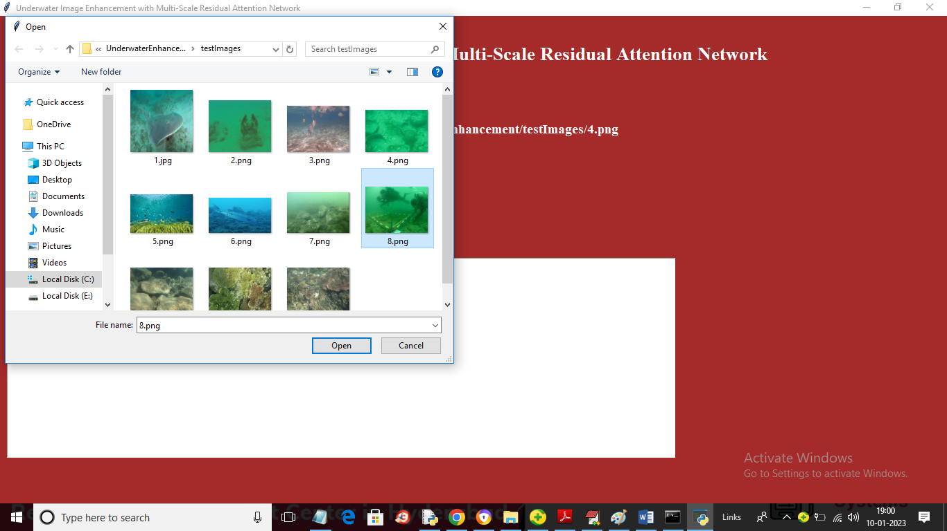

In above screen uploading 8.png and below is the output

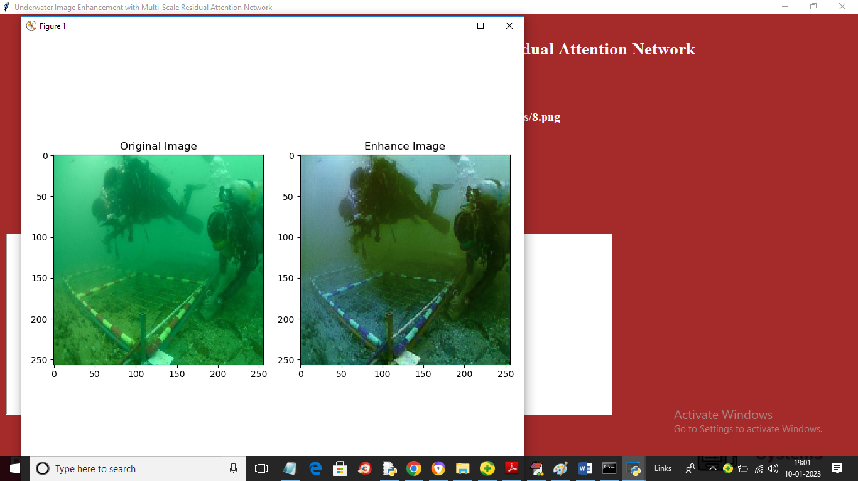

In above screen you can see enhanced image

