***Implementation & Recognition of the solutions for OWASP ZAP***

1)

Located the Options +Indexes line in the apache config file. Apache2.conf. Removed the +Indexes from that line.

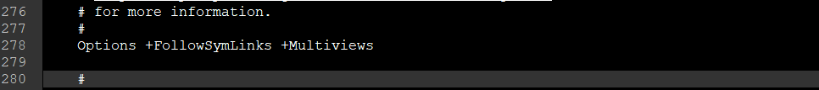

2)

Implemented X-Frame. Apache config file. Apache2.conf.



3)

Header set for cache control and pragma. Apache2.conf.

A close up of a logo

Description generated with very high confidence

4)

Implemented the autocomplete feature to be off. login.html.

A picture containing object, computer, keyboard

Description generated with high confidence

5)

Web browser XSS protection has been enabled. Apache config file. Apache2.conf.

A close up of a screen

Description generated with very high confidence

6)

The Anti-MIME-Sniffing Header X-Content-Type-Options has been set to nosniff. Apache config file. Apache2.conf

A close up of a screen

Description generated with high confidence