ANCOS LAB
Ecole Centrale de Nantes
2017/2018



Writers | Professor
NARDOUR Housseyne  BLAUD Pierre | PLESTAN Franck  TAHOUMI Elias

Introduction
The report is divided into four parts. First one deals with an input-output linearization. Second one,

System definition

System definition is extracted from [REF] :
(1)

Ne assume that the parameter is small, ε=10⁻³

First, the output of the system are declared as :

(2)

Then, the system is rewritten as:
(3)

Next, the system becomes:
(4)

Open Loop simulation
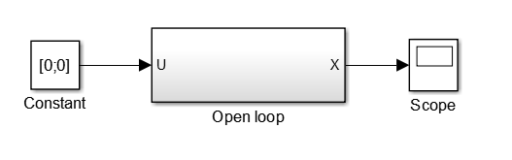
Illustration 1: Open Loop system with Simulink.
The system is simulated with Simulink, our simulation has shown us that the system is instable.
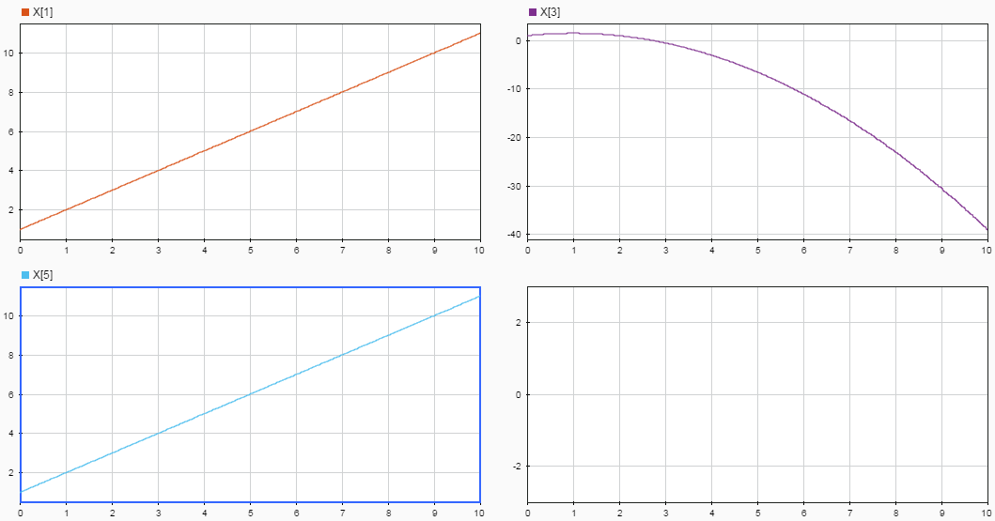
Illustration 2: System states.

We can see from Illustration 2 that the system is instable.

Part.1 : decoupling and linearization of the system

Decoupling and linearization
Decoupling and linearization equations are :

(5)

And
(6)

Thus,
(7)

Thus,
(8)

B0 is equal to :

(9)

This system can be decoupled because B0 is invertible. There is an internal dynamic because the relative degree is lower than the degree of the system.

Decoupling and linearization can be done if we take:

(10)

Then, it can be written as:

(11)

Remark, we have two systems decoupled and linear.

Static state feedback
The first system can be written as:
(12)

The static state feedback is :
(13)

Pole placement design is:
We calculate the characteristic polynomial :

(14)
It yields

(15)

Then

(16)
And

(17)

We get :

(18)

Simulation
The system is coded in Simulink :
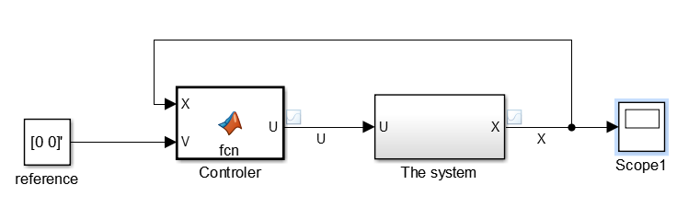
Illustration 3: Simulation of the closed loop system
Simulation results are :

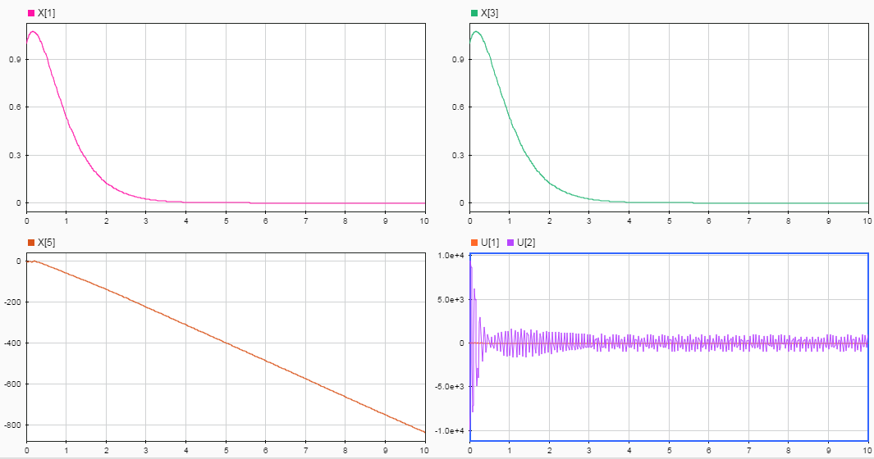
Illustration 4: States simulation
We note that the feedback control has ensured the stability of x1 and x3. However the internal dynamic x5 (Θ ) is instable.

Part.2 : stabilization of all states x, z and Θ
In order to simulate the system, states variables of the system are :

(19)

And

(20)

After four derivation of the outputs, the system is equal to:

(21)

(22)

(23)

(24)

(25)

Such that:
(26)

And
(27)

Remark:
- the system can be decoupled as long as u1 is different from 0;
- the system has no internal dynamic because its relative degree = 8. Which is the same of the system ;
In order to have a decoupled system, the input is equal to:

(28)

The system will be :

(29)

Remark : we have two linear decoupled systems.

The state space representation of each sub-systems is:
We denote that:

(30)

The system can be written as :

(31)

With

(32)

We take ω₁ = - k * q with

(33)

Simulation is equal to :

The degree relative is equal to 2 for y1 and 2 for y2

