ROSE
REAL-TIME FINANCE
A new financial infrastructure layer where trading, settlement,
interest payments and liquidity coordination happen continuously.
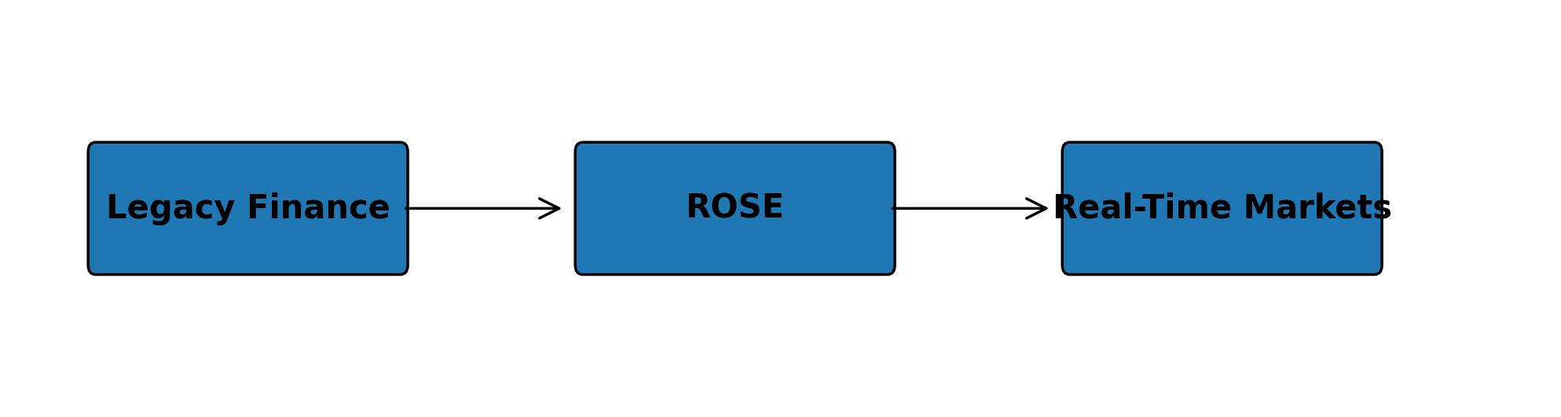
“Modern finance is digital on the surface.
ROSE is designed to make it digital underneath.”
The Hidden Problem
Markets move in milliseconds, yet settlement still takes hours or days. Liquidity remains trapped overnight while risk accumulates. Modern finance still operates largely on batch-processing infrastructure inherited from a pre-digital era.
A Truly Digital Market
ROSE is built around a different premise: finance should happen in real time. Trading, settlement, interest payments, and liquidity coordination occur continuously rather than in delayed intervals.
Real-Time Lending
ROSE introduces continuous intraday money markets where liquidity can be borrowed or lent instantly while capital remains dynamically active at all times.
Intrinsic Time
Traditional finance measures markets according to the clock. ROSE measures markets according to meaningful events. When markets are calm, financial time slows down. When volatility accelerates, financial time accelerates with it.
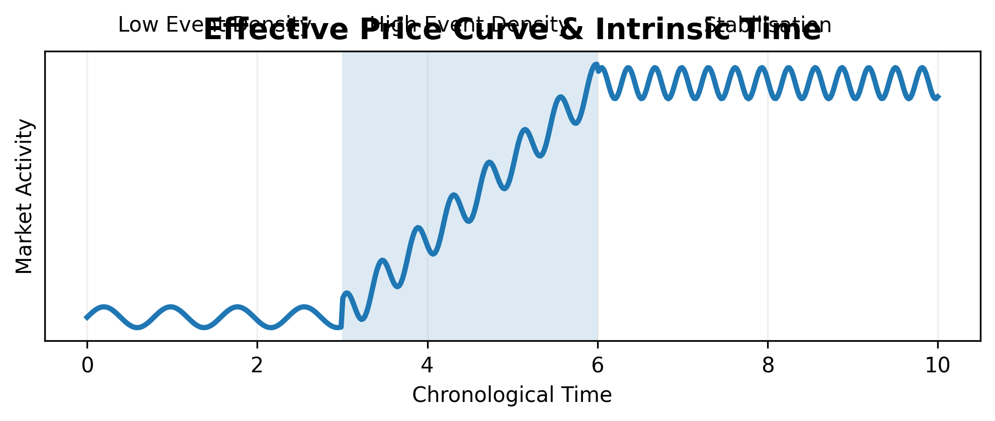
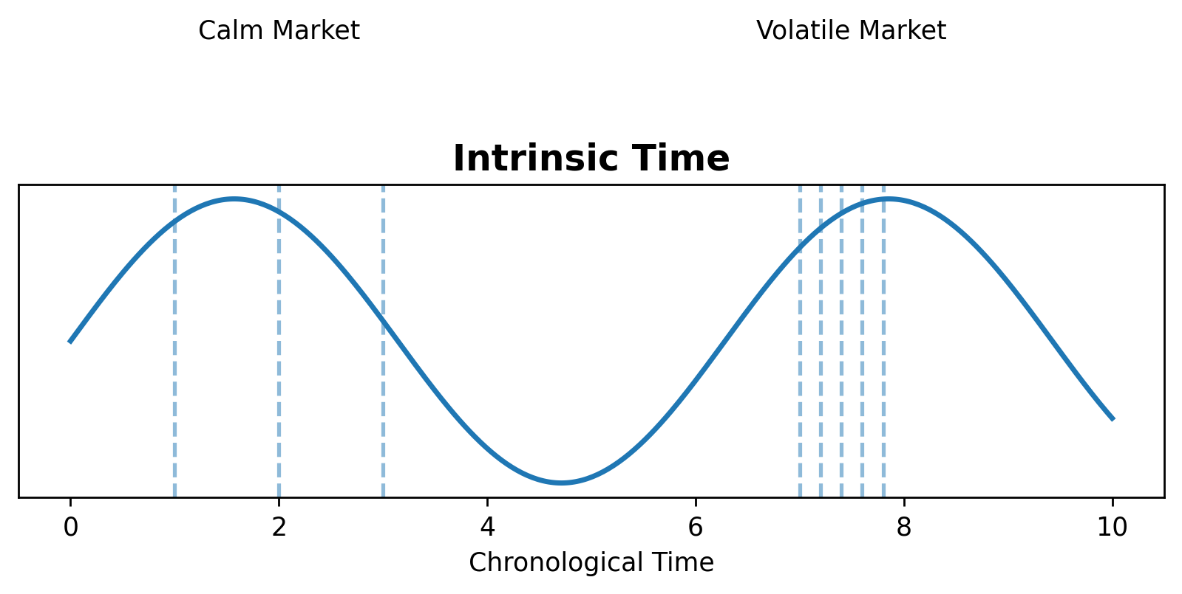
Coupled Infrastructure
ROSE introduces paired financial structures designed to remain delta-balanced while recycling liquidity internally across the system. Instead of leaving collateral dormant, liquidity continuously circulates through the infrastructure itself.
Long-Term Stewardship
ROSE operates through a Swiss non-profit structure designed around long-term infrastructure development. A substantial part of the generated economic surplus is intended to support broader societal, scientific, and environmental initiatives.
Selected Contributors
- James Glattfelder — Complexity researcher and author
- Fabrice Croiseaux — CEO of InTech
- Rémy Klammers — CEO of Namara Wealth Advisors
- Annie-Laure — Systems architecture contributor
- Thibault Verbiest — Founding Partner of AUSIA
- Theo Helfenstein — Financial architecture contributor
- Ryan Anderson — Systems engineering contributor

