# Project Overview

The **Student Score Analyzer** project is designed to analyze student performance based on their grades and subject scores. Using **Python**, **Jupyter Notebook**, and the **Pandas** library, this project processes dataset information, computes key insights, and visualizes grade distributions.

# Tools & Technologies Used

* **Python** (for data processing)
* **Jupyter Notebook** (for interactive coding)
* **Pandas** (for data manipulation)
* **Matplotlib** (for data visualization)

# Dataset Details

The dataset (student_scores_100_with_grades.csv) contains:

* Student names
* Math scores
* Grades assigned to students

The first few rows of the dataset can be displayed using:

import pandas as pd

**df = pd. read_csv("student_scores_100_with_grades.csv")**

**print (df. Head ())**

# Data Analysis

### Highest & Lowest Marks Per Student

The following code identifies the **minimum and maximum marks per student**:

**student_perf = df. groupby("Name”) ["Math"]. agg (["min", "max"])**

**print ("Student Performance Summary:\n", student_perf)**

This helps track individual student performance trends.

## Grade Distribution Analysis

We visualize the **grade distribution** using bar charts:

**import matplotlib.pyplot as plt**

**df["Grade"].value_counts (). plot(kind="bar", color="skyblue", edgecolor="black")**

**plt.title("Grade Distribution")**

**plt.xlabel("Grades")**

**plt.ylabel("Number of Students")**

**plt.show()**

# Visual Representations

## Bar Chart: Grade Distribution

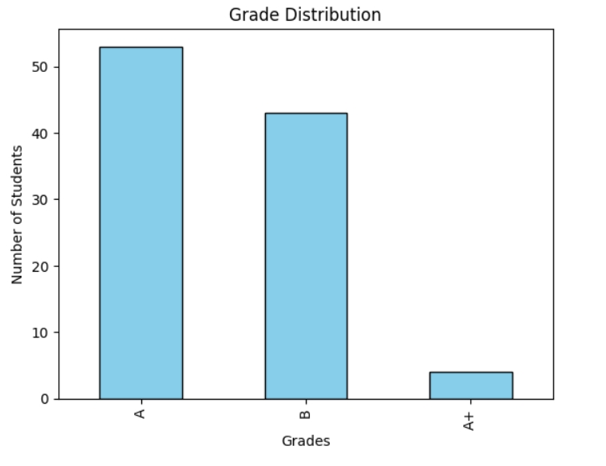

# Pie Chart: Grade Breakdown

To enhance visualization, we use a **pie chart** to display grade distribution:

**grade counts = df["Grade"].value counts ()**

**plt. figure (figsize= (6, 6))**

**plt.pie (grade counts, labels=grade_counts. index, autopct="%1.1f%%", startangle=140,**

**colors= ["#ff9999", "#66b3ff", "#99ff99", "#ffcc99"])**

**plt.title("Grade Distribution")**

**plt. show ()**

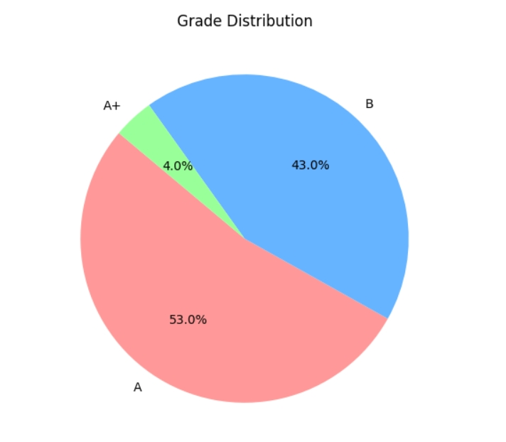

# Conclusion

This project effectively analyzes student scores and grades, offering insights into student performance trends. The visualization elements make the analysis more intuitive and easier to interpret.