**Assignment 5**

**TaskA:**

## Task A

1. What is the expected reaction time for the individual called “the dude” in [our data set](https://docs.google.com/spreadsheets/d/1y8Hvj8AeIt1Nl7b6yNQ6-z9_XlUAE7ftHM2sSmA7gsM/edit?usp=sharing) (corresponding to ind = 3 in python and ind=4 in STAN/matlab/julia)?
   1. Answer this by providing a histogram and appropriate summaries (e.g. mean, mode, median, 95% credible interval of the expected reaction time).

**Mean: 346**

**Median: 334**

**HDI =[249,431]**

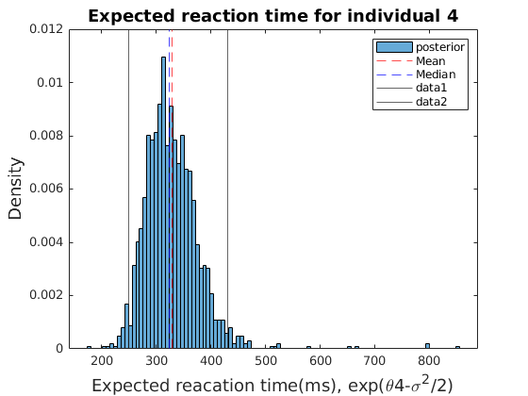

* 1. With only one measurement, how are we able to give a 95% credible interval for “the dude”? This is not possible using frequentist statistics.

1. What is the group’s reaction time?
   1. Given a random new individual from our group, e.g. someone that simply “forgot” to do the test, what is the:

**Mean: 345**

**Median: 334**

**HDI =[303,380]**

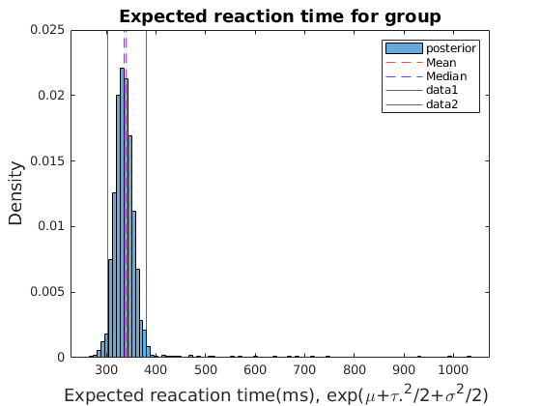

* + 1. expected reaction time for that random individual?

**Mean: 342**

**Median: 316**

**HDI =[184,606]**

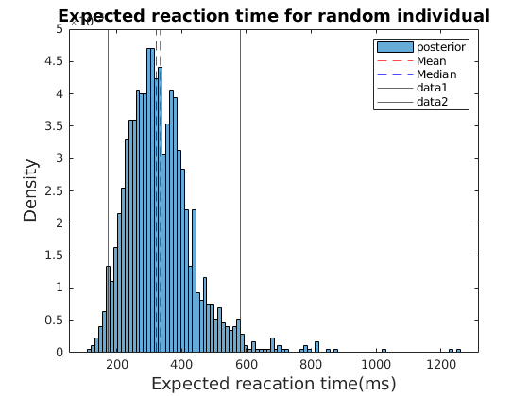

* + 1. predicted reaction time for a single measurement for that individual? (provide the posterior predictive distribution for the reaction time) In STAN you can do this in the “generated quantities { }” section in your STAN code. In python/matlab/julia: 1) pick a posterior sample from mu, tau and sigma given your data. 2) simulate a new theta given these samples, i.e. theta~N(mu,tau). 3) simulate a reaction time measurements given this theta and sigma (from step 1 above), i.e.

