**Assignment 6**

1. Do the two groups (i.e. adults and kids) have different log (reaction times) and if so what is the effect? (provide posterior point and interval estimates (mean, hdi, etc.))

Yes, there is difference in reaction time between two group this is phi. Phi distribution is plotted as figure below.

**Mean: 0.37**

**Median: 0.37**

**HDI = [0.194,0.564]**

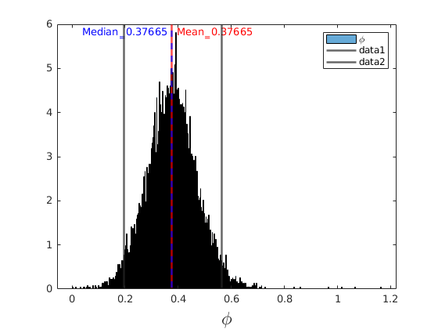

1. Posterior of tau is different compared to the previous case of using no indicator for kids and adults (i.e. Assignment 5).

a. Provide plots and estimates (mean, hdi, etc.) of tau in both cases (i.e. Assignment 5 and 6)

b. Why are they different?

c. What does this mean in terms of shrinkage?

a) posterior distribution for tau is plotted for assignmetn5, and assignment 6 classified with kids and adults

**Mean_asi5: 0.277**

**Median_asi5: 0.282**

**HDI_asi5 = [0.21,0.37]**

**Mean_asi6: 0.226**

**Median_asi6: 0.376**

**HDI_asi6 = [0.172,0.301]**

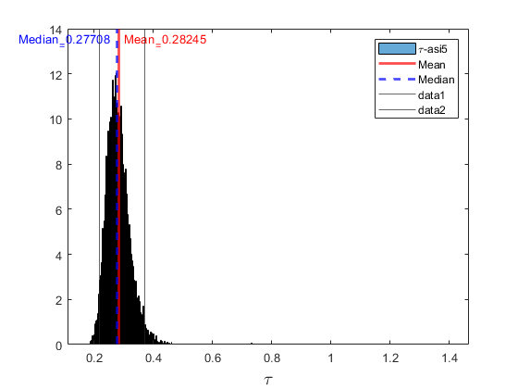

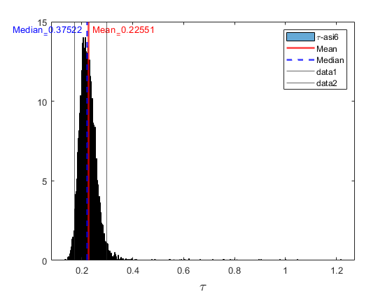

b) because in assignment 6 there is additional parameter to fit the data.

normal(mu + phi,tau).

c) Here there is two distribution, adult and kids, the reaction time distribution is denser and the shrinkage is increased compared to assignment 5 only with one group.

1. Plot the two prior distributions for the expected log(reaction time), one for kids and one for adults (i.e. prior for theta in Gelman’s approach and prior for (theta+phi*child) in Kruschke’s approach when child = 0,1). Compare against a single prior of theta in Assignment 5. When plotting the prior you may plot it using the mean value of its dependent parameters.
   1. Explain what you see and can you give an explanation to why the curves look like they do?

**Mean_asi5= 5.75**

**HDI_asi5 = [5.17,6.32]**

**Mean_adult:5.69**

**HDI_adult = [5.19,6.11]**

**Mean_kids:6.03**

**HDI_kids = [5.56,6.51]**

here we have two groups, but in assignment 5 there was only one group which seems the prior is wider and located between two groups shifted a little to Adult group. Here the prior for kids group is added by phi parameter to adults groups so we can see it is shifted.

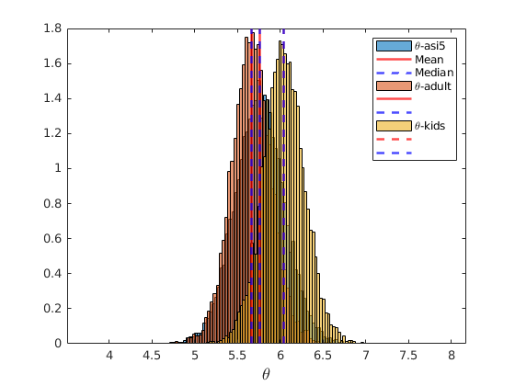

1. Provide posterior predictive distribution with knowledge of if the individual is a child and one without knowledge of if it is a child. If you do not have time to do this numerically, it is enough to explain how to do this.
   1. To provide the latter distribution we need to make assumptions on the fraction of adults and kids in our material.
      * Given number of children and the total number of participants in our study, you may use posterior predictive draws from a bernoulli distribution (i.e coin flip examples we have worked with in previous assignments). To simulate this you may
        + Pick a posterior sample of a theta (representing the probability of children) given the fraction of children and adults in our data set.
        + Draw a new participant given this theta.
        + If the new participant is a child use child=1 otherwise use child=0.
        + …. your code to generate samples from the posterior predictive distribution of the reaction time given knowledge of child ….
      * Another alternative is to pick a fixed fraction given knowledge of it from the entire population. However, in our case the participants in our study is not representative of any population what I know of.

**Mean_adult: 292**

**Median_adult: 287**

**HDI_adult = [164,507]**

**Mean_kids: 437**

**Median_kids: 418**

**HDI_kids = [233,732]**

