**Assignment 7**

1. **Tasks**
2. When answering the questions below, remember to transform theta back to the original scale if needed.
3. **1.** Give an interpretation of theta0 and theta1 in plain text. Explain to a non-statistician what these two parameters mean.

Assuming the average log reaction time is a linear function of the attempts number and follow a normal distribution, then we can consider theta_0 as intercept (reaction time at attempt zero) and theta_1 as the slope of the line.

**2.** Give an interpretation of all the phi:s and mu:s in plain text. Explain to a non-statistician what these parameters mean. Try to do it in the original scale, i.e. in terms of average reaction time rather than log reaction time.

Considering the linear regression model described above in number of attempts and reaction time (theta_0+theta_1*x), we assumed Thea_0 as the reaction time for each individuals at zero attempt, so mu_0 is the average of theta_0 representing the average reaction time of an individual. And phi_0 describe the shift between the mean reaction time of the kids and adults.

Moreover, Theta_1 was assumed as rate change in each attempt for an individual, So the mu_1 represent the average of theta_1 and phi_1 is the shift between the rate change of adults and kids.

**3.** Provide the expected reaction time for the first attempt (x=1) and the fifth attempt (x=5) for the first individual (Oliver), third individual (Jesper) and fourth individual (“the dude”), i.e. individuals j = 0,2,3 in python or j=1,3,4 in julia/matlab. See my (soon to come) results below if you get similar results.

**First individual (Oliver):**

**Mean_(x=1) = 545**

**HDI_(x=1) = [468.1971,** **635.3432]**

**Mean_(x=5) = 477**

**HDI_(x=5) = [404.6737,** **550.9850]**

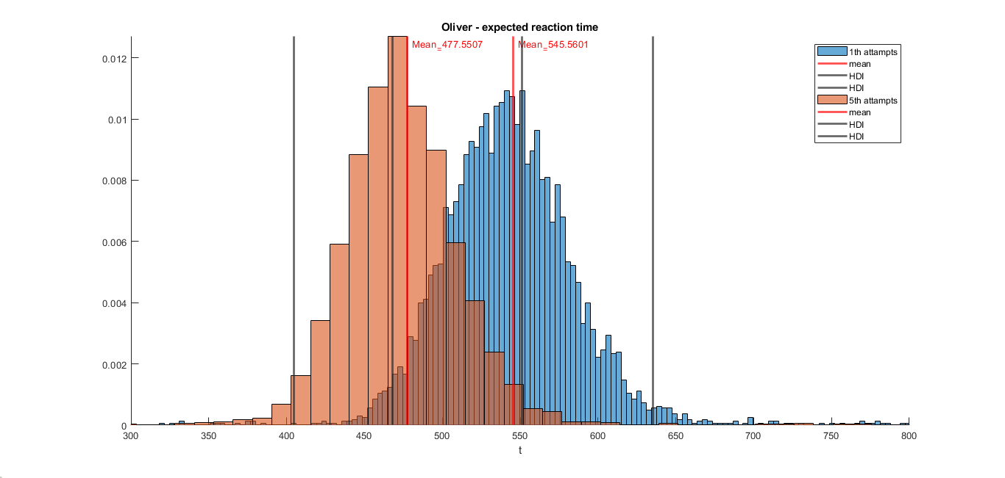

**Third individual (Jesper):**

**Mean_(x=1) = 377**

**HDI_(x=1) = [323.0544,** **420.1824]**

**Mean_(x=5) = 349**

**HDI_(x=5) = [312.7939,** **387.3905]**

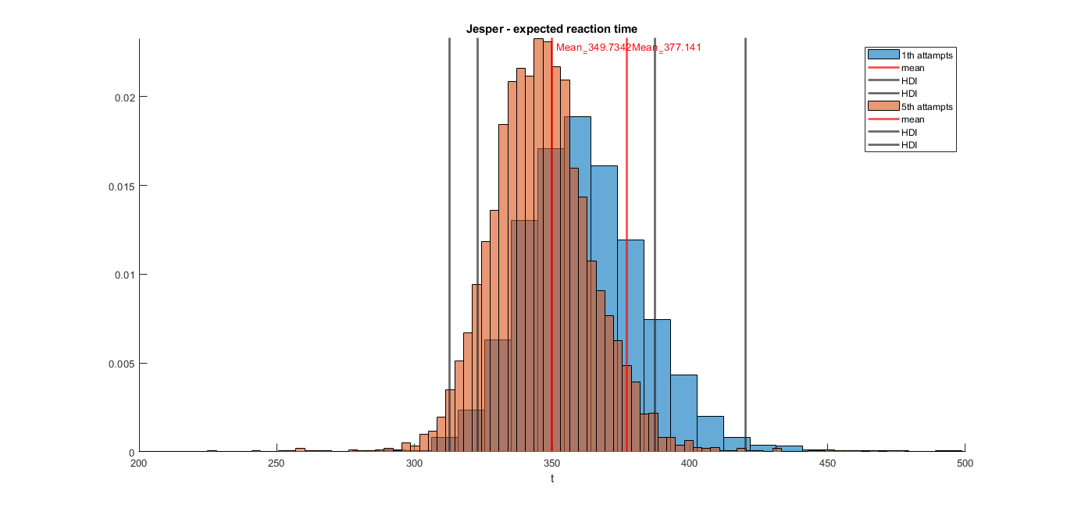

**Fourth individual (“the dude”):**

**Mean_(x=1) = 322.9518**

**HDI_(x=1) = [243.7365,** **421.9509]**

**Mean_(x=5) = 320.0360**

**HDI_(x=5) = [226.6187,** **415.5910]**

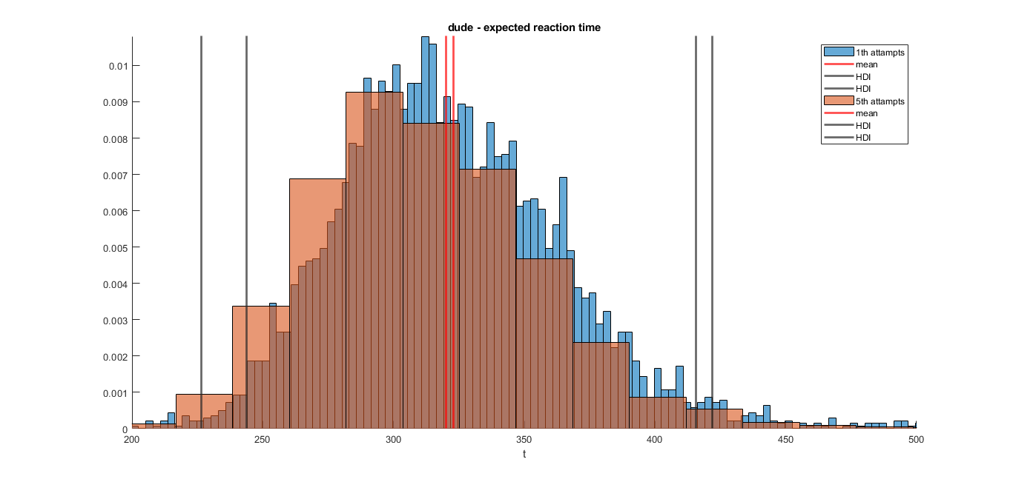

**4.** Discuss possible model improvements to our model.

* 1. What would happen if x goes to infinity? Is this physically realistic? It seems like there is no way to get a reaction time less than 100ms looking at the website and our data.

By increasing x and goes to infinity, the reaction time would decrease and reach to zero in most of the models, but it could be wrong and unrealistic.

* + - How can we improve the model?
    - Should we change distributions (likelihood, priors)? What options do we have and why?

**5.** Notice that your sigma has decreased in Assignment 7,but are the same in 6 and 5. Why is that do you think?

In previous assignments (5 and 6), the model is defined in different way compared to this assignment (7), because more parameter is used here, so it could fit the data better and decrease the sigma with lower value.

**6.** When reporting your findings, you may follow section 25.1 on how to report Bayesian analysis using MCMC. However, this is too cumbersome for this Assignment. My suggestion is that you read section 25.1 and create the same bullet list as Kruschke has. In your bullet list, explain what you have not done according to Kruschke and similarly what you have done.

