ITA0612-Machine Learning

CO1-AT2- CONCEPT MAPPING

Submitted By:ROSHNI M(192424037)

Submitted To:Dr. Shri Vindhya A

1. Design a machine learning system for health
analysis to predict diseases such as heart disease or diabetes using patient
data including age, blood pressure, glucose level, and lifestyle factors.
Explain the choice of suitable algorithms and justify their selection. Describe
the steps involved in data preprocessing, feature selection, and model training
to ensure accurate and reliable predictions.

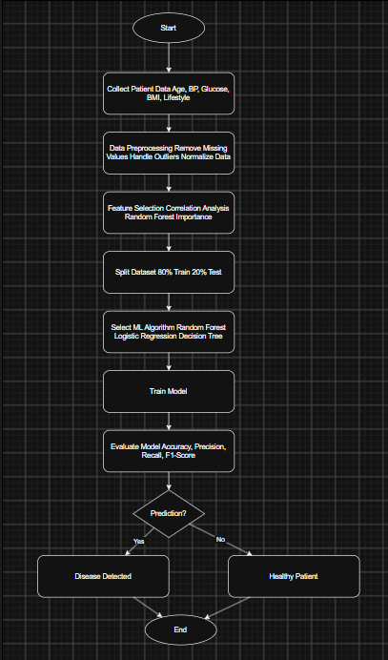
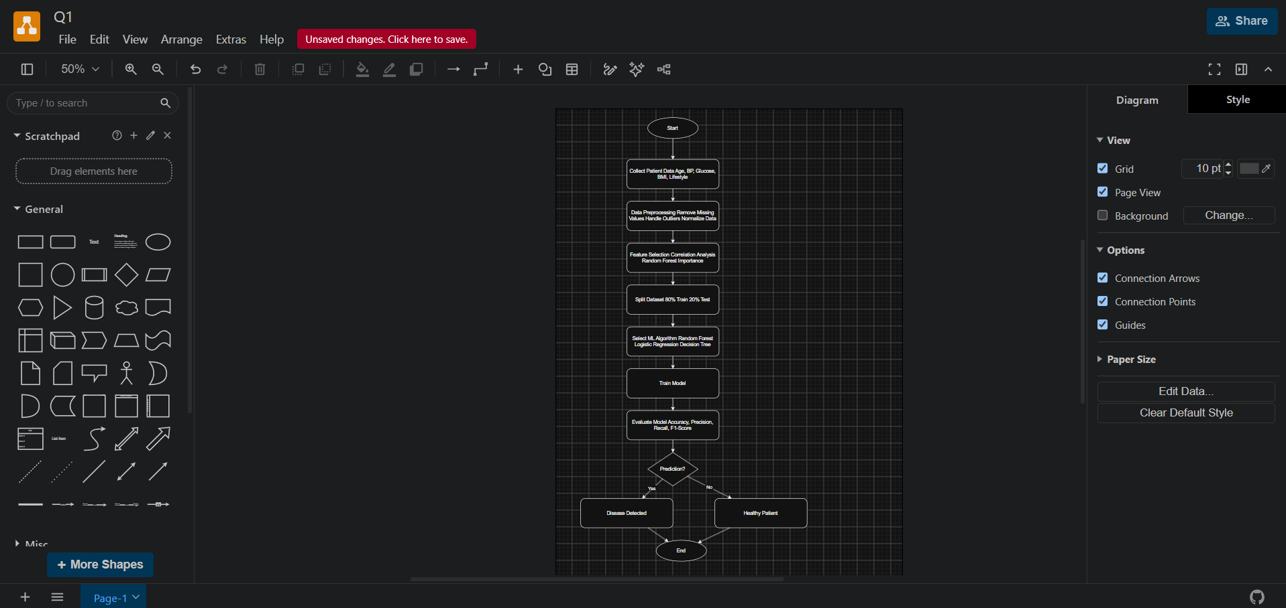
2. . In the context of the Find-S algorithm,
consider a dataset used to determine whether a loan should be approved based on
attributes such as Employment Status, Salary Level, Credit Score, and Loan
History. Apply the Find-S algorithm to derive the most specific hypothesis
consistent with the positive examples.
