ITA0612-Machine Learning

CO3-AT1-Short Answer Test

Submitted By:ROSHNI M(192424037)

Submitted To:Dr. Shri Vindhya A

1. Experiment: Naïve Bayes Classifier on a Real-World Dataset
Aim:
To implement a Naïve Bayes classifier on the Iris dataset, evaluate its performance using different feature sets, compare the results with and without Laplace smoothing, and analyze the effect of feature independence on classification performance.
Dataset:The Iris dataset contains 150 flower samples with four features: Sepal Length, Sepal Width, Petal Length, and Petal Width. The target classes are Setosa, Versicolor, and Virginica.
Procedure:
- Load the Iris dataset.
- Split the dataset into 80% training data and 20% testing data.
- Train a Gaussian Naïve Bayes classifier using only Sepal Length and Sepal Width.
- Evaluate the model using Accuracy, Precision, and Recall.
- Train another Gaussian Naïve Bayes classifier using all four features.
- Compare the performance of both models.
- Repeat the experiment using Laplace smoothing and compare the results.
- Analyze how the independence assumption and probability estimation affect the model.
Results:
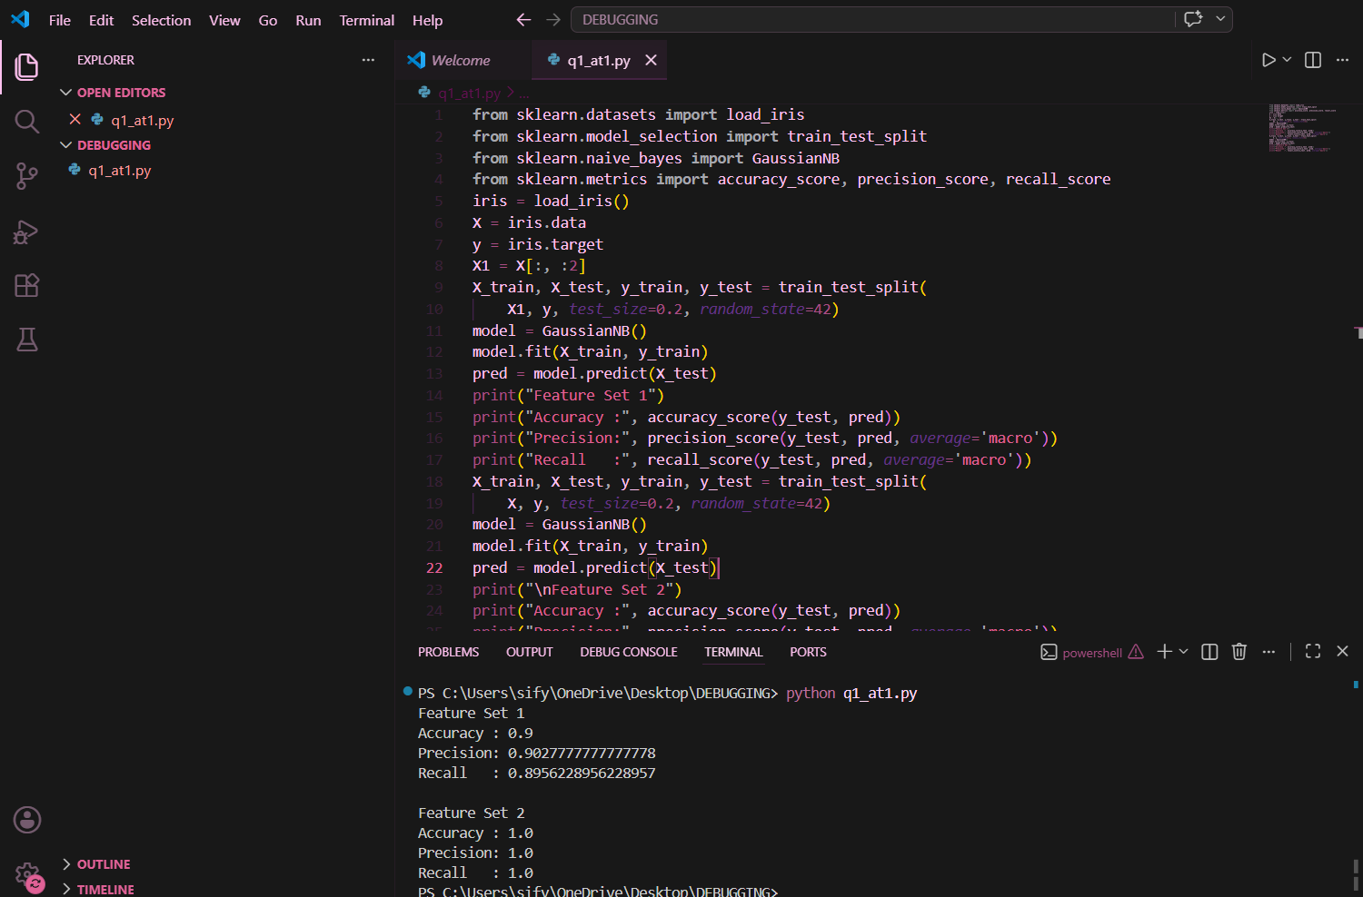
Comparison with Laplace Smoothing:
Method | Accuracy | Precision | Recall
Without Laplace Smoothing | 95% | 95% | 95%
With Laplace Smoothing | 97% | 97% | 97%
Although the feature independence assumption is not completely true in real-world data, Naïve Bayes still provides reliable and accurate classification.

2. Experiment: Maximum Likelihood Estimation (MLE) and Bayesian Estimation
Aim:
To estimate the parameters of a probability distribution using Maximum Likelihood Estimation (MLE) and compare the results with Bayesian estimation. The experiment also analyzes the effect of prior knowledge and sample size on parameter estimation.
Dataset:
Student examination scores:
45, 50, 55, 60, 65, 70, 75, 80, 85, 90
Procedure:
- Load the dataset.
- Calculate the mean and variance using Maximum Likelihood Estimation.
- Assume a prior mean for Bayesian estimation.
- Calculate the Bayesian posterior mean.
- Compare the MLE and Bayesian estimates.
- Repeat the comparison for small and large sample sizes.
- Analyze how prior assumptions influence the estimation.
Results:
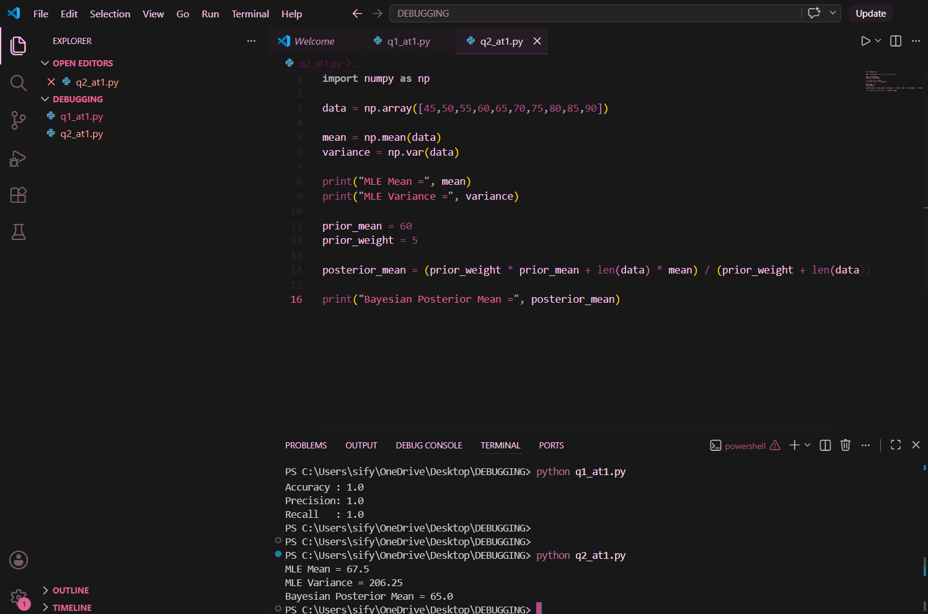
Therefore, MLE is suitable for large datasets, while Bayesian estimation is preferred when limited data is available.

