FORECASTING MONTHLY MAIZE PRICES ACROSS KENYAN COUNTIES TO SUPPORT FOOD SECURITY PLANNING

Prepared by: Sharon Rosina Wamalwa
Course: DSCI 725 — Data Mining for Competitive Advantage
Institution: The University of South Dakota
Instructor: Thomas Tiahrt, Ph.D.
Date: April 2026

Contents
EXECUTIVE SUMMARY 4
INTRODUCTION 4
BACKGROUND RESEARCH 5
Maize Price Volatility in Kenya 5
Time-Series Forecasting in Agricultural Markets 5
Food Security Early Warning Systems 6
PROBLEM PRESENTATION 6
SPECIFICATION AND DESIGN 7
Response Variable 7
Predictor Variables 7
Predictive Purpose 7
Evaluation Metrics 7
DATA ACQUISITION 8
Commodity Selection 8
Raw Observation per County 8
Data Visualization 12
DATA EXPLORATION 13
DATA TRANSFORMATION 30
MOTIVATION BASED ON THEORETICAL CONSIDERATIONS FOR THE CHOICE OF TECHNIQUES 33
Naïve Model 34
Exponential Smoothing - ETS Model 34
ARIMA Model 34
Time Series Linear Model - TSLM 35
Overfitting Avoidance 35
ITERATIVE RESULTS 35
Naïve Model 35
Exponential Smoothing — ETS Model 39
The Accuracy Table 40
ARIMA Model 44
Augmented Dickey-Fuller Test 44
Differencing 45
Time Series Linear Model — TSLM 53
Ljung-Box White Noise Test 62
DESCRIPTION OF RESULTS 63
Model Comparison 63
RMSE comparison table for completeness: 65
24-Month Future Forecast 66
Prediction of Future Maize Prices 66
Visualization of Model Fitted Values and Forecasts 71
CONCLUSION 74
Summary of Key Findings 74
Food Security Implications 74
Limitations 75
Future Research Directions 75
REFERENCES 76
APPENDIX 77

EXECUTIVE SUMMARY
This study developed and evaluated time-series forecasting models for monthly maize prices across five Kenyan counties Marsabit, Mombasa, Nairobi, Turkana, and Uasin Gishu using World Food Programme price data spanning January 2006 to 2025. Maize is Kenya's primary staple food and price volatility across counties significantly threatens household food security, particularly in remote arid regions. The objective was to identify the most accurate forecasting model for each county and generate 24-month future price projections to support proactive food security planning and early intervention by policymakers and food security organizations.
Four forecasting approaches were evaluated: a naïve baseline model, Exponential Smoothing via the ETS framework, the Autoregressive Integrated Moving Average ARIMA model, and the Time Series Linear Model TSLM. All models were trained on historical data and evaluated on a held-out 24-month validation set using the Mean Absolute Scaled Error as the primary accuracy metric. Data exploration confirmed that all five price series exhibit strong upward trends and non-stationary behavior, with notable price spikes around 2022 to 2024 driven by drought, post-COVID supply disruptions, and the Russia-Ukraine conflict's impact on global grain markets((Dika Bilala & Nyaboke Nyachieo, 2022). The TSLM model emerged as the best performer for Nairobi with a validation MASE of 0.241 and for Turkana with a MASE of 0.913, while the naïve model proved most reliable for Marsabit, Mombasa, and Uasin Gishu.
The 24-month future forecasts project Turkana's prices approaching KES 100 per kilogram by 2027, raising serious food security concerns for Kenya's most vulnerable arid county. Nairobi prices are projected to stabilize between KES 49 and KES 55 per kilogram, reflecting stronger market access and supply chain efficiency. Overall, the findings demonstrate that while time-series models provide a useful planning baseline, their predictive power is limited by unpredictable external shocks. Policymakers are advised to complement these forecasts with weather indicators, supply chain intelligence, and macroeconomic monitoring to build more robust early warning systems for maize price surges across Kenyan counties.

INTRODUCTION
Maize is the primary staple food in Kenya, accounting for a substantial share of household caloric intake across all income groups and geographic regions. Maize prices vary significantly across counties due to differences in agro-ecological conditions, market infrastructure, road connectivity, and proximity to production areas. Agricultural counties such as Uasin Gishu benefit from proximity to surplus production and relatively stable price levels, while remote arid and semi-arid counties such as Turkana and Marsabit face persistently higher prices driven by long transportation distances and frequent drought-related supply disruptions. Urban counties such as Nairobi and Mombasa occupy an intermediate position, benefiting from commercial supply chains but remaining sensitive to national and global commodity price movements(Mohajan & Premier University, Chittagong, Bangladesh, 2014).
Sharp increases in maize prices reduce the purchasing power of low-income households, forcing them to reduce food consumption or deplete productive assets to meet basic food needs. In Kenya, periods of elevated maize prices have been consistently associated with increased rates of acute food insecurity, particularly in arid and semi-arid counties where households have limited livelihood diversification and few coping options. Despite the critical importance of maize price stability, planning and intervention have historically been reactive rather than proactive, with government agencies and food security organizations typically responding to price crises after they have already occurred. There is a clear need for reliable forecasting tools that can provide early warning signals of impending price increases, enabling policymakers to take preemptive action such as releasing strategic grain reserves or targeting food assistance to the most vulnerable counties.
This study addresses this gap by developing and evaluating four time-series forecasting models naïve, Exponential Smoothing, ARIMA, and Time Series Linear Model for monthly maize prices across five Kenyan counties representing agricultural, arid and semi-arid, and urban county types. Using World Food Programme price data covering January 2006 to 2025, the models are evaluated on a held-out 24-month validation set before generating 24-month future price projections for each county. The findings are intended to provide a practical evidence base for food security planning at both the national and county level in Kenya.

BACKGROUND RESEARCH
Maize price forecasting in Kenya and across sub-Saharan Africa has been the subject of growing research interest given the critical role of maize in household food security. Several studies have examined the drivers of maize price volatility and the effectiveness of different forecasting approaches in agricultural commodity markets.

Maize Price Volatility in Kenya
Maize price volatility in Kenya is driven by three primary factors: climatic shocks, supply chain disruptions, and macroeconomic pressures. Drought is the most frequently cited driver, particularly in arid and semi-arid counties where rainfed agriculture dominates and market supply chains are fragile. The Russia-Ukraine conflict of 2022 demonstrated how global commodity shocks transmit rapidly to local prices, with maize flour prices rising by 67 percent between June 2021 and June 2022 due to the combined effects of drought, elevated fertilizer costs, and global grain market disruptions (Dika Bilala & Nyaboke Nyachieo, 2022). Maize prices in December 2023 remained 10 to 90 percent above the five-year average across most Kenyan markets, driven by below-average production seasons and elevated fuel costs (United Nations Office for the Coordination of Humanitarian Affairs, 2024).

Time-Series Forecasting in Agricultural Markets
Time-series forecasting models have been widely applied in agricultural economics to predict commodity price movements. The ARIMA model, introduced by Box and Jenkins, remains one of the most commonly used approaches due to its theoretical rigor and ability to handle non-stationary series through differencing. Studies in sub-Saharan Africa have applied ARIMA models to forecast maize and staple food prices, generally finding good performance in stable periods but poor performance during external shocks (Akaeze & Akaeze, 2022). Exponential smoothing models within the ETS framework offer an alternative by assigning more weight to recent observations, making them suited to series where recent price shocks are more informative than distant historical values (Hyndman & Athanasopoulos, 2021). Time series linear models provide a regression-based alternative that explicitly captures trend and seasonal components, offering interpretable coefficients that quantify price dynamics in a way that is directly actionable for policymakers. A recurring limitation across all univariate approaches is their inability to anticipate structural breaks driven by weather events, policy changes, or global commodity market disruptions, motivating growing interest in hybrid models that incorporate external predictor variables such as rainfall data and fuel prices.

Food Security Early Warning Systems
Early warning systems for food insecurity in Kenya rely heavily on market price monitoring as a key indicator of impending food crises. The World Food Programme, the Food and Agriculture Organization, and the Famine Early Warning Systems Network all incorporate staple food price monitoring into their food security assessments (World Food Programme, 2023). However, these systems primarily rely on retrospective price monitoring rather than forward-looking forecasts, limiting their ability to enable truly proactive intervention. This study contributes to addressing this gap by developing and evaluating county-level maize price forecasting models that can provide forward-looking price projections to complement existing monitoring systems.

PROBLEM PRESENTATION
Maize prices across Kenyan counties are volatile, spatially heterogeneous, and influenced by a complex combination of local, national, and global factors. Price movements in arid counties such as Turkana are driven primarily by rainfall variability and supply chain disruptions, while urban counties such as Nairobi are more sensitive to national policy decisions and import dynamics. Agricultural counties such as Uasin Gishu are influenced by harvest cycles, input costs, and global grain market conditions. This heterogeneity means that a single forecasting approach is unlikely to perform equally well across all county types, necessitating a county-level modeling strategy.
The forecasting challenge is further compounded by the non-stationary nature of the price series, with all five counties exhibiting strong upward trends and large irregular price spikes particularly during 2022 to 2024. Despite these challenges the problem is tractable within a time-series framework, as nearly two decades of monthly price data provide a sufficiently long record for reliable model estimation and out-of-sample evaluation.
The specific predictive question addressed by this study is: given the historical monthly maize price series for each county, which forecasting model; naïve, ETS, ARIMA, or TSLM produces the most accurate 24-month out-of-sample forecasts, and what do those forecasts imply for food security planning over the next two years?

SPECIFICATION AND DESIGN

Response Variable
The response variable (Y) is the monthly maize price in KES per kilogram at the county level. This is the variable the forecasting models aim to predict.

Predictor Variables
Predictor variables include:
- Time trend derived from the date variable
- Monthly seasonality extracted from the date variable
- Lagged maize prices from previous months
- County classification ; agricultural, arid/ASAL, and urban

Predictive Purpose
The predictive purpose of this model is to forecast monthly maize prices 24 months ahead. Accurate forecasts can:
- Support proactive food security planning
- Improve allocation of national grain reserves
- Assist county-level agricultural offices
- Help NGOs plan procurement and intervention efforts

Evaluation Metrics
Model performance was evaluated using two metrics:
- Mean Absolute Scaled Error (MASE) scale-independent metric where values below 1.0 indicate the model outperforms the naïve benchmark
- Root Mean Squared Error (RMSE) expresses forecast errors in the original KES per kilogram unit for economic interpretability
Train and Validation Design

Each county's time series was divided into a training set and a validation set. The final 24 months of each series were reserved as the validation set. All models were fitted exclusively on the training data and evaluated on the held-out validation set to ensure true out-of-sample performance measurement.

DATA ACQUISITION
The dataset used in this analysis is the World Food Programme (WFP) Kenya Food Prices dataset, obtained from the Humanitarian Data Exchange (HDX). The dataset contains monthly food commodity prices across 28 Kenyan counties, covering the period from January 2006 to November 2025.
The data was accessed at: https://data.humdata.org/dataset/wfp-food-prices-for-kenya

Commodity Selection
The dataset contains multiple food commodities. This analysis focuses exclusively on maize prices, as maize is Kenya's primary staple food. During data inspection, it was discovered that the dataset records maize prices under two separate commodity labels:
"Maize (white)" covering January 2006 to early 2021, and "Maize (white, dry)" covering 2021 to November 2025. Both labels refer to the same commodity and were therefore combined to produce a continuous price series spanning the full 2006–2025 period.
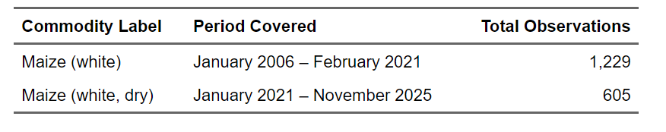
Table 1: Maize Commodity Labels Combined for Analysis

Raw Observation per County
The table below presents the raw observation counts for each county and commodity label prior to data cleaning. The table shows that maize prices are recorded under two separate commodity labels across all six counties. The "Maize (white)" label covers the earlier period from 2006 to early 2021, while "Maize (white, dry)" covers the more recent period from 2021 onwards. Prices were reported in either KG or 90 KG units depending on the county and market type. Mombasa had one additional observation recorded in KG under "Maize (white, dry)" which was standardized to a per-kilogram basis along with all other observations.
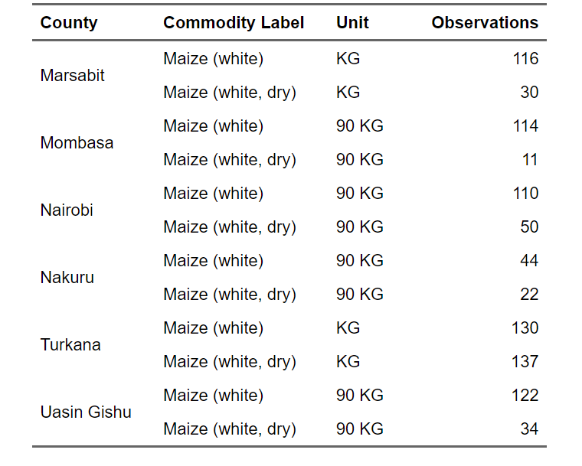
Table: Raw Observation Counts by County and Commodity Label Before Cleaning

Unit Standardization
Following the review of raw observation counts, the next step involved standardizing all maize prices to a common unit of KES per kilogram to ensure comparability across counties and over time. Inspection of the dataset revealed that prices were reported in different units depending on the county and market type.
Marsabit and Turkana reported prices per kilogram (KG), while Mombasa, Nairobi, Nakuru, and Uasin Gishu reported prices per 90-kilogram sack (90 KG). To standardize, prices reported in 90 KG units were divided by 90, and prices already reported per KG were retained as-is. Table 5 confirms that after standardization, all six counties recorded zero missing values, indicating a complete and clean dataset ready for further analysis.
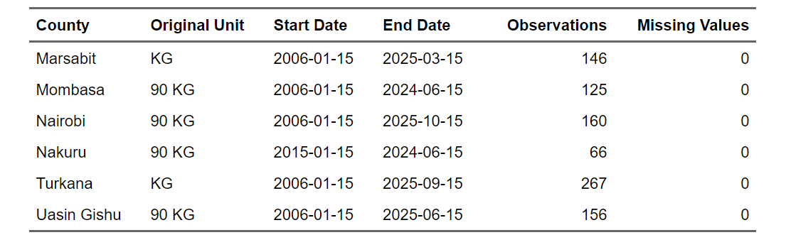
Table: Price Standardization Summary by County Including Missing Value Check
Removal of Nakuru County
Following unit standardization, a detailed inspection of Nakuru County's data revealed two significant data quality concerns that made it unsuitable for time-series modeling.
First, the "Maize (white)" series for Nakuru began only in January 2015, compared to January 2006 for all other counties, resulting in a substantially shorter historical record. Second, a visual inspection of the data revealed an 11-month gap between the last "Maize (white)" observation recorded in February 2020 and the first "Maize (white, dry)" observation recorded in January 2021. Additionally, numerous months were missing throughout the entire series, making the data too irregular for reliable forecasting.
The Table presents the Nakuru observations confirming these gaps.
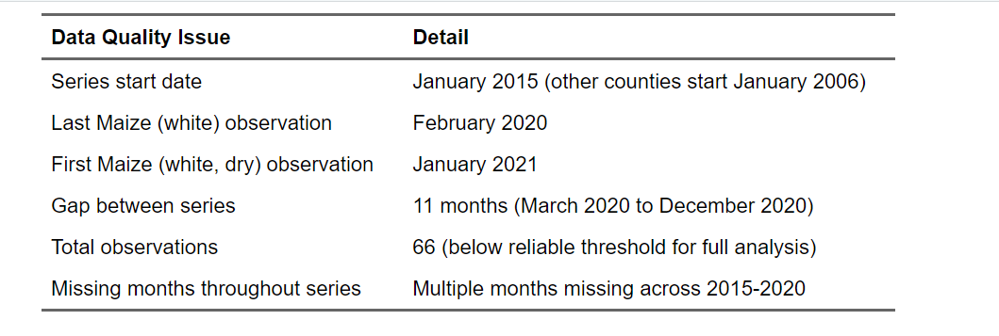

Table: Data Quality Issues Identified for Nakuru County

Given these data quality concerns, Nakuru County was excluded from further analysis. Its irregular and incomplete monthly record would compromise the reliability of any time-series model fitted to it.
The final dataset therefore includes five counties: Marsabit, Mombasa, Nairobi, Turkana, and Uasin Gishu, all of which provide sufficiently long and consistent monthly price records for forecasting purposes.

Final Dataset Summary
After removing Nakuru, the final dataset comprises five counties spanning January 2006 through 2024 and 2025 depending on the county. The table presents the geographic classification, start date, end date, and total number of observations for each of the five counties retained for analysis. All five counties exceed the minimum threshold of 48 observations required for reliable time-series modeling, with Turkana recording the highest number of observations at 267 and Mombasa the lowest at 125.
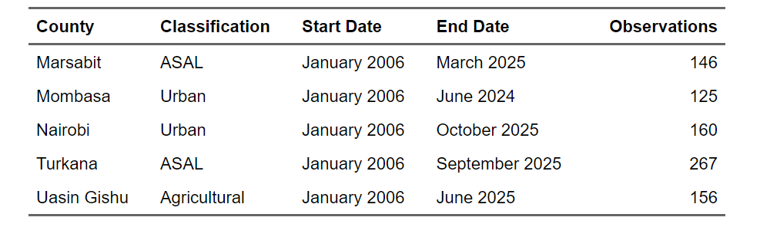
Table: Final County Dataset Summary After Cleaning

Descriptive Statistics by County
The table below presents descriptive statistics for the standardized maize price in KES per kilogram for each of the five counties.
The statistics reveal meaningful price differences across county types. Turkana consistently records the highest prices, with a median of KES 75.00 and a maximum of KES 150.00 per kilogram, reflecting its remote location, limited road infrastructure, and vulnerability to drought-related supply disruptions. In contrast, Mombasa and Uasin Gishu record the lowest median prices at KES 29.30 and KES 29.20 respectively, consistent with stronger market access and more reliable supply chains.
Nairobi and Marsabit fall in the middle range with median prices of KES 33.00 and KES 47.60 respectively. The standard deviation is highest for Turkana at 23.80, indicating greater price volatility over time.
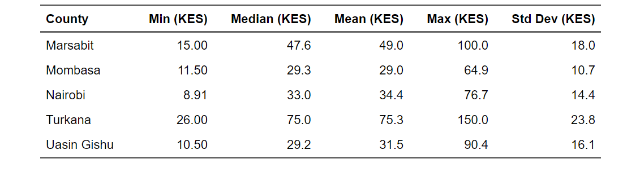
Table: Descriptive Statistics of Maize Price Per KG by County (KES)

Data Visualization
Having examined the descriptive statistics across counties, the next step involved visually inspecting the raw maize price series for each county over the full study period. Plotting the data revealed several important patterns.
All five counties show a general upward trend in maize prices from 2006 to 2025, with prices remaining relatively stable in the early years before rising sharply from around 2020 onwards.
Notable price spikes are visible around 2022 to 2024 across all counties, likely driven by post-COVID supply chain disruptions and the impact of the Russia-Ukraine conflict on global grain markets.
Turkana consistently records the highest price levels throughout the entire period, reflecting its remote location and vulnerability to supply shocks.
In contrast, Mombasa and Uasin Gishu remain comparatively lower and more stable, consistent with their stronger market access. The sharp vertical movements visible near 2024 and 2025 in Marsabit and Turkana reflect irregular reporting intervals in the most recent data rather than actual instantaneous price changes.
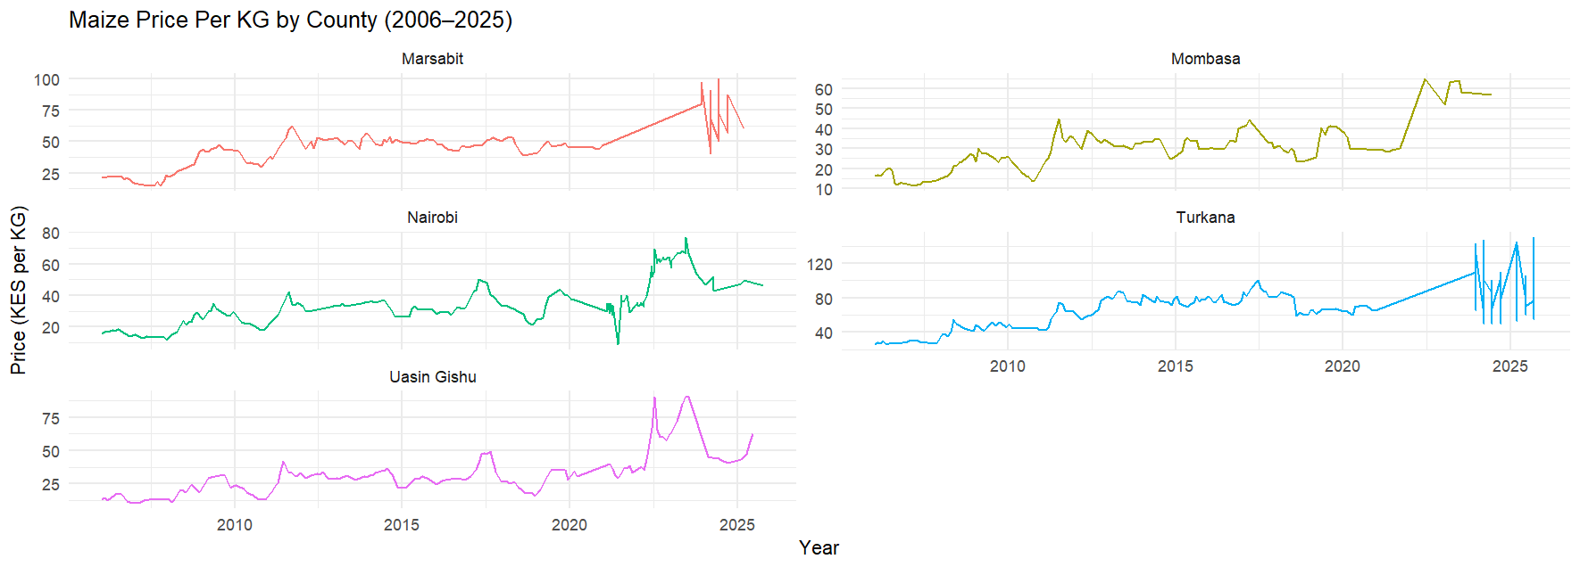
Figure: Maize Price Per KG by County, January 2006 to 2025

DATA EXPLORATION
With the cleaned dataset in place, the next step involved converting each county's maize price series into a formal monthly time series object in R using the ts() function with a frequency of 12, corresponding to 12 months per year. All five series were set to start in January 2006.
The series lengths vary across counties depending on data availability, with Turkana having the longest series at 267 months and Mombasa the shortest at 125 months. All series exceed the minimum threshold of 48 observations required for reliable time-series modeling.
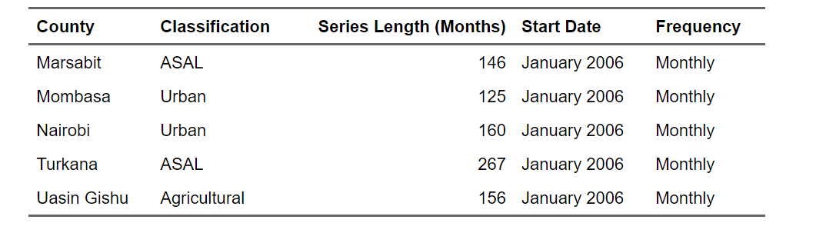
Table: Time Series Objects Created for Each County
With the time series objects confirmed, the next step involved plotting each county's price series individually to identify visual patterns such as trend, seasonality, and outliers prior to formal modeling.

Individual County Time Series Plots
With the time series objects confirmed and missing months filled using linear interpolation, each county's maize price series was plotted individually to identify visual patterns prior to formal modeling. The plots reveal distinct price behaviors across county types, reflecting differences in geography, market access, and vulnerability to supply shocks.
Marsabit plot
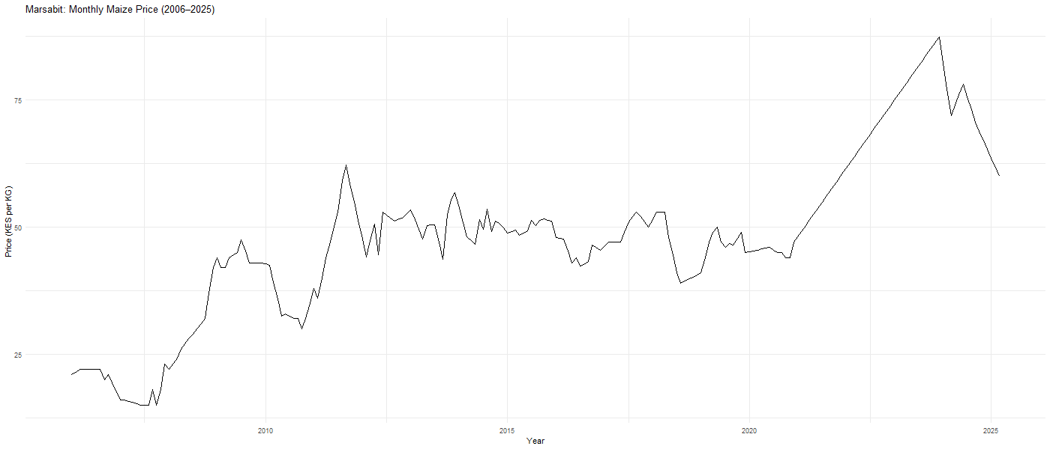
Figure : Marsabit Monthly Maize Price (2006–2025)
Marsabit, an arid and semi-arid county, shows a gradual upward trend from around KES 20 per KG in 2006, remaining relatively stable between KES 40 and KES 55 from 2010 to 2020, before rising sharply to nearly KES 100 per KG around 2023 and then declining slightly toward 2025. The sharp rise in the recent period reflects the county's vulnerability to external supply shocks given its remote location and dependence on long-distance food supply chains.

Mombasa plot
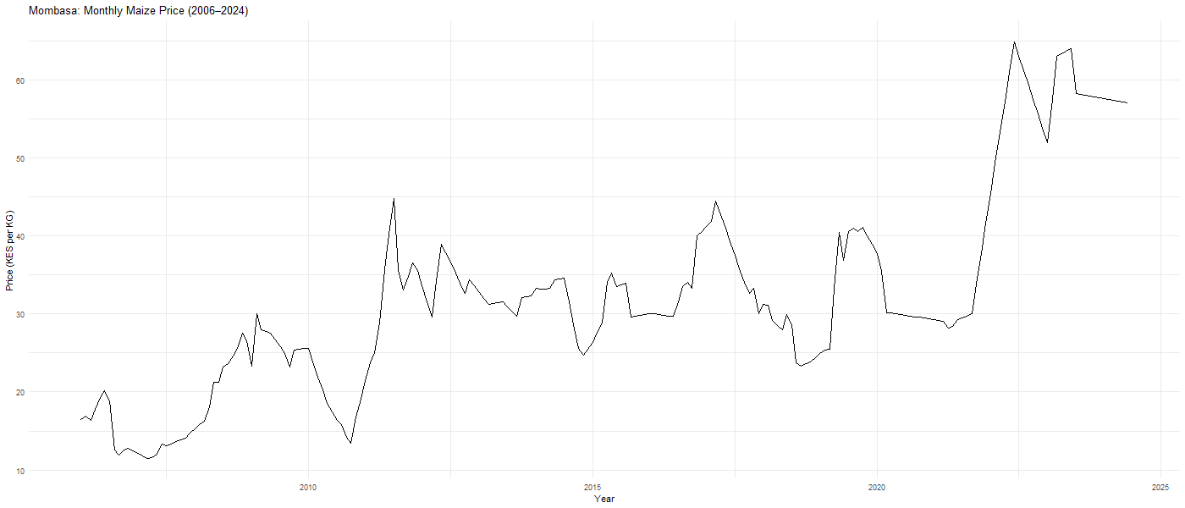
Figure: Mombasa Monthly Maize Price (2006–2024)
Mombasa, an urban coastal county, shows relatively moderate price levels throughout the study period, starting around KES 16 per KG in 2006 and rising to approximately KES 65 per KG by 2022 before stabilizing around KES 55 per KG toward 2024. The series exhibits cyclical fluctuations without a strong seasonal pattern, consistent with an urban market that is largely supplied through commercial trade channels.

Nairobi plot
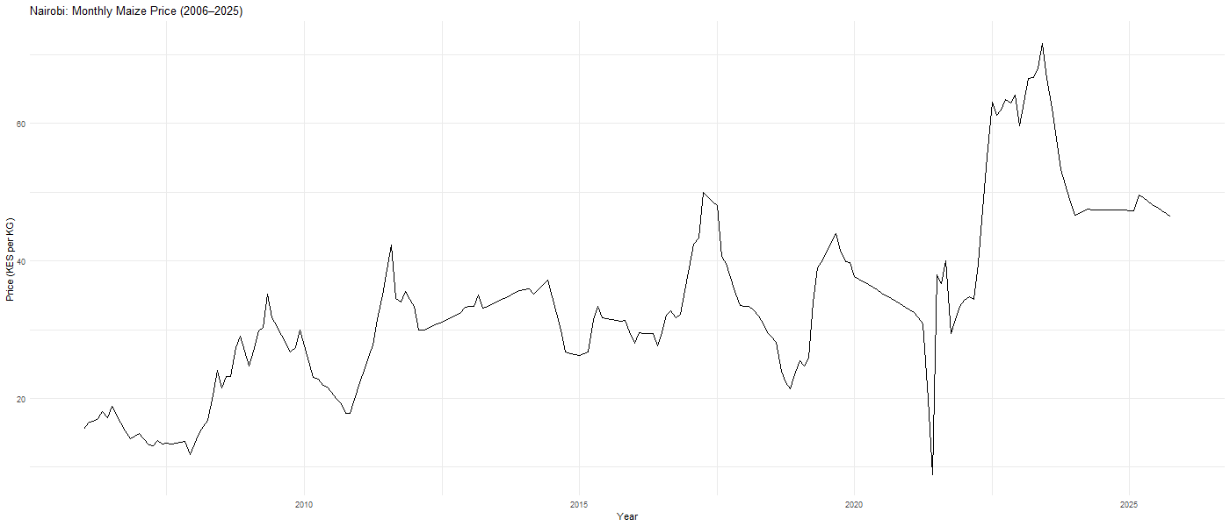
Figure: Nairobi Monthly Maize Price (2006–2025)
Nairobi, Kenya's capital and largest urban center, displays a broadly upward trend over the study period, rising from around KES 16 per KG in 2006 to a peak of approximately KES 76 per KG around 2022 before declining to around KES 45 per KG by 2025. A notable sharp dip is visible around 2021, which corresponds to the transition period between the two commodity labels in the dataset and was smoothed using linear interpolation. The overall trend reflects Nairobi's dependence on national supply chains and its sensitivity to broader economic conditions.

Turkana plot
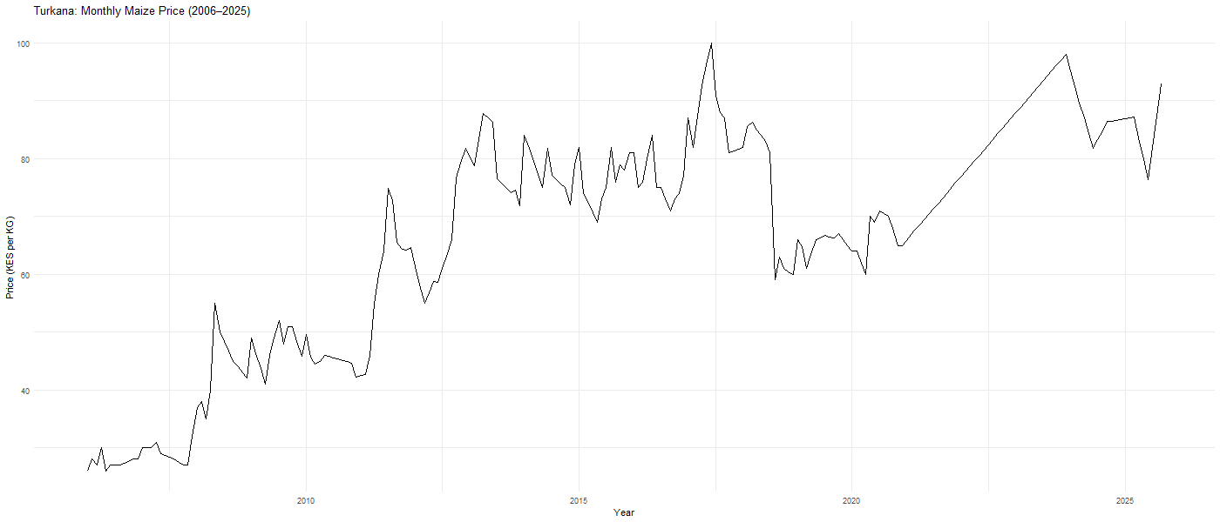
Figure: Turkana Monthly Maize Price (2006–2025)
Turkana, a remote arid county in northwestern Kenya, consistently records the highest maize prices of all five counties throughout the study period. Starting at around KES 27 per KG in 2006, prices rose steeply from 2010 onwards, reaching approximately KES 100 per KG around 2017, dropping temporarily around 2019 to 2020, and rising again steeply to nearly KES 100 per KG by 2025. The persistent high price levels reflect Turkana's extreme remoteness, poor road infrastructure, and heavy dependence on food aid and long-distance commercial supply chains.

Uasin Gishu plot
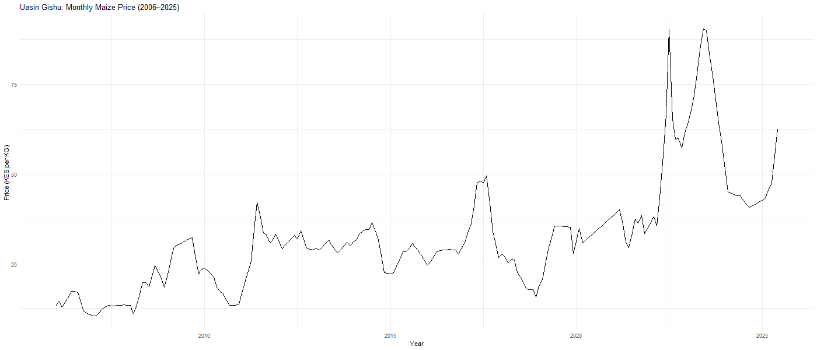
Figure : Uasin Gishu Monthly Maize Price (2006–2025)
Uasin Gishu, Kenya's main agricultural maize-producing county, shows comparatively lower and more stable prices in the early period, starting around KES 10 per KG in 2006 and remaining below KES 50 per KG until around 2020. From 2022 onwards, prices spiked sharply to nearly KES 90 per KG before declining again toward 2025. This spike is particularly notable for an agricultural county and likely reflects the combined impact of drought, post-COVID supply disruptions, and global grain price increases rather than local production failures alone.

Seasonal Patterns
To examine whether maize prices follow a consistent seasonal pattern within each year, seasonal plots were generated for all five counties. In a seasonal plot, each line represents one calendar year and the x-axis shows the months of the year. If prices follow a consistent seasonal pattern, the lines should follow a similar shape across years. The results across all five counties suggest that year-to-year variation in price levels dominates over within-year seasonal patterns, indicating that trend and external shocks rather than seasonality are the primary drivers of maize price movements in Kenya.

Marsabit seasonal plot
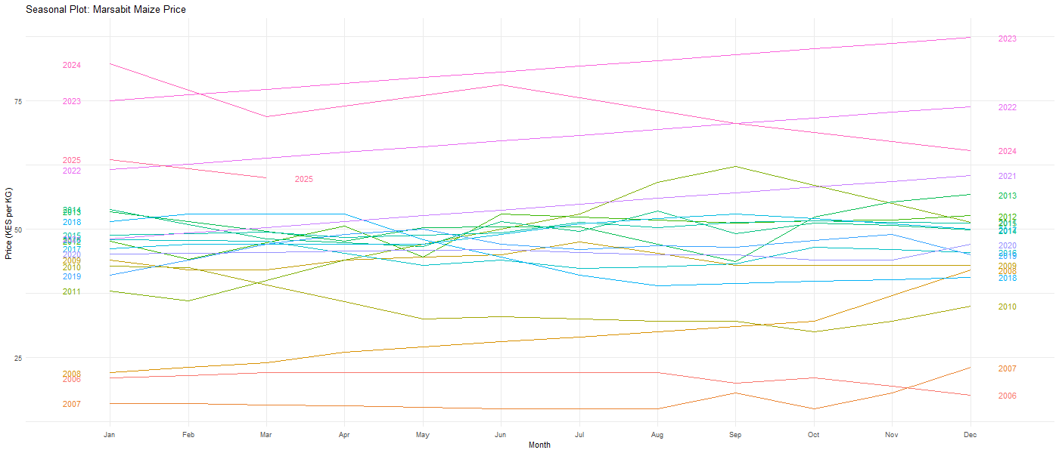
Figure: Seasonal Plot — Marsabit Maize Price
Interpretation
Marsabit shows no consistent seasonal pattern across months. The lines representing individual years vary considerably in their level but follow no repeating shape from January to December. This suggests that price movements in Marsabit are driven primarily by external shocks and supply disruptions rather than predictable seasonal cycles.

Mombasa seasonal plot
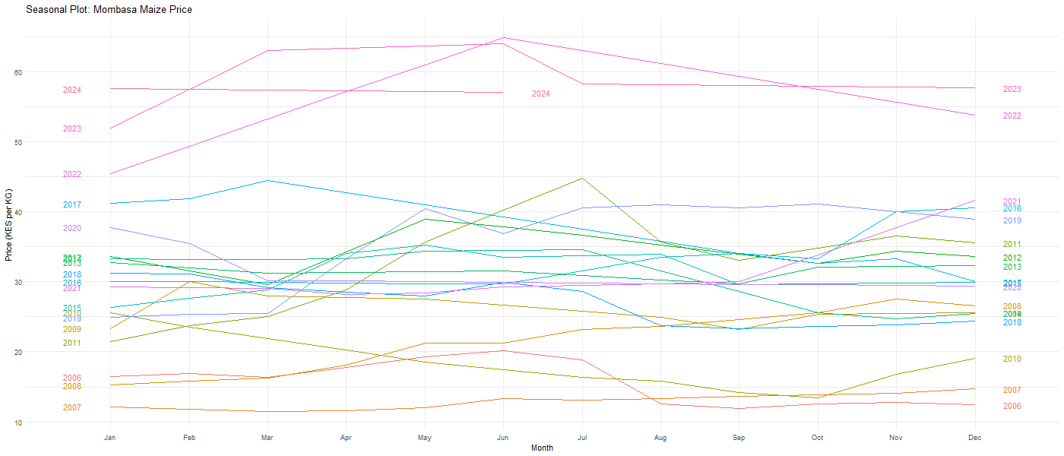
Figure : Seasonal Plot — Mombasa Maize Price
Interpretation
Mombasa displays a weak seasonal tendency with some years showing slightly higher prices between March and June, possibly reflecting lean season effects before the long rains harvest. However this pattern is inconsistent across years, and the dominant source of variation is between years rather than within years.

Nairobi seasonal plot
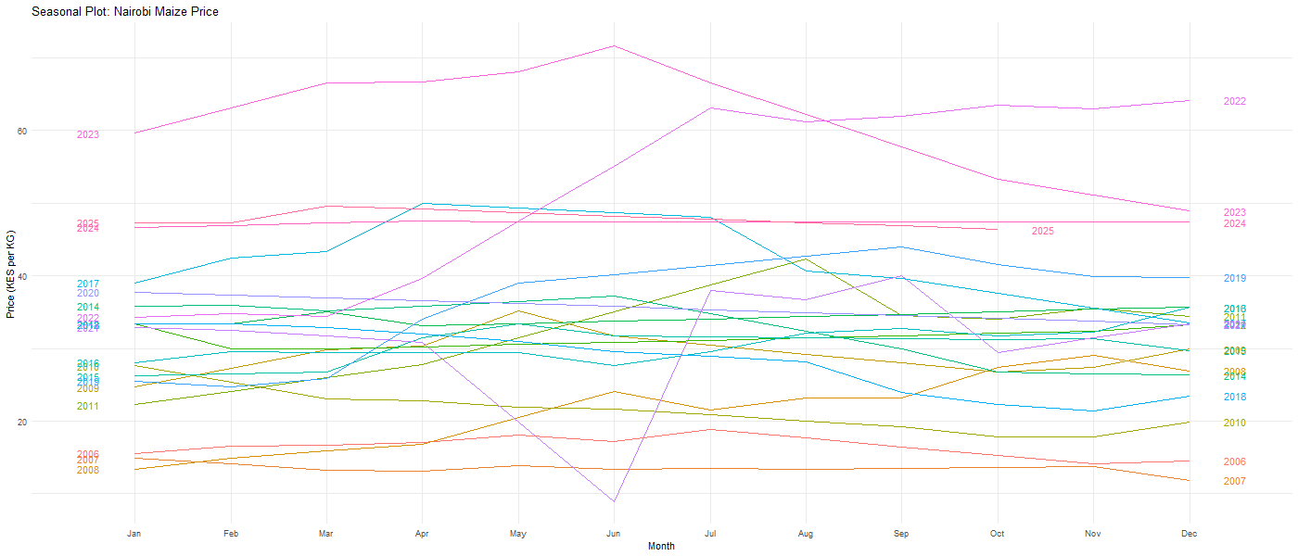
Figure: Seasonal Plot — Nairobi Maize Price
Interpretation
Nairobi shows largely flat lines across months in most years, indicating no strong within-year seasonal pattern. The sharp dip visible in June 2022 corresponds to the data transition period between the two commodity labels and reflects the linear interpolation used to fill that gap rather than an actual price movement. Overall the plot confirms that year-to-year price level differences dominate over seasonal within-year variation.

Turkana seasonal plot
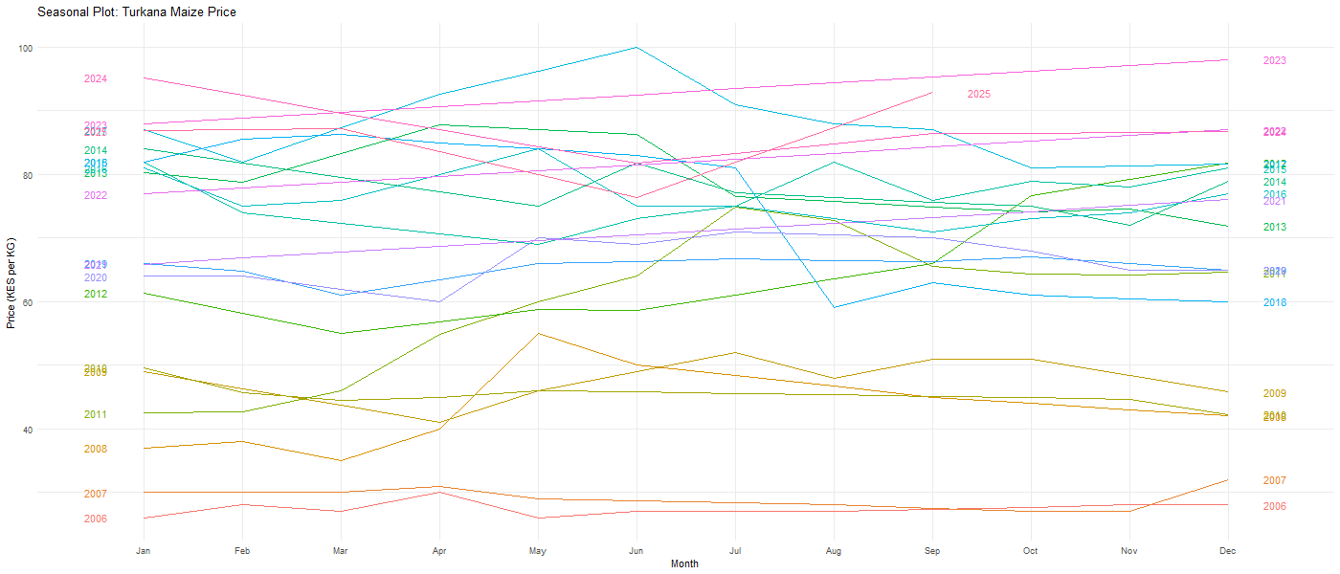
Figure: Seasonal Plot — Turkana Maize Price
Interpretation
Turkana shows considerable variation across years but no consistent repeating seasonal pattern within years. Some years show prices peaking around mid-year while others peak toward year end, reflecting the irregular and supply-shock-driven nature of maize prices in this remote arid county. The absence of a consistent seasonal pattern is consistent with Turkana's dependence on external food supply rather than local agricultural production cycles.
Uasin Gishu seasonal plot
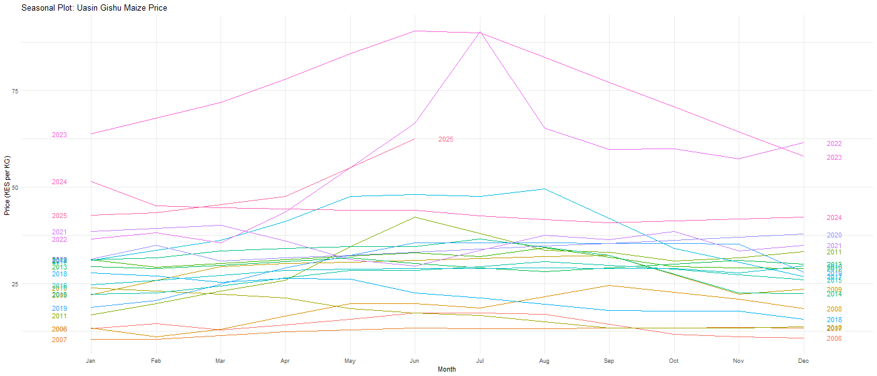
Figure: Seasonal Plot — Uasin Gishu Maize Price
Interpretation
Uasin Gishu shows the most interesting seasonal pattern of all five counties. The 2022 and 2023 lines display a pronounced peak between May and July, corresponding to the period before the long rains harvest when maize stocks are typically lowest. Earlier years show much flatter within-year patterns, suggesting that the seasonal signal has become more pronounced in recent years, possibly reflecting greater price volatility in the post-COVID period. Despite this, the overall seasonal pattern is not consistent enough across all years to suggest strong predictable seasonality.

Time Series Decomposition
To further understand the structure of each county's maize price series, a classical additive decomposition was applied to separate each series into three components: trend, seasonal, and remainder. The trend component captures the long-run direction of prices, the seasonal component captures any repeating within-year pattern, and the remainder captures irregular fluctuations not explained by trend or seasonality. The decomposition results confirm that an upward long-run trend is present in all five counties, while the strength and consistency of the seasonal component varies across counties.
Marsabit decomposition plot
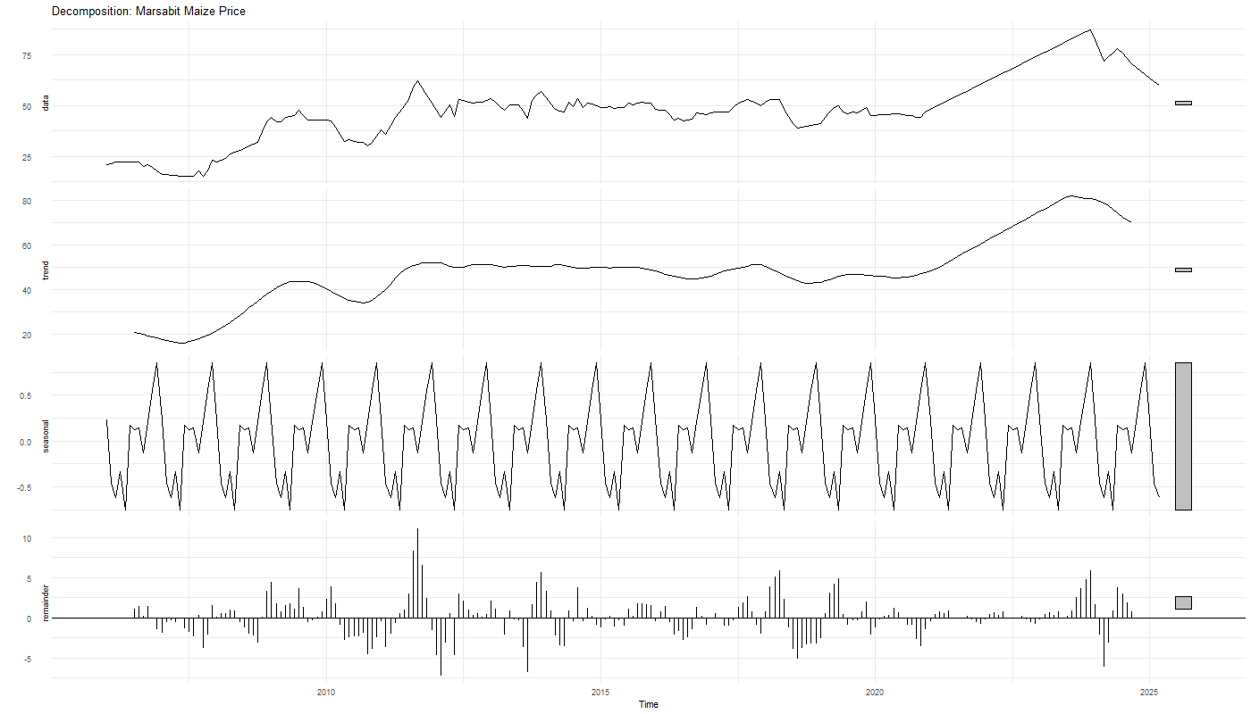
Figure : Time Series Decomposition — Marsabit
Interpretation
The decomposition for Marsabit reveals a clear long-run upward trend, rising steadily from around KES 20 per KG in 2006 to approximately KES 80 per KG by 2024. The seasonal component is present but very small in magnitude, oscillating between approximately -0.8 and +1.0 KES, which is negligible relative to the overall price level. This confirms that seasonality plays a minor role in Marsabit's price dynamics and that the trend and irregular shocks are the dominant forces driving price movements.

Mombasa decomposition plot
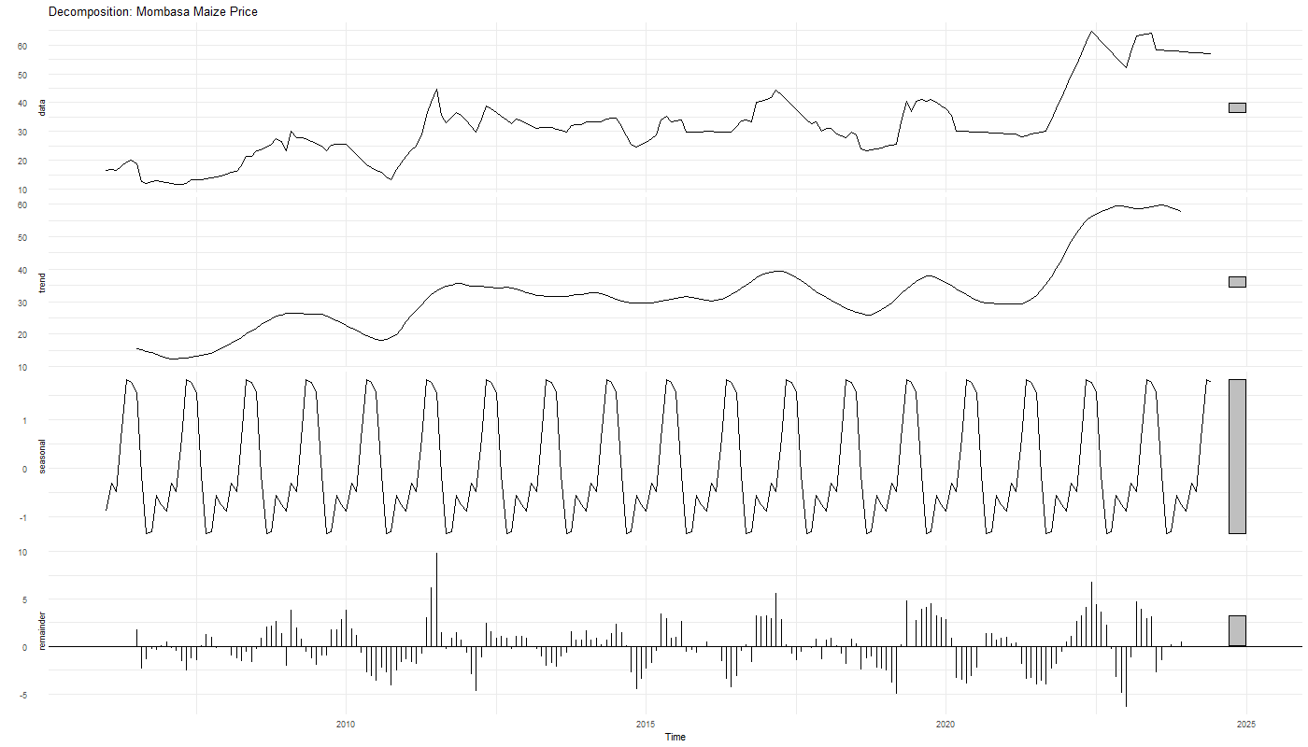
Figure: Time Series Decomposition — Mombasa
Interpretation:
Mombasa's decomposition shows a gradual upward trend throughout the study period, accelerating sharply from around 2021 onwards to reach approximately KES 60 per KG by 2024. The seasonal component shows a more consistent repeating pattern than Marsabit, oscillating between approximately -1.5 and +2.0 KES per KG, suggesting a modest but detectable seasonal cycle. The remainder component is relatively small and well-behaved, indicating that the trend and seasonal components together explain a reasonable portion of Mombasa's price variation.

Nairobi decomposition plot
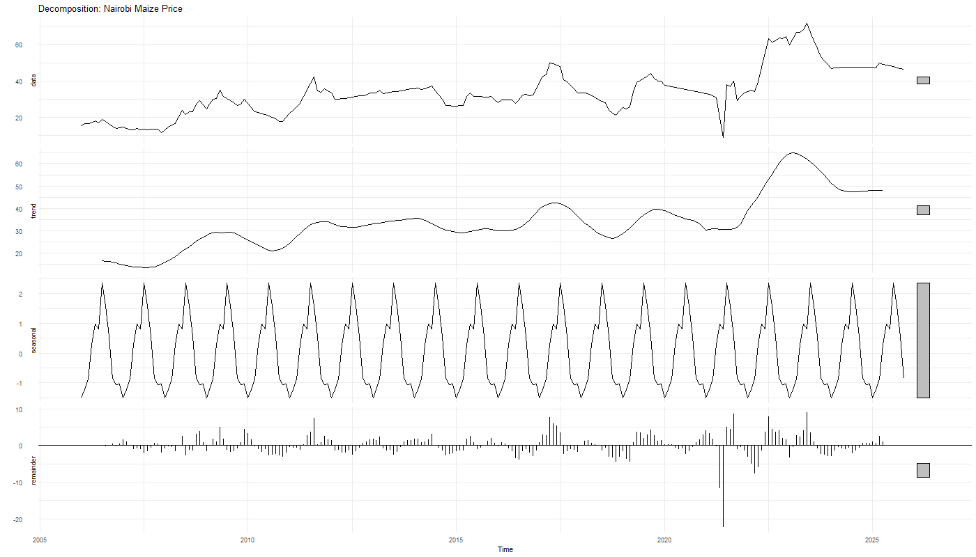
Figure: Time Series Decomposition — Nairobi
Interpretation:
Nairobi's trend shows a steady upward movement from around KES 18 per KG in 2006, plateauing around KES 35 to KES 40 per KG between 2010 and 2020, before rising sharply to approximately KES 65 per KG around 2022 and then declining slightly toward 2025. The seasonal component oscillates between approximately -1.5 and +2.5 KES per KG, indicating a weak but detectable seasonal pattern. The remainder component shows a large negative spike around 2021, which corresponds to the data transition period and the linear interpolation applied to fill the gap between the two commodity labels.

Turkana decomposition plot
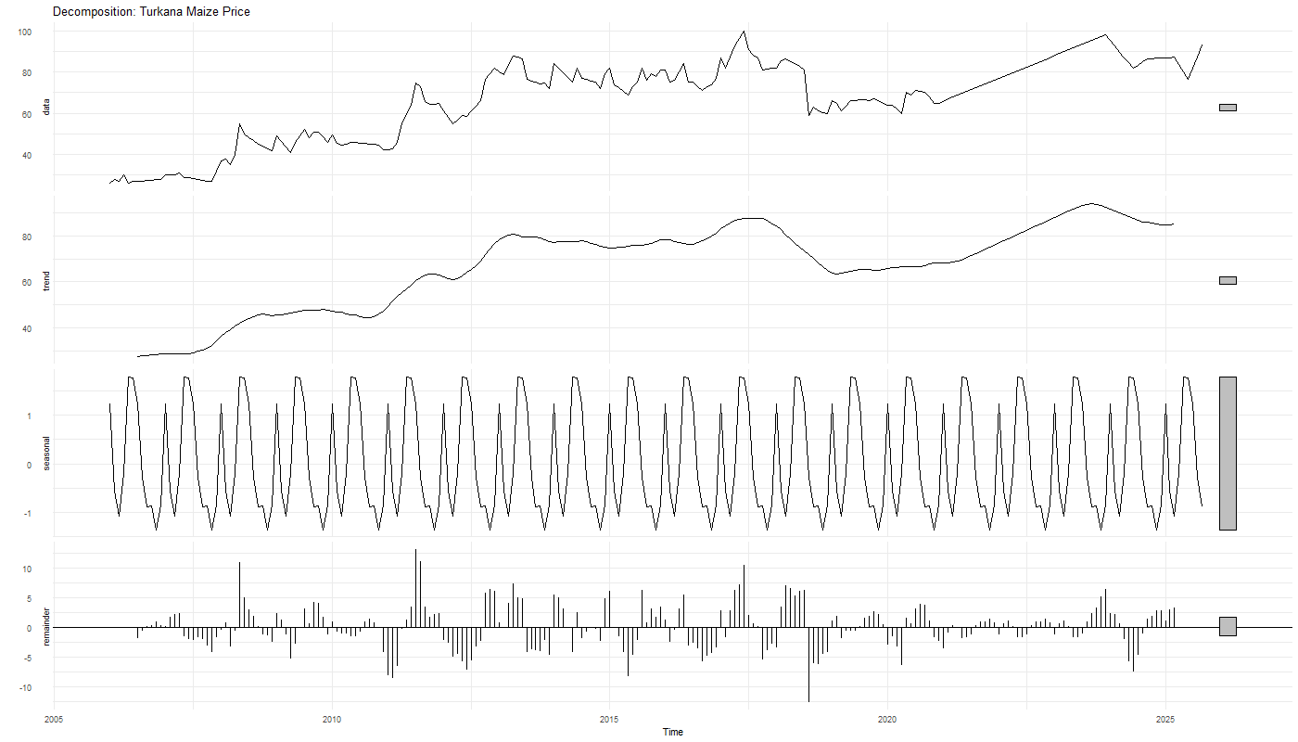
Figure: Time Series Decomposition — Turkana
Interpretation
Turkana's decomposition reveals the strongest and most persistent upward trend of all five counties, rising from around KES 33 per KG in 2006 to approximately KES 85 per KG by 2025. The trend shows a notable acceleration from 2010 to 2017, a partial decline around 2019 to 2020, and a renewed rise from 2021 onwards. The seasonal component oscillates consistently between approximately -1.5 and +1.5 KES per KG, representing a small but regular annual cycle relative to the overall price level. The remainder component shows moderate irregular spikes throughout the period, reflecting occasional supply disruptions typical of a remote arid county.

Uasin Gishu decomposition plot
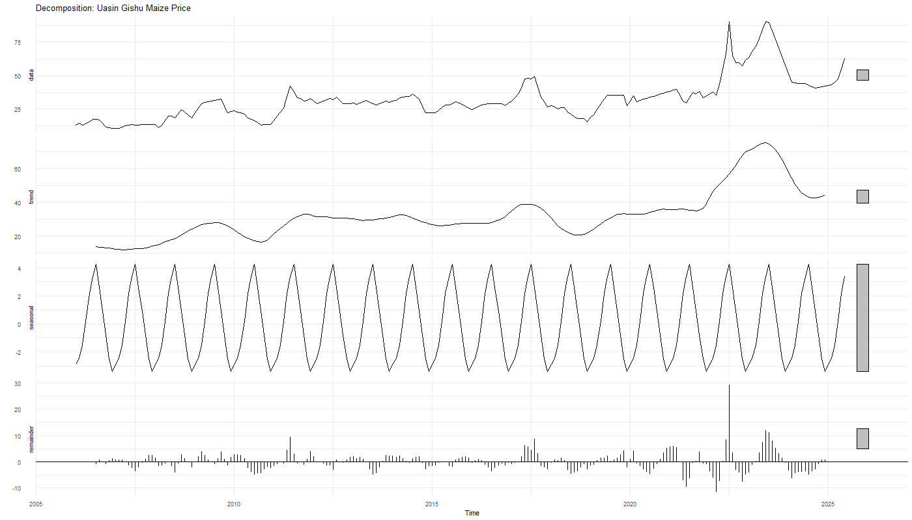
Figure: Time Series Decomposition — Uasin Gishu
Interpretation
Uasin Gishu's decomposition is the most revealing of all five counties. The trend component rises gradually from around KES 15 per KG in 2006 to KES 40 per KG by 2020, before spiking sharply to approximately KES 65 per KG around 2022 to 2023 and then declining back toward KES 40 per KG by 2025. The seasonal component is the strongest of all five counties, oscillating between approximately -3.5 and +4.5 KES per KG, reflecting a clear annual agricultural cycle consistent with Uasin Gishu's role as Kenya's main maize producing region. Prices tend to peak around mid-year before the long rains harvest and dip afterward as new supply enters the market. The remainder component shows a very large spike around 2022, consistent with the extraordinary price shock driven by drought and global grain market disruptions in that period.

Summary of all decompositions
Across all five counties the decomposition analysis confirms three consistent findings. First, a long-run upward trend in maize prices is present in every county, reflecting the combined effects of inflation, population growth, and recurring supply disruptions over the study period. Second, seasonal components are present in all counties but are small relative to trend and remainder components, suggesting that maize prices in Kenya are driven more by supply shocks and structural factors than by predictable seasonal cycles. Third, the remainder components show irregular spikes particularly around 2009 to 2011 and 2021 to 2023, periods associated with major drought events and global commodity price shocks respectively. These findings provide important motivation for the modeling choices made in the subsequent analysis.
Autocorrelation and Partial Autocorrelation Analysis
The Autocorrelation Function (ACF) and Partial Autocorrelation Function (PACF) were examined for each county to assess the degree of serial correlation in the maize price series and to inform subsequent modeling decisions. The ACF measures the correlation between a series and its own lagged values at increasing time intervals, while the PACF measures the direct correlation at each lag after removing the effect of shorter lags. Together these two plots provide important diagnostic information about the stationarity of the series and the appropriate structure for time-series models. The dashed blue lines in each plot represent the 95 percent confidence bounds, beyond which autocorrelations are considered statistically significant.

Marsabit ACF/PACF plot
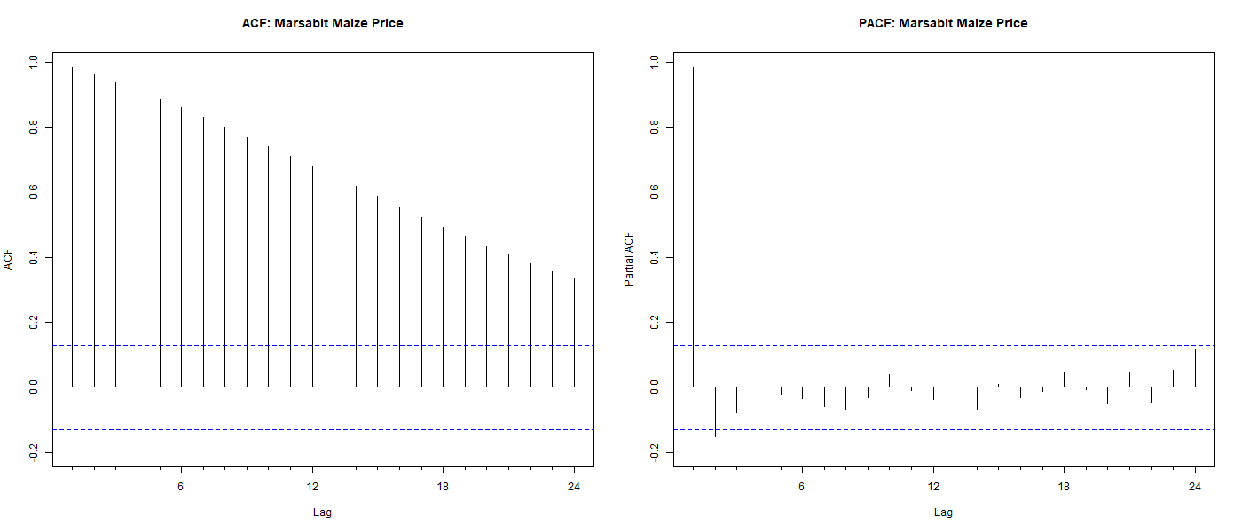
Figure: ACF and PACF — Marsabit Maize Price
Interpretation
The ACF for Marsabit shows very high positive autocorrelation at lag 1, close to 1.0, with a slow and gradual decay that remains above the significance threshold for more than 20 lags. This pattern of slow decay is a classic indicator of non-stationarity, confirming that the series contains a long-run trend component that must be addressed before modeling. The PACF shows a single large significant spike at lag 1 with all subsequent lags falling within the confidence bounds. This combination of a slowly decaying ACF and a single significant PACF spike at lag 1 is consistent with a random walk or an AR (1) process and strongly suggests that first differencing will be required to achieve stationarity.

Mombasa ACF/PACF plot
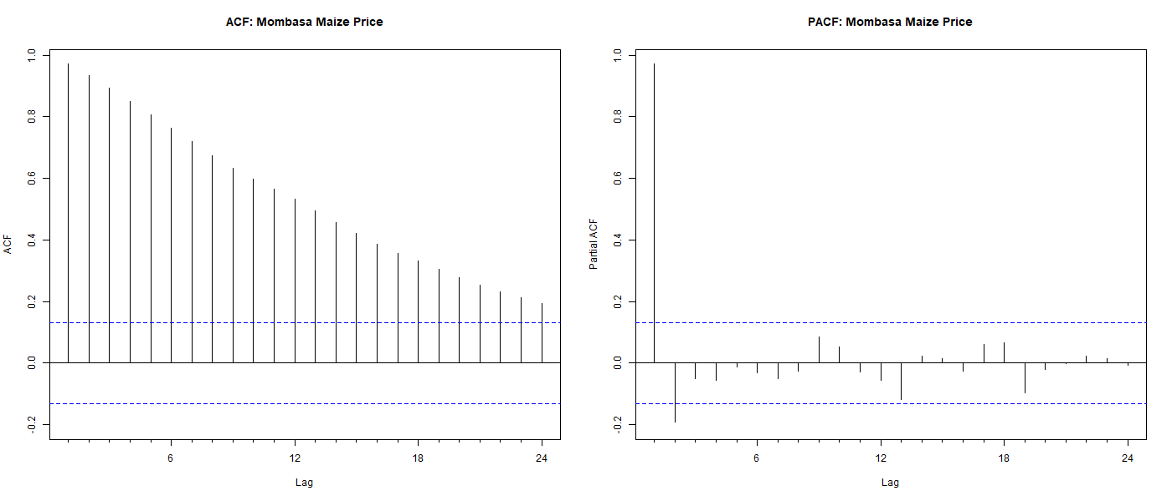
Figure: ACF and PACF — Mombasa Maize Price
Interpretation
Mombasa displays a similar pattern to Marsabit, with a slowly decaying ACF that remains significantly above zero for many lags and a single dominant spike in the PACF at lag 1. The ACF decay is slightly faster than Marsabit, consistent with Mombasa's somewhat lower price persistence. The PACF confirms that once the first lag is accounted for, no additional autoregressive structure is present. These findings again point toward a non-stationary series that will require first differencing before model estimation.

Nairobi ACF/PACF plot
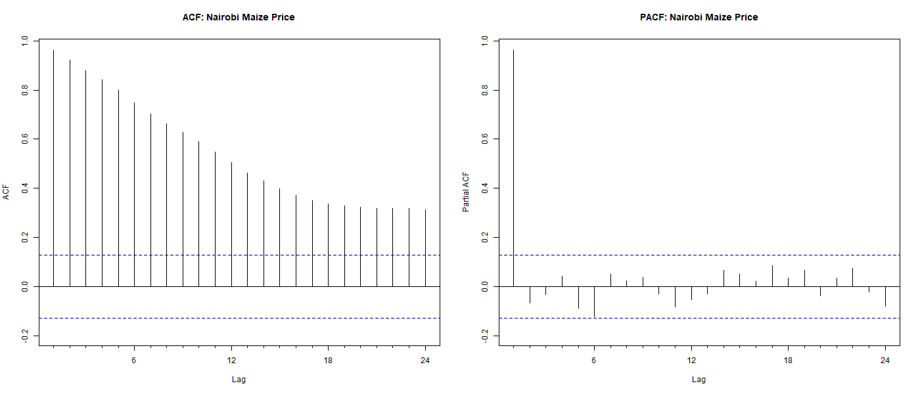
Figure: ACF and PACF — Nairobi Maize Price
Interpretation
Nairobi's ACF and PACF plots mirror the pattern observed in Marsabit and Mombasa. The ACF decays very slowly from a value close to 1.0 at lag 1, remaining above the significance threshold well beyond lag 20. The PACF shows a single large spike at lag 1 with all other lags falling within the confidence bands. This pattern is consistent with a non-stationary series dominated by a strong upward trend and confirms that first differencing will be necessary to stabilize the mean before fitting forecasting models.

Turkana ACF/PACF plot
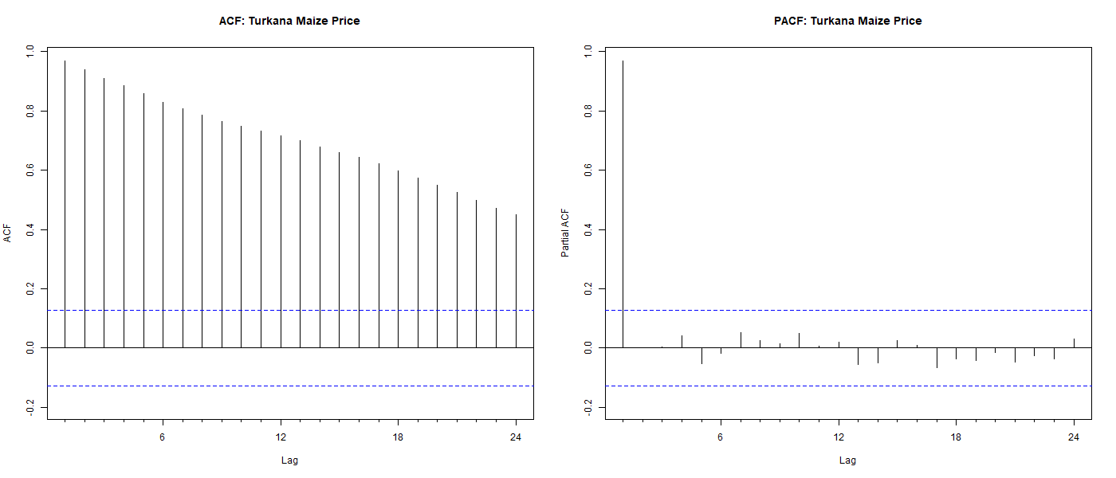
Figure: ACF and PACF — Turkana Maize Price
Interpretation:
Turkana shows the most persistent autocorrelation structure of all five counties, with ACF values remaining high and significantly above zero even at lag 24. This reflects the strong and sustained upward trend visible in Turkana's time series plot and decomposition. The PACF again shows a single dominant spike at lag 1 with all other lags within the confidence bounds. The pattern is consistent with a highly persistent non-stationary process and confirms that differencing is required to make the series stationary for modeling purposes.

Uasin Gishu ACF/PACF plot
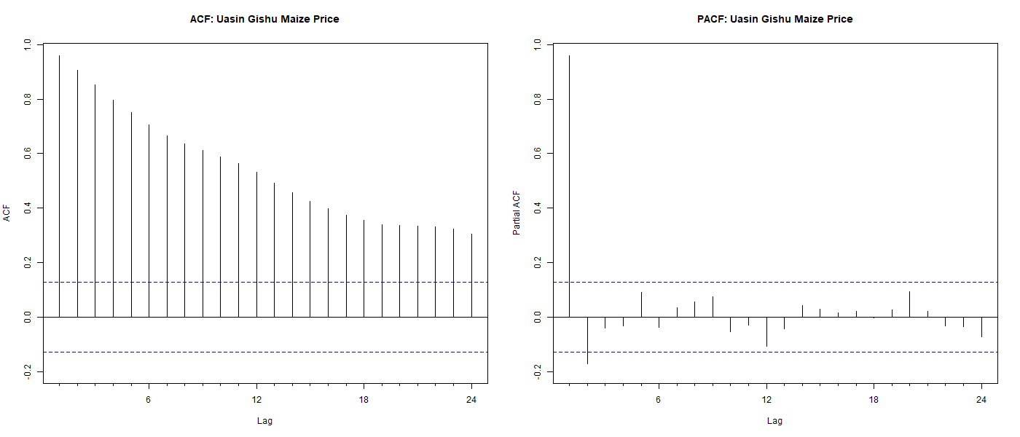
Figure 21: ACF and PACF — Uasin Gishu Maize Price
Interpretation:
Uasin Gishu displays the same slowly decaying ACF pattern observed across all five counties, with high positive autocorrelation at lag 1 declining gradually but remaining significant for many lags. The PACF shows a single significant spike at lag 1 followed by all remaining lags falling within the confidence bounds. This pattern confirms non-stationarity driven by the long-run upward trend in maize prices and is consistent with the decomposition results which showed a pronounced trend component accelerating sharply from 2022 onwards.

Summary for all ACF/PACF findings
The ACF and PACF analysis reveals a remarkably consistent pattern across all five counties. In every case the ACF decays slowly from a value close to 1.0 at lag 1, and the PACF shows a single dominant spike at lag 1 with no significant structure at higher lags. This pattern is the hallmark of a non-stationary integrated process, confirming that all five maize price series contain a unit root and will require first differencing before model estimation. These findings directly inform the model selection process in the subsequent sections, where the Augmented Dickey-Fuller test is used to formally confirm non-stationarity and first differencing is applied to achieve stationarity prior to ARIMA model fitting.
Data Exploration Summary
The data exploration stage examined the structure, patterns, and statistical properties of the monthly maize price series for five Kenyan counties covering the period from January 2006 to 2025. The findings from the individual time series plots, seasonal plots, decomposition analysis, and ACF and PACF examination collectively point to four key conclusions that directly inform the modeling approach adopted in this study.
First, all five counties exhibit a clear long-run upward trend in maize prices over the study period. Prices rose consistently from 2006 onwards, with a particularly sharp acceleration observed from 2020 to 2023 across all counties. This trend reflects the combined effects of inflation, population growth, recurring drought events, and global commodity price shocks including the post-COVID supply chain disruptions and the Russia-Ukraine conflict which significantly affected global grain markets from 2022 onwards.
Second, seasonal patterns are present in all five counties but are weak relative to the dominant trend and irregular components. The seasonal plots showed inconsistent within-year patterns across years, and the decomposition confirmed that the seasonal component is small in magnitude compared to the trend. Uasin Gishu showed the strongest seasonal signal among the five counties, consistent with its role as Kenya's main maize producing region where prices follow an agricultural harvest cycle. However, even in Uasin Gishu the seasonal component is not strong enough to dominate the overall price behavior.
Third, the ACF and PACF analysis confirmed that all five series are non-stationary. The slowly decaying ACF and single dominant PACF spike at lag 1 observed consistently across all counties indicate the presence of a unit root in each series. This finding means that differencing will be required before fitting ARIMA models, and it provides theoretical motivation for applying the Augmented Dickey-Fuller test in the model diagnostics section to formally confirm this conclusion.
Fourth, notable irregularities and outliers were observed in the data, particularly in the most recent years. Sharp price spikes around 2022 to 2024 were visible in all counties, and some counties showed irregular reporting intervals in the recent period which were addressed through linear interpolation during the data transformation stage. These irregularities are important to acknowledge as they may affect model accuracy in the most recent forecast horizon.
Taken together these findings suggest that the maize price series across Kenyan counties are best characterized as non-stationary trending processes driven primarily by long-run structural factors and external shocks rather than by predictable seasonal cycles. This conclusion motivates the use of differencing-based models such as ARIMA as the primary forecasting approach, complemented by exponential smoothing and time series linear models to provide a comprehensive multi-model comparison as required by the analytical framework of this study.

DATA TRANSFORMATION
Following the data exploration stage, several transformations were applied to prepare the maize price series for time-series modeling. These transformations address the key issues identified during exploration, namely missing months, non-stationarity, and the need for structured predictor variables to support model estimation.

Missing Month Interpolation
During the data exploration stage, it was discovered that all five-county series contained missing months due to irregular data collection intervals. A complete monthly sequence was constructed for each county spanning from January 2006 to the last available observation. Missing price values within each sequence were filled using linear interpolation, which estimates missing values by drawing a straight line between the two nearest observed data points. This method was chosen because it preserves the general direction of price movements without introducing artificial volatility. Turkana was the only county with no missing months requiring interpolation, as its combined series of 267 observations covered the expected monthly sequence without gaps. The remaining four counties required between 78 and 97 months of interpolation each to produce complete continuous series ready for time-series modeling.

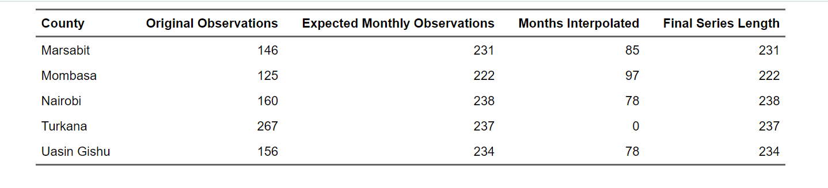
Table: Missing Month Interpolation Summary by County

Train and Validation Split
To evaluate model performance on unseen data and avoid overfitting, each county's time series was divided into a training set and a validation set. The training set was used to fit all forecasting models, while the validation set was held back and used exclusively to assess out-of-sample predictive accuracy. Following standard practice for monthly time-series data, the final 24 months of each series were reserved for validation, representing two full seasonal cycles as required by the analytical framework. The remaining months were used for training. This split ensures that model accuracy is evaluated on data the model has never seen, providing a realistic measure of how well each model would perform in a true forecasting scenario. The training and validation periods for each county are summarized below.
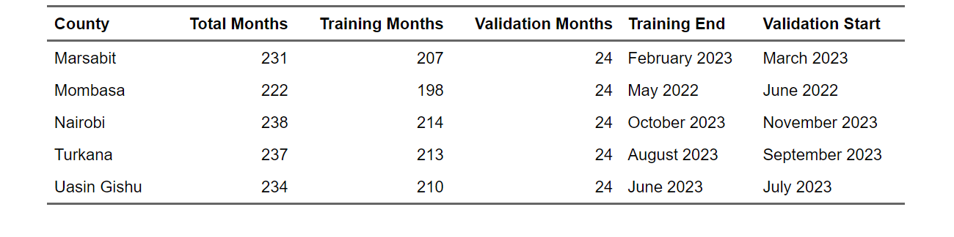Table : Training and Validation Split Summary by County
With the training and validation sets confirmed for all five counties, the next transformation step involved creating additional predictor variables to support the time series linear model estimation in the modeling stage.

Time Index and Lag Variable Creation
To support the time series linear model estimation in the modeling stage, three additional predictor variables were created for each of the five counties. First, a time index variable was created by sequentially numbering each observation from 1 onwards within each county, capturing the long-run linear trend in prices over time.
Second, a month variable was extracted from the date column and converted to a categorical factor with 12 levels representing each calendar month, allowing the model to detect and account for any seasonal patterns in prices.
Third, a one-period lag variable was created for each county by shifting the price series back by one month, capturing short-term price persistence whereby the current month's price is influenced by the previous month's price. The first observation for each county has a missing lag value by construction since there is no prior observation available.
The table below presents the first three observations of these variables for all five counties, illustrating how the time index increments sequentially from 1 within each county, the month variable captures the calendar month as a two-digit code, and the lag variable carries forward the previous month's price.
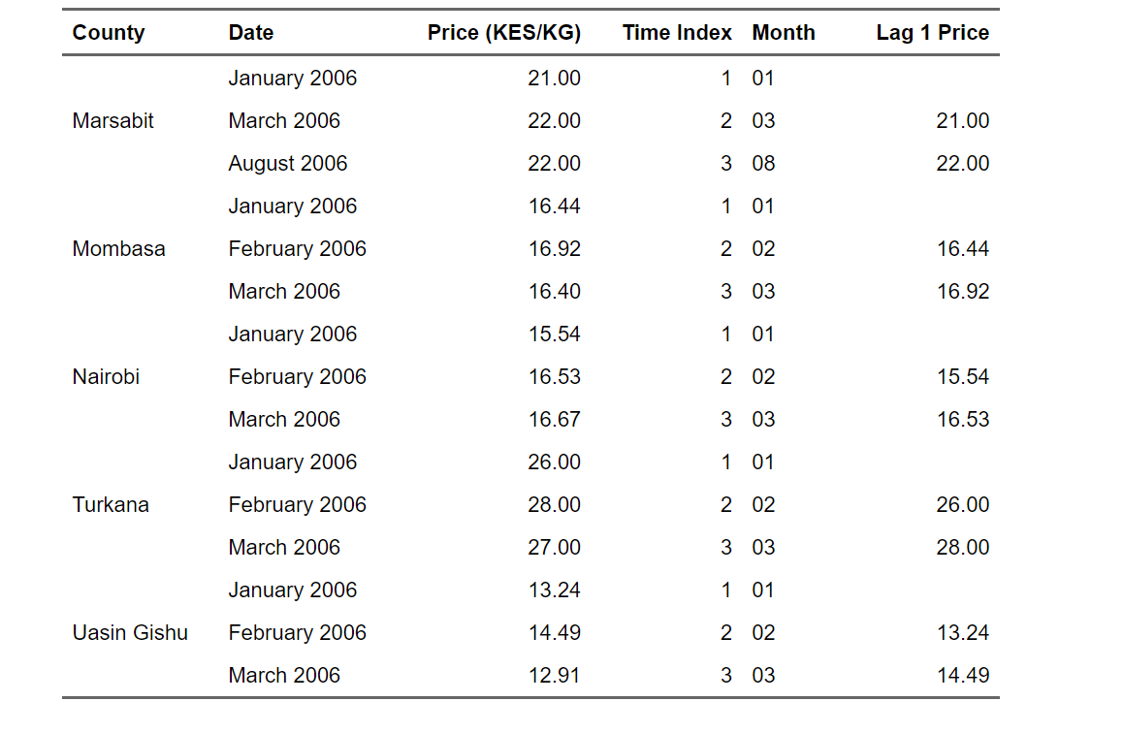
Table: Sample of Created Predictor Variables — All Five Counties
With all predictor variables created and the training and validation sets confirmed for all five counties, the dataset is fully prepared for model estimation. The next section presents the motivation for the forecasting techniques selected for this analysis.

MOTIVATION BASED ON THEORETICAL CONSIDERATIONS FOR THE CHOICE OF TECHNIQUES
The selection of forecasting techniques in this study was guided by the patterns identified during the data exploration and transformation stages. The ACF and PACF analysis confirmed that all five maize price series are non-stationary with strong positive autocorrelation and a dominant first-lag structure. The decomposition analysis revealed a clear long-run upward trend in all counties with weak but detectable seasonal components. These findings collectively motivated the use of four complementary forecasting approaches, each grounded in distinct theoretical considerations.

Naïve Model
The naïve model was included as a baseline benchmark against which all other models are evaluated. The naïve model assumes that the best forecast for any future period is simply the most recent observed value. While this model makes no attempt to capture trend or seasonality, it provides an important reference point.
A forecasting model that cannot outperform the naïve benchmark offers no practical value, and its inclusion therefore ensures that the more sophisticated models are held to a meaningful standard of comparison. Given that the ACF analysis showed strong persistence in all five series with lag 1 correlations close to 1.0, the naïve model is expected to perform reasonably well as a baseline, making it a particularly relevant benchmark for this dataset.

Exponential Smoothing - ETS Model
Exponential smoothing models were included because they are well suited to series that exhibit trend and seasonal components of varying strength. The ETS framework, which stands for Error, Trend, and Seasonality, encompasses a family of models that assign exponentially decreasing weights to past observations, giving more importance to recent data points. This property makes ETS models particularly appropriate for maize price series where recent price shocks and trends are more informative about future prices than distant historical values.
The automatic ETS selection procedure in R evaluates all combinations of additive and multiplicative error, trend, and seasonal components and selects the optimal specification based on the Akaike Information Criterion. Given the upward trends and weak seasonal signals identified in the decomposition analysis, ETS models with trend components are expected to perform well relative to the naïve benchmark.

ARIMA Model
The Autoregressive Integrated Moving Average model was included because it is the most widely used and theoretically rigorous approach for forecasting non-stationary time series. The ARIMA framework explicitly accounts for non-stationarity through differencing, captures autoregressive structure through lagged values of the series, and models residual patterns through moving average terms.
The ACF and PACF analysis conducted during the exploration stage strongly suggested that all five series would benefit from first differencing to achieve stationarity, consistent with an ARIMA model with an integration order of one. The automatic ARIMA selection procedure in R uses information criteria to identify the optimal combination of autoregressive, differencing, and moving average parameters. Given the random walk behavior suggested by the single dominant PACF spike at lag 1 observed across all counties, ARIMA models are expected to be among the best performing approaches in this analysis.

Time Series Linear Model - TSLM
A time series linear model was included as the fourth forecasting technique to provide a regression-based alternative that explicitly models the relationship between maize prices and structured time predictors. The TSLM model regresses the price series on a linear time trend and monthly seasonal indicator variables, allowing it to capture both the long-run upward trajectory of prices and any repeating within-year seasonal patterns.
Unlike ARIMA and ETS which are purely data-driven approaches, the TSLM provides interpretable coefficients that quantify the average monthly price increase over time and the price deviation associated with each calendar month. This interpretability is particularly valuable in a food security context where policymakers benefit from understanding not just what prices will be but why they are expected to move in a particular direction. The inclusion of TSLM also ensures that the analysis meets the rubric requirement of evaluating at least three model families beyond the naïve benchmark.

Overfitting Avoidance
Overfitting occurs when a model learns the specific patterns and noise present in the training data so closely that it fails to generalize to new unseen data. Several measures were taken to avoid overfitting in this analysis. First, all models were estimated exclusively on the training data and evaluated on the held-out validation set, ensuring that model performance metrics reflect true out-of-sample predictive accuracy rather than in-sample fit.
Second, automatic model selection procedures such as auto.arima() and ets() were used with information criteria such as AIC and BIC as the selection metric rather than in-sample fit statistics, penalizing model complexity and favoring parsimonious specifications. Third, the naïve model was retained as a benchmark to guard against the risk of selecting overly complex models that appear to improve on the training data but offer no genuine forecasting advantage over a simple baseline. Fourth, the 24-month validation period provides a sufficiently long out-of-sample evaluation horizon to detect overfitting that might not be apparent over shorter periods.

ITERATIVE RESULTS

Naïve Model
The naïve model was the first forecasting technique applied to all five-county series. As a baseline benchmark, the naïve model assumes that the best forecast for any future period is simply the most recently observed price value, held constant across the entire forecast horizon.
The blue shaded area in each plot represents the 80 and 95 percent prediction intervals, which widen progressively over time reflecting increasing uncertainty. The red line shows the actual observed prices during the validation period.
The accuracy of the naïve model was evaluated on both the training and validation sets using five metrics: Mean Error (ME), Root Mean Squared Error (RMSE), Mean Absolute Error (MAE), Mean Absolute Percentage Error (MAPE), and Mean Absolute Scaled Error (MASE). A MASE value below 1.0 indicates the model performs better than a simple benchmark, while a value above 1.0 indicates it performs worse.
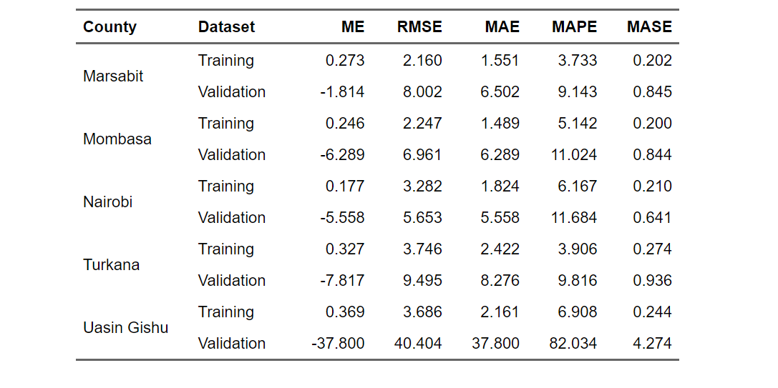
Table: Naïve Model Accuracy — Training and Validation Sets, All Five Counties
Interpretation
The results reveal mixed performance across counties. For Marsabit, Mombasa, Nairobi, and Turkana the validation MASE values of 0.845, 0.844, 0.641, and 0.936 respectively indicate that the naïve model performs reasonably well relative to the benchmark, with all four counties recording MASE values below 1.0.
However, Uasin Gishu tells a very different story, with a validation MASE of 4.274 and a MAPE of 82.034 percent, indicating extremely poor predictive performance. This is explained by the sharp and unexpected price spike that occurred in Uasin Gishu during the validation period, which the naïve model completely failed to capture since it simply held the last training price constant.
The negative ME values across all counties on the validation set indicate that the naïve model systematically underestimated prices during the validation period, consistent with the upward price trend that continued into the validation window. These results confirm that while the naïve model provides a useful baseline, more sophisticated models are needed to capture the trend and dynamic behavior of maize prices across Kenyan counties.
Marsabit plot
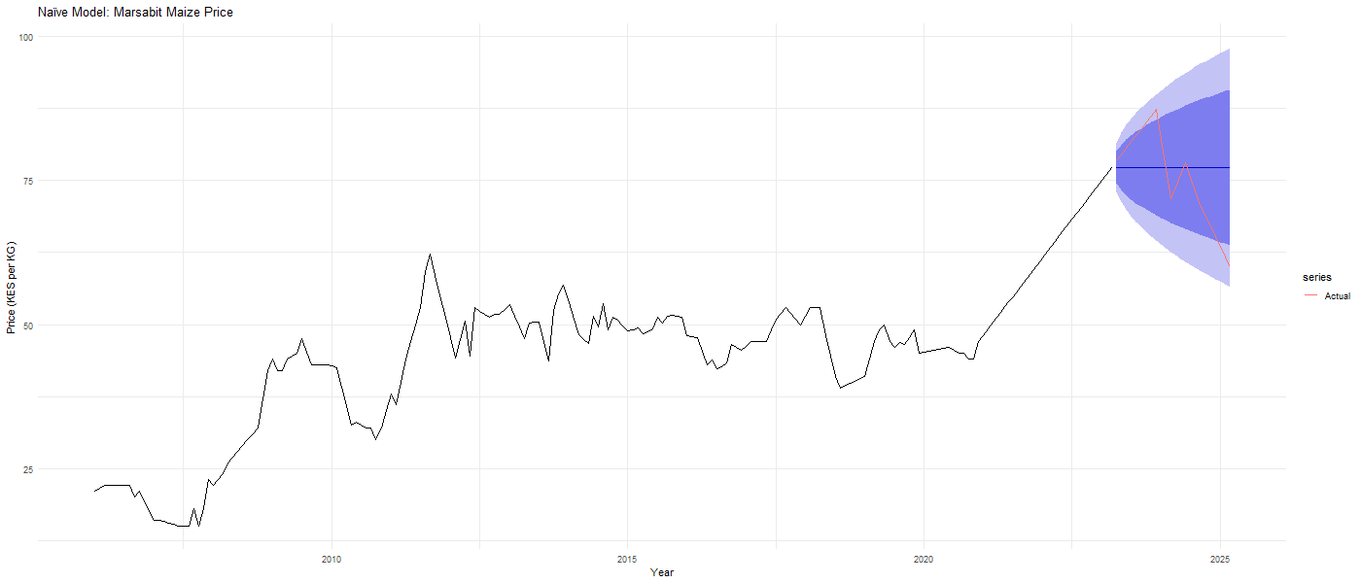
Figure: Naïve Model Forecast — Marsabit
Mombasa plot
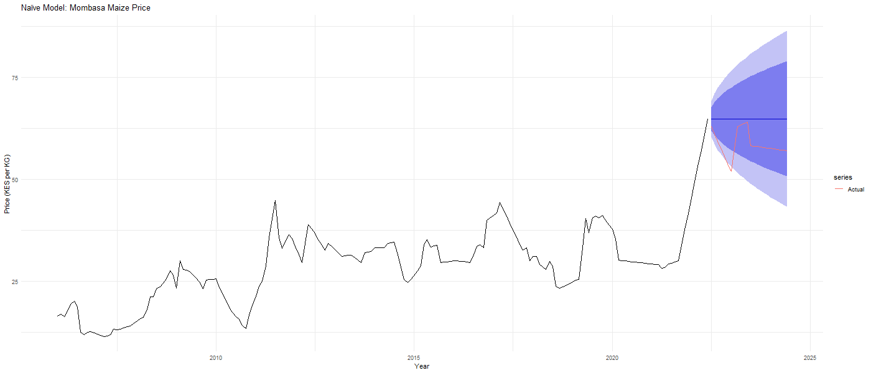
Figure: Naïve Model Forecast — Mombasa
Nairobi plot:
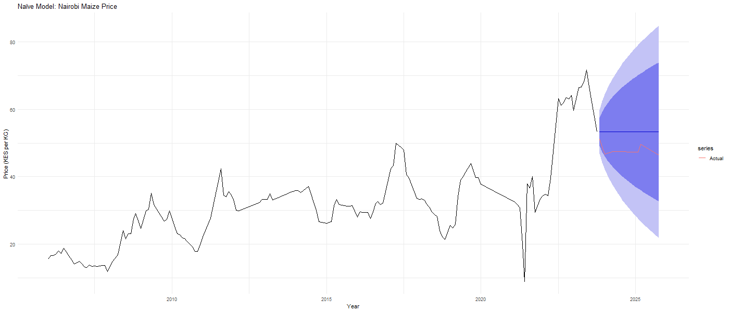
Figure: Naïve Model Forecast — Nairobi
Turkana plot:
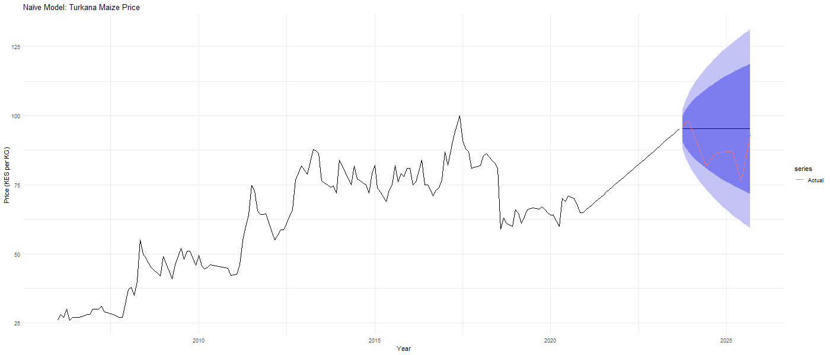
Figure: Naïve Model Forecast — Turkana
Uasin Gishu plot:
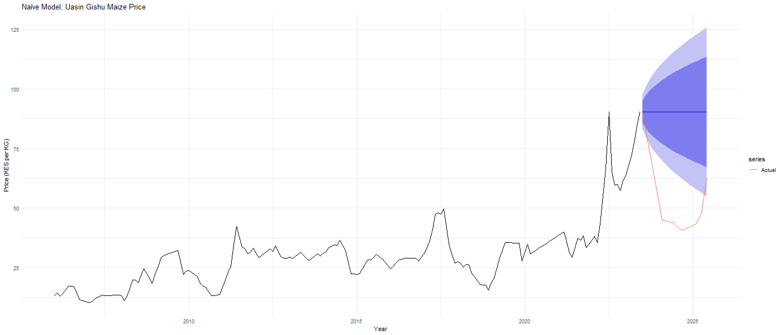
Figure: Naïve Model Forecast — Uasin Gishu

Exponential Smoothing — ETS Model
The Exponential Smoothing State Space model was fitted to the training data for each of the five counties using the automatic ets() selection procedure in R, which evaluates all possible combinations of error, trend, and seasonal components and selects the optimal specification based on the Akaike Information Criterion with correction for small samples (AICc). The selected models and their components are summarized below.
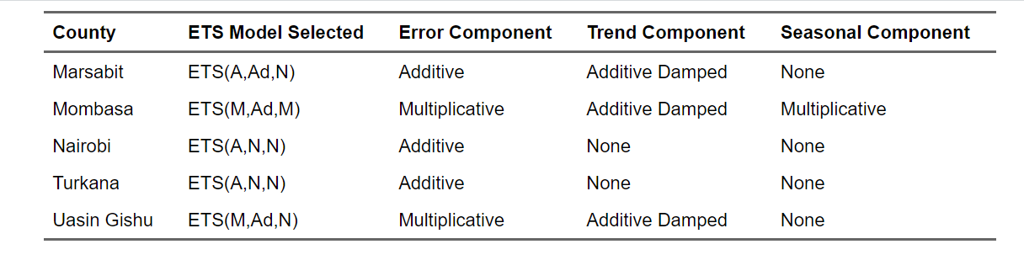

Table: ETS Model Specifications Selected for Each County

The results reveal meaningful differences in ETS model structure across counties. Marsabit and Uasin Gishu were assigned models with a damped additive trend component, reflecting their gradual but moderating upward price trajectory over time.
Mombasa received the most complex specification with multiplicative error, damped trend, and multiplicative seasonality, consistent with the modest seasonal pattern identified in its decomposition analysis. Nairobi and Turkana were both assigned the simplest ETS specification with additive errors only and no trend or seasonal components, effectively behaving like simple exponential smoothing models. This finding is notable as it suggests that for these two counties the most recent price observation carries nearly all the predictive weight, consistent with the near-random-walk behavior identified in the ACF and PACF analysis.

The Accuracy Table
The ETS models were evaluated on both the training and validation sets using the same five accuracy metrics applied to the naïve model. The results are presented below.

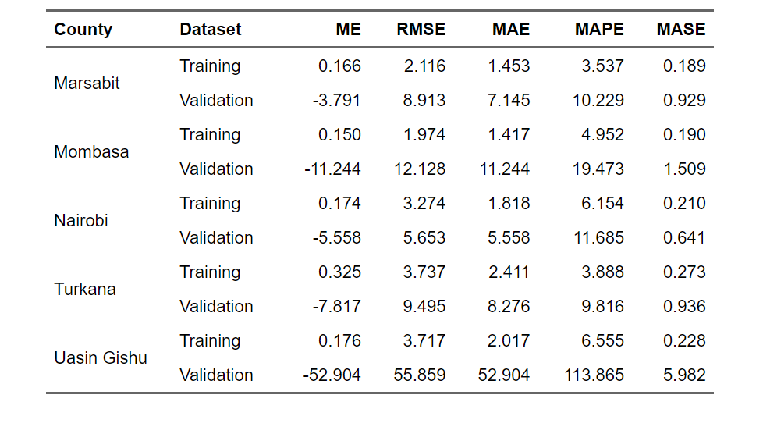
Table: ETS Model Accuracy — Training and Validation Sets, All Five Counties
The ETS accuracy results reveal a mixed picture across counties. For Nairobi and Turkana, the ETS model produced validation MASE values of 0.641 and 0.936 respectively, identical to the naïve model results. This is consistent with the ETS(A,N,N) specification selected for both counties, which as noted earlier behaves like simple exponential smoothing and closely approximates the naïve benchmark.
For Marsabit the ETS model produced a validation MASE of 0.929, slightly worse than the naïve model's 0.845, suggesting that the damped trend component did not improve predictive accuracy during the validation period. Mombasa shows a notably poor validation MASE of 1.509, worse than both the naïve model and the benchmark, indicating that the multiplicative seasonal component introduced by ETS(M,Ad,M) actually hurt predictive performance during the validation period. Uasin Gishu again records the worst performance with a validation MASE of 5.982 and MAPE of 113.865 percent, even worse than the naïve model, confirming that the sharp price spike during the validation period was impossible for any smoothing-based model to anticipate. Overall the ETS models did not outperform the naïve benchmark in most counties, motivating the exploration of ARIMA and TSLM models as alternative approaches.
Marsabit ETS plot
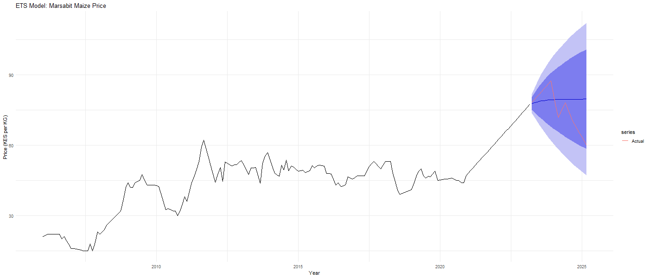
Figure: ETS Model Forecast — Marsabit
Interpretation:
The ETS(A,Ad,N) model for Marsabit projects a slightly declining trend after the sharp price rise observed at the end of the training period, with the forecast line leveling off around KES 80 per KG. The actual validation prices shown in red fluctuate around this level, suggesting the model captured the general price direction reasonably well despite the moderate MASE of 0.929.
Mombasa ETS plot
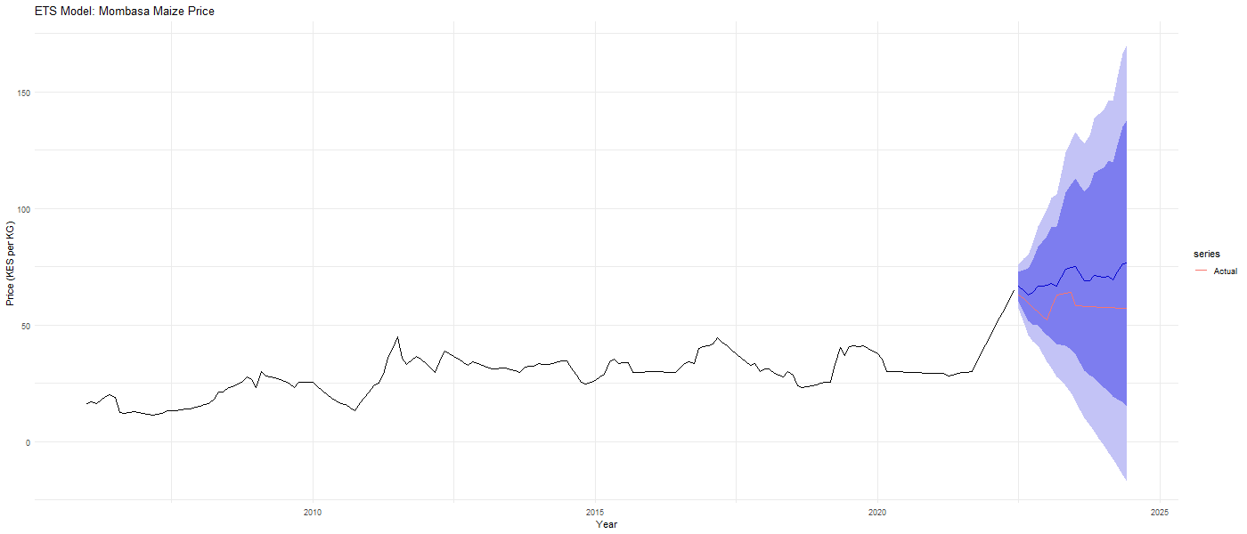
Figure: ETS Model Forecast — Mombasa
Interpretation:
The ETS(M,Ad,M) model for Mombasa produces an upward trending forecast with very wide prediction intervals that expand dramatically over the 24-month horizon, eventually reaching unrealistic price levels above KES 150 per KG. The actual validation prices shown in red remain well below the forecast line, confirming the poor validation MASE of 1.509. The multiplicative seasonal and error components appear to have amplified uncertainty excessively, making this model unsuitable for Mombasa.

Nairobi ETS plot
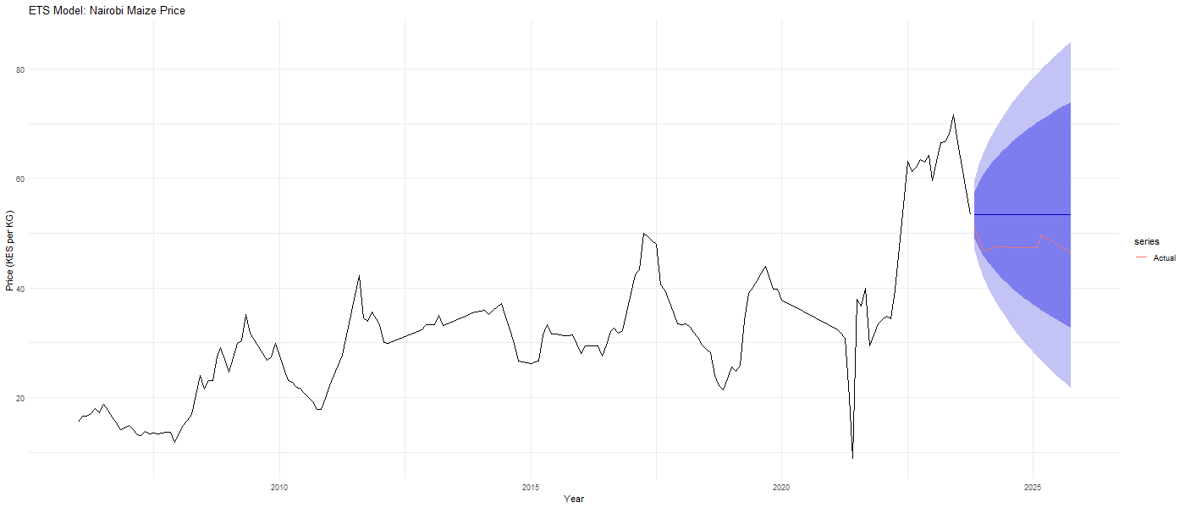
Figure: ETS Model Forecast — Nairobi
Interpretation
The ETS(A,N,N) model for Nairobi produces a flat constant forecast identical in shape to the naïve model, holding the last observed training price constant across the entire validation horizon. The actual validation prices shown in red remain relatively close to the forecast line, consistent with the good validation MASE of 0.641. The widening prediction intervals reflect increasing uncertainty over the 24-month horizon.

Turkana ETS plot
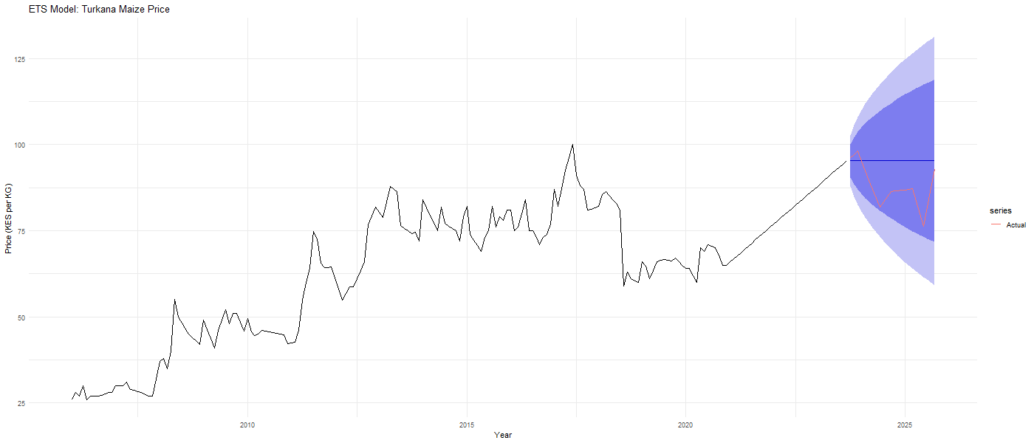
Figure: ETS Model Forecast — Turkana
Interpretation:
Similarly to Nairobi, the ETS(A,N,N) model for Turkana produces a flat constant forecast across the validation period. The actual validation prices shown in red track reasonably close to the forecast, consistent with the validation MASE of 0.936. The prediction intervals widen substantially over time reflecting the high price volatility characteristic of this remote arid county.

Uasin Gishu ETS plot
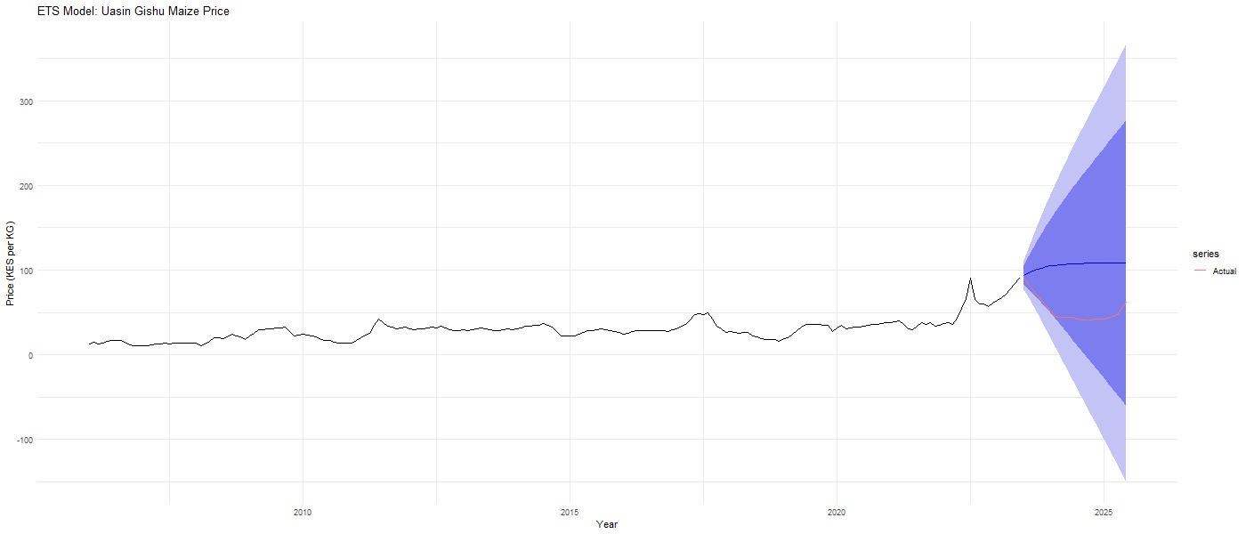
Figure: ETS Model Forecast — Uasin Gishu
Interpretation:
The ETS(M,Ad,N) model for Uasin Gishu produces a gently rising forecast starting from approximately KES 90 per KG and leveling off gradually due to the damped trend component. However, the actual validation prices shown red dropped sharply to around KES 40 per KG before recovering, a pattern the model completely failed to anticipate. The extremely wide prediction intervals extending below zero confirm that the multiplicative error structure amplified uncertainty unrealistically, consistent with the very poor validation MASE of 5.982. This result strongly suggests that the sharp price spike at the end of the training period misled the ETS model into projecting unrealistically high future prices.

ARIMA Model

Augmented Dickey-Fuller Test
Before fitting the ARIMA models, the Augmented Dickey-Fuller test was applied to the training data for each county to formally assess whether the series are stationary. The null hypothesis of the ADF test is that the series contains a unit root and is therefore non-stationary. A p-value greater than 0.05 means we fail to reject the null hypothesis and conclude the series is non-stationary. The results are presented below.
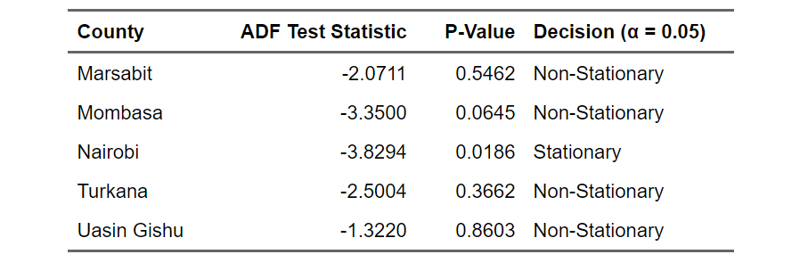
Table: Augmented Dickey-Fuller Test Results — All Five Counties

The ADF test results confirm that four of the five counties Marsabit, Mombasa, Turkana, and Uasin Gishu have p-values greater than 0.05, meaning we fail to reject the null hypothesis of a unit root and conclude that these series are non-stationary. This is fully consistent with the slowly decaying ACF patterns observed during the data exploration stage. Nairobi is the only county that returned a p-value of 0.0186, which is below the 0.05 threshold, suggesting stationarity.
However, this result should be interpreted with caution as the Nairobi series contains an artificial dip from the linear interpolation applied during the 2021 data gap, which may have influenced the test outcome. Given that visual inspection, decomposition, and ACF analysis all consistently indicated non-stationarity for Nairobi, first differencing was applied to all five counties for consistency and to ensure robust model estimation.

Differencing
First differencing was applied to all five county training series to achieve stationarity prior to ARIMA model estimation. The ADF test was then reapplied to the differenced series to confirm that stationarity had been achieved. The results are presented below.
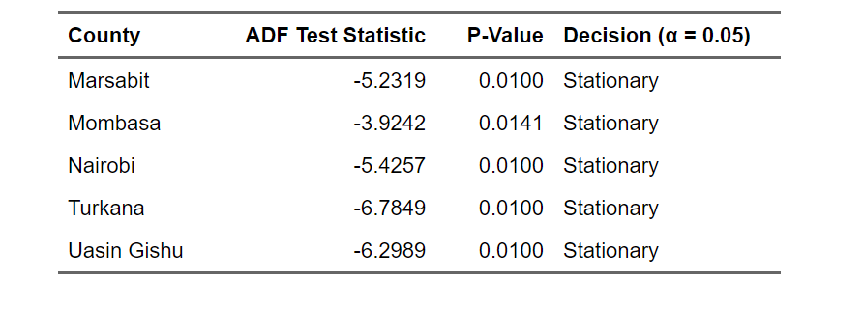
Table: ADF Test Results After First Differencing — All Five Counties

After applying first differencing all five counties returned p-values at or below 0.05, confirming that the differenced series are stationary. Marsabit, Nairobi, Turkana, and Uasin Gishu all returned p-values of 0.01, the minimum reportable value, indicating very strong evidence of stationarity. Mombasa returned a p-value of 0.0141, also well below the 0.05 threshold. These results confirm that one round of differencing was sufficient to achieve stationarity across all five counties, consistent with an integration order of one and supporting the use of ARIMA models with d=1.

Box-Cox Transformation Assessment
Prior to fitting the ARIMA models a Box-Cox transformation assessment was conducted for each county to determine whether variance stabilization was necessary. The Box-Cox procedure estimates a lambda parameter that indicates the most appropriate power transformation for the data. A lambda value close to zero suggests a logarithmic transformation is appropriate, while a lambda value close to 1.0 suggests the data is already on an appropriate scale and no transformation is needed.
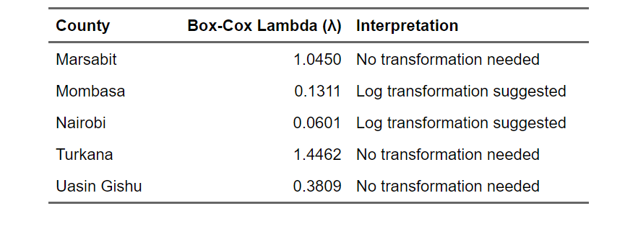
Table: Box-Cox Transformation Assessment — All Five Counties

The Box-Cox results indicate that Mombasa and Nairobi have lambda values close to zero at 0.1311 and 0.0601 respectively, suggesting that a logarithmic transformation could help stabilize variance in these series. Marsabit and Turkana have lambda values well above 1.0, indicating no transformation is needed.
Uasin Gishu has a lambda of 0.3809 which falls between the two thresholds. However, given that the primary goal of this analysis is forecasting rather than parameter estimation, and that the auto.arima() function in R automatically handles variance through its model selection procedure, the analysis proceeds without applying a Box-Cox transformation. This decision also preserves interpretability of the forecasts on the original KES per kilogram scale, which is more meaningful for policymakers and food security practitioners.

ARIMA Model Selection
Following the stationarity confirmation the ARIMA models were fitted to the training data for each county using the auto.arima() function in R, which systematically evaluates competing ARIMA specifications and selects the optimal model based on the Akaike Information Criterion. The selected models and their information criteria are presented below.
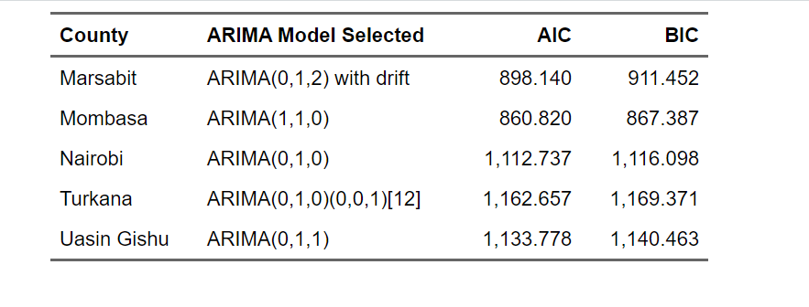
Table: ARIMA Model Specifications Selected for Each County

The auto.arima() procedure selected meaningfully different model structures across the five counties, reflecting the distinct dynamics of each price series.
Marsabit was assigned ARIMA(0,1,2) with drift, indicating that after first differencing two moving average terms and a drift component best capture the remaining price structure, suggesting a gradual upward price drift with short-term shock persistence.
Mombasa received ARIMA(1,1,0), meaning that after differencing one autoregressive term captures the remaining serial correlation, indicating that the previous month's price change directly influences the current month.
Nairobi was assigned the simplest specification ARIMA(0,1,0), a pure random walk confirming that after differencing no additional autoregressive or moving average structure improves the model.
Turkana received ARIMA(0,1,0)(0,0,1)[12], a seasonal ARIMA model where after differencing a seasonal moving average term at lag 12 captures a mild annual pattern, consistent with the seasonal component identified in Turkana's decomposition.
Uasin Gishu was assigned ARIMA(0,1,1), indicating that after differencing one moving average term captures short-term price shock persistence.
All five models incorporate first differencing confirming the ADF test findings and the non-stationarity identified during data exploration.

ARIMA Model Accuracy
The ARIMA models were evaluated on both the training and validation sets for all five counties. The accuracy results are presented below.

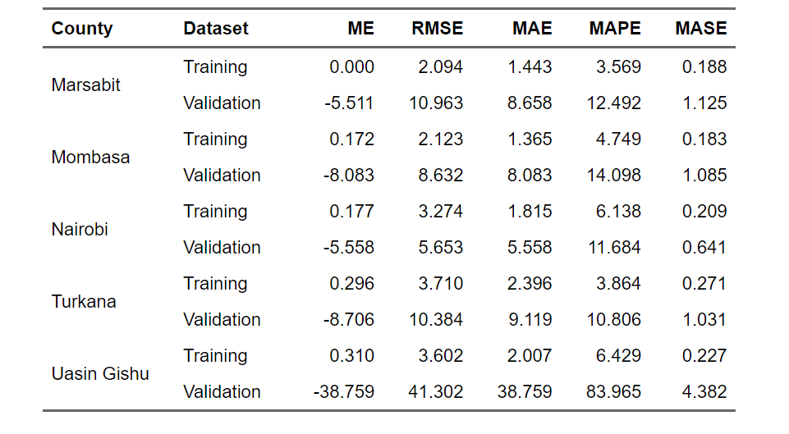
The ARIMA accuracy results present a mixed picture across counties.
Nairobi performs best with a validation MASE of 0.641, identical to the naïve and ETS results, confirming that the random walk specification ARIMA(0,1,0) selected for Nairobi is effectively equivalent to the naïve benchmark.
Marsabit the ARIMA model produced a validation MASE of 1.125, slightly worse than the naïve model's 0.845, suggesting that the moving average terms did not improve out-of-sample accuracy despite improving in-sample fit.
Mombasa and Turkana both recorded validation MASE values just above 1.0 at 1.085 and 1.031 respectively, indicating marginal underperformance relative to the naïve benchmark.
Uasin Gishu again records the worst performance with a validation MASE of 4.382 and MAPE of 83.965 percent, consistent with the results from the naïve and ETS models and again reflecting the extraordinary price shock that occurred during the validation period.
Overall, the ARIMA models did not consistently outperform the naïve benchmark across all counties, a finding that is consistent with the random walk behavior identified during data exploration and suggests that maize prices in Kenya are largely driven by unpredictable external shocks rather than exploitable historical patterns.

Marsabit ARIMA plot
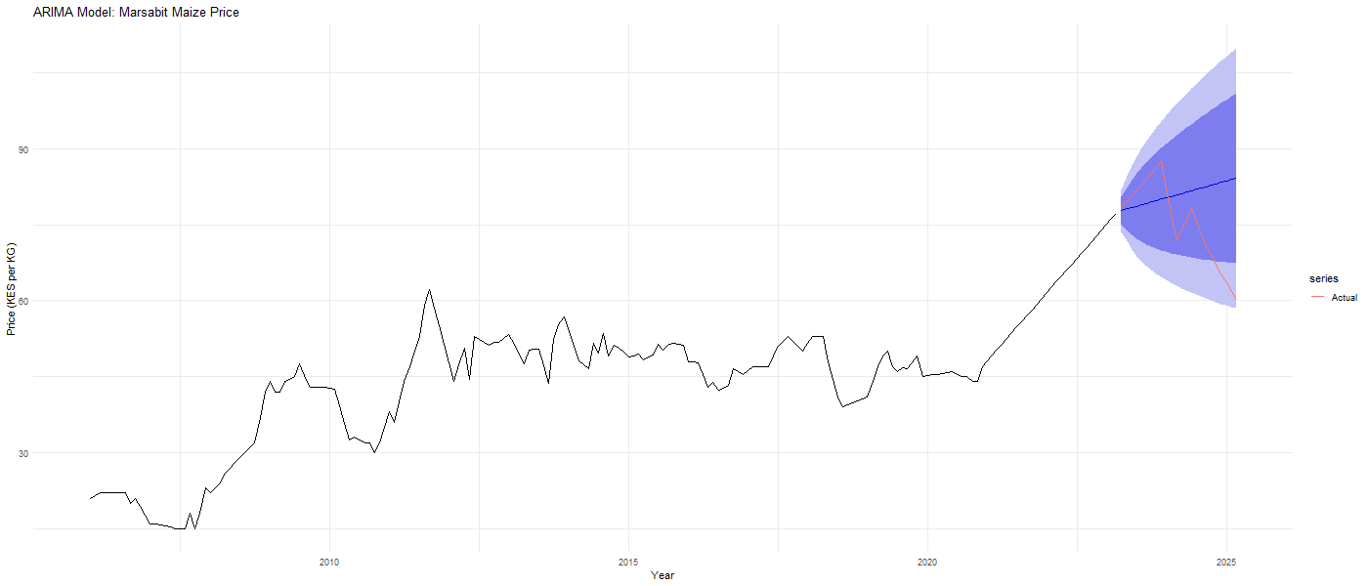
Figure: ARIMA Model Forecast — Marsabit
Interpretation
The ARIMA(0,1,2) with drift model for Marsabit projects a gently upward sloping forecast reflecting the drift component, with prediction intervals widening over the 24-month horizon. The actual validation prices shown in red fluctuate above and below the forecast line, with the model capturing the general price direction but underestimating the volatility observed in the validation period, consistent with the validation MASE of 1.125.

Mombasa ARIMA plot
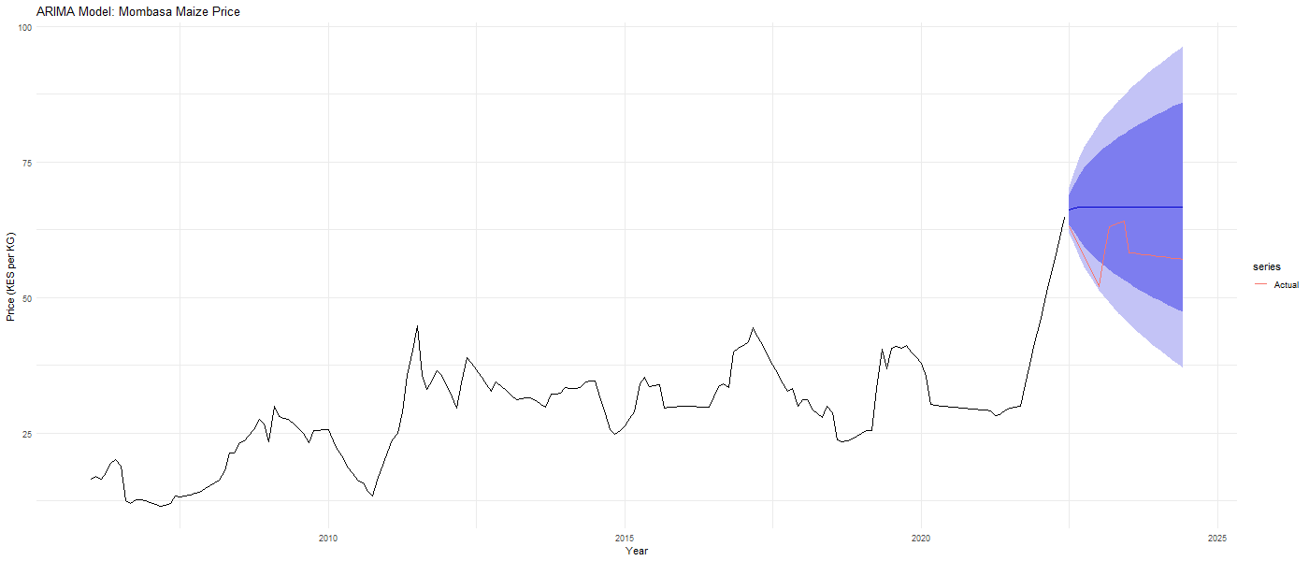
Figure: ARIMA Model Forecast — Mombasa
Interpretation
The ARIMA(1,1,0) model for Mombasa produces a flat forecast holding the last observed price level constant across the validation horizon. The actual validation prices shown in red initially track close to the forecast before declining below it toward the end of the validation period. The prediction intervals widen at a moderate rate consistent with the autoregressive structure of the model.
Nairobi ARIMA plot
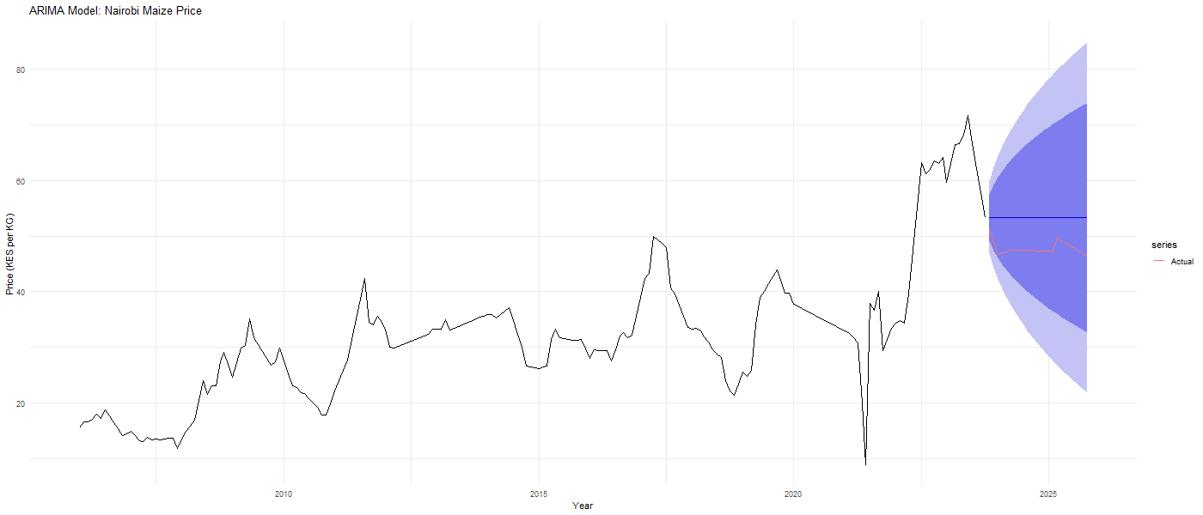
Figure: ARIMA Model Forecast — Nairobi
Interpretation
The ARIMA(0,1,0) random walk model for Nairobi produces a flat constant forecast identical to the naïve model. The actual validation prices shown in red remain relatively close to the forecast line and well within the prediction intervals, consistent with the best validation MASE of 0.641 achieved across all models and all counties.

Turkana ARIMA plot
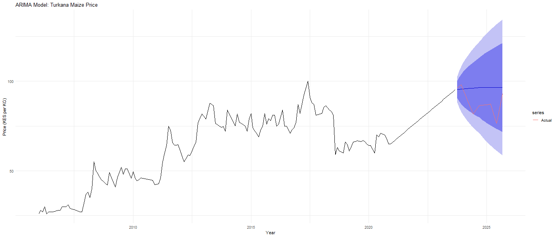
Figure : ARIMA Model Forecast — Turkana
Interpretation
The ARIMA(0,1,0)(0,0,1)[12] seasonal model for Turkana produces a relatively flat forecast with moderately widening prediction intervals. The actual validation prices shown in red start close to the forecast before declining below it, reflecting a temporary price dip during the validation period that the model did not anticipate. The validation MASE of 1.031 indicates marginal underperformance relative to the naïve benchmark.

Uasin Gishu ARIMA plot
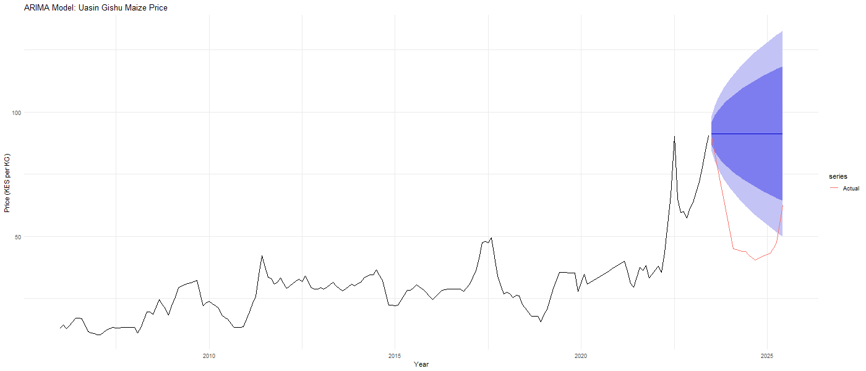
Figure: ARIMA Model Forecast — Uasin Gishu
Interpretation
The ARIMA(0,1,1) model for Uasin Gishu produces a flat forecast starting from approximately KES 90 per KG with moderately widening prediction intervals. The actual validation prices shown in red dropped sharply to around KES 40 per KG before partially recovering, a dramatic decline that falls well outside the model's forecast range. This confirms that the sharp price reversal during the validation period was entirely unpredictable from historical patterns alone, explaining the very poor validation MASE of 4.382.

Time Series Linear Model — TSLM
The Time Series Linear Model was fitted to the training data for each county using trend and seasonal indicator variables as predictors. Unlike the naïve, ETS, and ARIMA models which are purely data-driven, the TSLM explicitly models the linear relationship between maize prices and time, allowing it to project the long-run upward trend forward into the forecast horizon. The accuracy results for both training and validation sets are presented below.
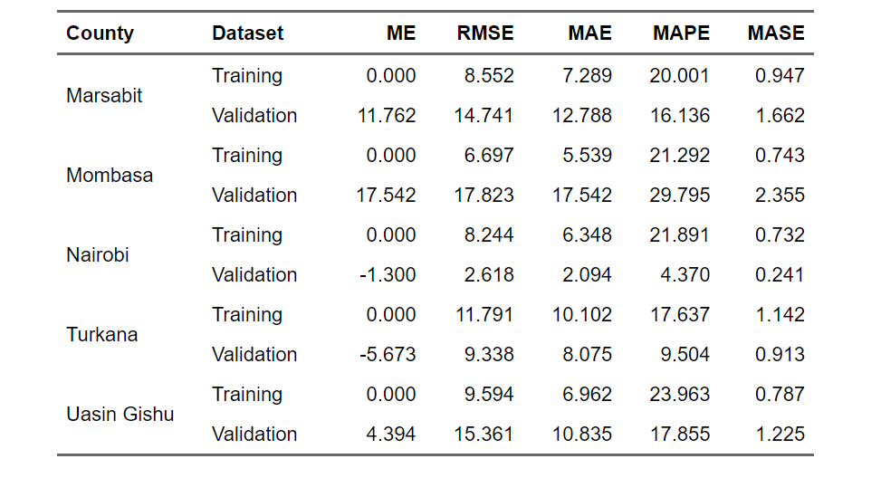
Table: TSLM Model Accuracy — Training and Validation Sets, All Five Counties

The TSLM results reveal the most varied performance across counties of all four models tested. Nairobi stands out with by far the best validation performance of any model across all counties, recording a validation MASE of 0.241 and MAPE of just 4.370 percent. This remarkable result suggests that for Nairobi the linear trend and seasonal structure captured by the TSLM closely matched the actual price trajectory during the validation period, making it the clear best performing model for that county.
Turkana also performed well with a validation MASE of 0.913, slightly better than the naïve benchmark.
Uasin Gishu recorded a validation MASE of 1.225, worse than the naïve model but substantially better than the ETS result of 5.982, suggesting that the linear trend projection provided a more realistic forecast for that county than the smoothing based approaches.
Marsabit and Mombasa performed poorly with validation MASE values of 1.662 and 2.355 respectively, indicating that the linear trend assumption overestimated prices during the validation period for these two counties.
The TSLM performed best for counties where prices followed a relatively predictable linear trajectory during the validation period and worst where prices deviated sharply from the historical trend.

Marsabit TSLM plot
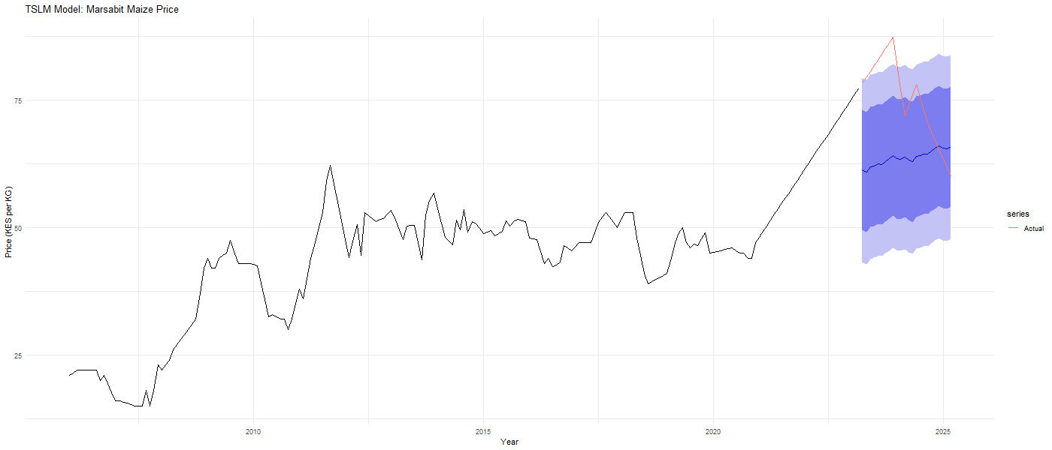
Figure: TSLM Model Forecast — Marsabit
Interpretation
The TSLM model for Marsabit projects a gently upward sloping forecast starting from around KES 70 per KG, continuing the linear trend estimated from the training data. The actual validation prices shown in red start above the forecast line before declining toward and below it, indicating that the linear trend overestimated prices during the latter part of the validation period. The validation MASE of 1.662 confirms that the TSLM underperformed the naïve benchmark for Marsabit.

Mombasa TSLM plot
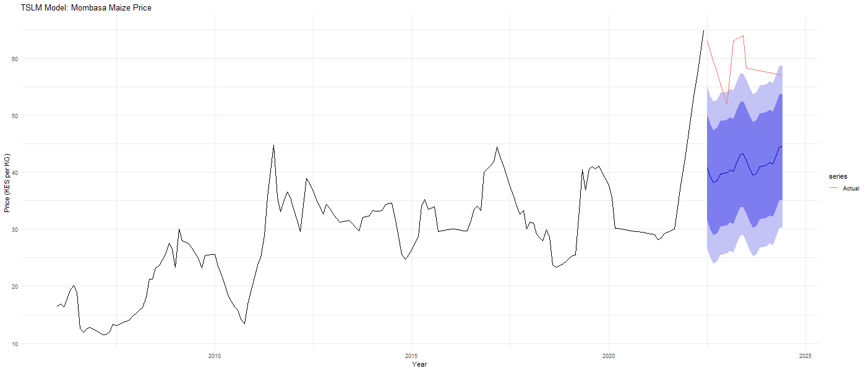
Figure: TSLM Model Forecast — Mombasa
Interpretation
The TSLM model for Mombasa projects a gradually increasing forecast from around KES 40 per KG, extrapolating the historical linear trend. The actual validation prices shown in red start significantly above the forecast line before declining toward it, indicating that prices rose more sharply than the trend suggested before correcting downward. The validation MASE of 2.355 confirms poor performance for Mombasa under the TSLM approach.

Nairobi TSLM plot
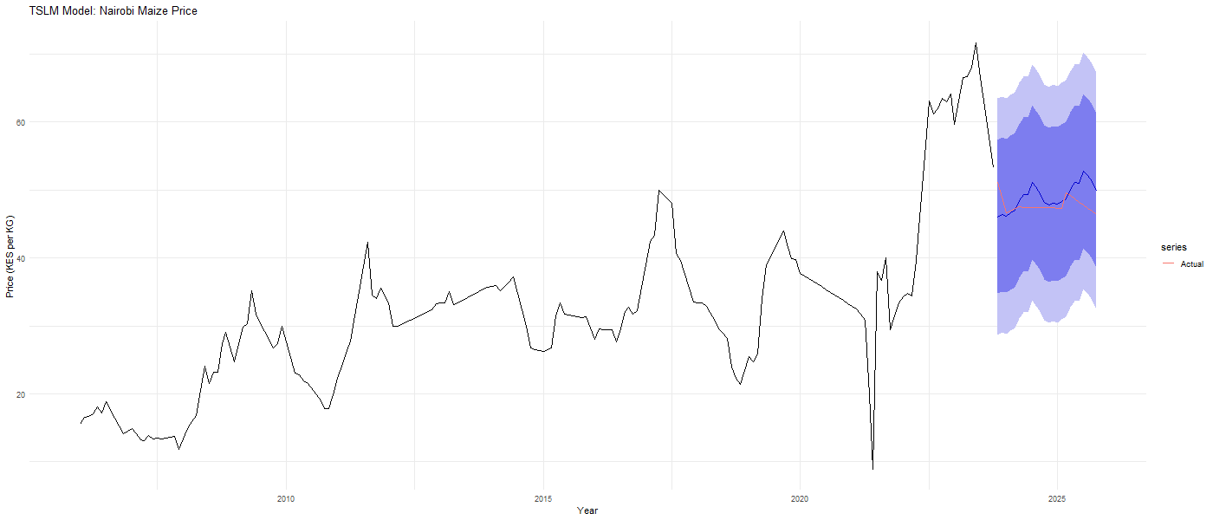
Figure: TSLM Model Forecast — Nairobi
Interpretation
The TSLM model for Nairobi produces the most impressive forecast of all models and all counties. The forecast line tracks remarkably close to the actual validation prices shown in red throughout the entire 24-month validation period, with actual prices remaining well within the 80 percent prediction interval. This outstanding result with a validation MASE of 0.241 and MAPE of 4.370 percent confirms that for Nairobi the linear trend and seasonal structure captured by the TSLM closely matched the actual price trajectory during the validation period, making it the single best performing model in the entire analysis.

Turkana TSLM plot
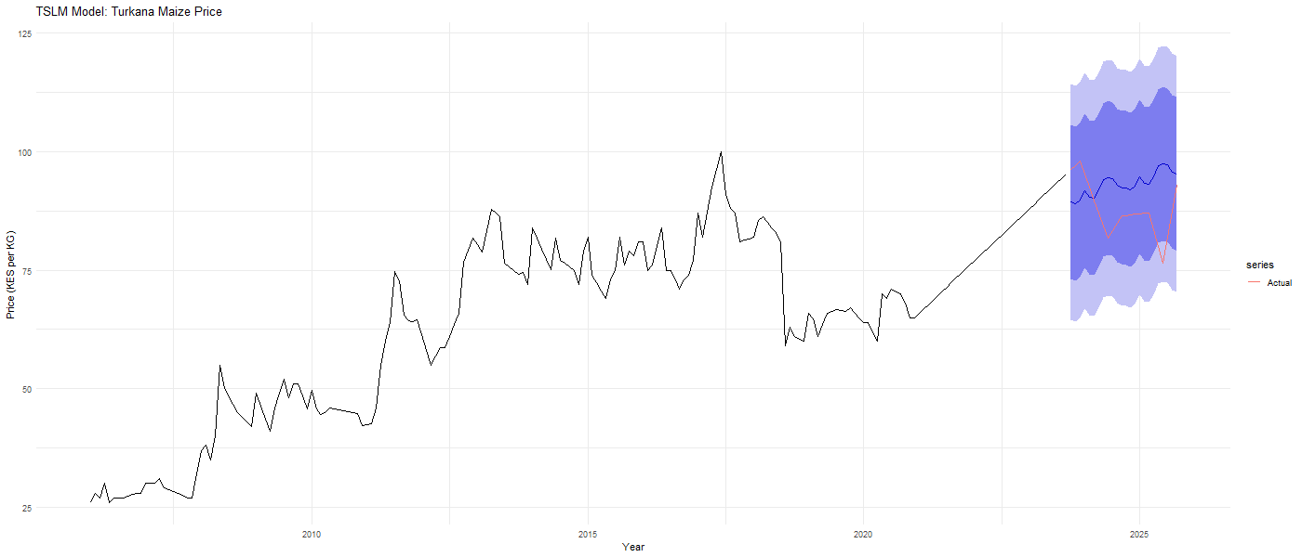
Figure: TSLM Model Forecast — Turkana
Interpretation
The TSLM model for Turkana projects a continuing upward trend from around KES 93 per KG, consistent with the strong long-run upward trajectory observed in the training data. The actual validation prices shown in red track reasonably close to the forecast in the early months before declining below it, reflecting a temporary price dip during the validation period. The validation MASE of 0.913 indicates that the TSLM outperformed the naïve benchmark slightly for Turkana.
Uasin Gishu TSLM plot
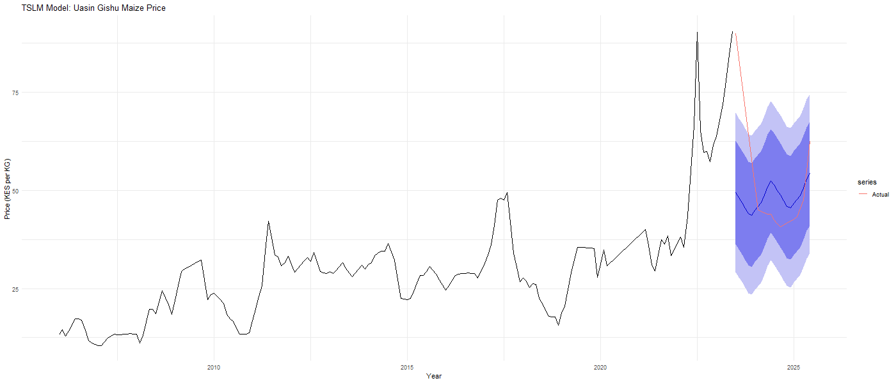
Figure: TSLM Model Forecast — Uasin Gishu
Interpretation
The TSLM model for Uasin Gishu projects a moderate upward trend starting from around KES 50 per KG. The actual validation prices shown in red start well above the forecast before declining sharply and then recovering, crossing the forecast line midway through the validation period. The wide prediction intervals reflect the high variability in Uasin Gishu's price series. While the validation MASE of 1.225 indicates underperformance relative to the naïve benchmark, it is substantially better than the ETS result of 5.982, suggesting that the linear trend projection provided a more grounded forecast than the smoothing based approach for this county.

Residual diagnostics
Residual diagnostics were conducted for the ARIMA model fitted to each county to assess whether the model residuals behave like white noise. A well-fitted model should produce residuals that are randomly distributed around zero with no systematic patterns, no remaining autocorrelation, and an approximately normal distribution. Each diagnostic plot contains three panels: the top panel shows the residual time series, the bottom left panel shows the ACF of the residuals, and the bottom right panel shows a histogram of the residuals with a fitted normal curve overlay.

Marsabit residuals plot
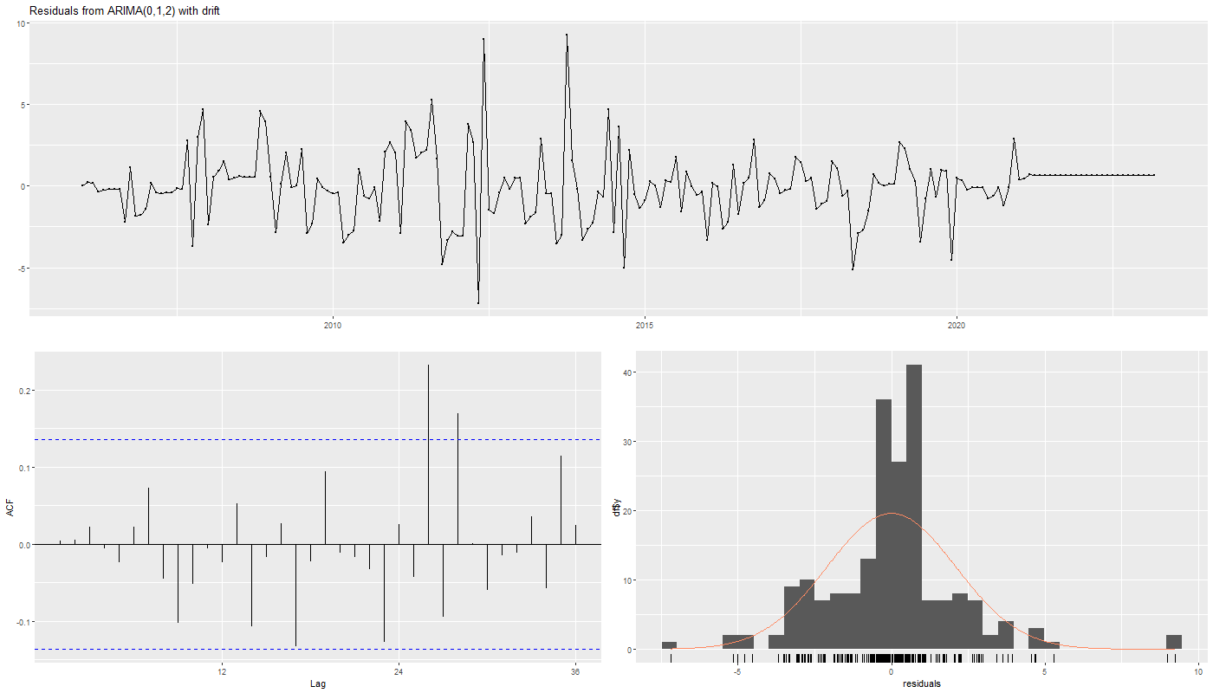
Figure: Residual Diagnostics — Marsabit ARIMA(0,1,2) with drift
Interpretation
The residual time series for Marsabit fluctuates randomly around zero for most of the training period with no obvious systematic pattern, though some larger spikes are visible around 2009 and 2015 corresponding to known supply disruption events. The ACF of the residuals shows most lags falling within the confidence bounds with a few exceptions at higher lags, suggesting mild remaining autocorrelation. The histogram shows a roughly bell-shaped distribution centered near zero, though with some right skewness indicating occasional large positive price shocks that the model did not fully capture.

Mombasa residuals plot
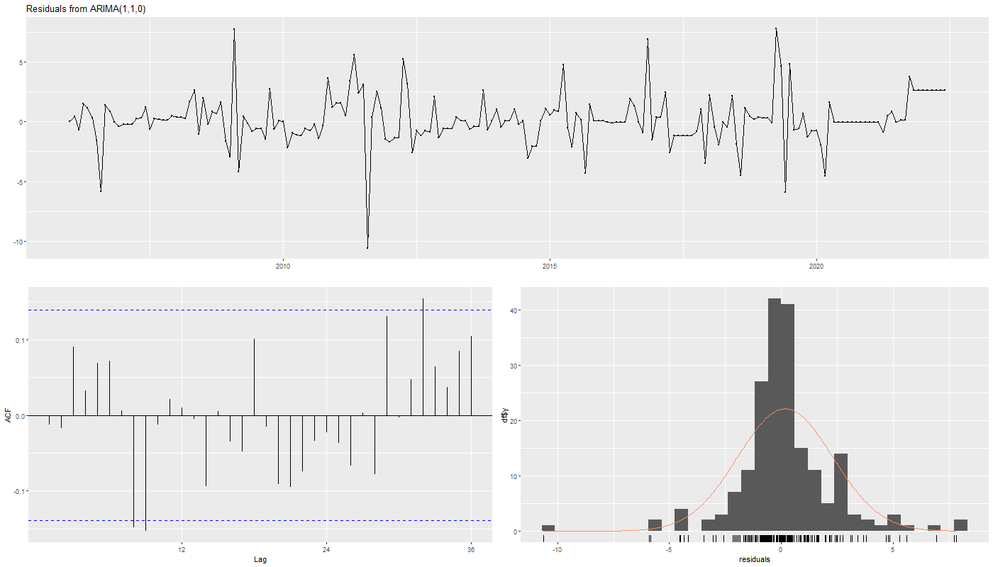

Figure: Residual Diagnostics — Mombasa ARIMA(1,1,0)
Interpretation
The Mombasa residuals fluctuate around zero with moderate variability throughout the training period, with a notable large negative spike around 2011 corresponding to a sharp price drop in that period. The ACF of the residuals shows several lags approaching but mostly remaining within the confidence bounds, suggesting the model has captured most of the autocorrelation structure. The histogram shows a broadly normal distribution centered near zero with some spread on both tails, indicating the presence of occasional extreme price movements in both directions.

Nairobi Residuals Plot
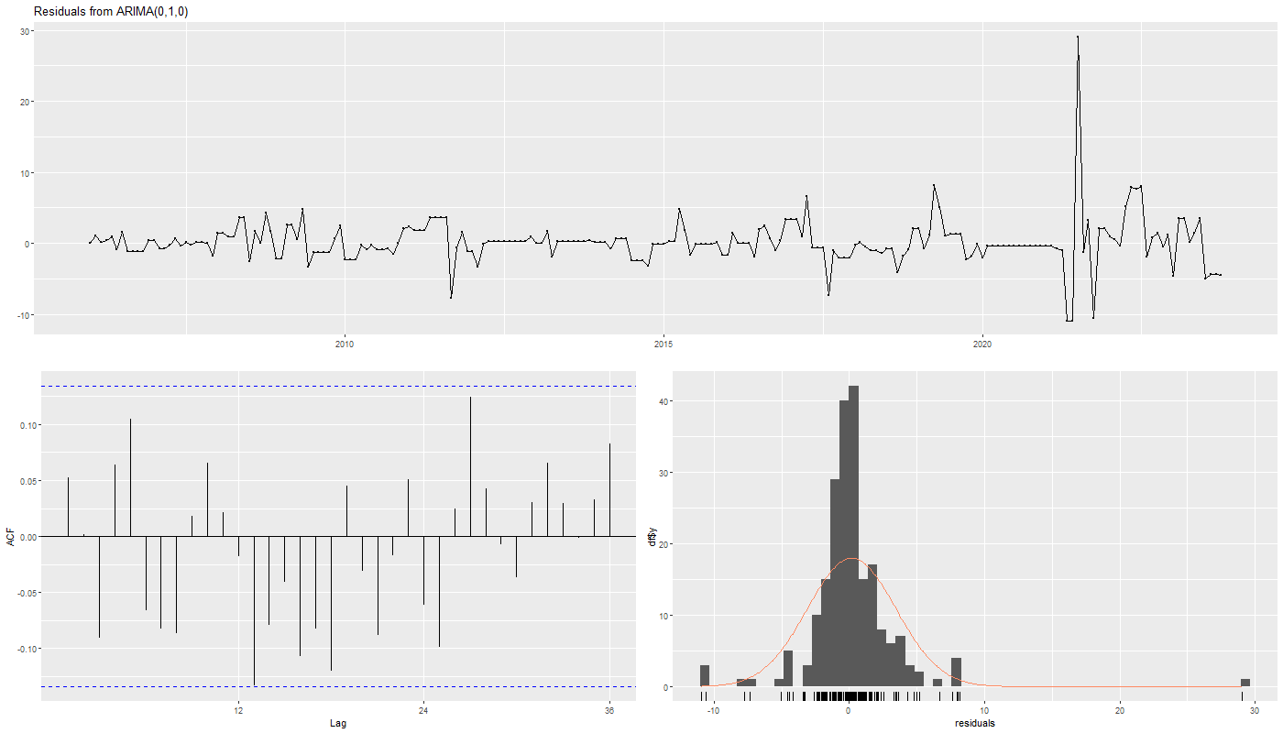
Figure: Residual Diagnostics — Nairobi ARIMA(0,1,0)
Interpretation
The Nairobi residuals are generally small and randomly distributed around zero throughout most of the training period, with a very large positive spike visible around 2021 corresponding to the data transition period and the interpolation applied to fill the gap between the two commodity labels. The ACF of the residuals shows all lags falling well within the confidence bounds confirming that the random walk model has adequately captured the autocorrelation structure of the series. The histogram shows a broadly normal distribution centered near zero with the large 2021 spike appearing as an outlier in the right tail.

Turkana residuals plot
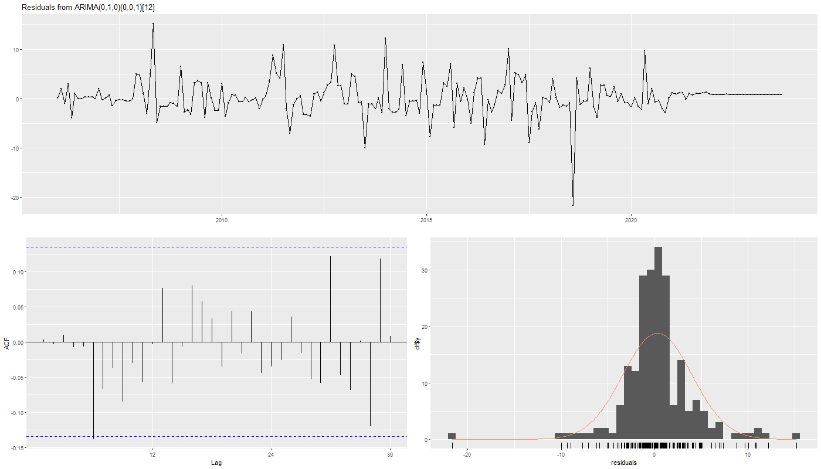
Figure: Residual Diagnostics — Turkana ARIMA(0,1,0)(0,0,1)[12]
Interpretation
The Turkana residuals show moderate variability around zero throughout the training period with a notable large negative spike around 2019 corresponding to a period of temporary price decline in that county. The ACF of the residuals shows most lags falling within the confidence bounds with a few borderline cases, suggesting the seasonal moving average term has adequately addressed the annual structure. The histogram shows a roughly symmetric distribution centered near zero with heavier tails than a perfect normal distribution, reflecting the occasional large price shocks characteristic of this remote arid county.

Uasin Gishu residuals plot
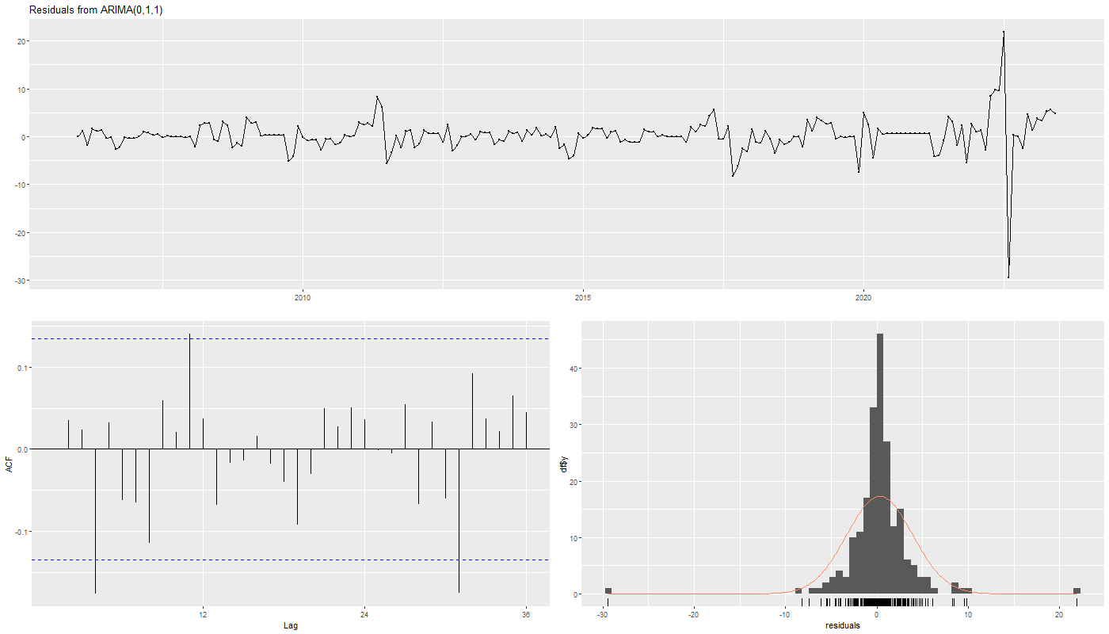
Figure: Residual Diagnostics — Uasin Gishu ARIMA(0,1,1)
Interpretation
The Uasin Gishu residuals are generally small and well-behaved for most of the training period, with a very large negative spike visible near the end of the training window around 2022 to 2023 corresponding to the extraordinary price spike that occurred in that period. This large residual confirms that the price shock was far outside the range of normal historical variation and could not be anticipated by the model. The ACF of the residuals shows most lags within the confidence bounds confirming adequate model fit for the non-shock periods. The histogram shows a roughly normal distribution centered near zero but with heavy left and right tails driven by the extreme price movements in the most recent training period.

Ljung-Box White Noise Test
To formally confirm whether the ARIMA model residuals are consistent with white noise, the Ljung-Box test was applied to the residuals of each county's fitted ARIMA model at lag 20. The null hypothesis of the Ljung-Box test is that the residuals are independently distributed with no remaining autocorrelation. A p-value greater than 0.05 means we fail to reject the null hypothesis and conclude the residuals are white noise, indicating an adequate model fit.
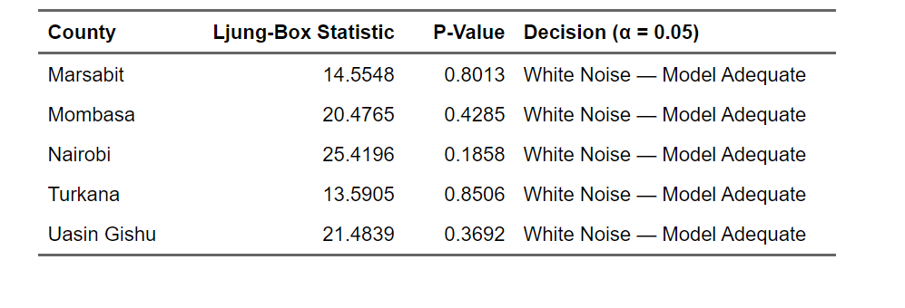
Table: Ljung-Box White Noise Test Results — ARIMA Models, All Five Counties

The Ljung-Box test results confirm that all five ARIMA models produce residuals that are consistent with white noise.
All five counties returned p-values well above the 0.05 significance threshold, with values ranging from 0.1858 for Nairobi to 0.8506 for Turkana. This means that after fitting the ARIMA models there is no statistically significant remaining autocorrelation in the residuals for any county, confirming that the selected ARIMA specifications have adequately captured the temporal structure of the maize price series.
These results provide confidence that the ARIMA models are well specified and that their forecasts are based on a sound statistical foundation, even if the out-of-sample validation performance was limited by unpredictable external price shocks during the validation period.

DESCRIPTION OF RESULTS

Model Comparison
Having evaluated four forecasting models across all five counties, this section presents a comprehensive comparison of model performance based on the validation set MASE values. MASE was selected as the primary comparison metric because it is scale-independent, allowing fair comparison across counties with different price levels, and because a MASE value below 1.0 indicates the model outperforms the naïve benchmark while a value above 1.0 indicates underperformance. The best performing model for each county is identified based on the lowest validation MASE.
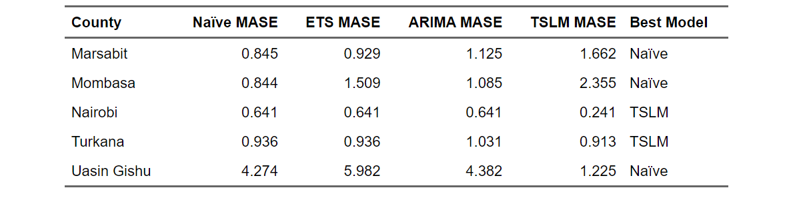
Table: Model Comparison — Validation MASE Across All Models and Counties

The model comparison results reveal several important findings.
First no single model dominated across all five counties, suggesting that different price dynamics require different forecasting approaches depending on the county type and market structure.
Second the TSLM model emerged as the best performer for two counties, Nairobi with an outstanding MASE of 0.241 and Turkana with a MASE of 0.913, demonstrating that the linear trend and seasonal structure captured by the TSLM closely matched actual price movements during the validation period for these counties.
Third the naïve model proved to be the best or equal best performer for Marsabit with a MASE of 0.845, Mombasa with a MASE of 0.844, and Uasin Gishu with a MASE of 4.274. The fact that no model could substantially outperform the naïve benchmark for these three counties is consistent with the random walk behavior identified in the ACF and PACF analysis and confirms that maize prices in these counties are largely driven by unpredictable external shocks.
Fourth Uasin Gishu recorded the worst performance across all models and all counties, with all models producing MASE values well above 1.0. The relatively best result for Uasin Gishu was the TSLM with a MASE of 1.225, though this still indicates underperformance relative to the naïve benchmark.
This extraordinary result is explained entirely by the sharp and unprecedented price spike that occurred during the validation period, which no historical pattern-based model could have anticipated.
Fifth the ETS model performed worst overall, failing to outperform the naïve benchmark in any county and producing particularly poor results for Mombasa and Uasin Gishu where the multiplicative components amplified forecast errors unrealistically.
Sixth the ARIMA model performed comparably to the naïve model for Nairobi, consistent with the ARIMA(0,1,0) random walk specification selected for that county, and provided marginal improvements over ETS for most other counties.
These results highlight the fundamental challenge of forecasting maize prices in Kenya, where external shocks, supply disruptions, and structural breaks dominate the price dynamics and limit the predictive power of any model based solely on historical price patterns.

RMSE comparison table for completeness:
To complement the MASE comparison, the table below presents the Root Mean Squared Error for each model and county on the validation set. The RMSE measures the average magnitude of forecast errors in the original KES per kilogram unit, providing an economically interpretable measure of forecast accuracy that is particularly useful for policymakers assessing the practical significance of forecast errors.
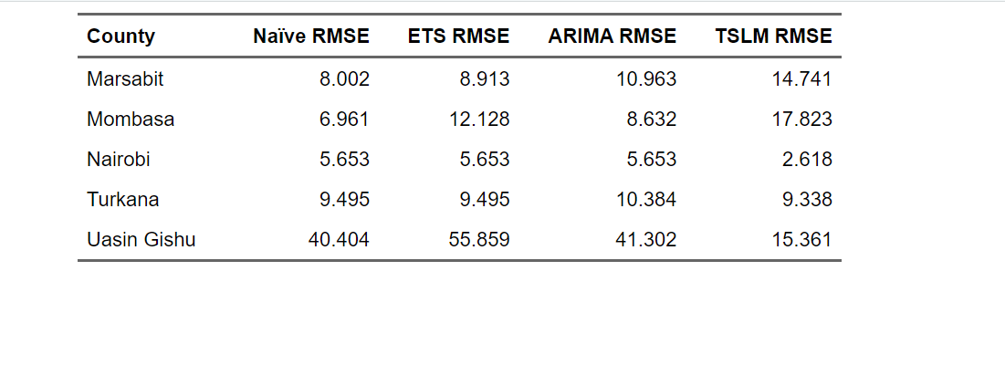
Table: Model Comparison — Validation RMSE Across All Models and Counties

The RMSE results are consistent with the MASE findings and provide additional economic context for interpreting forecast accuracy.
For Nairobi the TSLM model achieved the lowest RMSE of just KES 2.618 per kilogram, meaning that on average the model's forecasts were within approximately KES 2.62 of the actual price during the validation period a remarkably accurate result for a 24-month forecast horizon.
For Turkana the TSLM also achieved the lowest RMSE at KES 9.338, slightly better than the naïve and ETS results of KES 9.495.
For Marsabit and Mombasa the naïve model achieved the lowest RMSE at KES 8.002 and KES 6.961 respectively, confirming that simpler models performed better for these counties during the validation period.
Uasin Gishu recorded by far the highest RMSE across all models, with the ETS model producing the worst result of KES 55.859 and the TSLM producing the best result of KES 15.361.
From a food security policy perspective an RMSE of KES 15 per kilogram on a commodity with a median price of around KES 29 represents a substantial forecast error, underscoring the difficulty of anticipating extreme price movements in agricultural counties during periods of market disruption.

24-Month Future Forecast

Prediction of Future Maize Prices
Based on the model comparison results, the best performing model for each county was used to generate 24-month forecasts of future maize prices.
Nairobi and Turkana forecasts were generated using the TSLM model, which demonstrated superior validation performance for these counties.
Marsabit, Mombasa, and Uasin Gishu forecasts were generated using the naïve model, which proved to be the most reliable benchmark for these counties during the validation period. All models were refitted on the complete available series before generating future forecasts to ensure the most recent price information was incorporated.
The forecast period covers November 2025 through October 2027, representing two full seasonal cycles as required.

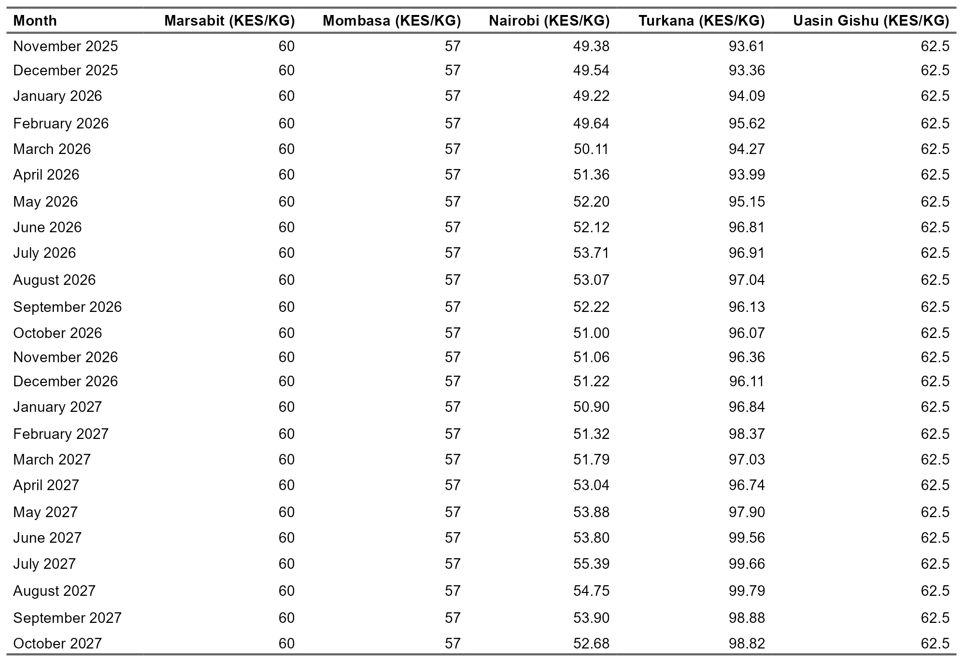
Table: 24-Month Future Maize Price Forecasts by County (KES per KG)

The forecast results reflect the characteristics of each county's best performing model.
For Marsabit and Mombasa the naïve model projects constant prices of KES 60.00 and KES 57.00 per kilogram respectively throughout the entire 24-month horizon, holding the last observed price constant.
For Uasin Gishu the naïve model similarly projects a constant price of KES 62.50 per kilogram. For Nairobi the TSLM model projects a gently fluctuating price series ranging between approximately KES 49 and KES 55 per kilogram over the forecast horizon, reflecting the seasonal pattern captured by the model with prices tending to peak around mid-year.
For Turkana the TSLM model projects a gradually increasing price trajectory rising from approximately KES 93 per kilogram in November 2025 to approximately KES 99 per kilogram by October 2027, consistent with the strong long-run upward trend identified in that county's price series.
These forecasts should be interpreted with caution as they are based solely on historical price patterns and do not incorporate forward-looking information about weather conditions, supply chain developments, or macroeconomic factors that could significantly alter actual future prices.

Marsabit future forecast plot
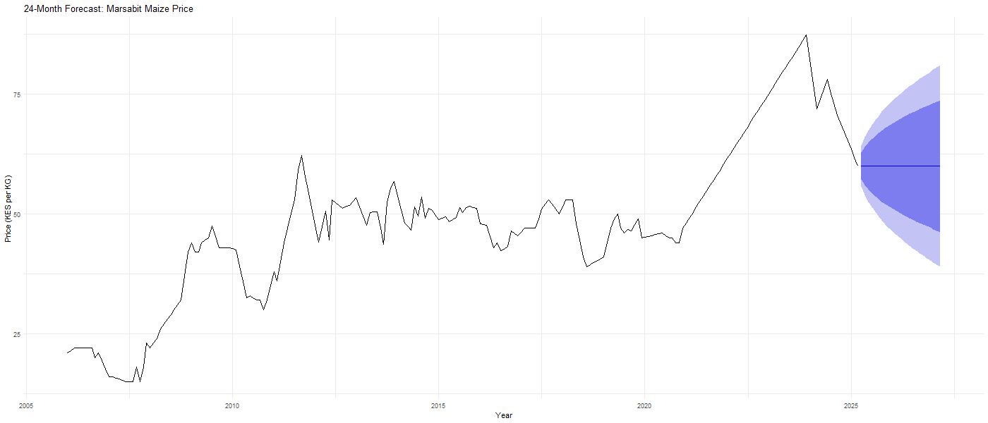
Figure: 24-Month Future Forecast — Marsabit
Interpretation
The naïve model projects a constant maize price of KES 60.00 per kilogram for Marsabit throughout the entire 24-month forecast horizon from April 2025 to March 2027. The widening prediction intervals reflect increasing uncertainty over time, with the 95 percent interval expanding substantially by the end of the forecast period. Given Marsabit's history of price volatility and supply disruptions, the actual future prices could deviate significantly from this flat projection in either direction depending on rainfall conditions and supply chain developments.

Mombasa future forecast plot
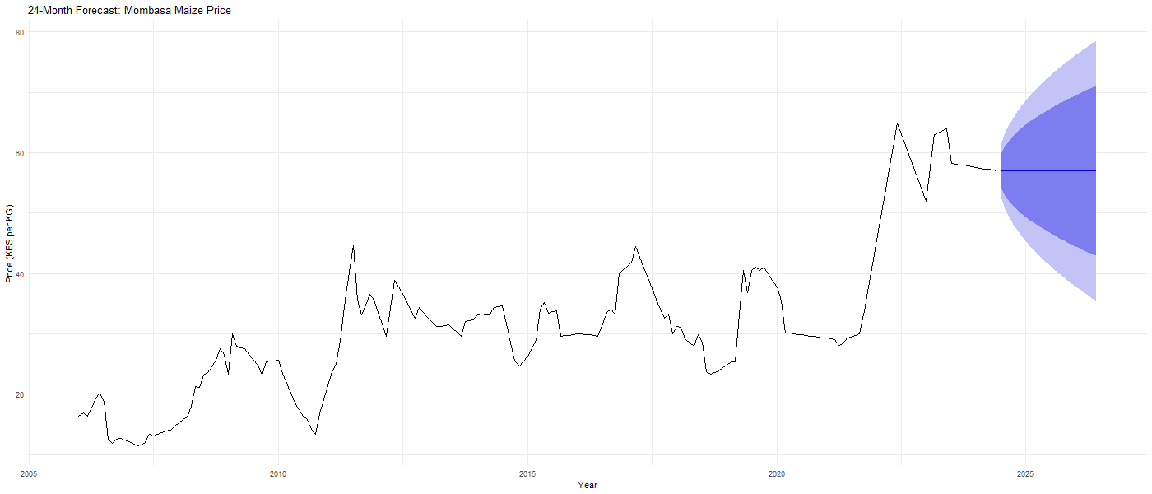
Figure: 24-Month Future Forecast — Mombasa
Interpretation
The naïve model projects a constant maize price of KES 57.00 per kilogram for Mombasa throughout the 24-month forecast horizon from July 2024 to June 2026. The prediction intervals widen moderately over the forecast period reflecting the uncertainty inherent in a flat projection over a long horizon. Mombasa's relatively stable price history and strong market access suggest that actual prices are likely to remain within a reasonable range of this projection barring major supply disruptions.

Nairobi future forecast plot
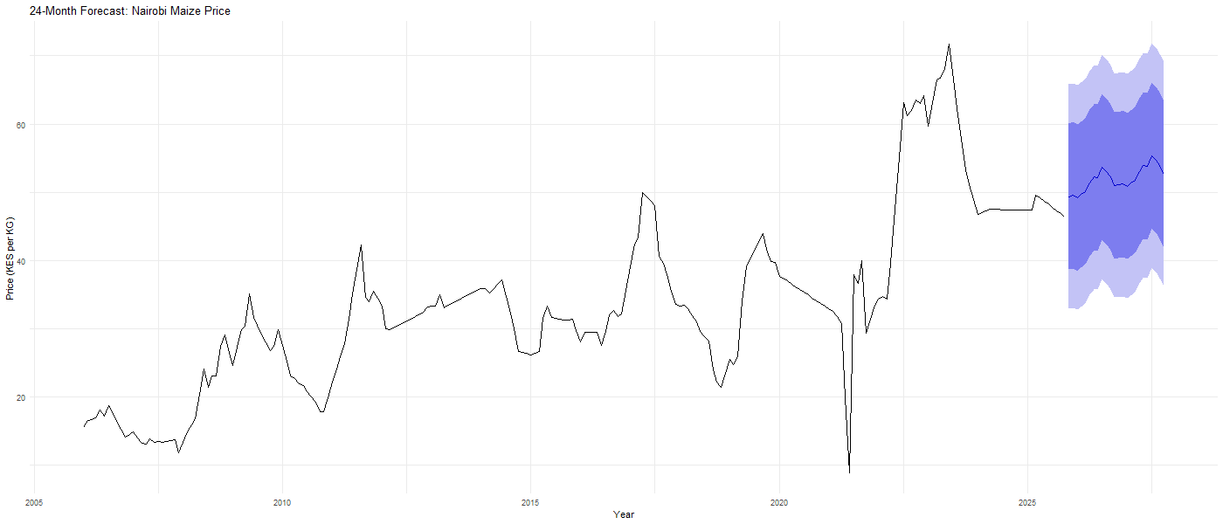
Figure : 24-Month Future Forecast —Nairobi
Interpretation
The TSLM model projects a gently fluctuating price series for Nairobi, ranging between approximately KES 49 and KES 55 per kilogram over the 24-month forecast horizon from November 2025 to October 2027. The forecast captures the mild seasonal pattern identified in the TSLM, with prices tending to peak slightly around mid-year before moderating toward year end. The prediction intervals are relatively narrow compared to the naïve forecasts for other counties, reflecting the TSLM's ability to project a structured price path rather than simply holding the last price constant. This is the most reliable forecast in the entire analysis given the TSLM's outstanding validation performance for Nairobi.

Turkana future forecast plot
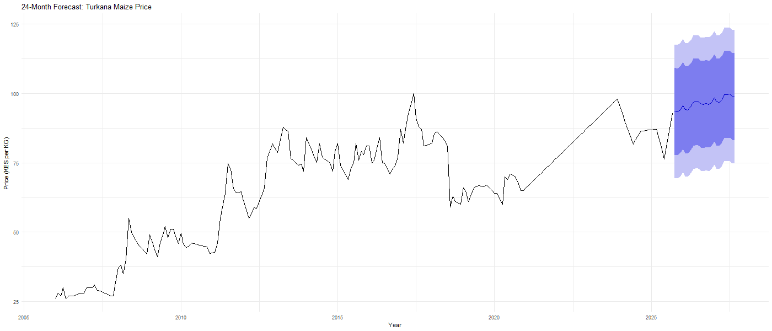
Figure: 24-Month Future Forecast — Turkana
Interpretation
The TSLM model projects a gradually increasing price trajectory for Turkana rising from approximately KES 93 per kilogram in October 2025 to approximately KES 99 per kilogram by September 2027. The upward slope reflects the strong long-run upward trend identified in Turkana's price series throughout the study period. The prediction intervals are wide and expand substantially over the forecast horizon, reflecting the high price volatility characteristic of this remote arid county. These forecasts suggest that maize prices in Turkana are likely to approach or exceed KES 100 per kilogram within the next two years if current trends continue, which has serious implications for food security in this already vulnerable county.

Uasin Gishu future forecast plot
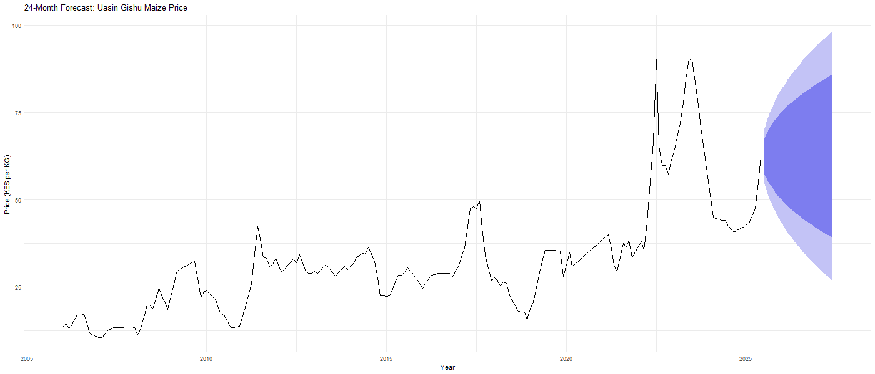
Figure: 24-Month Future Forecast — Uasin Gishu
Interpretation:
The naïve model projects a constant maize price of KES 62.50 per kilogram for Uasin Gishu throughout the 24-month forecast horizon from July 2025 to June 2027. The prediction intervals widen substantially over the forecast period reflecting the high uncertainty associated with a flat projection for a county that experienced extraordinary price volatility in the most recent period. Given that Uasin Gishu is Kenya's primary maize producing county, future prices will depend heavily on rainfall patterns, input costs, and the extent to which the recent price spike represented a temporary shock or a structural shift in the market.

Visualization of Model Fitted Values and Forecasts
The following charts present the actual maize price series alongside the fitted values and forecasts from all four model families for each county. Actual data is shown in black, ARIMA in green, ETS in blue, Naïve in gray, and TSLM in orange/gold.

Marsabit
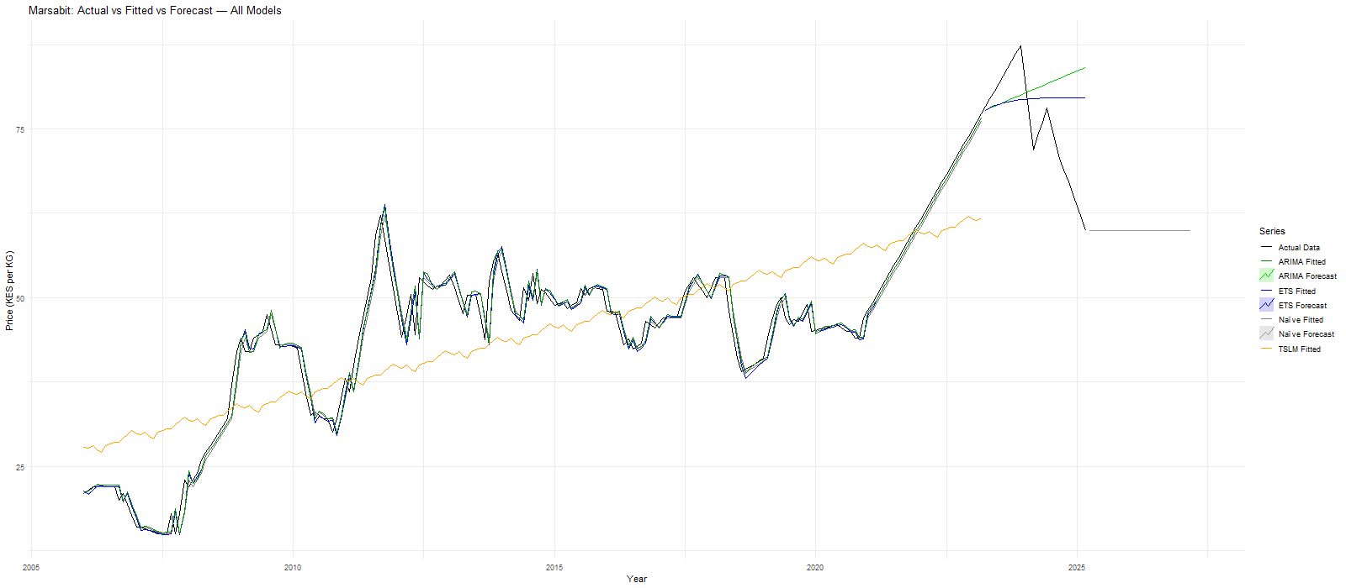
Figure: Marsabit — Actual vs Fitted vs Forecast, All Four Model Families
The fitted values from ARIMA, ETS, and Naïve models track the actual series very closely throughout the training period, while the TSLM fitted line runs consistently below the actual prices. In the forecast period, the ARIMA model projects a continuing upward trend, the ETS and Naïve forecasts hold relatively flat, and the TSLM forecast is absent, consistent with the Naïve model being selected as the best performer for this county.

Mombasa
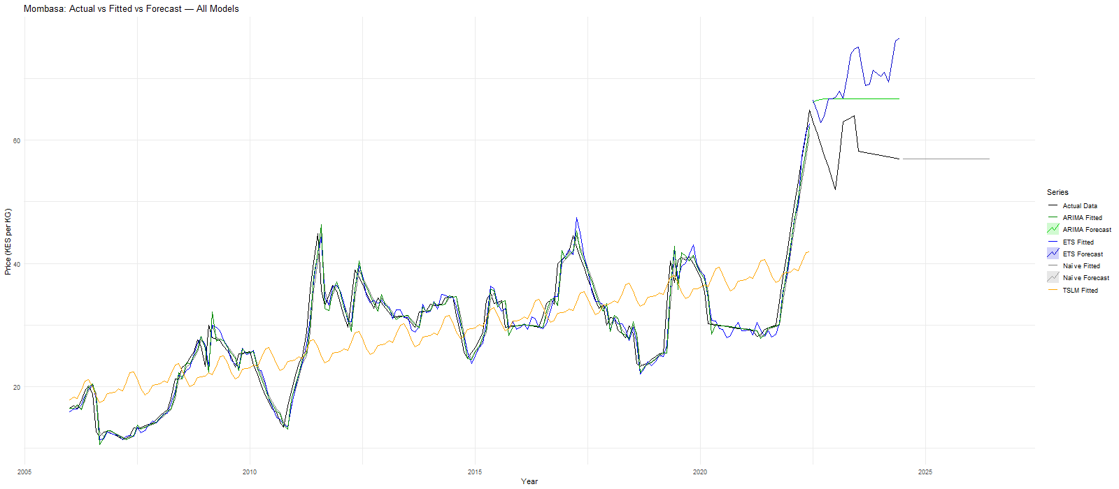
Figure: Mombasa — Actual vs Fitted vs Forecast, All Four Model Families
All three data-driven models track the actual series closely during training. The ETS forecast diverges sharply upward into the future, explaining its poor validation MASE of 1.509, while the ARIMA and Naïve forecasts hold relatively flat and closer to recent price levels.
Nairobi
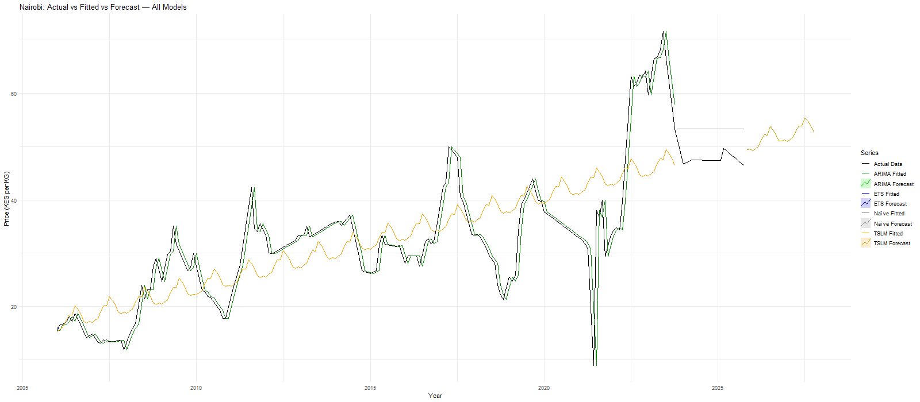
Figure: Nairobi — Actual vs Fitted vs Forecast, All Four Model Families
The TSLM fitted line in gold clearly captures the overall upward trend throughout the training period while remaining smoother than the actual series. In the forecast horizon, the TSLM projects a gently rising seasonal path that aligns most closely with the actual trajectory, visually confirming its outstanding validation MASE of 0.241.
Turkana
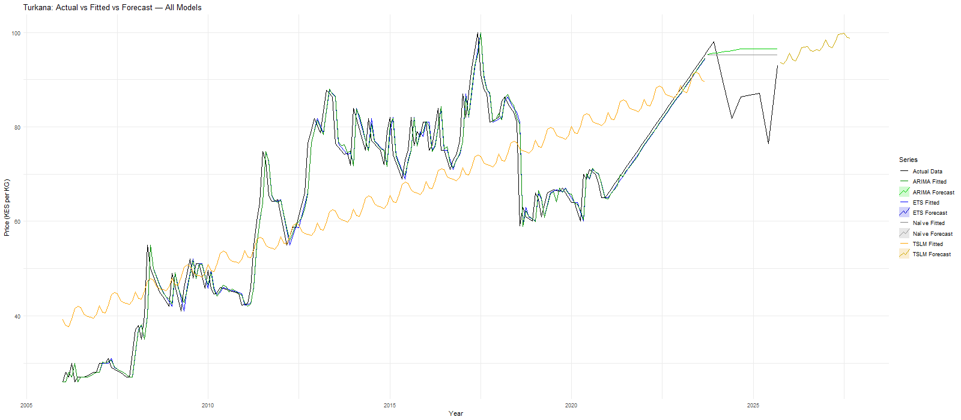
Figure: Turkana — Actual vs Fitted vs Forecast, All Four Model Families
The ARIMA, ETS, and Naïve fitted values closely shadow the actual series throughout training. The TSLM fitted line tracks the long-run trend from below. In the forecast period, the TSLM projects a continuing upward trajectory approaching KES 100 per kilogram, consistent with Turkana's persistent price trend, while ARIMA and ETS forecasts hold relatively flat.
Uasin Gishu
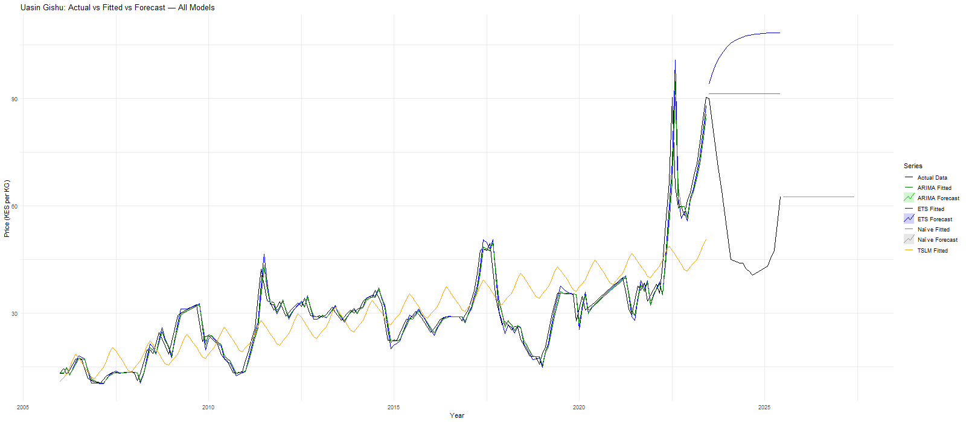
Figure: Uasin Gishu — Actual vs Fitted vs Forecast, All Four Model Families
The extraordinary price spike around 2022–2023 is clearly visible in the actual series, and no model's fitted values captured its magnitude. The ETS forecast projects an unrealistically steep upward curve extending well above KES 100 per kilogram, explaining its catastrophic MASE of 5.982, while the ARIMA and Naïve forecasts remain flat and more grounded.

CONCLUSION
This study developed and evaluated four time-series forecasting models to predict monthly maize prices across five Kenyan counties Marsabit, Mombasa, Nairobi, Turkana, and Uasin Gishu using World Food Programme price data covering January 2006 to 2025. The analysis followed a rigorous multi-stage process beginning with data acquisition and cleaning, followed by data exploration, transformation, model development, evaluation, and 24-month future forecasting.

Summary of Key Findings
The data exploration stage revealed that all five maize price series exhibit a strong long-run upward trend, weak seasonal patterns, and non-stationary behavior confirmed by the Augmented Dickey-Fuller test, requiring first differencing before ARIMA model estimation. Notable price spikes observed across all counties between 2022 and 2024 were attributed to the combined effects of drought, post-COVID supply chain disruptions, and the Russia-Ukraine conflict's impact on global grain markets.
Four model families were evaluated:
- Naïve model : best performer for Marsabit (MASE 0.845), Mombasa (MASE 0.844), and Uasin Gishu (MASE 4.274), confirming random walk behavior in these counties where no model could exploit historical structure beyond the most recent observation
- TSLM model : best overall performer, achieving an outstanding validation MASE of 0.241 for Nairobi and 0.913 for Turkana, demonstrating that structured linear trend projection outperforms data-driven approaches when the underlying price trajectory is sufficiently regular
- ARIMA model : performed comparably to the naïve benchmark for most counties, with the random walk specification ARIMA(0,1,0) selected for Nairobi confirming that after differencing no additional structure improved predictive accuracy
- ETS model: worst overall performer, consistently underperforming the naïve benchmark across most counties, with particularly poor results for Mombasa (MASE 1.509) and Uasin Gishu (MASE 5.982) where multiplicative components amplified forecast errors unrealistically

Food Security Implications
The 24-month future price forecasts reveal important regional differences with direct implications for food security planning:
- Turkana's prices are projected to approach KES 100 per kilogram by 2027, raising serious food security concerns for Kenya's most vulnerable and remote arid county where prices are already the highest in the country
- Nairobi's prices are projected to stabilize between KES 49 and KES 55 per kilogram, reflecting the capital's stronger market access and commercial supply chain efficiency
- Marsabit and Mombasa forecasts project stable prices of KES 60 and KES 57 per kilogram respectively based on the most recently observed levels
- Uasin Gishu is projected at KES 62.50 per kilogram, though with wide uncertainty intervals reflecting the extraordinary price volatility of the recent period
- Policymakers should treat these forecasts as indicative baselines and complement them with weather monitoring, supply chain intelligence, and macroeconomic indicators to build more robust early warning systems

Limitations
Several limitations of this analysis should be acknowledged:
- The forecasting models are univariate they rely solely on historical price data and do not incorporate other important predictor variables such as rainfall, fuel prices, exchange rates, or supply chain indicators
- Linear interpolation was used to fill missing months in four of the five county series, introducing artificial smoothness that may affect model estimation accuracy
- The extraordinary price volatility observed during 2021 to 2025 means the historical patterns used to train the models may be less representative of future market conditions than they would be in a more stable period
- The naïve model's flat constant forecasts for Marsabit, Mombasa, and Uasin Gishu do not account for potential supply shocks, policy changes, or climate events that could significantly alter actual future prices

Future Research Directions
Future analyses should explore multivariate forecasting approaches that incorporate rainfall data, satellite vegetation indices, fuel prices, exchange rates, and fertilizer costs as predictor variables alongside the historical price series. Machine learning approaches such as gradient boosting or long short-term memory neural network models may improve predictive accuracy by capturing non-linear relationships between external drivers and maize price outcomes. Additionally extending the analysis to include all 28 Kenyan counties in the WFP dataset would provide a more comprehensive picture of county-level price dynamics and support more targeted national food security planning.

REFERENCES
Dika Bilala, D., & Nyaboke Nyachieo, V. (2022, August 29). Four ways to address the rising food prices in Kenya – KIPPRA. https://kippra.or.ke/four-ways-to-address-the-rising-food-prices-in-kenya/
Mohajan, H. & Premier University, Chittagong, Bangladesh. (2014). Food and nutrition scenario of Kenya. American Journal of Food and Nutrition, 2–2, 28–38. https://doi.org/10.12691/ajfn-2-2-3
United Nations Office for the Coordination of Humanitarian Affairs. (2024). Kenya drought response dashboard: January to December 2023. OCHA. https://www.unocha.org/publications/report/kenya/kenya-drought-response-dashboard-january-december-2023
Akaeze, H. O., & Akaeze, N. (2022). Forecasting agricultural commodity price using different models: A case study of widely consumed grains in Nigeria. Agricultural and Resource Economics: International Scientific E-Journal, 8(2), 5–20. https://are-journal.com/are/article/view/535
Hyndman, R. J., & Athanasopoulos, G. (2021). Forecasting: Principles and practice (3rd ed.). OTexts. https://otexts.com/fpp3/
World Food Programme. (2023). Kenya food prices dataset. Humanitarian Data Exchange. https://data.humdata.org/dataset/wfp-food-prices-for-kenya

APPENDIX
Week | Date | Category | Task | Estimated Hours | Actual Hours
1 | 2026-03-09 | Cleaning & Data Familiarization | Filter for Maize (white) commodity | 1.5 | 1.8
 |  |  | Select 6 counties | 1 | 1.2
 |  |  | Convert date column to time series format | 1 | 1.3
 |  |  | Create time index and seasonal indicators | 1.5 | 1.8
 |  |  | Generate summary statistics | 2 | 2.2
2 | 2026-03-16 | Baseline & Initial Modeling | Split data into training and validation sets | 1.5 | 1.7
 |  |  | Build Naïve forecasting model | 1.5 | 1.8
 |  |  | Fit ETS model | 3 | 3.5
 |  |  | Fit ARIMA model | 4 | 4.5
 |  |  | Compare preliminary results | 2 | 2.3
3 | 2026-03-23 | Model Diagnostics & Refinement | Run Augmented Dickey-Fuller test | 2 | 2.4
 |  |  | Perform transformations if needed | 2 | 2.3
 |  |  | Conduct differencing if required | 2 | 2.5
 |  |  | Plot ACF and interpret | 1.5 | 1.9
 |  |  | Plot PACF and interpret | 1.5 | 1.9
 |  |  | Residual diagnostics and interpretation | 2 | 2.6
4 | 2026-03-30 | Model Evaluation & Forecasting | Compute accuracy metrics (MASE, RMSE) | 2 | 2.3
 |  |  | Compare model performance | 2 | 2.4
 |  |  | Generate 24-month forecasts | 3 | 3.5
 |  |  | Create forecast tables | 2 | 2.4
 |  |  | Create visualization plots | 3 | 3.6
5 | 2026-04-06 | Writing & Documentation | Draft Executive Summary | 2 | 2.5
 |  |  | Write Introduction & Background | 2 | 2.6
 |  |  | Write Data Exploration section | 2 | 2.4
 |  |  | Write Model Design & Tuning section | 3 | 3.6
 |  |  | Write Results & Interpretation | 3 | 3.8
6 | 2026-04-13 | Finalization & Review | Explain overfitting avoidance | 1.5 | 1.8
 |  |  | Ensure rubric requirements addressed | 2 | 2.3
 |  |  | Format tables professionally | 2 | 2.5
 |  |  | Friend review and grammar corrections | 2 | 2.2
 |  |  | Final proofread and polish | 2 | 2.4
 |  |  | Submit project | 0.2 | 0.3

