Ubuntu20.04-icinga2-setup
- curl https://packages.icinga.com/icinga.key | apt-key add -
2.cd /etc/apt/sources.list.d/
3.vim icinga-focal.list
4.add :
deb http://packages.icinga.com/ubuntu icinga-focal main
deb-src http://packages.icinga.com/ubuntu icinga-focal main
5.sudo apt update
6.sudo apt install icinga2 monitoring-plugins
7.systemctl start icinga2
8.systemctl enable icinga2
9.sudo apt install mysql-server mysql-client
10.systemctl start mysql
11.systemctl enable mysql
12.mysql_secure_installation(set mysql passwd)
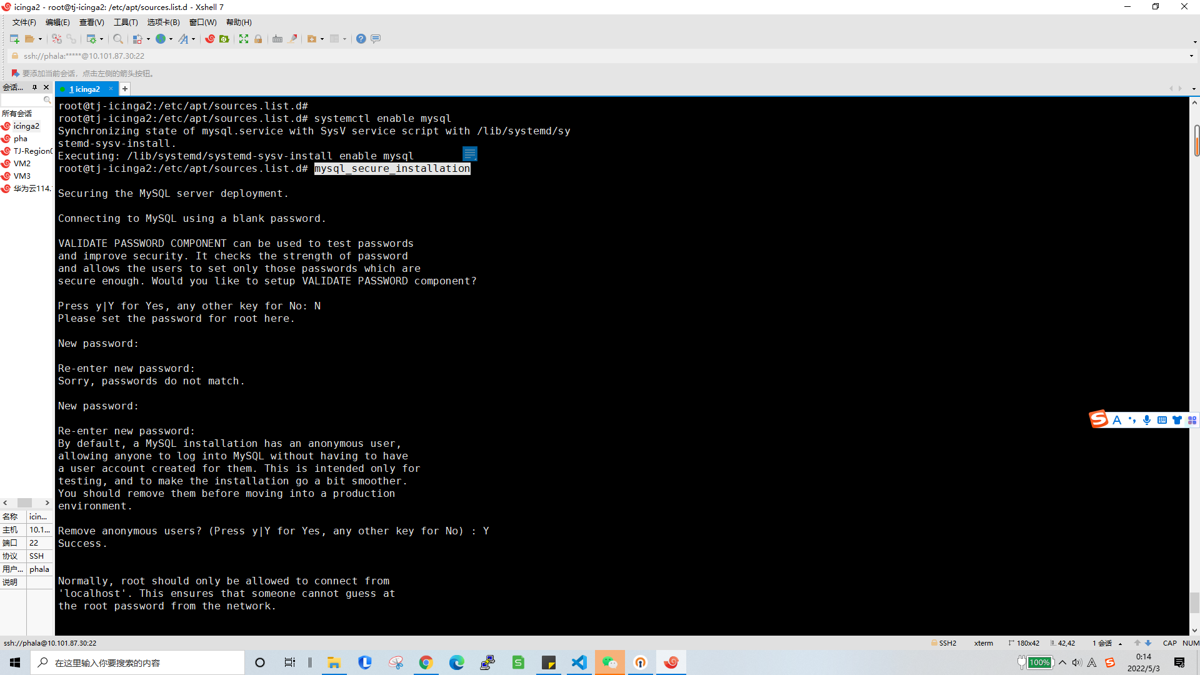

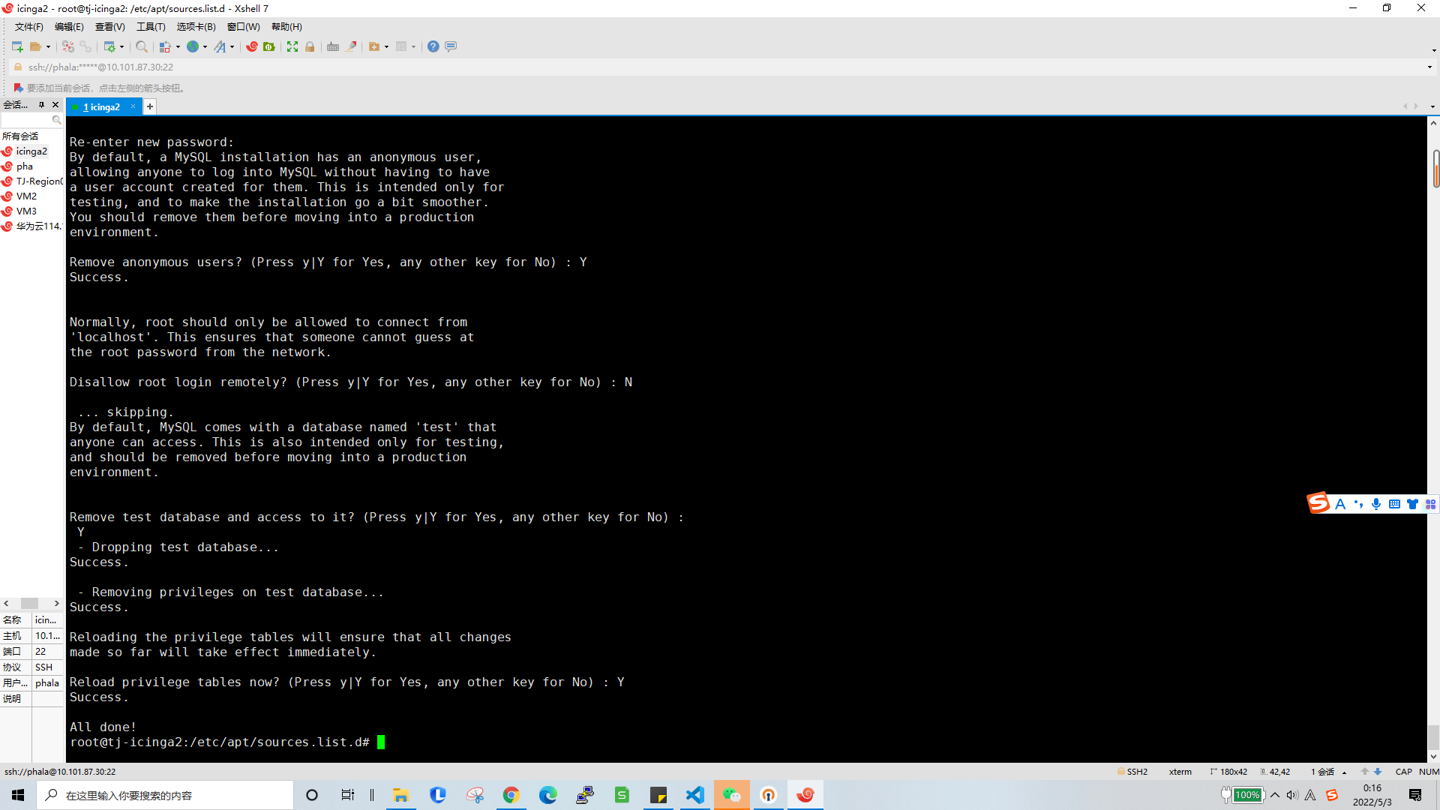
14.sudo apt install icinga2-ido-mysql(chose yes,yes,and set icinga2-ido-passwd)
15.mysql -u root -p
16.
ALTER USER icinga2@localhost IDENTIFIED WITH mysql_native_password BY 'setpasswd';
flush privileges;
exit
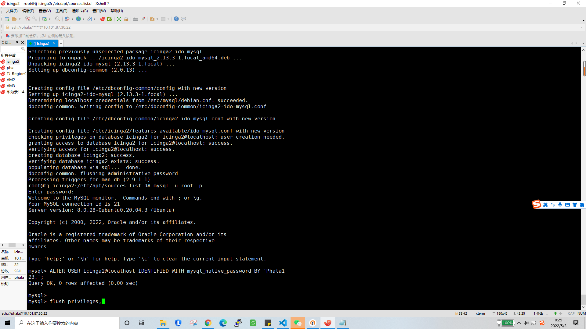
17.
icinga2 feature enable ido-mysql
icinga2 feature list
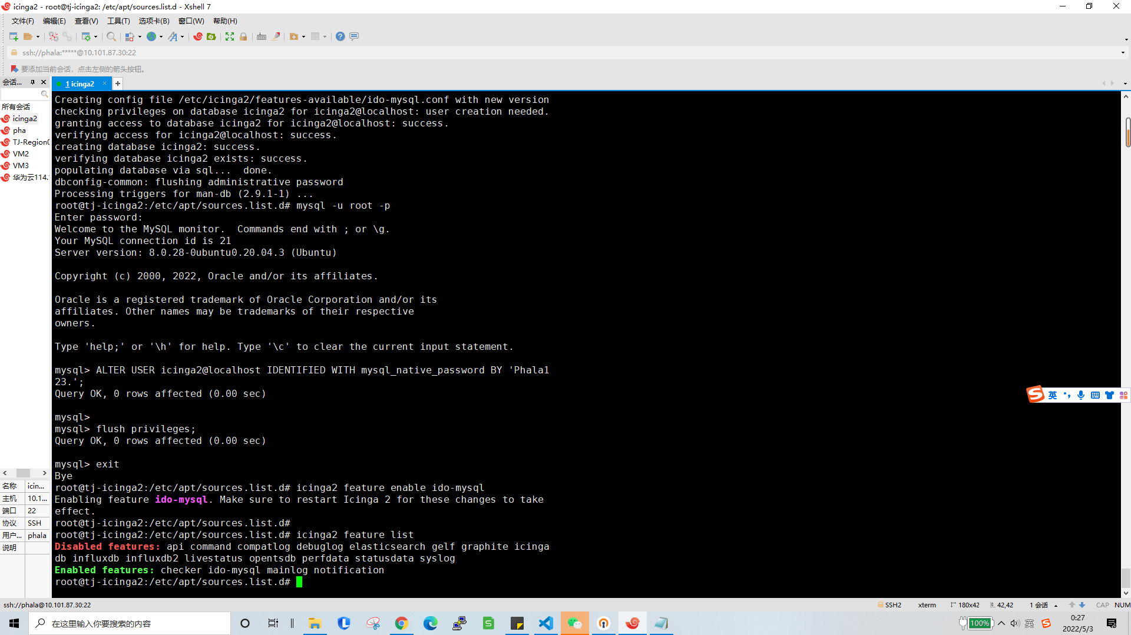
18.systemctl restart icinga2
19.
sudo apt install python3-software-properties
sudo add-apt-repository ppa:ondrej/php
20.
sudo apt install apache2 php7.3 php7.3-common php7.3-gd php7.3-ldap php7.3-intl php7.3-curl libapache2-mod-php7.3 php7.3-mysql php7.3-pgsql php7.3-xml
21.vim /etc/php/7.3/apache2/php.ini (date.timezone = Asia/ShangHai
,cgi.fix_pathinfo=0)
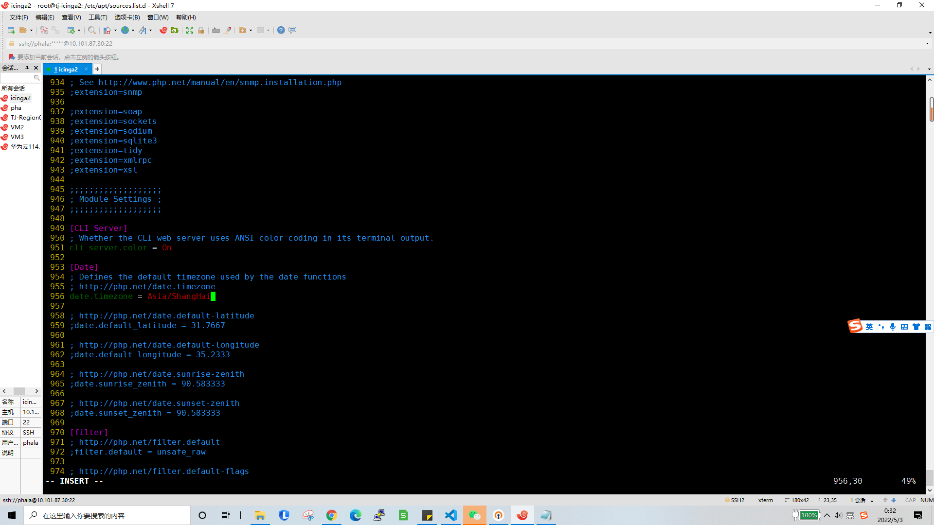
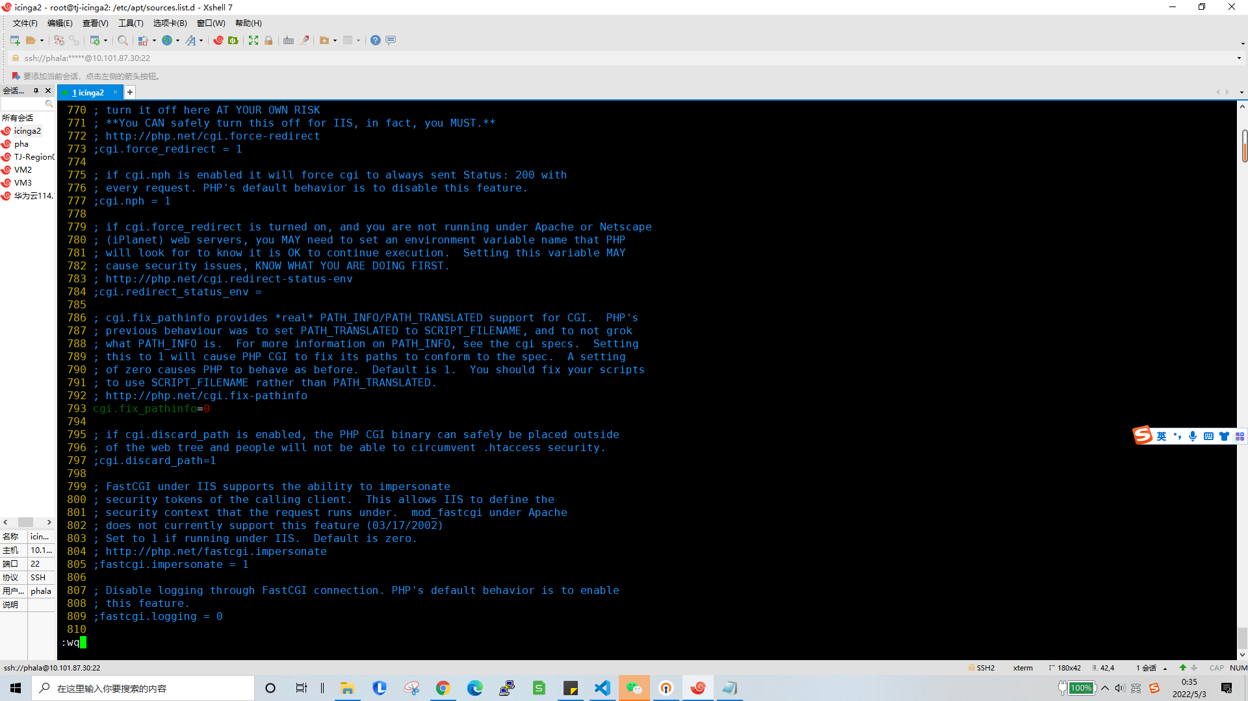

22.
systemctl restart apache2
systemctl enable apache2
23.sudo apt install icingaweb2 icingacli
24.icingacli setup token create (copy The newly generated setup token is: 9b871ead0a60c94f)
25.mysql -u root -p
26
create database icingaweb2;
create user icingaweb2@localhost identified with mysql_native_password by "icingaweb2pass";
grant all privileges on icingaweb2.* to icingaweb2@localhost with grant option;
flush privileges;
exit
27.open http://your-IP/icingaweb2/setup and input setp 24 result

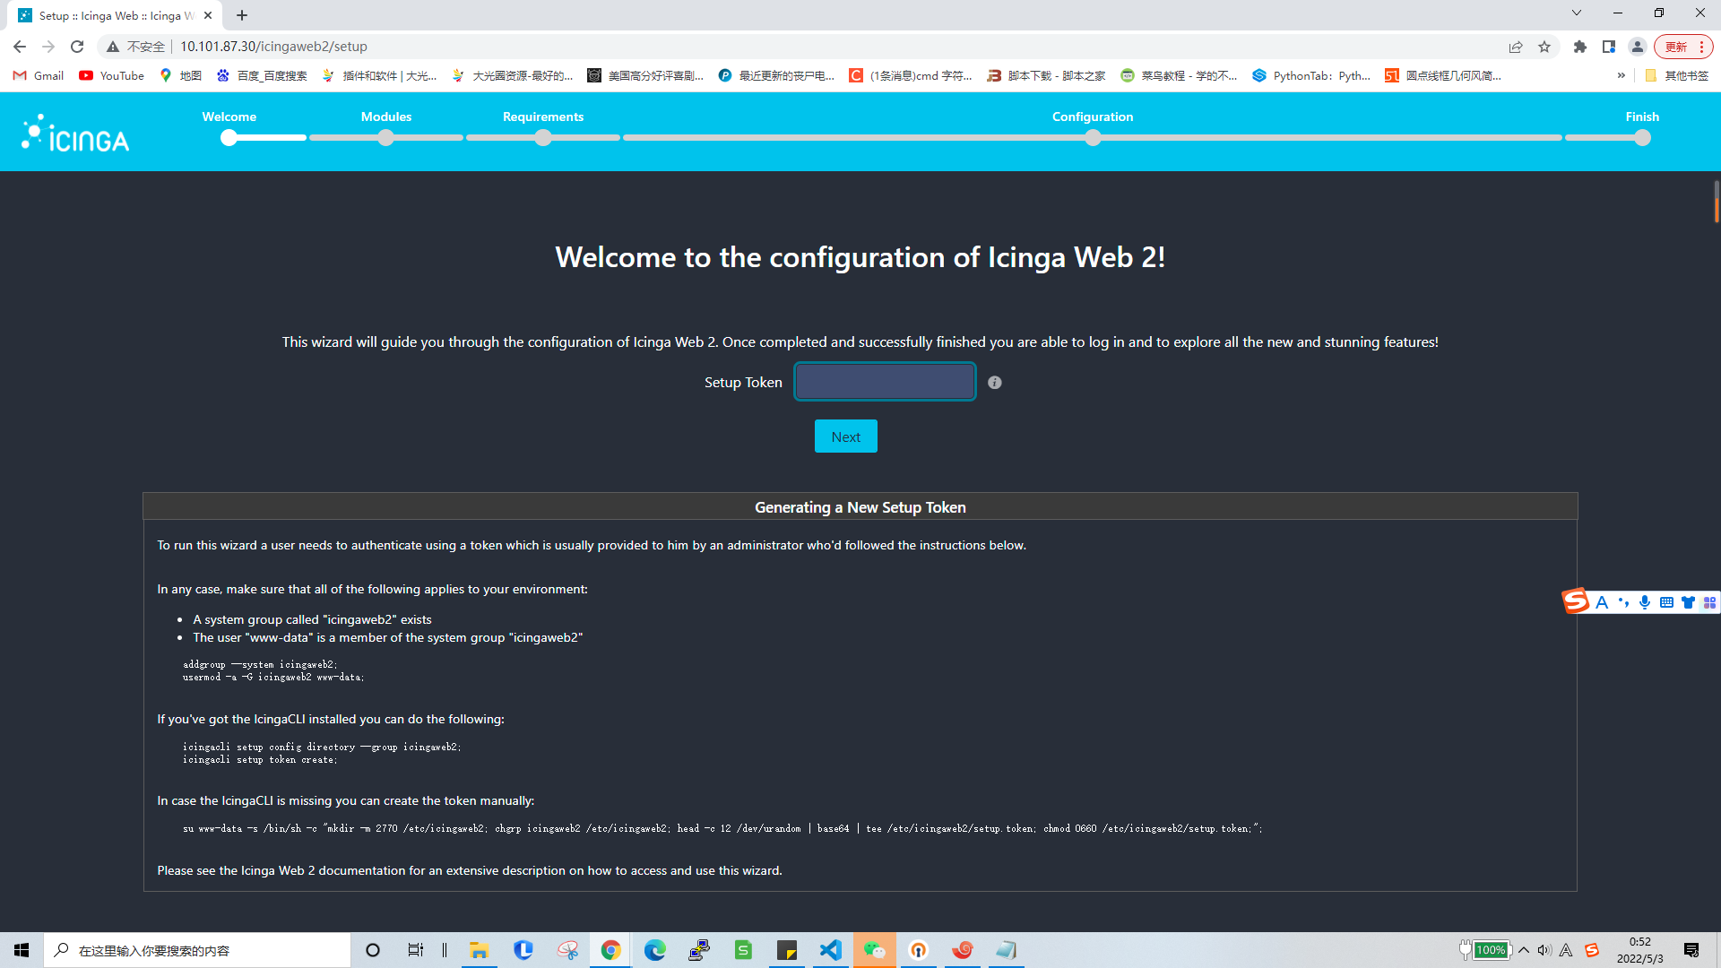

28.chose doc and monitroing
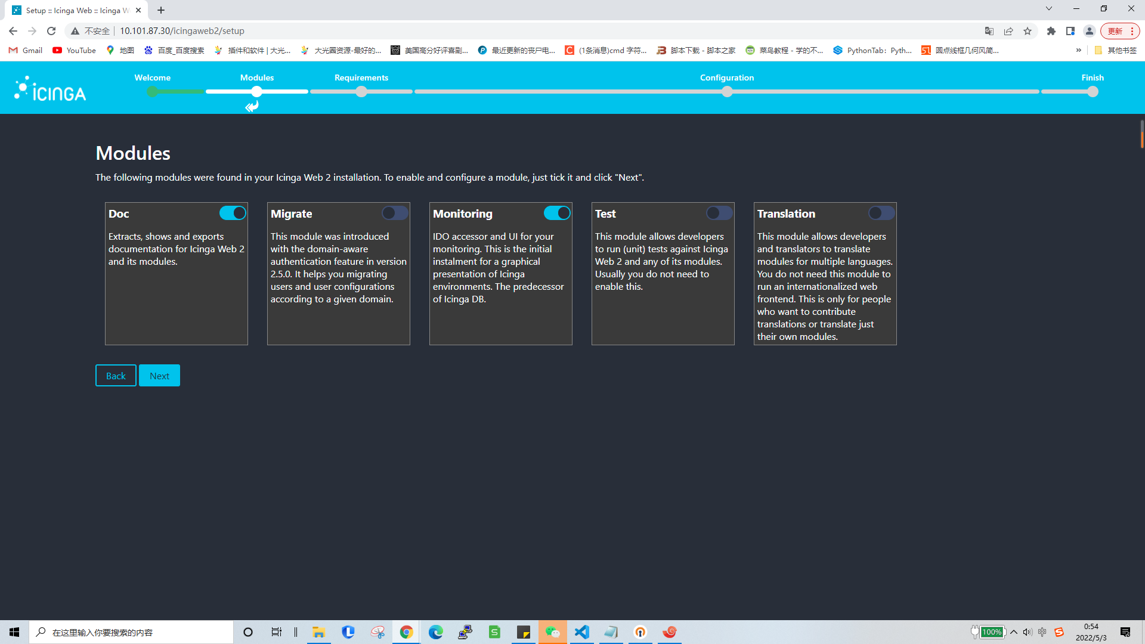
- Two modules are missing
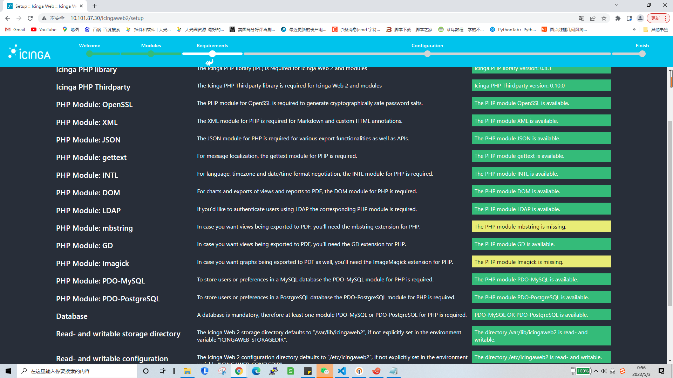
30.
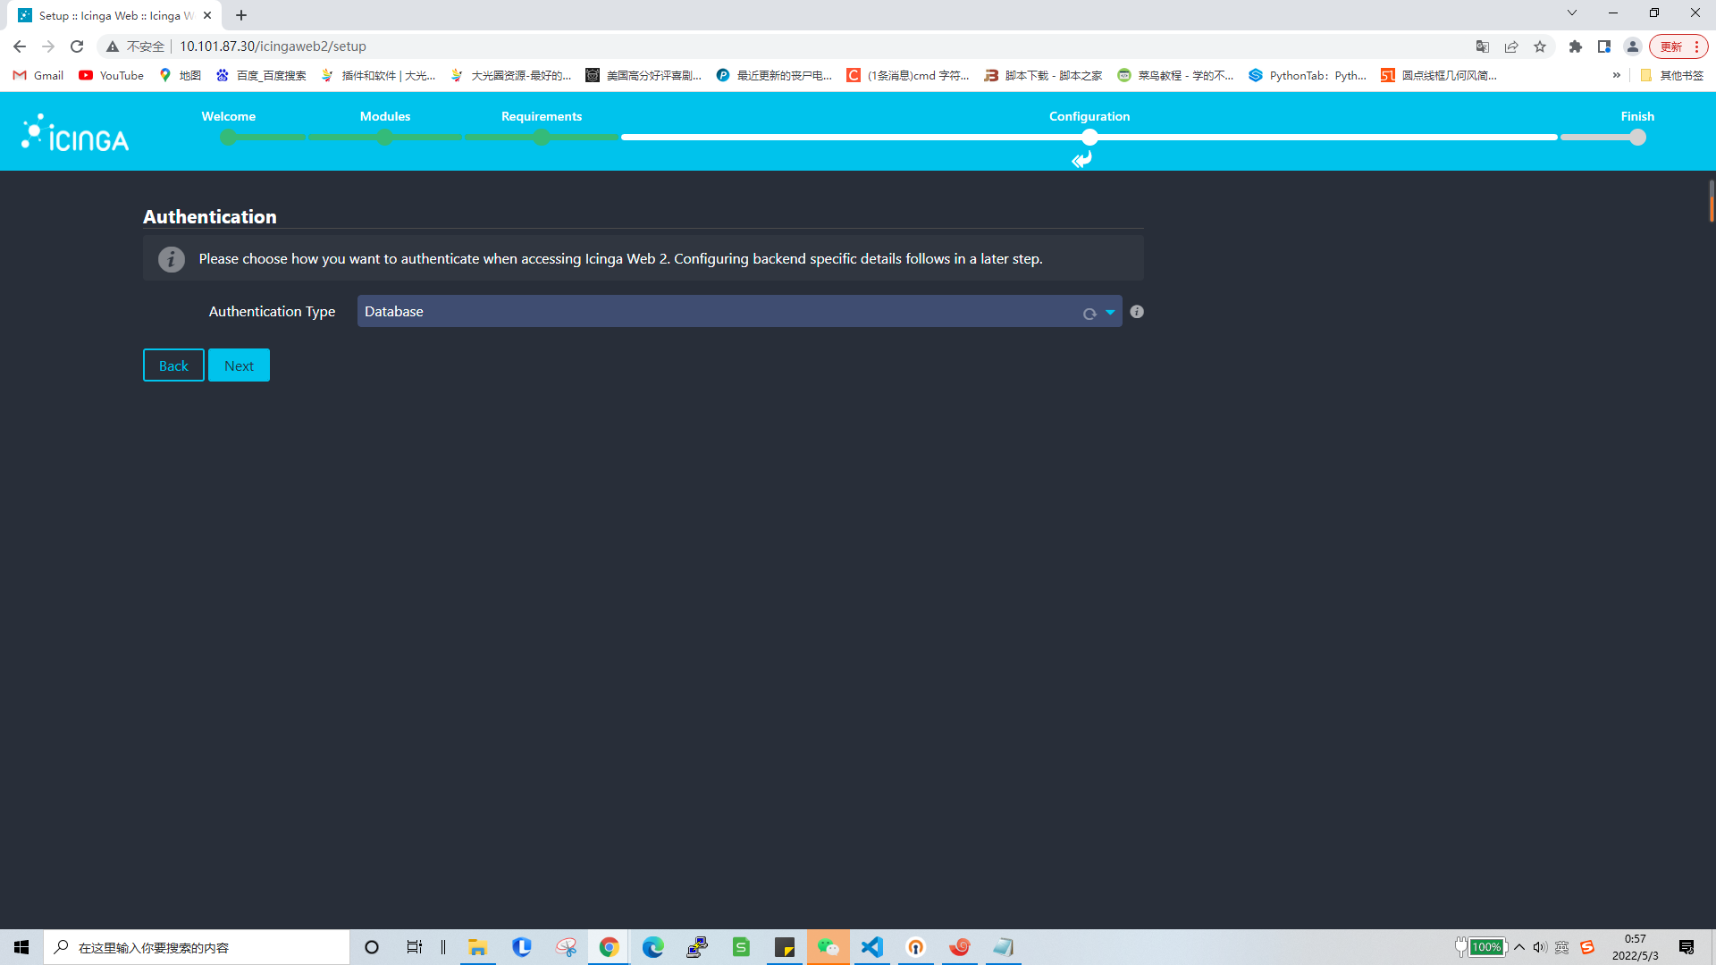
40.setp 26 creat database
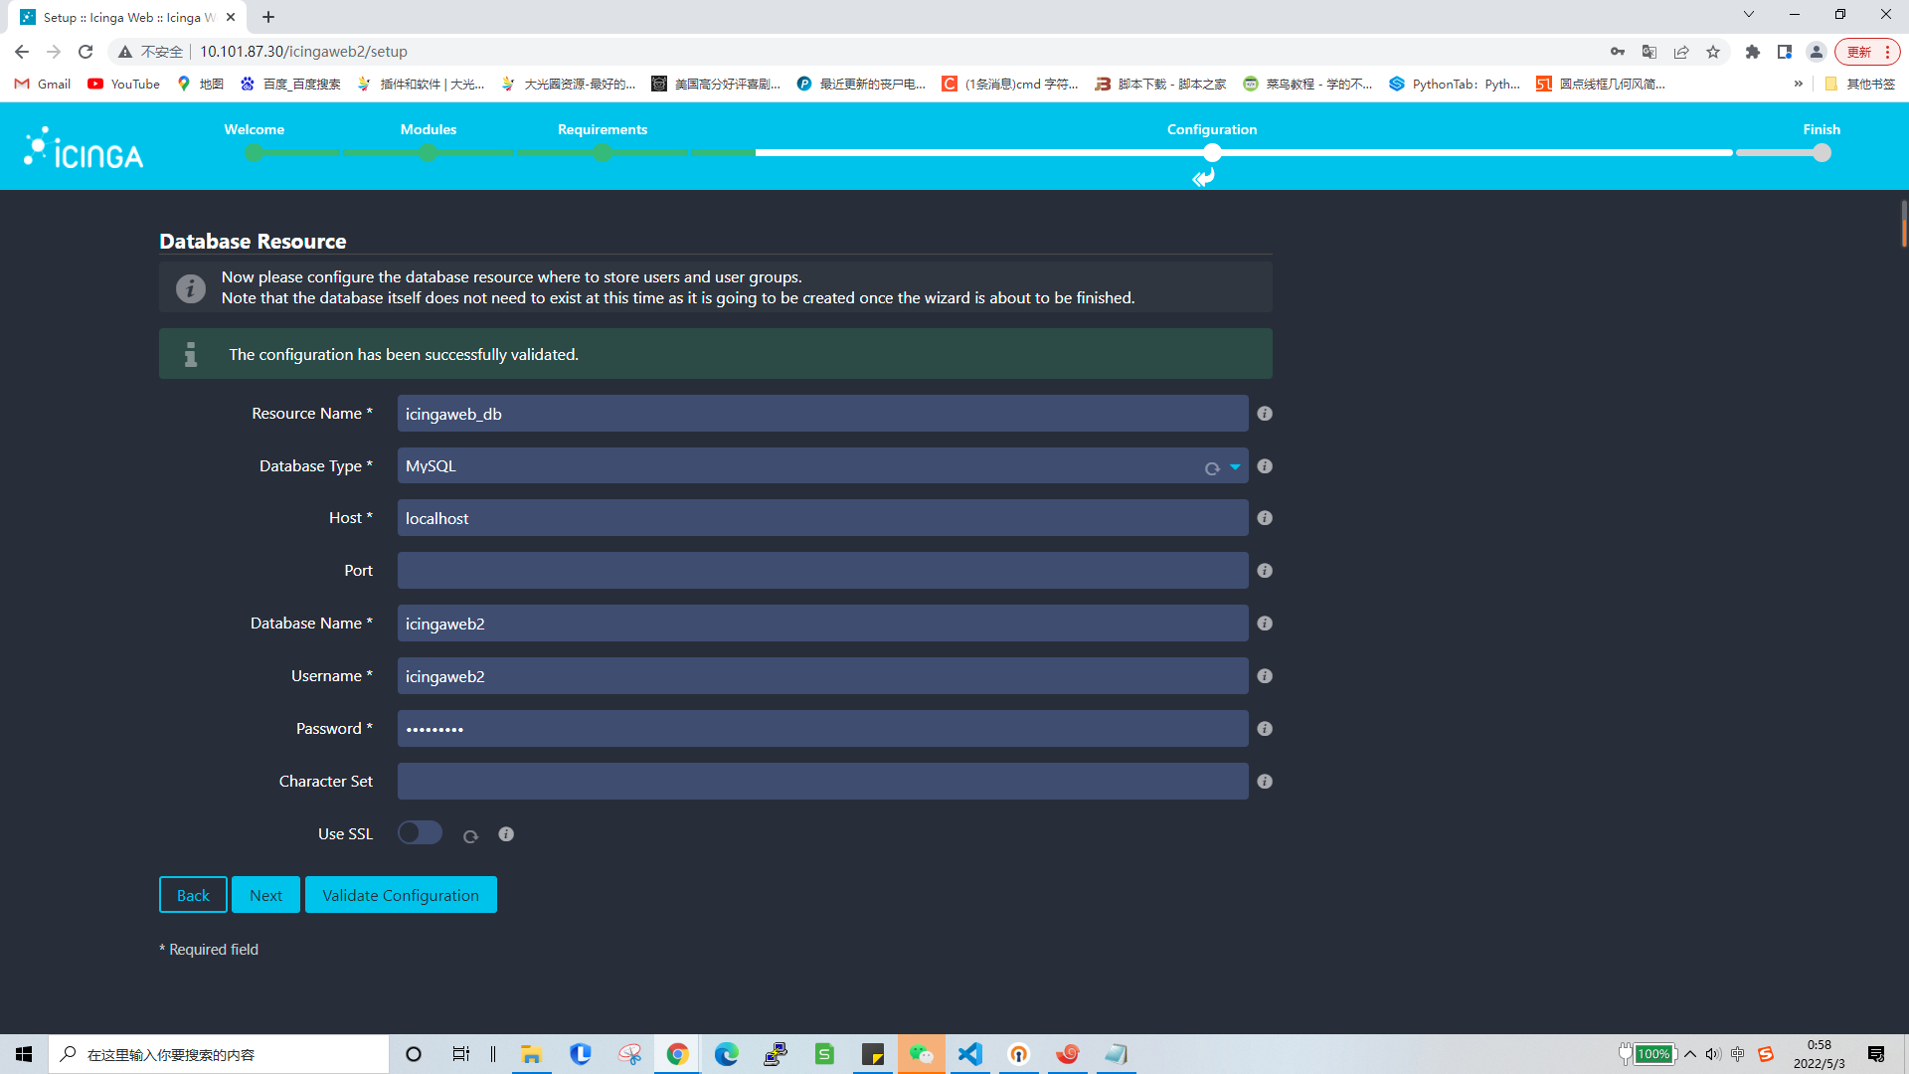

41.
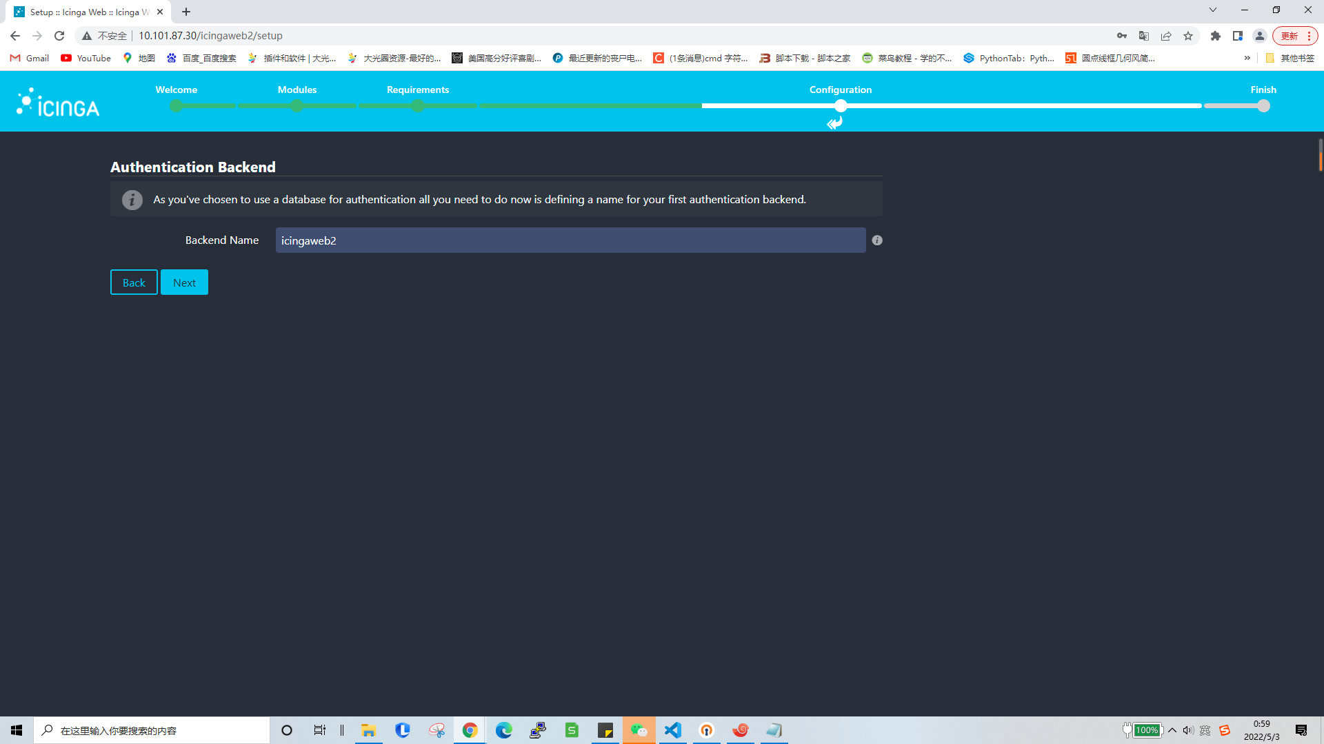
42.set log web account and passwd
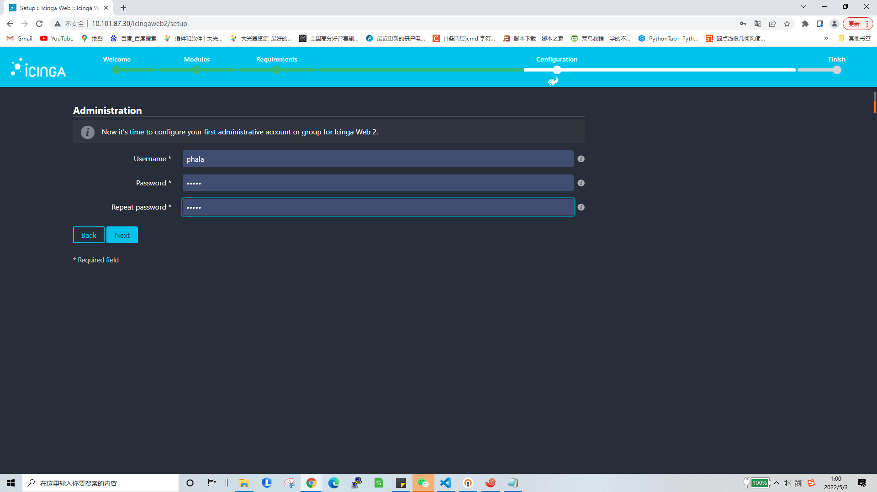
43.
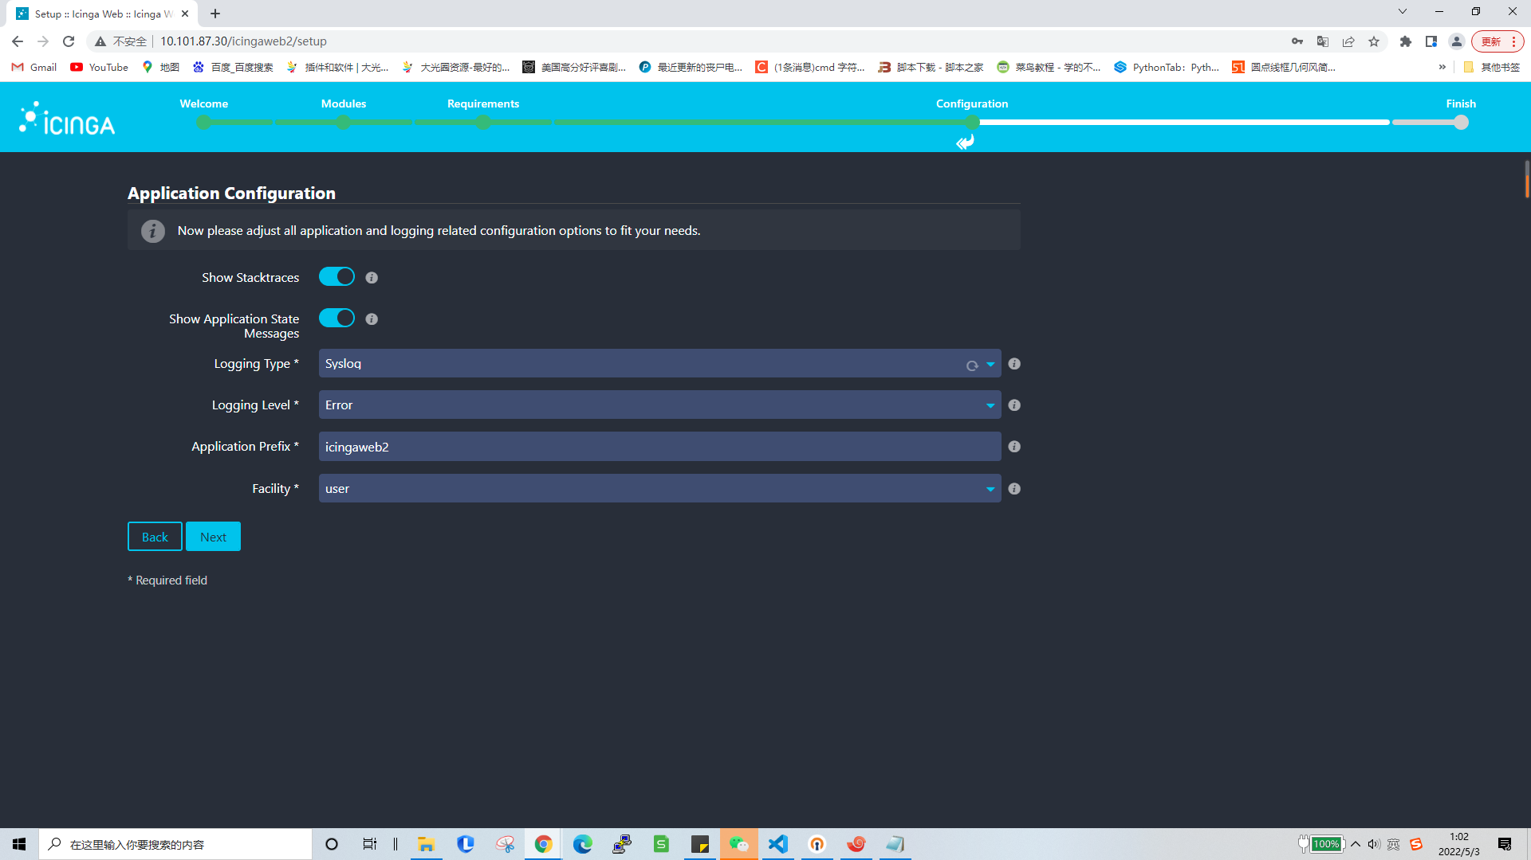
44.
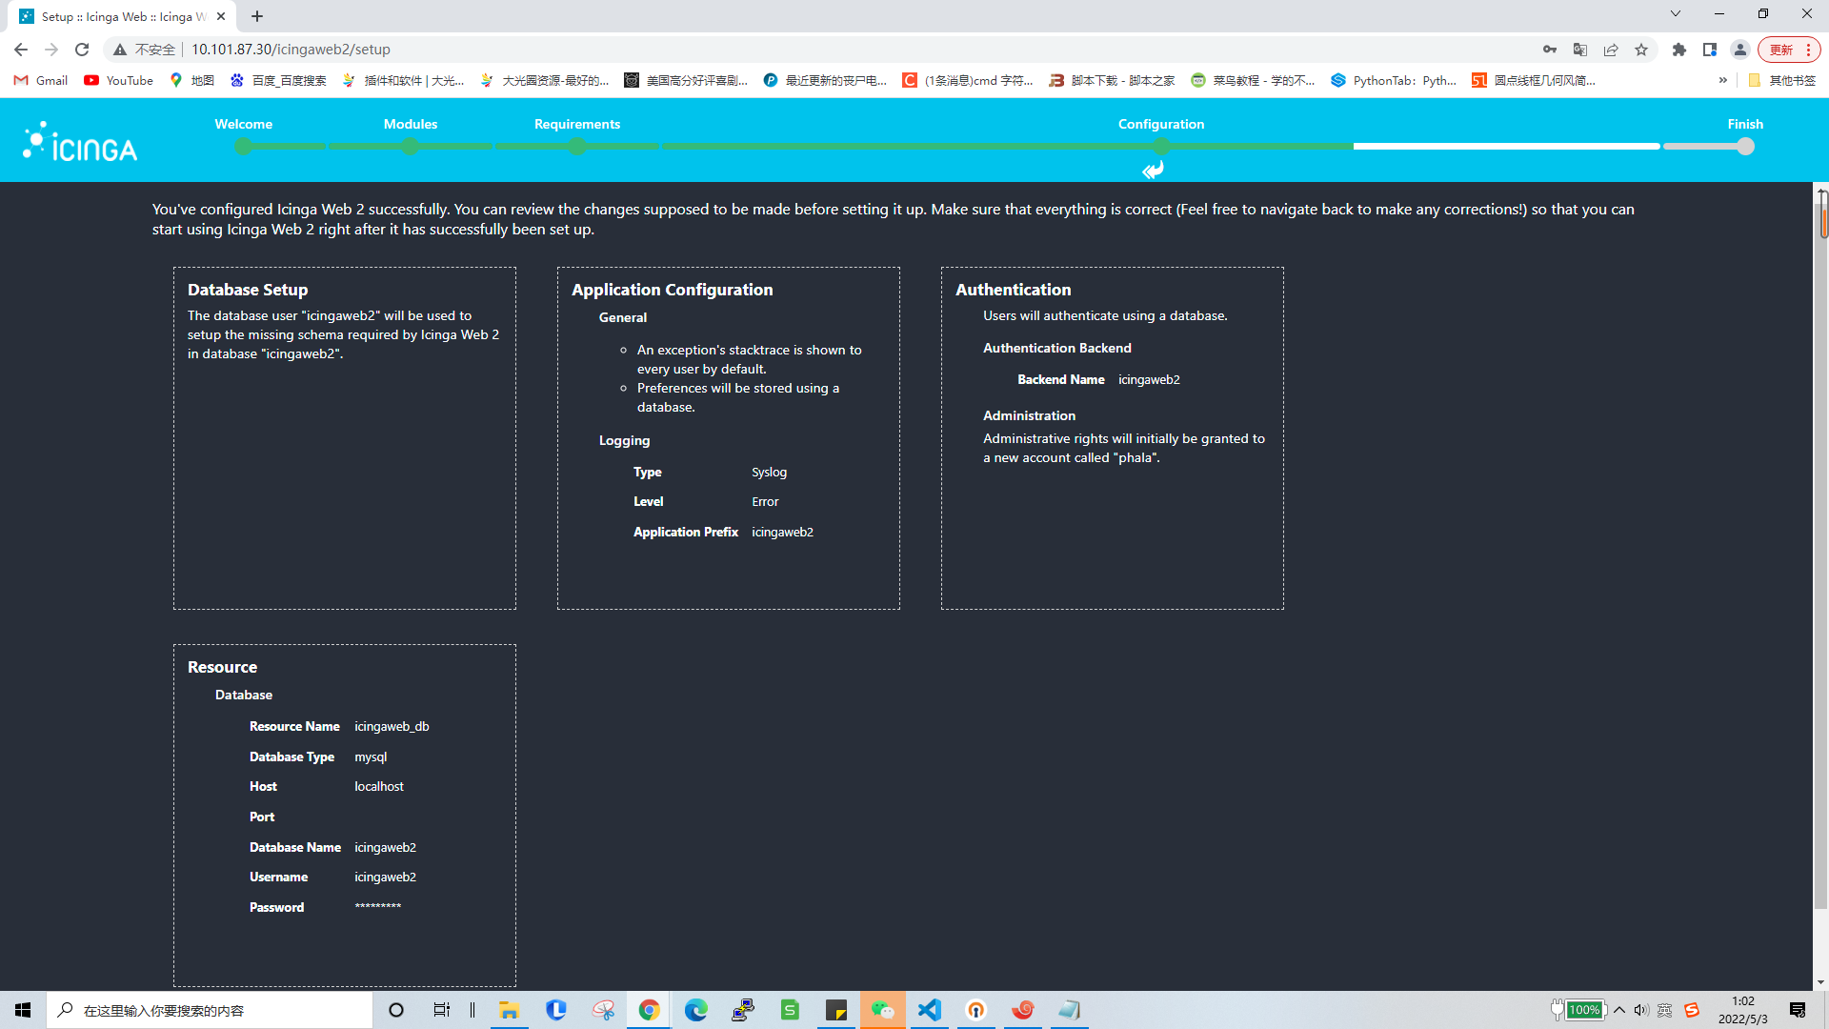
45.
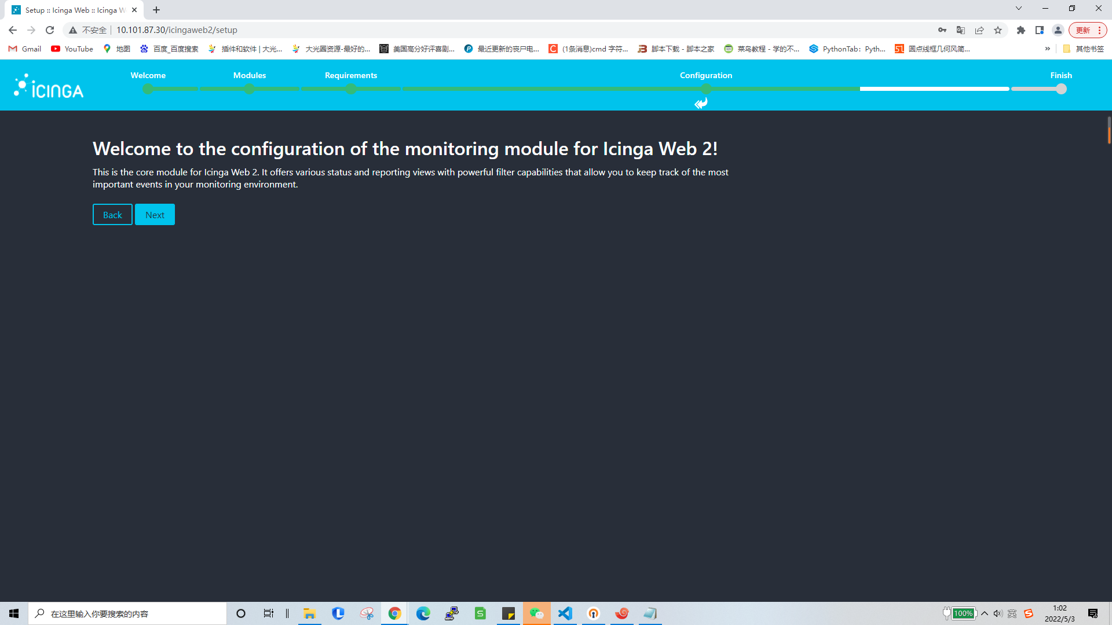
46.step 16
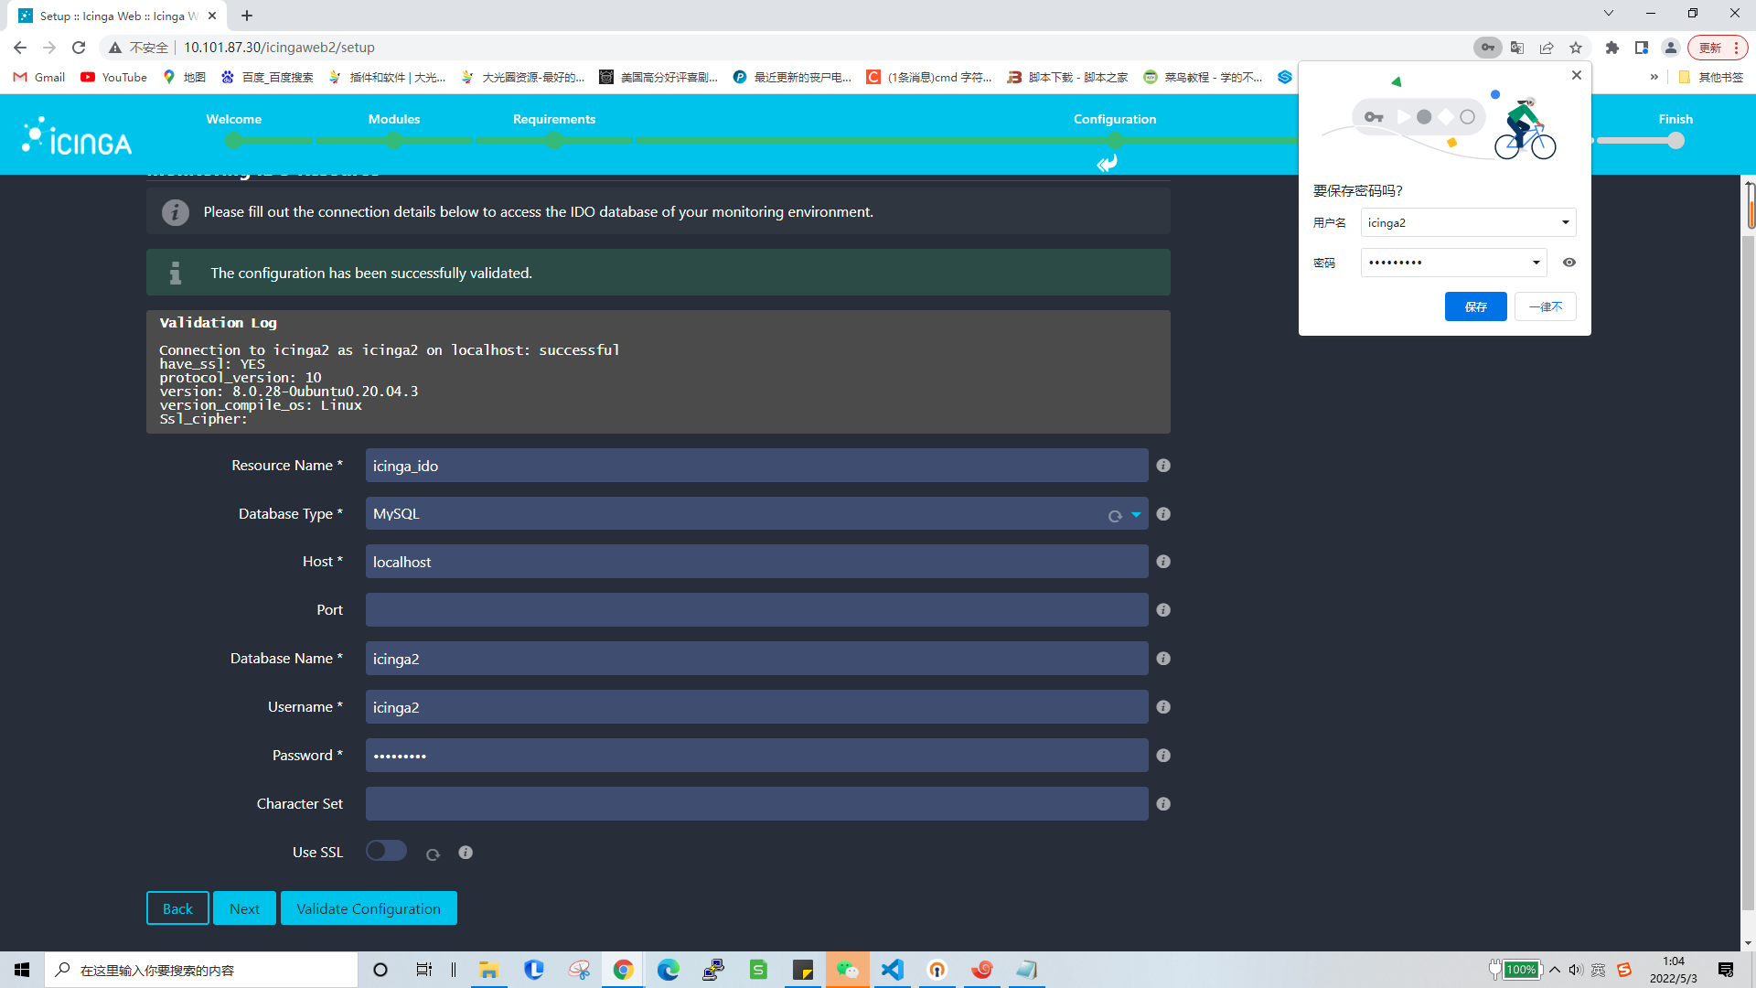
47.
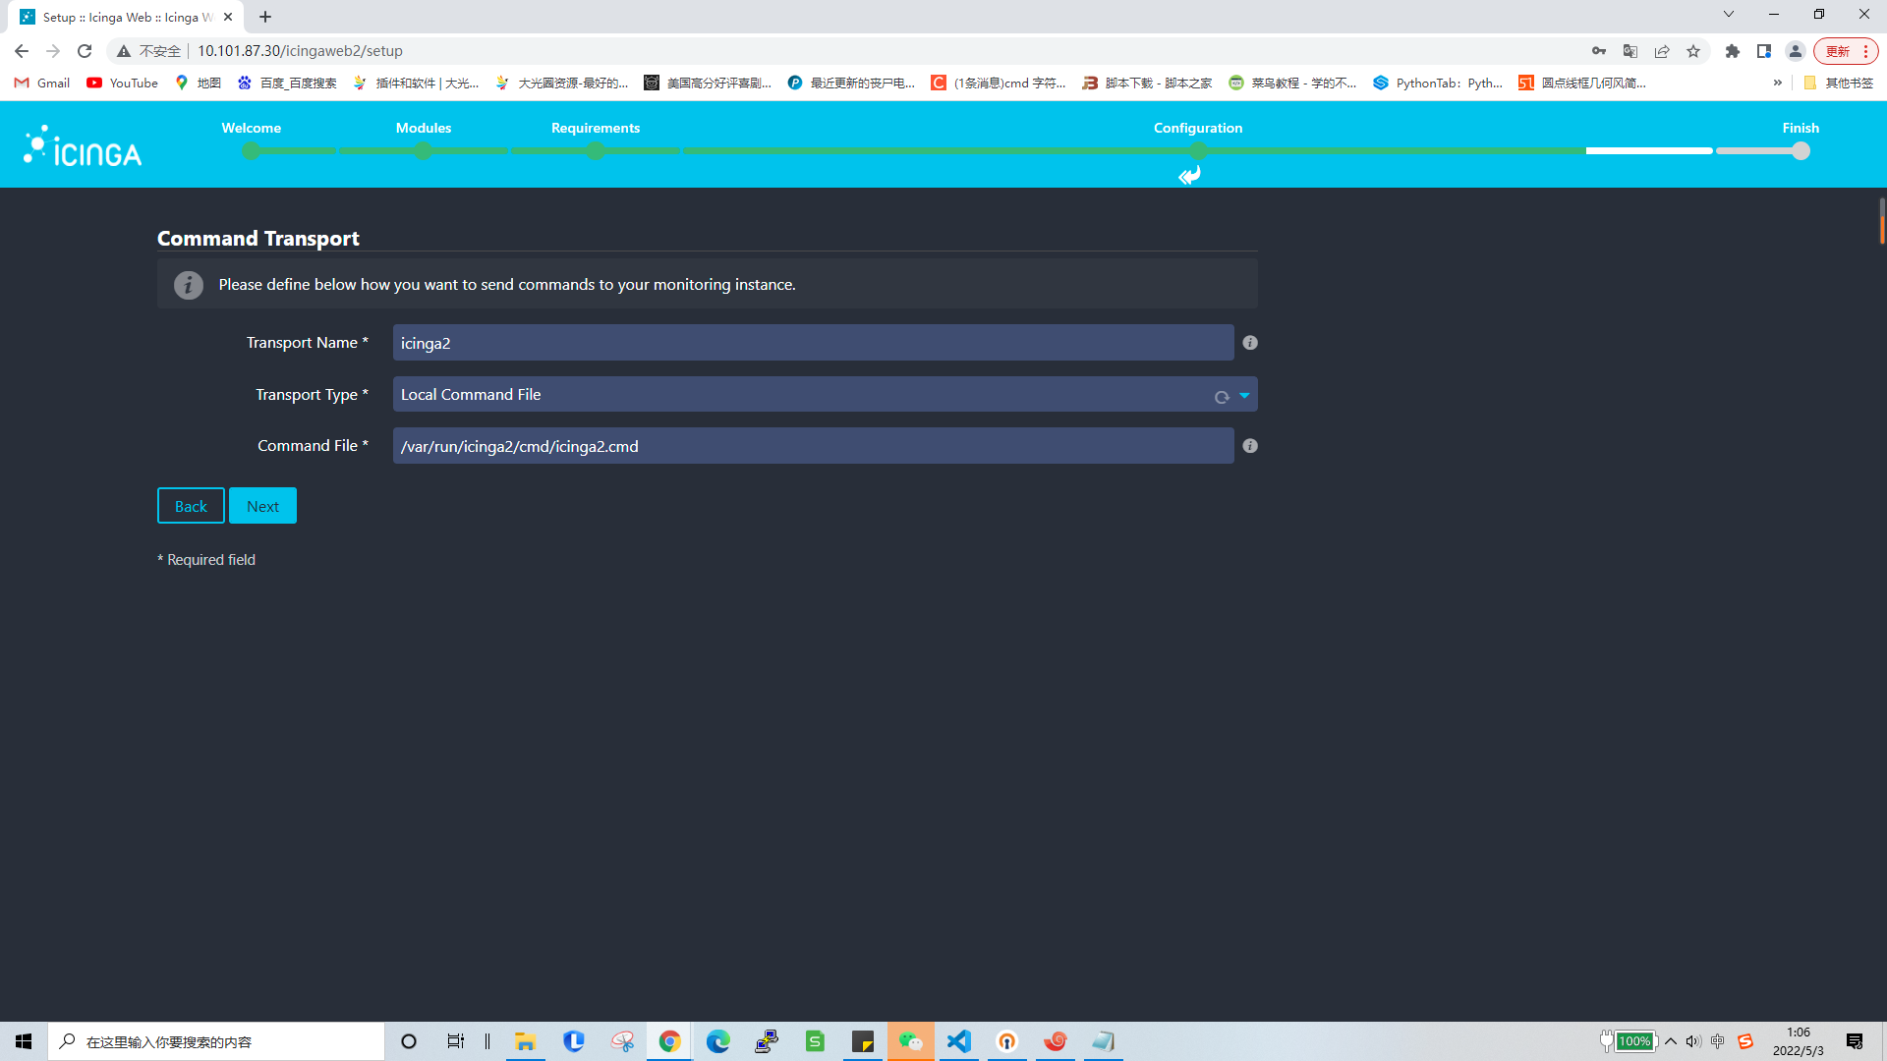
48.
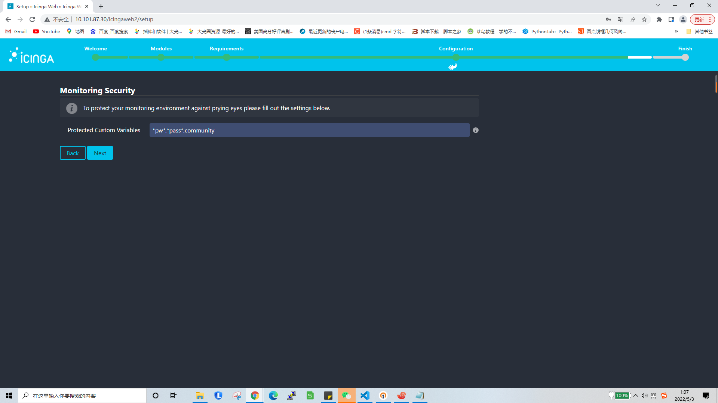
49.
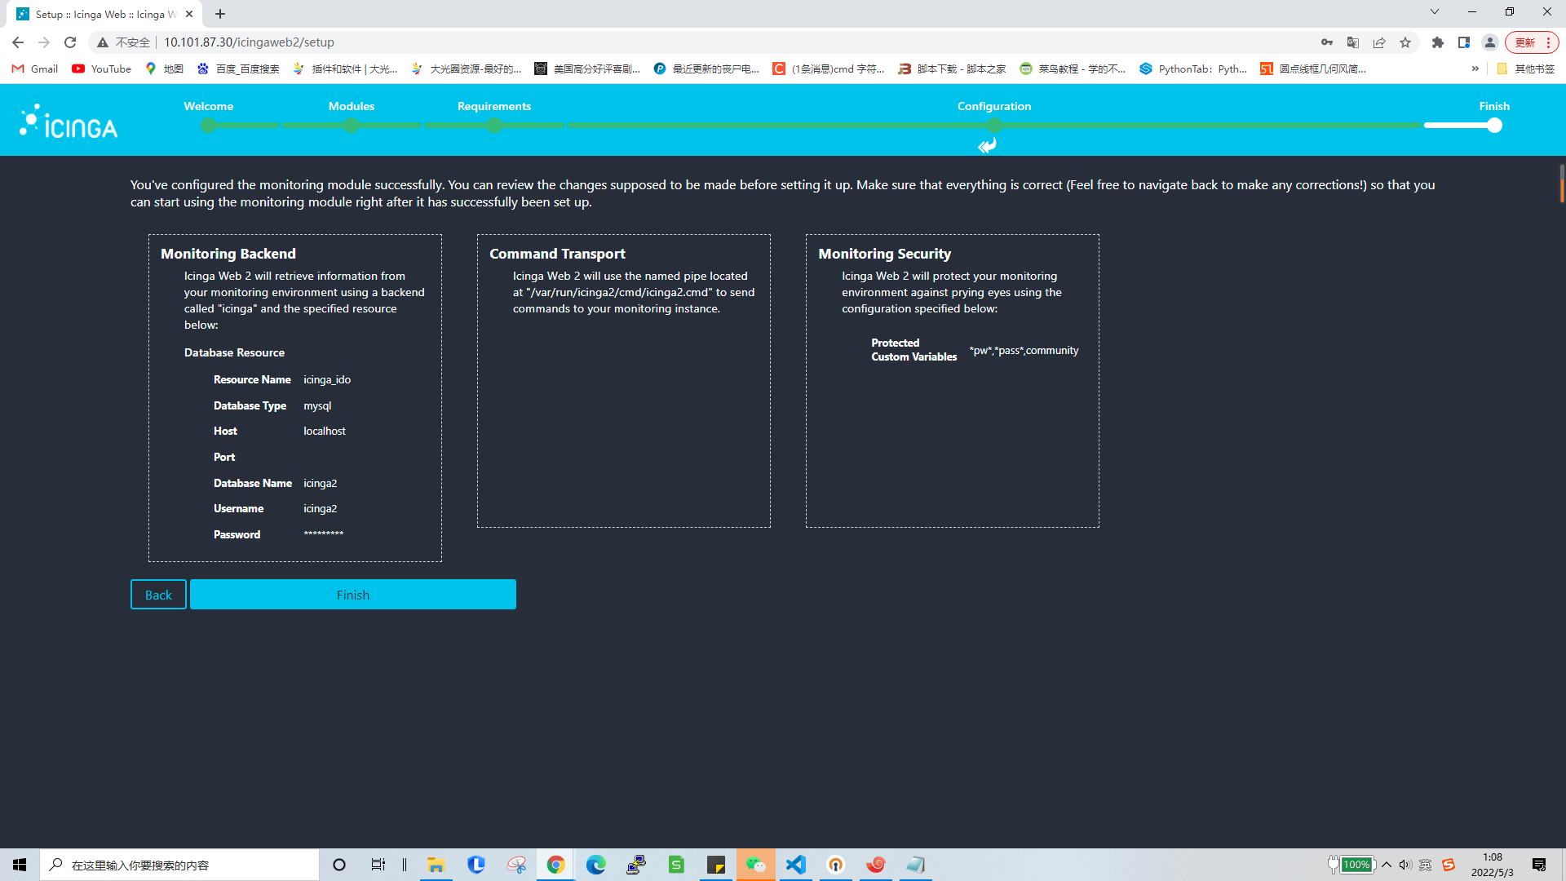
50.icinga2 setup done
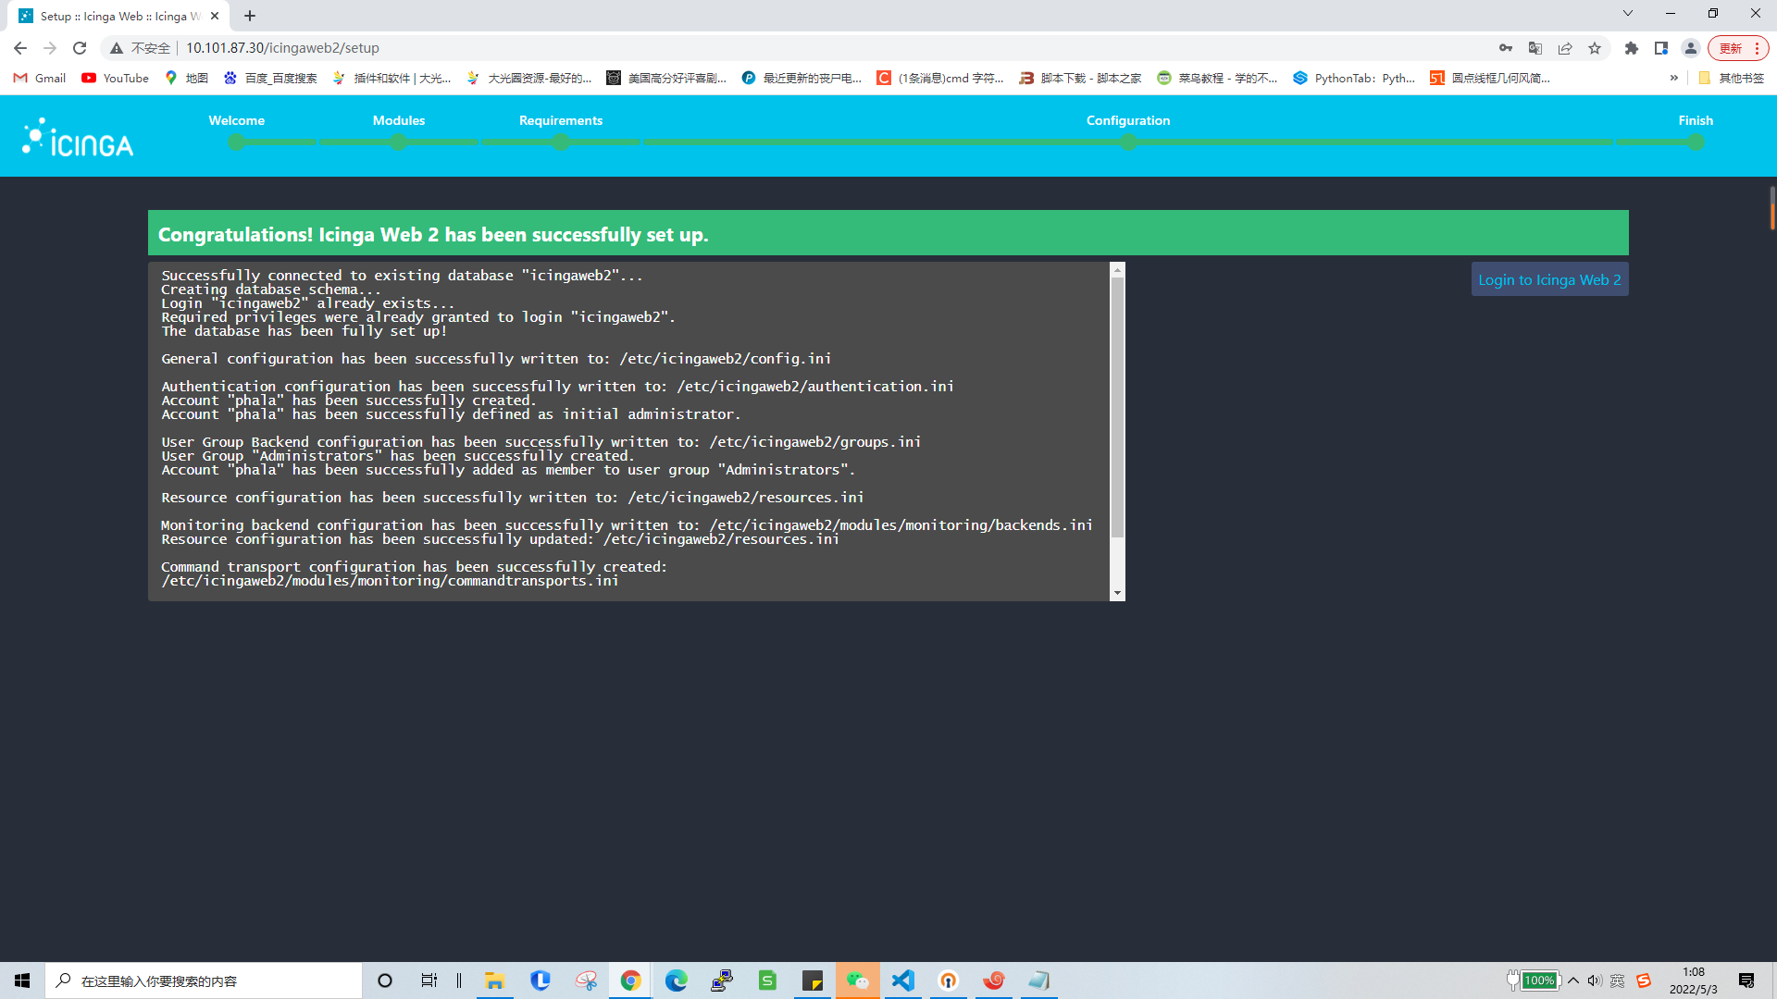
- open http://your-IP/icingaweb2/authentication/login login

cd /root/
sudo apt install git
git clone https://github.com/PHA-SYSOPS/Monitoring.git
cp ./Monitoring/all-generated-machines ./

- Add hostname to all-generated-machines

54.
cd /root/Monitoring
chmod 777 generate-host-template
./generate-host-template > /etc/icinga2/conf.d/miners.conf
cd scripts/
chmod 777 collect-api-data
chmod 777 check_worker
vim collect-api-data
- Edit
api_collect("http://10.201.87.201/ptp/proxy/REPLACE-WITH-DATAPROVIDER-ID/GetWorkerStatus");
55.
cp /root/Monitoring/scripts/* /etc/icinga2/scripts/
cp /root/Monitoring/conf.d/* /etc/icinga2/conf.d/
crontab -e
- Add
* * * * * /etc/icinga2/scripts/collect-api-data
56.
systemctl restart icinga2
Open icinga2 web
