**Executed by Python in command prompt**

**Executed by Python in PyCharm IDE**

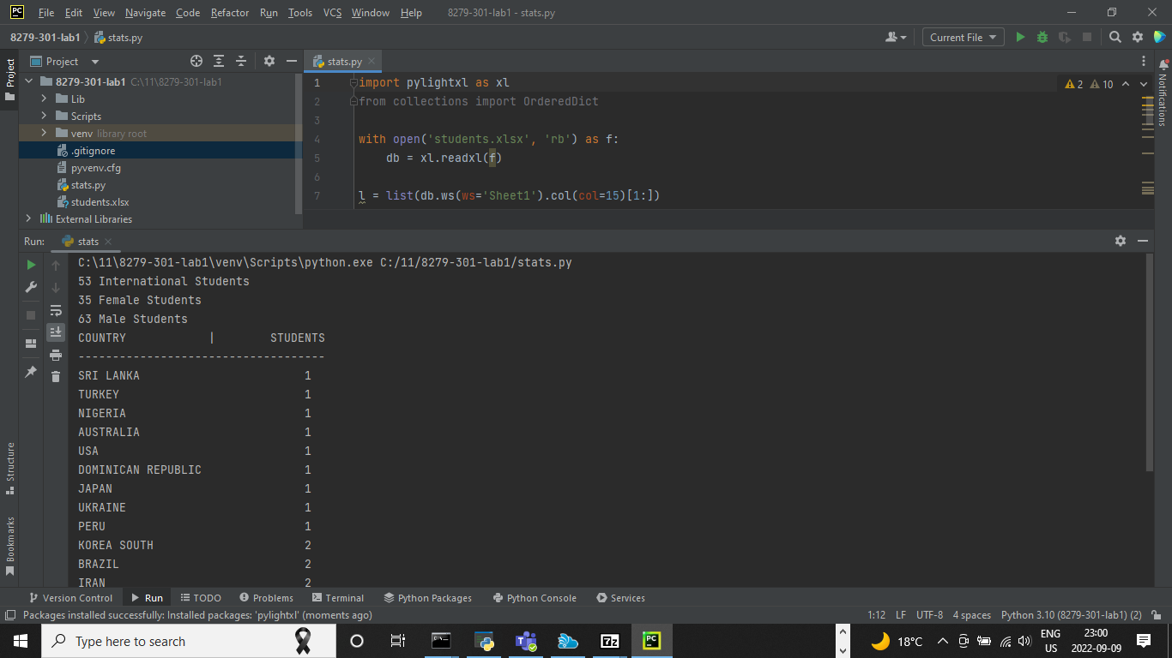

**Executed by Python in Atom IDE**

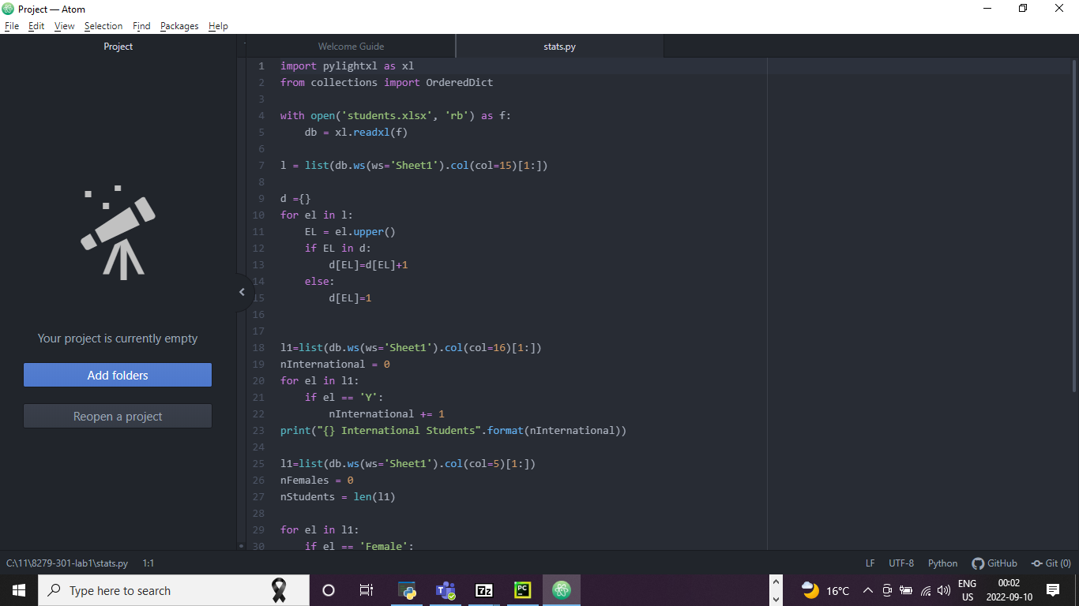

**Executed by Visual studio code IDE**

