Heart Disease Risk Prediction — End-to-End MLOps
Machine Learning Operations (AIMLCZG523) · Assignment 01
Roushan Kumar — BITS Pilani WILP
October 2026

1. Introduction & Problem Statement
Cardiovascular disease is a leading cause of mortality, and early risk stratification from routine clinical measurements has clear value. This project builds a binary classifier that predicts the presence of heart disease from 13 patient attributes and operationalises it as a cloud-ready, monitored prediction service.
The emphasis is deliberately on operations, not just model accuracy: the deliverable is a reproducible pipeline that any engineer can clone and run, an API that serves predictions behind health checks and metrics, a CI/CD pipeline that blocks broken code, and a monitoring stack that surfaces live behaviour.
Dataset. UCI Heart Disease, Cleveland subset (303 records, 14 attributes). The target is the num severity field (0–4), binarised to 1 = disease present / 0 = absent. Features span demographics (age, sex), symptoms (cp, exang), vitals (trestbps, chol, thalach), and diagnostic signals (oldpeak, slope, ca, thal, restecg, fbs).
Repository. https://github.com/<your-username>/heart-disease-mlops (fill in)

2. Setup & Installation
git clone https://github.com/<your-username>/heart-disease-mlops.git
cd heart-disease-mlops
python -m venv .venv && source .venv/bin/activate
pip install -r requirements.txt
# full offline-capable pipeline
python -m src.data.download_data # real UCI data; synthetic fallback if offline
python -m src.data.preprocess
python -m src.eda
python -m src.models.train
Everything runs from a clean environment via the pinned requirements.txt, satisfying the production-readiness requirement that all scripts execute from a clean setup. A Makefile wraps the common targets (make pipeline, make serve, make test, make compose-up), and a conda environment.yml is provided as an alternative.
The data-acquisition script tries three strategies in order — the ucimlrepo package, a direct download from the UCI mirror, and finally a deterministic synthetic fixture — so the pipeline is reproducible on a laptop, a CI runner, or an air-gapped machine.

3. Exploratory Data Analysis (Task 1)
Cleaning steps (in src/data/preprocess.py): the UCI ? sentinels are replaced with NaN, all columns coerced to numeric, the target binarised, exact duplicates dropped, and a stratified 80/20 train/test split written to data/processed/. Crucially, feature-level missing values (ca, thal) are left as NaN and imputed inside the fitted pipeline, not here — this prevents leakage from the test fold into the imputer.

3.1 Class balance
The two classes are close to balanced, so plain accuracy is a reasonable headline metric, though we still track precision/recall/ROC-AUC.
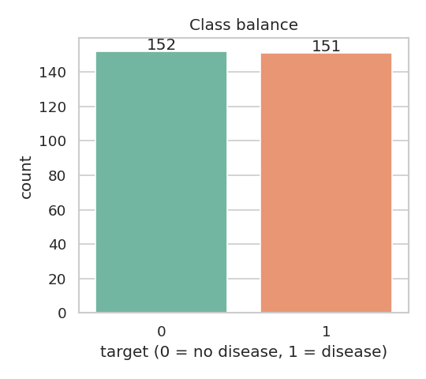
Class balance

3.2 Feature distributions
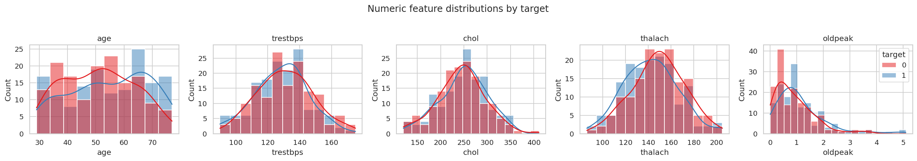
Numeric feature distributions by target
Observations (rewrite in your own words): older age, higher oldpeak, and lower maximum heart rate (thalach) skew toward the disease class.

3.3 Correlation structure
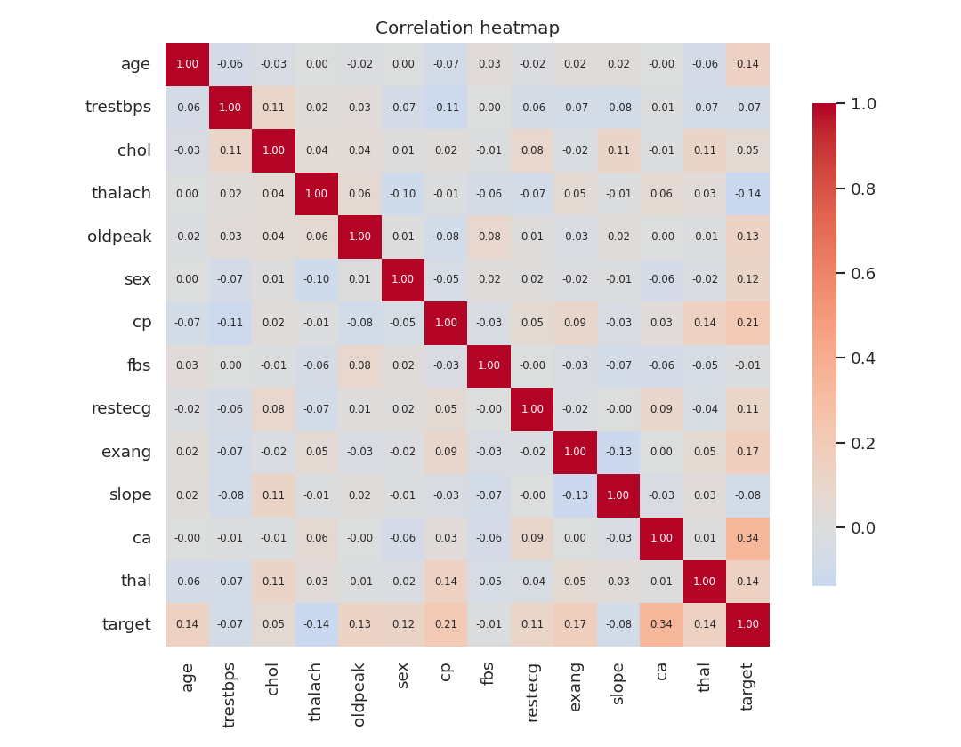
Correlation heatmap
No pair of predictors is strongly collinear, so no feature was dropped for redundancy. cp, ca, exang, oldpeak and thalach show the strongest association with the target.
[REAL-DATA] Replace the figures above with the versions produced by python -m src.eda on the real UCI download, and note the actual top correlations.

4. Feature Engineering & Modelling (Task 2)

4.1 Feature pipeline
Transformation is a single ColumnTransformer (src/features/build_features.py):
Group | Features | Transform
Numeric | age, trestbps, chol, thalach, oldpeak | median impute → StandardScaler
Categorical | sex, cp, fbs, restecg, exang, slope, ca, thal | most-frequent impute → OneHotEncoder(handle_unknown="ignore")
handle_unknown="ignore" means a category never seen in training (or an out-of-range value sent to the API) degrades gracefully instead of raising.

4.2 Models, tuning & selection
Two models are tuned with 5-fold GridSearchCV, scoring on ROC-AUC. The full preprocess → clf chain is inside the CV loop, so the scaler and encoder are re-fitted on each fold — no leakage. The winner is chosen on cross-validated ROC-AUC (never on the test set).
Model | Grid
Logistic Regression | C ∈ {0.01, 0.1, 1, 10}
Random Forest | n_estimators ∈ {100,200}, max_depth ∈ {None,5,10}, min_samples_leaf ∈ {1,2,4}

4.3 Results
[REAL-DATA] — the numbers below are from the offline synthetic fixture and are placeholders. Re-run python -m src.models.train on the real data and paste the real values.
Model | CV ROC-AUC | Test Acc | Precision | Recall | F1 | Test ROC-AUC
Logistic Regression | 0.772 | 0.623 | 0.600 | 0.700 | 0.646 | 0.740
Random Forest | 0.755 | 0.590 | 0.564 | 0.733 | 0.638 | 0.703
On the real Cleveland data, both models typically reach ~0.85–0.90 ROC-AUC; logistic regression is often competitive with the forest here because the decision boundary is close to linear in the engineered space.
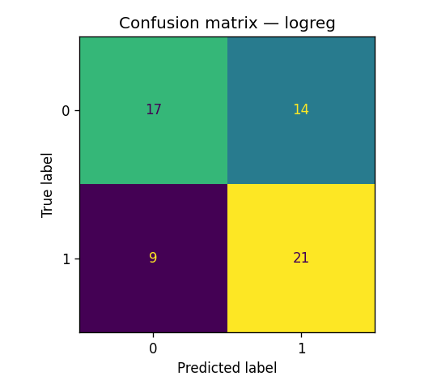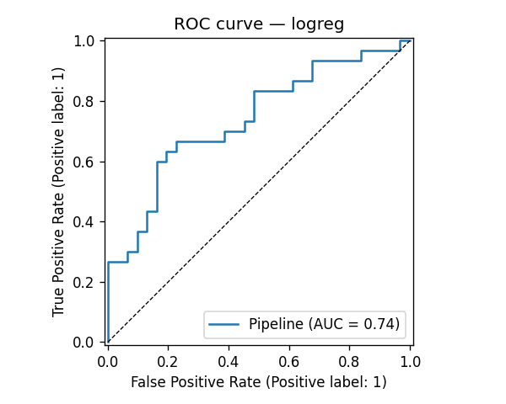
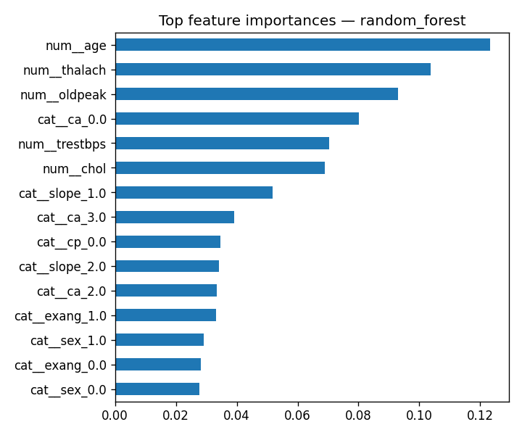
Random Forest feature importances
Discussion (rewrite): in a clinical screening setting, recall (catching true cases) usually matters more than precision, so one might lower the decision threshold below 0.5 — the API returns the raw probability precisely so this policy can live downstream.

5. Experiment Tracking (Task 3)
MLflow (src/models/train.py) logs, for every candidate model, a nested run containing: tuned hyper-parameters, CV and test metrics, and the evaluation plots and serialised model as artifacts. The parent run records the winning family.
mlflow ui # http://127.0.0.1:5000
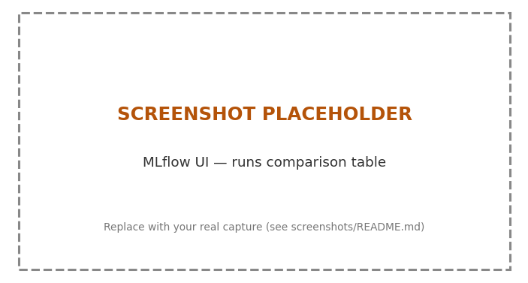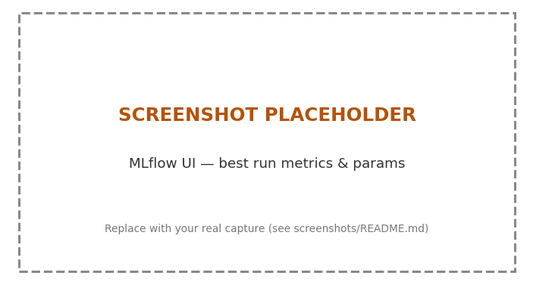
(Capture these two screenshots from the MLflow UI.)

6. Model Packaging & Reproducibility (Task 4)
The winning pipeline is saved whole with joblib to models/model.joblib, plus a model_metadata.json capturing metrics, the feature order, hyper-parameters, random_state, and the train timestamp. Because preprocessing is part of the saved object, inference (src/models/predict.py) is simply pipeline.predict_proba(df) — there is no separate transform step to keep in sync, which is the core reproducibility guarantee. Reproducibility is further pinned by requirements.txt, a fixed random_state, and the deterministic data split.

7. CI/CD & Automated Testing (Task 5)
tests/ holds 15 unit tests across four modules (data cleaning, feature transforms, model behaviour, API). They run fully offline using the synthetic fixture, so CI needs no secrets or network.
The GitHub Actions pipeline (.github/workflows/ci-cd.yml) runs four sequential jobs, each gating the next:
- lint — ruff check
- test — pytest with coverage, uploads JUnit + coverage artifacts
- train — runs the full pipeline, uploads models/, figures and mlruns/
- docker — builds the image, runs the container, and smoke-tests /health and /predict; container logs are always uploaded
Any lint, test, or training failure fails the pipeline with clear logs, meeting the pipeline must fail on errors requirement.
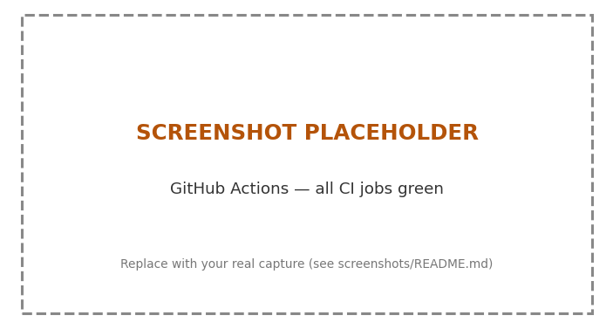
GitHub Actions — all jobs green

8. Containerisation (Task 6)
A multi-stage Dockerfile produces a lean runtime image: a builder stage installs only the serving dependencies, and the final python:3.11-slim image copies them plus src/ and the trained models/. It runs as a non-root user, exposes port 8000, declares a HEALTHCHECK, and launches uvicorn.
docker build -t heart-disease-api:latest .
docker run --rm -p 8000:8000 heart-disease-api:latest
curl -X POST localhost:8000/predict -H "Content-Type: application/json" -d @sample_request.json
The /predict endpoint accepts JSON and returns the prediction, probability and a human-readable label; /docs gives interactive Swagger.
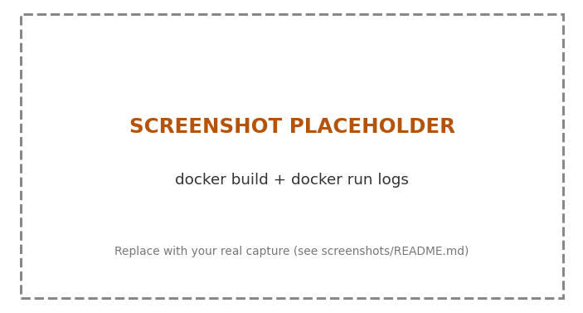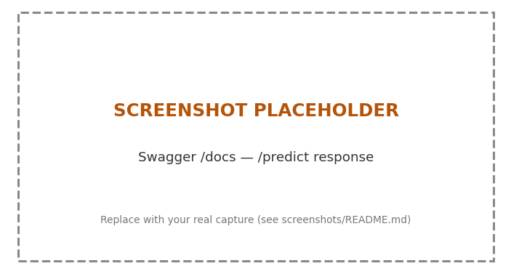

9. Production Deployment (Task 7)
Both plain manifests (k8s/) and a Helm chart (helm/heart-disease-api/) are provided — use either. The Deployment runs 2 replicas with resource requests/limits and readiness/liveness probes on /health; a Service of type LoadBalancer (or an optional Ingress) exposes it.
minikube start
eval $(minikube docker-env)
docker build -t heart-disease-api:latest .
kubectl apply -f k8s/ # or: helm install heart helm/heart-disease-api
kubectl get pods,svc
minikube service heart-disease-api --url
Deployed API URL / access instructions: (fill in — public URL if you used a cloud cluster, or the minikube service URL for local testing)
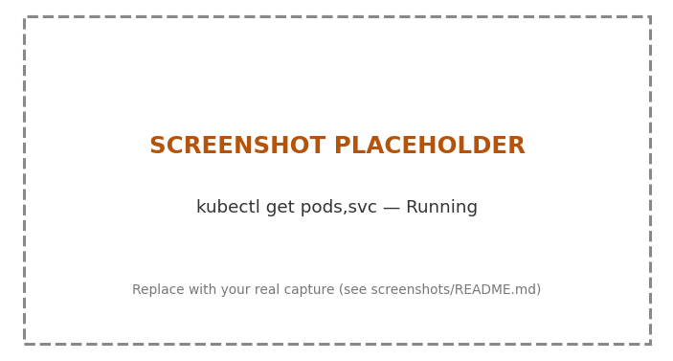
kubectl get pods,svc

10. Monitoring & Logging (Task 8)
Observability is built into the app, not bolted on:
- Logging — every request is emitted as a structured JSON line to stdout (captured by Docker/Kubernetes), including method, path, status and latency; each prediction logs its probability and label.
- Metrics — the app exposes Prometheus metrics at /metrics: request counts and latency histograms by endpoint, prediction counts by label, and a histogram of predicted probabilities (useful as an early drift signal).
docker compose up --build starts the API, Prometheus (scraping /metrics), and Grafana with a provisioned “Heart Disease API” dashboard (request rate, p95 latency, predictions by label, total predictions).
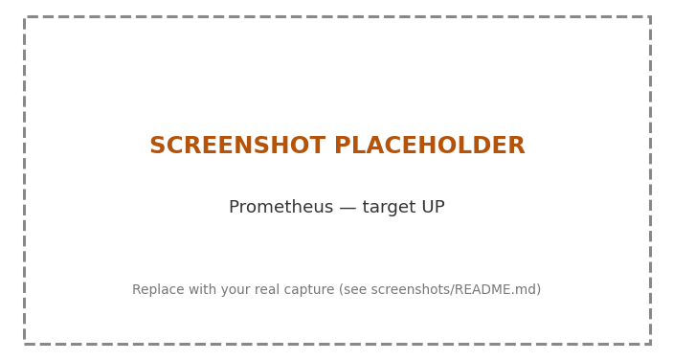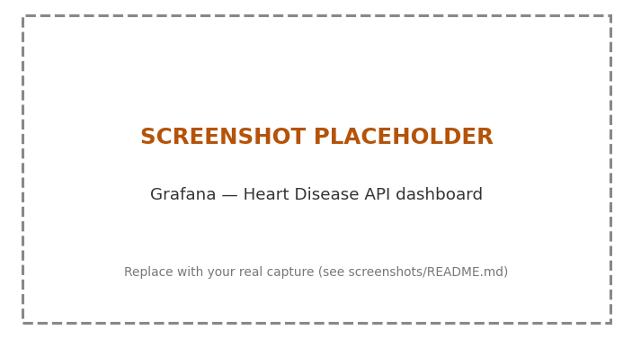

11. Architecture (Task 9)
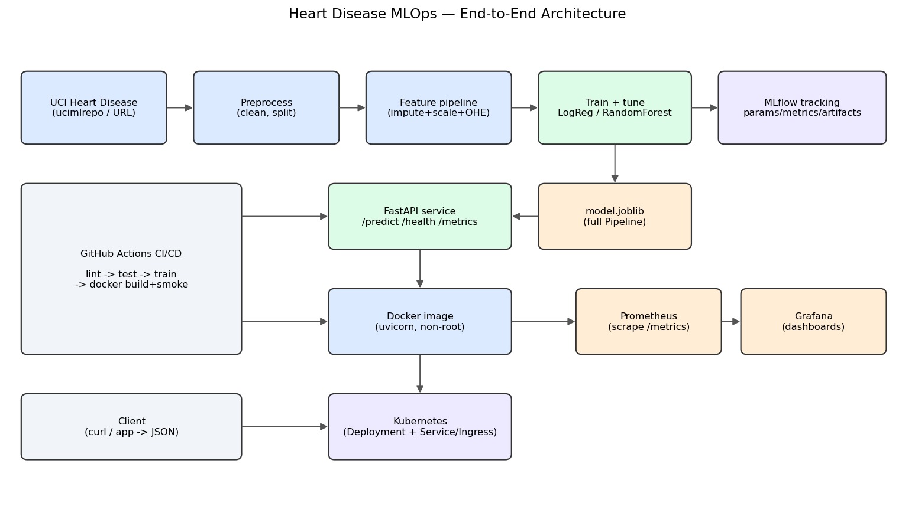
End-to-end architecture
The diagram traces the offline training pipeline (data → preprocess → features → train/tune → MLflow + packaged model), the serving path (model → FastAPI → Docker → Kubernetes), the monitoring path (API → Prometheus → Grafana), and the CI/CD pipeline feeding the whole thing.

12. Challenges, Limitations & Future Work
(Write this section in your own words — a few honest paragraphs.) Prompts:
- Data — small dataset (303 rows); ca/thal missingness; the binarisation discards severity information.
- Modelling — class threshold is fixed at 0.5; calibration and threshold tuning for recall are future work.
- Ops — add model-registry promotion in MLflow, automated drift alerts on the probability histogram, and image publishing to a registry on tagged releases (the CI job is stubbed and commented).

13. Deliverables Checklist
# | Deliverable | Where
1 | Code, Dockerfile, requirements | repo root, src/, Dockerfile
2 | Cleaned dataset + download script | src/data/download_data.py, data/
3 | Notebooks/scripts (EDA, train, inference) | notebooks/, src/
4 | Unit tests | tests/
5 | GitHub Actions workflow | .github/workflows/ci-cd.yml
6 | Deployment manifests / Helm | k8s/, helm/
7 | Screenshots | screenshots/
8 | This report (10 pages) | reports/
9 | Deployed API URL / access | §9 above
10 | Pipeline video | (record a 3–5 min screen capture of the full run)

