AI Debate-Based Multi-Domain Recommendation System Using Large Language Models
[[FILL IN: Student 1]]#1, [[FILL IN: Student 2]]#2, [[FILL IN: Student 3]]#3
#School of Computer Science and Engineering, [[FILL IN: University]]
[[FILL IN: City, Country]]
1[[FILL IN: email1]]
2[[FILL IN: email2]]
3[[FILL IN: email3]]

Abstract— Recommender systems built on large language models (LLMs) usually act as single-pass rankers whose justifications cannot be audited, while multi-agent debate and LLM-as-a-judge research shows both the promise and the bias of letting models argue and grade. This paper presents DebateRec, an AI debate-based multi-domain recommendation system. A natural-language request is converted into hard and soft constraints, candidates are retrieved from a seven-domain, 22,614-record catalogue by a fused BM25 and TF-IDF model, and each shortlisted item is then argued for by a Supporter agent, argued against by a Critic agent, and decided by a Judge agent that must defer to a deterministic, code-computed constraint audit. The reasoning backend switches at runtime between a cloud LLM and a fully offline local model. A five-condition ablation shows hybrid retrieval lifting NDCG@5 from 0.194 (popularity) to 0.720, while a live run against Llama 3.1 8B yields genuine debate transcripts in which the Critic catches an overstated Supporter claim; the debate stages themselves show no measurable ranking gain on the small interim subsample, which is reported as inconclusive rather than as a result.
Keywords— Recommender Systems, Large Language Models, Multi-Agent Debate, Explainable Recommendation, Hybrid Retrieval, Constraint-Based Recommendation
I. Introduction
Recommender systems decide which items from a large catalogue a person sees. Classical collaborative and content-based methods [1]–[5] rely on interaction history or structured metadata and return a ranked list with little to no explanation. Large language models (LLMs) now read free-text requests such as “a funny science-fiction movie from after 2015, preferably under two hours,” which mixes a hard constraint, a soft preference and a genre in one sentence, and they have been inserted into recommendation pipelines as encoders, scorers and generators [6]–[10].
The difficulty is trust. A single LLM call produces a fluent ranking with no retrieval grounding and no way to tell whether a stated reason is true. Zero-shot LLM rankers are known to inherit position and popularity bias [9], and LLM judges show position, verbosity and self-enhancement bias [20], [21]. Multi-agent debate improves factuality on open-domain reasoning [16]–[18], but its benefit shrinks once compute is matched [19], and it has not been applied to constraint-grounded item recommendation.
This paper contributes (1) a controlled three-role debate (Supporter, Critic, Judge) for recommendation in which the Judge is bound to a deterministic constraint audit computed in code; (2) one architecture serving seven structurally different catalogues through a declared facet schema; (3) interchangeable cloud and fully offline LLM backends with a rule-based fallback; and (4) a reproducible five-condition ablation, reported with its limitations.
II. Related Work
A. Classical and LLM-Based Recommendation
Surveys [1] and the collaborative-filtering line [2]–[4] define the content-based, collaborative and hybrid families and the evaluation practice summarised in [5]. LLM-based work is surveyed in [6]–[8]; Hou et al. [9] show that prompted re-ranking is order-sensitive, and PALR [10] couples candidate retrieval with one LLM ranker. Retrieval-augmented recommenders [24], [25] ground the model in retrieved items but keep a single reasoning pass.
B. Conversational and Explainable Recommendation
Conversational recommenders elicit preferences over dialogue [11]; LLM versions handle intent detection, slot filling and response generation with one model [12], or split the work across cooperating agents [13]. Evaluation practice for them is being revisited in [14]. Explainable recommendation [15] generates a single-pass justification per item rather than an adversarial pros-and-cons record.
C. Debate, LLM-as-a-Judge and Constraints
Debate protocols [16]–[18] and the cautions in [19]–[21] motivate pairing a judge with an independent check. Classical constraint-based recommenders handle hard and soft requirements symbolically [26]–[28] but have no language layer. Domain systems for courses and e-learning [29]–[31], including Indian-affiliated work, are single-domain deep-learning pipelines without explanation or debate. To our knowledge no surveyed system combines debate, a deterministic audit, multi-domain generality and an offline option.
III. Proposed System
A. Overview
A request flows through five stages (Fig. 1): natural-language understanding, hybrid retrieval, a deterministic constraint audit, a Supporter–Critic–Judge debate, and ranked explainable output. One asynchronous pipeline serves both the live interface and the evaluation harness, so reported numbers describe the shipped code.
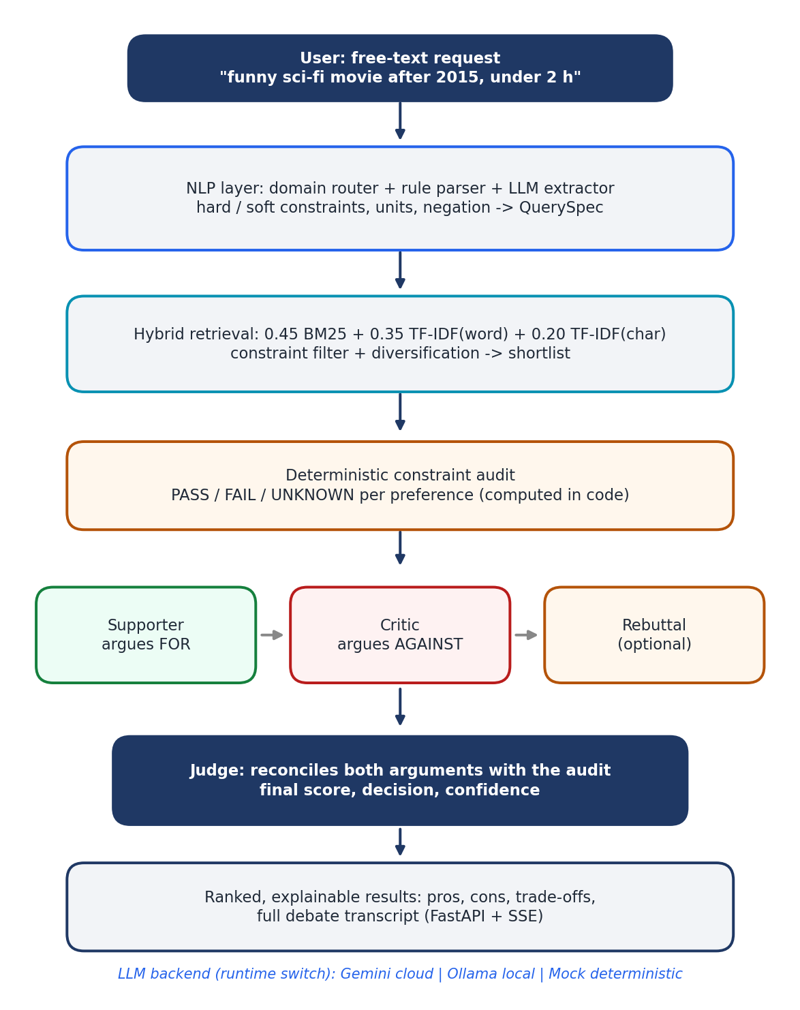
Fig. 1. Block schematic of the proposed recommender.
B. Understanding and Domain Adapters
A rule parser resolves unit-aware numbers (“30k”, “1.5 lakh”, “two hours”), comparison direction, negation, and whether a constraint is hard or soft, judged from the clause containing the number. An LLM extractor constrained to the domain's facet vocabulary adds implicit preferences; rules stay authoritative on any facet they resolve. Each domain (movies, books, courses, phones, laptops, cars, bikes) has an adapter that normalises its own raw format into one item schema and declares numeric facets with units and aliases, so an eighth domain is one file.
C. Hybrid Retrieval
Okapi BM25 [22] scores a query q against a document D as
BM25 = Σ IDF·f·(k₁+1) / [f + k₁(1−b+b|D|/avgdl)] (1)
where f is the frequency of a query term in D, with k₁ = 1.4 and b = 0.72. The retrieval score fuses it with word (TFw) and character (TFc) n-gram TF-IDF cosine scores, each max-normalised:
s = 0.45·BM25 + 0.35·TFw + 0.20·TFc (2)
An optional dense-embedding mode [23] replaces the three scorers without touching later stages.
D. Constraint Audit and Soft Satisfaction
Before any agent sees a candidate, code evaluates every stated preference as PASS, FAIL or UNKNOWN. For a soft upper bound with target t, catalogue spread S (maximum minus minimum of that facet) and item value v, satisfaction decays continuously with the overshoot:
d = 1 if v ≤ t, else max(0, 1 − (v−t)/S) (3)
so a 130-minute film against “under 120 minutes” is a small miss and a 200-minute film a large one, scaled by the real catalogue rather than a constant.
E. Debate Protocol and Judge
Every candidate follows the same fixed rounds: the Supporter argues for the item, the Critic argues against it after seeing that case and flags unsupported claims, an optional rebuttal lets the Supporter concede or answer, and the Judge decides. Each role is one LLM call with one fixed prompt and one structured output schema, so the stage can be switched off and measured. The Judge is told to discard any claim that contradicts the audit. Item text from the catalogue is fenced as untrusted data and instruction-like phrases in it are neutralised before reaching an agent. If no model is available, deterministic heuristics reproduce each role from the audit alone.
IV. Experimental Setup
The catalogue holds 214 hand-curated and 22,400 procedurally generated records (22,614 in total) across seven domains (Table I). Synthetic records carry invented directors, authors and brands and are flagged; all quality claims use the curated pool, and the full catalogue is used only for scale and latency. Twenty-one hand-labelled queries with graded relevance, written from the catalogue before any system was run and not derived from the constraint checker, cover all domains.
TABLE I Catalogue Composition
Domain | Curated | Generated | Total
Movies | 46 | 4,800 | 4,846
Books | 38 | 4,000 | 4,038
Courses | 30 | 3,000 | 3,030
Phones | 24 | 3,000 | 3,024
Laptops | 26 | 2,800 | 2,826
Cars | 26 | 2,600 | 2,626
Bikes | 24 | 2,200 | 2,224
Total | 214 | 22,400 | 22,614
Five conditions form the ablation: E0 popularity only; E1 hybrid retrieval only; E2 adds the Supporter; E3 adds the Critic; E4 is the full debate. E0 and E1 run on all 21 queries with no LLM. E2–E4 ran live on an 8-query, 3-domain subset against Llama 3.1 8B (Q4_K_M) served by Ollama on an 8 GB laptop GPU, with the debated shortlist reduced from 8 to 5 candidates to fit local compute. Metrics are P@5, R@5, NDCG@5, MRR, hit@3, hard-constraint violation rate, diversity, coverage, latency and LLM calls.
V. Results and Discussion
A. Ablation
TABLE II Ablation Results
Cond. | Method | P@5 | NDCG@5 | MRR
E0 | Popularity (21q) | 0.152 | 0.194 | 0.359
E1 | Retrieval only (21q) | 0.514 | 0.720 | 0.849
E2 | +Supporter (8q) | 0.525 | 0.697 | 0.938
E3 | +Critic (8q) | 0.500 | 0.647 | 0.792
E4 | Full debate (8q) | 0.525 | 0.665 | 0.875
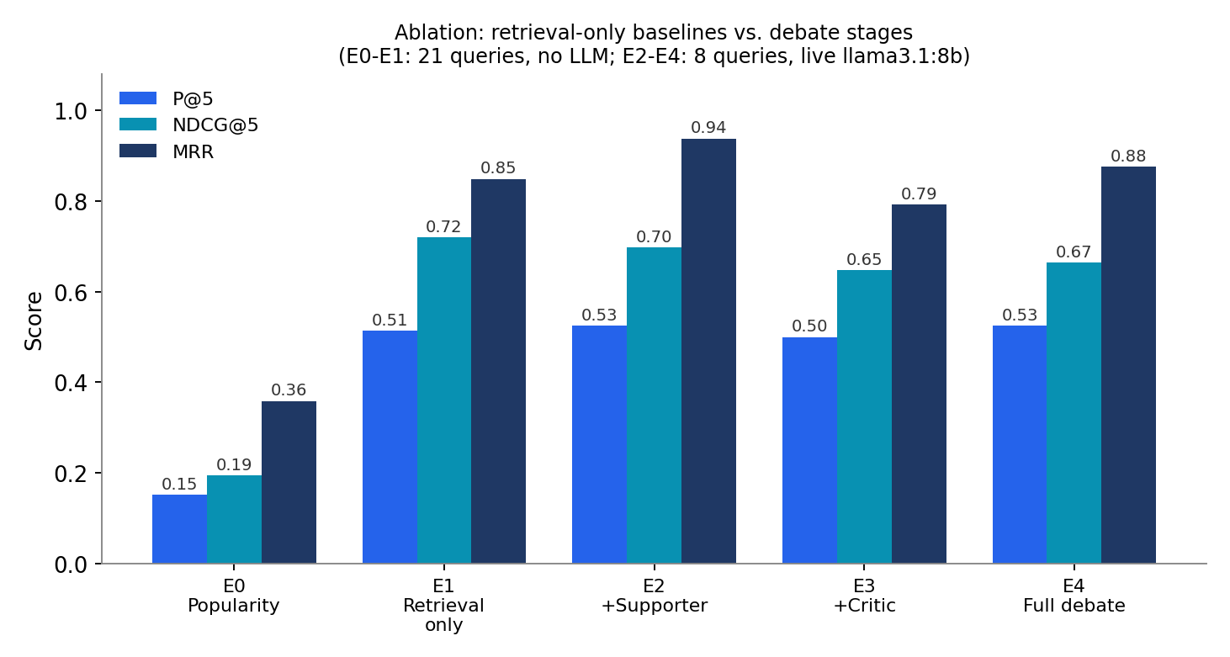
Fig. 2. Retrieval baselines versus debate stages.
Hybrid retrieval raises NDCG@5 from 0.194 to 0.720, so constraint-aware retrieval does most of the ranking work. The hard-violation rate is 0.000 in every condition. On the 8-query live subset the full debate does not exceed retrieval alone (0.665 vs. 0.720). The same ablation was run twice: E4 NDCG@5 was stable (0.666, then 0.665) but E2 and E3 moved by up to 0.11 between runs because the model samples stochastically. E1 and E2–E4 also differ in query count and shortlist width, so this is not a paired comparison. We therefore report the debate's effect on ranking as inconclusive at this sample size, and plan a matched 21-query run with the harness's Wilcoxon signed-rank test and Cohen's d.
B. Cost
TABLE III Debate Cost per Query
Cond. | LLM calls | Seconds | Total calls
E2 | 6 | 33.5 | 48
E3 | 11 | 66.7 | 88
E4 | 16 | 96.2 | 128
Cost grows linearly with each agent: one extraction call plus five calls per added role, and about 33, 67 and 96 s per query locally, against roughly 0.01 s for retrieval alone. This latency is the main practical cost of the approach.
C. Qualitative Case
For the query “a funny science-fiction movie from after 2015, preferably under two hours,” the top result was Spider-Man: No Way Home (148 min), scored 0.3/10 and marked “consider.” The Supporter argued genre and tone fit. The Critic flagged that the film lists several genres of which only one is science fiction, catching an overstated claim, and noted the runtime failure. The Judge's score followed the audit (runtime FAIL, degree 0.529) rather than the Supporter's framing, which is the behaviour the audit is meant to enforce.
D. Comparison and Limitations
Against single-LLM recommenders [9], [10], [12], the debate adds an adversarial check the model cannot override; against explainable recommenders [15], the explanation is an auditable transcript rather than one narrative; against constraint-based systems [26]–[28], it adds language understanding and argumentation. Limitations found during evaluation: the harness's LLM-call counter is cumulative across a run, not per query (corrected here from successive differences, which match the pipeline's call arithmetic); the test suite raises an event-loop teardown error under a live provider but not under the mock; extraction is single-turn; and 22,400 of 22,614 records are synthetic.
VI. Conclusion
DebateRec combines adversarial LLM debate with a deterministic constraint audit for multi-domain, explainable recommendation, with a fully offline option. A 34-test suite passes, and a live local model produces evidence-grounded transcripts. Whether the debate improves ranking beyond constraint-aware retrieval remains open at the present sample. Future work is the matched, statistically tested 21-query ablation, public datasets through the adapter interface, evaluation of dense retrieval, multi-turn elicitation, and a user study of explanation usefulness.
Acknowledgment
The authors thank their faculty guide and institution for guidance and computing resources, and the maintainers of FastAPI, scikit-learn, NumPy, SciPy and Ollama.
References
[1] G. Adomavicius and A. Tuzhilin, "Toward the next generation of recommender systems: A survey of the state-of-the-art and possible extensions," IEEE Trans. Knowl. Data Eng., vol. 17, no. 6, pp. 734–749, 2005.
[2] P. Resnick, N. Iacovou, M. Suchak, P. Bergstrom, and J. Riedl, "GroupLens: An open architecture for collaborative filtering of netnews," in Proc. ACM CSCW, 1994.
[3] B. Sarwar, G. Karypis, J. Konstan, and J. Riedl, "Item-based collaborative filtering recommendation algorithms," in Proc. WWW, 2001.
[4] Y. Koren, R. Bell, and C. Volinsky, "Matrix factorization techniques for recommender systems," Computer, vol. 42, no. 8, pp. 30–37, 2009.
[5] F. Ricci, L. Rokach, and B. Shapira, Eds., Recommender Systems Handbook, 2nd ed. Boston, MA, USA: Springer, 2011.
[6] L. Wu et al., "A survey on large language models for recommendation," World Wide Web, vol. 27, no. 5, 2024.
[7] J. Lin et al., "How can recommender systems benefit from large language models: A survey," ACM Trans. Inf. Syst., vol. 43, no. 2, 2025.
[8] L. Li, Y. Zhang, D. Liu, and L. Chen, "Large language models for generative recommendation: A survey and visionary discussions," in Proc. LREC-COLING, 2024.
[9] Y. Hou et al., "Large language models are zero-shot rankers for recommender systems," in Proc. ECIR, 2024.
[10] F. Yang, Z. Chen, Z. Jiang, E. Cho, X. Huang, and Y. Lu, "PALR: Personalization aware LLMs for recommendation," arXiv:2305.07622, 2023.
[11] D. Jannach, A. Manzoor, W. Cai, and L. Chen, "A survey on conversational recommender systems," ACM Comput. Surveys, vol. 54, no. 5, 2021.
[12] Y. Feng et al., "A large language model enhanced conversational recommender system," arXiv:2308.06212, 2023.
[13] J. Huang et al., "A multi-agent conversational recommender system," arXiv:2402.01135, 2024.
[14] X. Wang et al., "Rethinking the evaluation for conversational recommendation in the era of large language models," in Proc. EMNLP, 2023.
[15] Y. Zhang and X. Chen, "Explainable recommendation: A survey and new perspectives," Found. Trends Inf. Retrieval, vol. 14, no. 1, 2020.
[16] Y. Du, S. Li, A. Torralba, J. B. Tenenbaum, and I. Mordatch, "Improving factuality and reasoning in language models through multiagent debate," in Proc. ICML, 2024.
[17] T. Liang et al., "Encouraging divergent thinking in large language models through multi-agent debate," in Proc. EMNLP, 2024.
[18] C.-M. Chan et al., "ChatEval: Towards better LLM-based evaluators through multi-agent debate," arXiv:2308.07201, 2023.
[19] A. Smit et al., "Rethinking the bounds of LLM reasoning: Are multi-agent discussions the key?," in Proc. ACL, 2024.
[20] L. Zheng et al., "Judging LLM-as-a-judge with MT-bench and chatbot arena," in Proc. NeurIPS, 2023.
[21] "LLMs-as-judges: A comprehensive survey on LLM-based evaluation methods," arXiv:2412.05579, 2024.
[22] S. Robertson and H. Zaragoza, "The probabilistic relevance framework: BM25 and beyond," Found. Trends Inf. Retrieval, vol. 3, no. 4, 2009.
[23] V. Karpukhin et al., "Dense passage retrieval for open-domain question answering," in Proc. EMNLP, 2020.
[24] A. Aly et al., "RAG-Rec: Retrieval augmented generation for robust personalized recommendation systems," Procedia Comput. Sci., 2026.
[25] Y. Deldjoo et al., "A review of modern recommender systems using generative models (Gen-RecSys)," in Proc. ACM KDD, 2024.
[26] A. Felfernig and R. Burke, "Constraint-based recommender systems: Technologies and research issues," in Proc. ICEC, 2008, pp. 17–26.
[27] M. Zanker, M. Jessenitschnig, and W. Schmid, "Preference reasoning with soft constraints in constraint-based recommender systems," Constraints, vol. 15, no. 4, pp. 574–595, 2010.
[28] N. L. Le et al., "A constraint-based recommender system via RDF knowledge graphs," arXiv:2307.10702, 2023.
[29] Y. Ma, R. Ouyang, X. Long, Z. Gao, T. Lai, and C. Fan, "DORIS: Personalized course recommendation system based on deep learning," PLOS ONE, 2023.
[30] S. Subha et al., "Personalization-based deep hybrid e-learning model for online course recommendation system," PeerJ Comput. Sci., vol. 9, e1670, 2023.
[31] N. Vedavathi and K. M. Anil Kumar, "E-learning course recommendation based on sentiment analysis using hybrid Elman similarity," Knowledge-Based Syst., vol. 259, 110086, 2023.

