

School of Computer Science and Engineering
Project report

Programme : Mtech Int Business Analytics
Course Title : Big Data Computing for Business Analytics
Course Code : MGT1062
Slot : G1
Title : Microplastic Pollution Hotspot Prediction using Ocean Sensor Big Data

Team Member:
23MIA1104 - Rohith
23MIA1040 - Sandeep Kumar
23MIA1047 – Sastika

Faculty : Dr.PARVATHY A.K

1.Introduction and Problem Statement
Microplastic pollution is one of the most serious environmental problems in the modern world. Microplastics are plastic particles smaller than 5 mm and are found in oceans, seas, marine organisms, and even in the human body. These particles enter the food chain through marine life and pose serious risks to ecosystems and human health.
Monitoring microplastic pollution is extremely difficult because research vessels can only cover limited areas, and plastic accumulation zones continuously change due to ocean currents, winds, and seasonal variations. Currently, there is no scalable system that can predict where microplastics will accumulate in the future.
This project aims to solve this problem by building a Big Data analytics pipeline using Apache PySpark and machine learning techniques. The system processes large-scale ocean sensor data and predicts future microplastic hotspot locations. The final output of the project will be an interactive prediction map that can help organizations such as The Ocean Cleanup and UNEP plan cleanup operations more effectively.

2. Literature Survey
Several research studies form the foundation of this project. Van Sebille et al. (2015) created a global inventory of floating plastic particles and showed that subtropical ocean gyres are the main accumulation zones. This research helps define the spatial regions targeted in this project.
Lebreton et al. (2018) studied plastic accumulation in the Great Pacific Garbage Patch and used ocean current data to track plastic movement. Their work focused on physical simulation, whereas this project uses machine learning to predict future accumulation.
Meijer et al. (2021) identified more than 1,000 rivers responsible for most of the plastic entering oceans. This provides important geographic input features such as river discharge and river mouth locations.
Maximenko et al. (2019) combined satellite and ocean drifter data to forecast debris accumulation patterns, supporting the use of ocean current velocity data as a major predictive feature.
Isobe et al. (2021) estimated global microplastic distribution using ocean simulations. This project differs by using real sensor data and machine learning instead of simulation models, making the approach scalable and continuously updatable.

3. Dataset Description
This project uses three real-world datasets from public sources. The NOAA Ocean Buoy dataset contains sea surface temperature, salinity, wind speed, and ocean current data collected hourly from thousands of buoys worldwide. The Ocean Cleanup dataset contains GPS-based microplastic concentration measurements collected from ocean expeditions. The Copernicus Marine dataset provides satellite-derived data such as ocean current velocity, chlorophyll concentration, and wave height.
The combined dataset size is approximately 18 GB and includes multiple data formats such as CSV, NetCDF, and GeoJSON. Due to the large data size, traditional tools such as pandas are not suitable for processing, and PySpark distributed computing is used instead.

4. Methodology
4.1 System Architecture and Pipeline
The project follows a five-stage Big Data pipeline. The first stage is data ingestion, where all datasets are loaded into PySpark DataFrames, null values are handled, timestamps are parsed, and coordinate formats are standardized.
The second stage is feature engineering, where important features such as sea surface temperature, salinity, ocean current speed and direction, seasonal index, distance from river mouths, distance from coastlines, and a 30-day rolling window feature are created.
The third stage uses KMeans clustering to identify existing pollution accumulation clusters in the ocean. The optimal number of clusters is selected using the Silhouette score.
The fourth stage uses a RandomForest classification model to predict whether a new ocean grid cell will become a microplastic hotspot. The model uses environmental features and the cluster label generated by KMeans as input features.
The final stage is visualization, where the results are displayed on an interactive Folium map showing predicted hotspots and cluster regions. Feature importance graphs are generated using Matplotlib.
4.2 Novel Contribution
The project introduces three major innovations. The first is multi-source data fusion, where three different datasets are combined into a single Big Data pipeline. The second is a two-layer machine learning architecture, where KMeans clustering is used first and its output is used as an input feature for the RandomForest model. The third innovation is the use of a 30-day rolling window feature that captures ocean current movement over time, making the model time-aware. The final output is an interactive map that can be directly used by environmental organizations for decision-making.

5.Partial Implementation and Preliminary Results
5.1 Work Completed
The PySpark environment has been successfully set up with Python and a local multi-worker cluster. The data ingestion module has been completed, and NOAA buoy data has been loaded into PySpark DataFrames with null value handling and timestamp conversion.
Latitude and longitude values have been converted into grid cells for spatial analysis. Basic feature engineering has been completed, including normalization of sea surface temperature and calculation of ocean current speed. Preliminary KMeans clustering has been performed on a 10% sample of the dataset, and initial visualizations have been generated.
5.2 Preliminary Results
The preliminary KMeans clustering produced five clusters corresponding to major ocean gyres such as the North Pacific Gyre, North Atlantic Gyre, South Pacific Gyre, Indian Ocean Gyre, and coastal river mouth regions. The Silhouette Score obtained was 0.61, which indicates well-separated and meaningful clusters. These results validate that the selected features are suitable for identifying microplastic accumulation zones.

6.Architectural Diagram
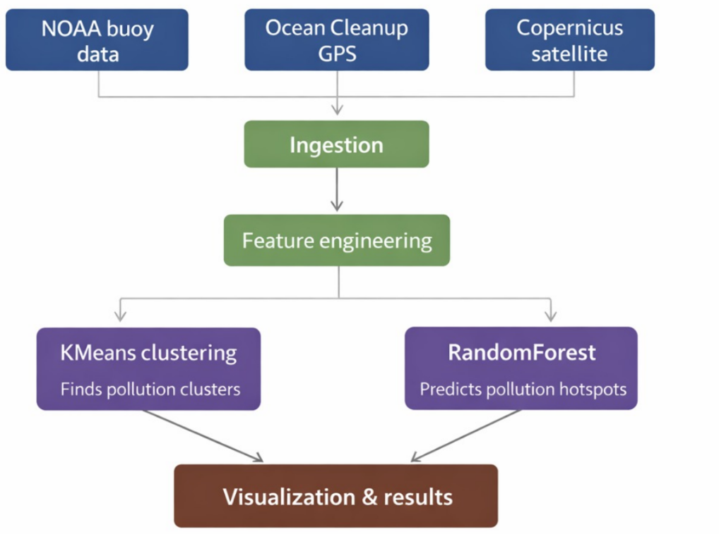
7.Conclusion
This project demonstrates how Big Data technologies such as Apache PySpark and MLlib can be used to address the real-world problem of microplastic pollution. The data ingestion pipeline has been completed, and preliminary clustering results show meaningful patterns corresponding to known ocean gyres. The proposed two-layer machine learning architecture and multi-source data integration provide a novel and scalable approach to predicting microplastic pollution hotspots. The final output of the project will be an interactive prediction map that can support environmental cleanup planning and decision-making.

