Practical 3

Create a Simple REST Service

**Software Tools Required:**

* **Code Editor**: Visual Studio Code (VS Code)
* **API Testing Software Application**: Postman
* **Framework**: Flask (micro web framework)

**Downloads Required:**

* Python: [Download Python | Python.org](https://www.python.org/downloads/?form=MG0AV3)
* Postman: [Download Postman | Get Started for Free](https://www.postman.com/downloads/)

(Create Account/ Log in with Google)

After Downloading Python, Set the Path in Environment Variable in User Variables > Path > Edit > New and Paste the Path for Python.

New version is 3.13, Here the version is 3.12 so following the same for new version.

**Till Python312:** Copy Directory Path

Start > Python 3.13.1 (64 bit) > Open File Location > Python 3.13.1 (64 bit)

**Till Python312\Scripts:** Copy the Directory Path

Start > Python 3.13.1 (64 bit) > Open File Location > Python 3.13.1 (64 bit) > Open File Location > Scripts

**Demonstration:**

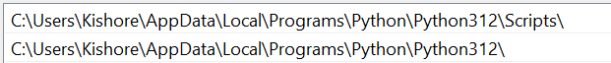

**Check Version:**

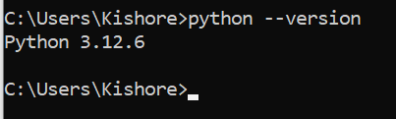

**Python Programming Language**

**Step 1:** Install Flask: Make sure you have Python installed on your system.

Open cmd and type the following command

**pip install Flask**

**Demonstration:**

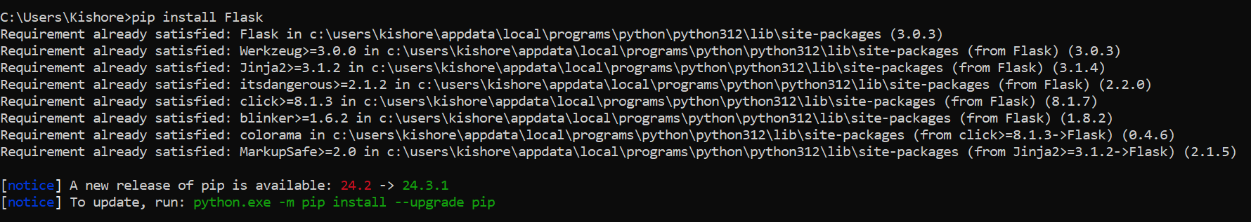

**Step 2:** Create a folder name SimpleRESTService, Open with VS Code and create python file.

Check and Install Extensions for Python

**Extensions:**

**Python**

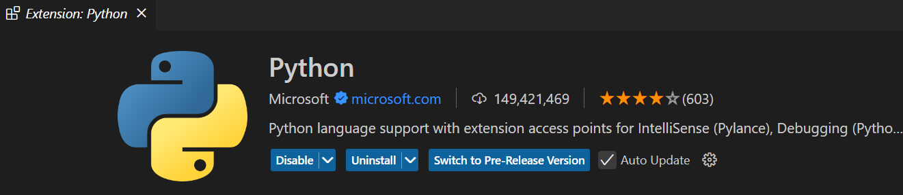

**Python Debugger**

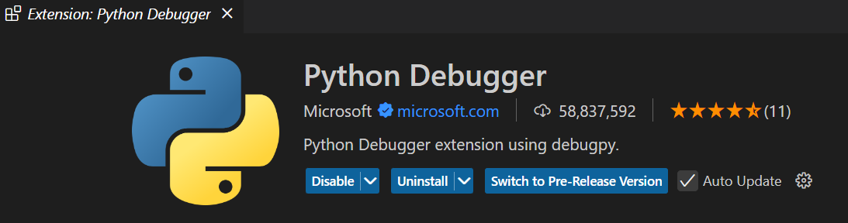

**Filename:** app.py

**Code:**

from flask import Flask, jsonify, request

app = Flask(__name__)

# Sample data

data = [

    {'id': 1, 'name': 'Item 1'},

    {'id': 2, 'name': 'Item 2'},

]

# Endpoint to get all items

@app.route('/items', methods=['GET'])

def get_items():

    return jsonify({'items': data})

# Endpoint to get a specific item by ID

@app.route('/items/<int:item_id>', methods=['GET'])

def get_item(item_id):

    item = next((item for item in data if item['id'] == item_id), None)

    if item:

        return jsonify({'item': item})

    else:

        return jsonify({'message': 'Item not found'}), 404

# Endpoint to add a new item

@app.route('/items', methods=['POST'])

def add_item():

    new_item = {'id': len(data) + 1, 'name': request.json['name']}

    data.append(new_item)

    return jsonify({'message': 'Item added successfully', 'item': new_item}), 201

# Run the application

if __name__ == '__main__':

    app.run(debug=True)

**Output:**

View>Terminal

Type

Path> **python app.py**

**Demonstration:**

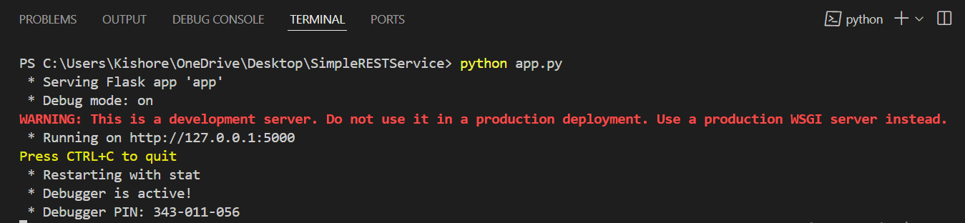

**Postman**

**API Testing Software Application to Test the API**

**Open Postman**

**# Endpoint to get all items**

**Send a GET Request:**

**URL:** [**http://127.0.0.1:5000/items**](http://127.0.0.1:5000/items)

**Response:**

**{**

**"items": [**

**{**

**"id": 1,**

**"name": "Item 1"**

**},**

**{**

**"id": 2,**

**"name": "Item 2"**

**}**

**]**

**}**

**Demonstration:**

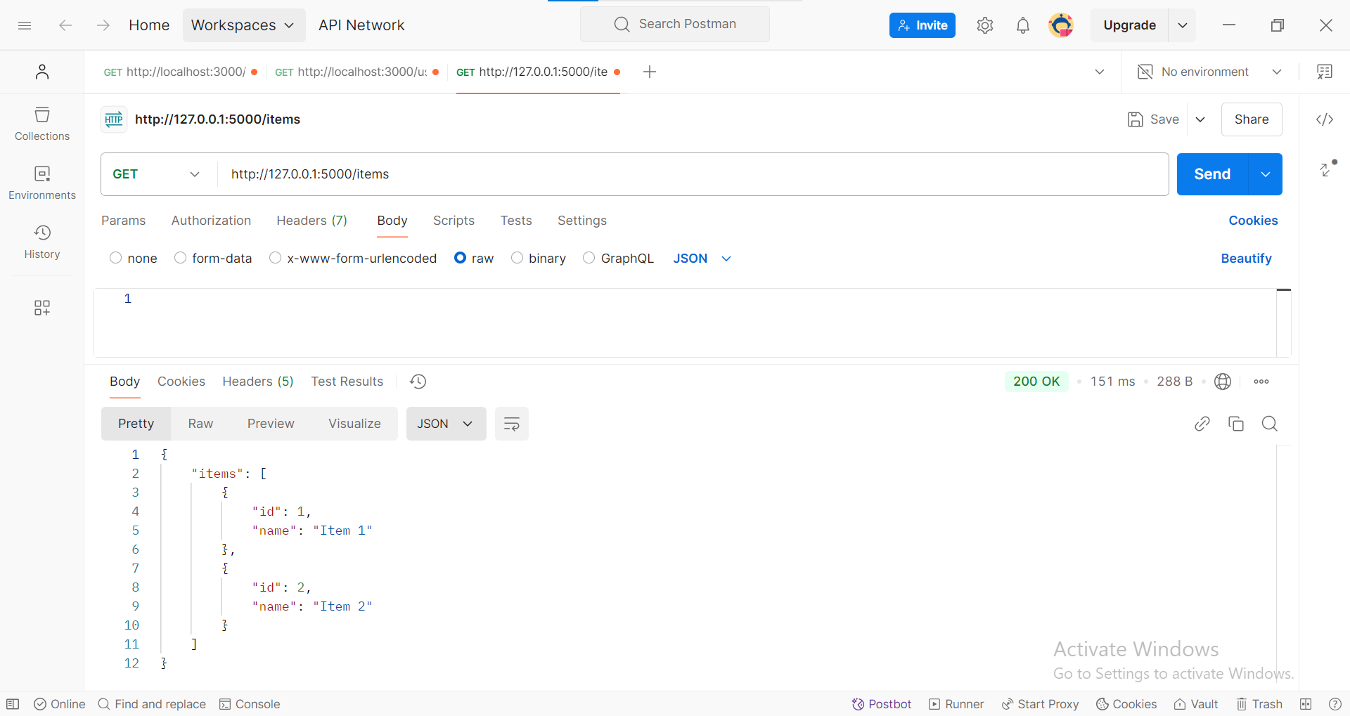

**# Endpoint to get a specific item by ID**

**Send a GET Request:**

**URL:** [**http://127.0.0.1:5000/items**](http://127.0.0.1:5000/items)**/1**

**Response:**

**{**

**"item": {**

**"id": 1,**

**"name": "Item 1"**

**}**

**}**

**Provides specific id from Sample Data available i.e., URL:** [**http://127.0.0.1:5000/items/1**](http://127.0.0.1:5000/items/1)

**Demonstration:**

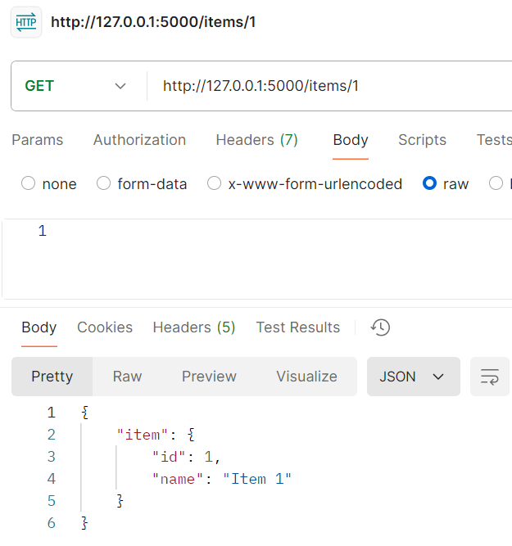

**Throws Error when not item not found from Sample Data. Example**

**URL:** [**http://127.0.0.1:5000/items/100**](http://127.0.0.1:5000/items/100)

**Demonstration:**

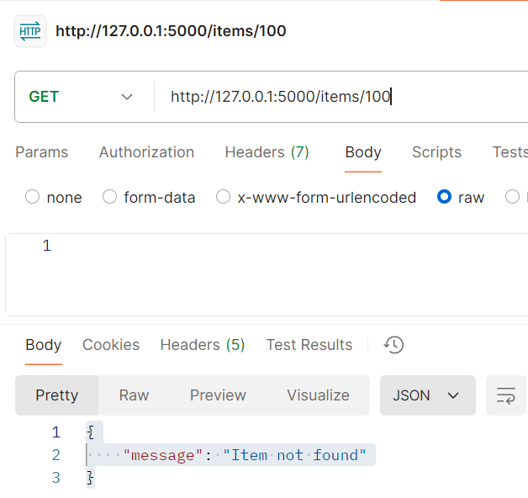

**# Endpoint to add a new item**

**Send a POST Request:**

**URL:** [**http://127.0.0.1:5000/items**](http://127.0.0.1:5000/items)

**Body:** Set the body to raw JSON and include:

{"name":"item3"}

**Response:**

{

    "item": {

        "id": 3,

        "name": "item3"

    },

    "message": "Item added successfully"

}

**Demonstration:**



