

Safety Plan Lane Assistance

**Document Version: [Version]**

**Template Version 1.0, Released on 2017-06-21**



# Document history

**[Instructions: Fill in the date, version and description fields. You can fill out the Editor field with your name if you want to do so. Keep track of your editing as if this were a real world project.**

**For example, if this were your first draft or first submission, you might say version 1.0. If this is a second submission attempt, then you'd add a second line with a new date and version 2.0]**

|  |  |  |  |
| --- | --- | --- | --- |
| Date | Version | Editor | Description |
| 01/22/2019 | 1.0 | Rouzbeh Shirvani | First Attempt |
| 01/24/2019 | 1.1 | Rouzbeh Shirvani | Second Attempt |
|  |  |  |  |
|  |  |  |  |
|  |  |  |  |

# Table of Contents

**[Instructions: We have provided a table of contents. If the table of contents is not showing up correctly in your word processor of choice, please update it. The table of contents should show each section of the document and page numbers or links. Most word processors can do this for you. In** [**Google Docs**](https://support.google.com/docs/answer/116338?co=GENIE.Platform%3DDesktop&hl=en)**, you can use headings for each section and then go to Insert > Table of Contents.** [**Microsoft Word**](https://support.microsoft.com/en-us/help/285059/how-to-create-a-table-of-contents-by-marking-text-in-word) **has similar capabilities]**

Document history

Table of Contents

Introduction

Purpose of the Safety Plan

Scope of the Project

Deliverables of the Project

Item Definition

Goals and Measures

Goals

Measures

Safety Culture

Safety Lifecycle Tailoring

Roles

Development Interface Agreement

Confirmation Measures

# Introduction

## Purpose of the Safety Plan

**[Instructions: Answer what is the purpose of a safety plan?]**

A safety plan provides an overall framework for the lane assistance item, and to assign roles and responsibilities for the functional safety for this item.

## Scope of the Project

**[Instructions: Nothing to do here. This is for your information.]**

For the lane assistance project, the following safety lifecycle phases are in scope:

Concept phase

Product Development at the System Level

Product Development at the Software Level

The following phases are out of scope:

Product Development at the Hardware Level

Production and Operation

## Deliverables of the Project

**[Instructions: Nothing to do here. This is for your information.]**

The deliverables of the project are:

Safety Plan

Hazard Analysis and Risk Assessment

Functional Safety Concept

Technical Safety Concept

Software Safety Requirements and Architecture

# Item Definition

**[Instructions:**

**REQUIRED**

**Discuss these key points about the system:**

**What is the item in question, and what does the item do?**

**The item in question is Lane Assitance System. It allerts the driver that the vehicle accidentally deprated its lane and attemps to steer the vehicle toward the center of the lane.**

**What are its two main functions? How do they work?**

**Lane departure warning: Functionality that vibrates the steering wheel when the driver drifts away from the center by mistake.**

**Lane keeping assistance: Functionality that turns the steering wheel back towards the center of the lane if the driver starts to drift away from the center without flashers.**

**Which subsystems are responsible for each function?**

**Camera sub-system, car display sub-system, electronic power steering system are all responsible for each of the functions.**

**What are the boundaries of the item? What subsystems are inside the item? What elements or subsystems are outside of the item?**

**The following diagram shows the item boundaries**

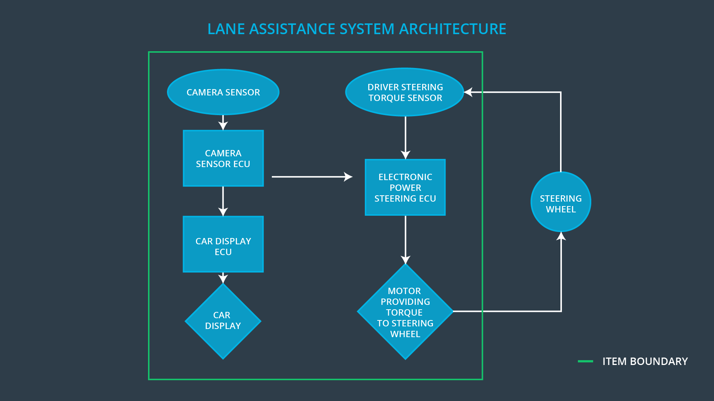

**OPTIONAL**

**Optionally, include information about these points as well. These were not included in the lectures, but you might be able to find this information online:**

* **Operational and Environmental Constraints. This could especially be limited to camera performance; lane lines are difficult to detect in snow, fog, etc**
* **Legal requirements in your country for lane assistance technology**
* **National and International Standards Related to the Item**
* **Records of previously known safety-related incidents or behavioral shortfalls**

**]**

# Goals and Measures

## Goals

**[Instructions:**

**Describe the major goal of this project; what are we trying to accomplish by analyzing**

**the lane assistance functions with ISO 26262?]**

The main goal in functional safety is to reduce risk to acceptable levels. We would provide our arguments in a final document called a **safety case**. A safety case would provide evidence that your project has made the vehicle safer. The evidence would include all the ISO 26262 documentation such as the safety plan, design plans, functional safety concept, technical safety concepts, as well as evidence documenting testing and integration.

## Measures

**[Instructions:**

**Fill in who will be responsible for each measure or activity. Hint: The lesson on Safety Management Roles and Responsibilities.**

**The options are:**

**All Team Members**

**Safety Manager**

**Project Manager**

**Safety Auditor**

**Safety Assessor**

**]**

|  |  |  |
| --- | --- | --- |
| Measures and Activities | Responsibility | Timeline |
| Follow safety processes | All Team Members | Constantly |
| Create and sustain a safety culture | All Team Members | Constantly |
| Coordinate and document the planned safety activities | Safety Manager | Constantly |
| Allocate resources with adequate functional safety competency | Project Manager | Within 2 weeks of start of project |
| Tailor the safety lifecycle | Project Manager | Within 4 weeks of start of project |
| Plan the safety activities of the safety lifecycle | Project Manager | Within 4 weeks of start of project |
| Perform regular functional safety audits | Safety Auditor | Once every 2 months |
| Perform functional safety pre-assessment prior to audit by external functional safety assessor | Project Manager | 3 months prior to main assessment |
| Perform functional safety assessment | Safety Asessor | Conclusion of functional safety activities |

# Safety Culture

**[Instructions:**

**Describe the characteristics of your company's safety culture. How do these characteristics help maintain your safety culture. Hint: See the lesson about Safety Culture**

**]**

* **High priority**: safety has the highest priority among competing constraints like cost and productivity
* **Accountability**: processes ensure accountability such that design decisions are traceable back to the people and teams who made the decisions
* **Rewards**: the organization motivates and supports the achievement of functional safety
* **Penalties**: the organization penalizes shortcuts that jeopardize safety or quality
* **Independence**: teams who design and develop a product should be independent from the teams who audit the work
* **Well defined processes**: company design and management processes should be clearly defined
* **Resources**: projects have necessary resources including people with appropriate skills
* **Diversity**: intellectual diversity is sought after, valued and integrated into processes
* **Communication**: communication channels encourage disclosure of problems

# Safety Lifecycle Tailoring

**[Instructions:**

**Describe which phases of the safety lifecycle are in scope and which are out of scope for this particular project. Hint: See the** **Intro section** **of this document**

**]**

For the lane assistance project, the following safety lifecycle phases are in scope:

Concept phase

Product Development at the System Level

Product Development at the Software Level

The following phases are out of scope:

Product Development at the Hardware Level

Production and Operation

# Roles

**[Instructions:**

**This section is here for your reference. You do not need to do anything here. It is provided to help with filling out the development interface agreement section.**

**]**

|  |  |
| --- | --- |
| Role | Org |
| Functional Safety Manager- Item Level | OEM |
| Functional Safety Engineer- Item Level | OEM |
| Project Manager - Item Level | OEM |
| Functional Safety Manager- Component Level | Tier-1 |
| Functional Safety Engineer- Component Level | Tier-1 |
| Functional Safety Auditor | OEM or external |
| Functional Safety Assessor | OEM or external |

# 

# Development Interface Agreement

**[Instructions:**

**Assume in this project that you work for the tier-1 organization as described in the above roles table. You are taking on the role of both the functional safety manager and functional safety engineer.**

**Please answer the following questions:**

1. **What is the purpose of a development interface agreement?**

* Avoiding disputes
* Liability
* Makes it clear who should fix safety issues

1. **What will be the responsibilities of your company versus the responsibilities of the OEM? Hint: In this project, the OEM is supplying a functioning lane assistance system. Your company needs to analyze and modify the various sub-systems from a functional safety viewpoint.**

**]**

The OEM provides requirements what a vehicle system needs to do then my company developes and produces the system for the OEM. OEM might also provide a preliminary design and my company finishes the design. Once these communication are made, my company for example develops an ABS brake system for the OEM.

# Confirmation Measures

**[Instructions:**

**Please answer the following questions:**

1. **What is the main purpose of confirmation measures?**

- A functional safety project conforms to ISO 26262.

- The project really does make the vehicle safer.

1. **What is a confirmation review?**

Confirmation review ensures that the project complies with ISO 26262. As the product is designed and developed, an independent person would review the work to make sure ISO 26262 is being followed.

1. **What is a functional safety audit?**

Functional safety audit checks to make sure that the actual implementation of the project conforms to the safety plan is called a functional safety audit.

1. **What is a functional safety assessment?**

Functional safety assessment confirms that plans, designs and developed products actually achieve functional safety is called a functional safety assessment.

**]**

A safety plan could have other sections that we are not including here. For example, a safety plan would probably contain a complete project schedule.

There might also be a "Supporting Process Management" section that would cover "Part 8: Supporting Processes" of the ISO 26262 functional safety standard. This would include descriptions of how the company handles requirements management, change management, configuration management, documentation management, and software tool usage and confidence.

Similarly, a confirmation measures section would go into more detail about how each confirmation will be carried out.