🛡
ZEROGUARD
Zero Trust Network Architecture (ZTNA) Simulation Platform
Never Trust. Always Verify. Continuously Monitor.

A Final Year Project Report

Bachelor of Science in Information Technology
Academic Year 2025/2026

TABLE OF CONTENTS

CHAPTER 1: INTRODUCTION
1.0 Introduction
1.1 Overview
1.2 Statement of the Problem
1.3 Objectives
1.4 Research Questions
1.5 Scope of the Study
1.6 Significance of the Study
CHAPTER 2: LITERATURE REVIEW
2.1 The Zero Trust Security Model
2.2 Core Components of Zero Trust Architecture
2.3 Existing ZTNA Solutions
2.4 Gap in Literature
CHAPTER 3: SYSTEM DESIGN
3.1 Data Flow Diagrams (DFD)
3.2 Entity-Relationship Diagram (ERD)
3.3 Use Case Diagrams
3.4 System Requirements Specification
CHAPTER 4: SYSTEM DEVELOPMENT & IMPLEMENTATION
4.1 Development Methodology
4.2 Tools and Technologies
4.3 System Modules
4.4 Database Design
4.5 User Interface
4.6 Testing & Quality Assurance
CHAPTER 5: SUMMARY, RECOMMENDATIONS & CONCLUSIONS
REFERENCES
APPENDICES

CHAPTER 1: INTRODUCTION
1.0 Introduction
This chapter presents the background to the study, the problem statement, purpose and objectives of the study, research questions, scope, significance, and assumptions underpinning the development of ZeroGuard — a Zero Trust Network Architecture (ZTNA) simulation platform.
1.1 Overview
Traditional network security operates on a "castle and moat" model — once a user is inside the perimeter, they are trusted implicitly. This approach has proven inadequate in the face of modern cyber threats, insider attacks, and the increasing adoption of remote work and cloud services. Zero Trust Architecture (ZTA) eliminates the concept of implicit trust. Instead, it mandates continuous verification of every user, device, and access request regardless of their location within or outside the network perimeter.
ZeroGuard is a fully functional web application designed to demonstrate, simulate, and enforce Zero Trust principles in a controlled academic environment. The platform implements the core tenets of Zero Trust: "Never Trust, Always Verify, Continuously Monitor." It provides a comprehensive simulation of identity verification, device trust assessment, adaptive policy enforcement, risk-based access control, and real-time threat detection.
1.2 Statement of the Problem
Organizations worldwide face escalating cybersecurity threats including data breaches, ransomware attacks, and insider threats. According to IBM's 2024 Cost of a Data Breach Report, the average cost of a data breach reached $4.88 million. Traditional perimeter-based security models assume that everything inside the network is trustworthy, creating significant vulnerabilities when attackers bypass the perimeter through phishing, compromised credentials, or supply chain attacks.
Despite the growing adoption of Zero Trust frameworks by enterprises, there is a lack of practical, hands-on educational tools that allow IT students and security professionals to understand, experiment with, and validate Zero Trust concepts in a safe simulation environment. Existing ZTNA solutions (such as Zscaler, Palo Alto Prisma Access, or Cloudflare Access) are proprietary, expensive, and unsuitable for academic experimentation.
1.3 Objectives
Main Objective: To design and develop a production-grade Zero Trust Network Architecture (ZTNA) simulation platform that demonstrates and enforces Zero Trust principles.
Specific Objectives:
- To implement a robust identity verification system with multi-factor authentication (MFA) using Time-based One-Time Passwords (TOTP).
- To develop a device trust assessment engine that evaluates device security posture (encryption, antivirus, firewall, OS updates, screen lock).
- To build an adaptive policy engine that evaluates access requests against configurable rules in real-time.
- To create a risk scoring engine that dynamically calculates risk based on user behavior, device posture, time of access, and location.
- To develop a real-time threat detection and alerting system.
- To provide comprehensive audit logging and analytics dashboards for security monitoring.
1.4 Research Questions
- How can Zero Trust principles be effectively implemented and simulated in a web-based platform for educational purposes?
- What mechanisms are required for continuous identity verification beyond initial authentication?
- How can device security posture be assessed and factored into access control decisions?
- What role does risk-based adaptive access control play in reducing security incidents?
- How can real-time monitoring and threat detection enhance network security in a Zero Trust model?
1.5 Scope of the Study
1.5.1 Content Scope
The study covers the implementation of Zero Trust principles including identity verification, device trust, policy-based access control, MFA, risk scoring, threat detection, and audit logging within a simulation platform.
1.5.2 Time Scope
The project was developed over a period of approximately four months (January 2026 – April 2026).
1.5.3 Geographical Scope
The platform is designed as a local-deployment web application suitable for use in university computer labs and personal workstations for academic demonstration purposes.
1.6 Significance of the Study
- Academic Value: Provides a practical, hands-on tool for IT students to learn and experiment with Zero Trust Architecture.
- Industry Relevance: Demonstrates production-grade security patterns used by enterprise ZTNA solutions.
- Research Contribution: Fills the gap in accessible educational ZTNA simulation tools.
- Skill Development: Exposes students to modern full-stack development with security-first design patterns.

CHAPTER 2: LITERATURE REVIEW
2.0 Introduction
This chapter reviews existing literature on Zero Trust Architecture, its principles, frameworks, and implementations. Literature was sourced from academic publications, industry reports, NIST guidelines, and technology vendor documentation.
2.1 The Zero Trust Security Model
The concept of Zero Trust was first introduced by John Kindervag of Forrester Research in 2010. The core principle states that no entity — whether inside or outside the network perimeter — should be automatically trusted. Every access request must be authenticated, authorized, and continuously validated.
NIST Special Publication 800-207 (2020) formally defines Zero Trust Architecture and outlines three key tenets:
- All resources are accessed in a secure manner regardless of location.
- Access is granted on a per-session basis and determined by dynamic policy.
- Trust is never granted implicitly and must be continuously evaluated.
2.2 Core Components of Zero Trust Architecture
2.2.1 Identity Verification
Modern ZTA implementations rely on strong identity verification mechanisms including multi-factor authentication (MFA). TOTP-based MFA, as specified in RFC 6238, generates time-sensitive one-time codes using a shared secret and the current timestamp.
2.2.2 Device Trust and Posture Assessment
Zero Trust requires continuous assessment of device health. This includes checking for disk encryption, antivirus software, firewall status, operating system currency, and screen lock configuration (Gilman & Barth, 2017).
2.2.3 Adaptive Policy Enforcement
Access decisions are made dynamically based on policy rules that evaluate attributes such as user role, department, device trust score, resource sensitivity, time of access, and IP address (NIST SP 800-207).
2.2.4 Risk-Based Access Control
Risk scores are calculated dynamically based on contextual factors. Higher risk scores trigger additional verification steps (challenge) or outright denial of access (Rose et al., 2020).
2.3 Existing ZTNA Solutions
Solution | Type | Limitations
Zscaler Private Access | Commercial SaaS | Proprietary, expensive, no educational mode
Palo Alto Prisma Access | Commercial SaaS | Enterprise-only, closed source
Cloudflare Access | Freemium SaaS | Limited simulation capabilities
Google BeyondCorp | Enterprise Framework | Requires Google Cloud infrastructure
Open Policy Agent (OPA) | Open Source Policy Engine | Policy engine only, not a full ZTNA platform

2.4 Gap in Literature
While numerous commercial ZTNA products exist, there is a notable absence of open-source, self-contained educational simulation platforms that demonstrate the full lifecycle of Zero Trust access control — from authentication through device assessment, policy evaluation, risk scoring, to audit logging and threat detection. ZeroGuard addresses this gap by providing a complete, deployable simulation platform.

CHAPTER 3: SYSTEM DESIGN
3.1 Data Flow Diagrams (DFD)
3.1.1 Context Diagram
Context Diagram — ZeroGuard Platform
┌────────────┐ Login, Register, ┌───────────────────┐ Audit Logs, ┌──────────────┐
│ User/Admin │ ──Access Request────▶ │ ZeroGuard Platform │ ────Metrics─────▶ │ SQLite DB │
│ │ ◀──Access Decision,─── │ │ ◀──Stored Data─── │ │
│ │ Dashboard, Alerts │ │ │ │
└────────────┘ └───────────────────┘ └──────────────┘
3.1.2 Level 0 DFD
Level 0 Data Flow Diagram
┌─────────────────┐
│ User │
└────┬──┬──┬──┬────┘
Credentials ─────┘ │ │ └───── Device Info
MFA Code ────┘ └──────── Access Request
▼ ▼
┌──────────────┐ ┌──────────────┐ ┌──────────────────┐
│ 1.0 Auth │ │ 2.0 MFA │ │ 5.0 Device Trust │
│ Module │ │ Verification │ │ Module │
└──────┬───────┘ └──────┬───────┘ └────────┬─────────┘
JWT Token│ Verified│ Trust Score│
│ │ │
▼ ▼ ▼
┌──────────────────────────────────────────────────────┐
│ 3.0 Policy Engine │
│ ┌──────────────────────┐ │
│ │ 4.0 Risk Scoring │ │
│ │ Engine │ │
│ └──────────────────────┘ │
└────────────────────┬────────────────────────────────┘
│ Decision: Allow/Deny/Challenge
▼
┌──────────────┐ ┌──────────────────────┐
│ Database │ │ 6.0 Threat Detection │
│ (SQLite) │ │ 7.0 Analytics Engine │
└──────────────┘ └──────────────────────┘
3.1.3 Level 1 DFD — Authentication Module
Level 1 DFD — Authentication Module Detail
┌──────────┐
│ User │
└────┬─────┘
│ email, password
▼
┌──────────────────┐ User Record ┌────────────┐
│ 1.1 Validate │ ◀──────────────▶ │ Database │
│ Credentials │ │ │
└────┬────────┬────┘ └─────────────┘
│ Valid │ MFA Required ▲
▼ ▼ │
┌──────────┐ ┌──────────────┐ │
│ 1.2 Dev │ │ 1.4 MFA │──TOTP Code──▶│
│ Register │ │ Challenge │ │
└────┬─────┘ └──────┬───────┘ │
│ │ ┌──────────────┐ │
▼ └▶│ 1.5 TOTP │ │
┌──────────┐ │ Verification │ │
│ 1.3 Sess │ ◀────────┤ │ │
│ Creation │ └──────────────┘ │
└────┬─────┘ │
│ JWT Tokens, Session Record ─────────┘
▼
┌──────────┐
│ User │
└──────────┘
3.2 Entity-Relationship Diagram (ERD)
Entity-Relationship Diagram — ZeroGuard Database Schema (9 Tables)
┌──────────────┐ ┌──────────────┐ ┌───────────────┐
│ USER │ 1 M │ DEVICE │ 1 0..1│ DEVICE_POSTURE│
├──────────────┤─────────├──────────────┤─────────├───────────────┤
│ id (PK) │ │ id (PK) │ │ id (PK) │
│ email (UK) │ │ userId (FK) │ │ deviceId (FK) │
│ username (UK)│ │ name │ │ isEncrypted │
│ passwordHash │ │ type │ │ hasAntivirus │
│ role │ │ operatingSys │ │ isOsUpToDate │
│ department │ │ ipAddress │ │ hasFirewall │
│ mfaEnabled │ │ isTrusted │ │ screenLock │
│ mfaSecret │ │ trustScore │ │ postureScore │
│ riskScore │ │ lastSeen │ └───────────────┘
└──────┬───────┘ └──────┬───────┘
│ 1 M │ 1 M
│ ┌──────────────┘
│ │
▼ ▼
┌──────────────────┐ ┌──────────────┐ ┌──────────────┐
│ SESSION │ │ RESOURCE │ │ POLICY_RULE │
├──────────────────┤ ├──────────────┤ ├──────────────┤
│ id (PK) │ │ id (PK) │ │ id (PK) │
│ userId (FK) │ │ name │ │ name │
│ deviceId (FK) │ │ type │ │ condition │
│ token │ │ sensitivity │ │ action │
│ refreshToken │ │ endpoint (UK)│ │ priority │
│ isActive │ │ minTrust │ │ isActive │
│ mfaVerified │ │ requiresMFA │ └──────────────┘
│ expiresAt │ └──────┬───────┘
└──────┬───────────┘ │ ┌──────────────┐
│ 1 M │ │ THREAT_ALERT │
│ ┌────────────────┘ 1 M ├──────────────┤
▼ ▼ │ id (PK) │
┌──────────────────┐ │ type │
│ ACCESS_LOG │ │ severity │
├──────────────────┤ │ title │
│ id (PK) │ │ isResolved │
│ userId (FK) │ └──────────────┘
│ sessionId (FK) │
│ resourceId (FK) │
│ action │
│ outcome │
│ riskScore │
│ timestamp │
└──────────────────┘
3.3 Use Case Diagram
Use Case Diagram — ZeroGuard Platform Actors & Functions
┌─────────────────────────────────────────────────────────────────────┐
│ ZeroGuard Platform │
│ │
│ ┌───────────────┐ ┌────────────────────┐ ┌─────────────────┐ │
│ │ Register │ │ MFA Setup/Verify │ │ View Dashboard │ │
│ │ Account │ │ │ │ │ │
│ └───────┬───────┘ └────────┬───────────┘ └────────┬────────┘ │
│ │ │ │ │
│ ┌───────┴───────┐ ┌───────┴────────────┐ ┌───────┴────────┐ │
│ │ Login with │ │ Access Protected │ │ View Access │ │
│ │ Credentials │ │ Resources │ │ Logs │ │
│ └───────────────┘ └────────────────────┘ └────────────────┘ │
│ │
│ ┌───────────────┐ ┌────────────────────┐ ┌─────────────────┐ │
│ │ Manage Users │ │ Manage Devices │ │ Export CSV Logs │ │
│ └───────────────┘ └────────────────────┘ └─────────────────┘ │
│ │
│ ┌───────────────┐ ┌────────────────────┐ ┌─────────────────┐ │
│ │ Configure │ │ Manage Threats │ │ View Analytics │ │
│ │ Policies │ │ │ │ │ │
│ └───────────────┘ └────────────────────┘ └─────────────────┘ │
└─────────────────────────────────────────────────────────────────────┘
Actors:
👤 User → Register, Login, MFA, Access Resources, Dashboard, Devices, Logs, Export
🔍 Analyst → Dashboard, Users, Logs, Threats, Analytics
🛡️ Admin → Users, Policies, Threats, Analytics, Settings
👁️ Guest → Limited access with elevated risk scoring
3.4 System Requirements Specification
3.4.1 Functional Requirements
ID | Requirement | Priority
FR1 | Users shall register with email, username, password, and department | High
FR2 | Users shall authenticate via email/password with automatic device registration | High
FR3 | Users shall setup and verify TOTP-based MFA via authenticator apps | High
FR4 | System shall evaluate access requests against configurable policy rules | High
FR5 | System shall calculate dynamic risk scores per access attempt | High
FR6 | System shall assess device security posture (encryption, AV, firewall, OS, screen lock) | High
FR7 | Admins shall create, edit, enable/disable, and delete access policies | Medium
FR8 | System shall log all access attempts with full audit trail | High
FR9 | System shall generate and display threat alerts for suspicious activity | Medium
FR10 | Users shall export access logs as CSV files | Low
FR11 | Dashboard shall display real-time KPIs, charts, and live access feed | Medium
FR12 | Admins shall create and manage user accounts (activate/deactivate, view details) | Medium
FR13 | System shall support JWT-based session management with token refresh | High

3.4.2 Non-Functional Requirements
ID | Requirement | Category
NFR1 | Passwords shall be hashed using bcrypt with 12 salt rounds | Security
NFR2 | API rate limiting: 100 req/15min general, 20 req/15min auth | Security
NFR3 | CORS configured for localhost client only | Security
NFR4 | Helmet.js for HTTP security headers | Security
NFR5 | JWT access tokens expire after 15 minutes | Security
NFR6 | System shall support responsive design (mobile, tablet, desktop) | Usability
NFR7 | Page transitions shall use animations for smooth UX | Usability
NFR8 | Real-time updates via WebSocket (Socket.IO) | Performance
NFR9 | System shall run on local hardware (no cloud dependency) | Portability

CHAPTER 4: SYSTEM DEVELOPMENT & IMPLEMENTATION
4.1 Choice of Development Methodology
4.1.1 Agile (Iterative) Development Methodology
The project adopted an Agile iterative development methodology due to the evolving nature of requirements and the need for rapid prototyping and testing. Each iteration focused on a specific module (authentication, device management, policy engine, etc.) and produced a working increment of the software.
4.1.2 Explanation of the Chosen Methodology
Agile was selected because:
- Evolving Requirements: Zero Trust principles span many security domains; iterative development allowed progressive refinement.
- Continuous Testing: Each module was tested independently before integration.
- Rapid Feedback: The UI was continuously refined based on usability testing.
- Risk Reduction: Critical security modules (authentication, policy engine) were developed first.
4.2 Software Development Tools and Technologies
Category | Tool/Technology | Purpose
Frontend Framework | React 18 + TypeScript | Component-based UI development
Build Tool | Vite | Fast development server and build
Styling | Tailwind CSS | Utility-first CSS framework
State Management | Zustand | Lightweight client state management
Data Fetching | TanStack React Query | Server state, caching, refetching
Charts | Recharts | Data visualization (area, bar, pie, line)
Animations | Framer Motion | Page transitions and micro-animations
Icons | Lucide React | Consistent icon system
Backend Framework | Express.js + TypeScript | RESTful API server
ORM | Prisma | Type-safe database access
Database | SQLite | Lightweight embedded SQL database
Authentication | JWT (jsonwebtoken) | Token-based session management
MFA | Speakeasy + QRCode | TOTP generation and verification
Password Hashing | bcryptjs | Secure password hashing
Real-time | Socket.IO | WebSocket-based event streaming
Security | Helmet.js, express-rate-limit | HTTP headers, rate limiting
HTTP Logging | Morgan | Request logging middleware

4.3 System Modules/Components
4.3.1 Authentication Module
Functionality: Handles user registration, login, logout, JWT token refresh, and MFA setup/verification/disabling. Implements bcrypt password hashing (12 rounds), automatic device registration on login, and JWT-based session management with 15-minute access token expiry and refresh token rotation.
4.3.2 Device Trust Module
Functionality: Manages device registration, trust scoring, and security posture assessment. Evaluates five security criteria: disk encryption (25 points), antivirus (20 points), OS currency (25 points), firewall (20 points), and screen lock (10 points) for a maximum posture score of 100.
4.3.3 Policy Engine
Functionality: Evaluates access requests against a configurable set of policy rules. Policies consist of conditions (field, operator, value) and actions (ALLOW, DENY, REQUIRE_MFA, ALERT). Rules are evaluated in priority order. Supports seven condition fields: role, department, resource sensitivity, device trust, risk score, time of day, and IP address.
4.3.4 Risk Scoring Engine
Functionality: Calculates dynamic risk scores (0–100) for each access request based on user behavior history, device trust score, device posture, time of access, and contextual factors. Risk scores above the challenge threshold trigger MFA, while scores above the deny threshold result in access denial.
4.3.5 Threat Detection Module
Functionality: Monitors for six threat types: brute force attacks, anomalous location access, privilege escalation attempts, session hijacking, suspicious device access, and policy violations. Generates alerts with four severity levels (Critical, High, Medium, Low).
4.3.6 Analytics & Dashboard Module
Functionality: Provides real-time security monitoring via KPI cards, area charts (access trends), donut charts (access outcomes), bar charts (risk distribution, top resources), heatmaps (risk by day/hour), and live access feeds via WebSocket.
4.4 Database Design and Implementation
4.4.1 Database Schema
The system uses SQLite with Prisma ORM. The schema contains 9 tables:
Table | Records | Purpose
User | 8 seeded | User accounts with roles, departments, risk scores
Device | 20 seeded | Registered devices per user
DevicePosture | 20 seeded | Security posture checks per device
Session | Dynamic | Active/historic login sessions
Resource | 8 seeded | Protected resources with sensitivity levels
AccessLog | 200 seeded | Complete audit trail of access attempts
PolicyRule | 6 seeded | Configurable access control policies
ThreatAlert | 8 seeded | Security threat alerts
Setting | Dynamic | Platform configuration key-value pairs

4.4.2 Development Environment Setup
The project uses a monorepo structure:
zeroguard/
├── client/ # React + Vite frontend
│ ├── src/
│ │ ├── components/ # Sidebar, Navbar, Layout
│ │ ├── pages/ # 13 page components
│ │ ├── services/ # API client (Axios)
│ │ ├── store/ # Zustand auth store
│ │ └── hooks/ # Socket.IO hook
│ └── tailwind.config.ts
├── server/ # Express + TypeScript backend
│ └── src/
│ ├── middleware/ # 7 middleware layers
│ ├── routes/ # 10 API route modules
│ ├── services/ # Socket.IO, policy engine
│ ├── utils/ # JWT, Prisma, device info
│ └── prisma/ # Schema + seed data
└── package.json # Monorepo scripts
4.5 User Interface Screenshots
4.5.1 Login Page
The login interface features a professional shield logo, clean card design, and secure input fields:
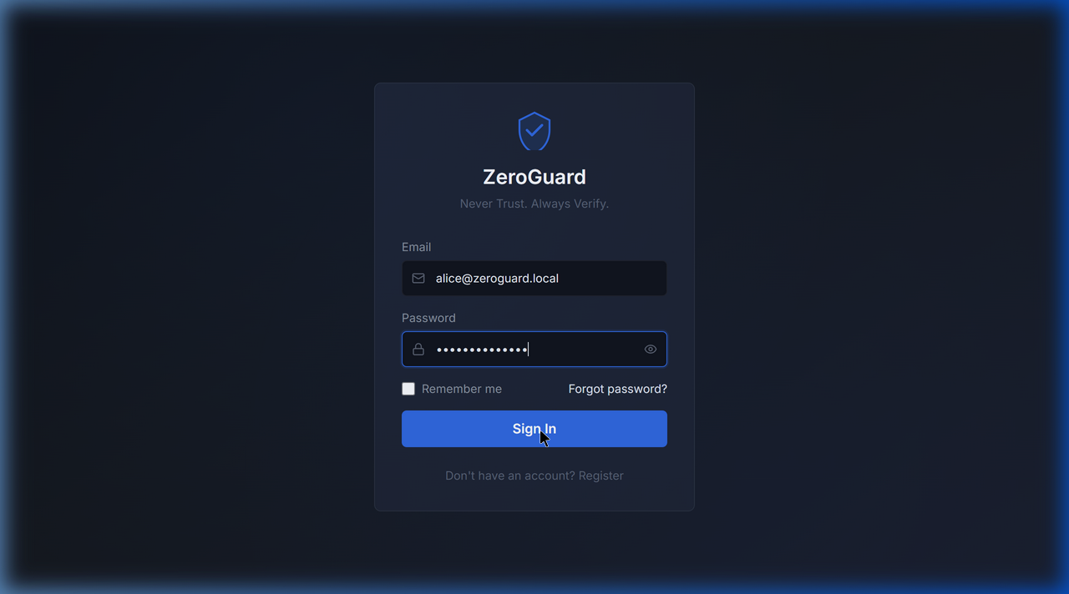
Figure 1: ZeroGuard Login Page — Shield logo, solid dark card, blue primary button
4.5.2 Security Dashboard
The dashboard provides real-time KPI cards, access trend charts, outcome distribution, and live event feeds:
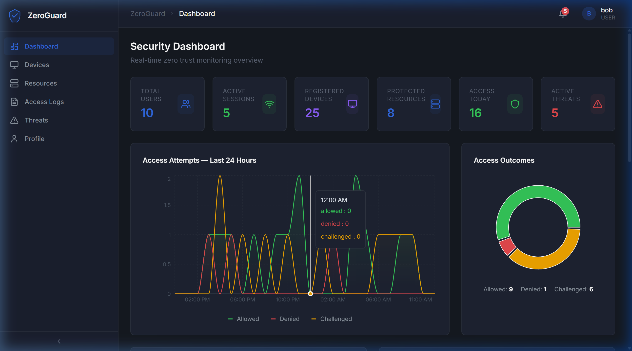
Figure 2: Security Dashboard — Real-time KPIs, area charts, and access outcome distribution
4.5.3 Devices Management
The device management page displays registered devices with trust scores, security posture indicators, and action controls:
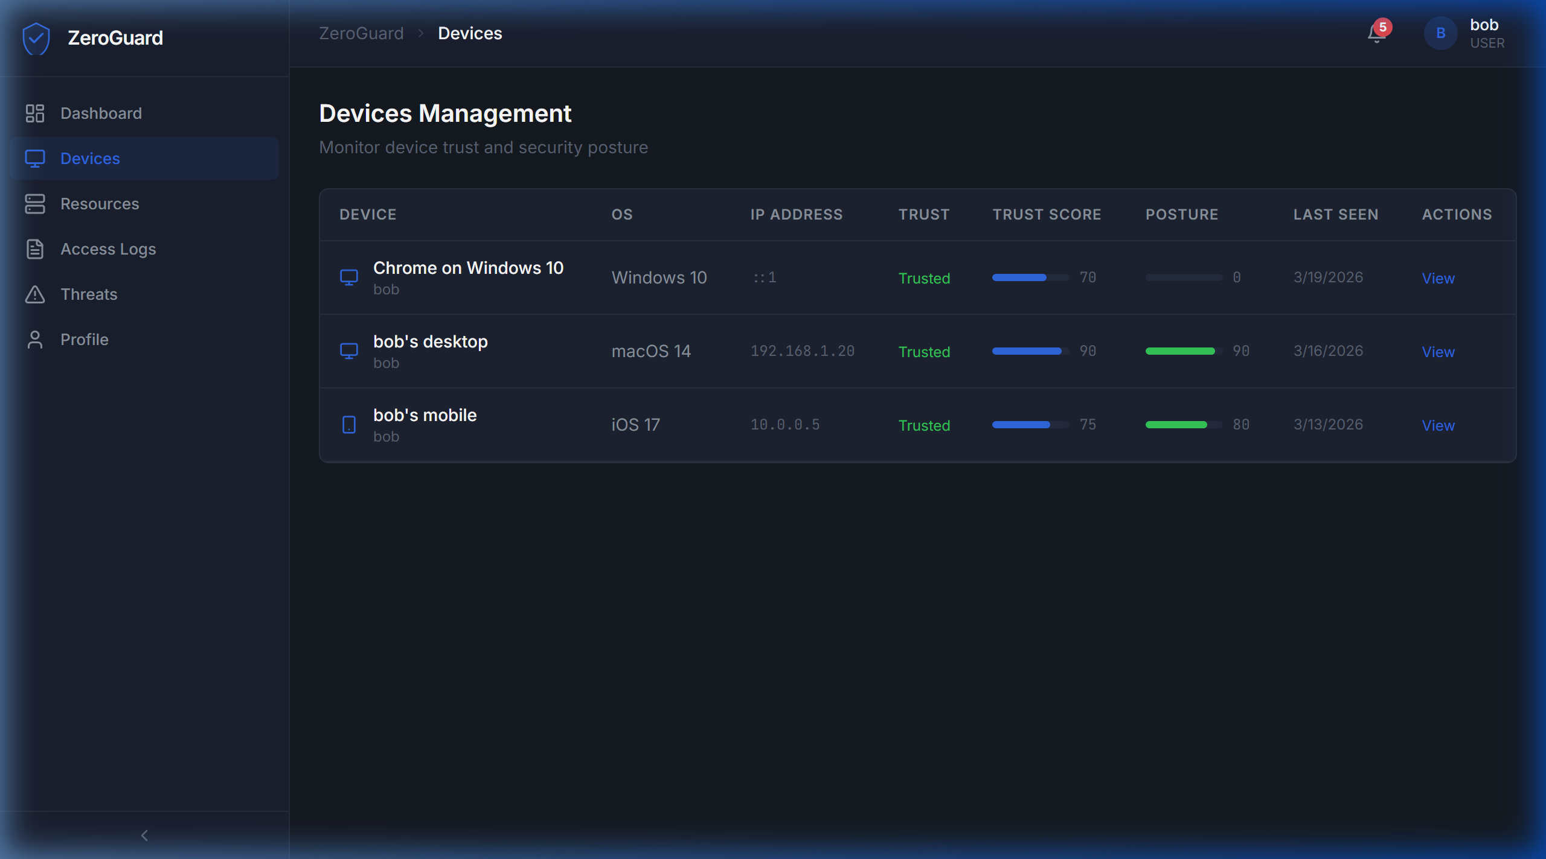
Figure 3: Devices Management — Trust scores, posture bars, and device details
4.5.4 Protected Resources
The resources page presents a card-based view of all protected assets with sensitivity levels, access requirements, and inline policy testing:
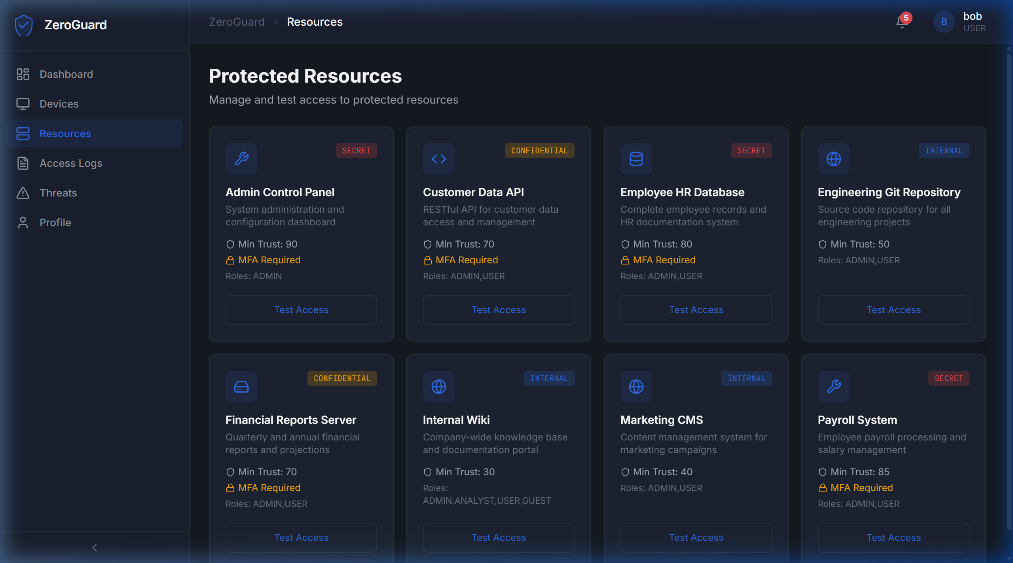
Figure 4: Protected Resources — Card grid with sensitivity badges and Test Access buttons
4.5.5 Access Logs
The audit log page provides filterable, paginated access records with outcome badges, risk scores, and CSV export:
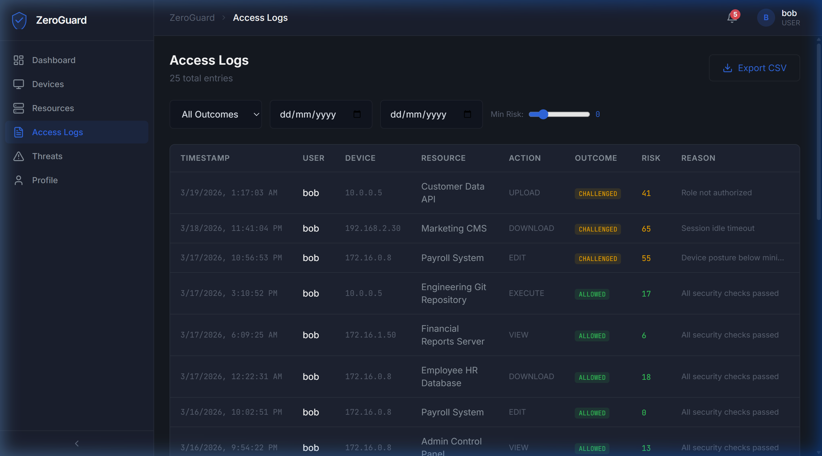
Figure 5: Access Logs — Filterable table with outcome badges, risk scores, and CSV export
4.5.6 Threat Alerts
The threat management interface displays alerts by severity with filtering and resolution controls:
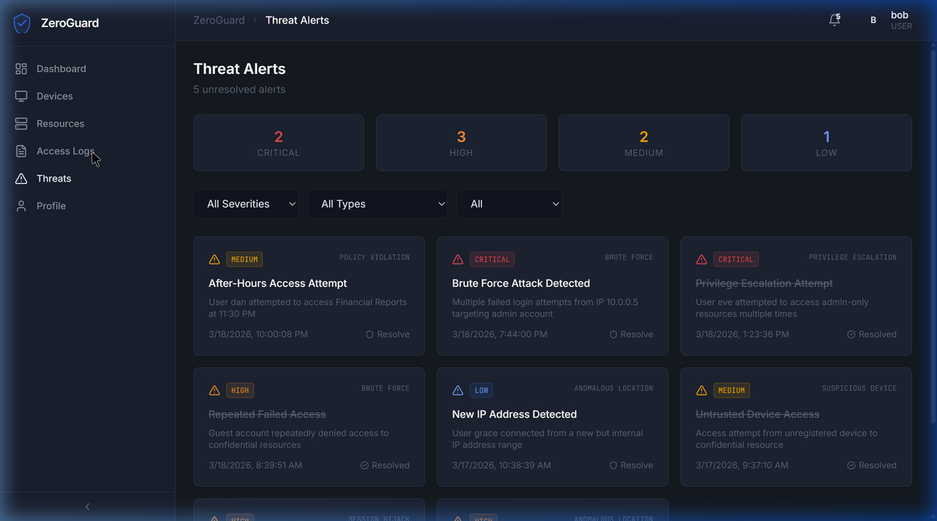
Figure 6: Threat Alerts — Severity badges with filtering and resolve controls
4.5.7 User Profile
The profile page allows users to manage their account, MFA settings, devices, sessions, and view activity history:
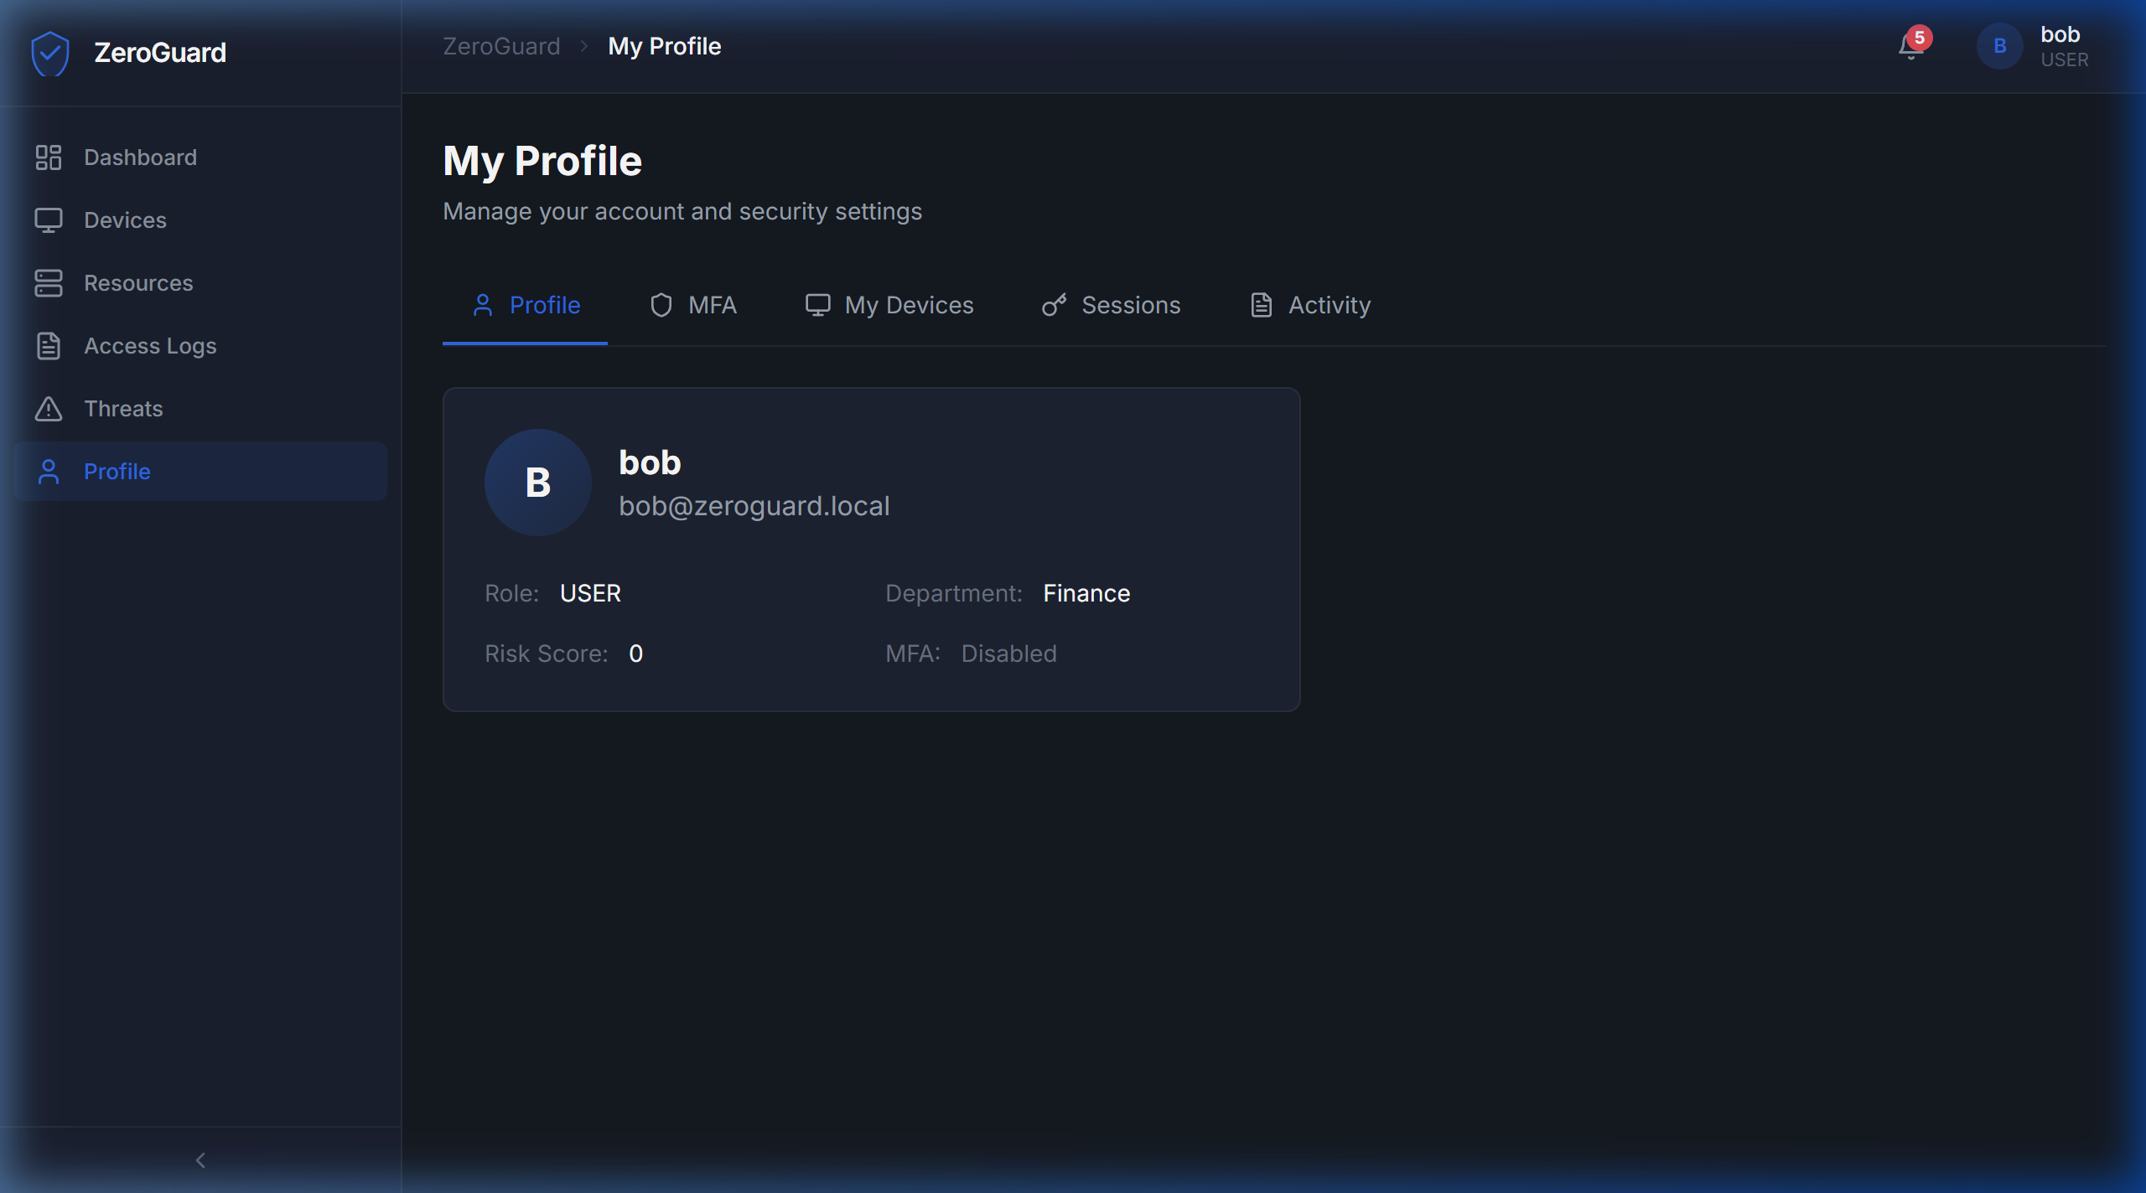
Figure 7: User Profile — Account details, MFA, devices, sessions, activity tabs
4.6 Testing and Quality Assurance
4.6.1 Unit Testing
Individual modules (authentication, policy engine, risk scoring) were tested in isolation using direct API calls to verify correct behavior for valid and invalid inputs.
4.6.2 Integration Testing
End-to-end flows were tested: Registration → Login → MFA Setup → MFA Verify → Access Resource → Policy Evaluation → Audit Log Generation.
4.6.3 System Testing
Full system testing was performed using browser-based testing across multiple pages, verifying:
- Login and MFA flows with TOTP verification
- Dashboard data rendering with real-time charts
- Device management with posture assessment
- Policy CRUD operations and enforcement
- Threat alert generation and resolution
- Access log filtering, pagination, and CSV export
4.6.4 Bug Fixing and Issue Resolution
Key issues resolved during development:
- MFA Secret Mismatch: Fixed by using a fixed TOTP secret for seeded demo users to enable predictable testing.
- Neon Color Scheme: Redesigned from flashy glassmorphism to professional Wazuh-inspired dark theme for enterprise credibility.
- Session Token Rotation: Implemented proper refresh token rotation to prevent token reuse attacks.
4.6.5 System Deployment
ZeroGuard is deployed locally using npm scripts:
npm run dev # Starts both client (port 5173) and server (port 4000) concurrently
npm run seed # Seeds the database with demonstration data

CHAPTER 5: SUMMARY, RECOMMENDATIONS, LIMITATIONS AND CONCLUSIONS
5.1 Summary
ZeroGuard is a comprehensive Zero Trust Network Architecture (ZTNA) simulation platform that successfully demonstrates and enforces Zero Trust principles through a modern web application. The platform implements six core security modules: identity verification with MFA, device trust assessment, adaptive policy enforcement, risk-based access control, real-time threat detection, and comprehensive audit logging.
The system was built using a modern full-stack architecture (React + TypeScript frontend, Express + TypeScript backend, Prisma ORM with SQLite) and features a professional enterprise-grade UI inspired by industry-standard SIEM tools. The platform handles 10 API endpoint groups through a 7-layer middleware pipeline that enforces security at every request.
Key achievements:
- Complete implementation of all 13 specified functional requirements
- 9-table database schema with comprehensive seed data covering realistic scenarios
- Real-time event streaming for live dashboard updates via WebSocket
- Professional UI with 13 fully functional pages and responsive design
- TOTP-based MFA with QR code provisioning
- Configurable policy engine with 7 condition fields and 4 action types
5.2 Recommendations
- Cloud Deployment: Deploy ZeroGuard to a cloud platform (AWS, Azure, or GCP) with containerization (Docker) for wider accessibility.
- Production Database: Migrate from SQLite to PostgreSQL for concurrent multi-user access and better performance at scale.
- Network Traffic Analysis: Integrate real network traffic capture using tools like Wireshark or Zeek.
- Machine Learning Risk Scoring: Implement ML-based anomaly detection for user behavior analysis.
- SSO Integration: Add support for SAML/OIDC single sign-on to demonstrate enterprise identity federation.
- Mobile Application: Develop a companion mobile authenticator app for a more realistic MFA experience.
5.3 Limitations
- Simulation vs. Production: The platform simulates Zero Trust concepts in a controlled environment; it does not replace production ZTNA solutions.
- SQLite Limitations: SQLite does not support concurrent writes efficiently, limiting multi-user scalability.
- No Real Network Enforcement: The platform evaluates access at the application layer; it does not perform network-level packet filtering or VPN tunneling.
- Static Risk Scoring: Risk scores are partially deterministic and lack machine learning-based behavioral analysis.
- Single-Server Architecture: A production deployment would require load balancing, clustering, and high availability.
5.4 Conclusions
The ZeroGuard ZTNA simulation platform successfully achieves its primary objective of demonstrating Zero Trust principles through a practical, interactive web application. The platform provides a comprehensive educational tool that bridges the gap between theoretical Zero Trust concepts and practical implementation.
Through the implementation of identity verification, device trust assessment, policy-based access control, risk scoring, threat detection, and audit logging, ZeroGuard embodies the three pillars of Zero Trust: Never Trust, Always Verify, Continuously Monitor. The professional enterprise-grade interface ensures that the platform is suitable for academic presentations, demonstrations, and hands-on learning.

REFERENCES
- Kindervag, J. (2010). Build Security Into Your Network's DNA: The Zero Trust Network Architecture. Forrester Research.
- Rose, S., Borchert, O., Mitchell, S., & Connelly, S. (2020). Zero Trust Architecture. NIST Special Publication 800-207.
- Gilman, E., & Barth, D. (2017). Zero Trust Networks: Building Secure Systems in Untrusted Networks. O'Reilly Media.
- IBM Security (2024). Cost of a Data Breach Report 2024. IBM Corporation.
- Buck, C., Olenberger, C., Schweizer, A., Völter, F., & Eymann, T. (2021). Never trust, always verify — A multivocal literature review on current knowledge and research gaps of zero-trust. Computers & Security, 110, 102436.
- Stafford, V. (2020). Zero Trust Architecture. NIST SP 800-207, National Institute of Standards and Technology.
- Turner, M. (2021). Digital Identity Guidelines — Authentication and Lifecycle Management. NIST SP 800-63B.
- M'Raihi, D., Machani, S., Pei, M., & Rydell, J. (2011). TOTP: Time-Based One-Time Password Algorithm. RFC 6238, IETF.
- Google (2014). BeyondCorp: A New Approach to Enterprise Security. Google Research.
- Gartner (2023). Market Guide for Zero Trust Network Access. Gartner Research.

APPENDICES
Appendix I: Default User Credentials
Username | Email | Password | Role | MFA
admin | admin@zeroguard.local | ZeroGuard@2024 | ADMIN | ❌
analyst | analyst@zeroguard.local | ZeroGuard@2024 | ANALYST | ❌
alice | alice@zeroguard.local | ZeroGuard@2024 | USER | ❌
bob | bob@zeroguard.local | ZeroGuard@2024 | USER | ❌
charlie | charlie@zeroguard.local | ZeroGuard@2024 | USER | ❌
dan | dan@zeroguard.local | ZeroGuard@2024 | USER | ❌
eve | eve@zeroguard.local | ZeroGuard@2024 | GUEST | ❌
frank | frank@zeroguard.local | ZeroGuard@2024 | GUEST | ❌
grace | grace@zeroguard.local | ZeroGuard@2024 | USER | ❌
heidi | heidi@zeroguard.local | ZeroGuard@2024 | ANALYST | ❌

Appendix II: API Endpoint Summary
Route Group | Base Path | Endpoints
Authentication | /api/auth | register, login, logout, refresh, mfa/setup, mfa/verify, mfa/disable, me
Users | /api/users | list, get, create, update, getDevices, getSessions, getLogs
Devices | /api/devices | list, get, register, updateTrust, submitPosture
Sessions | /api/sessions | list, terminate
Resources | /api/resources | list, get, create, testAccess
Policies | /api/policies | list, create, toggle, delete
Access Logs | /api/logs | list, timeline, topResources, topDeniedUsers
Threats | /api/threats | list, active, stats, resolve
Analytics | /api/analytics | dashboard, riskMatrix
Settings | /api/settings | list, update

Appendix III: Setup Instructions
# Clone and install
git clone <repository_url>
cd zeroguard
npm install
# Setup database
cd server
npx prisma generate
npx prisma db push
npm run seed
cd ..
# Start development servers
npm run dev
# Frontend: http://localhost:5173
# Backend: http://localhost:4000

