ISO 20022
Multilateral Settlement - Maintenance 2023 - 2024

Message Definition Report Part 1
Approved by the Payments SEG on 8th January 2024
This document provides information about the use of the messages for Multilateral Settlement message set and includes, for example, business transactions and messages flows.

March 2024

Table of Contents
Table of Contents 2
1 Introduction 4
1.1 Terms and Definitions 4
1.2 Abbreviations and Acronyms 4
1.3 Document Scope and Objectives 5
1.4 References 5
2 Scope and Functionality 6
2.1 Background 6
2.2 Scope 6
2.3 Groups of MessageDefinitions and Functionality 7
3 BusinessRoles and Participants 8
4 BusinessProcess Description 9
5 Description of BusinessActivities 10
6 BusinessTransactions 14
6.1 Settlement request with open/close notification 14
7 Business Examples 15
7.1 MultilateralSettlementRequest 15
8 Revision Record 18

Preliminary Note
The Message Definition Report (MDR) is made of three parts:
MDR Part 1
This describes the contextual background required to understand the functionality of the proposed message set. Part 1 is produced by the submitting organization that developed or maintained the message set in line with an MDR Part 1 template provided by the ISO 20022 Registration Authority (RA) on www.iso20022.org.
MDR Part 2
This is the detailed description of each message definition of the message set. Part 2 is produced by the RA using the model developed by the submitting organization.
MDR Part 3
This is an extract if the ISO 20022 Business Model describing the business concepts used in the message set. Part 2 is an Excel document produced by the RA.

Introduction

Terms and Definitions
The following terms are reserved words defined in ISO 20022 Edition 2013 – Part1. When used in this document, the UpperCamelCase notation is followed.
Term | Definition
BusinessRole | Functional role played by a business actor in a particular BusinessProcess or BusinessTransaction.
Participant | Involvement of a BusinessRole in a BusinessTransaction.
BusinessProcess | Definition of the business activities undertaken by BusinessRoles within a BusinessArea whereby each BusinessProcess fulfils one type of business activity and whereby a BusinessProcess may include and extend other BusinessProcesses.
BusinessTransaction | Particular solution that meets the communication requirements and the interaction requirements of a particular BusinessProcess and BusinessArea.
MessageDefinition | Formal description of the structure of a message instance.
When a MessageDefinition or message identifier is specified, it should include the variant and version number. However, in this document (except in the business examples section, if present), variant and version numbers are not included. In order to know the correct variant and version number for a MessageDefinition, the related Message Definition Report Part 2 document should be consulted.

Abbreviations and Acronyms
The following is a list of abbreviations and acronyms used in the document.
Abbreviation/Acronyms | Definition
BAH | Business Application Header
BIC | Business Identifier Code
BJ | Business Justification
BoE | The Bank of England
CHAPS | Clearing House Automated Payment System
DNS | Deferred Net Settlement
FI | Financial Institution
MCR | Message Change Request
MDR | Message Definition Report
RTGS | Real Time Gross Settlement
SEG | Standards Evaluation Group
XML | eXtensible Mark-up Language

Document Scope and Objectives
This document is the first part of the ISO 20022 Multilateral Settlement Message Definition Report (MDR) that describes the BusinessTransactions and underlying message set. For the sake of completeness, the document may also describe BusinessActivities that are not in the scope of the business processes covered in this document.
This document describes the following:
- the BusinessProcess scope
- the BusinessRoles involved in these BusinessProcesses
The main objectives of this document are as follows:
- To explain what BusinessProcesses and BusinessActivities these MessageDefinitions have addressed
- To give a high level description of BusinessProcesses and the associated BusinessRoles
- To document the BusinessTransactions and their Participants (sequence diagrams)
- To list the MessageDefinitions
The messages definitions are specified in Message Definition Report Part 2.

References
Document | Version | Date | Author
186_MultilateralAncillarySettlementMessages_PaymentSystems_BJ_BoE_v1.2 | Final | 14-05-2021 | The Bank of England
ISO 20022 Maintenance Change Request (MCR #234) document (Payments Maintenance 2023/2024) | 2023 | 31-08-2023 | SWIFT

Scope and Functionality

Background
This Message Definition Report covers one (1) MessageDefinition which was developed by The Bank of England and approved by the Payments Standards Evaluation Group (SEG) on 08 January 2024. In addition, there are two (2) existing ISO 20022 MessageDefinitions that shall be used in conjunction to provide full multilateral settlement functionality.
This message is specifically designed to support the multilateral settlement process in the UK under the Deferred Net Settlement system managed by The Bank of England, and is planned to be used by the UK payment systems’ operators to settle their obligations through this market infrastructure. The message is however designed in a generic way to ensure potential future usage by other jurisdictions and payment operators, if decided to transition their multilateral settlement processes into ISO 20022.

Scope
In recent years, the need for financial institutions to manage payment transactions intra-day in real-time across currencies has become a reality. Financial institutions face growing volumes in domestic and cross-border real-time payment settlement systems. They must have the means to adequately address the following areas of concern: the increased regulatory pressure on managing settlement risk, monitoring the centralisation of liquidity management and treasury functions and the integration of securities settlement systems with payment settlement systems.
In many jurisdictions, central banks have been acting as a settlement agents for payment systems where accounts held in the RTGS are used to settle the obligations arising from customer transactions for the main retail payment systems. The Bank of England has decided to build a specific system which settles the obligations of payment operators on a net basis at the end of a predefined settlement cycle and is defined as a periodic batch settlement between settlement members on a multilateral net basis. On a typical day, the majority of payments made in the UK (by volume) are exchanged between retail customers via this Deferred Net Settlement Scheme, rather than directly over the RTGS infrastructure. The resulting net obligations between settlement participants are settled periodically through the RTGS Accounts. This differs to the CHAPS Settlement Scheme model, which settles payments individually on a gross basis (i.e. Real-Time, Gross Settlement).
For that purpose, The Bank of England considered the application of the ISO 20022 as the main format of exchanging relevant information through the DNS system. It was envisaged that most of the functionalities of such system can be covered (without the need for modifications) by the existing MessageDefinitions already registered at the ISO level, however one particular information flow – multilateral settlement request – requires a new MessageDefinition to cover all relevant requirements of The Bank of England (and requirements of other jurisdictions that may decide to transition to ISO 20022 in the same context). The Bank of England is aware of the other existing MessageDefinitions that potentially could be used for the above mentioned process, however the application of such messages would require redefinition of certain structures and message components, addition of new/removal of existing message components, and could ultimately lead to misuse of such MessageDefinitions for purposes not originally envisaged for. Furthermore, The Bank of England is also aware of the initiative run by The Australian Securities Exchange to replace the existing CHESS system (Clearing House Electronic Subregister System) with a new system driven by the ISO 20022 format, for which the ASX commenced development new MessageDefinitions. A subset of these message is considered as similar to the new MessageDefinition developed by The Bank of England, however the scope of information covered is tailored for the Securities market and therefore would not be appropriate for use in the UK DNS context.
This Message Definition Report presents the overview of all MessageDefinitions in scope of the multilateral settlement exchange process.

Groups of MessageDefinitions and Functionality
The messages intended for use in the context of Multilateral Settlement are classified into three groups:
- Request messages – to be sent by the Payment System Operator(s) to the Market Infrastructure/Multilateral Settlement System to request certain actions related to the settlement process;
- Response messages – to be sent by the Market Infrastructure/Multilateral Settlement System to the Payment System Operator(s) to respond to the original settlement request submitted by the Payment System Operator(s); and
- Notification messages – to be sent from the Market Infrastructure/Multilateral Settlement System to the Payment System Operator(s) with the relevant notifications about the certain events happening on the System side.
These messages are to be used with the ISO 20022 Business Application Header (head.001). The schema and more information about the Business Application Header (BAH) can be found on the www.iso20022.org web site

Groups
Particular messages to be used for the above mentioned groups are listed in the subsections below.

Request messages
MessageDefinition | Message Identifier
MultilateralSettlementRequest | pacs.029.001.02

Response message(s)
MessageDefinition | Message Identifier
FIToFIPaymentStatusReport | pacs.002

Notification message(s)
MessageDefinition | Message Identifier
SystemEventNotification | admi.004

BusinessRoles and Participants
A BusinessRole represents an entity (or a class of entities) of the real world, physical or legal, a person, a group of persons, a corporation. Examples of BusinessRoles: “Financial Institution”, “Automated Clearing House”, “Central Securities Depository”.
A Participant is a functional role performed by a BusinessRole in a particular BusinessProcess or BusinessTransaction. Examples of Participants: the “user” of a system, “debtor”, “creditor”, “investor”.
The relationship between BusinessRoles and Participants is many-to-many. One BusinessRole can be involved as different Participants at different moments in time or at the same time. Examples of BusinessRoles: "user", "debtor”, "creditor", "investor". Different BusinessRoles can be involved as the same Participant.
In the context of Multilateral Settlement, the high-level BusinessRoles and typical Participants can be represented as follows:

Participants
Description | Definition
Settlement system | System established to serve as a mechanism for the settlement of obligations among the members the system.
Participant | Member of the settlement system.
Business Roles
Description | Definition
Multilateral settlement service | Multilateral net settlement service in the settlement system
Retail payment system operator | Payment system that settle their obligations through the multilateral settlement service

BusinessRoles/Participants Matrix Table
Participants  BusinessRoles | Settlement system | Participant
Multilateral settlement service | X
Retail payment system operator |  | X

BusinessProcess Description
Open/Close Notification
Item | Description
Definition | The process of notifying the retail payment system operator about opening or closing the window for settlement within the multilateral net settlement service in the multilateral settlement service.
Trigger | The process is triggered at a specific time set by the operator of the multilateral settlement service when the system is ready to receive settlement requests from retail payment system operators.
Pre-conditions | Specific time for opening and closing the window for settlement is set by the multilateral settlement service
Post-conditions | Retail payment system operator is informed about the times for opening and closing the window for settlement within the multilateral settlement service.
Role | Multilateral settlement service
Settlement Request
Item | Description
Definition | The process of instructing the multilateral settlement service to settle obligations on multilateral basis through the accounts held by its participants at the settlement service provider.
Trigger | The process is triggered by the retail payment system operator in an event where payment obligations shall be settled on behalf of its participants.
Pre-conditions | Settlement window must be open as notified by the multilateral settlement service
Post-conditions | Retail payment system operator is provided with the response message from the multilateral settlement service about the status of the request.
Role | Retail payment system operator.

Description of BusinessActivities
This section presents the different BusinessActivities within each BusinessProcess. The BusinessActivities of a process are described with activity diagrams.

Open/Close Notification

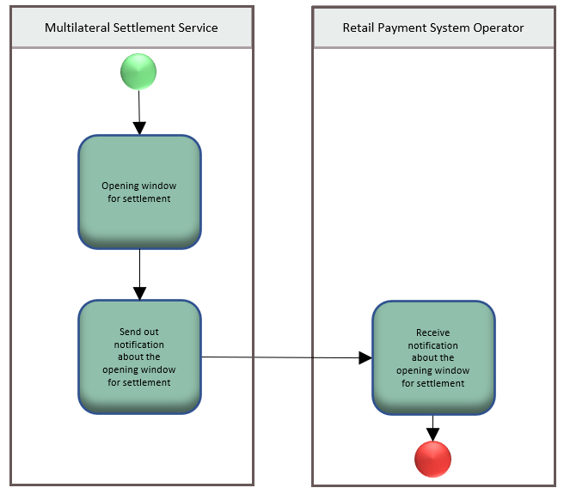

Step | Description | Initiator
Opening window for settlement | Multilateral settlement service operator initiates process of opening settlement window. | Multilateral settlement service
Send out notification about the opening window for settlement | Multilateral settlement service operator provides message to the participants about open window for settlement. | Multilateral settlement service
Receive notification about the opening window for settlement | Information about open window for settlement is provided to Retail Payment System Operator through the notification message. | Retail Payment System Operator
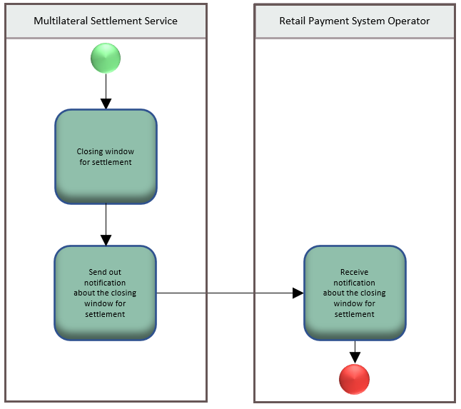

Step | Description | Initiator
Closing window for settlement | Multilateral settlement service operator initiates process of closing settlement window. | Multilateral settlement service
Send out notification about the closing window for settlement | Multilateral settlement service operator provides message to the participants about closing window for settlement. | Multilateral settlement service
Receive notification about the closing window for settlement | Information about closing window for settlement is provided to Retail Payment System Operator through the notification message. | Retail Payment System Operator

Settlement Request
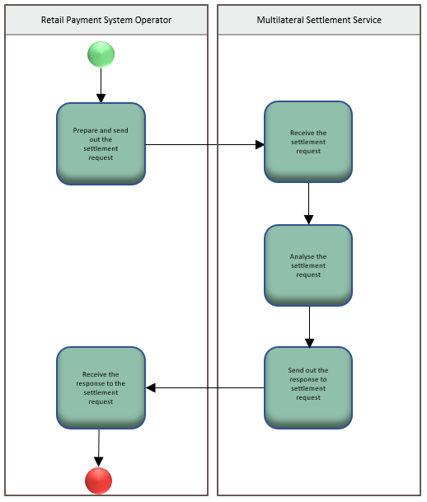

Step | Description | Initiator
Prepare and send out the settlement request | Retail Payment System Operator provides a settlement request message to the Settlement System Operator. | Retail Payment System Operator
Receive the settlement request | Multilateral settlement service receives a settlement request message. | Multilateral settlement service
Analyse the settlement request | Multilateral settlement service analyses a request message and interprets the scope of the request. | Multilateral settlement service
Send out the response to settlement request | Multilateral settlement service provides a response to the request message | Multilateral settlement service
Receive the response to the settlement request | Opening message with the response from Settlement System. | Retail Payment System Operator

Legend
Symbol | Name | Definition
 | Start Point | Shows where the lifecycle of the business process commences.
 | End Point | Shows where the lifecycle of the business process may ends.
 | Lozenge (or diamond) | Indicates that a choice between several actions can be made.
 | Bar | Indicates that several actions are initiated in parallel.

BusinessTransactions
This section describes the message flows based on the activity diagrams documented above. It shows the typical exchanges of information in the context of a multilateral settlement.

Settlement request with open/close notification
Below messages flows are related to the submission of a multilateral settlement request within the widow offered by the settlement system for submitting requests. In particular it presents the success flow where the request is accepted by the settlement system, as well as an alternative flow in case of the original instruction being rejected by the system.
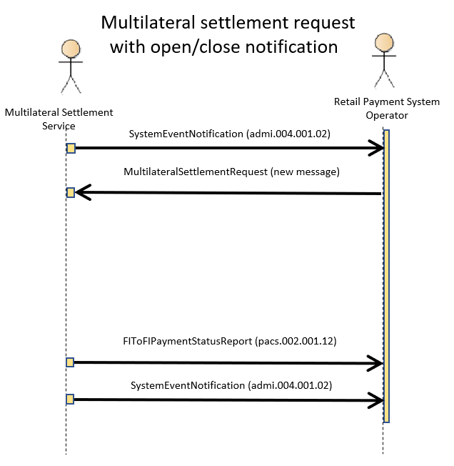

Business Examples
This section describes business examples of the use of the various MessageDefinitions.

MultilateralSettlementRequest
The multilateral settlement service operator opens a settlement window and notifies the payment system operator about this event with STWO code (SettlementWindowOpen).
<?xml version="1.0" encoding="UTF-8"?>
<n1:Document xmlns:xsi="http://www.w3.org/2001/XMLSchema-instance" xmlns:n1="urn:iso:std:iso:20022:tech:xsd:admi.004.001.02">
<n1:SysEvtNtfctn>
<n1:EvtInf>
<n1:EvtCd>STWO</n1:EvtCd>
<n1:EvtTm>2021-07-12T09:30:47Z</n1:EvtTm>
</n1:EvtInf>
</n1:SysEvtNtfctn>
</n1:Document>
Payment system operator submits a single request for deferred settlement within a single message. The request is detailed with two movements of funds between the accounts.
<?xml version="1.0" encoding="UTF-8"?>
<n1:Document xmlns:xsi="http://www.w3.org/2001/XMLSchema-instance" xmlns:n1="urn:iso:std:iso:20022:tech:xsd:pacs.029.001.02">
<n1:MulSttlmReq>
<n1:GrpHdr>
<n1:MsgId>123456789</n1:MsgId>
<n1:CreDtTm>2021-07-12T09:31:02Z</n1:CreDtTm>
<n1:NbOfSttlmReqs>1</n1:NbOfSttlmReqs>
<n1:SttlmInf>
<n1:SttlmMtd>CLRG</n1:SttlmMtd>
<n1:ClrSys>
<n1:Cd>FPS</n1:Cd>
</n1:ClrSys>
</n1:SttlmInf>
</n1:GrpHdr>
<n1:SttlmReq>
<n1:InstrId>ABC123</n1:InstrId>
<n1:InstrPrty>NORM</n1:InstrPrty>
<n1:SttlmTmReq>
<n1:TillTm>15:30:47Z</n1:TillTm>
<n1:RjctTm>17:59:59Z</n1:RjctTm>
</n1:SttlmTmReq>
<n1:SttlmPrty>NORM</n1:SttlmPrty>
<n1:SttlmCycl>20210521001</n1:SttlmCycl>
<n1:NbOfMvmntRcrds>2</n1:NbOfMvmntRcrds>
<n1:MvmntRcrd>
<n1:Id>MVMNT2</n1:Id>
<n1:SeqNb>0001</n1:SeqNb>
<n1:Amt>
<n1:Amt Ccy="GBP">800</n1:Amt>
<n1:CdtDbt>CRDT</n1:CdtDbt>
</n1:Amt>
<n1:SttlmAgt>
<n1:Nm>Agent 1</n1:Nm>
<n1:Id>
<n1:OrgId>
<n1:AnyBIC>BKENGB2LXXX</n1:AnyBIC>
</n1:OrgId>
</n1:Id>
</n1:SttlmAgt>
<n1:SttlmAgtAcct>
<n1:Id>
<n1:IBAN>AA000</n1:IBAN>
</n1:Id>
</n1:SttlmAgtAcct>
<n1:Ptcpt>
<n1:Nm>Participant 1</n1:Nm>
<n1:Id>
<n1:OrgId>
<n1:AnyBIC>BARCGB22</n1:AnyBIC>
</n1:OrgId>
</n1:Id>
</n1:Ptcpt>
<n1:PtcptAcct>
<n1:Id>
<n1:IBAN>BB000</n1:IBAN>
</n1:Id>
</n1:PtcptAcct>
<n1:Ref>Movement 1</n1:Ref>
</n1:MvmntRcrd>
<n1:MvmntRcrd>
<n1:Id>MVMNT1</n1:Id>
<n1:SeqNb>0002</n1:SeqNb>
<n1:Amt>
<n1:Amt Ccy="GBP">800</n1:Amt>
<n1:CdtDbt>DBIT</n1:CdtDbt>
</n1:Amt>
<n1:SttlmAgt>
<n1:Nm>Agent 1</n1:Nm>
<n1:Id>
<n1:OrgId>
<n1:AnyBIC>BKENGB2LXXX</n1:AnyBIC>
</n1:OrgId>
</n1:Id>
</n1:SttlmAgt>
<n1:SttlmAgtAcct>
<n1:Id>
<n1:IBAN>AA000</n1:IBAN>
</n1:Id>
</n1:SttlmAgtAcct>
<n1:Ptcpt>
<n1:Nm>Participant 2</n1:Nm>
<n1:Id>
<n1:OrgId>
<n1:AnyBIC>BARCGB22</n1:AnyBIC>
</n1:OrgId>
</n1:Id>
</n1:Ptcpt>
<n1:PtcptAcct>
<n1:Id>
<n1:IBAN>CC000</n1:IBAN>
</n1:Id>
</n1:PtcptAcct>
<n1:Ref>Movement 2</n1:Ref>
</n1:MvmntRcrd>
</n1:SttlmReq>
</n1:MulSttlmReq>
</n1:Document>
The multilateral settlement service operator acknowledges the receipt of the settlement request sent by the retail payment system operator with the ACTC code (AcceptedTechnicalValidation). Note that there might be further pacs.002 messages informing the recipient about further actions related to the settlement process.
<?xml version="1.0" encoding="UTF-8"?>
<n1:Document xmlns:xsi="http://www.w3.org/2001/XMLSchema-instance" xmlns:n1="urn:iso:std:iso:20022:tech:xsd:pacs.002.001.12">
<n1:FIToFIPmtStsRpt>
<n1:GrpHdr>
<n1:MsgId>0000000000241</n1:MsgId>
<n1:CreDtTm>2021-07-12T09:32:11Z</n1:CreDtTm>
</n1:GrpHdr>
<n1:TxInfAndSts>
<n1:StsId>STS01</n1:StsId>
<n1:OrgnlInstrId>ABC123</n1:OrgnlInstrId>
<n1:TxSts>ACTC</n1:TxSts>
</n1:TxInfAndSts>
</n1:FIToFIPmtStsRpt>
</n1:Document>
The multilateral settlement service operator closes a settlement window and notifies the payment system operator about this event with STWC code (SettlementWindowClose).
<?xml version="1.0" encoding="UTF-8"?>
<n1:Document xmlns:xsi="http://www.w3.org/2001/XMLSchema-instance" xmlns:n1="urn:iso:std:iso:20022:tech:xsd:admi.004.001.02">
<n1:SysEvtNtfctn>
<n1:EvtInf>
<n1:EvtCd>STWC</n1:EvtCd>
<n1:EvtTm>2021-07-12T18:00:01Z</n1:EvtTm>
</n1:EvtInf>
</n1:SysEvtNtfctn>
</n1:Document>

Revision Record

Revision | Date | Author | Description | Sections affected
1.0 | December 2023 | SWIFT | Draft version for SEG review | All
2.0 | March 2024 | ISO 20022 RA | Approved version | All

Disclaimer:
Although the Registration Authority has used all reasonable efforts to ensure accuracy of the contents of the iso20022.org website and the information published thereon, the Registration Authority assumes no liability whatsoever for any inadvertent errors or omissions that may appear thereon. Moreover, the information is provided on an "as is" basis. The Registration Authority disclaims all warranties and conditions, either express or implied, including but not limited to implied warranties of merchantability, title, non-infringement and fitness for a particular purpose.
The Registration Authority shall not be liable for any direct, indirect, special or consequential damages arising out of the use of the information published on the iso20022.org website, even if the Registration Authority has been advised of the possibility of such damages.

Intellectual Property Rights:
The ISO 20022 MessageDefinition described in this document were contributed by Bank of England. The ISO 20022 IPR policy is available at www.ISO20022.org > About ISO 20022 > Intellectual Property Rights.

